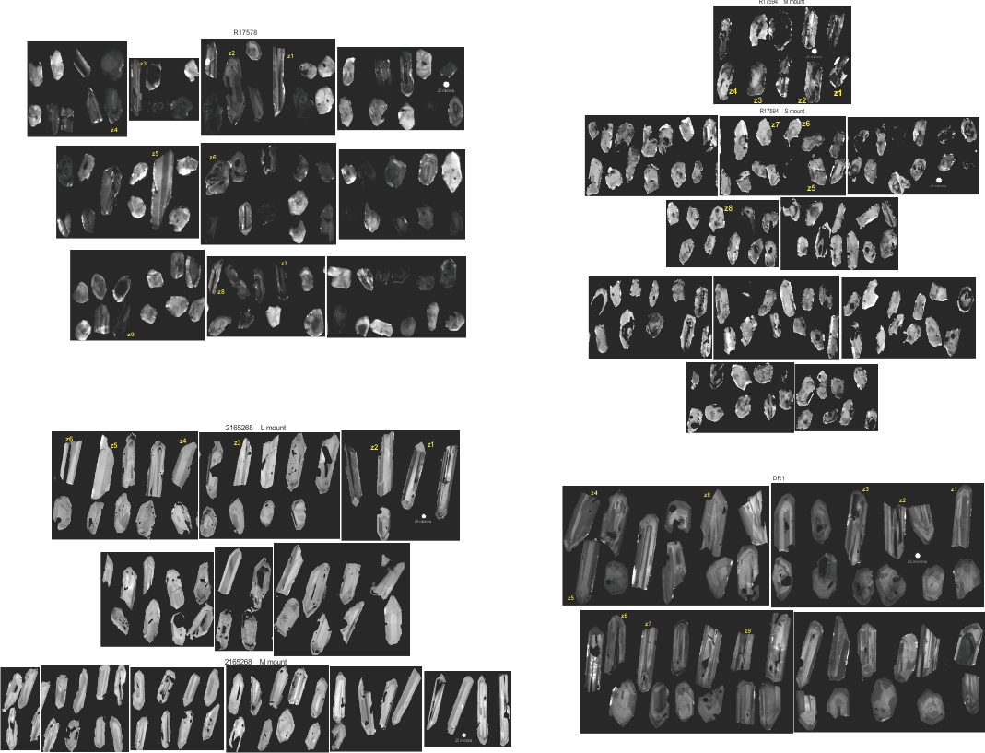
CL images of zircon. Labels for grains dated by CA-TIMS are shown in yellow.

