APPENDIX B
PICNIC POINT KINK BAND STUDY
In January 1972 a detailed investigation was undertaken of part of the Picnic Point wavecut platform (Figures1 and 2). This was part of a Kerry Burns led CSIRO test of computer optical pattern recognition from aerial photographs.

Structural data was collected on a detailed grid set up on the rock platform by David Gray (assisted initially by Alex Ozolins) as part of a Macquarie University PhD study initially supervised by Burns. Structural measurements were made at grid points on the attitudes of the dominant foliation Sm, the dominant lineation Lm (L1,2) and kink band axes and boundaries. The CSIRO test was not successful due to the inadquate aerial imagery available, despite an attempted low level helicopter flight along the grid lines over the wavecut platform.

The structural data collected in 1972 is presented in diagram form as part of this Appendix. The digital data is no longer available. No discussion is presented.

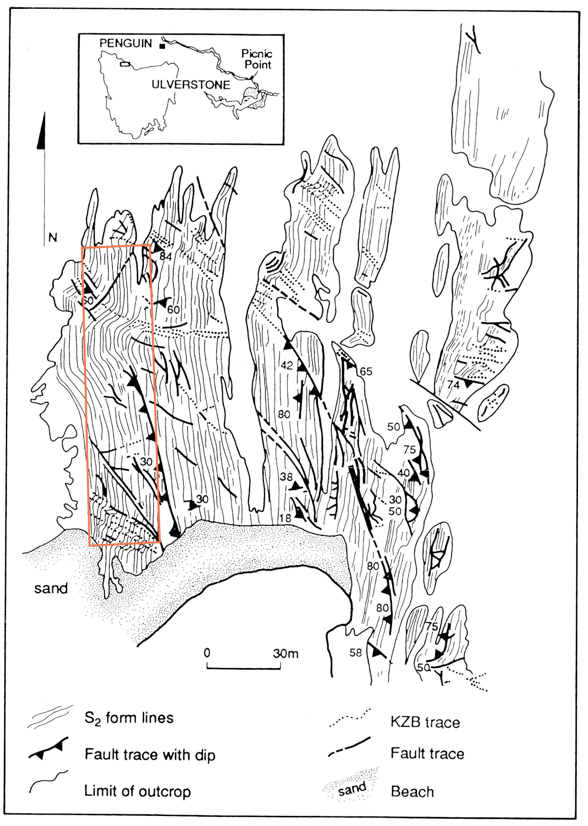

Figure 1: Simplified structural formline map in Sm of the Picnic Point wavecut platform The map is oriented to Magnetic North. The red recatngle outlines the detailed mapping area shown in Figures 3 and X.
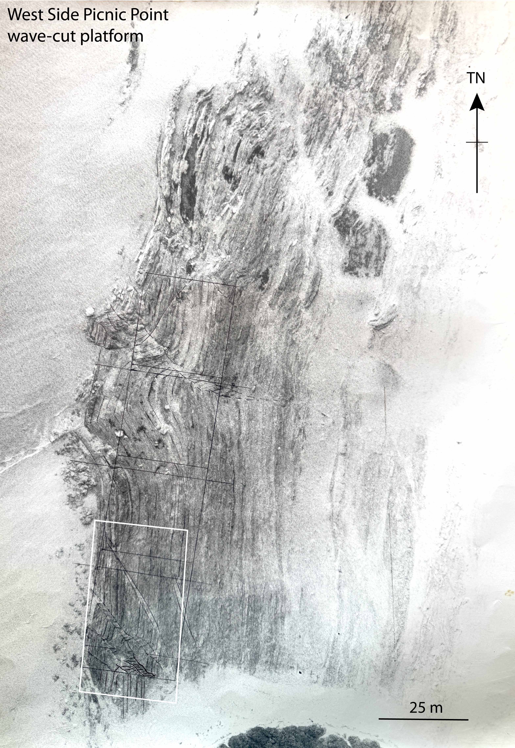

Figure 2: Black/white aerial photograph of the Picnic Point wavecut platform. The white rectangle in the lower left is the area of the more detailed black/white photograph shown in Figure 3. The black lines mark the position of the detailed map area shown in Figure 1.
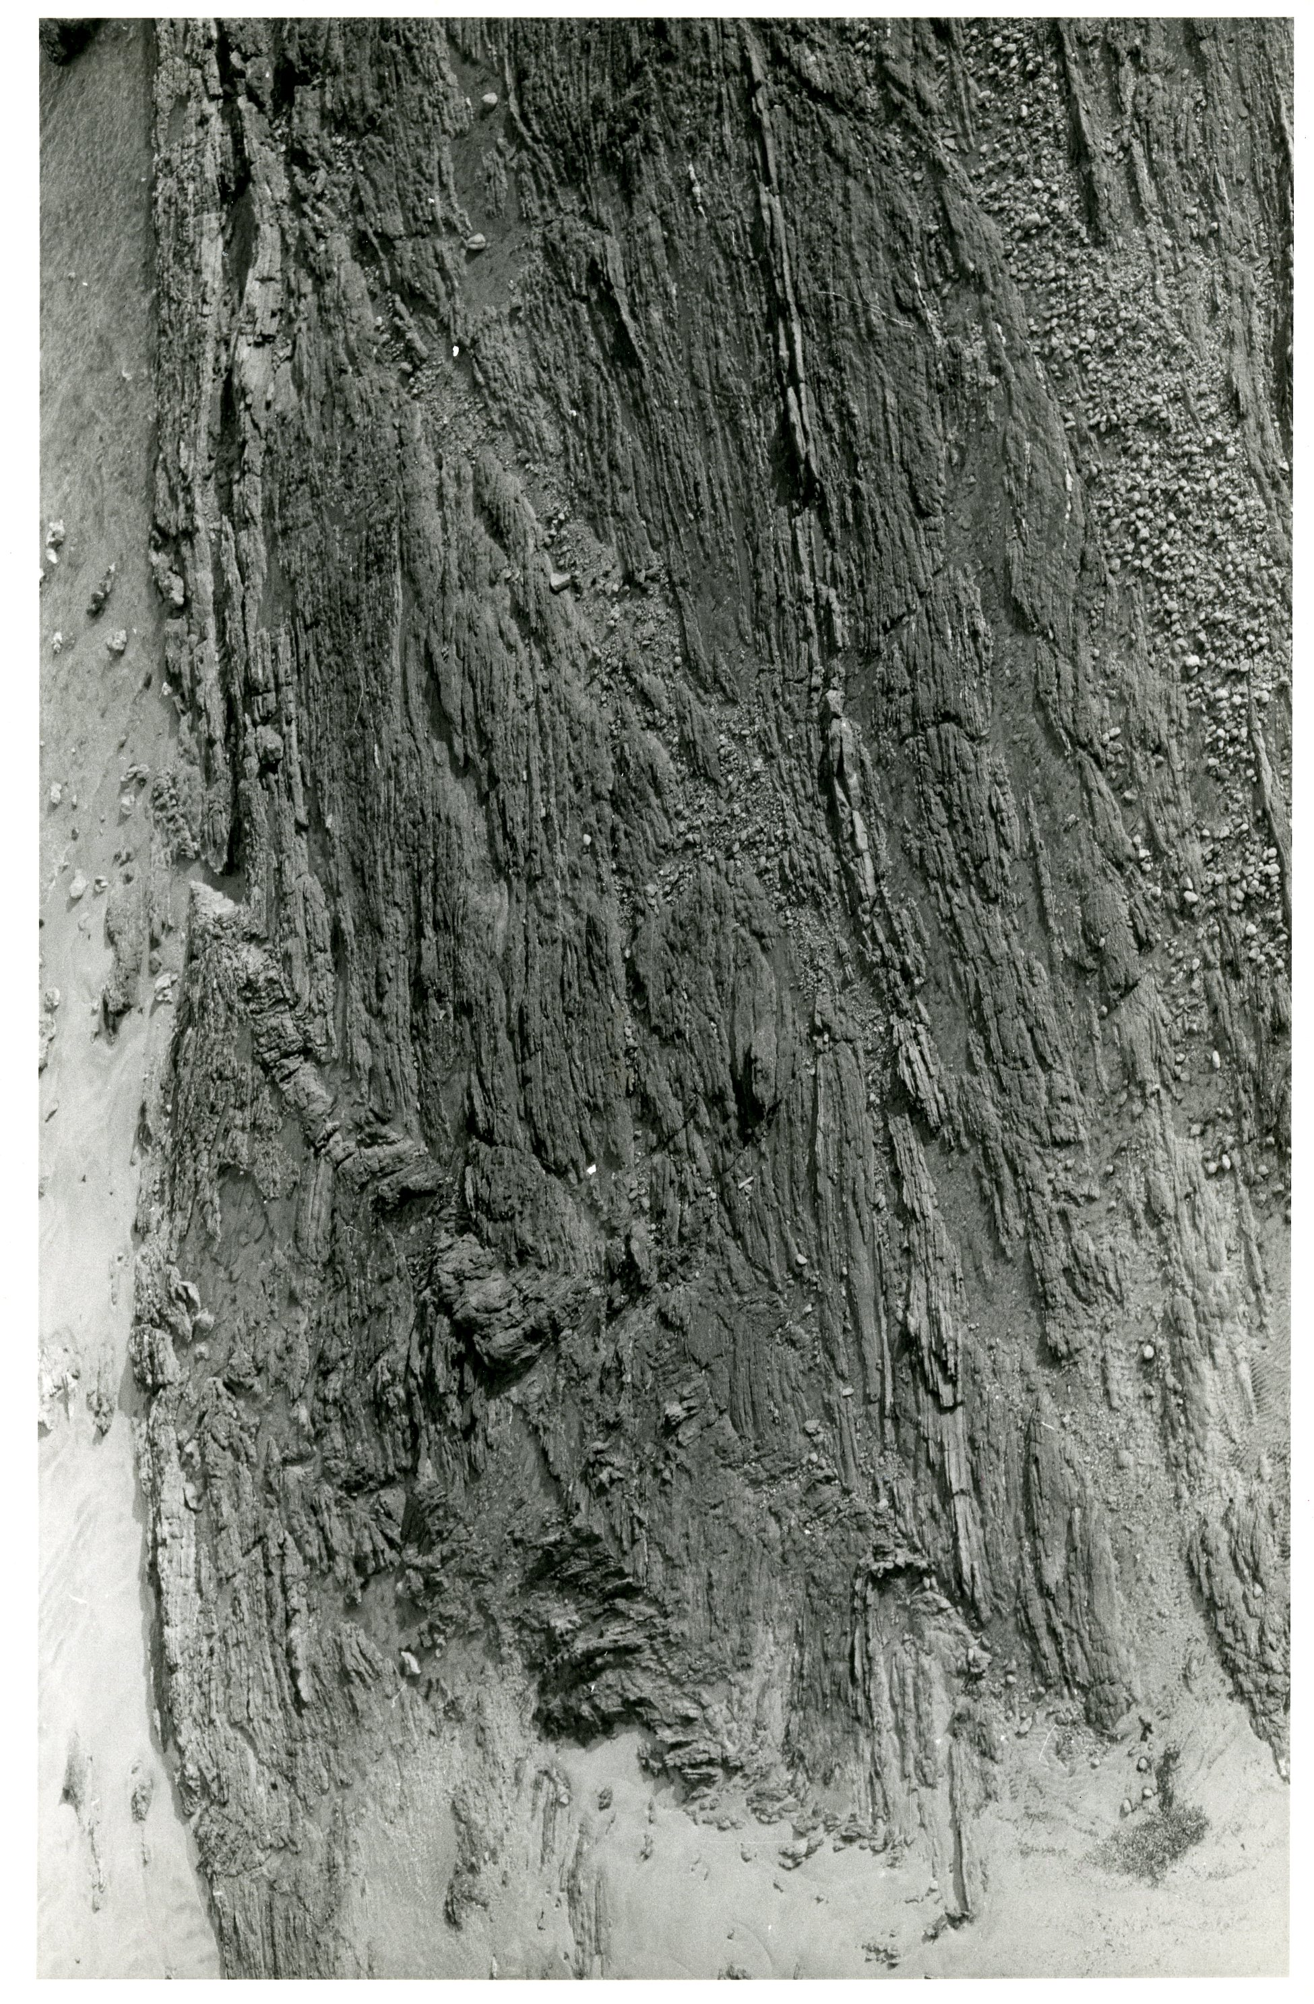
Figure 3: Picnic Point rock platform aerial photograph taken from a helicopter flown at low level. The kink bands are shown by the marked strike changes in the So/Sm foliation.
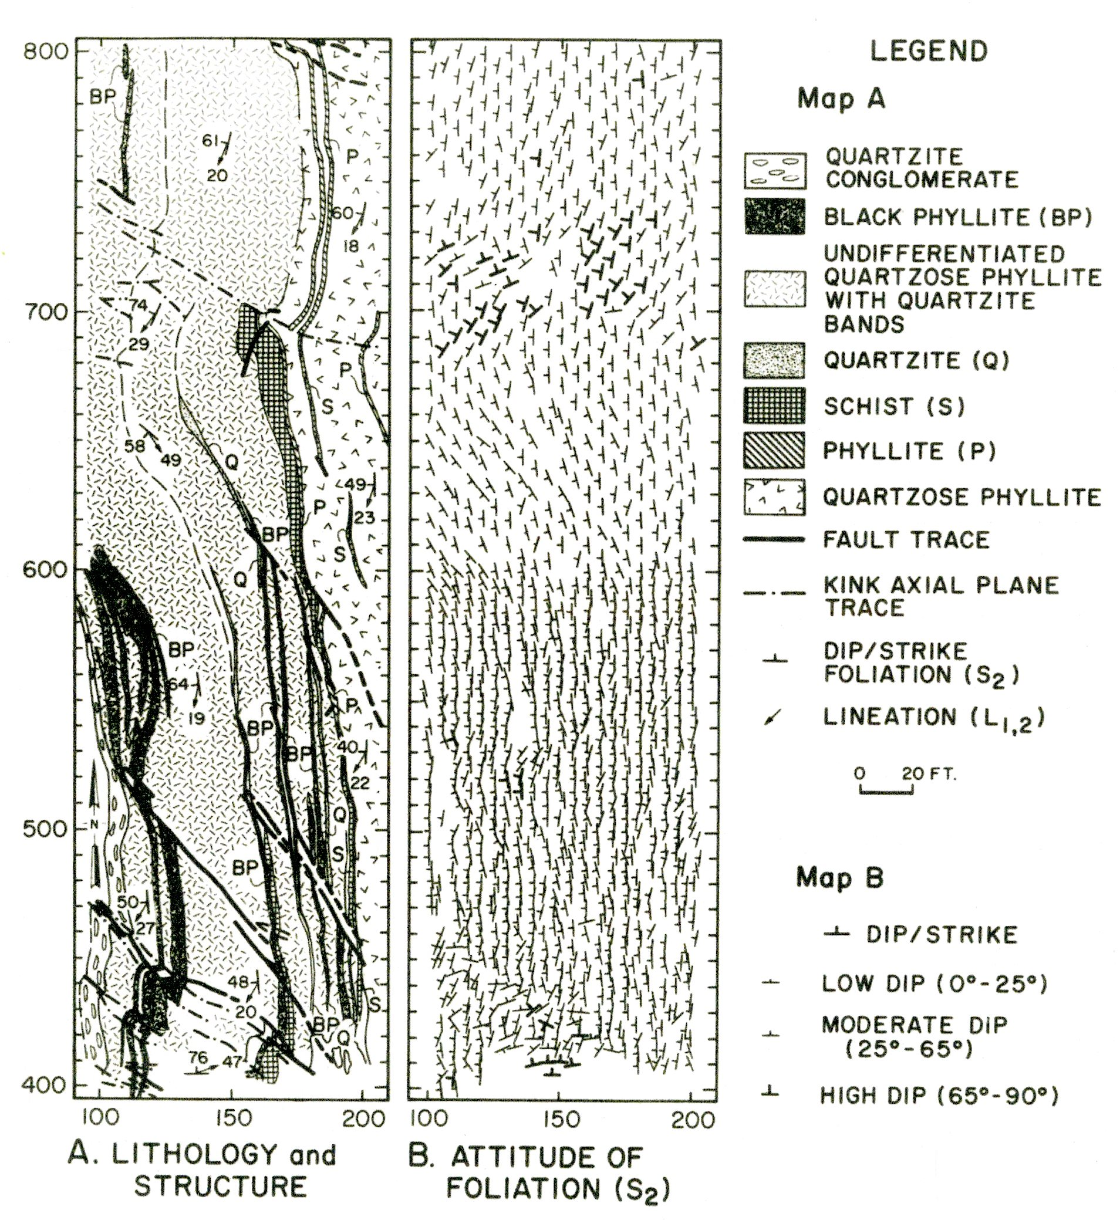Figure 4: Detailed lithological and structural maps of part of the Picnic Poiont wavecut platform. The location of the map area is shown in Figures 1 and 2.

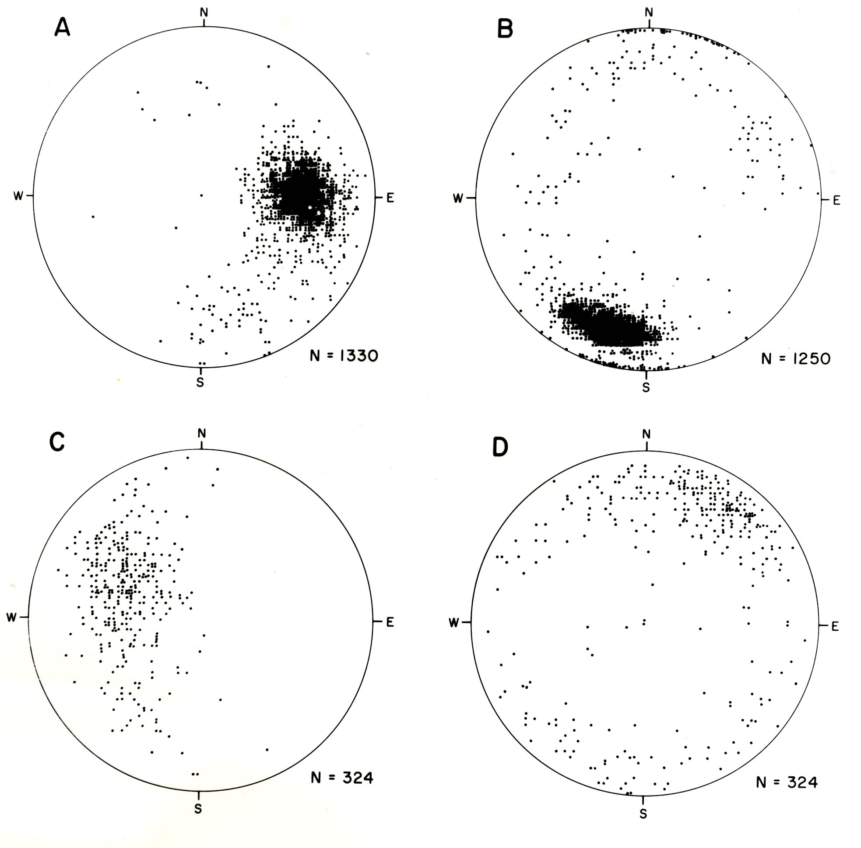
Figure 5: Structural data plots of the dominant foliation Sm, lineation Lm, Kink band axes and axial surfaces form the detaiuled mapping area on the Picnic Point wavecut platform (see Figure 1 for map area location).
A) Stereonet showing poles to transposition foliation Sm/S2.
B) Stereonet showing lineatiion Lm attitude.
C) Styereonet showing kink band axis attitudes.
D) Stereonet showing poles to kink band boundaries.

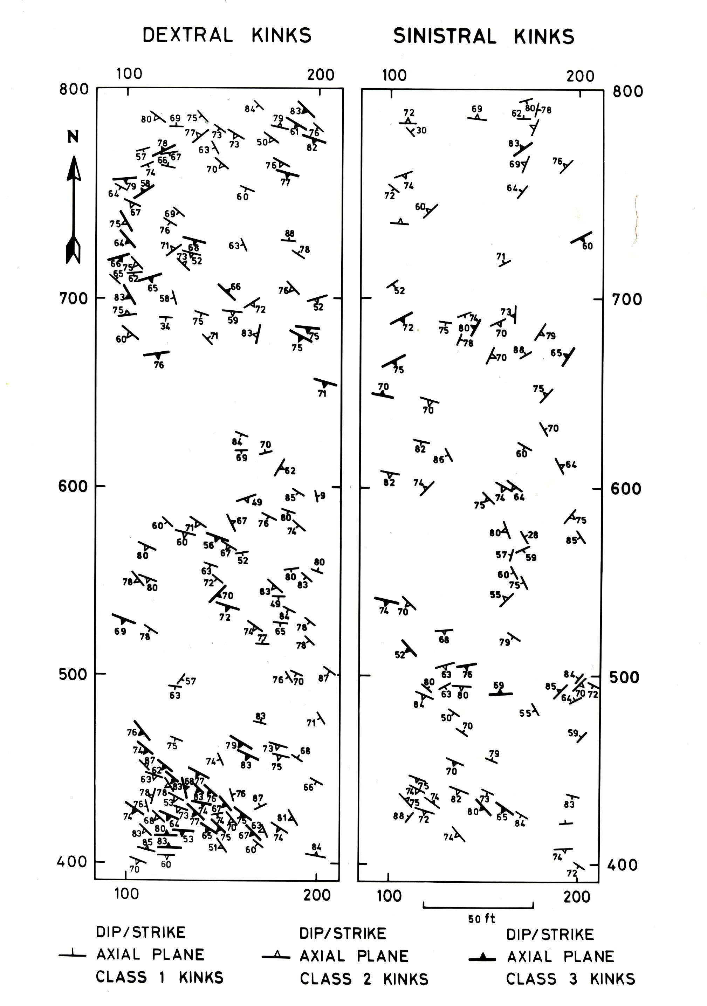
Figure 6: Kink band boundary attitude map for dextral and sinistral kink bands in the detailed mapping area of the Picnic Point wavecut platform.

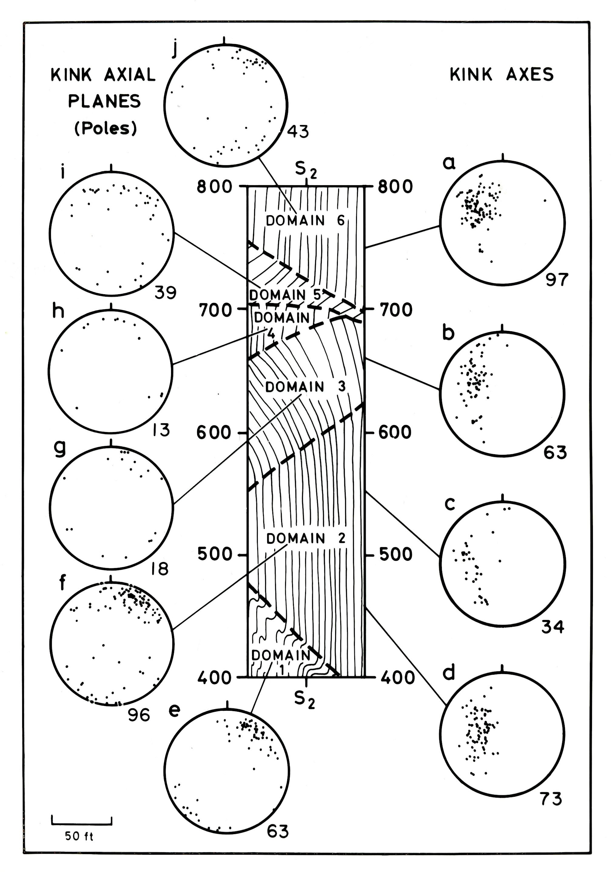
Figure 7: Stereonets of kink band axis and axial surface data from a domain map based on the large kink band pattern in the wavecut platform.
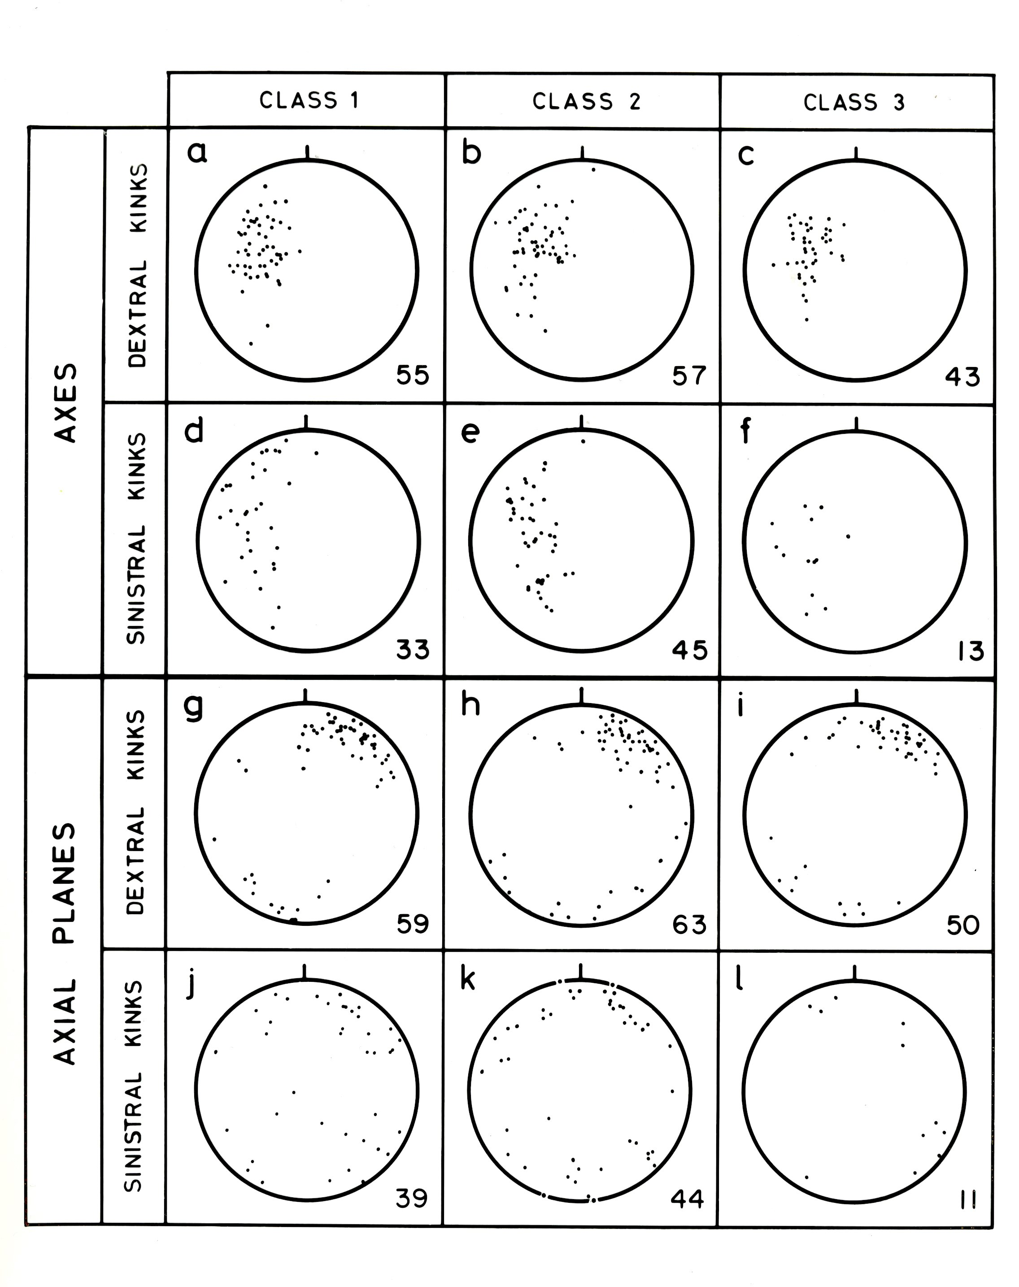Figure 8: Kink band attitude data based on a size analysis of kink band widths. Class 1 involves kink band widths 50 cm-1 metre. Class 2 involves kink band widths 10 cm to 50 cm. Class 3 involves kink band widths >10 cm. This incolves a comparison between large kink bands, intermediate scale kink bands and small scale kink bands.

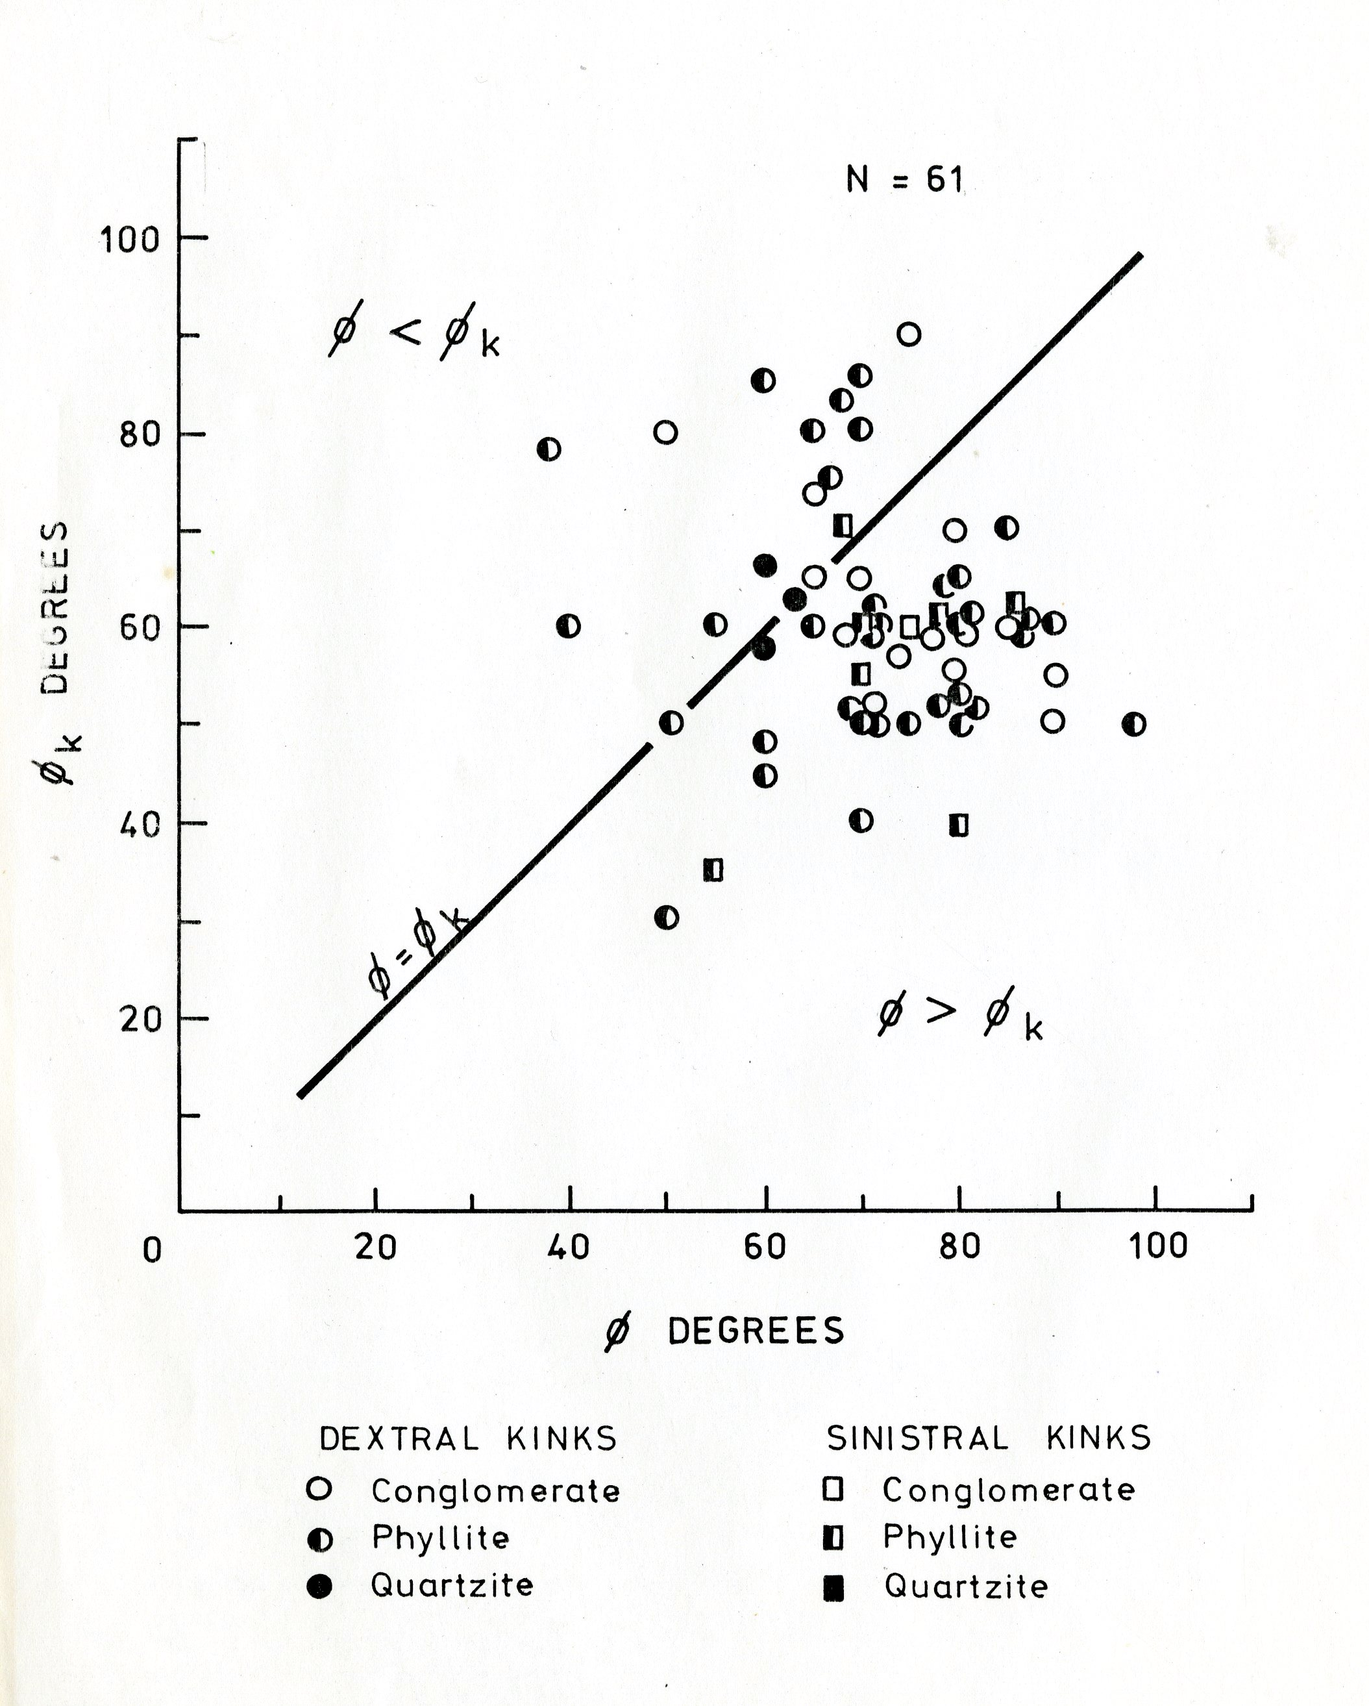

Figure 9: Plot of the internal and external angular relationships between the foliation and the kink band boundary plotted for the different lithologies involved in the kinking..
Ø: angle between the foiliation and the kink band boundary external to the kink. Ø_{k}: angle between the kink band boundary and the foliation within the kink band.

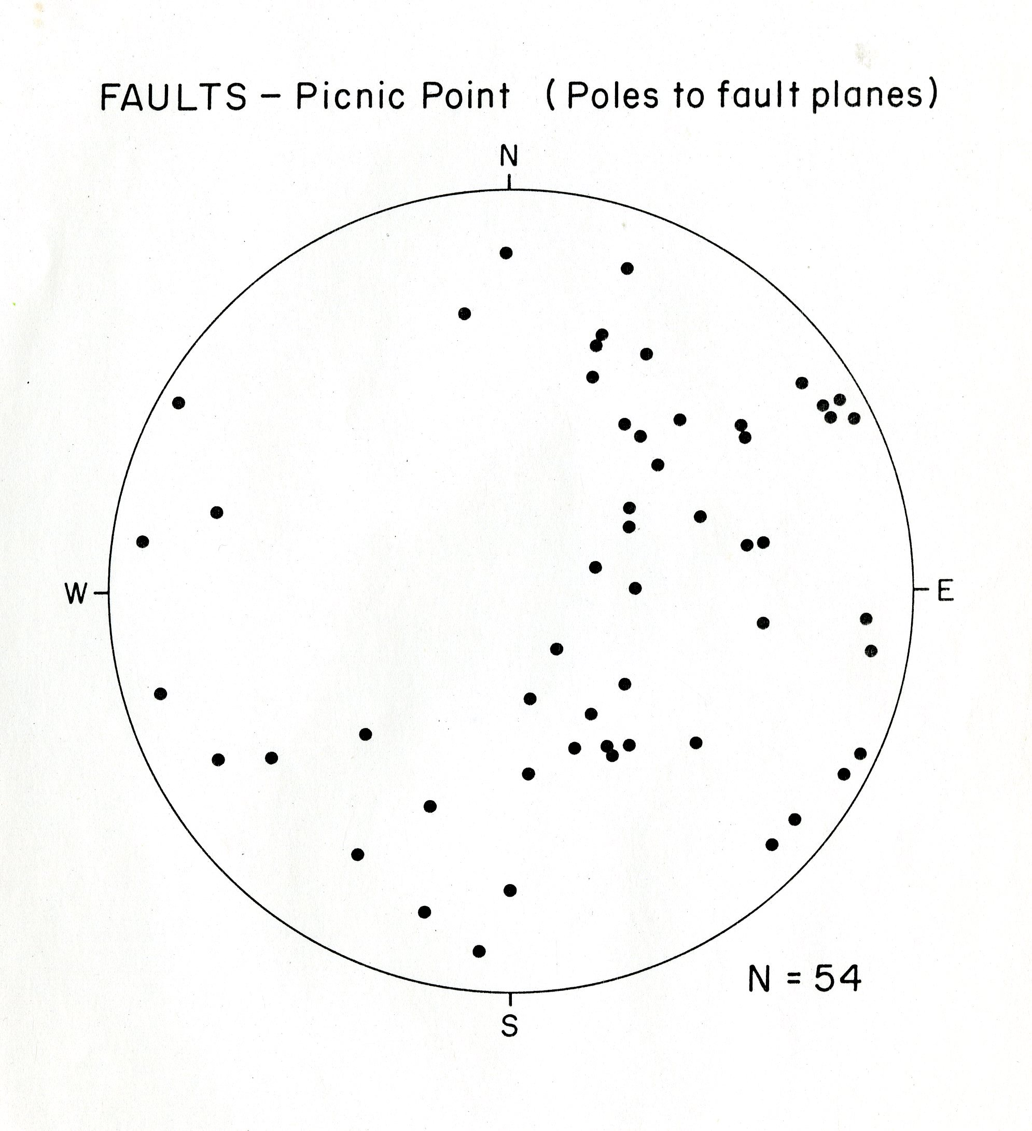Figure 10: Stereonet of poles to faults measured wiuthin the Picnic Point detailed map area. Most of the kink band boundaries are transitional into brittle oblique slip thrust faults southwards along their strike lengfths.

