MINERAL RESOURCES TASMANIA

Laboratory Report
LJN2021-007

PETROPHYSICAL TESTS,
CETHANA

An unpublished Mineral Resources Report for:

Mark Duffett, MRT

By: R.Bottrill, L.Unwin and
R. King

Date: 25 February 2021


Mineral Resources Tasmania
Department of State Growth

Introduction
Eight rock samples were collected from Cethana Diamond Drill Cores by M Duffett, for physical property measurements; with details listed in Table 1 below.
Table 1: Sample details
Reg. # | DDH | Depth (m) | Sample Description
L301901 | 89116 CE_BH03 | 481.5 | granite
L301902 | 89116 CE_BH03 | 517.1 | granite
L301903 | 89116 CE_BH03 | 548.9 | granite
L301904 | 89116 CE_BH03 | 580 | granite
L301905 | 89116 CE_BH03 | 610.45 | granite
L301906 | 89116 CE_BH03 | 637.6 | microgranite
L301907 | 89116 CE_BH03 | 638.1 | microgranite
L301908 | 89116 CE_BH03 | 640.4 | microgranite

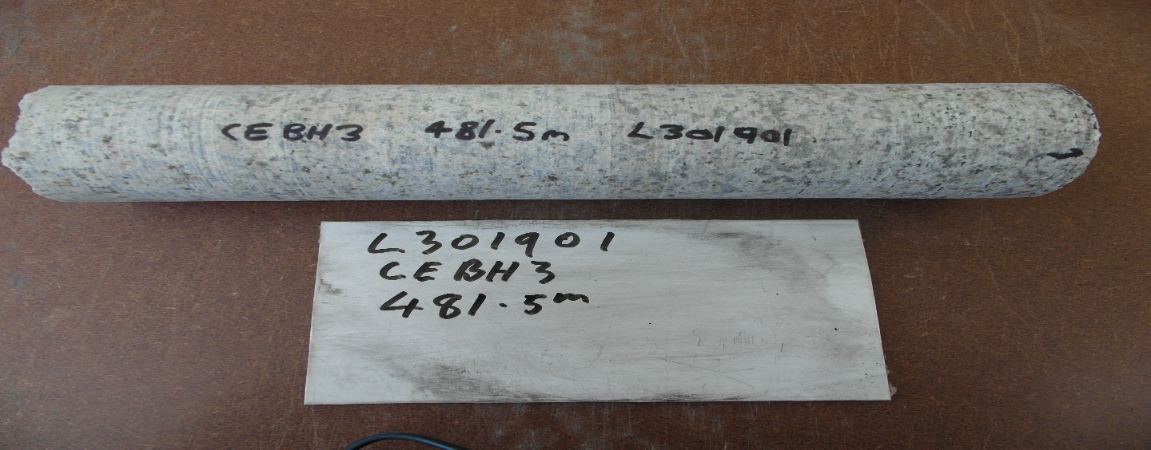

Photo 1: Sample L301901- Granite. FOV: about 200 mm
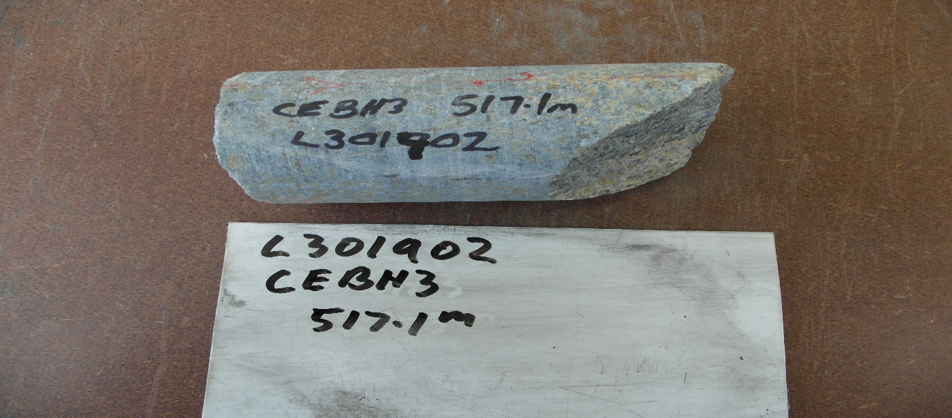
Photo 2: Sample L301902 - Granite. FOV: about 300 mm
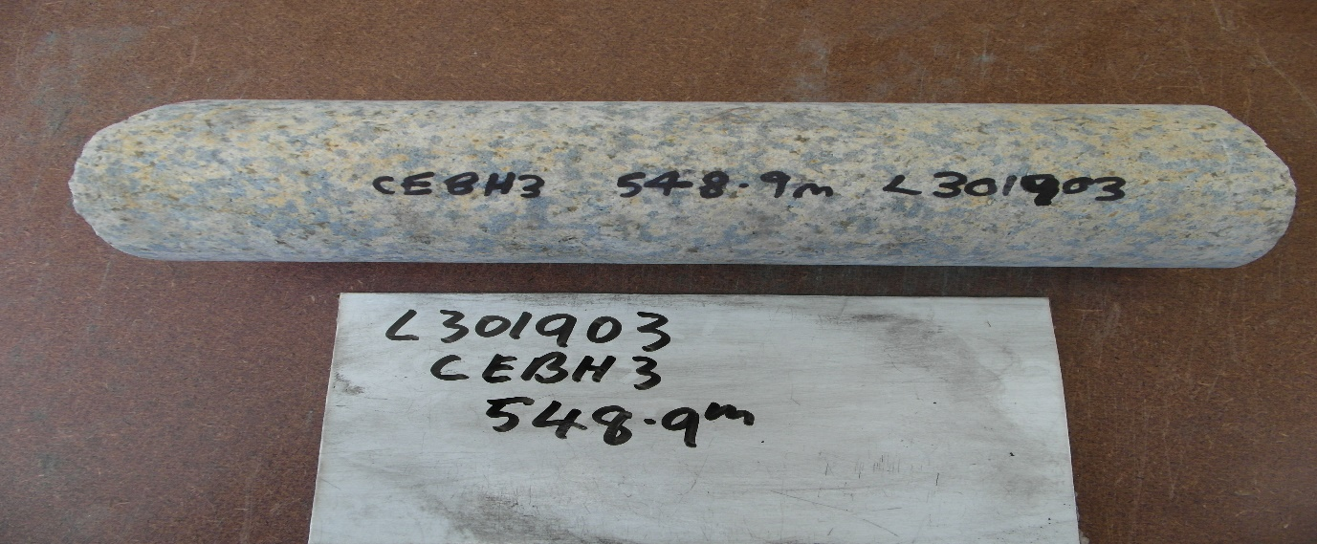
Photo 3: Sample L301903 – Granite. FOV: about 200 mm
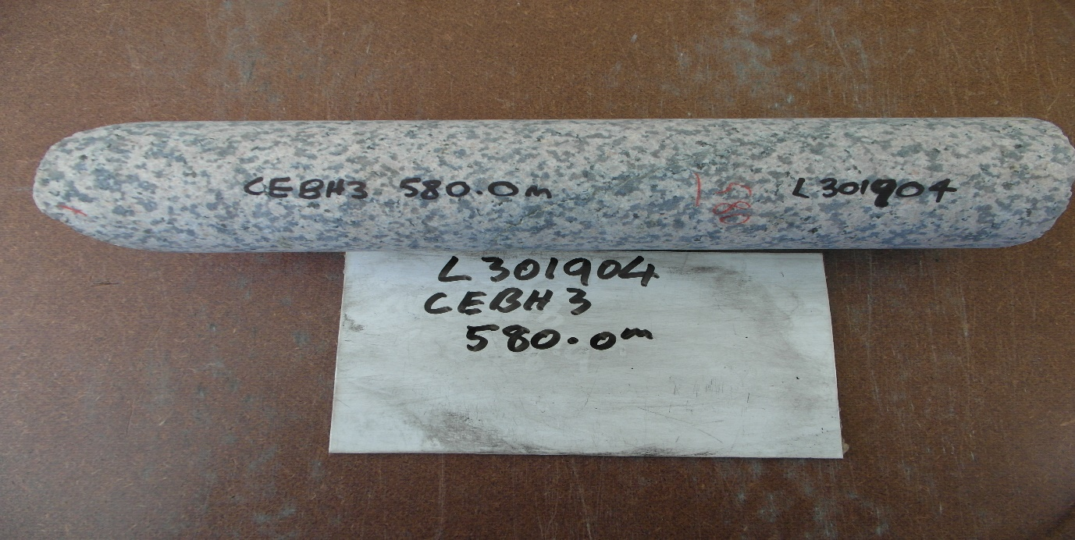
Photo 4: Sample L301904 – Granite. FOV: about 200 mm
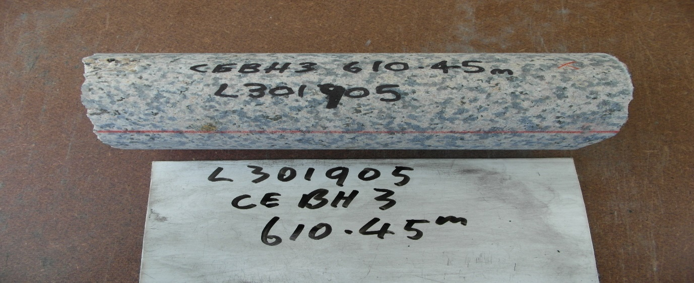
Photo 5: Sample L301905 - Granite. FOV: about 200 mm
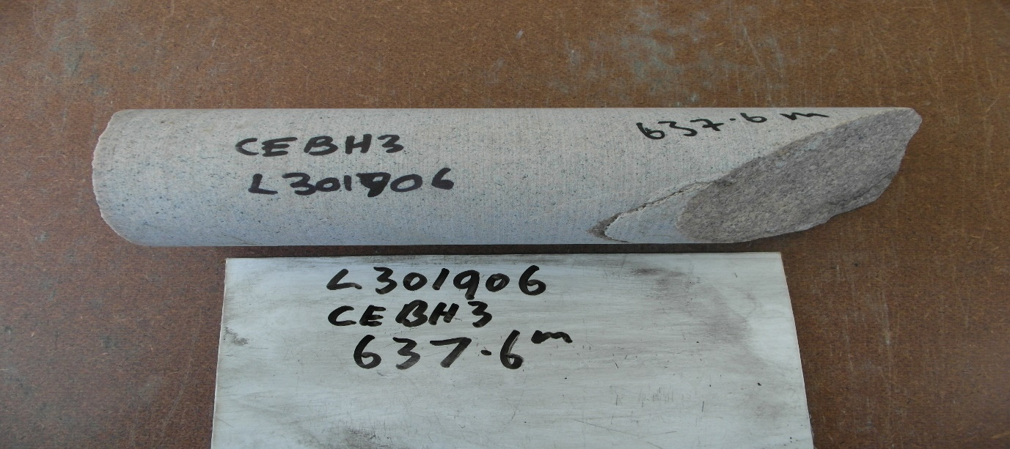
Photo 6: Sample L301906 - Microgranite. FOV: about 300 mm
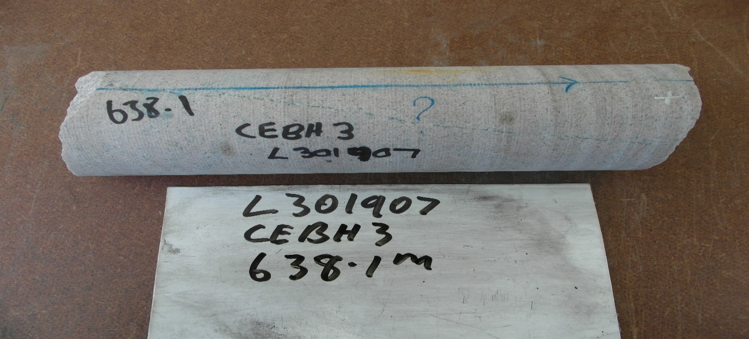
Photo 7: Sample L301907 - Microgranite. FOV: about 250 mm
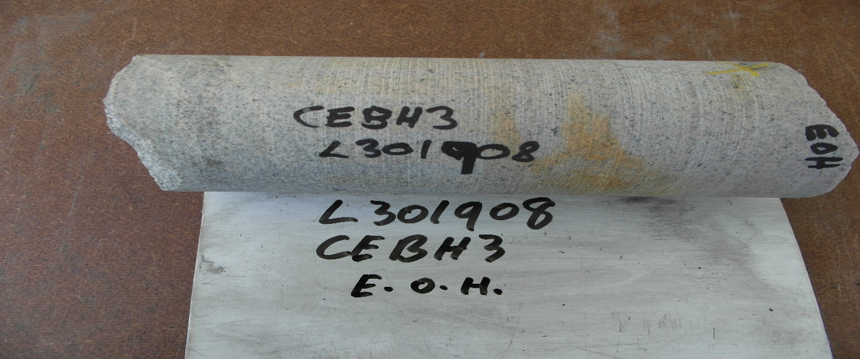
Photo 8: Sample L301908 – Microgranite. FOV: about 400 mm

Laboratory Tests

The samples were soaked for a minimum of 48 hours and weighed in water, and then wet in air. Samples were dried in a 90°C oven for a minimum of 12 hours then weighed dry. The wet porosity and density (specific gravity) was determined by standard gravimetric methods in the Mineral Resources Tasmania (MRT) Core Library, with an electronic balance accurate to 0.1g. The relative accuracy of the results is ~1% for specific gravity and ~5% for wet porosity. The summary of results is shown in Table 2 and full details listed in Appendix 1.
Table 2: Summary of Specific Gravity and Wet porosity
Reg. # | DDH | Depth (m) | Rocktype | Dry bulk SG | Wet bulk SG | Wet Porosity (%)
L301901 | 89116 CE_BH03 | 481.5 | granite | 2.63 | 2.63 | 0.81
L301902 | 89116 CE_BH03 | 517.1 | granite | 2.67 | 2.69 | 1.40
L301903 | 89116 CE_BH03 | 548.9 | granite | 2.62 | 2.63 | 0.73
L301904 | 89116 CE_BH03 | 580 | granite | 2.61 | 2.62 | 0.53
L301905 | 89116 CE_BH03 | 610.45 | granite | 2.61 | 2.61 | 0.61
L301906 | 89116 CE_BH03 | 637.6 | microgranite | 2.60 | 2.61 | 0.42
L301907 | 89116 CE_BH03 | 638.1 | microgranite | 2.60 | 2.61 | 0.38
L301908 | 89116 CE_BH03 | 640.4 | microgranite | 2.64 | 2.65 | 0.70

R.S. Bottrill R King and L Unwin

Mineralogist/Petrologist TECHNICAL OFFICERs

Disclaimers:
While every care has been taken in the preparation of this report, no warranty is given as to the correctness of the information and no liability is accepted for any statement or opinion or for any error or omission. No reader should act or fail to act on the basis of any material contained herein. Readers should consult professional advisers. As a result the Crown in Right of the State of Tasmania and its employees, contractors and agents expressly disclaim all and any liability (including all liability from or attributable to any negligent or wrongful act or omission) to any persons whatsoever in respect of anything done or omitted to be done by any such person in reliance whether in whole or in part upon any of the material in this report. The MRT laboratories are not NATA registered but work to similar standards. This and other data collected in MRT laboratories may enter the MRT databases but every attempt will be made to ensure it remains closed file and not be available externally, unless at your request.

Appendix 1: Laboratory Report – Physical Property analyses
Client: M Duffett
Analysis: Physical Properties
Method: Gravimetric S.G. & Porosity
Location: Cethana
Job No.: LJN2021-007
Date: 25/02/2021

Results
Sample ID | Dry Weight in Air (g) | Sub-sat Wt in water (g) | Sat. Wt. in Air (g) | Dry bulk SG | Wet bulk SG | Wet porosity (%)
L301901 | 2079.6 | 1294.3 | 2086.0 | 2.63 | 2.63 | 0.81
L301902 | 802.8 | 506.8 | 807.0 | 2.67 | 2.69 | 1.40
L301903 | 1610.0 | 999.7 | 1614.5 | 2.62 | 2.63 | 0.73
L301904 | 1973.0 | 1221.3 | 1977.0 | 2.61 | 2.62 | 0.53
L301905 | 1233.3 | 763.0 | 1236.2 | 2.61 | 2.61 | 0.61
L301906 | 1356.3 | 837.3 | 1358.5 | 2.60 | 2.61 | 0.42
L301907 | 1527.2 | 943.0 | 1529.4 | 2.60 | 2.61 | 0.38
L301908 | 1199.7 | 748.2 | 1202.9 | 2.64 | 2.65 | 0.70

Analyst: R. King
Date: 25/02/2021

