MINERAL RESOURCES TASMANIA
Laboratory Report
LJN2021-013

XRD and geochemical ANALYSES

Cleveland mine, Luina

An unpublished Mineral Resources Report for:

Mirella Terrones, MRT

By: R S Bottrill, M Terrones, L Unwin, J Traynor & E. Lounejeva
Date: 22 April 2021


Mineral Resources Tasmania
Department of State Growth

Summary

Summary
The samples of drillcore from the Cleveland mine were examined by XRD and optical petrography and are all rich in plagioclase (albite?), amphiboles and chlorite, with lesser quartz, biotite, ilmenite, magnetite, tourmaline and other minerals. The amphiboles appear to be mostly calcic species, generally matching actinolite well, but some more sodic amphiboles such as riebeckite/magnesio-riebeckite and hastingsite are also possible, but unconfirmed. Petrography suggests an intermediate Na-Ca amphibole like barroisite or winchite is possible in G408289, so is possible in others also.

Introduction
The Hylogger IR spectroscopic analyses of drill core, conducted by various Geological Surveys in Australia, routinely returns analyses indicating various minerals that often cannot be readily confirmed in the hand specimens, and require XRD (X-ray diffraction) or other methods for confirmation.

The objective of this study was to confirm the mineralogy of 5 samples of Hylogged drill core from various Cleveland mine drillholes especially to confirm the amphibole mineralogy. The sample details and summarised Hylogger mineralogy results (from Mirella Terrones) are given in Table 1, and Hylogger photos presented below.

Table 1: Sample details
Reg. # | Field No. | Location | Sample Description | Hylogger Mineralogy | Process
G408282 | 82800_C2115/# 21636, 72.8m | Cleveland mine | black vein | Chl, rbk, alb, act?, qtz, | XRD & XRF
G408283 | 82800_C2115/# 21473, 73.4m | Cleveland mine |  | Chl, rbk, hbd, olig?, qtz | XRD & XRF
G408287 | 82797_C2112/# 4064, 20.28m | Cleveland mine | black minerals, OXs microveins | Chl, rbk, tourm?, alb, | XRD & XRF
G408285 | 82794_C2109/ #3056, 21.15m | Cleveland mine | black veins | Chl, rbk, cbs?, alb, | XRD & XRF
G408289 | 82794_C2109/ #3056, 21.15m | Cleveland mine | black veins | Chl, rbk, cbs?, alb, | TS

Methodology
The samples (except G408289) were split into representative subsamples and analysed for mineralogy by XRD (X-Ray Diffraction) and major element geochemistry by XRF (X-ray fluorescence) in the Mineral Resources Tasmania (MRT) laboratories, Rosny, and reported here.
One sample G408289 (equivalent to G408285) was prepared as a thin section and studied under polarised light microscopy to help determine the mineralogy. The other three samples were examined petrographically by studying their crushed powders in oil under polarised light microscopy.

Description & Petrographic examination
In hand specimen, the samples all appear to be fine grained mafic rocks, some with irregular black veining to ~2 mm wide (Fig. 1).
In thin section (Figs 2 & 3) G408289 (=G408285) is a fine grained dolerite or basalt dolerite or basalt with ~60% plagioclase (~0.5 mm) plus few coarser plagioclase crystals to about 1mm. There are abundant (~20%) uralitised pyroxenes, altered to green to bluish amphiboles, resembling sodic-calcic varieties, e.g. winchite or barroisite. There is about 10% biotite, partly altered to chlorite and muscovite, and a few % magnetite and other opaques. The rock is cut by fine grained veins, to a few mm thick, composed of fine grained, brownish green biotite and chlorite, and some very late stage limonite (Figs 2 & 3).
Samples G408282, G408283 and G408287 were examined petrographically in oil immersion and contain abundant prismatic grains of green amphiboles and various other minerals but no blue amphiboles resembling riebeckite or magnesio-riebeckite were observed (Figs 4 – 6).
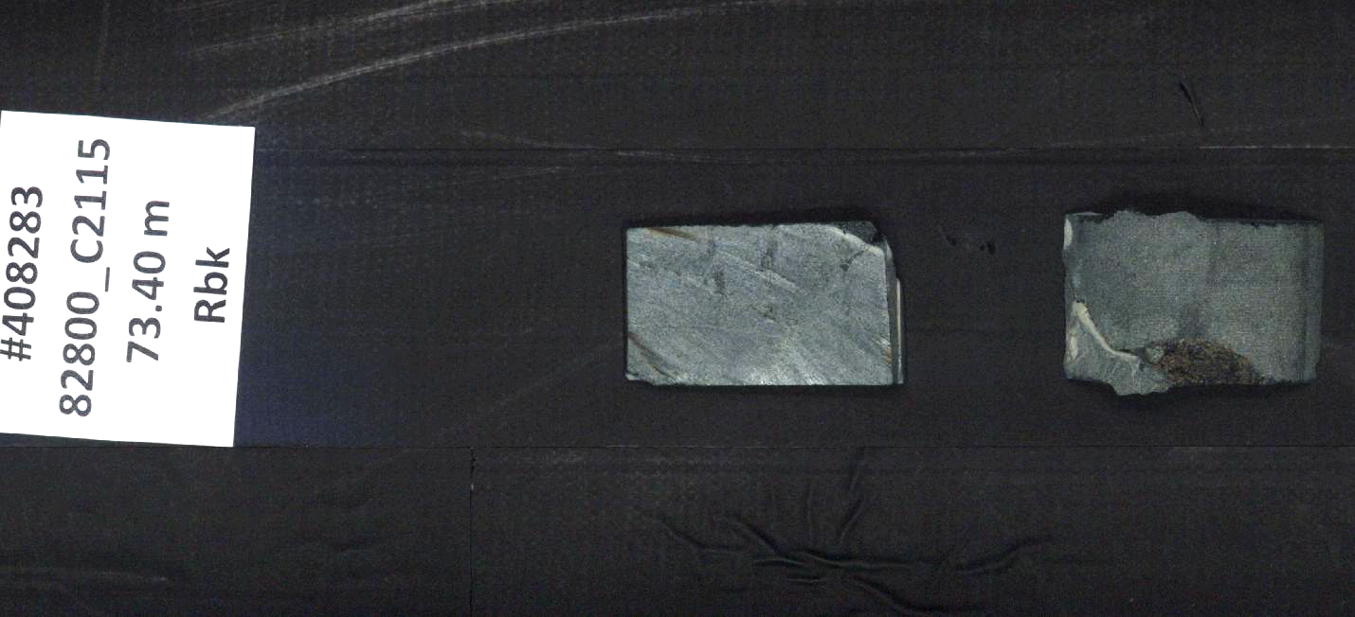
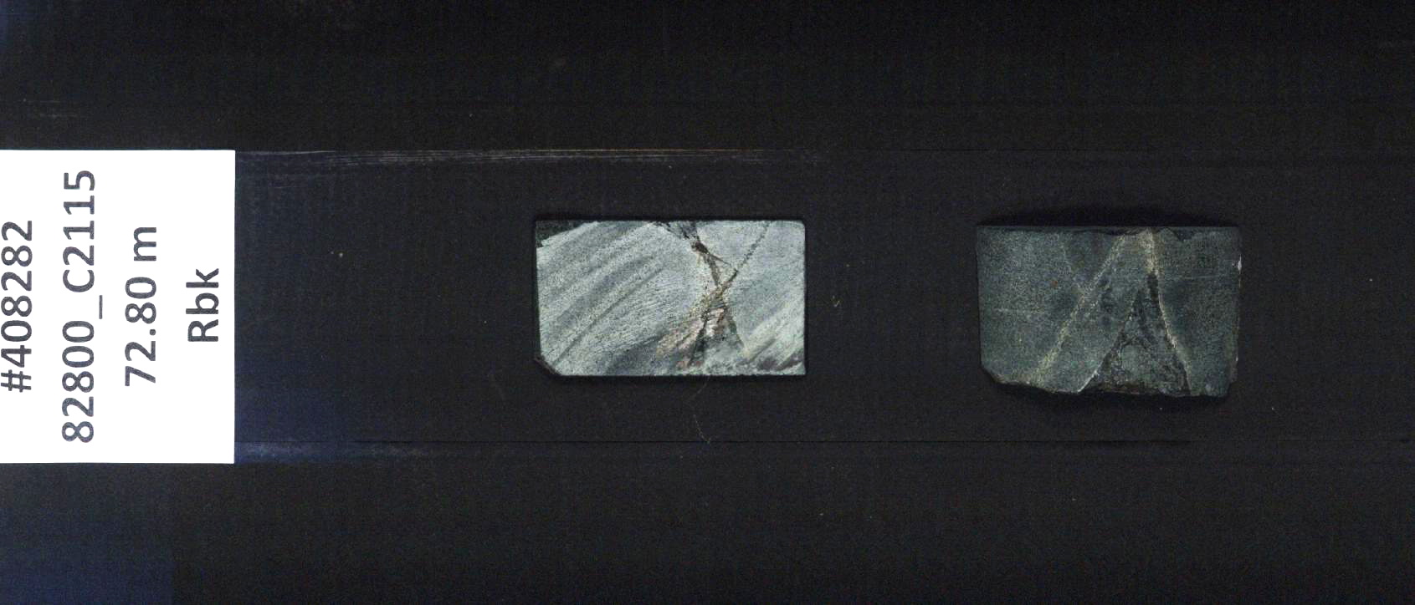
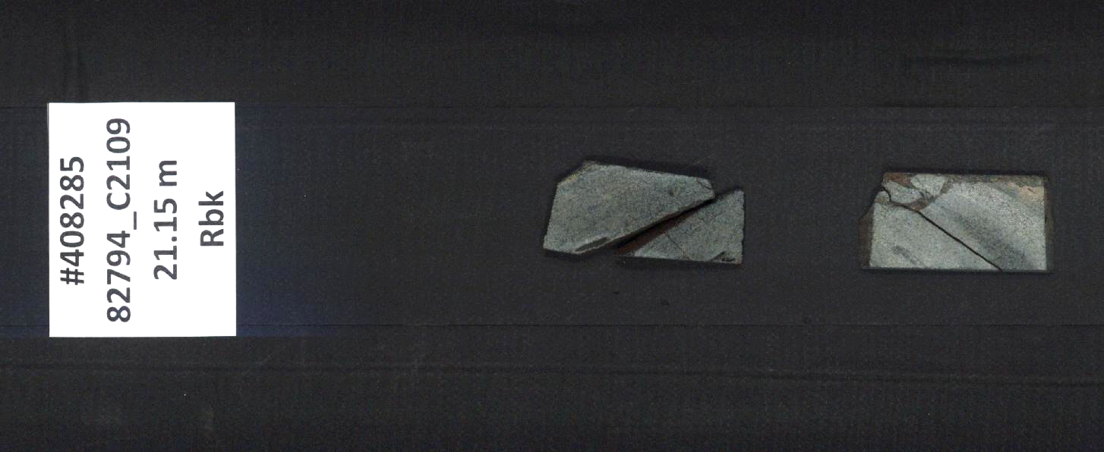
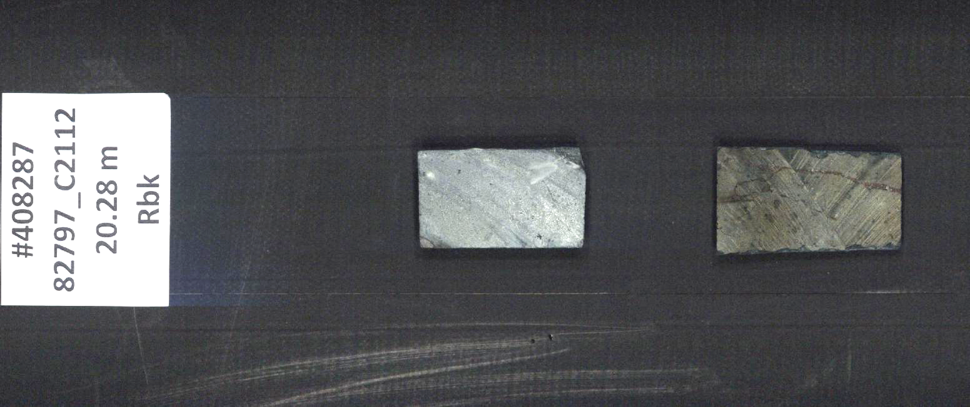
Fig. 1. Cut core samples, G408282 - 289, as Hylogged; each about 2 x4cm.

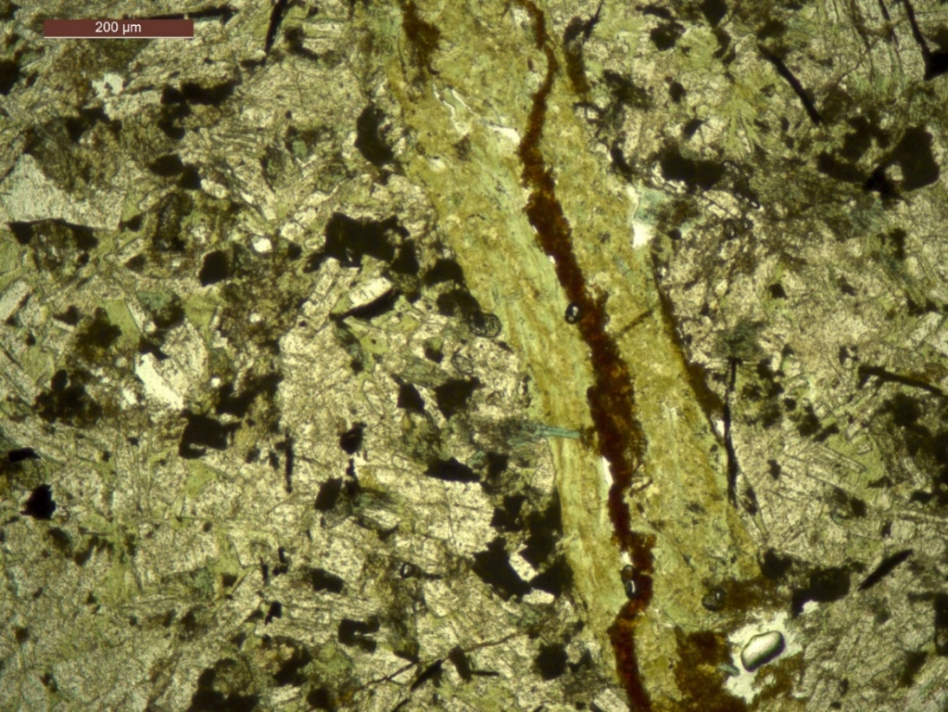
Figure 2. Sample G408289, showing a matrix of blocky white plagioclase, blue-green amphiboles and black opaques, cut by brownish green biotite-chlorite veins and brown limonite. Plane polarised transmitted light (XPTL).
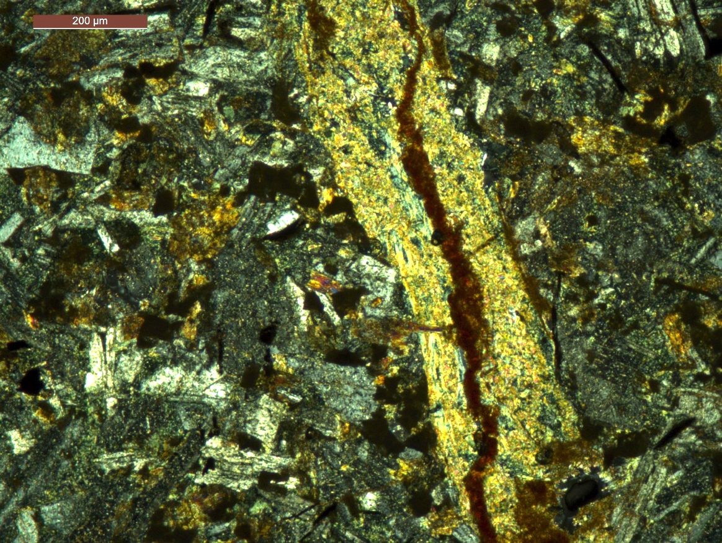
Figure 3. Sample G408289, showing a matrix of blocky plagioclase, amphiboles and black opaques, cut by biotite-chlorite veins plus limonite. Cross polarised transmitted light (XPTL).

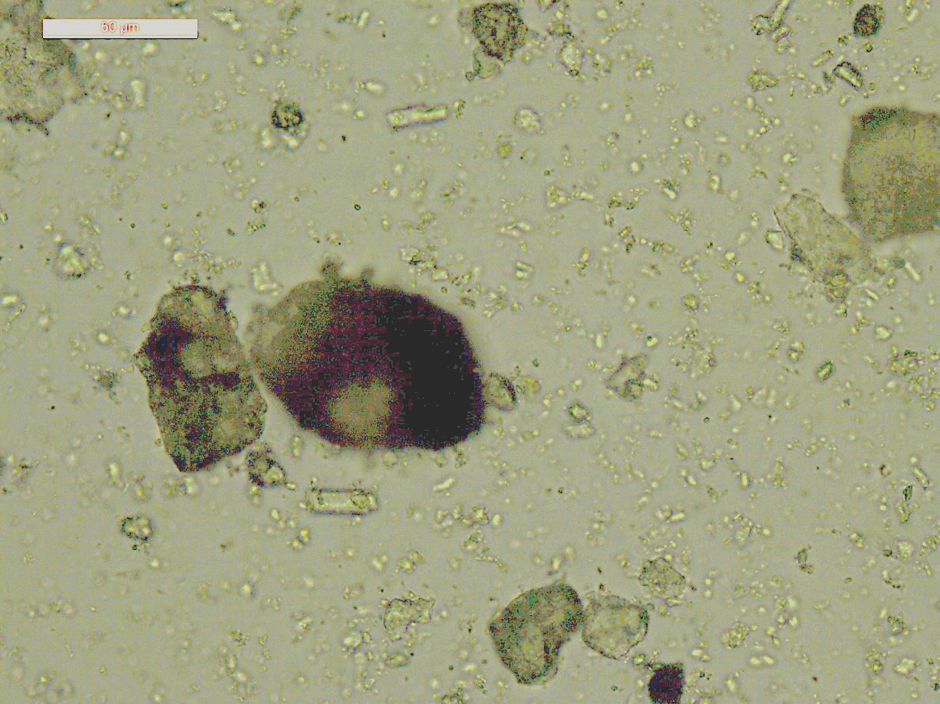
Figure 4. Sample G408282, showing a grain mount in oil, including green amphiboles and other minerals. PPTL. Scale bar is 50 microns.

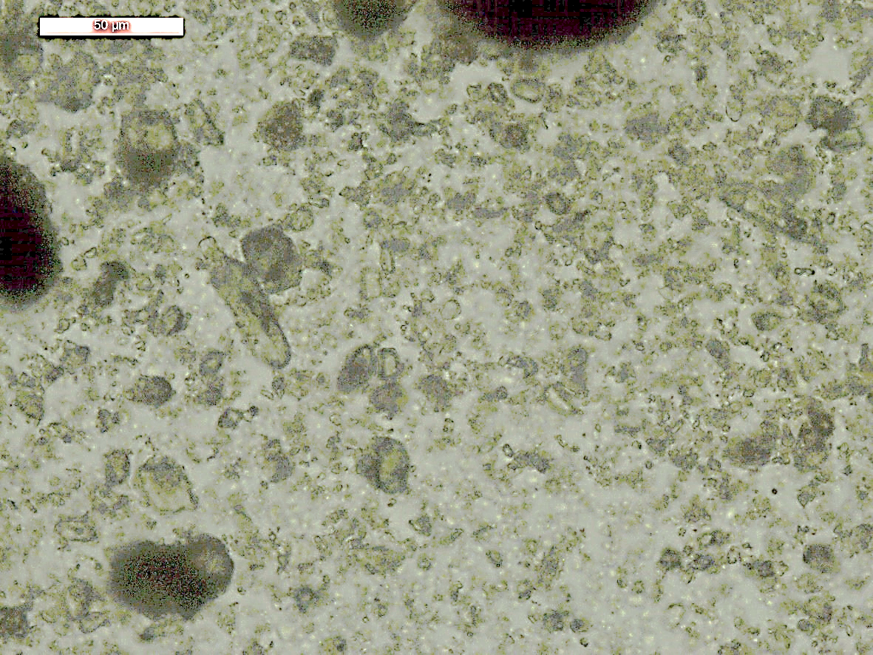
Figure 5. Sample G408282, showing a grain mount in oil, including green amphiboles and other minerals. PPTL. Scale bar is 50 microns.

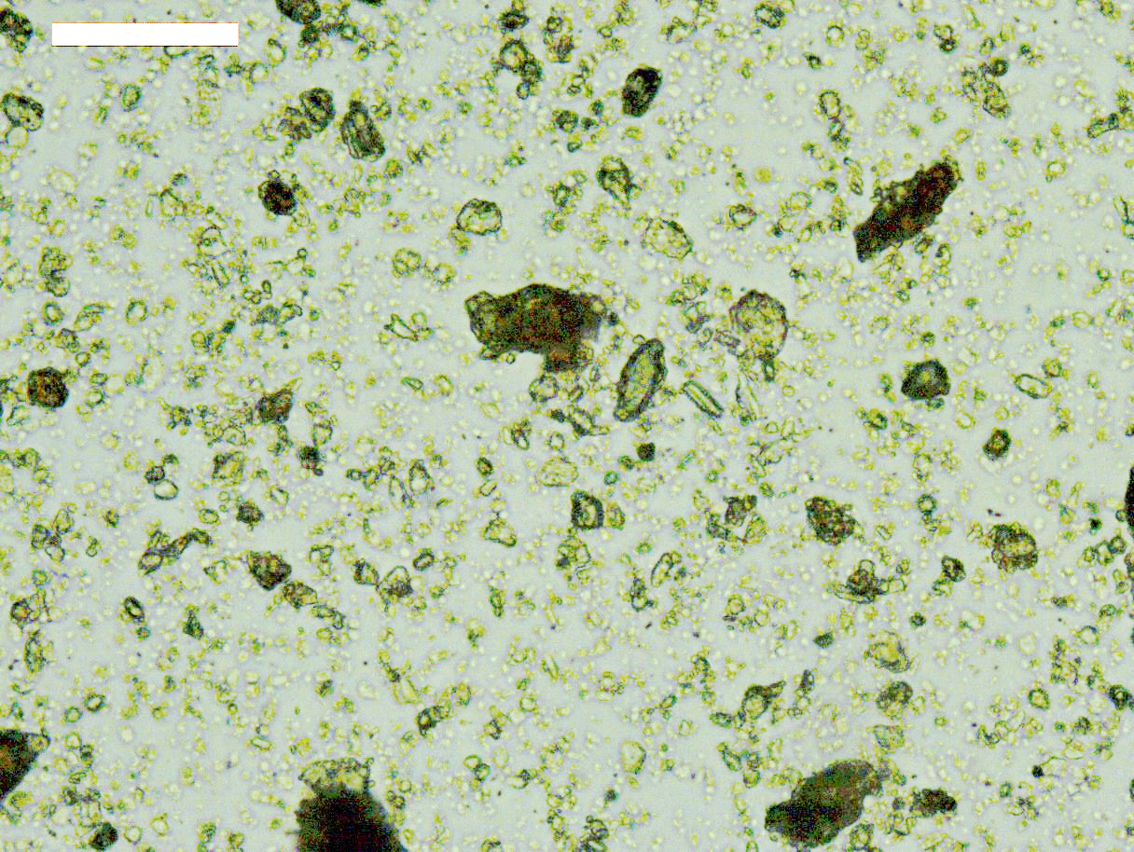
Figure 6. Sample G408287, showing a grain mount in oil, including green amphiboles and other minerals. PPTL. Scale bar is 50 microns.

XRF
The samples were analysed for trace elements on a pressed pellet, in a Bruker S8 Tiger XRF, with proprietary Bruker software and a series of commercial standards. The results are shown in Appendix 2.

NDIR
The carbon and sulphur contents of the sample was determined by Non-dispersive infrared (NDIR) analysis using a Bruker G4 Icarus analyser, in the MRT laboratories, Rosny Park.
The results have been included in Table 3.

XRD analyses
The samples were prepared, examined, and analysed in the MRT laboratories, Rosny Park, Tasmania. They were run on a Rigaku Miniflex 600 X-Ray Diffractometer system: a 600W generator 150mm goniometer with a Cu tube; 40kV/15mA, sample spinner and a Scintillation counter (SC) with Be window, 3º to 63º 2Theta-2Theta scanning range, with a scanning speed of 0.5°/min, a graphite counter monochromator and a Kß Ni- filter. The analysis software used is the PDXL2 using the ICCD database.
Quantification is largely manual, using a series of prepared standards of the more common minerals to enable some semi-quantitative analysis. Quartz, if present, is used as an internal standard; and if not present, it is often added to the sample for a supplementary scan. Our semi-quantitative results are calculated using single-peak calibration factors derived from scans of known mixtures of minerals.
The results are shown in Appendix 1 and summarised in Table 2; they indicate all these samples are rich in plagioclase (albite?), amphiboles and chlorite, with lesser quartz, biotite (siderophyllite?), ilmenite, magnetite, tourmaline (dravite?), calcite and other minerals.
The amphiboles appear to be mostly calcic species, matching actinolite well, but generally appear to contain some more sodic amphiboles also: magnesio-riebeckite and hastingsite are possible, but unconfirmed. Petrography suggests an intermediate Na-Ca amphibole like barroisite or winchite is more likely in G408289, so is possible in other samples also.

Table 2: XRD/MinSQ Results Summary (wt%)
Sample No. | G408282 | G408283 | G408287 | G408289/285
Quartz | 23.4 | 13.5 | 2.6 | 2.3
Plagioclase (albite?) | 25.0 | 30.8 | 27.8 | 39.0
Actinolite | 8.0 | 10.0 | 12.0 | 18.0
Magnesio-riebeckite? | 5.0 | 9.0 | 12.0 | 9.0
Hastingsite? |  |  | 20.0
Chlorite Mg-Fe | 15.0 | 14.0 | 6.0 | 9.5
Biotite - | 5.0 | 4.0 |  | 3.5
ilmenite | 5.0 | 4.5 | 3.7 | 8.0
Apatite | 0.6 | 0.7 | 0.5 | 2.0
Magnetite | 8.2 | 7.4 |  | 2.3
K feldspar | 0.0 | 1.0 | 2.0
Muscovite | 2.0 |  |  | 4.5
Calcite |  | 5.6
Tourmaline (dravite?) |  |  | 13.0

Discussion and Conclusions
The results are summarised in Table 4, along with the Hylogger interpretations, which are nearly all confirmed, except for carbonates in G408289. The XRD identified some minor minerals not recorded by the Hylogger, though some like magnetite and ilmenite are always very hard to detect spectrally. The amphiboles cannot be confirmed without chemical analysis; riebeckite/magnesio-riebeckite is possible from the XRD analyses, but could not be confirmed optically, and is rather unlikely in these mineral assemblages. An intermediate Na-Ca amphibole is more likely, and probably present in G408289.

Table 3: Comparison of Hylogger and XRD Results;
Discrepancies highlighted
Reg. No. | Field No. | XRD Mineralogy (>5%) | Hylogger Mineralogy
G408282 | 82800_C2115/# 21636, 72.8m | Actinolite*/Magnesio-riebeckite*  Quartz  Chamosite, magnesian  Albite  Orthoclase  Biotite | Chlorite,  Riebeckite,  Albite,  Actinolite?,  Quartz,
G408283 | 82800_C2115/# 21473, 73.4m | Actinolite*/Magnesio-riebeckite*  Chamosite, magnesian  Quartz, Albite  Magnetite,  Calcite | Chlorite,  Riebeckite,  Hornblende,  Oligoclase?,  Quartz
G408289 | 82794_C2109/ #3056, 21.15m | Actinolite*/Hastingsite/Magnesio-riebeckite  Chamosite - magnesian *  Albite  Ilmenite | Chlorite,  Riebeckite,  carbonates,  Albite,
G408287 | 82797_C2112/# 4064, 20.28m | Actinolite*/Magnesio-riebeckite*  Clinochlore  Albite  Dravite | Chlorite,  Riebeckite,  Tourmaline?,  Albite,

R.S. Bottrill L. Unwin

Mineralogist/Petrologist TECHNICAL OFFICER

Disclaimers:
While every care has been taken in the preparation of this report, no warranty is given as to the correctness of the information and no liability is accepted for any statement or opinion or for any error or omission. No reader should act or fail to act on the basis of any material contained herein. Readers should consult professional advisers. As a result the Crown in Right of the State of Tasmania and its employees, contractors and agents expressly disclaim all and any liability (including all liability from or attributable to any negligent or wrongful act or omission) to any persons whatsoever in respect of anything done or omitted to be done by any such person in reliance whether in whole or in part upon any of the material in this report. The MRT laboratories are not NATA registered but work to similar standards. This and other data collected in MRT laboratories may enter the MRT databases but every attempt will be made to ensure it remains closed file and not be available externally, unless at your request.
Appendix 1: MRT Laboratory Report

Lab Job No.: LJN2021-013
Submitted by: R Bottrill
Analysis type: XRD
Date completed: 12/03/2021
Analyst: L Unwin
MRT Laboratory Manager: Ralph Bottrill

XRD Results-G408282-LJN2021-013-MT-QA1-12/03/2021

General Information

Measurement date: | 12/3/2021 | Interpretative date: | 12/3/2021
Job Number/Client: | LJN2021-013 MT | XRD | Rigaku Miniflex 600
Registration Number: | G408282 | Analyst: | LUnwin
Quantitative Method: | Mineralogy Only | Process Medium: | Wholerock
Sample Holder: | Standard | Speed (deg/min): | 0.5
Comment: | Shifted -0.03

Analysis Results

Phase name | Formula
Actinolite* | Ca₂(Mg,Fe)(Si₈O₂₂)(OH)₂
Magnesio-riebeckite* | Na₂Mg₃Fe³⁺₂ (Si₈O₂₂)(OH)₂
Quartz | SiO₂
Mg-Chamosite | (Fe,Mg,Al)₆(Si,Al)₄O₁₀(OH)₈
Albite | NaAlSi₃O₈
Orthoclase | K(AlSi₃O₈)
Biotite | K(Mg,Fe)₃[AlSi₃O₁₀](OH)₂

Notes
Peak overlap may interfere with identifications and quantitative calculations.
Amorphous minerals and minerals present in trace amounts may not be detected.

Magnesio-riebeckite* and Actinolite* identified solely on position of peaks after calibration using Quartz peak as such they are indicated only not definitive.

Phase Data Pattern

XRD Results-G408283-LJN2021-013-MT-QA1-12/03/2021

General Information

Measurement date: | 12/3/2021 | Interpretative date: | 12/3/2021
Job Number/Client: | LJN2021-013 MT | XRD | Rigaku Miniflex 600
Registration Number: | G408283 | Analyst: | LUnwin
Quantitative Method: | Mineralogy Only | Process Medium: | Wholerock
Sample Holder: | Standard | Speed (deg/min): | 0.5
Comment: | Shifted -0.015

Analysis Results

Phase name | Formula
Actinolite* | Ca₂(Mg,Fe)(Si₈O₂₂)(OH)₂
Magnesio-riebeckite* | Na_{1.56}Ca_{0.43}K_{0.03}Mg_{1.93}Fe²⁺_{1.4}7Fe³⁺_{1.27}Al_{0.26}Mn³⁺_{0.05}Ti_{0.03}(Si₈O₂₂)(OH)₂
Quartz | SiO₂
Mg-Chamosite | (Fe,Mg,Al)₆(Si,Al)₄O₁₀(OH)₈
Albite | NaAlSi₃O₈
Orthoclase | K(AlSi₃O₈)
Biotite | K(Mg,Fe)₃[AlSi₃O₁₀](OH)₂

Notes
Peak overlap may interfere with identifications and quantitative calculations.
Amorphous minerals and minerals present in trace amounts may not be detected.

Magnesio-riebeckite* and Actinolite* identified solely on position of peaks after calibration using Quartz peak as such they are indicated only not definitive.

Phase Data Pattern

XRD Results-G408287-LJN2021-013-MT-QA1-12/03/2021

General Information

Measurement date: | 12/3/2021 | Interpretative date: | 12/3/2021
Job Number/Client: | LJN2021-013 MT | XRD | Rigaku Miniflex 600
Registration Number: | G408287 | Analyst: | LUnwin
Quantitative Method: | Mineralogy Only | Process Medium: | Wholerock
Sample Holder: | Standard | Speed (deg/min): | 0.5
Comment: | Shifted -0.05

Analysis Results

Phase name | Formula
Mg-Chamosite | (Fe,Mg,Al)₆(Si,Al)₄O₁₀(OH)₈
Quartz | SiO₂
Hastingsite* | NaCa₂Fe²⁺₄Fe³⁺(Si₆Al₂O₂₂)(OH)
Magnesio-riebeckite* | Na_{1.56}Ca_{0.43}K_{0.03}Mg_{1.93}Fe²⁺_{1.4}7Fe³⁺_{1.27}Al_{0.26}Mn³⁺_{0.05}Ti_{0.03}(Si₈O₂₂)(OH)₂
Actinolite* | Ca₂(Mg,Fe)(Si₈O₂₂)(OH)₂
Dravite | NaMg₃Al₆(BO₃)₃Si₆O₁₈(OH)₄
Albite | NaAlSi₃O₈

Notes
Peak overlap may interfere with identifications and quantitative calculations.
Amorphous minerals and minerals present in trace amounts may not be detected.

Hastingsite*, Magnesio-riebeckite* and Actinolite* identified solely on position of peaks after calibration using Quartz peak as such they are indicated only not definitive.

Phase Data Pattern

XRD Results-G408289-LJN2021-013-MT-QA1-12/03/2021

General Information

Measurement date: | 12/3/2021 | Interpretative date: | 12/3/2021
Job Number/Client: | LJN2021-013 MT | XRD | Rigaku Miniflex 600
Registration Number: | G408289 | Analyst: | LUnwin
Quantitative Method: | Mineralogy Only | Process Medium: | Wholerock
Sample Holder: | Standard | Speed (deg/min): | 0.5
Comment: | Shifted -0.03 - This sample was originally labelled G408285

Analysis Results

Phase name | Formula
Actinolite* | Ca₂(Mg,Fe)(Si₈O₂₂)(OH)₂
Magnesio-riebeckite* | Na_{1.56}Ca_{0.43}K_{0.03}Mg_{1.93}Fe²⁺_{1.4}7Fe³⁺_{1.27}Al_{0.26}Mn³⁺_{0.05}Ti_{0.03}(Si₈O₂₂)(OH)₂
Quartz | SiO₂
Clinochlore | (Mg,Fe,Al)₆(Si,Al)₄O₁₀(OH,O)₈
Albite | NaAlSi₃O₈
Siderophyllite (Biotite) | KFe²⁺₂Al₃Si₂O₁₀F_{1.5}(OH)_{0.5}

Notes
Peak overlap may interfere with identifications and quantitative calculations.
Amorphous minerals and minerals present in trace amounts may not be detected.

Magnesio-riebeckite* and Actinolite* identified solely on position of peaks after calibration using Quartz peak as such they are indicated only not definitive.

Phase Data Pattern

Appendix 2: MRT XRF Laboratory Report

Client: Mirella Torrens
Sample Location: Cleveland
Job Number: LJN2021-013
Analyses: Geochemistry - Majors
Methods: XRF
Analyst: E. Lounejeva
Lab Manager: R Bottrill
Date: 22/3/2021
Notes: Sample G408289 was effectively the same section of rock as G408285, but the former used for TS, the latter for XRD and XRF...

Results (Wt.%)
Reg. No. | G408282 | G408283 | G408289 | G408287
SiO2 | 48.68 | 45.47 | 47.01 | 48.33
TiO2 | 2.52 | 2.34 | 4.02 | 1.82
Al2O3 | 12.67 | 12.93 | 12.96 | 14.65
Fe2O3TOT | 17.76 | 17.52 | 15.06 | 13.39
MnO | 0.81 | 0.63 | 0.4 | 0.29
MgO | 5.46 | 5.66 | 5.03 | 7.22
CaO | 6.27 | 9.38 | 6.03 | 5.63
Na2O | 0.38 | 1.46 | 3.88 | 4.15
K2O | 0.68 | 0.62 | 0.94 | 0.49
P2O5 | 0.28 | 0.26 | 0.77 | 0.18
LOI | 3.88 | 4.36 | 3.48 | 3.52
TOTAL | 99.4 | 100.62 | 99.59 | 99.67

