Mineral Resources Tasmania Mineralogical/Petrology Report

LJN2021-044

Mineralogy and geochemical ANALYSES, Hercules mine

An unpublished Mineral Resources Tasmania Report for:

University of Qeensland and Mineral Resources Tasmania
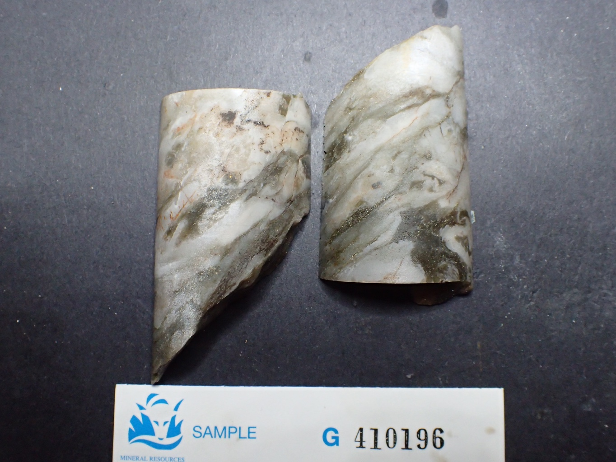
By: R S Bottrill

Date: 17/05/2021

By: R.S. Bottrill, L. Unwin
Date: 17 May 2021

Summary
The spotted rock, in H1127 has abundant carbonate spherules containing a mixture of dolomite (probably Mn rich) and kutnohorite, in a matrix of muscovite and chlorite.
The whispy foliated lenticular white/green rock, in H1034 is a quartz-sericite rock; the reason for the very low totals on the pXRF is unexplained.
A high content of Mn +/- Ca detected in other samples of these cores by portable XRF spectrometer suggests rhodochrosite and kutnohorite can be locally dominant in other parts of the cores not tested by XRD.

Introduction & Background
Two rock samples were collected from some Hercules mine drill cores by Laura Jackson (UQ) and Ralph Bottrill (MRT). They were submitted to MRT to help determine the mineralogy of the rocks. G410195 was of interest to determine the carbonate minerals, and G410195 was tested as the pXRF gave very low totals.

Samples
The details of the samples collected are given in Table 1 below.

Table 1: Sample details
MRT Lab Number | Field # | Location | Sample Description | Process
G410195 | H1127/50m | Hercules mine | Carbonate spotting | Xrd, pXRF
G410196 | H1034/35'2" | Hercules mine | Pink-white/green sericitic/cherty rock | Xrd, pXRF

Process
The samples were all prepared, examined by stereomicroscopy, tested by pXRF (portable X-ray Fluorescence spectrometry) for chemistry and were analysed by XRD (X-ray diffraction) for mineralogy. All preparation and testing was done in the Mineral Resources Tasmania (MRT) laboratories, Rosny Park and Mornington, Tasmania.

Sample Descriptions

G410195 H1127/50m Carbonate spotting
This rock is an unfoliated grey-green rock composed mostly of very pale grey carbonate spots about 5mm in diameter, in a dark green chloritic matrix. The oxidised surface shows some iron staining. There are some small carbonate-quartz-sulphide veins cross cutting it (Fig. 1).

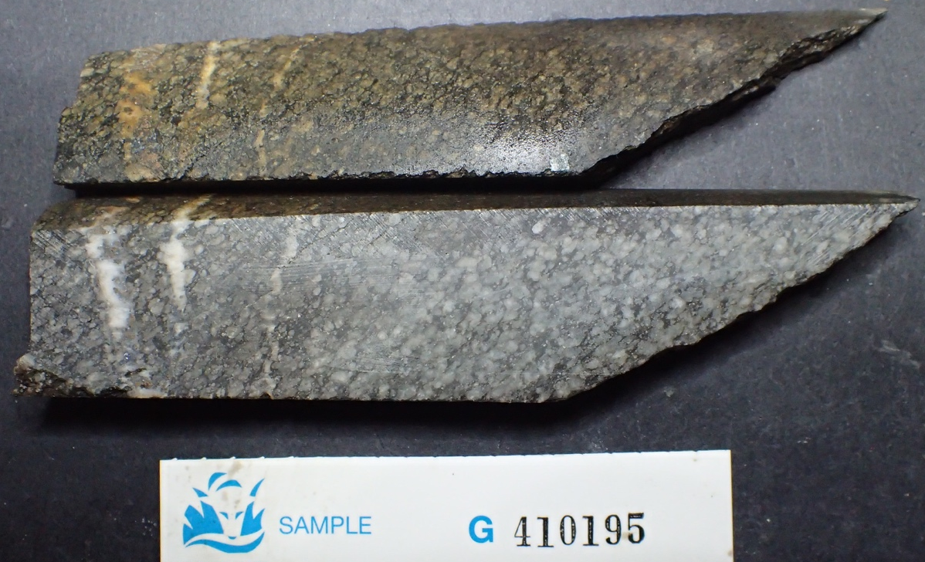
Figure 1. G410195. Spotted carbonate-rich rock. FOV (field of view) ~120mm.

G410196 H1034/35'2" Pink-white/green sericitic/cherty rock
This rock is a strongly foliated, mottled with white to pale pink lenticular clasts to about 20x60mm, in a grey-green sericitic matrix. The oxidised surface shows some weak iron staining (Fig. 1).

Figure 2. G410196. Sericite-chert rock. FOV (field of view) ~110mm.

XRD analyses

The samples were prepared, examined, and analysed in the MRT laboratories, Rosny Park, Tasmania. They were run on a Rigaku Miniflex 600 X-Ray Diffractometer system: a 600W generator 150mm goniometer with a Cu tube; 40kV/15mA, sample spinner and a Scintillation counter (SC) with Be window, a graphite counter monochromator and a Kß Ni- filter. Measurement setup: 3-63° Theta/2Theta range, with a scanning speed of 0.5° /min. The analysis software used is the PDXL2 using the ICCD database.
Quantification is largely manual, using a series of prepared standards of the more common minerals to enable some semi-quantitative analysis. Quartz, if present, is used as an internal standard; and if not present, it is often added to the sample for a supplementary scan. Our semi-quantitative results are calculated using single-peak calibration factors derived from scans of known mixtures of minerals.
The results are shown in Appendix 1 and summarised in Table 2. G410195 has carbonate spherules containing a mixture of dolomite (probably Mn rich) and kutnohorite, with a matrix of muscovite and chlorite and trace pyrite. G410196 is a quartz-sericite rock.

Table 2: XRD Summary
Sample No | G410195 | G410196
Description | Spotted carbonate rock | Sericite-Chert
Muscovite | 36(8) | 17(5)
Quartz |  | 80(10)
Chlorite* | 8(3)
Dolomite | 43(10)
Kutnohorite | 9(3)
Siderite |  | 3(2)
Pyrite | 4(2)

pXRF
The sample was analysed for major and trace elements using an Olympus Vanta M Series pXRF. The instrument uses a 4-Watt X-ray tube with application optimized anode material (rhodium Rh and tungsten W): 8-50 kV with a large area Silicon Drift Detector. The instrument uses the built-in Olympus Vanta analysis software version 3.12.34.
The results are shown in Table 3 and discussed below.

Table 3: pXRF Summary
Sample ID | DL | Hercules1 | Hercules2 | Hercules3 | Hercules4 | Hercules5 | Hercules6
Reg No |  |  |  |  |  | G410195 | G410195
Interpreted main carbonate |  | Rhc | Kut | Kut | Kut | Dol | Dol
SiO2 (%) | 9 | 43 | 25 | 12 | (1) | 18 | 23
TiO2 (%) | 0.2 | (0.2) | (0) | (0) | (0) | 0.7 | 1.1
Al2O3 (%) | 5 | 6 | (0) | (0) | (0) | 11 | 15
Fe2O3 (%) | 1.0 | 2.0 | (0.5) | 1.4 | 3.1 | 2.2 | 2.5
MnO (%) | 0.1 | 14.5 | 4.5 | 15.7 | 17.5 | 3.8 | 2.9
MgO (%) | 1.5 | (0) | (0) | (0) | 5.2 | 5.9 | 4.7
CaO (%) | 1.0 | (0.8) | 11.5 | 19.3 | 26.8 | 17.2 | 11.7
K2O (%) | 2.0 | 2.8 | (0) | (0) | (0) | 5.5 | 9.2
P2O5 (%) | 0.5 | (0) | (0) | (0) | (0) | (0.1) | (0.1)
S (%) | 1.0 | (0.4) | (0) | (0) | (0) | (0.5) | (0.6)

Sample ID | DL | Hercules7 | Hercules8 | Hercules9 | Hercules10 | Hercules11 | Hercules12
Reg No |  |  |  | G410196 | G410196 | G410196
Interpreted main carbonate |  |  | Rhc
SiO2 (%) | 9 | 72 | 11 | 19 | 24 | 24 | 61
TiO2 (%) | 0.2 | 0.2 | (0.1) | (0.2) | (0.1) | (0.1) | (0.1)
Al2O3 (%) | 5 | (4) | (2) | (0) | (2) | (1) | (1)
Fe2O3 (%) | 1.0 | (0.5) | 5.0 | (0.8) | 3.9 | (0.5) | (0.4)
MnO (%) | 0.1 | (0) | 24.4 | (0.1) | 0.3 | 0.1 | 0.1
MgO (%) | 1.5 | (0) | (0) | (0) | (0) | (0) | (0)
CaO (%) | 1.0 | (0) | 2.6 | (0.1) | (0) | (0.6) | (0.2)
K2O (%) | 2.0 | 2.9 | (1.7) | (1.3) | (1) | (2) | (2)
P2O5 (%) | 0.5 | (0) | (0) | (0) | (0) | (0) | (0)
S (%) | 1.0 | (0.7) | (0.7) | (0.1) | (0.1) | (0.1) | (0.1)

The pXRF strongly suggests a mixture of Ca-Mn-Mg carbonates in these rocks, including rhodochrosite, kutnohorite and dolomite.

Discussion and Summary
G410195 (spotted rock, H1127) has abundant carbonate spherules containing a mixture of dolomite (probably Mn rich) and subordinate kutnohorite, in a matrix of muscovite and chlorite with trace pyrite.
G410196 (lenticular white/green rock, H1034) is a quartz-sericite rock; the reason for the very low totals on the pXRF is unexplained.
PXRF suggests rhodochrosite and kutnohorite are locally dominant in parts of the core, but were not tested by XRD.

R S Bottrill L Unwin
Mineralogist/Petrologist Technical Officer

Disclaimers
While every care has been taken in the preparation of this report, no warranty is given as to the correctness of the information and no liability is accepted for any statement or opinion or for any error or omission. No reader should act or fail to act on the basis of any material contained herein. Readers should consult professional advisers. As a result the Crown in Right of the State of Tasmania and its employees, contractors and agents expressly disclaim all and any liability (including all liability from or attributable to any negligent or wrongful act or omission) to any persons whatsoever in respect of anything done or omitted to be done by any such person in reliance whether in whole or in part upon any of the material in this report.
This and other data collected in MRT laboratories may enter the MRT databases but every attempt will be made to ensure it remains closed file and not be available externally, unless at your request.
Appendix 1: MRT Laboratory Report

Client: MRT, UQ
Sample Location: Hercules
Job Number: LJN20201-044
Analyses: Approximate Mineralogy
Methods: XRD
Analyst: L Unwin
Lab Manager: R Bottrill
Date: 7/5/2021

XRD Results-G410195-LJN2021-044-Jackson-QA1-13/5/21

General Information

Measurement date: | 7/5/2021 | Interpretative date: | 13/5/2021
Job Number/Client: | LJN2021-44 Jackson | XRD | Rigaku Miniflex 600
Registration Number: | G410195 | Analyst: | LUnwin
Quantitative Method: | PDXL Relative Heights | Process Medium: | Wholerock
Sample Holder: | Standard | Speed (deg/min): | 0.5
Comment: | Shifted -0.07

Analysis Results

Phase name | Content wt% (± error) | Formula
Muscovite | 36(8) | KAl₂(AlSi₃O₁₀)(OH)₂
Dolomite | 43(10) | CaMg(CO₃)₂
Chlorite* | 8(3) | (Fe,Mg,Al)₆(Si,Al)₄O₁₀(OH)₈
Pyrite | 4(2) | FeS
Kutnohorite | 9(3) | Ca(Mn,Mg,Fe²⁺)(CO3)₂

Notes
Peak overlap may interfere with identifications and quantitative calculations.
Amorphous minerals and minerals present in trace amounts may not be detected.
Chlorite* probably Clinochlore

Phase Data Pattern

XRD Results-G410196-LJN2021-044-Jackson-QA1-13/5/21

General Information
Measurement date: | 7/5/2021 | Interpretative date: | 13/5/2021
Job Number/Client: | LJN2021-044 Jackson | XRD | Rigaku Miniflex 600
Registration Number: | G410196 | Analyst: | LUnwin
Quantitative Method: | PDXL Relative Heights | Process Medium: | Wholerock
Sample Holder: | Standard | Speed (deg/min): | 0.5

Comment:

Analysis Results
Phase name | Content wt% (± error) | Formula
Muscovite | 17(5) | KAl₂(AlSi₃O₁₀)(OH)₂
Quartz | 80(10) | SiO₂
Siderite | 3(2) | FeCO₃

Notes
Peak overlap may interfere with identifications and quantitative calculations.
Amorphous minerals and minerals present in trace amounts may not be detected.

Phase Data Pattern
Appendix 2: Abbreviations

Abbreviations | Mineral
Ab | Albite
Am- | Amphibole
Anh- | Anhydrite
Ank- | Ankerite
Bar | Baryte
Bt | Biotite
Cal | Calcite
Chl | Chlorite
Dol | Dolomite
Ep | Epidote
Gyp | Gypsum
Kut | Kutnohorite
Mont | Montmorillonite
Ms | Muscovite
Py | Pyrite
Q | Quartz
Rhc | Rhodochrosite

Appendix 1: MRT Laboratory Report

Client: MRT, UQ
Sample Location: Hercules
Job Number: LJN20201-044
Analyses: Approximate Chemistry
Methods: pXRF
Analyst: L Unwin
Lab Manager: R Bottrill
Date: 29/4/2021

Sample ID | DL | Hercules | Hercules | Hercules | Hercules | Hercules | Hercules
Date | - | 29/4/21 | 29/4/21 | 29/4/21 | 29/4/21 | 29/4/21 | 29/4/21
Time | - | 12:27:46 | 12:31:45 | 12:33:29 | 12:36:39 | 12:37:52 | 12:40:04
Method | - | Geochem(2) | Geochem(2) | Geochem(2) | Geochem(2) | Geochem(2) | Geochem(2)
Reg No./ID |  | Rhc | Kut | Kut | Kut | G410195 | G410195
SiO2 (%) | 9 | 43 | 25 | 12 | (1) | 18 | 23
TiO2 (%) | 0.2 | (0.2) | (0) | (0) | (0) | 0.7 | 1.1
Al2O3 (%) | 5 | 6 | (0) | (0) | (0) | 11 | 15
Fe2O3 (%) | 1.0 | 2.0 | (0.5) | 1.4 | 3.1 | 2.2 | 2.5
MnO (%) | 0.1 | 14.5 | 4.5 | 15.7 | 17.5 | 3.8 | 2.9
MgO (%) | 1.5 | (0) | (0) | (0) | 5.2 | 5.9 | 4.7
CaO (%) | 1.0 | (0.8) | 11.5 | 19.3 | 26.8 | 17.2 | 11.7
K2O (%) | 2.0 | 2.8 | (0) | (0) | (0) | 5.5 | 9.2
P2O5 (%) | 0.5 | (0) | (0) | (0) | (0) | (0.1) | (0.1)
S (%) | 1.0 | (0.4) | (0) | (0) | (0) | (0.5) | (0.6)
As (ppm) | 100 | (0) | (0) | (0) | (0) | (47) | (62)
Bi (ppm) | 200 | (0) | (0) | (0) | (0) | (0) | (0)
Cr (ppm) | 50 | (0) | (0) | (0) | (0) | (0) | 75
Cu (ppm) | 50 | (15) | (0) | (0) | (0) | (14) | (16)
Mo (ppm) | 100 | (0) | (0) | (0) | (0) | (0) | (15)
Nb (ppm) | 30 | (10) | (0) | (0) | (0) | (15) | (18)
Ni (ppm) | 30 | (0) | (0) | (0) | (0) | (0) | (0)
Pb (ppm) | 10 | (0) | (0) | (0) | (0) | (0) | (0)
Rb (ppm) | 10 | 77 | (0) | (0) | (0) | 214 | 333
Sb (ppm) | 100 | (0) | (0) | (0) | (0) | (0) | (0)
Sn (ppm) | 100 | (0) | (0) | (0) | (0) | (0) | (0)
Sr (ppm) | 10 | (9) | 40 | 126 | 131 | 138 | 103
Th (ppm) | 100 | (0) | (0) | (0) | (0) | (0) | (0)
U (ppm) | 50 | (0) | (0) | (0) | (0) | (0) | (0)
V (ppm) | 100 | (48) | (0) | (0) | (0) | 261 | 421
W (ppm) | 150 | (0) | (0) | (0) | (0) | (0) | (0)
Y (ppm) | 20 | (0) | (8) | 26 | 32 | 31 | 37
Zn (ppm) | 20 | 1290 | (6) | 20 | 26 | 267 | 69
Zr (ppm) | 50 | (29) | (0) | (0) | (0) | 226 | 326
Total |  | 68 | 41 | 48 | 53 | 64 | 70

Sample ID | DL | Hercules | Hercules | Hercules | Hercules | Hercules | Hercules
Date | - | 29/4/21 | 29/4/21 | 29/4/21 | 29/4/21 | 29/4/21 | 29/4/21
Time | - | 12:41:39 | 12:43:17 | 12:45:10 | 12:48:39 | 12:49:33 | 12:50:56
Method | - | Geochem(2) | Geochem(2) | Geochem(2) | Geochem(2) | Geochem(2) | Geochem(2)
Reg No./ID |  |  | Rhc | G410196 | G410196 | G410196
SiO2 (%) | 9 | 72 | 11 | 19 | 24 | 24 | 61
TiO2 (%) | 0.2 | 0.2 | (0.1) | (0.2) | (0.1) | (0.1) | (0.1)
Al2O3 (%) | 5 | (4) | (2) | (0) | (2) | (1) | (1)
Fe2O3 (%) | 1.0 | (0.5) | 5.0 | (0.8) | 3.9 | (0.5) | (0.4)
MnO (%) | 0.1 | (0) | 24.4 | (0.1) | 0.3 | 0.1 | 0.1
MgO (%) | 1.5 | (0) | (0) | (0) | (0) | (0) | (0)
CaO (%) | 1.0 | (0) | 2.6 | (0.1) | (0) | (0.6) | (0.2)
K2O (%) | 2.0 | 2.9 | (1.7) | (1.3) | (1) | (2) | (2)
P2O5 (%) | 0.5 | (0) | (0) | (0) | (0) | (0) | (0)
S (%) | 1.0 | (0.7) | (0.7) | (0.1) | (0.1) | (0.1) | (0.1)
As (ppm) | 100 | (24) | (53) | (0) | (0) | (0) | (0)
Bi (ppm) | 200 | (0) | (0) | (0) | (0) | (0) | (0)
Cr (ppm) | 50 | (0) | (0) | (0) | (0) | (0) | (0)
Cu (ppm) | 50 | 73 | (0) | (15) | (17) | 148 | 110
Mo (ppm) | 100 | (0) | (0) | (0) | (0) | (0) | (0)
Nb (ppm) | 30 | (0) | (7) | (4) | (4) | (8) | (5)
Ni (ppm) | 30 | (0) | (0) | (0) | (0) | (0) | (0)
Pb (ppm) | 10 | (0) | (0) | (0) | (0) | (0) | (0)
Rb (ppm) | 10 | 99 | 90 | 50 | 33 | 74 | 68
Sb (ppm) | 100 | (0) | (0) | (0) | (0) | (0) | (0)
Sn (ppm) | 100 | (0) | (0) | (0) | (0) | (0) | (0)
Sr (ppm) | 10 | 16 | 28 | (8) | (7) | 10 | (6)
Th (ppm) | 100 | (0) | (0) | (0) | (0) | (0) | (0)
U (ppm) | 50 | (0) | (0) | (0) | (0) | (0) | (0)
V (ppm) | 100 | (56) | (22) | (47) | (0) | (29) | (41)
W (ppm) | 150 | (0) | (0) | (0) | (0) | (0) | (0)
Y (ppm) | 20 | (12) | 28 | (9) | (4) | (11) | (10)
Zn (ppm) | 20 | 3196 | 44 | 738 | 240 | 325 | 279
Zr (ppm) | 50 | 83 | 67 | 74 | 57 | 80 | 64
Total |  | 75 | 43 | 19 | 29 | 24 | 61

