Mineral Resources Tasmania Mineralogical/Petrology Report

LJN2021-047

Mineralogical ANALYSES, Glenorchy

An unpublished Mineral Resources Tasmania Report for:

Kyle Eastman & Mineral Resources Tasmania
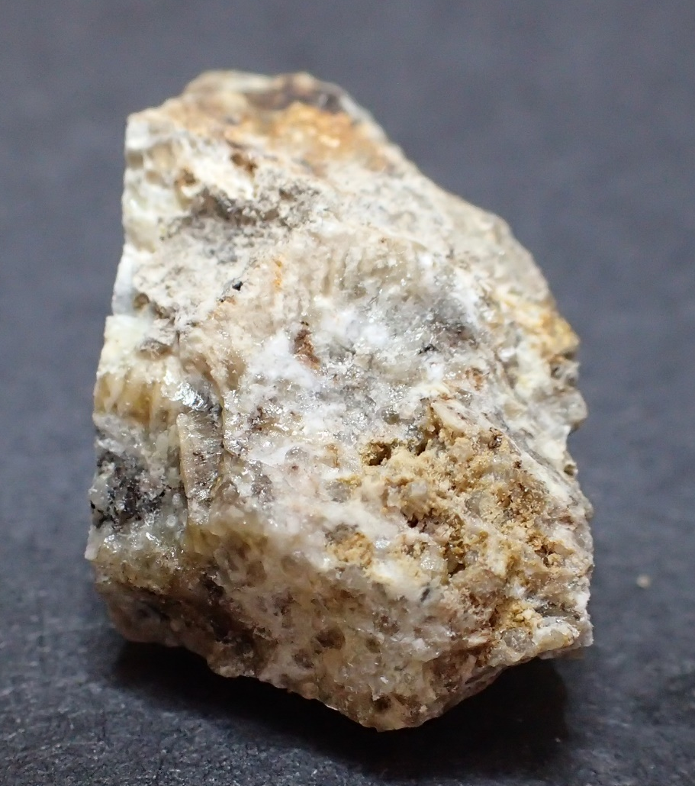
By: R.S. Bottrill, L. Unwin
Date: 16 June 2021
By: R S Bottrill

Date: 16/6/21

Summary
The samples from Glenorchy include a feldspathic hornfels and a grossular skarn with some white crystalline calcite veinlets, some botryoidal hyalite veins and some fossil-like features. The samples are typical of calc-silicate hornfels or skarns found in the Berridale limestone and other fossil-rich units in the Permian strata when intruded by Jurassic dolerite. The opal may form from the weathering of wollastonite.

Introduction & Background
Two rock samples were collected from probable Permian strata adjacent to dolerite, in the hills near Glenorchy, by Kyle Eastman, and were submitted to MRT to help determine the mineralogy and nature of the rocks.

Samples
The details of the samples collected are given in Table 1 below.

Table 1: Sample details
MRT Lab Number | Location | Sample Description | Process
G409391a | Glenorchy | Hornfels with hyalite | xrd
G409391b | Glenorchy | Garnet skarn, hyalite | xrd

Process
The samples were all prepared, examined by stereomicroscopy, and were analysed by XRD (X-ray diffraction) for mineralogy. All preparation and testing was done in the Mineral Resources Tasmania (MRT) laboratories, Rosny Park and Mornington, Tasmania.

Sample Descriptions
G409391A is a slightly weathered, pale green, mottled, hornfelsed rock with some white crystalline calcite veinlets, and some botryoidal hyalite coatings and black staining on joints (Fig. 1).

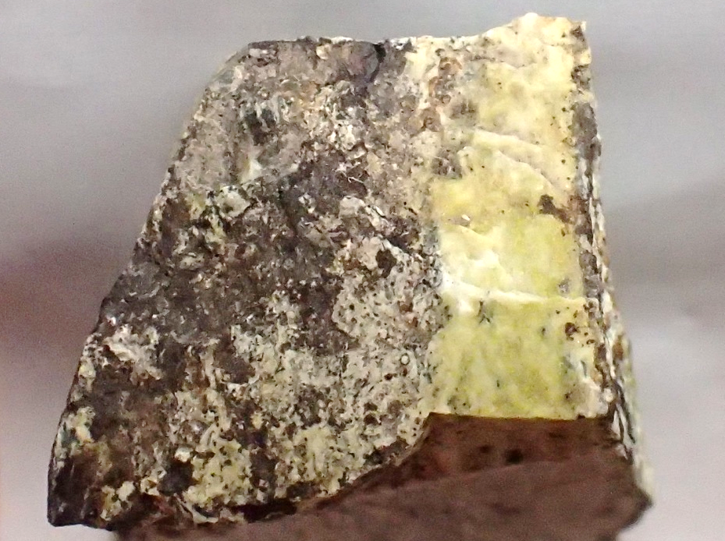
Figure 1. G409391A. A pale green/white hornfelsed rock. FOV (field of view) ~40mm.

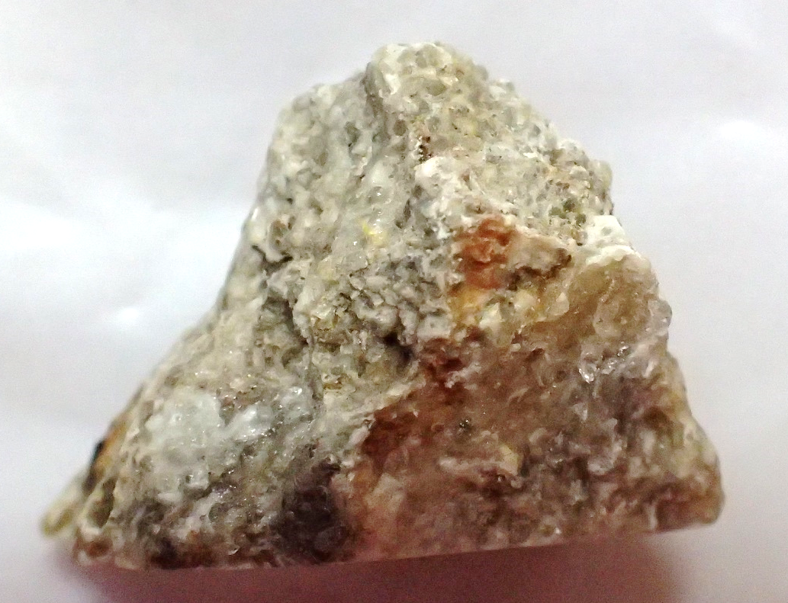
Figure 2. G409391B. A mottled, hornfelsed rock. FOV ~40mm.
G409391B is a mottled pale green/white hornfelsed rock with some fossil-like features (fenestella?, Figs 2 & 3). It contains abundant glassy white to pale yellowish grey crystals (dodecahedral?) of grossular garnet and/or vesuvianite, to about 2mm, and some botryoidal hyalite coatings on joints.

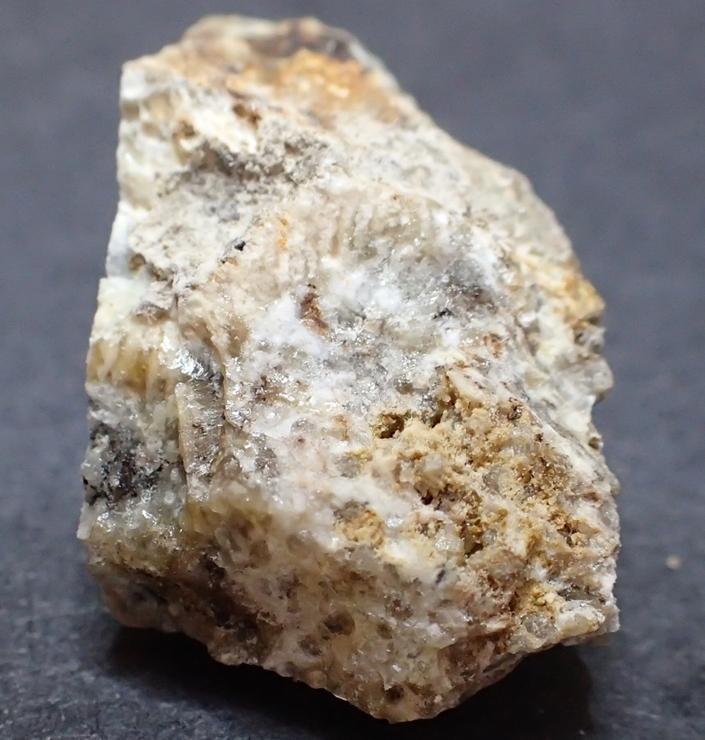
Fig. 3. G409391B. A mottled, hornfelsed rock with glassy garnet crystals. FOV ~40mm.

XRD analyses

The samples were prepared, examined, and analysed in the MRT laboratories, Rosny Park, Tasmania. They were run on a Rigaku Miniflex 600 X-Ray Diffractometer system: a 600W generator 150mm goniometer with a Cu tube; 40kV/15mA, sample spinner and a Scintillation counter (SC) with Be window, a graphite counter monochromator and a Kß Ni- filter. Measurement setup: 3-63° Theta/2Theta range, with a scanning speed of 0.5° /min. The analysis software used is the PDXL2 using the ICCD database.
Quantification is largely manual, using a series of prepared standards of the more common minerals to enable some semi-quantitative analysis. Quartz, if present, is used as an internal standard; and if not present, it is often added to the sample for a supplementary scan. Our semi-quantitative results are calculated using single-peak calibration factors derived from scans of known mixtures of minerals.
The results are shown in Appendix 1 and summarised in Table 2. G409391a has a feldspar-rich composition, mostly plagioclase, with some quartz, Kspar and smectite. G409391a contains mostly amorphous silica (opal), with some grossular garnet and trace vesuvianite.

Table 2: XRD Summary
Sample No | G409391a | G409391b
Description | Hornfels | Opal-skarn
Quartz | 12(4)
K-feldspar * | 12(4)
Plagioclase* | 53(10)
Smectite | 21(5)
Siderite | 1(1)
Amorphous Silica* |  | Major
Garnet* |  | Sub Dominant
Vesuvianite |  | Trace

Discussion and Summary
G409391A is a feldspathic hornfels with some white crystalline calcite veinlets, and some botryoidal hyalite. G409391B is a mottled pale green/white calc-silicate hornfels or skarn with some fossil-like features. It contains abundant grossular garnet crystals, to about 2mm, and some botryoidal hyalite coatings.

The samples are typical of many calc-silicate hornfels or skarns found in the Berridale limestone and other fossil-rich units in the Permian strata when intruded by Jurassic dolerite. The opal appears to form from the weathering of wollastonite. The plagioclase may be anorthite, typical of aluminous calcic skarns formed from limey mudstones.

R S Bottrill L Unwin
Mineralogist/Petrologist Technical Officer

Disclaimers
While every care has been taken in the preparation of this report, no warranty is given as to the correctness of the information and no liability is accepted for any statement or opinion or for any error or omission. No reader should act or fail to act on the basis of any material contained herein. Readers should consult professional advisers. As a result the Crown in Right of the State of Tasmania and its employees, contractors and agents expressly disclaim all and any liability (including all liability from or attributable to any negligent or wrongful act or omission) to any persons whatsoever in respect of anything done or omitted to be done by any such person in reliance whether in whole or in part upon any of the material in this report.
This and other data collected in MRT laboratories may enter the MRT databases but every attempt will be made to ensure it remains closed file and not be available externally, unless at your request.
Appendix 1: MRT Laboratory Report

Client: Kyle Eastman
Sample Location: Glenorchy
Job Number: LJN20201-047
Analyses: Approximate Mineralogy
Methods: XRD
Analyst: L Unwin
Lab Manager: R Bottrill
Date: 18/5/2021

XRD Results-G409391a-LJN2021-047-Eastman-QA1-18/5/21

General Information

Measurement date: | 18/5/2021 | Interpretative date: | 18/5/2021
Job Number/Client: | LJN2021-047 Eastman | XRD | Rigaku Miniflex 600
Registration Number: | G409391a | Analyst: | LUnwin
Quantitative Method: | PDXL Relative Heights | Process Medium: | Wholerock
Sample Holder: | Standard | Speed (deg/min): | 0.5
Comment: | Shifted -0.01

Analysis Results

Phase name | Content wt% (± error) | Formula
Quartz | 12(4) | SiO₂
K-feldspar * | 12(4) | (K,Na)AlSi₃O₈
Plagioclase* | 53(10) | NaAlSi₃O₈
Smectite | 21(5) | Var.
Siderite | 1(1) | FeCO₃

Notes
Peak overlap may interfere with identifications and quantitative calculations.
Amorphous minerals and minerals present in trace amounts may not be detected.
K-feldspar* possibly Microcline
Plagioclase* probably Albite

Peak List
No. | 2-theta(deg) | d(ang.) | Phase name | Rel. int. I(a.u.)
1 | 5.69(5) | 15.52(14) | Smectite(0,0,1) | 100.00
2 | 13.874(8) | 6.378(4) | K-feldspar(0,0,1),Plagioclase(0,0,1) | 24.32
3 | 14.99(3) | 5.905(12) | K-feldspar(1,-1,-1),Plagioclase(1,1,-1) | 8.33
4 | 15.9396 | 5.55564 | Plagioclase(1,-1,-1) | 3.21
5 | 19.72(3) | 4.499(7) | K-feldspar(0,2,1),Smectite(0,2,0) | 34.29
6 | 20.8521 | 4.25657 | Quartz(1,0,0) | 11.05
7 | 20.9539 | 4.23612 | K-feldspar(2,0,-1) | 41.42
8 | 22.006(5) | 4.0359(9) | Plagioclase(2,0,-1) | 41.47
9 | 22.503(19) | 3.948(3) | K-feldspar(1,-1,1) | 10.56
10 | 23.055(5) | 3.8546(9) | K-feldspar(2,0,0),Plagioclase(1,-1,1),Smectite(1,-1,-2) | 10.23
11 | 23.514(4) | 3.7804(7) | K-feldspar(1,3,0),Plagioclase(1,1,1) | 68.21
12 | 24.261(10) | 3.6657(14) | Plagioclase(1,3,0) | 31.65
13 | 24.558(10) | 3.6221(15) | K-feldspar(1,3,-1) | 4.62
14 | 25.380(13) | 3.5065(18) | Plagioclase(1,1,-2) | 6.51
15 | 25.602(4) | 3.4766(5) | K-feldspar(1,-1,-2),Plagioclase(2,2,-1) | 26.67
16 | 26.365(17) | 3.378(2) | Plagioclase(1,-1,-2) | 20.95
17 | 26.586(4) | 3.3501(5) | Plagioclase(2,-2,-1),Smectite(1,-1,3),Quartz(1,0,1) | 59.77
18 | 27.0402 | 3.29487 | K-feldspar(2,0,-2) | 64.35
19 | 27.484(5) | 3.2426(5) | K-feldspar(0,4,0),Plagioclase(2,0,-2) | 98.30
20 | 27.8901 | 3.19637 | Plagioclase(0,4,0) | 97.90
21 | 28.135(9) | 3.1691(10) | Plagioclase(2,2,0) | 27.99
22 | 29.814(3) | 2.9944(3) | K-feldspar(1,-3,1),Smectite(0,0,5) | 33.34
23 | 30.0316 | 2.97314 | Plagioclase(1,-3,1) | 26.04
24 | 30.4803 | 2.93038 | K-feldspar(2,2,-2),Plagioclase(0,4,-1) | 15.87
25 | 30.7523 | 2.90509 | K-feldspar(0,4,1) | 28.61
26 | 31.2191 | 2.8627 | Plagioclase(1,3,1),Smectite(1,1,4) | 10.31
27 | 32.320(10) | 2.7676(9) | K-feldspar(1,-3,-2),Siderite(1,0,4) | 13.67
28 | 34.3075 | 2.61173 | K-feldspar(3,-1,-2) | 8.44
29 | 34.86(7) | 2.572(5) | K-feldspar(2,-4,-1),Plagioclase(1,-3,-2),Smectite(2,0,0) | 84.36
30 | 35.4453 | 2.53046 | K-feldspar(3,1,0),Plagioclase(3,1,-2),Siderite(0,0,6) | 9.06
31 | 36.4748 | 2.46137 | K-feldspar(1,-5,0),Plagioclase(1,1,2),Smectite(1,-3,-2),Quartz(1,1,0) | 10.02
32 | 37.6668 | 2.38617 | K-feldspar(3,-3,-1),Plagioclase(2,-4,0) | 9.98
33 | 38.8588 | 2.31567 | K-feldspar(1,-1,-3),Plagioclase(3,3,-1),Smectite(1,3,-3) | 9.13
34 | 39.5632 | 2.27605 | K-feldspar(3,3,-2),Plagioclase(1,-1,-3),Smectite(0,4,0),Quartz(0,1,2) | 5.71
35 | 41.610(9) | 2.1687(5) | K-feldspar(0,6,0),Plagioclase(2,-2,-3),Smectite(0,4,2) | 12.87
36 | 42.426(10) | 2.1288(5) | K-feldspar(2,-4,1),Plagioclase(3,1,-3),Smectite(0,0,7),Quartz(2,0,0),Siderite(1,1,3) | 18.93
37 | 43.7352 | 2.06811 | K-feldspar(2,0,2),Plagioclase(0,6,-1) | 6.61
38 | 45.0898 | 2.00908 | K-feldspar(4,2,-2),Plagioclase(4,0,-2) | 6.39
39 | 45.83(2) | 1.9784(8) | K-feldspar(2,2,2),Plagioclase(0,2,3),Quartz(0,2,1) | 7.36
40 | 46.98(8) | 1.932(3) | K-feldspar(2,-6,-1),Plagioclase(2,-2,2),Smectite(1,1,-7) | 5.76
41 | 48.0157 | 1.89326 | K-feldspar(3,-3,1),Plagioclase(4,-2,-2) | 5.66
42 | 49.1535 | 1.85207 | K-feldspar(1,1,3),Plagioclase(4,0,-3) | 7.51
43 | 49.96(6) | 1.8242(19) | K-feldspar(3,5,0),Plagioclase(1,-1,3),Quartz(1,1,2) | 15.13
44 | 50.63(3) | 1.8014(11) | K-feldspar(1,7,0),Plagioclase(1,1,3),Smectite(1,3,-6),Quartz(0,0,3) | 26.97
45 | 51.12(3) | 1.7854(9) | K-feldspar(4,4,-1),Plagioclase(1,7,-1),Siderite(0,2,4) | 8.49
46 | 52.2961 | 1.74792 | K-feldspar(2,-4,2),Plagioclase(4,-2,-3) | 4.53
47 | 53.16(9) | 1.722(3) | K-feldspar(1,1,-4),Plagioclase(1,-3,3),Siderite(0,1,8) | 4.61
48 | 53.9216 | 1.69901 | K-feldspar(5,-1,-2),Plagioclase(3,5,-3),Smectite(1,5,1) | 4.84
49 | 54.866(19) | 1.6720(5) | K-feldspar(3,-5,-3),Plagioclase(4,-4,-1),Smectite(0,4,-6),Quartz(2,0,2) | 4.38
50 | 55.7096 | 1.64864 | K-feldspar(1,7,-2),Plagioclase(3,3,-4) | 4.30
51 | 56.414 | 1.62971 | K-feldspar(3,5,1),Plagioclase(5,1,-2) | 4.33
52 | 58.67(5) | 1.5723(12) | K-feldspar(2,-4,-4),Plagioclase(5,1,-1) | 7.84

Phase Data Pattern

XRD Results-G409391b-LJN2021-047-Eastman-03/06/2021

General Information

Measurement date: | 21/5/2021 | Interpretative date: | 03/06/2021
Job Number/Client: | LJN2021-047 Eastman | XRD | Rigaku Miniflex 600
Registration Number: | G409391b | Analyst: | LUnwin
Quantitative Method: | PDXL Relative Heights | Process Medium: | Wholerock
Sample Holder: | Standard | Speed (deg/min): | 0.5
Comment: | Shifted -0.03

Analysis Results

Phase name | Content - Estimate | Formula
Amorphous Silica* | Major | SiO₂
Garnet* | Sub Dominant | Ca₃Al₂(SiO₄)₃
Vesuvianite | Faint Trace | Ca₁₀Mg₂Al₄(Si₂O₇)₂(SiO₄)₅(OH)₄

Notes
Peak overlap may interfere with identifications and quantitative calculations.
Amorphous minerals and minerals present in trace amounts may not be detected.
Amorphous Silica* possibly Opal
Garnet* probably Grossular

Peak List
No. | 2-theta(deg) | d(ang.) | Phase name | Rel. int. I(a.u.)
1 | 21.5061 | 4.12858 | Amorphous Silica, Garnet(2,1,1),Vesuvianite(3,1,0) | 100.00
2 | 26.625(13) | 3.3453(16) | Amorphous Silica | 2.49
3 | 30.043(8) | 2.9720(8) | Garnet(4,0,0),Vesuvianite(5,0,1) | 17.17
4 | 32.397(10) | 2.7612(9) | Vesuvianite(2,0,4) | 1.57
5 | 33.693(4) | 2.6579(3) | Garnet(4,2,0),Vesuvianite(4,4,1) | 35.29
6 | 34.411(17) | 2.6041(12) | Vesuvianite(2,2,4) | 1.22
7 | 35.35(2) | 2.5369(16) | Garnet(3,3,2),Vesuvianite(3,1,4) | 4.50
8 | 37.001(16) | 2.4276(10) | Garnet(4,2,2),Vesuvianite(3,2,4) | 7.65
9 | 38.613(11) | 2.3299(6) | Garnet(4,3,1),Vesuvianite(6,1,2) | 6.34
10 | 41.580(5) | 2.1702(2) | Garnet(5,2,1),Vesuvianite(2,2,5) | 5.00
11 | 47.112(10) | 1.9275(4) | Garnet(6,1,1),Vesuvianite(6,1,4) | 8.46
12 | 48.36(2) | 1.8807(8) | Garnet(6,2,0),Vesuvianite(8,1,1) | 1.10
13 | 53.33(2) | 1.7165(7) | Garnet(4,4,4),Vesuvianite(7,2,4) | 3.57
14 | 55.760(13) | 1.6473(3) | Garnet(6,4,0),Vesuvianite(9,2,1) | 9.45
15 | 57.53(3) | 1.6008(7) | Vesuvianite(3,1,7) | 0.24
16 | 58.017(11) | 1.5884(3) | Garnet(6,4,2),Vesuvianite(6,4,5) | 16.09
17 | 62.560(16) | 1.4836(3) | Garnet(8,0,0),Vesuvianite(7,4,5) | 3.60

Phase Data Pattern

