Mineral Resources Tasmania Mineralogical/Petrology Report

LJN2021-053

MINERALOGICAL ANALYSES,
ARTHURS LAKE

An unpublished Mineral Resources Tasmania Report for:
R Bottrill & G Cumming,
Mineral Resources Tasmania
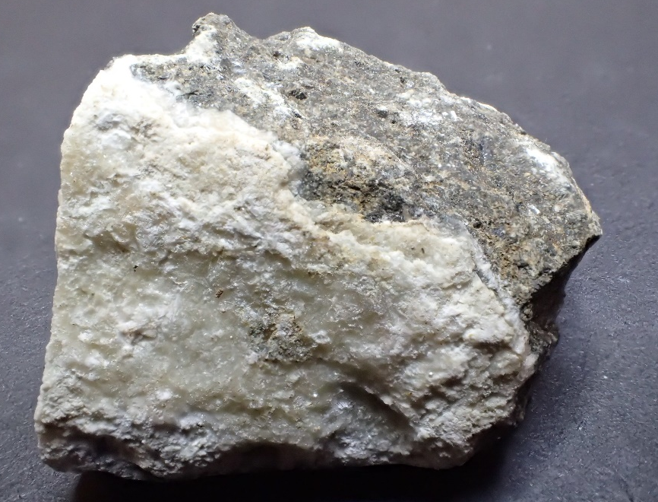
By: R S Bottrill

Date: 4/17/2025

By: R.S. Bottrill, L. Unwin
Date: 17 April 2025

Summary
Several rock samples were collected from the Arthurs Lake Quarry and indicate the white veins in dolerite contain a mixture of calcite and stilbite, with no detectable clays.

Introduction & Background
Several rock samples were collected from the Arthurs Lake Quarry by Grace Cumming and Ralph Bottrill (MRT). They were submitted to MRT to help determine the mineralogy of the rocks.

Samples
The details of the samples collected are given in Table 1 below.

Table 1: Sample details
MRT Lab Number | Location | Sample Description | Process
C114028 | Arthurs Lake Qy | White veins in dolerite | XRD

Process
The samples were all prepared by scraping off various bits of the white vein material, examining them by low power microscopy, and then analysis by XRD (X-ray diffraction) for mineralogy. All preparation and testing was done in the Mineral Resources Tasmania (MRT) laboratories, Rosny Park and Mornington, Tasmania.

Sample Descriptions
This rock is medium grained, dark grey doleritic rock with some white veins to about 4mm thick (Fig. 1).
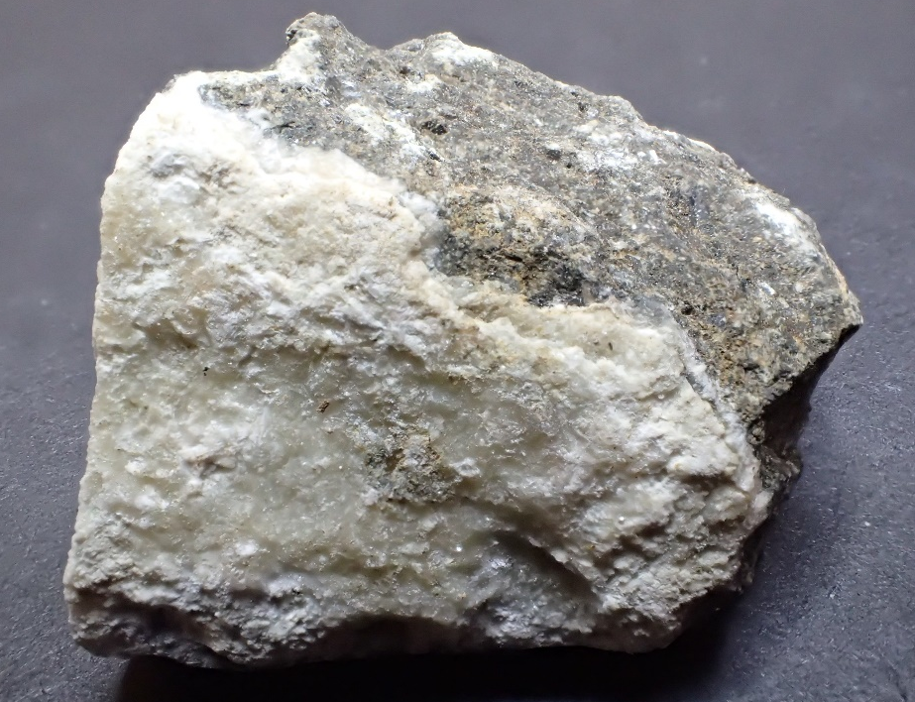
Figure 1. G410195. White veins in dolerite. FOV (field of view) ~30mm.

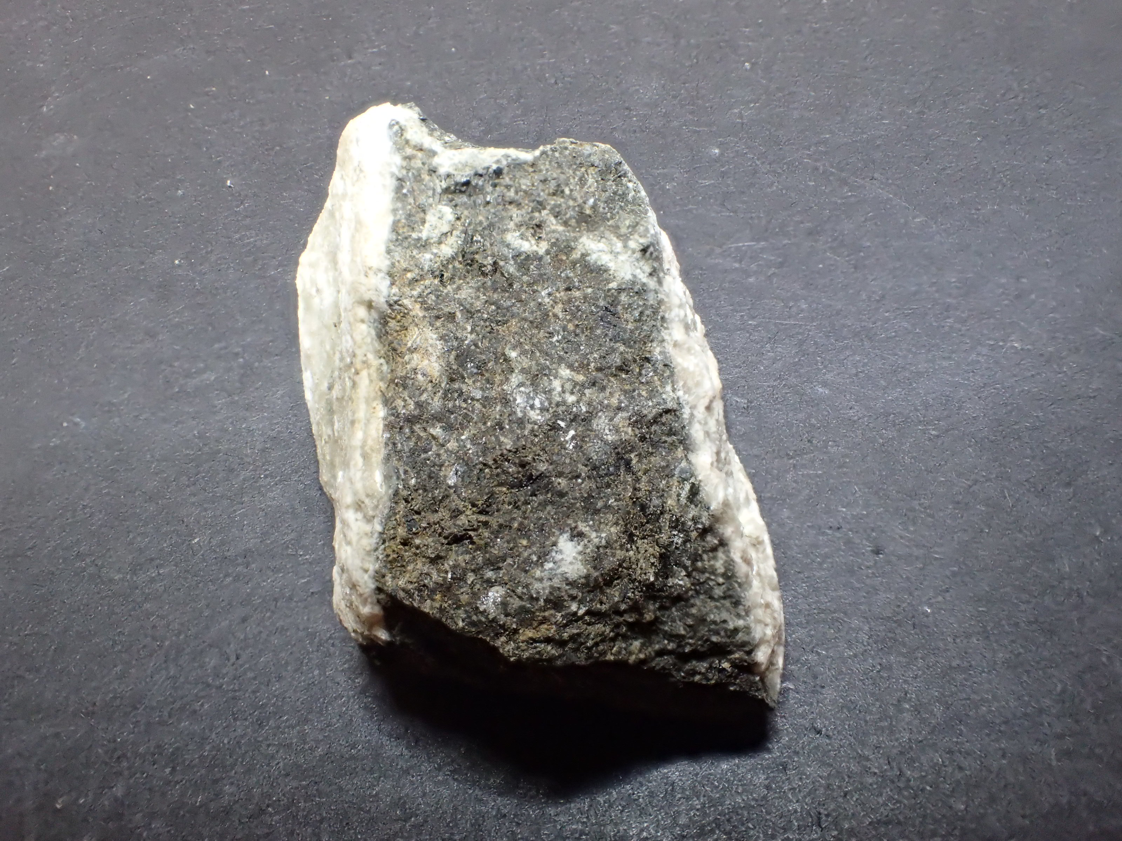
Figure 2. G410195. White veins in dolerite. FOV (field of view) ~30mm.

XRD analyses

The samples were prepared, examined, and analysed in the MRT laboratories, Rosny Park, Tasmania. They were run on a Rigaku Miniflex 600 X-Ray Diffractometer system: a 600W generator 150mm goniometer with a Cu tube; 40kV/15mA, sample spinner and a Scintillation counter (SC) with Be window, a graphite counter monochromator and a Kß Ni- filter. Measurement setup: 3-63° Theta/2Theta range, with a scanning speed of 0.5° /min. The analysis software used is the PDXL2 using the ICCD database.
Quantification is largely manual, using a series of prepared standards of the more common minerals to enable some semi-quantitative analysis. Quartz, if present, is used as an internal standard; and if not present, it is often added to the sample for a supplementary scan. Our semi-quantitative results are calculated using single-peak calibration factors derived from scans of known mixtures of minerals.
The results are shown in Appendix 1 and indicate the veins contain a mixture of calcite and stilbite, with no detectable clay.

R S Bottrill L Unwin
Mineralogist/Petrologist Technical Officer

Disclaimers
While every care has been taken in the preparation of this report, no warranty is given as to the correctness of the information and no liability is accepted for any statement or opinion or for any error or omission. No reader should act or fail to act on the basis of any material contained herein. Readers should consult professional advisers. As a result the Crown in Right of the State of Tasmania and its employees, contractors and agents expressly disclaim all and any liability (including all liability from or attributable to any negligent or wrongful act or omission) to any persons whatsoever in respect of anything done or omitted to be done by any such person in reliance whether in whole or in part upon any of the material in this report.
This and other data collected in MRT laboratories may enter the MRT databases but every attempt will be made to ensure it remains closed file and not be available externally, unless at your request.
Appendix 1: MRT Laboratory Report

XRD Results-C114028-LJN2021-053-Arthurs Lake-4/6/2021

General Information

Measurement date: | 4/6/2021 | Interpretative date: | 4/6/2021
Job Number/Client: | LJN2021-053 Arthurs Lake Quarry | XRD | Rigaku Miniflex 600
Registration Number: | C114028 | Analyst: | LUnwin
Quantitative Method: | PDXL Relative Heights | Process Medium: | White material only
Sample Holder: | Low Reflectance | Speed (deg/min): | 5.0
Comment: | Shifted -0.146, Quartz added for Calibration

Analysis Results

Phase name | Content wt% (± error) | Formula
Stilbite | 49(10) | NaCa₄[Al₉Si₂₇O₇₂] · nH₂O
Calcite | 51(10) | CaCO₃

Notes
Peak overlap may interfere with identifications and quantitative calculations.
Amorphous minerals and minerals present in trace amounts may not be detected.

Peak List
No. | 2-theta(deg) | d(ang.) | Phase name | Rel. int. I(a.u.)
1 | 9.683(3) | 9.126(3) | Stilbite(1,1,0) | 34.40
2 | 19.053(16) | 4.654(4) | Stilbite(2,2,-2) | 9.25
3 | 20.843(14) | 4.258(3) | Quartz(1,0,0),Stilbite(3,1,-1) | 20.55
4 | 21.819(15) | 4.070(3) | Stilbite(1,3,-2) | 29.88
5 | 26.131(11) | 3.4074(14) | Stilbite(1,1,-3) | 4.54
6 | 26.631(7) | 3.3446(8) | Quartz(0,1,1) | 100.00
7 | 27.89(6) | 3.197(6) | Stilbite(4,0,-3) | 4.90
8 | 29.3716 | 3.03843 | Calcite(1,0,4),Stilbite(0,6,0) | 51.14
9 | 32.210(9) | 2.7768(8) | Stilbite(2,6,-1) | 6.06
10 | 36.532(17) | 2.4576(11) | Quartz(1,1,0) | 10.01
11 | 39.380(8) | 2.2862(4) | Quartz(1,0,2),Calcite(1,1,3),Stilbite(5,3,-1) | 13.31
12 | 42.407(17) | 2.1298(8) | Quartz(2,0,0),Stilbite(2,0,-5) | 6.70
13 | 43.11(3) | 2.0966(15) | Calcite(2,0,2),Stilbite(2,8,0) | 4.66
14 | 47.476(17) | 1.9135(6) | Calcite(0,1,8),Stilbite(2,4,3) | 9.64
15 | 48.435(8) | 1.8779(3) | Calcite(1,1,6),Stilbite(4,0,-6) | 6.82
16 | 50.104(8) | 1.8191(3) | Quartz(1,1,2),Stilbite(6,0,-6) | 19.18
17 | 57.266(14) | 1.6075(4) | Quartz(2,1,0),Calcite(1,2,2),Stilbite(4,10,-2) | 5.97
18 | 57.80(2) | 1.5939(5) | Stilbite(1,1,5) | 3.22

Phase Data Pattern

