MINERAL RESOURCES TASMANIA

Laboratory Report
LJN2021-056

PETROPHYSICAL TESTS,

Fingal

An unpublished Mineral Resources Report for:

Mark Duffett, MRT

By: R.Bottrill, R. King and L. Unwin

Date: 3 March 2022


Mineral Resources Tasmania
Department of State Growth

Introduction
Eleven rock samples were collected from Fingal Tier Diamond Drill Cores by M Duffett, for physical property measurements; 5 samples (L301911, L301913, L301914, L301918 and L301919) disintegrated upon soaking and were unable to be analysed; with details listed in Table 1 below.
Table 1: Sample details
Reg. # | DDH | Depth (m) | Sample Description
L301909 | 3607 DOM82 Fingal Tier | 53 | dolerite - Lithology: dolerite
L301910 | 3607 DOM82 Fingal Tier | 100.2 | fine-medium grained lithic sandstone - Lithology: arenite, lithic
L301911 | 3607 DOM82 Fingal Tier | 149.7 | mudstone, grey, sandy occasional wispy carbonaceous laminae - Lithology: mudstone, carbonaceous
L301912 | 3607 DOM82 Fingal Tier | 200 | fine-medium grained lithic sandstone, rare coaly debris and minor wispy carbonaceous laminae - Lithology: arenite, lithic
L301913 | 3607 DOM82 Fingal Tier | 250.1 | mudstone, green-grey - Lithology: mudstone
L301914 | 3607 DOM82 Fingal Tier | 299.9 | grey sandy mudstone - Lithology: mudstone, sandy
L301915 | 3607 DOM82 Fingal Tier | 350 | carbonaceous quartz rich lithic sandstone fine grained sub-litharenite with carbonaceous bands - Lithology: arenite, lithic
L301916 | 3607 DOM82 Fingal Tier | 400 | interbedded and interlaminated fine grained lithic sandstone and green-grey mudstone with minor wispy carbonaceous laminae - Lithology: sediment and sedimentary rock
L301917 | 3607 DOM82 Fingal Tier | 421 | fine-medium grained quartz sandstone with carbonaceous laminae - Lithology: arenite, quartz
L301918 | 3607 DOM82 Fingal Tier | 426.5 | mudstone with angular clasts and quartz grits - Lithology: mudstone, pebbly
L301919 | 3607 DOM82 Fingal Tier | 427.5 | mudstone with angular clasts and quartz grits - Lithology: mudstone, pebbly

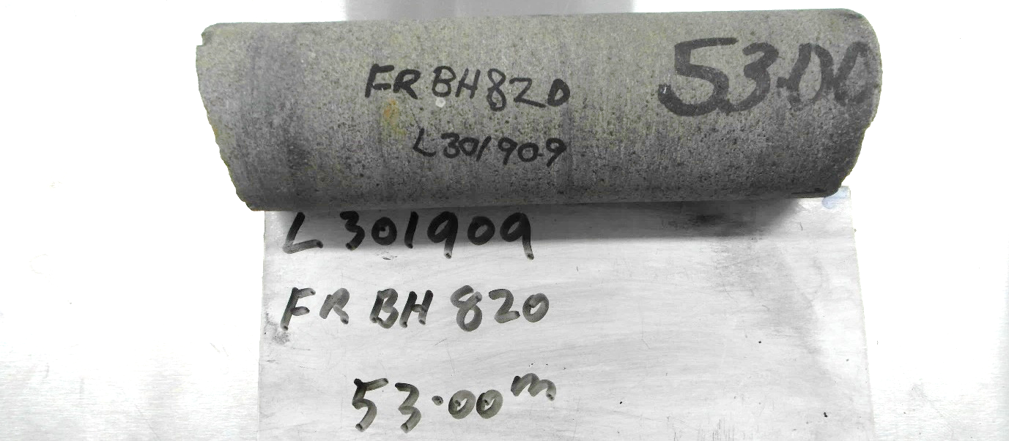
Photo 1: Sample L301909 – Dolerite. FOV: about 200 mm

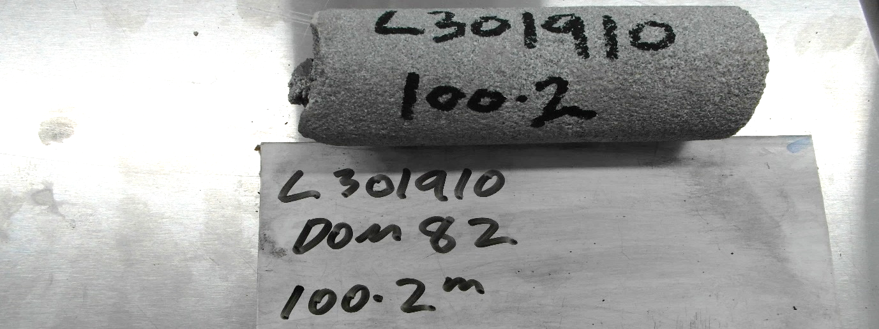
Photo 2: Sample L301910 - Sandstone. FOV: about 200 mm

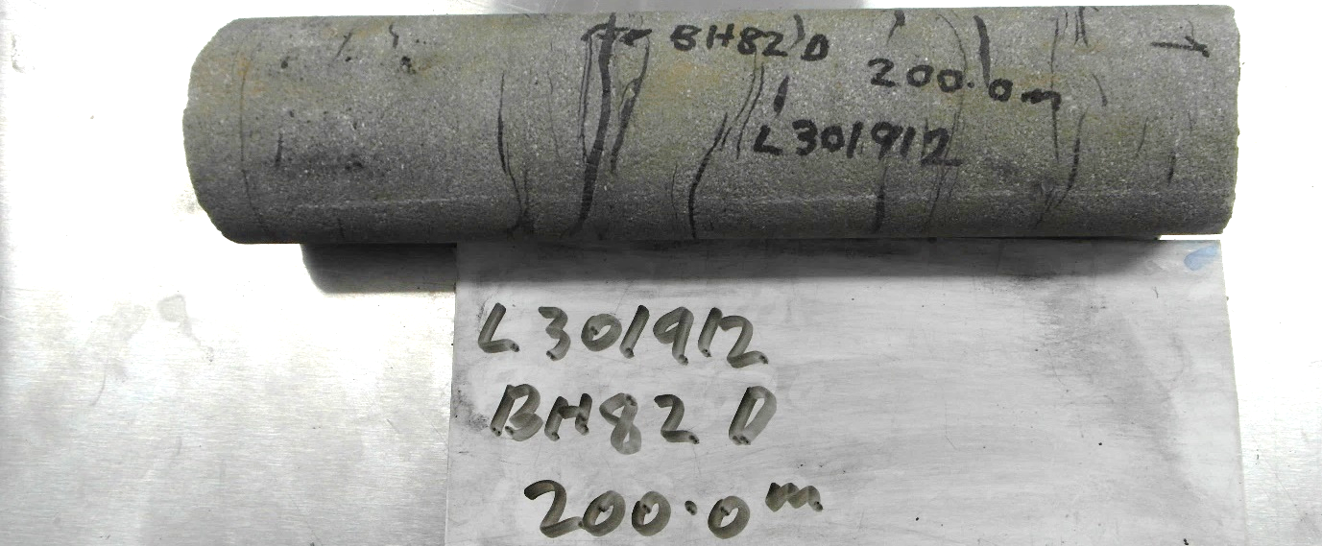
Photo 3: Sample L301912 – Lithic Sandstone. FOV: about 250 mm

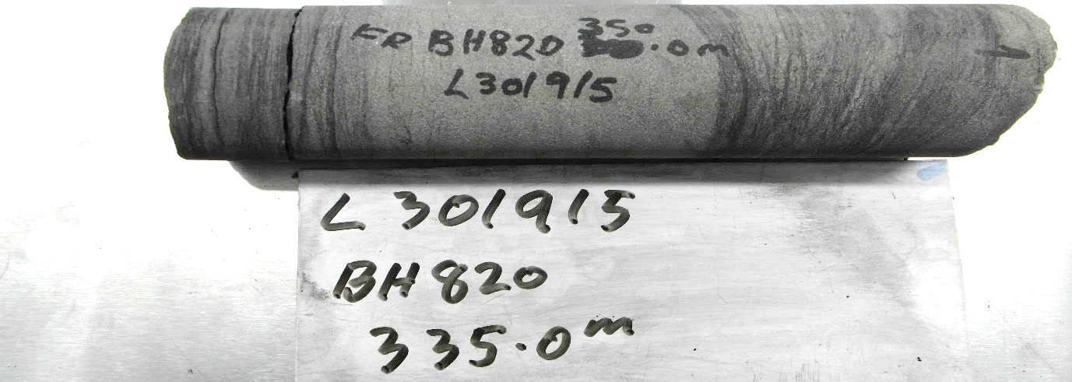
Photo 4: Sample L301915 – Sandstone. FOV: about 400 mm

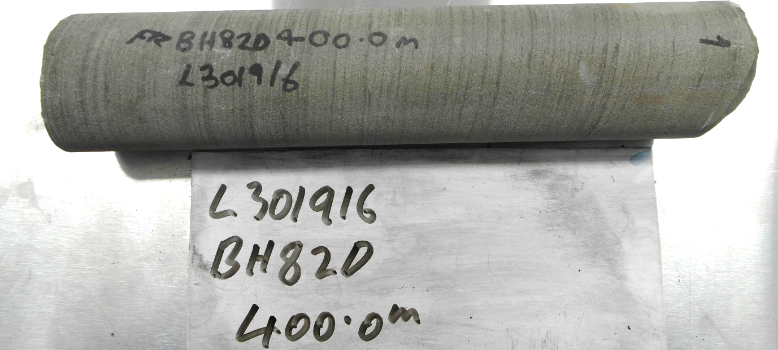
Photo 5: Sample L301916 – Sub-litharenite. FOV: about 400 mm

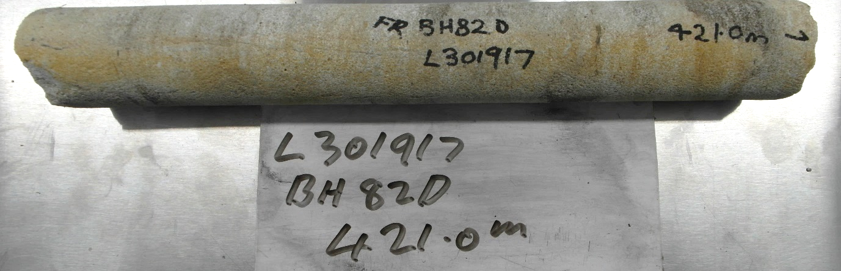
Photo 6: Sample L301917 – Sandstone. FOV: about 400 mm

Laboratory Tests

The samples were soaked for a minimum of 48 hours and weighed in water, and then wet in air. Samples were dried in a 90°C oven for a minimum of 12 hours then weighed dry. The wet porosity and density (specific gravity) was determined by standard gravimetric methods in the Mineral Resources Tasmania (MRT) Core Library, with an electronic balance accurate to 0.1g. The relative accuracy of the results is ~1% for specific gravity and ~5% for wet porosity. The summary of results is shown in Table 2 with full details listed in Appendix 1.

Table 2: Summary of Specific Gravity and Wet porosity
Reg. # | DDH | Depth (m) | Rocktype | Dry bulk SG | Wet bulk SG | Wet Porosity (%)
L301909 | 3607 DOM82 Fingal Tier | 53 | dolerite - Lithology: dolerite | 2.91 | 2.92 | 0.44
L301910 | 3607 DOM82 Fingal Tier | 100.2 | fine-medium grained lithic sandstone - Lithology: arenite, lithic | 2.14 | 2.29 | 14.95
L301912 | 3607 DOM82 Fingal Tier | 200 | fine-medium grained lithic sandstone, rare coaly debris and minor wispy carbonaceous laminae - Lithology: arenite, lithic | 2.30 | 2.42 | 12.01
L301915 | 3607 DOM82 Fingal Tier | 350 | carbonaceous quartz rich lithic sandstone fine grained sub-litharenite with carbonaceous bands - Lithology: arenite, lithic | 2.30 | 2.40 | 10.34
L301916 | 3607 DOM82 Fingal Tier | 400 | interbedded and interlaminated fine grained lithic sandstone and green-grey mudstone with minor wispy carbonaceous laminae - Lithology: sediment and sedimentary rock | 2.39 | 2.49 | 9.78
L301917 | 3607 DOM82 Fingal Tier | 421 | fine-medium grained quartz sandstone with carbonaceous laminae - Lithology: arenite, quartz | 2.15 | 2.30 | 15.39

R.S. Bottrill R King and L Unwin

Mineralogist/Petrologist TECHNICAL OFFICERs

Disclaimers:
While every care has been taken in the preparation of this report, no warranty is given as to the correctness of the information and no liability is accepted for any statement or opinion or for any error or omission. No reader should act or fail to act on the basis of any material contained herein. Readers should consult professional advisers. As a result the Crown in Right of the State of Tasmania and its employees, contractors and agents expressly disclaim all and any liability (including all liability from or attributable to any negligent or wrongful act or omission) to any persons whatsoever in respect of anything done or omitted to be done by any such person in reliance whether in whole or in part upon any of the material in this report. The MRT laboratories are not NATA registered but work to similar standards. This and other data collected in MRT laboratories may enter the MRT databases but every attempt will be made to ensure it remains closed file and not be available externally, unless at your request.

Appendix 1: Laboratory Report – Physical Property analyses
Client: M Duffett
Analysis: Physical Properties
Method: Gravimetric S.G. & Porosity
Location: Fingal
Job No.: LJN2021-056
Date: 28/2/2022

Results
Sample ID | Dry Weight in Air (g) | Sub-sat Wt in water (g) | Sat. Wt. in Air (g) | Dry bulk SG | Wet bulk SG | Wet porosity (%)
L301909 | 793.5 | 522.3 | 794.7 | 2.91 | 2.92 | 0.44
L301910 | 364.7 | 219.6 | 390.2 | 2.14 | 2.29 | 14.95
L301912 | 705.2 | 435.5 | 742.0 | 2.30 | 2.42 | 12.01
L301915 | 668.6 | 407.7 | 698.7 | 2.30 | 2.40 | 10.34
L301916 | 767.0 | 477.3 | 798.4 | 2.39 | 2.49 | 9.78
L301917 | 952.8 | 577.4 | 1021.1 | 2.15 | 2.30 | 15.39

Analyst: R. King
Date: 28/2/2022

