MINERAL RESOURCES TASMANIA

Laboratory Report
Mineralogical Analyses, Eddystone

LJN2021-086

Mineralogical analysEs:
Rocky River Mine

An unpublished Mineral Resources Tasmania Report for:
A Tuma

By: R S Bottrill

Date: 1 December 2021

Summary

The sample contains almandine garnet, annite mica, apatite, ilmenite and an altered aggregate of U minerals.

Introduction

One mineral sample was received from Andrew Tuma, for mineralogical analysis. Sample details are shown in Table 1. Similar material at Bicheno was reported to contain pyrope.

Table 1: sample details.
Reg. No | Location | Description
C113549 | Deep Ck, Eddystone | Garnet-biotite schlieren

Processes

The sample was examined microscopically and some small representative parts of the sample were extracted and mounted on Al stubs for SEM/EDS analysis in the CSL. pXRF (unrecorded) indicated high Ti and Nb.

Sample descriptions

The sample is a granitic rock containing patches of fine grained red garnet and black biotite, possibly a schlieren, or an altered metasedimentary xenolith.

SEM/EDAX analyses
The sample was analysed by SEM-EDS, in the CSL, University of Tasmania, with analytical conditions shown in Appendix 1. The results are given in Appendix 2 and summarised below.
The sample is an aggregate of almandine garnet, annite mica and minor fluorapatite, ilmenite and a U-rich mixture.
Garnet (almandine): (Fe_{2.6}Mg_{0.2}Ca_{0.1}Mn_{0.1})(Al_{1.6}Fe_{0.4})(Si_{2.7}Al_{0.3})O₁₂
Biotite (annite): K_{0.9}(Fe_{1.8}Mg_{0.5}Ti_{0.1}Al_{0.5}) (Si_{2.8}Al_{1.2})O₁₀(OH)₂
U material: averaging about (KFe₂U₃)(Si₄Al₂)O_{x} (doesn’t fit any known mineral, maybe a mixture off coffinite and annite, possibly replacing uraninite?

Discussion

The sample is an aggregate of almandine and annite, with trace ilmenite, fluorapaite and an unidentified U-rich mixture.

R.S. Bottrill

Mineralogist/Petrologist

Disclaimers
While every care has been taken in the preparation of this report, no warranty is given as to the correctness of the information and no liability is accepted for any statement or opinion or for any error or omission. No reader should act or fail to act on the basis of any material contained herein. Readers should consult professional advisers. As a result the Crown in Right of the State of Tasmania and its employees, contractors and agents expressly disclaim all and any liability (including all liability from or attributable to any negligent or wrongful act or omission) to any persons whatsoever in respect of anything done or omitted to be done by any such person in reliance whether in whole or in part upon any of the material in this report. The MRT laboratories are not NARA registers but work to similar standards.This and other data collected in MRT laboratories may enter the MRT databases but every attempt will be made to ensure it remains closed file and not be available externally, unless at your request.
Appendix 1: Laboratory Report –SEM analytical conditions

Hitachi SU-70 analytical field emission SEM
- Installed February 2011
- Schottky thermal field emission source
- ultra-high resolution (1.0 nm @ 15kV, 1.6 nm @ 1kV for SE imaging)
- high vacuum operation only (i.e. no variable pressure in chamber)
- Hitachi in-chamber and in-lens scintillation detectors, Super ExB filter, beam deceleration
- Hitachi in-chamber 5-segment solid state BSE detector, retractable
- in-column Faraday cup with picoammeter for beam current measurement
- anticontamination cold plate, liquid nitrogen cooled
- 5 axis motorised fully eucentric stage, XYZ range 110x110x40mm
- Oxford AZtec EDS/EBSD system with
  - X-Max 80 SDD EDS, MnKa 125 eV resolution, elements B-U, large area hyperspectral mapping, standardless and standards-based quantification, feature analysis
  - HKL NordlysNano EBSD camera & forescatter detector system, HKL & Channel 5 software packages, Synergy EDS/EBSD integration, HKL, ICSD & American Mineralogist phase databases
- Gatan ChromaCL2 colour cathodoluminescence imaging system with integrated BSE detector, Digital Micrograph 3 software, automated mosaic acquisition, simultaneous acquisition of SE, iBSE and colour CL images.

Label: | am 179
Element List Type: | Current
Processing Option: | All Elements
Specimen Coating: | On
Beam Calibration Element Coating: | Off
Coating Element: | Carbon
Coating Thickness: | 20 nm
Coating Density: | 2.25 g/cm³
Automatic Line Selection: | Disabled
Normalization: | Enabled
Thresholding: | Sigma level = 1
Detector Window Correction: | Enabled
Deconvolution Elements: | None
Selected Standards: | Minerals_15kV_2017-10-20 [ User ]
Pulse Pile Up Correction: | Succeeded
Detector file: | X-Max 3
Efficiency: | File based

Appendix 2: Laboratory Report –SEM Analyses

Client: A Tuma
Sample Location: Eddystone
Job Number: LJN2021-086
Analyses: Mineral chemistry
Methods: SEM-EDS
Analyst: R Bottrill
Date: 22/9/2021

Table 1: C113549 EDS analyses: garnet (at. %, 8 cations).
Label | Na | Mg | Al | Si | P | Ca | Ti | Mn | Fe
285 | 0.00 | 0.14 | 1.71 | 2.56 | 0.00 | 0.12 | 0.00 | 0.25 | 3.22
267 | 0.00 | 0.29 | 1.89 | 2.75 | 0.00 | 0.13 | 0.00 | 0.09 | 2.86
281 | 0.00 | 0.18 | 1.94 | 2.81 | 0.00 | 0.10 | 0.00 | 0.23 | 2.75
283 | 0.00 | 0.17 | 1.94 | 2.85 | 0.00 | 0.11 | 0.00 | 0.24 | 2.70
268 | 0.00 | 0.26 | 1.56 | 2.22 | 0.09 | 0.11 | 0.00 | 0.06 | 3.69
266 | 0.12 | 0.31 | 2.04 | 3.23 | 0.00 | 0.10 | 0.00 | 0.06 | 2.12
265 | 0.00 | 0.31 | 1.97 | 2.89 | 0.00 | 0.12 | 0.00 | 0.09 | 2.63
269 | 0.00 | 0.31 | 1.77 | 2.47 | 0.07 | 0.09 | 0.00 | 0.05 | 3.24
ave. | 0.02 | 0.24 | 1.85 | 2.72 | 0.02 | 0.11 | 0.00 | 0.13 | 2.90

Table 2: C113549 EDS analyses: biotite (at. %, 8 cations).
Label | Cl | Mg | Al | Si | K | Ti | Mn | Fe
252 | 0.02 | 0.41 | 1.47 | 2.50 | 1.11 | 0.23 | 0.00 | 2.27
270 | 0.02 | 0.43 | 1.73 | 2.73 | 0.99 | 0.22 | 0.00 | 1.91
260 | 0.02 | 0.50 | 2.02 | 2.72 | 0.95 | 0.00 | 0.00 | 1.82
271 | 0.03 | 0.44 | 1.77 | 2.76 | 0.96 | 0.23 | 0.00 | 1.84
272 | 0.03 | 0.45 | 1.75 | 2.78 | 0.95 | 0.23 | 0.00 | 1.84
253 | 0.02 | 0.48 | 1.80 | 2.80 | 0.95 | 0.18 | 0.00 | 1.78
251 | 0.02 | 0.51 | 1.86 | 2.76 | 0.94 | 0.16 | 0.00 | 1.78
256 | 0.02 | 0.51 | 1.87 | 2.82 | 0.93 | 0.15 | 0.02 | 1.70
264 | 0.03 | 0.51 | 1.86 | 2.82 | 0.93 | 0.15 | 0.00 | 1.71
250 | 0.02 | 0.48 | 1.87 | 2.79 | 0.93 | 0.17 | 0.00 | 1.76
245 | 0.03 | 0.50 | 1.86 | 2.80 | 0.93 | 0.18 | 0.00 | 1.74
262 | 0.02 | 0.63 | 2.08 | 2.83 | 0.87 | 0.00 | 0.02 | 1.56
275 | 0.02 | 0.56 | 2.02 | 2.80 | 0.91 | 0.02 | 0.00 | 1.69
ave. | 0.02 | 0.50 | 1.87 | 2.78 | 0.94 | 0.14 | 0.00 | 1.76

Table 3: C113549 EDS analyses: apatite (at. %, 8 cations).
Point | F | Cl | Na | Al | Si | P | K | Ca | Sc | Mn | Fe
254 | 1.44 | 0.00 | 0.00 | 0.03 | 0.05 | 3.15 | 0.03 | 4.65 | 0.03 | 0.00 | 0.06
246 | 2.66 | 0.00 | 0.04 | 0.05 | 0.11 | 3.14 | 0.05 | 4.43 | 0.00 | 0.02 | 0.15

Table 1: C113549 EDS analyses: ilmenite (at. %, 2 cations).
Label | Al | Si | Ti | Mn | Fe
274 | 0.011 | 0.014 | 0.994 | 0.045 | 0.936
273 | 0.000 | 0.009 | 0.993 | 0.041 | 0.957

Table 1: C113549 EDS analyses: U-Al-Si mineral (at. %, 12 cations).
Label | S | Mg | Al | Si | P | K | Ca | Ti | Mn | Fe | As | Pb | U
284 | 0.00 | 0.15 | 1.95 | 2.50 | 0.00 | 0.39 | 0.39 | 0.00 | 0.21 | 1.82 | 0.00 | 0.60 | 3.98
259 | 0.00 | 0.00 | 2.33 | 4.33 | 0.44 | 0.48 | 0.00 | 0.00 | 0.00 | 1.03 | 0.19 | 0.00 | 3.21
257 | 0.00 | 0.00 | 2.36 | 4.27 | 0.47 | 0.49 | 0.00 | 0.00 | 0.00 | 1.02 | 0.19 | 0.00 | 3.20
255 | 0.12 | 0.20 | 2.04 | 3.78 | 0.37 | 0.70 | 0.00 | 0.16 | 0.00 | 1.97 | 0.18 | 0.00 | 2.59
258 | 0.11 | 0.21 | 1.82 | 3.50 | 0.51 | 0.59 | 0.00 | 0.16 | 0.00 | 1.81 | 0.23 | 0.00 | 3.18

Electron micrographs with sample points: C113549

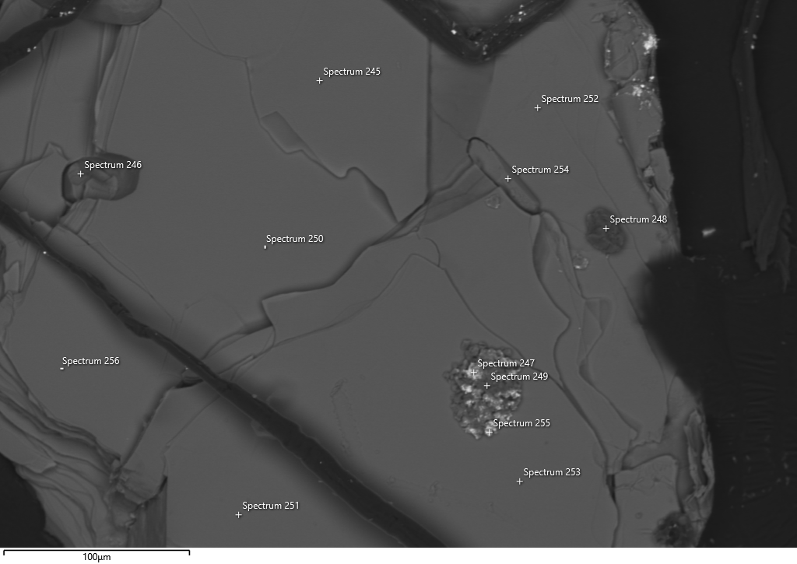
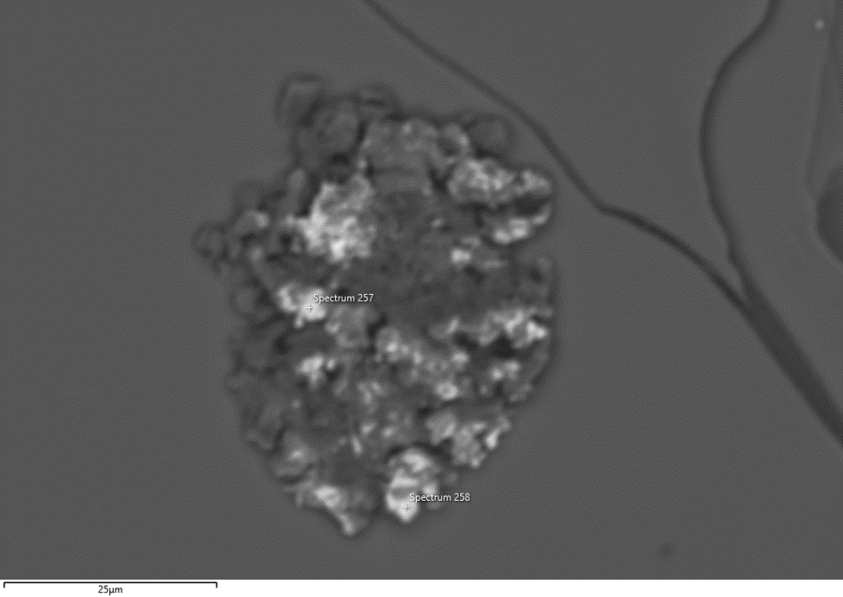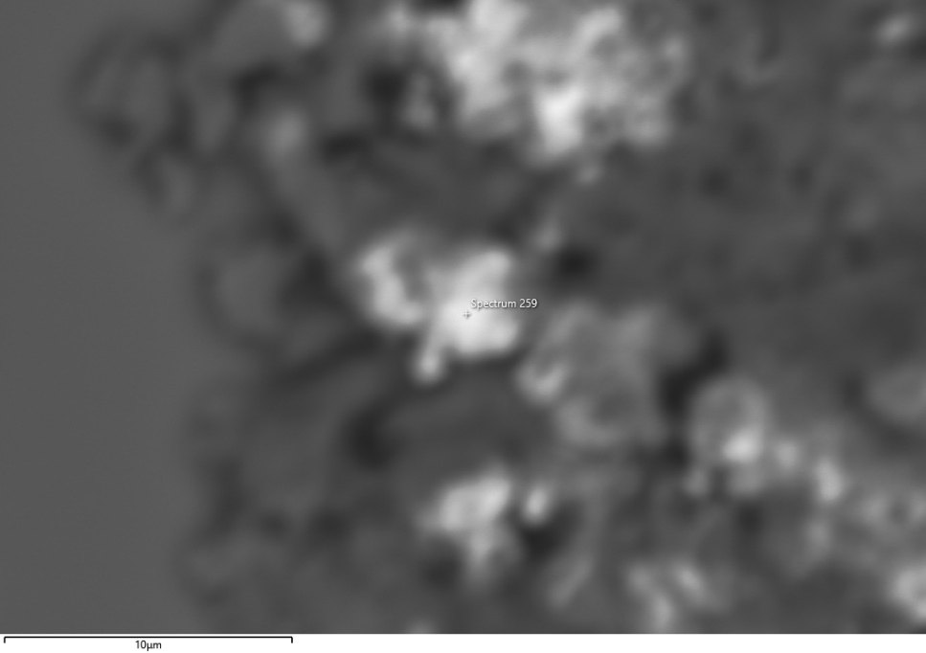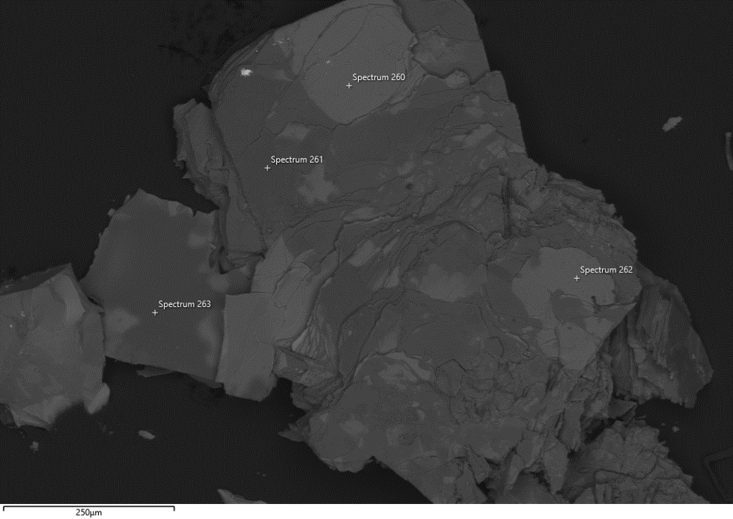
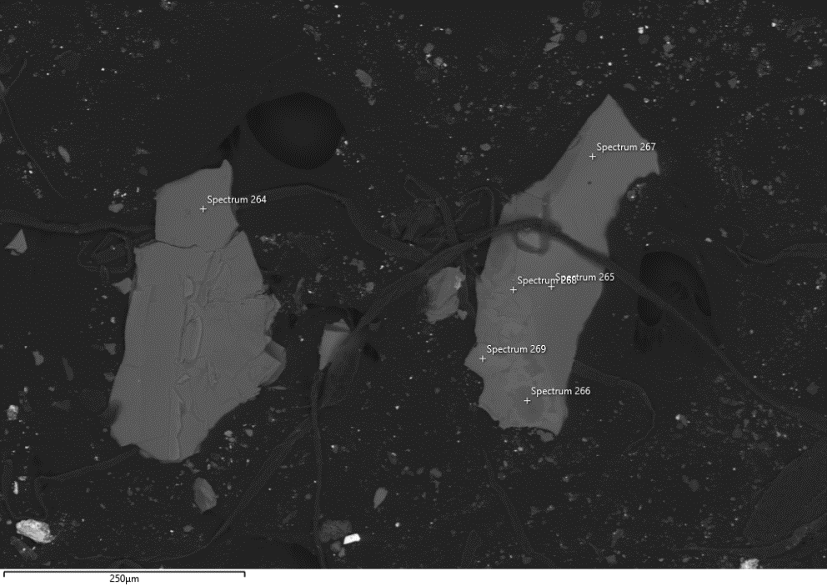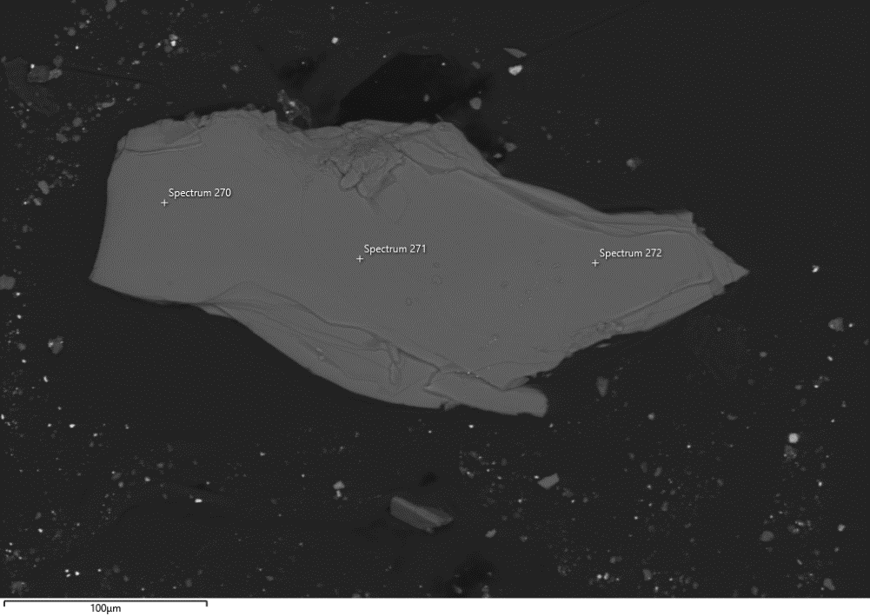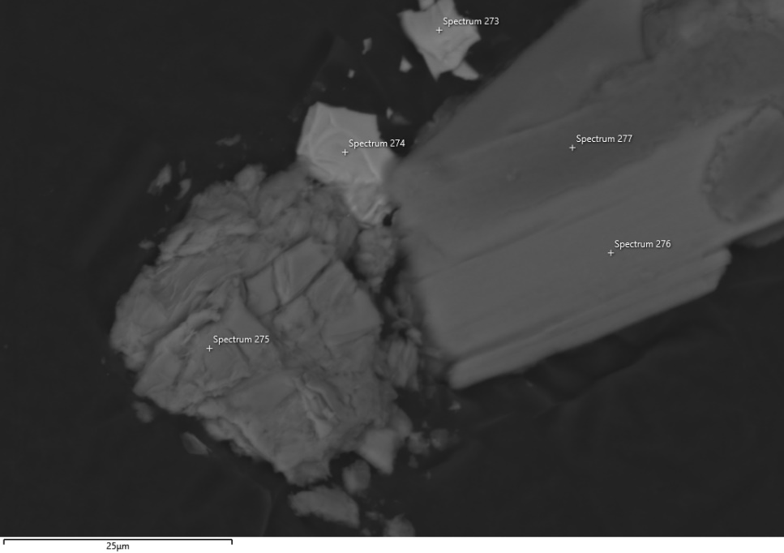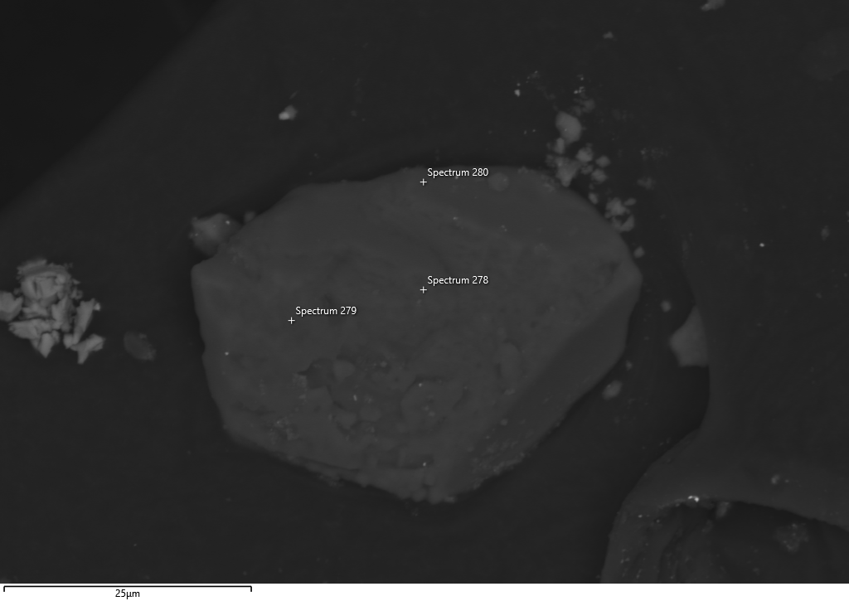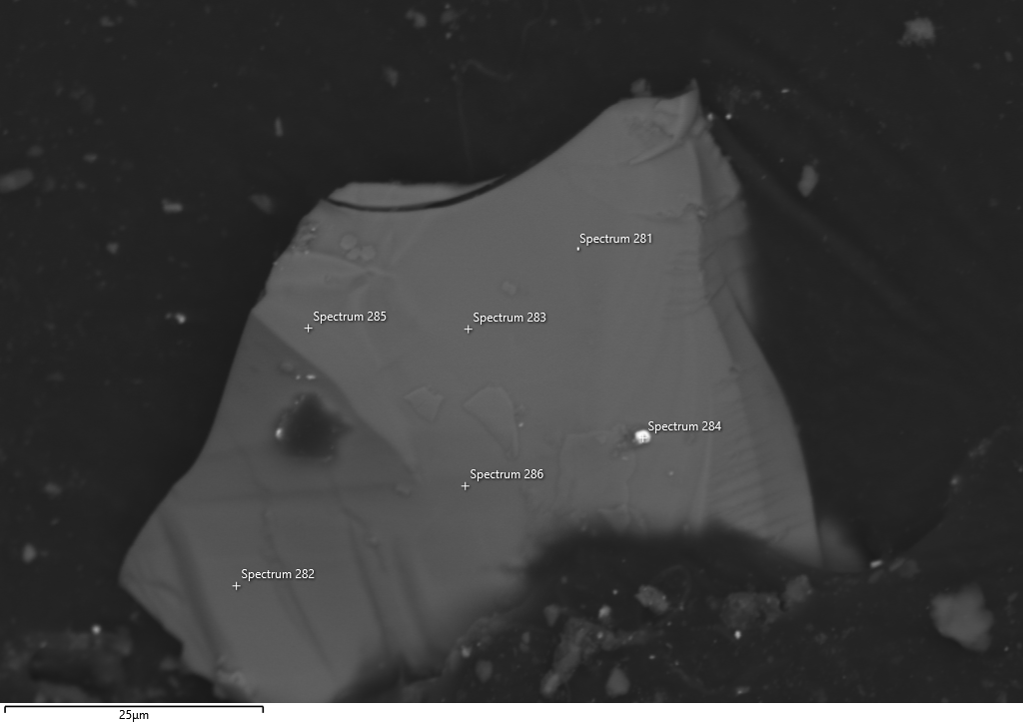 Electron micrographs with sample points: C113549

