MINERAL RESOURCES TASMANIA

Laboratory Report

LJN2021-088

MINERALOGICAL ANALYSES,

KANNUNAH

An unpublished Mineral Resources Tasmania Report for:
M Latham

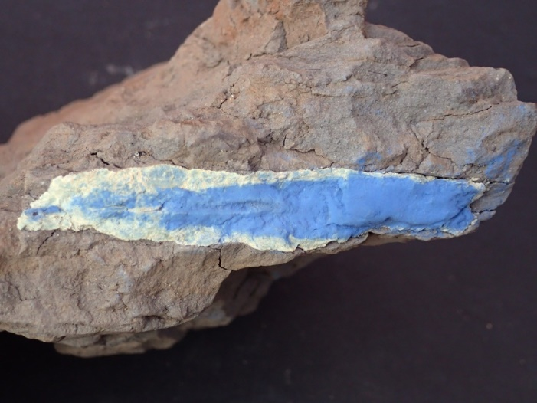
By: R.S. Bottrill
Date: 1 December 2021

Summary
The sample contains fine grained, blue vivianite and white illite, with trace quartz.

Introduction
One mineral sample was received from Mathew Latham, for mineralogical analysis. Sample details are shown in Table 1. Similar material was analysed by Bottrill, R. S.; & Woolley, R. (2017) and found to contain vivianite plus Quartz, Chlorite, Mica, Siderite, Plagioclase and K-Feldspar in matrix. As the white material was unidentified some was selected for a more detailed mineralogical study.

Table 1: Sample details.
Reg. No | Location | Description
C113551 | Nr Kannunah bridge, Arthur River | Blue and white minerals

PROCESSES
The sample was examined microscopically and some small representative parts of the sample were extracted and mounted on Al stubs for SEM/EDS analysis in the CSL. pXRF (unrecorded) indicated high Ti and Nb.

Sample descriptions
The sample contains elongate or discoidal blue concretions, up to about 6cm in diameter, comprising fine grained, blue and white material in mudstone (Fig. 1).
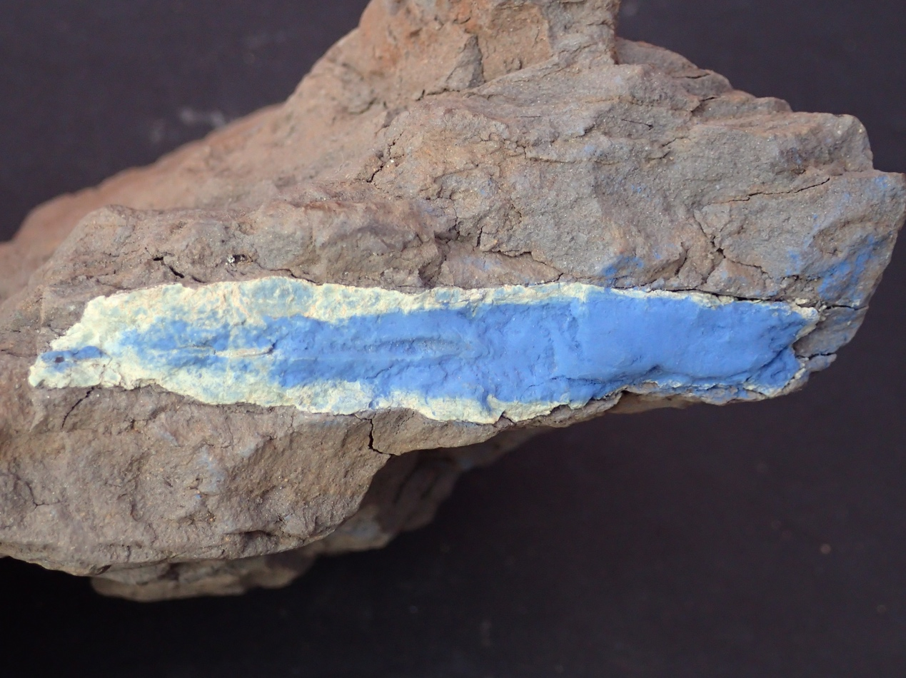
Fig. 1: Discoidal blue concretion of vivianite and a white clay, about 6cm in diameter.

SEM/EDAX analyses
The sample was analysed by SEM-EDS, in the CSL, University of Tasmania, with analytical conditions shown in Appendix 1. The results are given in Appendix 2 and summarised below.
The sample is an aggregate of vivianite, quartz and illite. The illite has a composition: K_{0.8}(Al_{1.9}Mg_{0.1}Fe_{0.1})(Si_{3.2}Al_{0.8})O₁₀(OH)_{2’} Vivianite looks very pure.

Table 2: SEM/EDAX analyses results
Spot | min | cats | Mg | Al | Si | P | S | K | Ti | Fe
156 | mix | 7 | 0.20 | 2.33 | 2.73 | 0.41 | 0.05 | 0.44 | 0.03 | 0.82
151 | mix | 7 | 0.11 | 2.23 | 2.88 | 0.52 | 0.05 | 0.48 | 0.02 | 0.71
152 | Fe ox | 7 | 0.00 | 0.16 | 0.45 | 0.39 | 0.15 | 0.18 | 0.07 | 5.59
153 | Viv | 2 | 0.00 | 0.00 | 0.00 | 0.89 | 0.00 | 0.00 | 0.00 | 1.11
154 | Viv | 2 | 0.00 | 0.00 | 0.00 | 0.86 | 0.00 | 0.00 | 0.00 | 1.14
158 | Viv++ | 2 | 0.00 | 0.01 | 0.11 | 0.90 | 0.00 | 0.00 | 0.03 | 0.95
157 | mica | 7 | 0.14 | 2.73 | 3.22 | 0.00 | 0.00 | 0.78 | 0.01 | 0.11

Discussion
The sample contains concretionary aggregates of blue vivianite and white illite in mudstone. The concretions may form through weak phosphoric acid solutions in the sediment, leaching iron from chlorite and other minerals, precipitating it as vivianite and replacing the matrix with illite.

References
BOTTRILL, R. S.; WOOLLEY, R., 2017. Mineralogical Analyses: Arthur River Area. Geol. Survey Tasmania Mineralogy/Petrology Report LJN2017-027

R.S. Bottrill
Mineralogist/Petrologist

Disclaimers
While every care has been taken in the preparation of this report, no warranty is given as to the correctness of the information and no liability is accepted for any statement or opinion or for any error or omission. No reader should act or fail to act on the basis of any material contained herein. Readers should consult professional advisers. As a result the Crown in Right of the State of Tasmania and its employees, contractors and agents expressly disclaim all and any liability (including all liability from or attributable to any negligent or wrongful act or omission) to any persons whatsoever in respect of anything done or omitted to be done by any such person in reliance whether in whole or in part upon any of the material in this report. The MRT laboratories are not NATA registered but work to similar standards. This and other data collected in MRT laboratories may enter the MRT databases but every attempt will be made to ensure it remains closed file and not be available externally, unless at your request.

Laboratory Details
Mineral Resources Tasmania (MRT) operates a laboratory facility at its offices at Rosny Park and Mornington, Tasmania. In the interests of full disclosure, these laboratories do not have NATA accreditation. However, all tests are performed according to relevant Australian Standards cited in the report and subject to internal peer review processes. The analytical facilities at MRT are periodically compared against other similar laboratories in other jurisdictions with favourable results.

Appendix 1: Laboratory Report –SEM analytical conditions

Hitachi SU-70 analytical field emission SEM
- Installed February 2011
- Schottky thermal field emission source
- ultra-high resolution (1.0 nm @ 15kV, 1.6 nm @ 1kV for SE imaging)
- high vacuum operation only (i.e. no variable pressure in chamber)
- Hitachi in-chamber and in-lens scintillation detectors, Super ExB filter, beam deceleration
- Hitachi in-chamber 5-segment solid state BSE detector, retractable
- in-column Faraday cup with picoammeter for beam current measurement
- anticontamination cold plate, liquid nitrogen cooled
- 5 axis motorised fully eucentric stage, XYZ range 110x110x40mm
- Oxford AZtec EDS/EBSD system with
  - X-Max 80 SDD EDS, MnKa 125 eV resolution, elements B-U, large area hyperspectral mapping, standardless and standards-based quantification, feature analysis
  - HKL NordlysNano EBSD camera & forescatter detector system, HKL & Channel 5 software packages, Synergy EDS/EBSD integration, HKL, ICSD & American Mineralogist phase databases
- Gatan ChromaCL2 colour cathodoluminescence imaging system with integrated BSE detector, Digital Micrograph 3 software, automated mosaic acquisition, simultaneous acquisition of SE, iBSE and colour CL images.
Label: | am 179
Element List Type: | Current
Processing Option: | All Elements
Specimen Coating: | On
Beam Calibration Element Coating: | Off
Coating Element: | Carbon
Coating Thickness: | 20 nm
Coating Density: | 2.25 g/cm³
Automatic Line Selection: | Disabled
Normalization: | Enabled
Thresholding: | Sigma level = 1
Detector Window Correction: | Enabled
Deconvolution Elements: | None
Selected Standards: | Minerals_15kV_2017-10-20 [ User ]
Pulse Pile Up Correction: | Succeeded
Detector file: | X-Max 3
Efficiency: | File based

Appendix 2: Laboratory Report –SEM Analyses

Client: M Latham
Sample Location: Kannunah
Job Number: LJN2021-088
Analyses: Mineral chemistry
Methods: SEM-EDS
Analyst: R Bottrill
Date: 22/9/2021

Table 1: C113551 EDS analyses (at. %).
Spot | min | cats | Mg | Al | Si | P | S | K | Ti | Fe
156 | mix | 7 | 0.20 | 2.33 | 2.73 | 0.41 | 0.05 | 0.44 | 0.03 | 0.82
151 | mix | 7 | 0.11 | 2.23 | 2.88 | 0.52 | 0.05 | 0.48 | 0.02 | 0.71
152 | Fe ox | 7 | 0.00 | 0.16 | 0.45 | 0.39 | 0.15 | 0.18 | 0.07 | 5.59
153 | Viv | 2 | 0.00 | 0.00 | 0.00 | 0.89 | 0.00 | 0.00 | 0.00 | 1.11
154 | Viv | 2 | 0.00 | 0.00 | 0.00 | 0.86 | 0.00 | 0.00 | 0.00 | 1.14
158 | Viv++ | 2 | 0.00 | 0.01 | 0.11 | 0.90 | 0.00 | 0.00 | 0.03 | 0.95
157 | mica | 7 | 0.14 | 2.73 | 3.22 | 0.00 | 0.00 | 0.78 | 0.01 | 0.11

