Mineralogical/Petrology Report

LJN2021-089

Mineralogical Analyses, LonG Point

An unpublished Mineral Resources Tasmania Report for:
J. van Moort
By: R.S. Bottrill,

Date: 17/8/2021

Summary
The sample from Long Point contains variably F-rich to F-poor muscovite, and F-poor biotite, plus some chlorite, plagioclase, K-feldspar and quartz.

Introduction

One mineral sample, comprising mica grains mounted in a polished block, was received from Jan van Moort, for microchemical analysis. Sample details are shown in Table 1. Some granitic micas were was analysed previously and found to contain mostly Fe-rich biotite and F-bearing muscovite (Bottrill & Unwin, 2019). The main interest is the identity and fluorine content of the micas.

Table 1: sample details.
Reg. No | Field No. | Location | Description | Process
C113280 | LP, 70.124, Ab, 17246 | Long point, NE Tas | granite | SEM

Processes

The polished block was examined microscopically and subjected to SEM/EDS analysis in the CSL, Utas.

Sample descriptions

The sample is a polished block with mica grains in epoxy (Fig. 1).

/’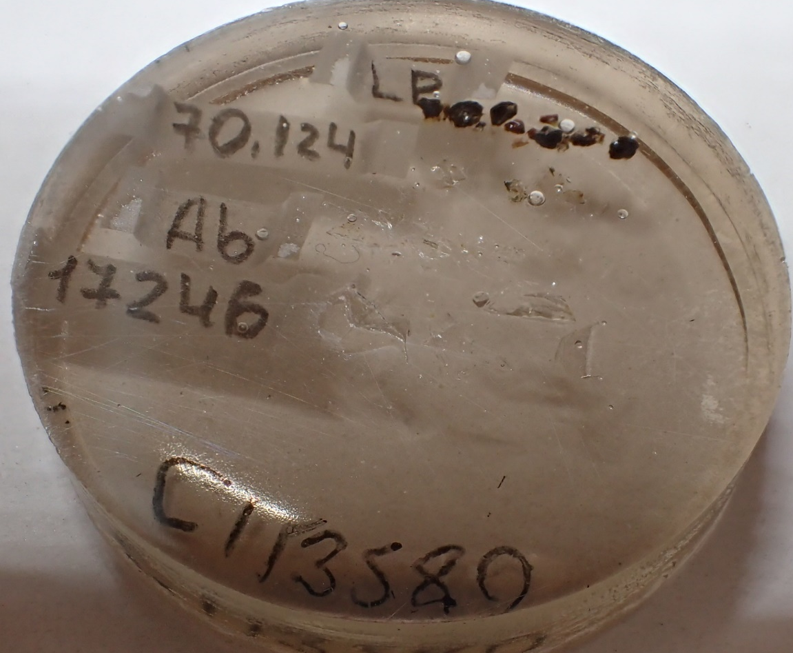
Fig. 1: Polished block, about 2.5cm in diameter, with micas C113580 (LP) & 70/124 & Ab17246.

SEM/EDAX analyses

The sample was analysed by SEM-EDS, CSL, University of Tasmania, with analytical conditions shown in Appendix 1. Li & FeO analyses are not available. Results are given in Appendix 2 and summarised below.

Ab: F-poor muscovite.
Average structural formula: (K_{0.8}Na_{0.1})(Al_{1.9} Fe³⁺_{0.1}) (Si_{3.1} Al_{0.9})O₁₀(OH)₂

70/124 F-rich muscovite.
Average structural formula: (K_{0.9})(Al_{1.9} Fe³⁺_{0.2}) (Si_{3.2} Al_{0.8})O₁₀(OH_{1.6},F_{0.4})₂

C113280 Mg-Fe biotite.
Average structural formula: (K_{0.9})( Fe³⁺_{1.2} Mg_{1.4} Ti_{0.2} Al_{0.3}) (Si_{2.8} Al_{1.2})O₁₀(OH)₂
C113280 F-bearing muscovite.
Average structural formula: (K_{0.9})(Al_{1.9} Fe³⁺_{0.1} Mg_{0.1}) (Si_{3.1} Al_{0.9})O₁₀(OH_{1.9} F_{0.1})₂

C113280 Mg-rich chamosite.
Average structural formula: (Mg_{1.2} Fe_{2.7} Mn_{0.1} Al_{1.9} K_{0.1}) (Si_{3.2}Al_{0.8})O₁₀(OH)₈

C113280 Plagioclase.
Average structural formula: (Na_{0.8}Ca_{0.2})Al_{1.2}Si_{2.8}O₈

C113280 Kspar.
Average structural formula: (K_{0.8}Na_{0.1})Al_{1.0}Si_{3.0}O₈

Discussion

The sample contains variably F-rich to F-poor muscovite, and F-poor biotite, plus some chlorite, plagioclase, K-feldspar and quartz.

References
Bottrill, R. S.; Unwin, L, 2019. Mineralogical Analyses, Micas, var Locations. Mineralogical/Petrology Report, LJN2019-028

R.S. Bottrill

Mineralogist/Petrologist

Disclaimers
While every care has been taken in the preparation of this report, no warranty is given as to the correctness of the information and no liability is accepted for any statement or opinion or for any error or omission. No reader should act or fail to act on the basis of any material contained herein. Readers should consult professional advisers. As a result the Crown in Right of the State of Tasmania and its employees, contractors and agents expressly disclaim all and any liability (including all liability from or attributable to any negligent or wrongful act or omission) to any persons whatsoever in respect of anything done or omitted to be done by any such person in reliance whether in whole or in part upon any of the material in this report. The MRT laboratories are not NARA registers but work to similar standards.This and other data collected in MRT laboratories may enter the MRT databases but every attempt will be made to ensure it remains closed file and not be available externally, unless at your request.
Appendix 1: Laboratory Report –SEM analytical conditions

Hitachi SU-70 analytical field emission SEM
- Installed February 2011
- Schottky thermal field emission source
- ultra-high resolution (1.0 nm @ 15kV, 1.6 nm @ 1kV for SE imaging)
- high vacuum operation only (i.e. no variable pressure in chamber)
- Hitachi in-chamber and in-lens scintillation detectors, Super ExB filter, beam deceleration
- Hitachi in-chamber 5-segment solid state BSE detector, retractable
- in-column Faraday cup with picoammeter for beam current measurement
- anticontamination cold plate, liquid nitrogen cooled
- 5 axis motorised fully eucentric stage, XYZ range 110x110x40mm
- Oxford AZtec EDS/EBSD system with
  - X-Max 80 SDD EDS, MnKa 125 eV resolution, elements B-U, large area hyperspectral mapping, standardless and standards-based quantification, feature analysis
  - HKL NordlysNano EBSD camera & forescatter detector system, HKL & Channel 5 software packages, Synergy EDS/EBSD integration, HKL, ICSD & American Mineralogist phase databases
- Gatan ChromaCL2 colour cathodoluminescence imaging system with integrated BSE detector, Digital Micrograph 3 software, automated mosaic acquisition, simultaneous acquisition of SE, iBSE and colour CL images.

Label: | am 179
Element List Type: | Current
Processing Option: | All Elements
Specimen Coating: | On
Beam Calibration Element Coating: | Off
Coating Element: | Carbon
Coating Thickness: | 20 nm
Coating Density: | 2.25 g/cm³
Automatic Line Selection: | Disabled
Normalization: | Enabled
Thresholding: | Sigma level = 1
Detector Window Correction: | Enabled
Deconvolution Elements: | None
Selected Standards: | Minerals_15kV_2017-10-20 [ User ]
Pulse Pile Up Correction: | Succeeded
Detector file: | X-Max 3
Efficiency: | File based

Appendix 2: Laboratory Report –SEM Analyses

Client: J van Moort
Sample Location: Long Point
Job Number: LJN2021-089
Analyses: Mineral chemistry
Methods: SEM-EDS
Analyst: R Bottrill
Date: 22/9/2021

Table 1: Ab EDS analyses (at. %). Muscovites to 7 cations. Row 3
Project Path | Label | F | Na | Mg | Al | Si | Cl | K | Ca | Ti | Mn | Fe | Ba
2021-09-22/C113280 LP JvM/Site 4 | 396 | 0.00 | 0.11 | 0.08 | 2.80 | 3.05 | 0.00 | 0.83 | 0.00 | 0.01 | 0.00 | 0.12 | 0.00
2021-09-22/C113280 LP JvM/Site 4 | 397 | 0.00 | 0.10 | 0.08 | 2.81 | 3.08 | 0.00 | 0.81 | 0.00 | 0.00 | 0.00 | 0.11 | 0.00
2021-09-22/C113280 LP JvM/Site 4 | 398 | 0.00 | 0.10 | 0.08 | 2.80 | 3.08 | 0.00 | 0.82 | 0.00 | 0.00 | 0.00 | 0.12 | 0.00
2021-09-22/C113280 LP JvM/Site 4 | 399 | 0.00 | 0.10 | 0.08 | 2.81 | 3.04 | 0.00 | 0.84 | 0.00 | 0.01 | 0.00 | 0.12 | 0.00
2021-09-22/C113280 LP JvM/Site 4 | 400 | 0.00 | 0.10 | 0.08 | 2.82 | 3.05 | 0.00 | 0.84 | 0.00 | 0.00 | 0.00 | 0.12 | 0.00

Table 2: 70/124 EDS analyses (at. %). Muscovites; to 7 cations. Row 2
Project Path | Label | F | Na | Mg | Al | Si | Cl | K | Ca | Ti | Mn | Fe | Ba
2021-09-22/C113280 LP JvM/Site 2 | 389 | 0.31 | 0.02 | 0.02 | 2.78 | 3.17 | 0.00 | 0.85 | 0.00 | 0.00 | 0.00 | 0.15 | 0.00
2021-09-22/C113280 LP JvM/Site 2 | 390 | 0.22 | 0.03 | 0.00 | 2.84 | 3.21 | 0.00 | 0.82 | 0.00 | 0.00 | 0.00 | 0.10 | 0.00
2021-09-22/C113280 LP JvM/Site 2 | 391 | 0.35 | 0.03 | 0.03 | 2.67 | 3.21 | 0.00 | 0.90 | 0.00 | 0.00 | 0.00 | 0.17 | 0.00
2021-09-22/C113280 LP JvM/Site 2 | 392 | 0.29 | 0.00 | 0.04 | 2.72 | 3.21 | 0.00 | 0.86 | 0.00 | 0.00 | 0.00 | 0.16 | 0.00
2021-09-22/C113280 LP JvM/Site 3 | 393 | 0.51 | 0.03 | 0.06 | 2.70 | 3.18 | 0.00 | 0.87 | 0.00 | 0.00 | 0.02 | 0.15 | 0.00
2021-09-22/C113280 LP JvM/Site 3 | 394 | 0.35 | 0.00 | 0.06 | 2.63 | 3.21 | 0.00 | 0.88 | 0.00 | 0.00 | 0.02 | 0.20 | 0.00
2021-09-22/C113280 LP JvM/Site 3 | 395 | 0.50 | 0.03 | 0.09 | 2.55 | 3.26 | 0.01 | 0.88 | 0.00 | 0.00 | 0.00 | 0.17 | 0.00

Table 3: C113280 EDS analyses (at. %).Row 1. Muscovites to 7 cations.
Project Path | Label | F | Na | Mg | Al | Si | Cl | K | Ca | Ti | Mn | Fe | Ba
2021-09-22/C113280 LP JvM/Site 1 | 383 | 0.09 | 0.08 | 0.07 | 2.84 | 3.04 | 0.00 | 0.84 | 0.00 | 0.03 | 0.00 | 0.10 | 0.00
2021-09-22/C113280 LP JvM/Site 1 | 384 | 0.14 | 0.08 | 0.09 | 2.76 | 3.10 | 0.00 | 0.82 | 0.00 | 0.03 | 0.00 | 0.13 | 0.00
2021-09-22/C113280 LP JvM/Site 1 | 385 | 0.09 | 0.08 | 0.07 | 2.81 | 3.10 | 0.00 | 0.81 | 0.00 | 0.03 | 0.00 | 0.11 | 0.00
2021-09-22/C113280 LP JvM/Site 1 | 386 | 0.13 | 0.07 | 0.07 | 2.81 | 3.08 | 0.00 | 0.82 | 0.00 | 0.03 | 0.00 | 0.12 | 0.00
2021-09-22/C113280 LP JvM/Site 1 | 387 | 0.12 | 0.07 | 0.07 | 2.81 | 3.09 | 0.00 | 0.81 | 0.00 | 0.03 | 0.00 | 0.11 | 0.00
2021-09-22/C113280 LP JvM/Site 1 | 388 | 0.14 | 0.08 | 0.07 | 2.82 | 3.06 | 0.00 | 0.84 | 0.00 | 0.03 | 0.00 | 0.10 | 0.00
2021-09-22/C113280 LP JvM/Site 5 | 401 | 0.00 | 0.08 | 0.08 | 2.79 | 3.10 | 0.00 | 0.80 | 0.00 | 0.01 | 0.00 | 0.13 | 0.00
2021-09-22/C113280 LP JvM/Site 5 | 402 | 0.00 | 0.09 | 0.07 | 2.80 | 3.12 | 0.00 | 0.79 | 0.00 | 0.00 | 0.00 | 0.13 | 0.00
2021-09-22/C113280 LP JvM/Site 5 | 403 | 0.00 | 0.08 | 0.08 | 2.80 | 3.09 | 0.00 | 0.80 | 0.00 | 0.00 | 0.00 | 0.13 | 0.00
2021-09-22/C113280 LP JvM/Site 5 | 404 | 0.00 | 0.10 | 0.08 | 2.79 | 3.11 | 0.00 | 0.79 | 0.00 | 0.00 | 0.00 | 0.13 | 0.00
2021-09-22/C113280 LP JvM/Site 9 | 420 | 0.13 | 0.07 | 0.08 | 2.79 | 3.11 | 0.00 | 0.81 | 0.00 | 0.02 | 0.00 | 0.13 | 0.00
2021-09-22/C113280 LP JvM/Site 9 | 421 | 0.07 | 0.06 | 0.09 | 2.77 | 3.13 | 0.00 | 0.84 | 0.00 | 0.00 | 0.00 | 0.11 | 0.00
2021-09-22/C113280 LP JvM/Site 9 | 422 | 0.00 | 0.07 | 0.07 | 2.84 | 3.11 | 0.00 | 0.79 | 0.00 | 0.02 | 0.00 | 0.10 | 0.00
2021-09-22/C113280 LP JvM/Site 9 | 423 | 0.00 | 0.05 | 0.08 | 2.82 | 3.11 | 0.00 | 0.83 | 0.00 | 0.02 | 0.00 | 0.10 | 0.00
2021-09-22/C113280 LP JvM/Site 9 | 424 | 0.09 | 0.04 | 0.11 | 2.74 | 3.14 | 0.00 | 0.83 | 0.00 | 0.00 | 0.00 | 0.14 | 0.00
2021-09-22/C113280 LP JvM/Site 9 | 425 | 0.10 | 0.05 | 0.09 | 2.77 | 3.13 | 0.00 | 0.83 | 0.00 | 0.02 | 0.00 | 0.11 | 0.00
2021-09-22/C113280 LP JvM/Site 10 | 428 | 0.11 | 0.08 | 0.07 | 2.83 | 3.07 | 0.00 | 0.82 | 0.00 | 0.03 | 0.00 | 0.11 | 0.00
2021-09-22/C113280 LP JvM/Site 10 | 429 | 0.08 | 0.08 | 0.08 | 2.82 | 3.10 | 0.00 | 0.83 | 0.00 | 0.02 | 0.00 | 0.09 | 0.00
2021-09-22/C113280 LP JvM/Site 10 | 430 | 0.15 | 0.06 | 0.08 | 2.80 | 3.08 | 0.00 | 0.84 | 0.00 | 0.02 | 0.00 | 0.12 | 0.00

Table 3: C113280 EDS analyses (at. %).Row 1. Biotites to 8 cations.
Project Path | Label | F | Na | Mg | Al | Si | Cl | K | Ca | Ti | Mn | Fe | Ba
2021-09-22/C113280 LP JvM/Site 6 | 405 | 0.00 | 0.00 | 1.40 | 1.44 | 2.84 | 0.02 | 0.92 | 0.00 | 0.18 | 0.00 | 1.19 | 0.00
2021-09-22/C113280 LP JvM/Site 6 | 407 | 0.00 | 0.00 | 1.40 | 1.46 | 2.80 | 0.03 | 0.93 | 0.00 | 0.19 | 0.02 | 1.17 | 0.00
2021-09-22/C113280 LP JvM/Site 6 | 408 | 0.00 | 0.00 | 1.41 | 1.46 | 2.84 | 0.03 | 0.92 | 0.00 | 0.18 | 0.00 | 1.17 | 0.00
2021-09-22/C113280 LP JvM/Site 6 | 409 | 0.00 | 0.00 | 1.39 | 1.46 | 2.85 | 0.03 | 0.92 | 0.00 | 0.19 | 0.00 | 1.17 | 0.00
2021-09-22/C113280 LP JvM/Site 6 | 410 | 0.00 | 0.00 | 1.43 | 1.47 | 2.83 | 0.02 | 0.91 | 0.00 | 0.19 | 0.00 | 1.15 | 0.00
2021-09-22/C113280 LP JvM/Site 7 | 411 | 0.00 | 0.00 | 1.41 | 1.45 | 2.84 | 0.02 | 0.92 | 0.00 | 0.19 | 0.01 | 1.15 | 0.00
2021-09-22/C113280 LP JvM/Site 7 | 412 | 0.00 | 0.00 | 1.41 | 1.46 | 2.81 | 0.02 | 0.93 | 0.00 | 0.19 | 0.02 | 1.17 | 0.00
2021-09-22/C113280 LP JvM/Site 7 | 413 | 0.00 | 0.00 | 1.40 | 1.43 | 2.82 | 0.02 | 0.94 | 0.00 | 0.19 | 0.00 | 1.19 | 0.00
2021-09-22/C113280 LP JvM/Site 7 | 414 | 0.00 | 0.00 | 1.40 | 1.45 | 2.82 | 0.03 | 0.91 | 0.00 | 0.20 | 0.02 | 1.17 | 0.00
2021-09-22/C113280 LP JvM/Site 7 | 415 | 0.00 | 0.00 | 1.39 | 1.48 | 2.84 | 0.02 | 0.90 | 0.00 | 0.19 | 0.02 | 1.16 | 0.00
2021-09-22/C113280 LP JvM/Site 7 | 416 | 0.00 | 0.00 | 1.42 | 1.44 | 2.82 | 0.03 | 0.90 | 0.00 | 0.20 | 0.02 | 1.18 | 0.00

Table 3: C113551 EDS analyses (at. %).Row 1. Chlorites to 8 cations.
Project Path | Label | F | Na | Mg | Al | Si | Cl | K | Ca | Ti | Mn | Fe | Ba
2021-09-22/C113280 LP JvM/Site 1 | 382 | 0.00 | 0.00 | 0.85 | 1.91 | 2.00 | 0.00 | 0.03 | 0.00 | 0.00 | 0.07 | 2.13 | 0.00
2021-09-22/C113280 LP JvM/Site 10 | 426 | 0.00 | 0.00 | 0.87 | 1.91 | 2.34 | 0.00 | 0.04 | 0.02 | 0.00 | 0.05 | 1.77 | 0.00
2021-09-22/C113280 LP JvM/Site 10 | 427 | 0.00 | 0.00 | 0.77 | 1.86 | 2.26 | 0.00 | 0.20 | 0.00 | 0.03 | 0.05 | 1.83 | 0.00

Table 3: C113280 EDS analyses (at. %).Row 1. Feldspars to 5 cations.
Project Path | Label | F | Na | Mg | Al | Si | Cl | K | Ca | Ti | Mn | Fe | Ba
2021-09-22/C113280 LP JvM/Site 8 Kf | 418 | 0.00 | 0.05 | 0.00 | 1.04 | 3.00 | 0.00 | 0.91 | 0.00 | 0.00 | 0.00 | 0.00 | 0.01
2021-09-22/C113280 LP JvM/Site 8 Plag | 419 | 0.00 | 0.74 | 0.00 | 1.23 | 2.81 | 0.00 | 0.01 | 0.20 | 0.00 | 0.00 | 0.00 | 0.00

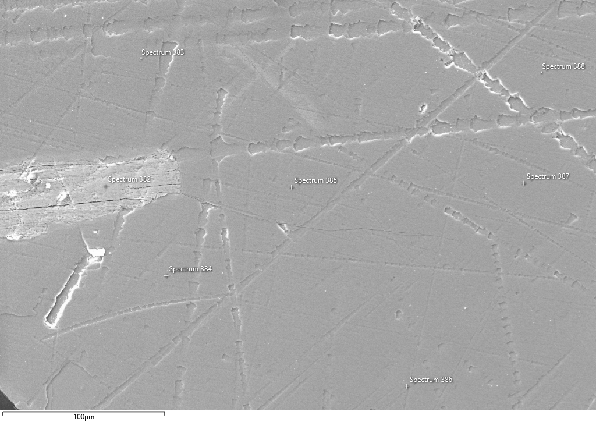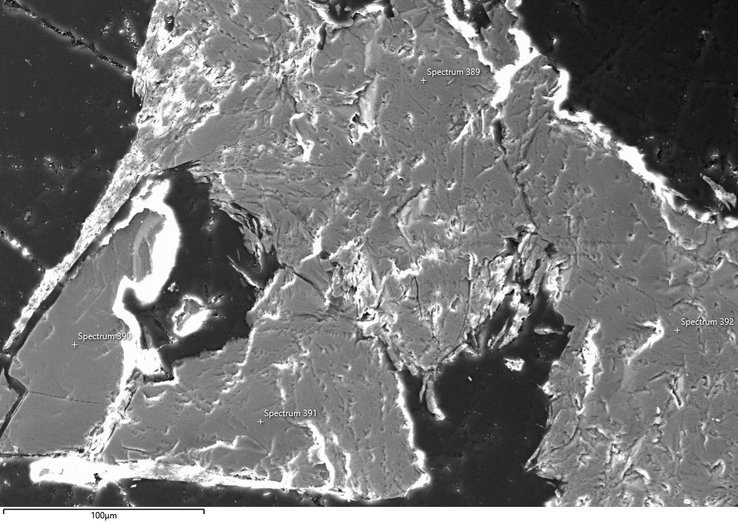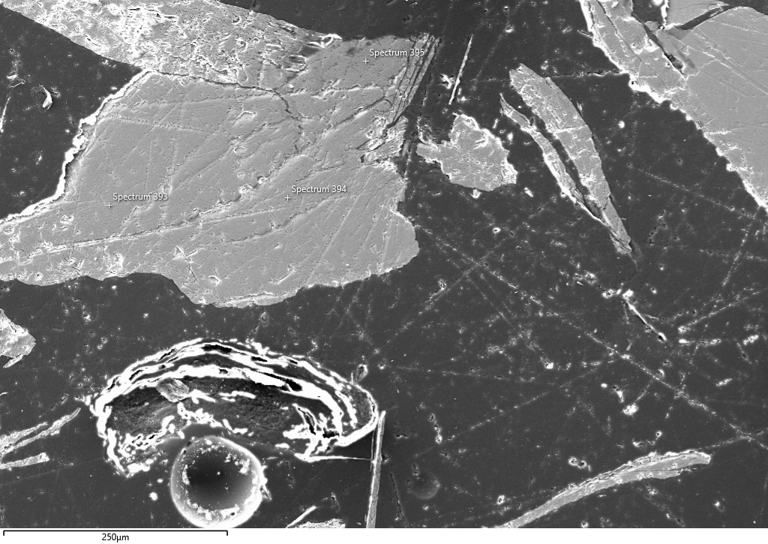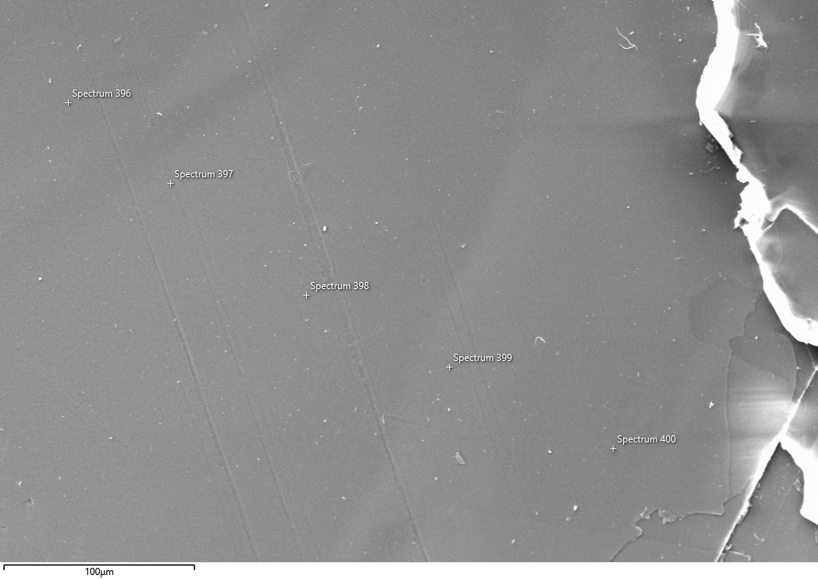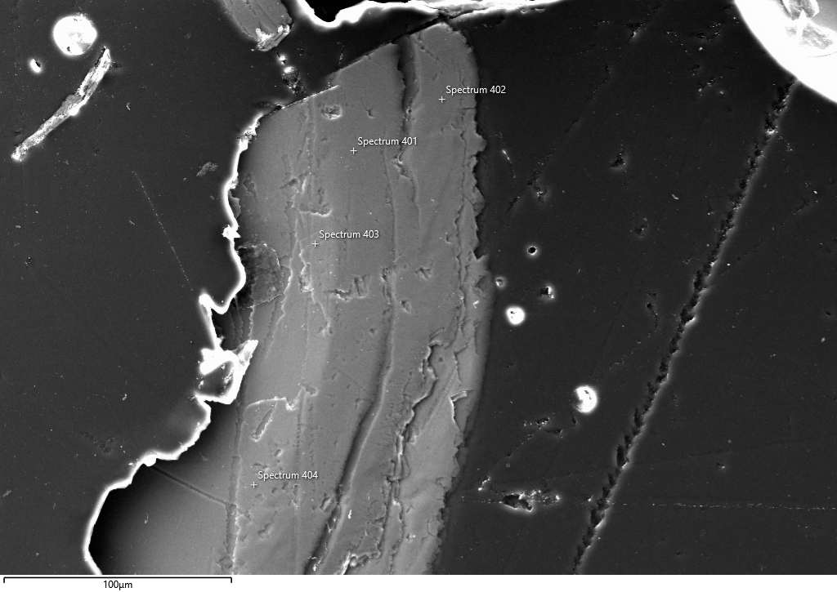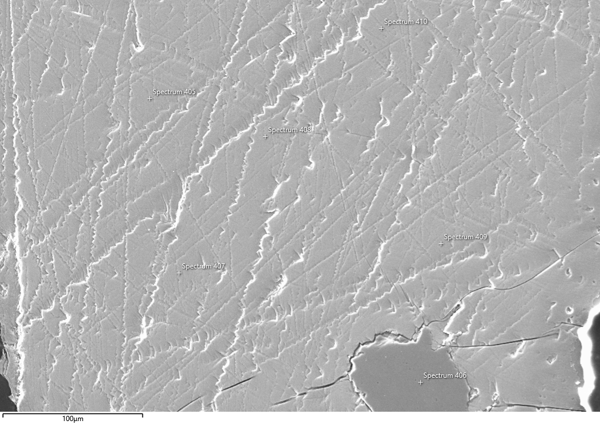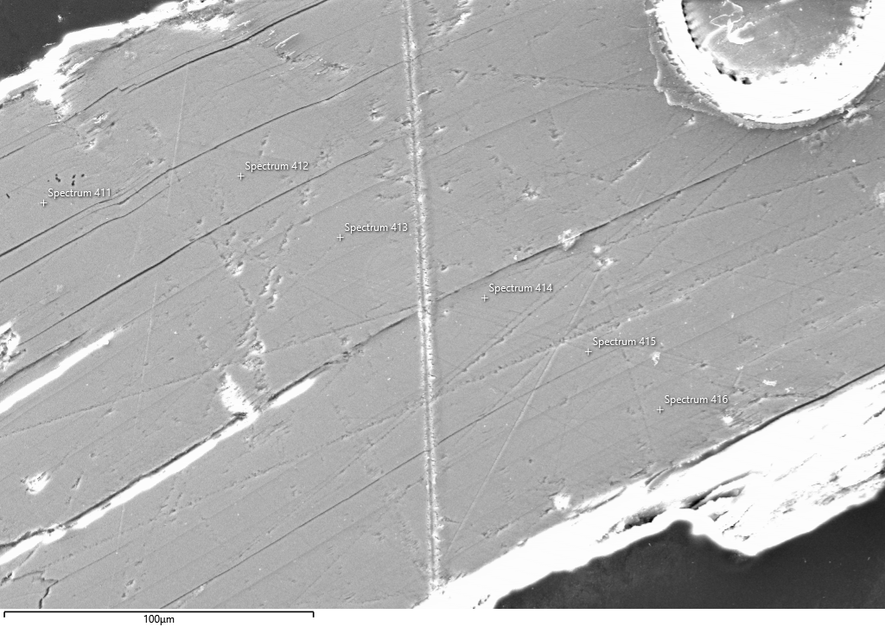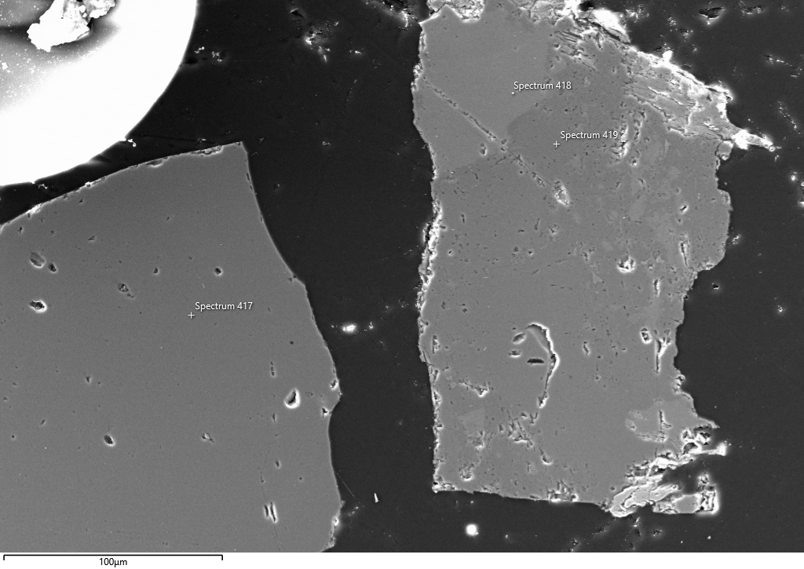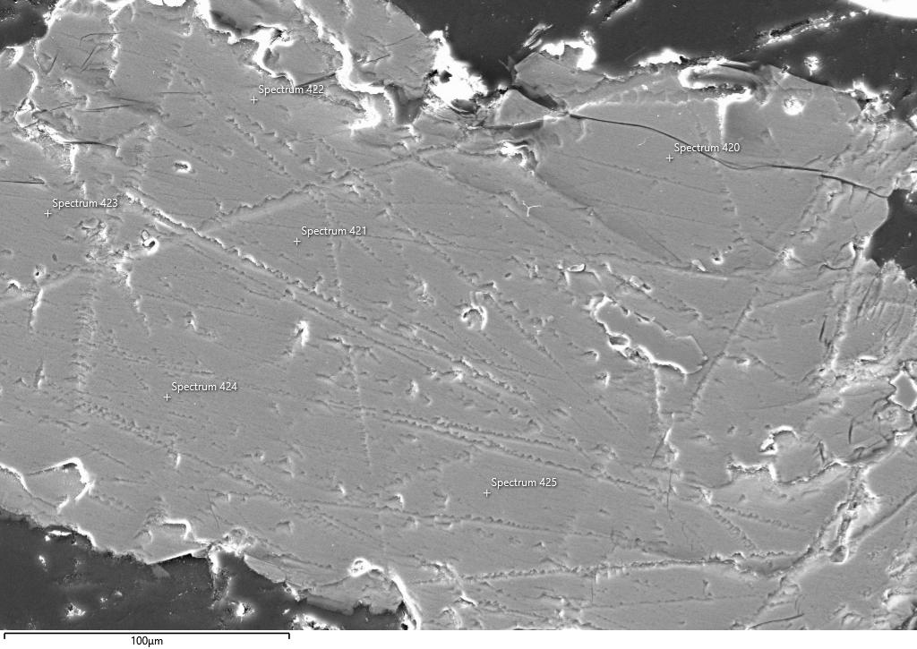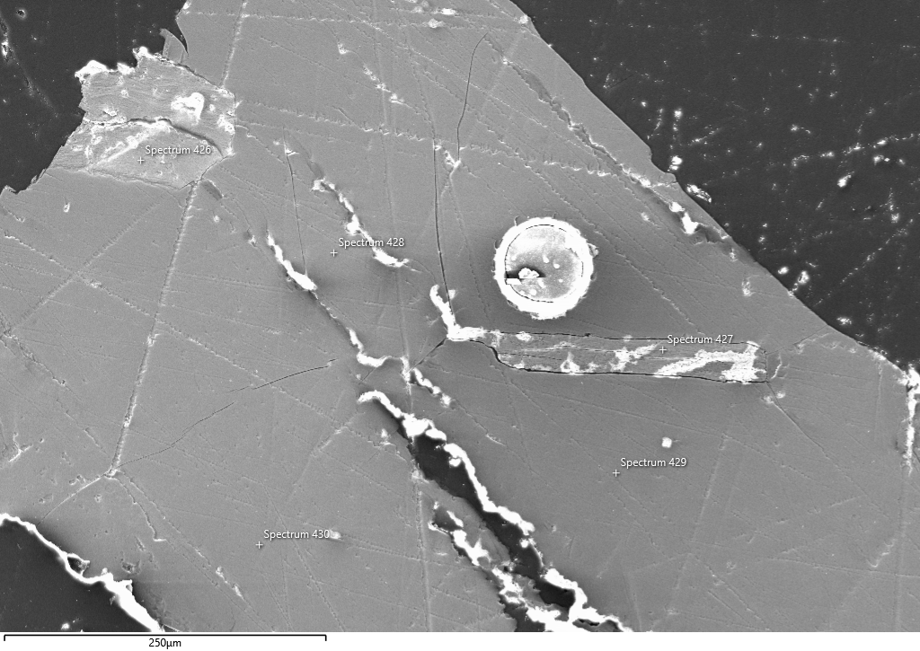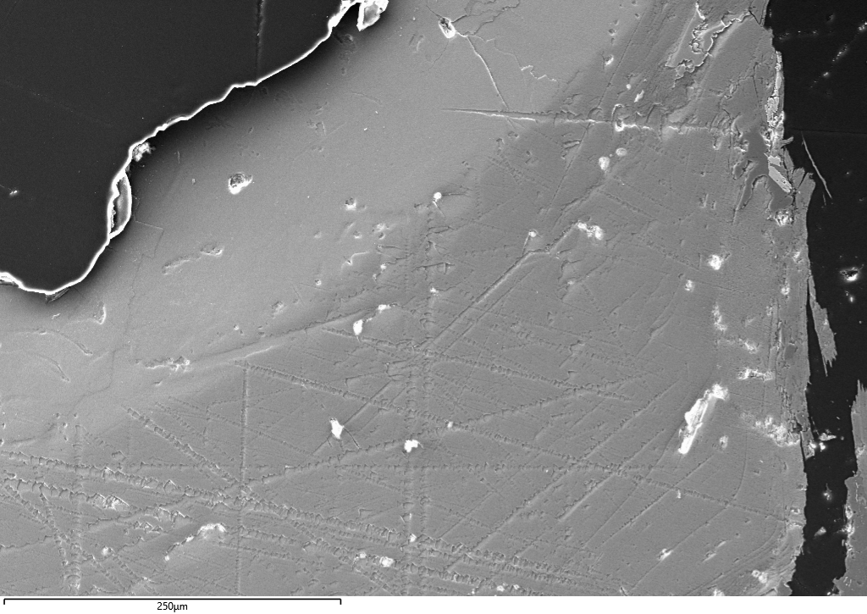Fig. 2: Electron micrographs with sample points: C113539

Fig. 3: Electron micrographs with sample points: C113539

