MINERAL RESOURCES TASMANIA

Laboratory Report

LJN2021-092

Mineralogical Examination of Rock from Cape Grim

An unpublished Mineral Resources Tasmania Report for:

M Latham

By: R.S. Bottrill and Lia Unwin
Date: 1 December 2021

Summary

The sample submitted, labelled as tacharanite, is a mixture of an apophyllite group mineral and natrolite.

Introduction
One mineral sample was submitted by M Latham for mineralogical analysis, with details shown in Table 1. The main goal was to determine if it is tacharanite, a rare mineral reported from this location, but with no confirmatory information.

Table 1: Sample details.
Reg. No | Location | Description
G409815 | Cape Grim | White porcellanous material

Sample Preparation
The rock was examined by stereomicroscopy, subsampled, and analysed for mineralogy by XRD (X-Ray diffraction), in the Mineral Resources Tasmania (MRT) laboratories, Rosny.

Sample descriptions
G409815 is a hard, white, fine grained, porcelaneous material (Fig. 1).
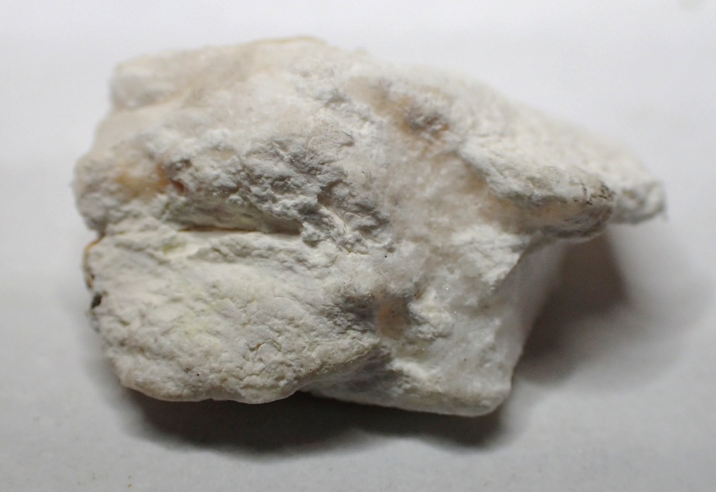

Figure 1. G409815. White porcelaneous material, as received. FOV ~10mm.

XRD analyses
The samples were prepared, examined and analysed in the MRT laboratories, Rosny Park, Tasmania. They were run on a Rigaku Miniflex 600 X-Ray Diffractometer system: a 600W generator 150mm goniometer with a Cu tube; 40kV/15mA, sample spinner and a Scintillation counter (SC) with Be window, -3º to 145º 2Ø scanning range and 2º - 145º 2Ø measuring range, with a scanning speed of 0.01 to 100º/min, a graphite counter monochromator and a Kß Ni- filter. The analysis software used is the PDXL2 using the ICCD database.
The results are shown in Appendix 1 and is mostly an apophyllite-group mineral, plus minor natrolite.

Discussion and Conclusions
Tacharanite was not confirmed on this sample so its prevalence in this site is uncertain.

R.S. Bottrill L Unwin
Mineralogist/Petrologist Technical Officer

Disclaimers

While every care has been taken in the preparation of this report, no warranty is given as to the correctness of the information and no liability is accepted for any statement or opinion or for any error or omission. No reader should act or fail to act on the basis of any material contained herein. Readers should consult professional advisers. As a result the Crown in Right of the State of Tasmania and its employees, contractors and agents expressly disclaim all and any liability (including all liability from or attributable to any negligent or wrongful act or omission) to any persons whatsoever in respect of anything done or omitted to be done by any such person in reliance whether in whole or in part upon any of the material in this report. The MRT laboratories are not NATA registered but work to similar standards. This and other data collected in MRT laboratories may enter the MRT databases but every attempt will be made to ensure it remains closed file and not be available externally, unless at your request.

Laboratory Details

Mineral Resources Tasmania (MRT) operates a laboratory facility at its offices at Rosny Park and Mornington, Tasmania. In the interests of full disclosure, these laboratories do not have NATA accreditation. However, all tests are performed according to relevant Australian Standards cited in the report and subject to internal peer review processes. The analytical facilities at MRT are periodically compared against other similar laboratories in other jurisdictions with favourable results.

Appendix 1 XRD Results-G409815+qtz

General Information

Measurement date: | 1/10/2021 | Interpretative date: | 26/11/2021
Job Number/Client: | LJN2021-092 RSB | XRD | Rigaku Miniflex 600
Registration Number: | G409815 | Analyst: | LUnwin
Quantitative Method: | Mineralogy Only | Process Medium: | Wholerock
Sample Holder: | Low Reflectance | Speed (deg/min): | 0.9
Comment: | Shifted -0.03, quartz added for calibration

Analysis Results

Phase name | Formula
Apophyllite | KCa₄(Si₄O₁₀)₂F•8(H₂O)
Natrolite | Na₂Al₂Si₃O₁₀•2(H₂O

Notes
Peak overlap may interfere with identifications and quantitative calculations.
Amorphous minerals and minerals present in trace amounts may not be detected.

Phase Data Pattern

Peak List
No. | 2-theta(deg) | d(ang.) | Phase name | Rel. int. I(a.u.)
1 | 11.323(6) | 7.809(4) | Apophyllite(0,0,2) | 81.22
2 | 13.890(7) | 6.370(3) | Apophyllite(1,1,0) | 7.92
3 | 14.9284 | 5.92963 | Natrolite(1,0,1) | 4.21
4 | 17.1116 | 5.17767 | Natrolite(3,-1,0) | 1.95
5 | 17.816 | 4.97452 | Apophyllite(1,1,2) | 2.56
6 | 19.519(11) | 4.544(2) | Apophyllite(1,0,3),Natrolite(3,-2,0) | 73.50
7 | 20.8369 | 4.25964 | Natrolite(0,4,0) | 15.24
8 | 22.143(9) | 4.0112(16) | Apophyllite(2,1,0) | 4.02
9 | 22.467(2) | 3.9542(4) | Apophyllite(0,0,4),Natrolite(4,-1,0) | 47.06
10 | 22.806(3) | 3.8961(5) | Apophyllite(2,0,2),Natrolite(3,3,0) | 36.15
11 | 24.854(7) | 3.5795(10) | Apophyllite(2,1,2) | 62.80
12 | 26.622(6) | 3.3457(8) | Apophyllite(1,1,4),Natrolite(3,-4,0) | 100.00
13 | 28.080(8) | 3.1751(8) | Apophyllite(2,1,3),Natrolite(4,-2,1) | 30.44
14 | 29.931(9) | 2.9829(9) | Apophyllite(1,0,5),Natrolite(2,0,2) | 99.61
15 | 30.340(10) | 2.9436(10) | Apophyllite(2,2,2),Natrolite(2,-1,2) | 25.94
16 | 31.807(19) | 2.8112(17) | Apophyllite(3,1,0),Natrolite(0,6,0) | 16.72
17 | 33.494(9) | 2.6733(7) | Apophyllite(3,1,2),Natrolite(2,6,0) | 16.34
18 | 34.5042 | 2.59729 | Apophyllite(3,0,3),Natrolite(0,6,1) | 2.49
19 | 35.880(17) | 2.5008(11) | Apophyllite(3,1,3),Natrolite(3,6,0) | 84.39
20 | 36.120(9) | 2.4847(6) | Apophyllite(3,2,0),Natrolite(3,-3,2) | 43.37
21 | 36.905(10) | 2.4337(7) | Apophyllite(1,1,6),Natrolite(0,7,0) | 9.09
22 | 39.42(4) | 2.284(2) | Natrolite(6,-3,1) | 2.99
23 | 40.94(3) | 2.2026(15) | Apophyllite(2,1,6),Natrolite(5,-5,1) | 12.94
24 | 41.79(2) | 2.1597(10) | Apophyllite(4,0,2),Natrolite(4,4,2) | 6.72
25 | 42.424(14) | 2.1289(7) | Natrolite(0,8,0) | 4.35
26 | 42.807(19) | 2.1108(9) | Apophyllite(3,3,0),Natrolite(6,5,0) | 36.55
27 | 45.102(12) | 2.0086(5) | Apophyllite(4,1,3),Natrolite(2,2,3) | 24.35
28 | 46.5869 | 1.94794 | Apophyllite(4,0,4),Natrolite(5,-7,0) | 3.13
29 | 50.119(13) | 1.8186(5) | Natrolite(0,9,1) | 8.34
30 | 51.04(5) | 1.7881(16) | Apophyllite(4,3,0),Natrolite(7,-6,0) | 10.34
31 | 51.68(3) | 1.7672(9) | Apophyllite(2,1,8),Natrolite(2,-9,1) | 22.36
32 | 53.0888 | 1.72368 | Apophyllite(1,0,9),Natrolite(7,-4,2) | 3.72
33 | 54.8768 | 1.67167 | Apophyllite(3,2,7),Natrolite(6,-8,0) | 6.74
34 | 55.4187 | 1.6566 | Apophyllite(5,2,1),Natrolite(4,-9,1) | 5.87
35 | 58.384(16) | 1.5793(4) | Apophyllite(0,0,10),Natrolite(5,5,3) | 17.59

