MINERAL RESOURCES TASMANIA

Laboratory Report
LJN2021-105

PETROPHYSICAL TESTS,

Bicheno

An unpublished Mineral Resources Report for:

Mark Duffett, MRT

By: R.Bottrill, R. King and
L.Unwin

Date: 3 March 2022


Mineral Resources Tasmania
Department of State Growth

Introduction
Twenty rock samples were collected from Bicheno Drill Cores by M Duffett, for physical property measurements; 1 sample “G405418” disintegrated upon soaking and could not be analysed; with details listed in Table 1 below.
Table 1: Sample details
Reg# | Field No. | Sample Description
L301920 | 60 m | arenite, lithic
G405420 | BBH5/12A | sandstone
G405423 | BBH5/14 | sandstone
G405416 | BBH5/9A | sandstone
G405418 | BBH5/10B | sandstone
L301922 | 210.1 | quartzose sandstone
L301934 | 438 | metaquartz-wacke
L301923 | 225.1 | glaciomarine siltstone with dropstones and quartz grits
L301921 | 64.9 m | arenite, lithic
L301931 | 399.9 | conglomerate
L301930 | 380 | conglomerate
L301932 | 420.8 | conglomerate
L301933 | 436 | metaquartz-wacke
L301928 | 340.5 | siltstone, shelly
L301924 | 228.9 | glaciomarine siltstone with dropstones and quartz grits
L301925 | 232.4 | glaciomarine siltstone with dropstones and quartz grits
L301927 | 322.5 | siltstone, shelly
L301926 | 242.1 | glaciomarine siltstone with dropstones and quartz grits
L301929 | 359.9 | siltstone, pebbly
G405421 | BBH5/13A | sandstone

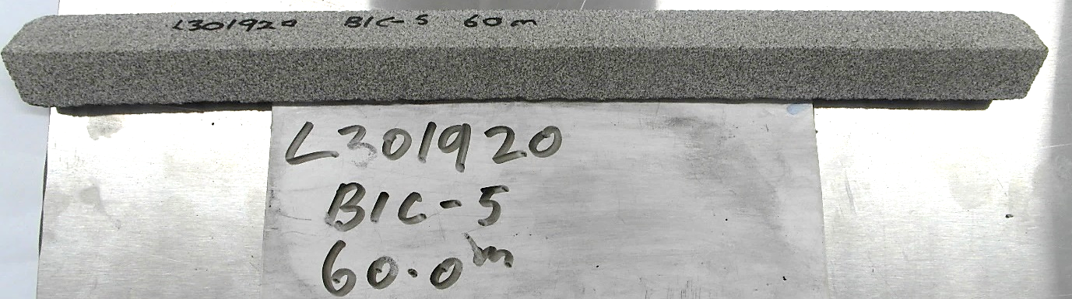
Photo 1: Sample L3019020 - Arenite. FOV: about 300 mm

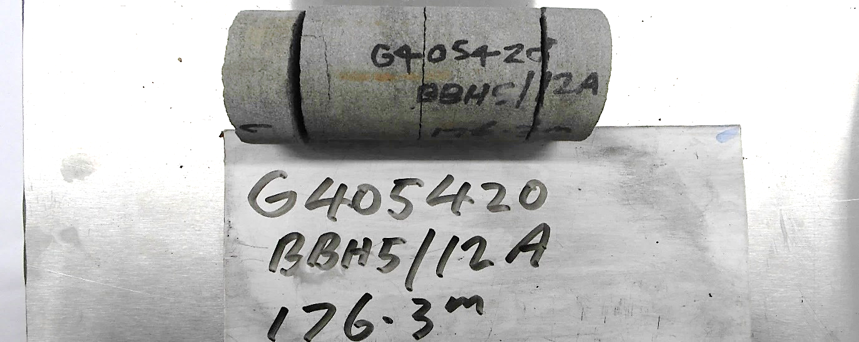
Photo 2: Sample G405420 – Sandstone. FOV: about 200 mm

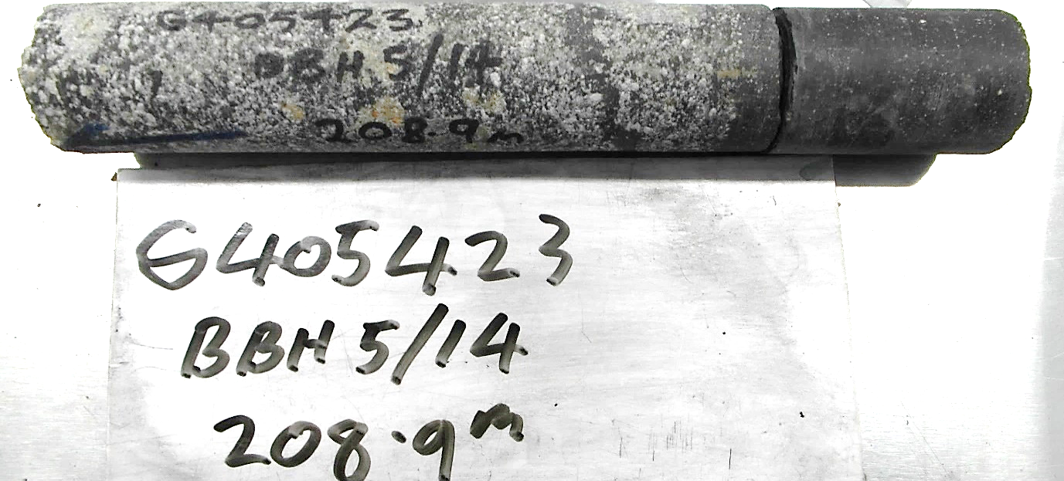
Photo 3: Sample G405423– Sandstone. FOV: about 200 mm
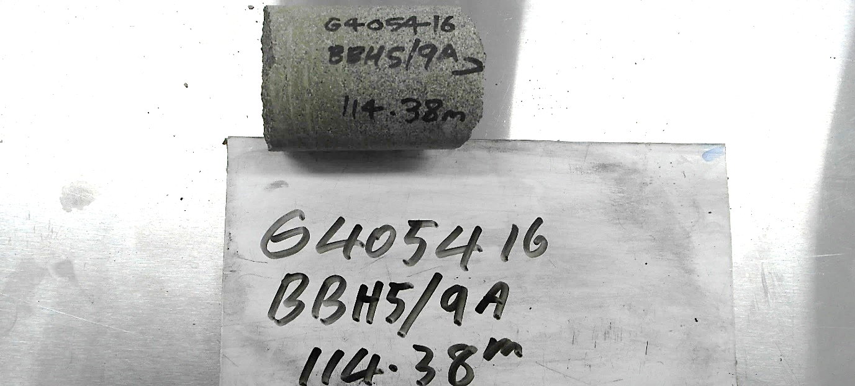
Photo 4: Sample G405416 - Sandstone. FOV: about 200 mm

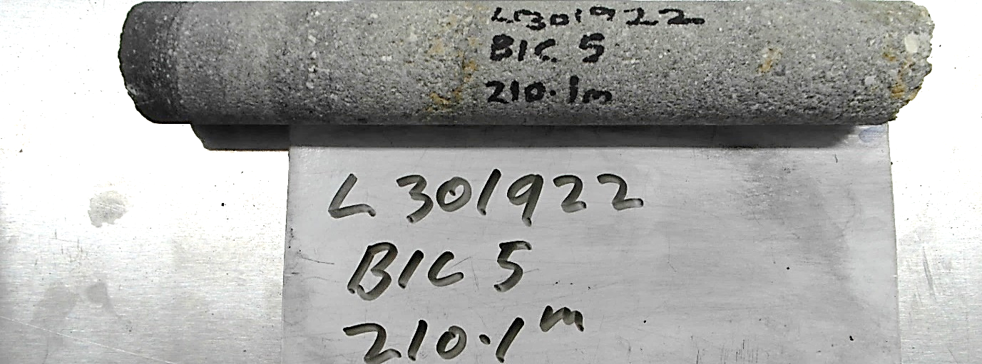
Photo 5: Sample L301922 – Quartzose Sandstone. FOV: about 300 mm

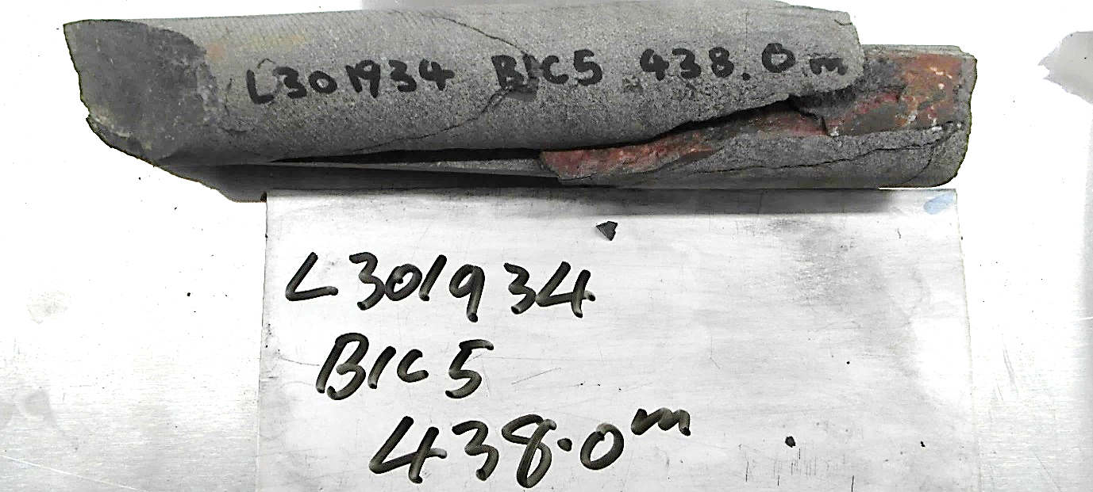
Photo 6: Sample L301934 - Metaquartz-wacke. FOV: about 250 mm
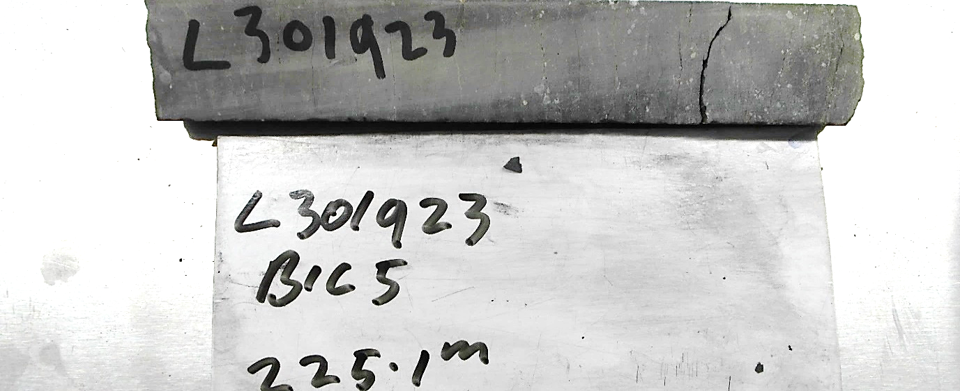
Photo 7: Sample L301923 – Sandstone. FOV: about 400 mm

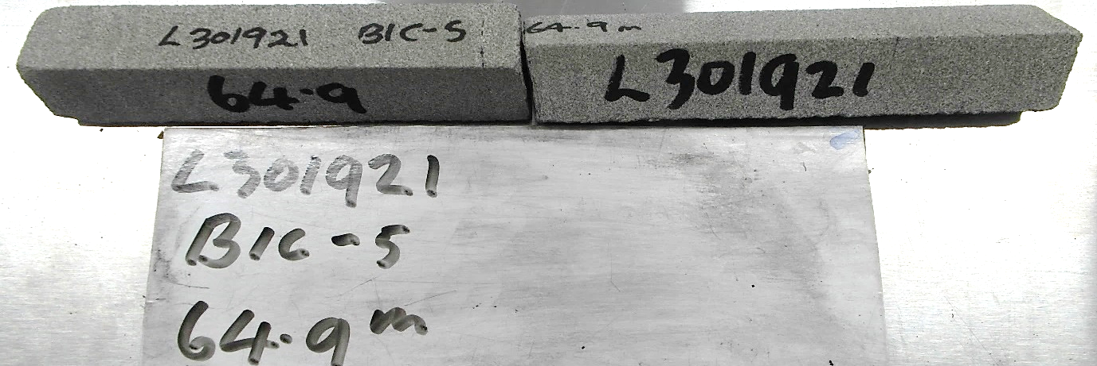
Photo 8: Sample L301921 – Arenite. FOV: about 400 mm

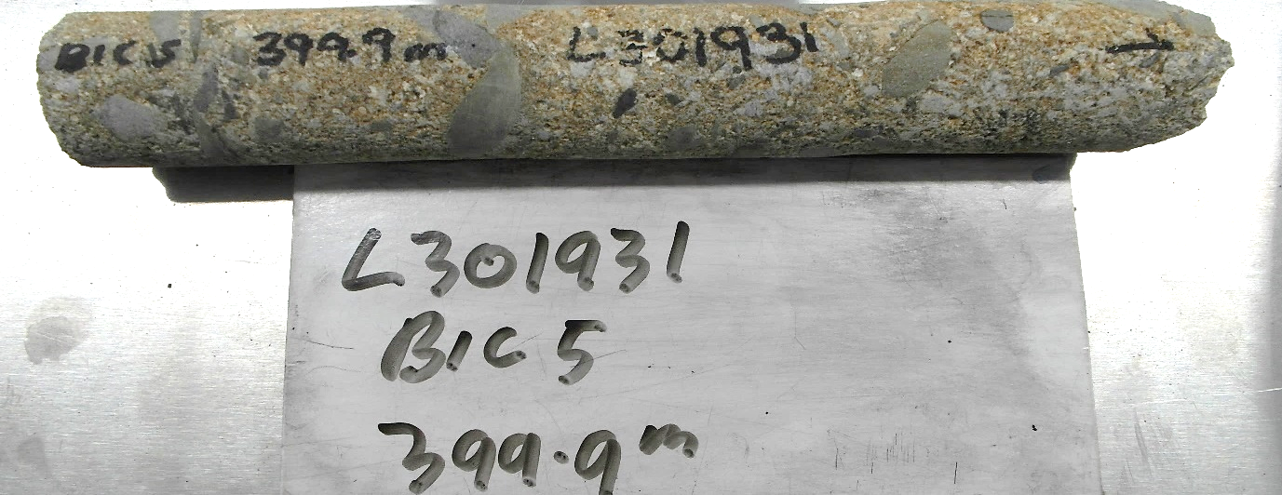
Photo 9: Sample L301931 – Conglomerate. FOV: about 400 mm
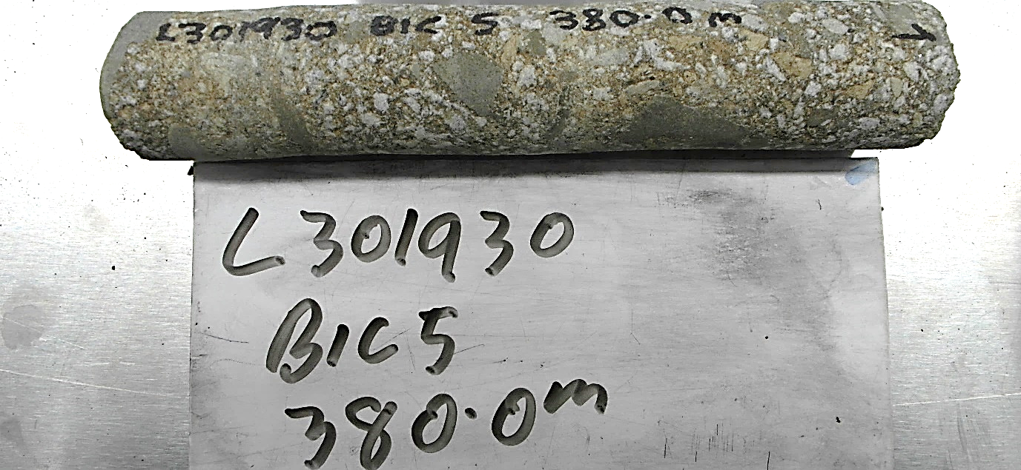
Photo 10: Sample L301908 – Conglomerate. FOV: about 400 mm

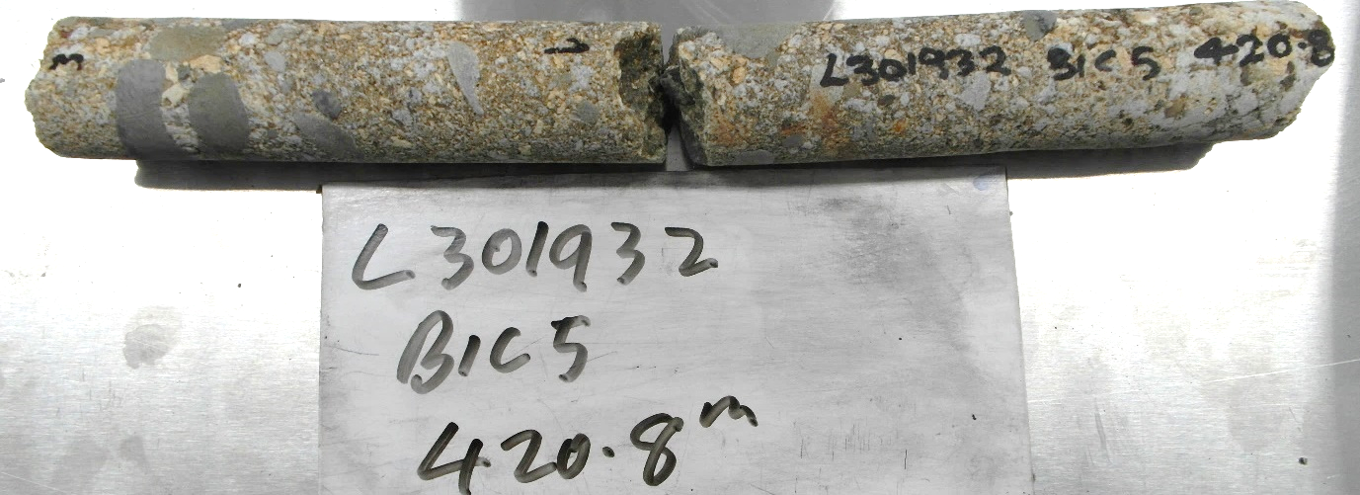
Photo 11: Sample L301932 – Conglomerate. FOV: about 400 mm

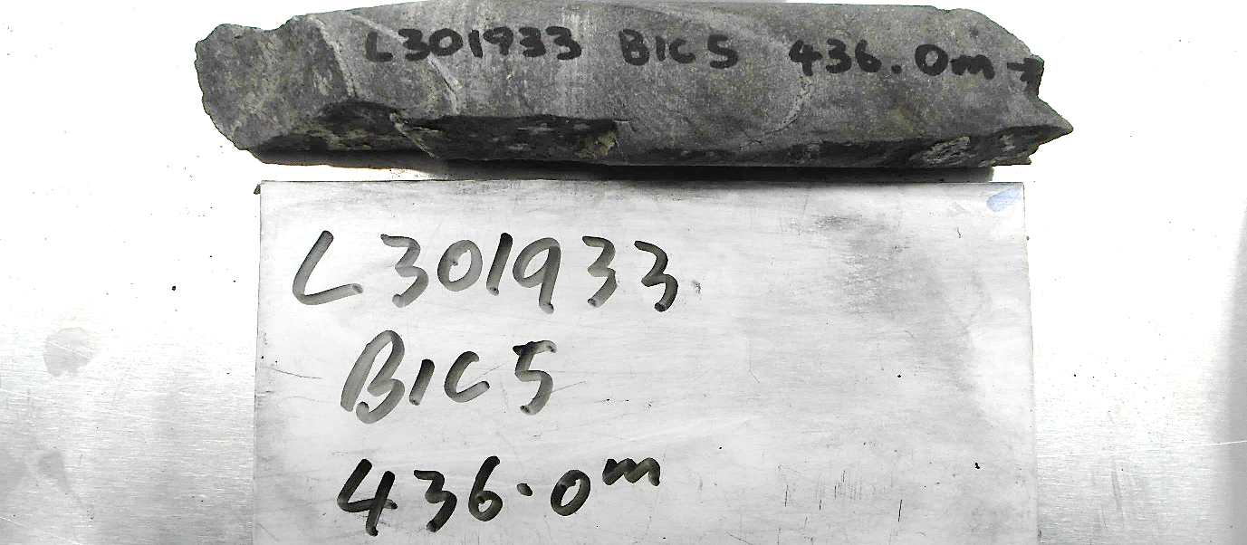
Photo 12: Sample L301933 – Metaquartz-wacke. FOV: about 400 mm
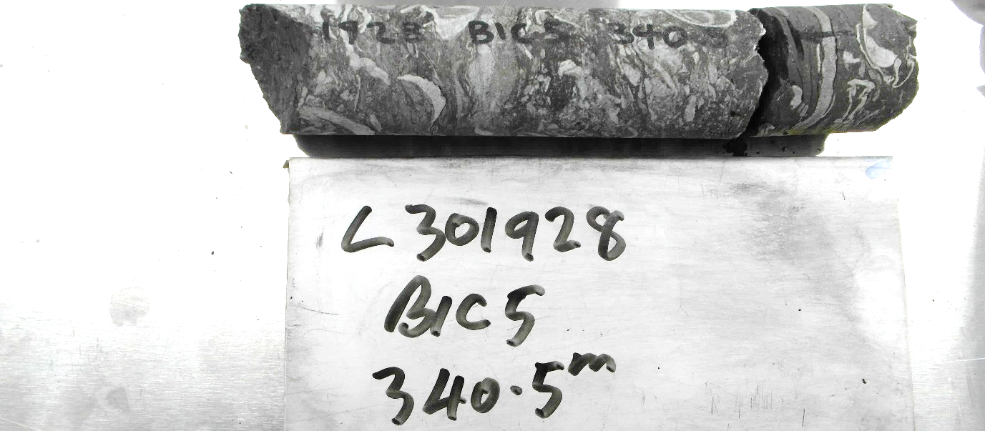
Photo 14: Sample L301928 – Siltstone - shelly. FOV: about 400 mm

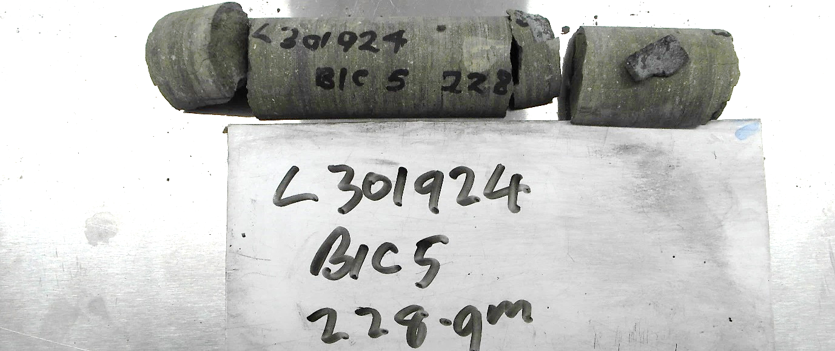
Photo 15: Sample L301924 – Metaquartz-wacke. FOV: about 400 mm

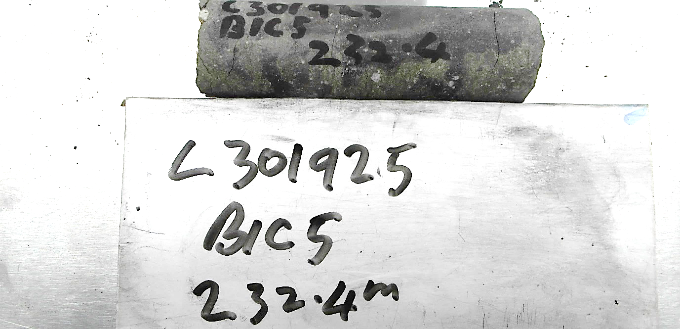
Photo 16: Sample L301925 – Metaquartz-wacke. FOV: about 400 mm
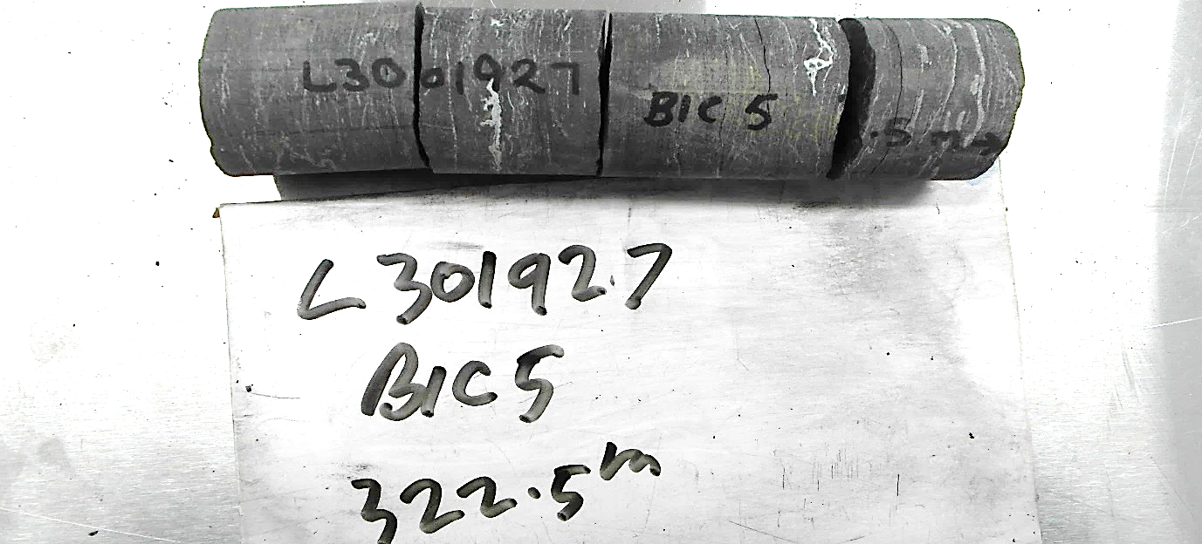
Photo 17: Sample L301927 – Siltstone. FOV: about 400 mm
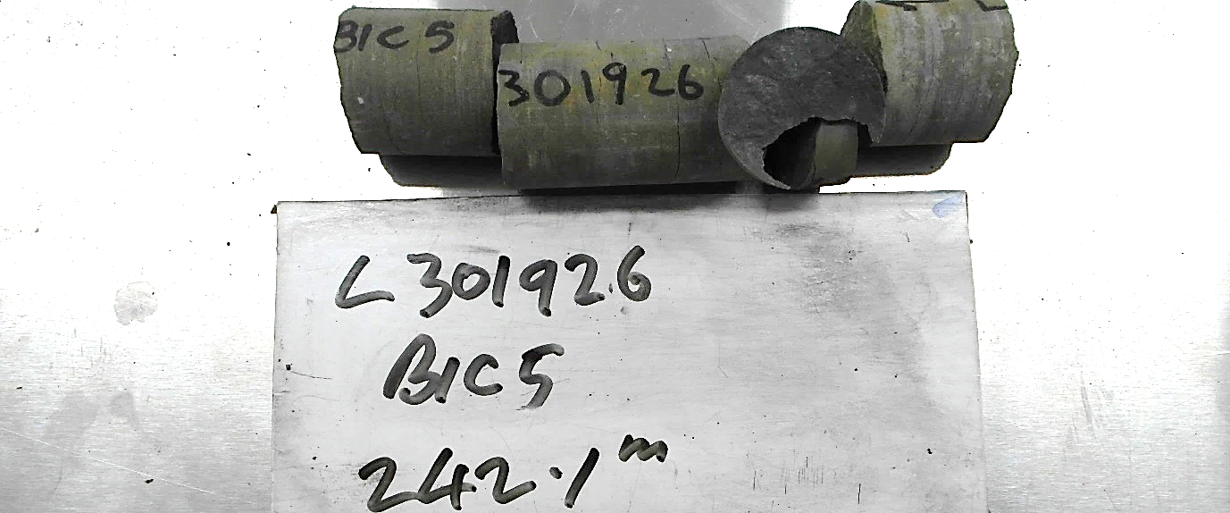
Photo 18: Sample L301926 – Metaquartz-wacke. FOV: about 400 mm

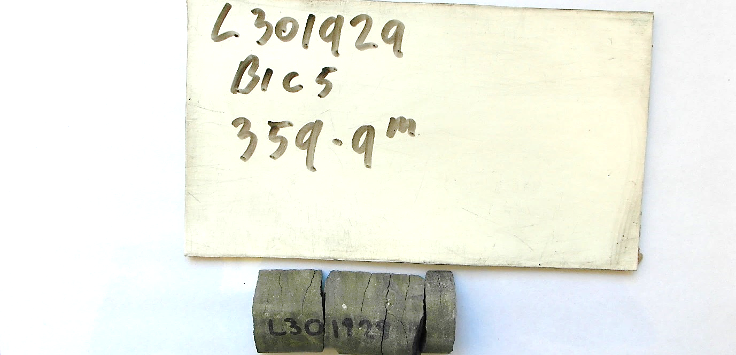
Photo 19: Sample L301929 – Siltstone - pebbly. FOV: about 400 mm
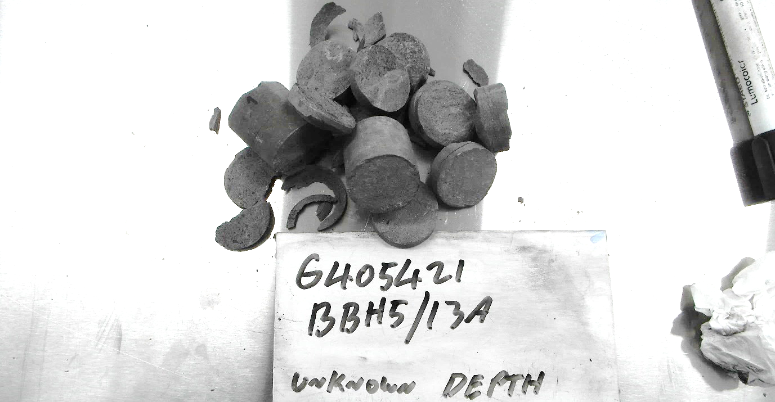
Photo 20: Sample G405421 – Sandstone. FOV: about 400 mm

Laboratory Tests

The samples were soaked for a minimum of 48 hours and weighed in water, and then wet in air. Samples were dried in a 90°C oven for a minimum of 12 hours then weighed dry. The wet porosity and density (specific gravity) was determined by standard gravimetric methods in the Mineral Resources Tasmania (MRT) Core Library, with an electronic balance accurate to 0.1g. The relative accuracy of the results is ~1% for specific gravity and ~5% for wet porosity. The summary of results is shown in Table 2 and full details listed in Appendix 1.

Table 2: Summary of Specific Gravity and Wet porosity
Sample ID | DDH | Depth (m) | Rock type | Dry bulk SG | Wet bulk SG | Wet porosity (%)
L301920 | Bicheno 5 | BBH5/14 | sandstone | 2.20 | 2.36 | 15.53
G405420 | Bicheno 5 | BBH5/10B | sandstone | 2.43 | 2.52 | 9.01
G405423 | Bicheno 5 | BBH5/13A | sandstone | 2.37 | 2.45 | 8.64
G405416 | Bicheno 5 | BBH5/9A | sandstone | 2.52 | 2.58 | 5.81
L301922 | Bicheno 5 | 64.9 m | arenite, lithic | 2.36 | 2.46 | 10.11
L301934 | Bicheno 5 | 436 | metaquartz-wacke | 2.63 | 2.67 | 4.42
L301923 | Bicheno 5 | 210.1 | quartzose sandstone | 2.39 | 2.49 | 10.04
L301921 | Bicheno 5 | 60 m | arenite, lithic | 2.23 | 2.39 | 16.17
L301931 | Bicheno 5 | 380 | conglomerate | 2.35 | 2.47 | 11.26
L301930 | Bicheno 5 | 359.9 | siltstone, pebbly | 2.40 | 2.49 | 8.75
L301932 | Bicheno 5 | 399.9 | conglomerate | 2.39 | 2.49 | 9.65
L301933 | Bicheno 5 | 420.8 | conglomerate | 2.65 | 2.66 | 1.25
L301928 | Bicheno 5 | 322.5 | siltstone, shelly | 2.51 | 2.58 | 7.88
L301924 | Bicheno 5 | 225.1 | glaciomarine siltstone with dropstones and quartz grits | 2.40 | 2.51 | 10.73
L301925 | Bicheno 5 | 228.9 | glaciomarine siltstone with dropstones and quartz grits | 2.41 | 2.51 | 10.63
L301927 | Bicheno 5 | 242.1 | glaciomarine siltstone with dropstones and quartz grits | 2.36 | 2.47 | 11.23
L301926 | Bicheno 5 | 232.4 | glaciomarine siltstone with dropstones and quartz grits | 2.39 | 2.49 | 10.05
L301929 | Bicheno 5 | 340.5 | siltstone, shelly | 2.48 | 2.56 | 8.28
G405421 | Bicheno 5 | BBH5/12A | sandstone | 2.40 | 2.52 | 12.33

R.S. Bottrill R King and L Unwin

Mineralogist/Petrologist TECHNICAL OFFICERs

Disclaimers:
While every care has been taken in the preparation of this report, no warranty is given as to the correctness of the information and no liability is accepted for any statement or opinion or for any error or omission. No reader should act or fail to act on the basis of any material contained herein. Readers should consult professional advisers. As a result the Crown in Right of the State of Tasmania and its employees, contractors and agents expressly disclaim all and any liability (including all liability from or attributable to any negligent or wrongful act or omission) to any persons whatsoever in respect of anything done or omitted to be done by any such person in reliance whether in whole or in part upon any of the material in this report. The MRT laboratories are not NATA registered but work to similar standards. This and other data collected in MRT laboratories may enter the MRT databases but every attempt will be made to ensure it remains closed file and not be available externally, unless at your request.

Appendix 1: Laboratory Report – Physical Property analyses
Client: M Duffett
Analysis: Physical Properties
Method: Gravimetric S.G. & Porosity
Location: Bicheno
Job No.: LJN2021-105
Date: 28/2/2022

Results
Sample ID | Dry Weight in Air (g) | Sub-sat Wt in water (g) | Sat. Wt. in Air (g) | Dry bulk SG | Wet bulk SG | Wet porosity (%)
L301920 | 262.5 | 161.9 | 281.0 | 2.20 | 2.36 | 15.53
G405420 | 352.9 | 220.6 | 366.0 | 2.43 | 2.52 | 9.01
G405423 | 397.3 | 244.0 | 411.8 | 2.37 | 2.45 | 8.64
G405416 | 216.5 | 135.5 | 221.5 | 2.52 | 2.58 | 5.81
L301922 | 387.5 | 239.9 | 404.1 | 2.36 | 2.46 | 10.11
L301934 | 415.7 | 264.5 | 422.7 | 2.63 | 2.67 | 4.42
L301923 | 178.8 | 111.6 | 186.3 | 2.39 | 2.49 | 10.04
L301921 | 204.1 | 127.4 | 218.9 | 2.23 | 2.39 | 16.17
L301931 | 433.0 | 269.8 | 453.7 | 2.35 | 2.47 | 11.26
L301930 | 356.7 | 221.2 | 369.7 | 2.40 | 2.49 | 8.75
L301932 | 566.6 | 352.3 | 589.5 | 2.39 | 2.49 | 9.65
L301933 | 318.6 | 199.8 | 320.1 | 2.65 | 2.66 | 1.25
L301928 | 333.7 | 211.0 | 344.2 | 2.51 | 2.58 | 7.88
L301924 | 147.9 | 93.0 | 154.5 | 2.40 | 2.51 | 10.73
L301925 | 83.7 | 52.6 | 87.4 | 2.41 | 2.51 | 10.63
L301927 | 292.5 | 182.6 | 306.4 | 2.36 | 2.47 | 11.23
L301926 | 327.7 | 204.2 | 341.5 | 2.39 | 2.49 | 10.05
L301929 | 71.8 | 45.2 | 74.2 | 2.48 | 2.56 | 8.28
G405421 | 350.5 | 222.5 | 368.5 | 2.40 | 2.52 | 12.33

Analyst: R. King
Date: 25/02/2021

