MINERAL RESOURCES TASMANIA
Laboratory Report
LJN2021-107

Soil tests and analyses,

Penna landslip

An unpublished Mineral Resources Tasmania Report for:
MRT

By: R.S. Bottrill, T Coyte, J Renaud and L Unwin
Date: 19 May 2022

Summary
Eight soil samples from the Penna landslip were collected by Claire Kain in November 2021 and submitted to MRT Laboratories for soil testing and mineralogical analyses.
The Atterberg test results showed the generally clayey nature of the soils at the site and indicate soil classifications, corresponded to inorganic clays of medium to high plasticity (CH). Sizing test also showed the samples vary from a Clay to a Sandy Loam based on the USDA soil classes.
The Emerson Class number (ECN) indicated that most samples tested had a tendency for the soil to slake with some dispersion. E204205 tended to slake with low susceptibility for dispersion and E204206 had a low susceptibility to slake with some swelling.
XRD analyses were dominated by quartz and kaolinite, with rock sample E204203 containing mostly goethite. Other phases identified in these samples are Illite/vermiculite, anatase, goethite and halloysite lepidocrocite and sepiolite.

Introduction
Eight soil samples were collected in November 2021 from the Penna landslip by Claire Kain and submitted to MRT Laboratories for soil tests and mineralogical analyses. They were prepared and analysed by standard mineralogical and petrophysical techniques in the MRT laboratories, Rosny Park and Mornington.

Samples
The details of the soil samples supplied by C Kain are given in Table 1 below and shown in Figs. 1 – 8 below. Sample E204203 is an ironstone; the remainder are reduced to slightly oxidised kaolinitic clays.

Table 1: Sample details.
MRT Reg# | Location | Sample Description | Process
E204201 | Penna | Silty/clayey orange mottled grey sand. Bedding visible | XRD, sizing
E204202 | Penna | Orange/brown mottled grey plastic clay | XRD, Atterbergs, sizing
E204203 | Penna | Hard, orange-brown ironstone(?) | XRD
E204204 | Penna | Saturated grey plastic clay | XRD, Atterbergs, sizing
E204205 | Penna | Grey plastic clay | XRD, Atterbergs, sizing
E204206 | Penna | Stiff grey-brown clay | XRD, Atterbergs, sizing
E204207 | Penna | Silty/clayey orange mottled grey sand | XRD, sizing
E204208 | Penna | Grey plastic clay | XRD, Atterbergs, sizing

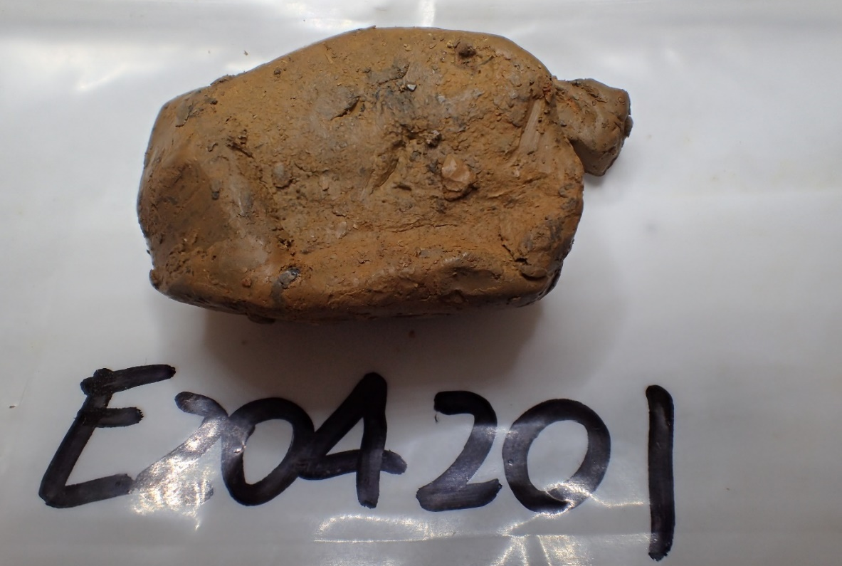
Figure 1. Sample E204201. Silty/clayey orange mottled grey sand. Bedding visible. FOV ~100 mm.

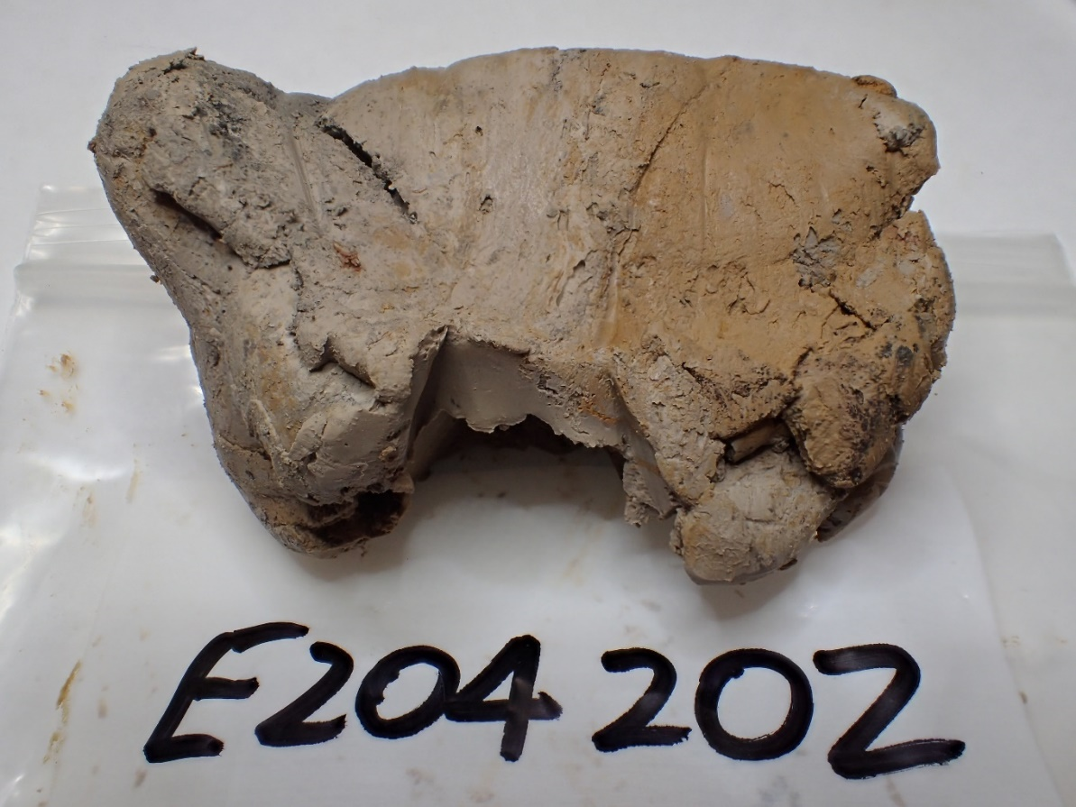
Figure 2. Sample E204202. Orange/brown mottled grey plastic clay FOV ~100 mm.
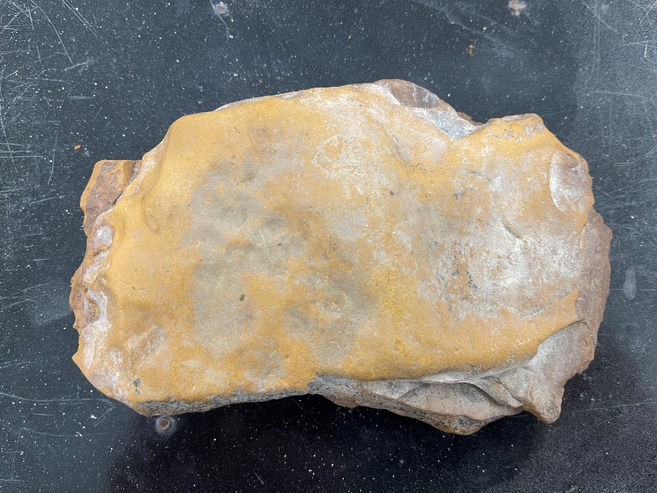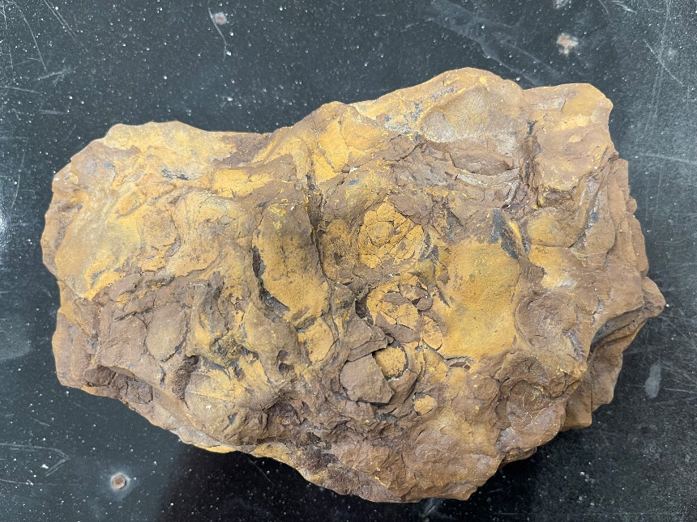Figure 3. Sample E204203. Hard, orange-brown ironstone(?) FOV ~200 mm.
.
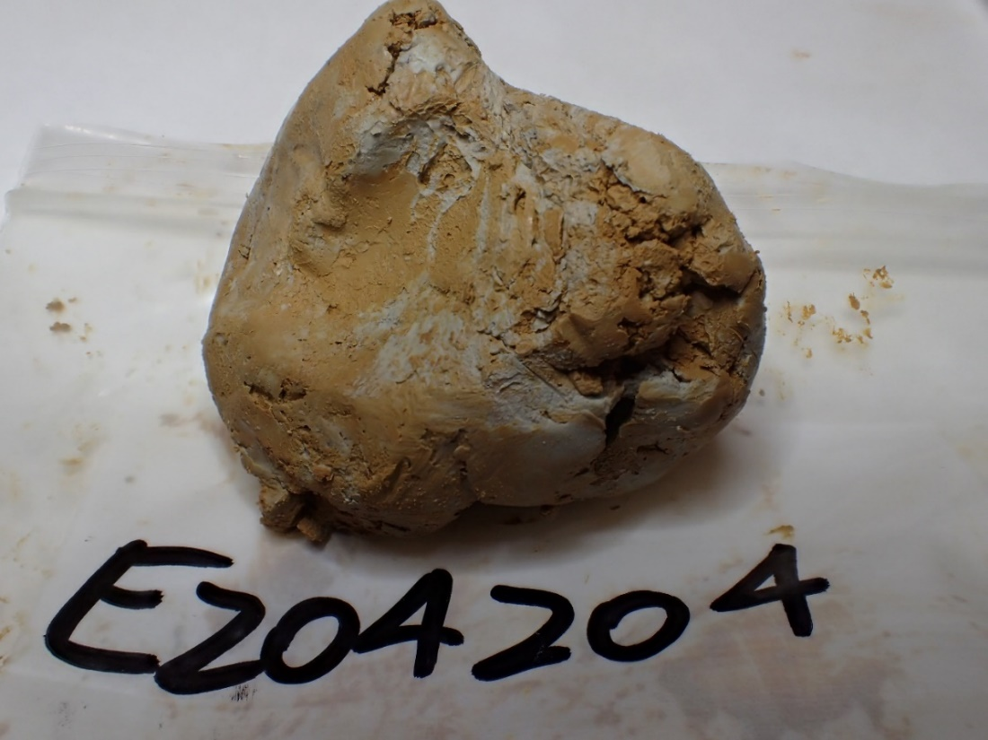
Figure 4. Sample E204204. Saturated grey plastic clay FOV ~100 mm.
.
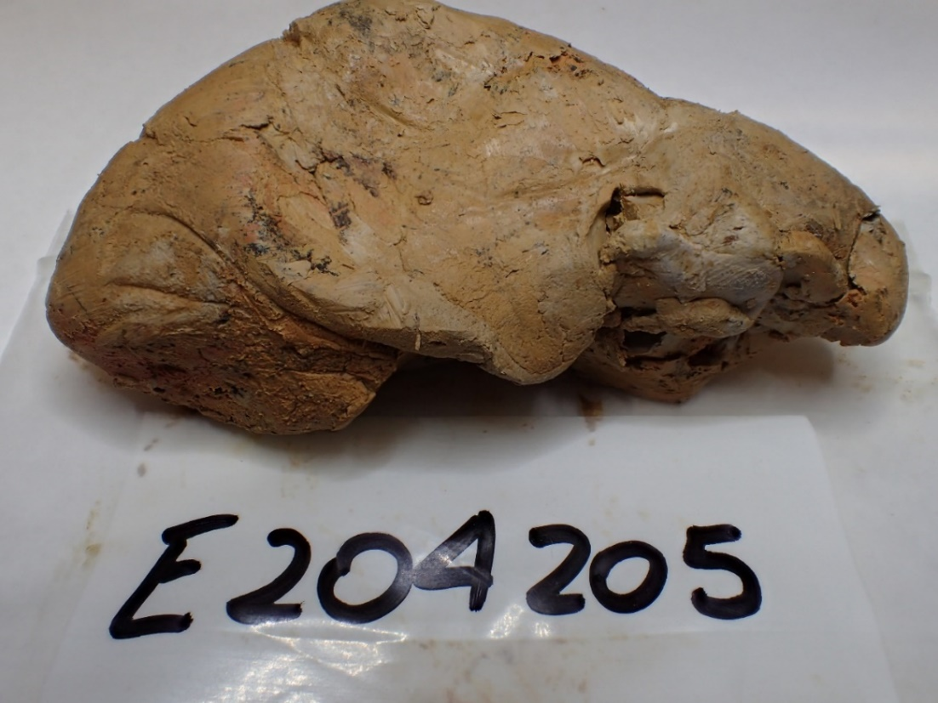
Figure 5. Sample E204205. Grey plastic clay FOV ~100 mm.

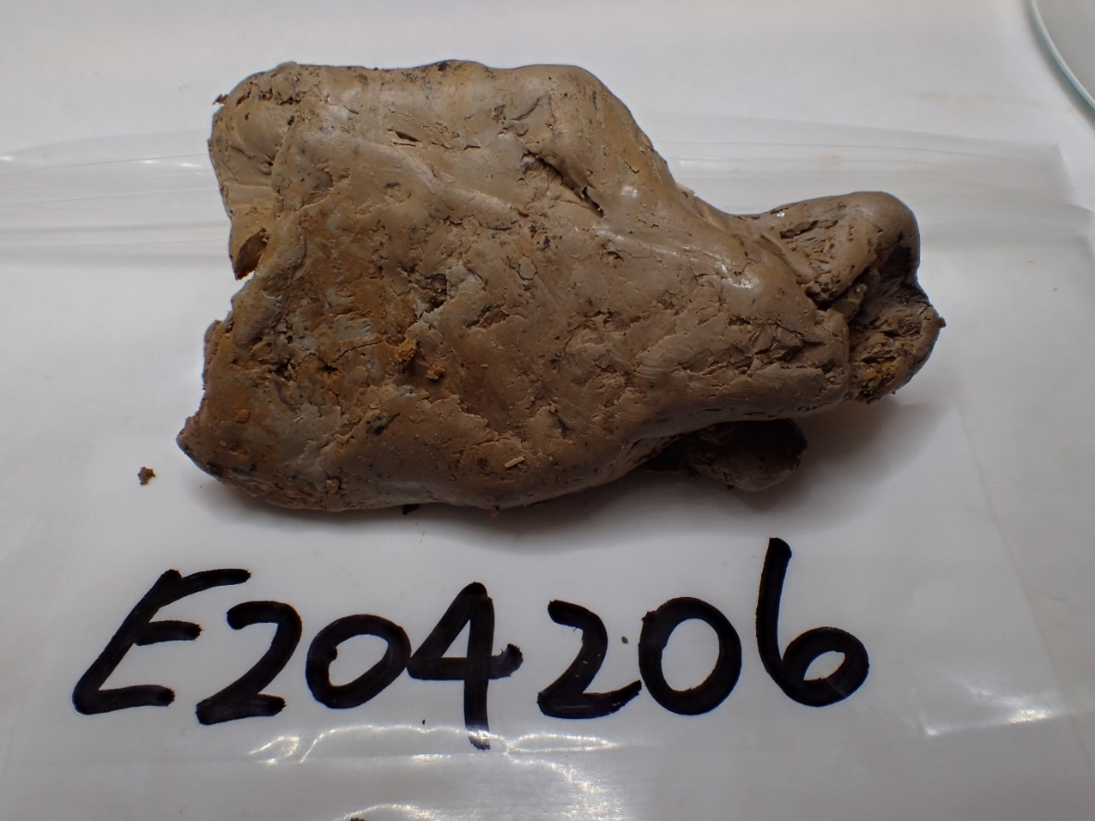
Figure 6. Sample E204206. Stiff grey-brown clay FOV ~100 mm.
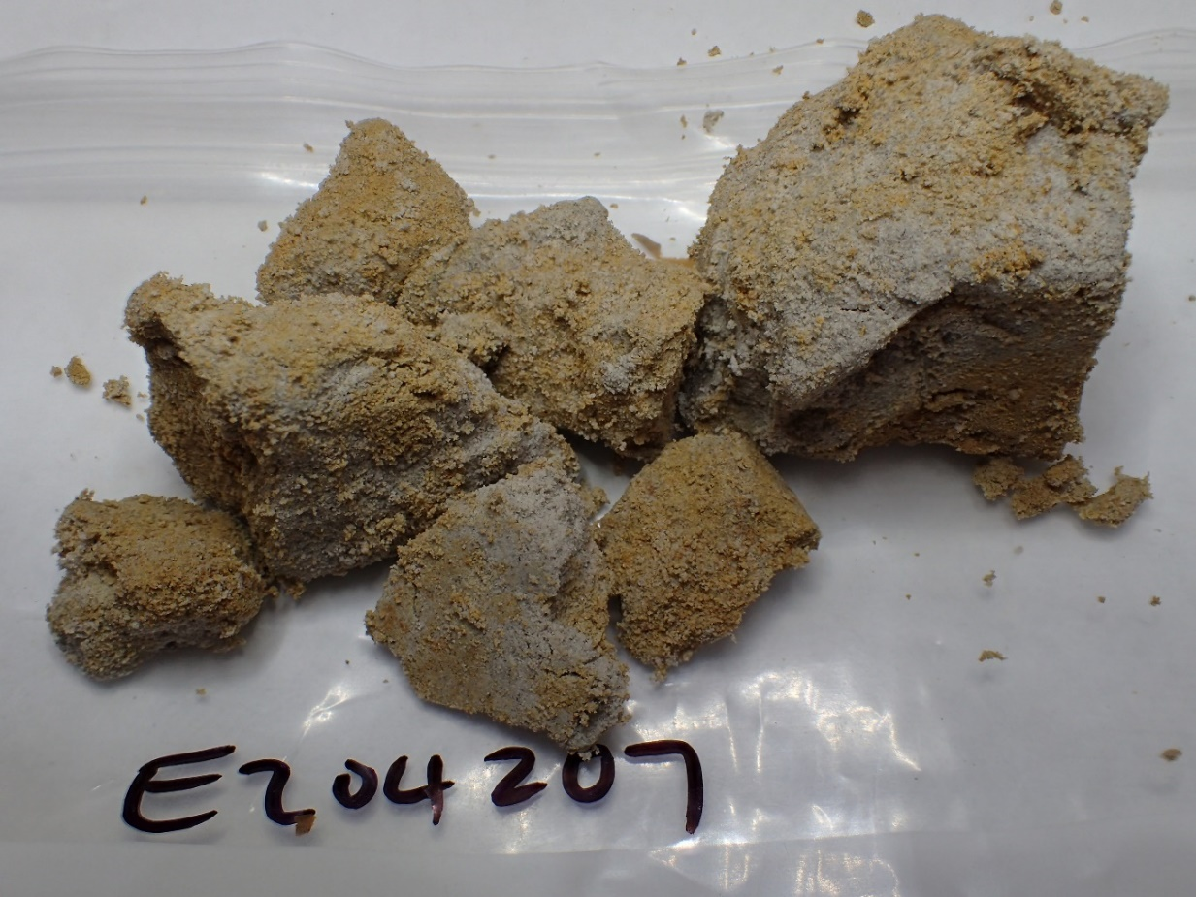
Figure 7. Sample E204207. Silty/clayey orange mottled grey sand. FOV ~100 mm.
. 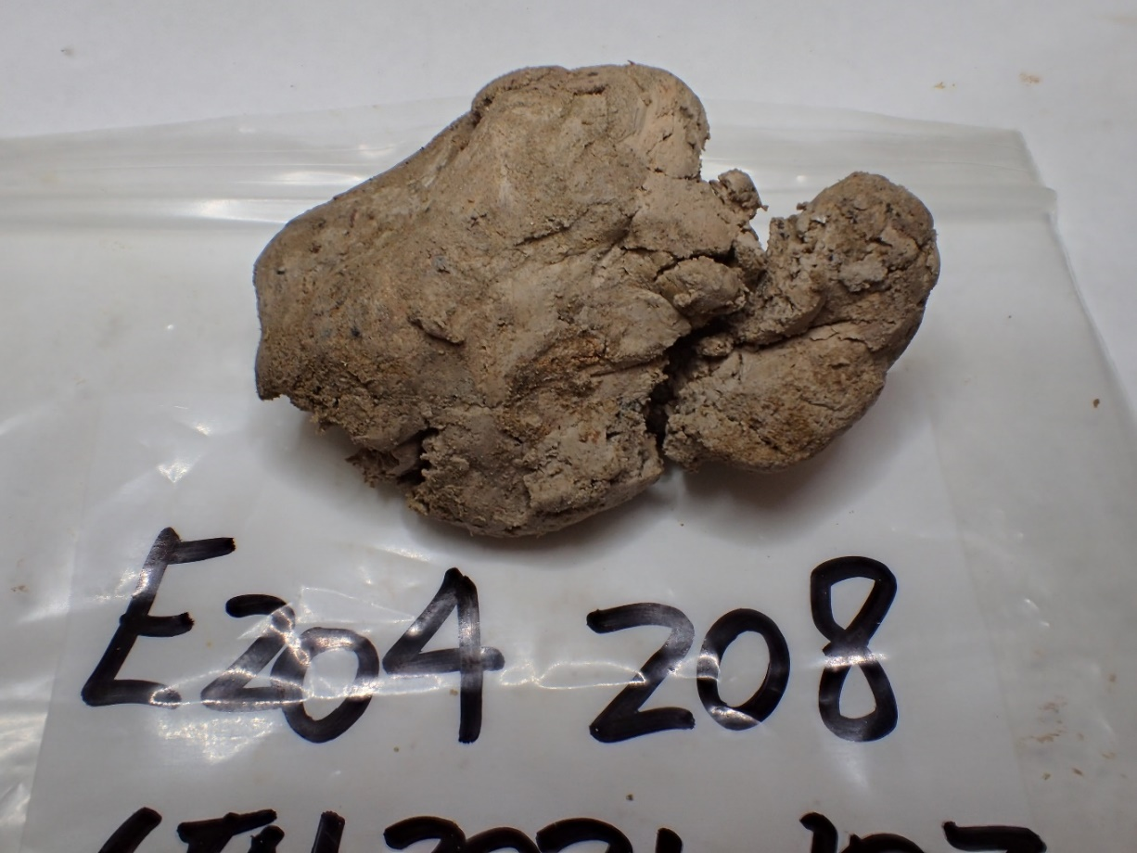
Figure 8. Sample E204208. Grey plastic clay. FOV ~100 mm.

Sample Preparation
The samples were split into representative subsamples and analysed for mineralogy by XRD (X-Ray diffraction), in the Mineral Resources Tasmania (MRT) laboratories, Rosny. Some samples were also subsamples for prepared for Atterberg tests, sediment and sieve size analysis, in the Mineral Resources Tasmania (MRT) laboratories, Rosny Park and Mornington, Tasmania.

AtterBerg Limits, Dispersion and Moisture Content
The following tests were undertaken in compliance with the following Australian Standards:
- Liquid Limit (LL) AS 1289.3.1.1 [pre-dried at 105ºC; see Test Note 1 (a)]
- Plastic Limit (PL) AS 1289.3.2.1
- Plasticity Index (PI) AS 1289.3.3.1
- Linear Shrinkage (LS) AS 1289.3.4.1
- Dispersion AS1289.3.8.1
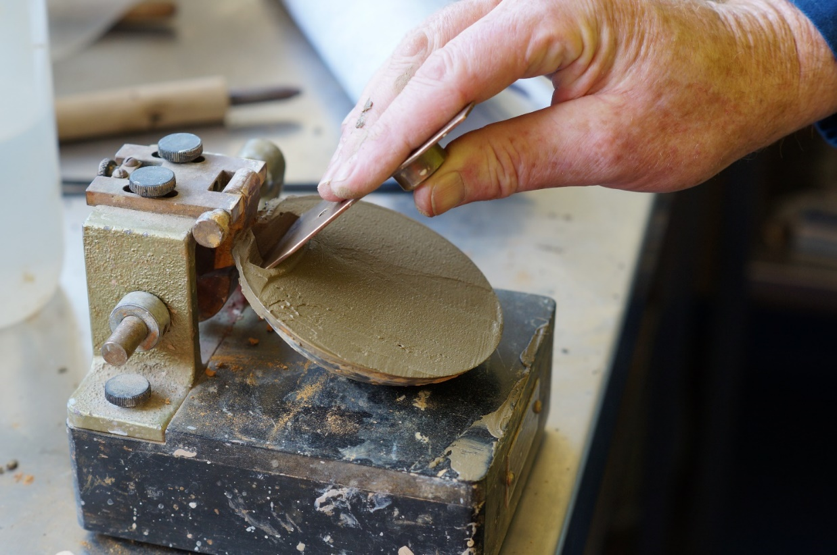
Figure 9. Liquid limit (Atterberg) testing at MRT

The results of the Atterberg tests are presented below in Table 2 and on Figs 10 & 11. For Atterbergs, samples were air dried and checked for coarse particles. Water used was distilled or demineralised. Emerson Dispersions were completed on natural samples.

All the soil samples can be classified as high plasticity (CH or OH) clays. The relationship between Plasticity Index and Linear Shrinkage was plotted and showed some correlation indicated by a general cluster of points, this is presented below in Figure 11.

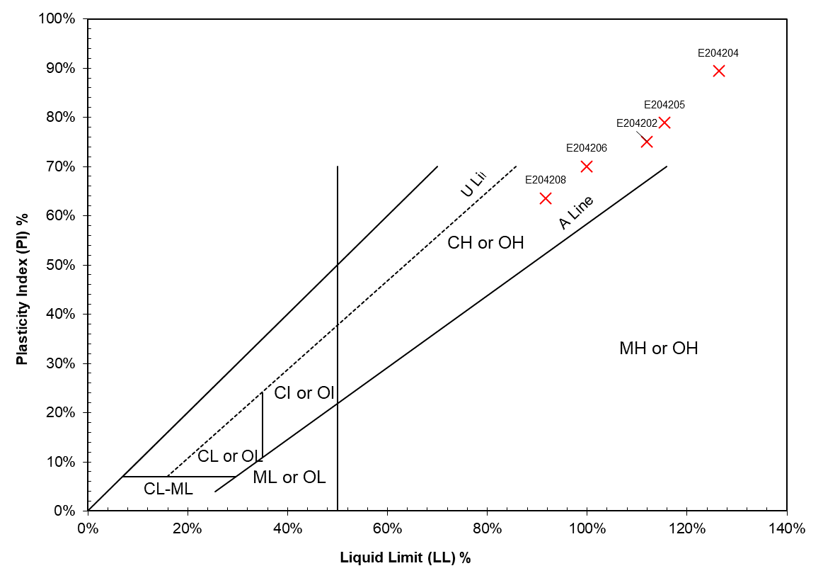
Figure 10. Plasticity chart (Australian Standard AS1726)

Table 1: USCS – inorganic fine-grained soils component only (ASTM D2487, ASTM D2488 and Casagrande, 1948)
Liquid Limit | Plasticity Index relative to A-line | Soil class and plasticity | Code
Liquid Limit <50% (L) | On or above | Lean Clay  Inorganic clays, sandy clays, silty clays, lean clays. Low to medium plasticity, no or slow dilatancy. | CL
Liquid Limit <50% (L) | Below | Silt  Inorganic silts and very fine sands, rock flour, silty or clayey fine sands. Slight plasticity to non-plastic, slow to rapid dilatancy. | ML
Liquid Limit >50% (H) | On or above | Fat Clay  Inorganic clays, fat clays. High plasticity, no dilatancy. | CH
Liquid Limit >50% (H) | Below | Elastic Silt  Micaceous or diatomaceous fine sandy and silty soils, elastic silts. Low to medium plasticity, no to slow dilatancy. | MH
Liquid Limit  <30% (L)  Plasticity Index  4 to 7% | Not applicable | Silty Clay  Mixed zone where both CL and ML soils plot | CL-ML

Table 2: Summary – Atterberg Limits, and Dispersion
 |  | Atterberg Limits |  |  |  | Dispersion ECN
MRT Reg. No. | Sample | LL | PL | LS | PI | Dispersion ECN
E204202 | Orange/brown mottled grey plastic clay | 104% | 37% | 15% | 67% | 2
E204204 | Saturated grey plastic clay | 129% | 37% | 10% | 92% | 2
E204205 | Grey plastic clay | 115% | 36% | 14% | 79% | 6
E204206 | Stiff grey-brown clay | 100% | 30% | 15% | 70% | 7
E204208 | Grey plastic clay | 92% | 29% | 13% | 63% | 2

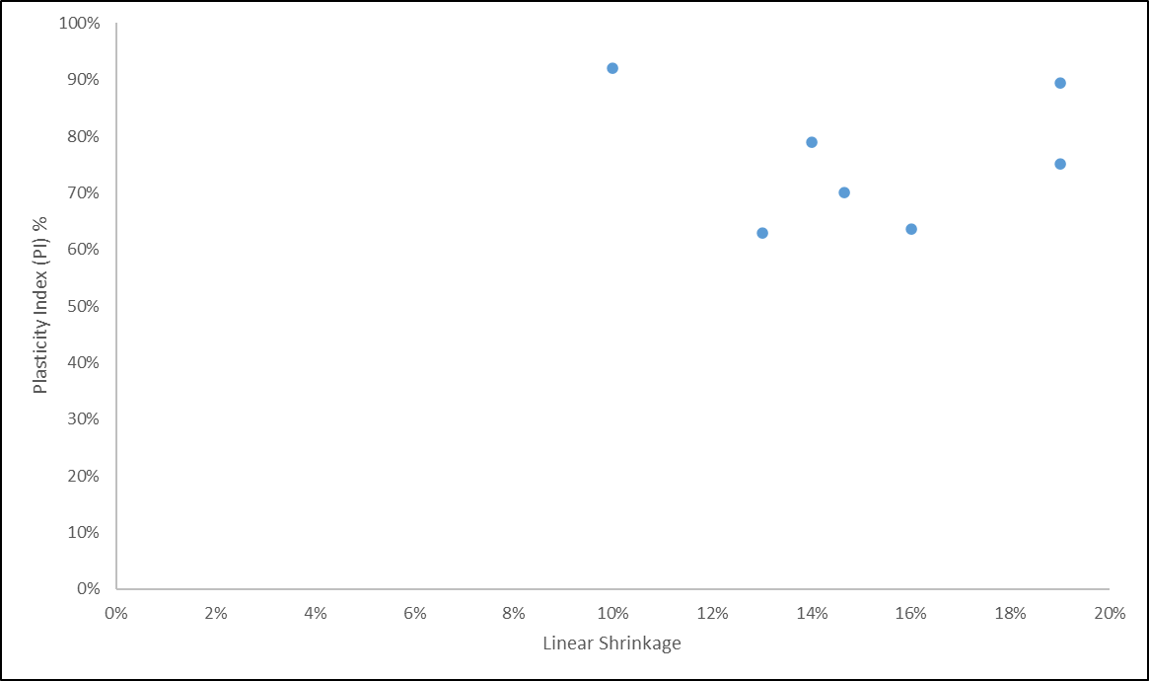
Figure 11. Relationship between Plasticity Index and Linear Shrinkage

Particle Size analysis
Seven sample of soil were submitted for sizing analysis. The sample details are shown in Table 1.
The whole samples were wet sieved by hand sieving, using Australian standard sieves. Each fraction was weighed and determined as a proportion of the total sample. Sedimentation Analysis was conducted on a whole sub-sample to determine the <2 micron fraction. The results are shown in Tables 4 and Appendix 2. Sieving was complete in accordance with AS1289.3.6.1 with some slight modifications. Fine particle size analysis was completed using a modified AS1289.3.6.3 sedimentation method.

Table 4: Size analysis summary)
Sample No. | <38 um (%) | ≤20 um (%) | ≤10 um (%) | ≤2 um (%)
E204201 | 98.1 | 45.0 | 37.3 | 19.6
E204202 | 99.6 | 86.0 | 84.3 | 80.3
E204204 | 99.7 | 92.5 | 91.4 | 89.0
E204205 | 97.3 | 67.4 | 66.5 | 64.7
E204206 | 98.5 | 96.3 | 93.8 | 88.1
E204207 | 39.0 | 32.4 | 27.0 | 14.4
E204208 | 85.1 | 43.4 | 41.9 | 38.5

XRD analyses
The samples were prepared, examined and analysed in the MRT laboratories, Rosny Park, Tasmania. They were run on a Rigaku Miniflex 600 X-Ray Diffractometer system: a 600W generator 150mm goniometer with a Cu tube; 40kV/15mA, sample spinner and a Scintillation counter (SC) with Be window, a graphite counter monochromator and a Kß Ni- filter. The analysis was performed using the following conditions: +3° to 63° 2Theta scanning and measuring range, with a scanning speed of 0.5 °/min with a resolution of 0.02° by step. The analysis software used is the PDXL2 using the ICCD database.
The results are shown in Appendix 1, and Table 5 and summarised below.
Table 5. Main mineral phases identified and qualitative results
Mineral | E204201 | E204202 | E204203 | E204204 | E204205 | E204206 | E204207 | E204208
Kaolinite | Sub-major | 52(10) | 8(3) | 48(10) | 36(10) | 40(10) | 10(3) | Major
Quartz | Major | 37(10) | 6(3) | 38(10) | 27(5) | 39(10) | 88(10) | Major
Mixed Layer Clay | Very Minor | 9(3) |  | 13(4) | 9(3) | 7(3) |  | Trace
Anatase | Faint Trace | 3(2) |  |  | 2(2) | 3(2) |  | Trace
Halite | Trace |  |  | 1(1) |  | 1(1) | 2(2)
Goethite |  |  | 86(10) |  | 9(3) | 11(4)
Lepidocrocite | Sub-major

E204203 (ironstone) is mostly goethite with very minor quartz and kaolinite. Quartz and kaolinite are the main mineralogical phases in the other samples, with most samples also having minor amounts of mixed-layer clays (Illite/smectite or vermiculite?), anatase and halite; some have goethite and one has lepidocrocite (E204201).

Results summary
Size analyses (sieving and sediment sizing) indicates the samples vary from a Clay to a Sandy Loam based on the USDA soil classes. Samples are described below:
- Sample E204201is a Silt Loam, with 20% of the sample <2um
- Sample E204202 is a Clay, with 80% of the sample <2um.
- Sample E204204 is a Clay, with 89% of the sample <2um.
- Sample E204205 is a Clay, with 65% of the sample <2um.
- Sample E204206 is a Clay, with 88% of the sample <2um.
- Sample E204207 is somewhere between a Clay Loan and Sandy Loam, with 14% of the sample <2um.
- Sample E204208 is a Silty Clay, with 38% of the sample <2um.
Based on Atterberg tests, the samples E204202, E204204, E204205, E204206 and E204208 are all classified as high plasticity clays (CH) using the Unified Soil Classification Scheme.
The Emerson Class number (ECN) for soils related to the potential for a soil to slake and disperse. Most samples tested indicated a tendency for the soil to slake with some dispersion. E204205 tended to slake with low susceptibility for dispersion and E204206 had a low susceptibility to slake with some swelling.
The ironstone is mostly goethite with very minor quartz and kaolinite. Quartz and kaolinite are the main mineralogical phases in the other samples (Penna Clays), with most samples also having minor amounts of mixed-layer clays (Illite/smectite or vermiculite?); some have goethite and one has lepidocrocite.

R.S. Bottrill T Coyte, J Renaud & L Unwin
MINERALOGIST/PETROLOGIST TECHNICAL OFFICERS

Disclaimers
While every care has been taken in the preparation of this report, no warranty is given as to the correctness of the information and no liability is accepted for any statement or opinion or for any error or omission. No reader should act or fail to act on the basis of any material contained herein. Readers should consult professional advisers. As a result the Crown in Right of the State of Tasmania and its employees, contractors and agents expressly disclaim all and any liability (including all liability from or attributable to any negligent or wrongful act or omission) to any persons whatsoever in respect of anything done or omitted to be done by any such person in reliance whether in whole or in part upon any of the material in this report. The MRT laboratories are not NATA registered but work to similar standards. This and other data collected in MRT laboratories may enter the MRT databases but every attempt will be made to ensure it remains closed file and not be available externally, unless at your request.

Laboratory Details
Mineral Resources Tasmania (MRT) operates a laboratory facility at its offices at Rosny Park and Mornington, Tasmania. In the interests of full disclosure, these laboratories do not have NATA accreditation. However, all tests are performed according to relevant Australian Standards cited in the report and subject to internal peer review processes. The analytical facilities at MRT are periodically compared against other similar laboratories in other jurisdictions with favourable results.

Appendix 1: Laboratory Report: XRD Analyses

XRD Results-E204201

General Information

Measurement date: | 9/12/2021 | Interpretative date: | 19/5/2022
Job Number/Client: | LJN2021-107 CKain | XRD | Rigaku Miniflex 600
Registration Number: | E204201 | Analyst: | LUnwin
Quantitative Method: | Semi-Quantitative | Process Medium: | Wholerock
Sample Holder: | Standard | Speed (deg/min): | 0.5
Comment: | Shifted -0.01, Sample dried at 30degrees

Analysis Results

Phase name | Content - Estimate | Formula
Kaolinite | Sub-major | Al₂(Si₂O₅)(OH)₄
Mixed Layer Clay | Very Minor | Various
Quartz | Sub-major | SiO₂
Lepidocrocite | Sub-major | Fe³⁺O(OH)
Halite | Trace | NaCl
Anatase | Faint Trace | TiO₂

Peak List
No. | 2-theta(deg) | d(ang.) | Phase name | Rel. int. I(a.u.)
1 | 8.83288 | 10.0032 | Mixed Layer Clay(0,0,1) | 3.74
2 | 12.372(5) | 7.148(3) | Kaolinite(0,0,1) | 36.20
3 | 14.157(3) | 6.2507(14) | Lepidocrocite(0,2,0) | 37.39
4 | 17.7276 | 4.99912 | Kaolinite(1,0,0),Mixed Layer Clay(0,0,2) | 1.18
5 | 19.8836 | 4.46167 | Kaolinite(0,2,0),Mixed Layer Clay(0,2,0) | 20.55
6 | 20.3766 | 4.35481 | Kaolinite(1,-1,0) | 9.64
7 | 20.8449 | 4.25803 | Quartz(1,0,0) | 34.44
8 | 24.90(3) | 3.572(4) | Kaolinite(1,0,1),Mixed Layer Clay(1,1,-2) | 40.65
9 | 25.259 | 3.52303 | Anatase(1,0,1) | 4.49
10 | 26.6155 | 3.34647 | Quartz(1,0,1),Kaolinite(1,1,1),Mixed Layer Clay(0,2,2) | 100.00
11 | 27.026(8) | 3.2966(9) | Lepidocrocite(0,2,1),Kaolinite(1,2,0) | 21.69
12 | 29.7562 | 3.00003 | Lepidocrocite(1,1,0) | 1.88
13 | 31.666(14) | 2.8233(12) | Kaolinite(0,2,-2),Halite(2,0,0) | 11.08
14 | 35.108(15) | 2.5540(11) | Kaolinite(2,0,-1),Mixed Layer Clay(1,3,0) | 22.62
15 | 36.32(2) | 2.4716(13) | Lepidocrocite(1,3,0),Kaolinite(1,-3,-1),Mixed Layer Clay(2,0,-2) | 32.27
16 | 36.484(5) | 2.4608(4) | Quartz(1,1,0),Kaolinite(2,-1,-1),Mixed Layer Clay(1,3,1) | 4.62
17 | 38.19(6) | 2.355(3) | Lepidocrocite(1,1,1),Kaolinite(1,0,-3),Anatase(1,0,3),Mixed Layer Clay(2,0,1) | 28.63
18 | 39.385(13) | 2.2859(7) | Quartz(0,1,2),Kaolinite(1,3,1) | 5.82
19 | 40.249(7) | 2.2389(4) | Quartz(1,1,1),Mixed Layer Clay(2,2,-1) | 2.59
20 | 42.420(15) | 2.1291(7) | Quartz(2,0,0),Kaolinite(0,2,-3),Mixed Layer Clay | 7.00
21 | 43.254(19) | 2.0900(9) | Lepidocrocite(1,3,1),Kaolinite(2,2,-2) | 1.92
22 | 45.403(11) | 1.9959(5) | Kaolinite(2,0,-3),Halite(2,2,0) | 8.11
23 | 45.732(13) | 1.9824(5) | Quartz(0,2,1),Kaolinite(1,-3,2),Mixed Layer Clay | 6.45
24 | 46.74(2) | 1.9418(9) | Lepidocrocite(1,5,0),Kaolinite(2,3,-1),Mixed Layer Clay(2,0,-4) | 17.45
25 | 49.316 | 1.84634 | Kaolinite(1,-3,-3) | 1.66
26 | 50.082(10) | 1.8199(3) | Quartz(1,1,2) | 10.71
27 | 52.69(6) | 1.7357(18) | Lepidocrocite(1,5,1),Kaolinite(2,3,1),Mixed Layer Clay(1,1,5) | 5.01
28 | 54.951 | 1.66959 | Quartz(2,0,2),Lepidocrocite(0,4,2),Kaolinite(2,4,-1),Anatase(1,0,5),Mixed Layer Clay(2,4,0) | 21.68
29 | 56.5223 | 1.62684 | Lepidocrocite(1,1,2),Kaolinite(3,-1,0),Halite(2,2,2) | 2.12
30 | 58.923(16) | 1.5661(4) | Lepidocrocite(0,8,0),Kaolinite(2,-4,1),Mixed Layer Clay(0,2,6) | 2.40
31 | 59.901(5) | 1.54290(12) | Quartz(2,1,1),Lepidocrocite(1,7,0),Kaolinite(3,1,-3),Mixed Layer Clay(1,5,-3) | 7.80

Phase Data Pattern

XRD Results-E204202

General Information

Measurement date: | 9/12/2021 | Interpretative date: | 19/5/2022
Job Number/Client: | LJN2021-107 CKain | XRD | Rigaku Miniflex 600
Registration Number: | E204202 | Analyst: | LUnwin
Quantitative Method: | PDXL Relative Heights | Process Medium: | Wholerock
Sample Holder: | Standard | Speed (deg/min): | 0.5
Comment: | Shifted -0.03, Sample dried at 30degrees

Analysis Results

Phase name | Content wt% (± error) | Formula
Kaolinite | 52(10) | Al₂(Si₂O₅)(OH)₄
Mixed Layer Clay | 9(3) | Various
Quartz | 37(10) | SiO₂
Anatase | 3(2) | TiO₂

Notes
Peak overlap may interfere with identifications and quantitative calculations.
Amorphous minerals and minerals present in trace amounts may not be detected.

Peak List
No. | 2-theta(deg) | d(ang.) | Phase name | Rel. int. I(a.u.)
1 | 8.78762 | 10.0546 | Mixed Layer Clay(0,0,1) | 10.82
2 | 12.352(8) | 7.160(5) | Kaolinite(0,0,2) | 85.86
3 | 17.816 | 4.97452 | Mixed Layer Clay(0,0,2) | 2.49
4 | 19.9029 | 4.45739 | Kaolinite(1,1,-1),Mixed Layer Clay(0,2,0) | 32.70
5 | 20.8421 | 4.25859 | Kaolinite(0,2,1),Quartz(1,0,0) | 20.85
6 | 21.3049 | 4.16713 | Mixed Layer Clay(0,2,1) | 17.58
7 | 24.91(2) | 3.571(3) | Kaolinite(0,0,4),Mixed Layer Clay(1,1,-2) | 29.83
8 | 25.1918 | 3.53228 | Kaolinite(1,1,-3),Anatase(1,0,1) | 16.25
9 | 26.616(3) | 3.3464(3) | Quartz(1,0,1),Mixed Layer Clay(0,2,2) | 100.00
10 | 34.93(2) | 2.5666(16) | Kaolinite(1,1,4),Mixed Layer Clay(1,3,0) | 16.75
11 | 35.9209 | 2.49804 | Kaolinite(1,3,-2),Mixed Layer Clay(1,1,3) | 11.48
12 | 36.489(11) | 2.4605(7) | Quartz(1,1,0),Mixed Layer Clay(1,3,1) | 9.17
13 | 37.7552 | 2.38078 | Kaolinite(0,0,6),Anatase(0,0,4),Mixed Layer Clay(2,0,1) | 10.18
14 | 38.3387 | 2.34588 | Kaolinite(1,3,2),Anatase(1,1,2) | 11.81
15 | 39.409(5) | 2.2846(3) | Quartz(1,0,2) | 12.36
16 | 40.22(2) | 2.2405(12) | Kaolinite(2,2,-1),Quartz(1,1,1),Mixed Layer Clay(2,2,-1) | 4.59
17 | 42.383(4) | 2.1309(2) | Kaolinite(2,2,1),Quartz(2,0,0),Mixed Layer Clay(1,3,-3) | 6.13
18 | 45.73(3) | 1.9823(12) | Kaolinite(1,1,6),Quartz(2,0,1),Mixed Layer Clay(2,2,-3) | 10.26
19 | 47.90(3) | 1.8977(11) | Kaolinite(2,2,3),Anatase(2,0,0),Mixed Layer Clay(2,0,3) | 2.58
20 | 50.066(4) | 1.82041(13) | Quartz(1,1,2) | 13.34
21 | 51.0299 | 1.78828 | Kaolinite(0,0,8),Mixed Layer Clay(2,2,-4) | 1.72
22 | 54.3232 | 1.68739 | Kaolinite(2,4,-1),Mixed Layer Clay(1,5,-1) | 3.24
23 | 54.8689 | 1.67189 | Kaolinite(1,3,6),Anatase(2,1,1),Quartz(2,0,2),Mixed Layer Clay(0,4,4) | 11.98
24 | 55.297 | 1.65996 | Kaolinite(1,5,-2),Quartz(1,0,3),Mixed Layer Clay(1,5,1) | 5.33
25 | 59.885(7) | 1.54328(16) | Quartz(2,1,1) | 9.08

Phase Data Pattern

XRD Results-E204203

General Information

Measurement date: | 22/12/2021 | Interpretative date: | 19/5/2022
Job Number/Client: | LJN2021-107 CKain | XRD | Rigaku Miniflex 600
Registration Number: | E204203 | Analyst: | LUnwin
Quantitative Method: | PDXL Relative Heights | Process Medium: | Wholerock
Sample Holder: | Standard | Speed (deg/min): | 0.5
Comment: | Shifted -0.01, Sample dried at 30degrees

Analysis Results

Phase name | Content wt% (± error) | Formula
Kaolinite | 8(3) | Al₂(Si₂O₅)(OH)₄
Goethite | 86(10) | α-Fe³⁺O(OH)
Quartz | 6(3) | SiO₂

Peak List
No. | 2-theta(deg) | d(ang.) | Phase name | Rel. int. I(a.u.)
1 | 12.28(3) | 7.199(15) | Kaolinite(0,0,1) | 5.68
2 | 17.84(2) | 4.969(6) | Goethite(0,2,0) | 10.63
3 | 19.96(3) | 4.444(6) | Kaolinite(0,2,0) | 6.34
4 | 20.8441 | 4.25819 | Quartz(1,0,0) | 3.21
5 | 21.222(7) | 4.1831(13) | Kaolinite(1,1,-1),Goethite(1,1,0) | 100.00
6 | 24.8456 | 3.58072 | Kaolinite(0,0,2) | 4.67
7 | 26.36(8) | 3.379(10) | Kaolinite(1,-1,1),Goethite(1,2,0) | 10.03
8 | 26.630(3) | 3.3447(4) | Quartz(1,0,1) | 13.69
9 | 33.262(18) | 2.6914(14) | Goethite(1,3,0) | 36.43
10 | 34.784(12) | 2.5771(9) | Kaolinite(2,0,-1),Goethite(0,2,1) | 16.15
11 | 35.61(3) | 2.5191(19) | Kaolinite(1,-3,-1),Goethite(1,0,1) | 1.09
12 | 36.1155 | 2.48502 | Kaolinite(2,0,0),Goethite(0,4,0) | 11.06
13 | 36.677(16) | 2.4483(10) | Goethite(1,1,1),Quartz(1,1,0) | 77.25
14 | 38.337 | 2.34598 | Kaolinite(2,0,-2) | 5.39
15 | 39.97(3) | 2.2537(18) | Kaolinite(1,3,-2),Goethite(1,2,1),Quartz(1,1,1) | 13.60
16 | 41.27(3) | 2.1858(15) | Kaolinite(2,0,1),Goethite(1,4,0) | 14.89
17 | 42.6716 | 2.11717 | Kaolinite(0,4,1),Quartz(2,0,0) | 2.51
18 | 43.2134 | 2.09187 | Kaolinite(2,2,-2),Goethite(2,2,0) | 1.82
19 | 45.13(2) | 2.0074(10) | Kaolinite(2,0,-3),Goethite(1,3,1) | 7.20
20 | 47.38(3) | 1.9173(11) | Kaolinite(1,1,3),Goethite(0,4,1) | 5.35
21 | 50.0946 | 1.81946 | Kaolinite(1,1,-4),Goethite(1,5,0),Quartz(1,1,2) | 4.84
22 | 50.69(2) | 1.7995(7) | Kaolinite(1,-1,-4),Goethite(2,1,1),Quartz(0,0,3) | 9.74
23 | 51.6659 | 1.76775 | Goethite(1,4,1) | 2.54
24 | 53.29(3) | 1.7178(8) | Kaolinite(2,-2,2),Goethite(2,2,1) | 33.06
25 | 54.31(4) | 1.6877(12) | Kaolinite(2,4,-1),Goethite(2,4,0),Quartz(2,0,2) | 11.99
26 | 55.5129 | 1.65401 | Kaolinite(3,1,-2),Goethite(0,6,0),Quartz(1,0,3) | 4.61
27 | 57.54(3) | 1.6004(7) | Kaolinite(1,5,1),Goethite(2,3,1) | 1.94
28 | 59.09(4) | 1.5621(9) | Kaolinite(1,-5,-2),Goethite(1,5,1) | 15.85

Phase Data Pattern

XRD Results-E204204

General Information

Measurement date: | 9/12/2021 | Interpretative date: | 19/5/2022
Job Number/Client: | LJN2021-107 CKain | XRD | Rigaku Miniflex 600
Registration Number: | E204204 | Analyst: | LUnwin
Quantitative Method: | PDXL Relative Heights | Process Medium: | Wholerock
Sample Holder: | Standard | Speed (deg/min): | 0.5
Comment: | Shifted -0.03, Sample dried at 30degrees

Analysis Results

Phase name | Content wt% (± error) | Formula
Kaolinite | 48(10) | Al₂(Si₂O₅)(OH)₄
Mixed Layer Clay | 13(4) | Various
Quartz | 38(10) | SiO₂
Halite | 1(1) | NaCl

Peak List
No. | 2-theta(deg) | d(ang.) | Phase name | Rel. int. I(a.u.)
1 | 8.84(2) | 10.00(3) | Mixed Layer Clay(0,0,1) | 11.83
2 | 12.268(14) | 7.209(8) | Kaolinite(0,0,2) | 70.26
3 | 17.77(5) | 4.988(13) | Mixed Layer Clay(0,0,2) | 6.76
4 | 19.877(9) | 4.463(2) | Kaolinite(1,1,-1),Mixed Layer Clay(0,2,0) | 45.71
5 | 20.822(4) | 4.2626(7) | Kaolinite(0,2,1),Quartz(1,0,0),Mixed Layer Clay(1,1,-1) | 35.56
6 | 21.3339 | 4.16152 | Mixed Layer Clay(0,2,1) | 32.70
7 | 24.91(2) | 3.571(4) | Kaolinite(0,0,4),Mixed Layer Clay(1,1,-2) | 61.08
8 | 26.621(4) | 3.3458(5) | Quartz(1,0,1),Mixed Layer Clay(0,2,2) | 100.00
9 | 31.6986 | 2.82049 | Kaolinite(0,2,4),Halite(2,0,0) | 8.70
10 | 33.31 | 2.68763 | Mixed Layer Clay(0,2,3) | 3.02
11 | 34.98(2) | 2.5630(15) | Kaolinite(1,3,0),Mixed Layer Clay(1,3,0) | 34.51
12 | 35.91(5) | 2.499(3) | Kaolinite(1,3,-2),Mixed Layer Clay(1,1,3) | 19.95
13 | 36.516(11) | 2.4587(7) | Quartz(1,1,0),Mixed Layer Clay(1,3,1) | 14.33
14 | 38.15(6) | 2.357(4) | Kaolinite(0,0,6),Mixed Layer Clay(2,0,1) | 36.23
15 | 39.4492 | 2.28236 | Kaolinite(2,0,-4),Quartz(1,0,2) | 13.68
16 | 40.3076 | 2.23572 | Kaolinite(2,2,-1),Quartz(1,1,1),Mixed Layer Clay(0,4,0) | 14.25
17 | 41.1124 | 2.19379 | Kaolinite(1,3,-4),Mixed Layer Clay(2,0,-3) | 5.53
18 | 42.430(11) | 2.1287(5) | Quartz(2,0,0),Mixed Layer Clay(1,3,-3) | 10.71
19 | 44.34(2) | 2.0414(11) | Kaolinite(2,2,-4),Mixed Layer Clay(0,4,2) | 5.00
20 | 45.69(4) | 1.9839(16) | Kaolinite(1,3,4),Halite(2,2,0),Quartz(2,0,1),Mixed Layer Clay(0,0,5) | 25.89
21 | 47.9473 | 1.8958 | Kaolinite(2,2,3),Mixed Layer Clay(2,0,3) | 6.18
22 | 50.100(8) | 1.8193(3) | Quartz(1,1,2),Mixed Layer Clay(0,2,5) | 13.71
23 | 50.73(7) | 1.798(2) | Kaolinite(0,0,8),Quartz(0,0,3),Mixed Layer Clay(2,2,-4) | 3.41
24 | 54.8619 | 1.67209 | Kaolinite(1,5,-2),Quartz(2,0,2),Mixed Layer Clay(3,1,0) | 13.44
25 | 55.2872 | 1.66023 | Quartz(1,0,3),Mixed Layer Clay(0,0,6) | 6.55
26 | 56.42(13) | 1.630(3) | Kaolinite(2,4,1),Halite(2,2,2),Quartz(2,1,0),Mixed Layer Clay(1,5,1) | 3.65

Phase Data Pattern

XRD Results-E204205

General Information

Measurement date: | 22/12/2021 | Interpretative date: | 19/5/2022
Job Number/Client: | LJN2021-107 CKain | XRD | Rigaku Miniflex 600
Registration Number: | E204205 | Analyst: | LUnwin
Quantitative Method: | PDXL Relative Heights | Process Medium: | Wholerock
Sample Holder: | Standard | Speed (deg/min): | 0.5
Comment: | Shifted -0.02, Sample dried at 30degrees

Analysis Results

Phase name | Content wt% (± error) | Formula
Anatase | 2(2) | TiO₂
Halloysite-7 | 18(5) | Al₂Si₂O₅(OH)₄
Goethite | 9(3) | α-Fe³⁺O(OH)
Mixed Layer Clay | 9(3) | Various
Quartz | 27(5) | SiO₂
Kaolinite | 36(10) | Al₂(Si₂O₅)(OH)₄

Peak List
No. | 2-theta(deg) | d(ang.) | Phase name | Rel. int. I(a.u.)
1 | 8.877(13) | 9.953(14) | Mixed Layer Clay(0,0,1) | 17.87
2 | 12.357(6) | 7.157(4) | Kaolinite(0,0,1),Halloysite-7(0,0,1) | 100.00
3 | 17.79(6) | 4.981(17) | Goethite(0,2,0),Mixed Layer Clay(0,0,2) | 3.05
4 | 19.8157 | 4.4768 | Kaolinite(0,2,0),Mixed Layer Clay(0,2,0),Halloysite-7 | 12.81
5 | 20.8454 | 4.25793 | Quartz(1,0,0) | 15.14
6 | 21.3188 | 4.16443 | Kaolinite(1,1,-1),Goethite(1,1,0),Mixed Layer Clay(0,2,1),Halloysite-7(1,1,-1) | 21.10
7 | 24.8887 | 3.57461 | Kaolinite(0,0,2),Mixed Layer Clay(1,1,-2),Halloysite-7 | 30.52
8 | 25.215 | 3.52908 | Anatase(1,0,1) | 13.72
9 | 26.631 | 3.34457 | Quartz(1,0,1),Mixed Layer Clay(0,2,2) | 50.13
10 | 33.403 | 2.68036 | Goethite(1,3,0),Mixed Layer Clay(0,2,3),Halloysite-7 | 1.38
11 | 34.9951 | 2.56198 | Kaolinite(1,-3,0),Goethite(0,2,1),Mixed Layer Clay(1,3,0),Halloysite-7(1,3,0) | 12.67
12 | 35.8554 | 2.50245 | Kaolinite(1,-3,-1),Goethite(0,4,0),Mixed Layer Clay(1,1,3),Halloysite-7(1,3,-1) | 5.77
13 | 36.5278 | 2.45791 | Quartz(1,1,0),Anatase(1,0,3),Goethite(1,1,1),Mixed Layer Clay(1,3,1) | 13.94
14 | 37.7442 | 2.38145 | Kaolinite(0,0,3),Anatase(0,0,4),Mixed Layer Clay(2,0,1),Halloysite-7(1,3,1) | 5.75
15 | 38.42(7) | 2.341(4) | Kaolinite(1,-3,1),Anatase(1,1,2),Halloysite-7(1,1,-3) | 7.24
16 | 39.4055 | 2.2848 | Quartz(0,1,2),Goethite(2,0,0) | 5.01
17 | 40.246 | 2.23899 | Quartz(1,1,1),Kaolinite(1,3,-2),Goethite(2,1,0),Mixed Layer Clay(0,4,0),Halloysite-7(0,4,0) | 3.66
18 | 41.34(7) | 2.182(3) | Kaolinite(2,0,1),Goethite(1,4,0),Mixed Layer Clay(0,4,1),Halloysite-7(0,2,3) | 1.74
19 | 42.38(2) | 2.1310(11) | Quartz(2,0,0),Kaolinite(0,2,-3),Mixed Layer Clay | 2.69
20 | 45.753(16) | 1.9815(7) | Quartz(0,2,1),Kaolinite(2,0,-3),Mixed Layer Clay | 3.49
21 | 46.4886 | 1.95184 | Kaolinite(2,2,1),Mixed Layer Clay(2,0,-4),Halloysite-7 | 2.03
22 | 47.9791 | 1.89462 | Kaolinite(1,3,-3),Anatase(2,0,0),Mixed Layer Clay | 1.77
23 | 50.089(8) | 1.8196(3) | Quartz(1,1,2),Goethite(1,5,0) | 5.01
24 | 50.70(9) | 1.799(3) | Quartz(0,0,3),Kaolinite(1,1,-4),Goethite(2,1,1),Mixed Layer Clay(0,2,5),Halloysite-7(2,2,-3) | 4.00
25 | 53.36(4) | 1.7155(11) | Kaolinite(2,-2,2),Anatase(1,0,5),Goethite(2,2,1),Mixed Layer Clay(2,0,-5),Halloysite-7(1,3,3) | 3.48
26 | 54.79(3) | 1.6741(7) | Quartz(2,0,2),Kaolinite(2,-4,-1),Anatase(2,1,1),Goethite(2,4,0),Mixed Layer Clay(3,1,0),Halloysite-7(2,4,-1) | 10.75

Phase Data Pattern

XRD Results-E204206

General Information

Measurement date: | 9/12/2021 | Interpretative date: | 19/5/2022
Job Number/Client: | LJN2021-107 CKain | XRD | Rigaku Miniflex 600
Registration Number: | E204206 | Analyst: | LUnwin
Quantitative Method: | PDXL Relative Heights | Process Medium: | Wholerock
Sample Holder: | Standard | Speed (deg/min): | 0.5
Comment: | Shifted -0.03, Sample dried at 30degrees

Analysis Results

Phase name | Content wt% (± error) | Formula
Quartz | 39(10) | SiO₂
Anatase | 3(2) | TiO₂
Kaolinite | 40(10) | Al₂(Si₂O₅)(OH)₄
Illite-Vermiculite | 7(3) | K_{0.7}Al₂[Al_{0.7}Si_{3.3}O₁₀](OH)₂
Goethite | 11(4) | α-Fe³⁺O(OH)
Halite | 1(1) | NaCl

Peak List
No. | 2-theta(deg) | d(ang.) | Phase name | Rel. int. I(a.u.)
1 | 8.77(2) | 10.07(3) | Kaolinite(0,1,0),Mixed Layer Clay(0,0,1) | 20.94
2 | 12.388(9) | 7.139(5) | Kaolinite(0,0,1) | 68.14
3 | 17.8088 | 4.97652 | Goethite(0,2,0),Mixed Layer Clay(0,0,2) | 5.12
4 | 19.8558 | 4.46785 | Kaolinite(0,2,0),Mixed Layer Clay(0,2,0) | 30.67
5 | 20.4168 | 4.34634 | Kaolinite(1,-1,0),Mixed Layer Clay(1,1,-1) | 15.00
6 | 20.8249(19) | 4.2621(4) | Quartz(1,0,0) | 26.68
7 | 21.258(11) | 4.176(2) | Kaolinite(1,1,-1),Goethite(1,1,0) | 19.78
8 | 24.8954 | 3.57366 | Kaolinite(0,0,2),Mixed Layer Clay(1,1,-2) | 30.00
9 | 25.3181 | 3.51494 | Anatase(1,0,1) | 17.07
10 | 26.627(4) | 3.3450(4) | Quartz(1,0,1),Kaolinite(1,0,-2),Mixed Layer Clay(0,2,2) | 100.00
11 | 27.5409 | 3.23609 | Kaolinite(1,2,-1),Halite(1,1,1) | 8.59
12 | 31.693(9) | 2.8210(8) | Kaolinite(1,2,1),Halite(2,0,0) | 5.32
13 | 33.3122 | 2.68746 | Kaolinite(1,2,-2),Goethite(1,3,0),Mixed Layer Clay(0,2,3) | 5.79
14 | 34.98(4) | 2.563(2) | Kaolinite(1,-3,0),Goethite(0,2,1),Mixed Layer Clay(1,3,0) | 27.30
15 | 35.93(6) | 2.497(4) | Kaolinite(1,-1,2),Goethite(1,0,1),Mixed Layer Clay(1,1,3) | 19.72
16 | 36.515(12) | 2.4588(8) | Quartz(1,1,0),Mixed Layer Clay(1,3,1) | 12.08
17 | 38.370(17) | 2.3440(10) | Kaolinite(2,0,-2),Anatase(1,1,2),Mixed Layer Clay | 27.89
18 | 39.450(7) | 2.2823(4) | Quartz(0,1,2),Goethite(2,0,0) | 6.76
19 | 40.2811 | 2.23712 | Quartz(1,1,1),Kaolinite(0,4,0),Goethite(1,2,1) | 3.91
20 | 41.31(3) | 2.1836(13) | Kaolinite(2,-2,0),Goethite(1,4,0),Mixed Layer Clay(0,4,1) | 3.99
21 | 42.427(12) | 2.1288(6) | Quartz(2,0,0),Kaolinite(2,-1,1),Mixed Layer Clay | 7.71
22 | 45.4209 | 1.9952 | Kaolinite(2,0,-3),Goethite(1,3,1),Halite(2,2,0),Mixed Layer Clay(0,0,5) | 7.23
23 | 45.7324 | 1.98234 | Quartz(0,2,1),Kaolinite(1,-3,2),Mixed Layer Clay | 7.15
24 | 47.8906 | 1.89792 | Kaolinite(1,3,-3),Anatase(2,0,0),Mixed Layer Clay(2,0,3) | 3.17
25 | 50.106(9) | 1.8191(3) | Quartz(1,1,2) | 11.29
26 | 51.0501 | 1.78762 | Kaolinite(0,0,4),Goethite(2,1,1),Mixed Layer Clay | 4.03
27 | 54.8548 | 1.67229 | Quartz(2,0,2),Kaolinite(2,-4,0),Anatase(2,1,1),Mixed Layer Clay(0,4,4) | 19.80
28 | 55.2998 | 1.65988 | Quartz(1,0,3),Kaolinite(1,-5,-1),Goethite(0,6,0),Mixed Layer Clay(1,5,1) | 9.08

Phase Data Pattern

XRD Results-E204207

General Information

Measurement date: | 9/12/2021 | Interpretative date: | 19/5/2022
Job Number/Client: | LJN2021-107 CKain | XRD | Rigaku Miniflex 600
Registration Number: | E204207 | Analyst: | LUnwin
Quantitative Method: | PDXL Relative Heights | Process Medium: | Wholerock
Sample Holder: | Standard | Speed (deg/min): | 0.5
Comment: | Shifted -0.03, Sample dried at 30degrees

Analysis Results

Phase name | Content wt% (± error) | Formula
Quartz | 88(10) | SiO₂
Halite | 2(2) | NaCl
Kaolinite | 10(3) | Al₂(Si₂O₅)(OH)₄

Peak List
No. | 2-theta(deg) | d(ang.) | Phase name | Rel. int. I(a.u.)
1 | 12.3398 | 7.16708 | Kaolinite(0,0,2) | 5.70
2 | 19.8844 | 4.46149 | Kaolinite(1,1,-1) | 3.76
3 | 20.839(4) | 4.2592(8) | Quartz(1,0,0),Kaolinite(0,2,1) | 22.34
4 | 24.869(12) | 3.5774(17) | Kaolinite(0,0,4) | 2.48
5 | 25.2717 | 3.52129 | Kaolinite(1,1,-3) | 1.61
6 | 26.6267(16) | 3.3451(2) | Quartz(0,1,1) | 100.00
7 | 27.490(18) | 3.242(2) | Halite(1,1,1),Kaolinite(0,2,3) | 3.10
8 | 31.655(8) | 2.8243(7) | Halite(2,0,0) | 4.18
9 | 34.99(3) | 2.562(2) | Kaolinite(1,3,0) | 2.07
10 | 36.0229 | 2.4912 | Kaolinite(1,3,-2) | 1.10
11 | 36.499(3) | 2.4598(2) | Quartz(1,1,0) | 6.80
12 | 38.43(4) | 2.340(2) | Kaolinite(1,3,2) | 2.34
13 | 39.426(3) | 2.28367(18) | Quartz(1,0,2) | 5.90
14 | 40.238(6) | 2.2394(3) | Quartz(1,1,1) | 3.45
15 | 42.413(3) | 2.12948(16) | Quartz(2,0,0),Kaolinite(2,2,1) | 6.90
16 | 45.389(6) | 1.9965(3) | Halite(2,2,0),Kaolinite(1,3,4) | 2.59
17 | 45.749(5) | 1.98165(19) | Quartz(2,0,1) | 3.79
18 | 48.0346 | 1.89256 | Kaolinite(2,2,3) | 0.46
19 | 50.098(4) | 1.81934(14) | Quartz(1,1,2) | 12.65
20 | 54.846(5) | 1.67252(15) | Quartz(0,2,2),Kaolinite(1,3,6) | 4.96
21 | 55.291(7) | 1.6601(2) | Quartz(0,1,3),Kaolinite(1,5,-2) | 1.70
22 | 56.381(11) | 1.6306(3) | Halite(2,2,2),Kaolinite(2,2,5) | 0.85
23 | 57.181(9) | 1.6097(2) | Quartz(2,1,0) | 0.15
24 | 59.919(5) | 1.54248(11) | Quartz(1,2,1) | 9.46

Phase Data Pattern

XRD Results-E204208

General Information

Measurement date: | 9/12/2021 | Interpretative date: | 19/5/2022
Job Number/Client: | LJN2021-107 CKain | XRD | Rigaku Miniflex 600
Registration Number: | E204208 | Analyst: | LUnwin
Quantitative Method: | Semi-Quantitative | Process Medium: | Wholerock
Sample Holder: | Standard | Speed (deg/min): | 0.5
Comment: | Shifted -0.01, Sample dried at 30degrees

Analysis Results

Phase name | Content - Estimate | Formula
Quartz | Major | SiO₂
Kaolinite-1A | Major | Al₂(Si₂O₅)(OH)₄
Anatase | Trace | TiO₂
Mixed Layer Clay | Trace | Various
Halloysite (7Å) | Accessory | Al₂Si₂O₅(OH)₄

Peak List
No. | 2-theta(deg) | d(ang.) | Phase name | Rel. int. I(a.u.)
1 | 7.42(9) | 11.91(14) | Mixed Layer Clay(1,1,0) | 5.37
2 | 12.373(4) | 7.148(3) | Halloysite-7(0,0,1),Kaolinite(0,0,1) | 39.19
3 | 19.9129 | 4.45516 | Kaolinite(0,2,0),Mixed Layer Clay(0,6,0) | 9.29
4 | 20.3786 | 4.35439 | Kaolinite(1,-1,0) | 5.02
5 | 20.813(3) | 4.2646(5) | Quartz(1,0,0) | 18.39
6 | 24.87(2) | 3.578(3) | Halloysite-7(0,0,2),Kaolinite(0,0,2),Mixed Layer Clay | 22.45
7 | 25.2566 | 3.52337 | Anatase(1,0,1),Halloysite-7(0,2,1),Mixed Layer Clay | 6.67
8 | 26.626(2) | 3.3452(3) | Quartz(1,0,1),Kaolinite(1,-2,0),Mixed Layer Clay | 100.00
9 | 27.4419 | 3.24755 | Halloysite-7(1,1,1),Kaolinite(1,2,-1),Mixed Layer Clay(4,2,0) | 2.23
10 | 34.97(2) | 2.5640(16) | Kaolinite(2,0,-1),Mixed Layer Clay(5,3,0) | 10.33
11 | 35.9439 | 2.49649 | Kaolinite(1,-3,-1),Mixed Layer Clay(1,3,2) | 5.77
12 | 36.495(6) | 2.4601(4) | Quartz(1,1,0),Kaolinite(2,-1,-1),Mixed Layer Clay(2,0,2) | 8.61
13 | 38.4242 | 2.34086 | Anatase(0,0,4),Halloysite-7(1,3,0),Kaolinite(2,0,-2),Mixed Layer Clay(1,10,1) | 9.77
14 | 39.414(7) | 2.2843(4) | Quartz(1,0,2),Kaolinite(0,1,3),Mixed Layer Clay(0,6,2) | 10.33
15 | 40.243(6) | 2.2391(3) | Quartz(1,1,1),Kaolinite(0,4,0),Mixed Layer Clay(2,5,2) | 5.00
16 | 42.391(4) | 2.13054(18) | Quartz(2,0,0),Kaolinite(2,1,1) | 4.85
17 | 45.788(6) | 1.9800(2) | Quartz(2,0,1),Kaolinite(2,0,-3),Mixed Layer Clay(3,11,1) | 7.47
18 | 47.2042 | 1.9239 | Kaolinite(2,-1,-3),Mixed Layer Clay(0,13,1) | 1.09
19 | 47.9514 | 1.89565 | Kaolinite(1,3,-3) | 1.40
20 | 50.099(4) | 1.81929(15) | Quartz(1,1,2),Halloysite-7(1,1,-4),Kaolinite(2,-3,-2),Mixed Layer Clay(2,10,2) | 17.31
21 | 54.870(19) | 1.6719(5) | Quartz(2,0,2),Anatase(2,1,1),Kaolinite(1,-2,-4),Mixed Layer Clay(6,3,2) | 11.30
22 | 55.2851 | 1.66029 | Quartz(1,0,3),Kaolinite(2,0,-4),Mixed Layer Clay(4,14,0) | 3.23
23 | 59.906(7) | 1.54280(16) | Quartz(2,1,1),Kaolinite(2,-2,-4),Mixed Layer Clay(1,14,2) | 9.45

Phase Data Pattern

Appendix 2. Sedimentation tests

Client: C Kain, MRT
Sample Source: Shark Point Road, Penna Landslide
MRT Job Number: LJN2021-107
Methods: Sedimentation sizing
Date: 31-1-2022
Analysts: J Renaud and T Coyte

MRT Reg. No.: E204201
Results:
Whole Sample
Mass: 17.2933g
Volume: 500ml
Nominal Mass per 10ml: 0.345866g

 |  |  |  | Nominal Sedimentation (%) | Actual Sedimentation (%) | Particle Size Fractions Cumulative Weight (%)
Time (sec) | Fall (cm) | Diameter (um) | Mass in 10ml (g) | Nominal Sedimentation (%) | Actual Sedimentation (%) | Particle Size Fractions Cumulative Weight (%)
60 | 21.0 | 60.2 | 0.1470 | 57% | 43% | 57%
120 | 20.5 | 42.0 | 0.1974 | 43% | 47% | 53%
240 | 20.0 | 29.4 | 0.1537 | 56% | 51% | 49%
480 | 19.5 | 20.5 | 0.1427 | 59% | 55% | 45%
960 | 19.0 | 14.3 | 0.1554 |  | 59% | 41%
1920 | 18.5 | 10.0 | 0.0963 | 72% | 63% | 37%
3840 | 18.0 | 7.0 | 0.0969 | 72% | 67% | 33%

Approximately 37.3% of the sample is ≤10µm in diameter

Approximately 19.6% of the sample is ≤2µm in diameter

MRT Reg. No.: E204202
Mass: 16.3428g
Volume: 500ml
Nominal Mass per 10ml: 0.326856g

 |  |  |  | Nominal Sedimentation (%) | Actual Sedimentation (%) | Particle Size Fractions Cumulative Weight (%)
Time (sec) | Fall (cm) | Diameter (um) | Mass in 10ml (g) | Nominal Sedimentation (%) | Actual Sedimentation (%) | Particle Size Fractions Cumulative Weight (%)
60 | 21.0 | 62.4 | 0.2842 | 13% | 11% | 89%
120 | 20.5 | 43.6 | 0.2799 | 14% | 12% | 88%
240 | 20.0 | 30.4 | 0.2822 | 14% | 13% | 87%
480 | 19.5 | 21.3 | 0.2793 | 15% | 14% | 86%
960 | 19.0 | 14.8 | 0.2797 | 14% | 15% | 85%
1920 | 18.5 | 10.4 | 0.2731 | 16% | 16% | 84%
3840 | 18.0 | 7.2 | 0.2625 | 20% | 17% | 83%

Approximately 84.3% of the sample is ≤10µm in diameter

Approximately 80.3% of the sample is ≤2µm in diameter

MRT Reg. No.: E204204
Mass: 20.0185g
Volume: 500ml
Nominal Mass per 10ml: 0.40037g

 |  |  |  | Nominal Sedimentation (%) | Actual Sedimentation (%) | Particle Size Fractions Cumulative Weight (%)
Time (sec) | Fall (cm) | Diameter (um) | Mass in 10ml (g) | Nominal Sedimentation (%) | Actual Sedimentation (%) | Particle Size Fractions Cumulative Weight (%)
60 | 21.0 | 62.4 | 0.3735 | 7% | 6% | 94%
120 | 20.5 | 43.6 | 0.3700 | 8% | 6% | 94%
240 | 20.0 | 30.4 | 0.3709 | 7% | 7% | 93%
480 | 19.5 | 21.3 | 0.3699 | 8% | 7% | 93%
960 | 19.0 | 14.8 | 0.3662 | 9% | 8% | 92%
1920 | 18.5 | 10.4 | 0.3640 | 9% | 9% | 91%
3840 | 18.0 | 7.2 | 0.3583 | 11% | 9% | 91%

Approximately 91.4% of the sample is ≤10µm in diameter

Approximately 89% of the sample is ≤2µm in diameter

MRT Reg. No.: E204205
Mass: 19.548g
Volume: 500ml
Nominal Mass per 10ml: 0.39096g

 |  |  |  | Nominal Sedimentation (%) | Actual Sedimentation (%) | Particle Size Fractions Cumulative Weight (%)
Time (sec) | Fall (cm) | Diameter (um) | Mass in 10ml (g) | Nominal Sedimentation (%) | Actual Sedimentation (%) | Particle Size Fractions Cumulative Weight (%)
60 | 21.0 | 62.4 | 0.2666 | 32% | 31% | 69%
120 | 20.5 | 43.6 | 0.2651 | 32% | 32% | 68%
240 | 20.0 | 30.4 | 0.2582 |  | 32% | 68%
480 | 19.5 | 21.3 | 0.2602 | 33% | 33% | 67%
960 | 19.0 | 14.8 | 0.2591 | 34% | 33% | 67%
1920 | 18.5 | 10.4 | 0.2572 | 34% | 33% | 67%
3840 | 18.0 | 7.2 | 0.2578 | 34% | 34% | 66%

Approximately 66.5% of the sample is ≤10µm in diameter

Approximately 64.7% of the sample is ≤2µm in diameter

MRT Reg. No.: E204206 Dup
Mass: 19.8282g
Volume: 500ml
Nominal Mass per 10ml: 0.396564g

 |  |  |  | Nominal Sedimentation (%) | Actual Sedimentation (%) | Particle Size Fractions Cumulative Weight (%)
Time (sec) | Fall (cm) | Diameter (um) | Mass in 10ml (g) | Nominal Sedimentation (%) | Actual Sedimentation (%) | Particle Size Fractions Cumulative Weight (%)
60 | 21.0 | 62.4 | 0.3899 | 2% | 0% | 100%
120 | 20.5 | 43.6 | 0.3866 | 3% | 1% | 99%
240 | 20.0 | 30.4 | 0.3805 | 4% | 2% | 98%
480 | 19.5 | 21.3 | 0.3819 | 0% | 4% | 96%
960 | 19.0 | 14.8 | 0.3658 | 8% | 5% | 95%
1920 | 18.5 | 10.4 | 0.3719 | 6% | 6% | 94%
3840 | 18.0 | 7.2 | 0.3574 | 10% | 7% | 93%

Approximately 93.8% of the sample is ≤10µm in diameter

Approximately 88.1% of the sample is ≤2µm in diameter

MRT Reg. No.: E204207
Mass: 24.726g
Volume: 500ml
Nominal Mass per 10ml: 0.49452g

 |  |  |  | Nominal Sedimentation (%) | Actual Sedimentation (%) | Particle Size Fractions Cumulative Weight (%)
Time (sec) | Fall (cm) | Diameter (um) | Mass in 10ml (g) | Nominal Sedimentation (%) | Actual Sedimentation (%) | Particle Size Fractions Cumulative Weight (%)
60 | 21.0 | 61.6 | 0.1991 | 60% | 59% | 41%
120 | 20.5 | 43.1 | 0.1628 | 67% | 62% | 38%
240 | 20.0 | 30.1 | 0.1466 | 70% | 64% | 36%
480 | 19.5 | 21.0 | 0.1372 | 72% | 67% | 33%
960 | 19.0 | 14.7 | 0.1273 | 74% | 70% | 30%
1920 | 18.5 | 10.2 | 0.1143 | 77% | 73% | 27%
3840 | 18.0 | 7.1 | 0.1077 | 78% | 76% | 24%

Approximately 27% of the sample is ≤10µm in diameter
Approximately 14.4% of the sample is ≤2µm in diameter

MRT Reg. No.: E204208
Mass: 18.9045g
Volume: 500ml
Nominal Mass per 10ml: 0.37809g

 |  |  |  | Nominal Sedimentation (%) | Actual Sedimentation (%) | Particle Size Fractions Cumulative Weight (%)
Time (sec) | Fall (cm) | Diameter (um) | Mass in 10ml (g) | Nominal Sedimentation (%) | Actual Sedimentation (%) | Particle Size Fractions Cumulative Weight (%)
60 | 21.0 | 61.6 | 0.1677 | 56% | 54% | 46%
120 | 20.5 | 43.1 | 0.1635 | 57% | 55% | 45%
240 | 20.0 | 30.1 | 0.1670 | 56% | 56% | 44%
480 | 19.5 | 21.0 | 0.1614 | 57% | 57% | 43%
960 | 19.0 | 14.7 | 0.1577 | 58% | 57% | 43%
1920 | 18.5 | 10.2 | 0.1554 | 59% | 58% | 42%
3840 | 18.0 | 7.1 | 0.1495 | 60% | 59% | 41%

Approximately 41.9% of the sample is ≤10µm in diameter

Approximately 38.5% of the sample is ≤2µm in diameter

Appendix 3. Sedimentation tests

Client: C Kain, MRT
Sample Source: Shark Point Road, Penna Landslide
MRT Job Number: LJN2021-107
Methods: Sedimentation sizing
Date: 27/4/2022
Analysts: L Unwin and T Coyte

Sample No. | Original Dry Weight (g) | >38micron in size (g) | <38 um (%) | Comment
E204201 | 54.01 | 1.00 | 98.1
E204202 | 31.75 | 0.14 | 99.6
E204204 | 83.00 | 0.27 | 99.7 | included paint chips
E204205 | 36.13 | 0.99 | 97.3
E204206 | 44.54 | 0.69 | 98.5
E204207 | 99.16 | 60.53 | 39.0
E204208 | 89.27 | 13.34 | 85.1

