MINERAL RESOURCES TASMANIA

Laboratory Report

LJN2021-111

Mineralogical Examination of

DUst samples on Air Filters

PORT LATTA AREA

An unpublished Mineral Resources Tasmania Report for:
Grange Resources

By: R.S. Bottrill and T Coyte
Date: 24 December 2021

Summary
The mineralogical analyses (XRD) of dust on air filters indicate that the two Cowrie Point dust contain significant haematite plus halite and one has trace magnetite, whilst the Crayfish Creek filters contain halite as the only detectable crystalline dust component.

Introduction
Four dust samples were collected with air filters at Cowrie Point and Crayfish Creek in December 2021 and submitted to MRT from Grange Resources Pty Ltd. The samples were examined for iron minerals and other crystalline phases possibly related to the Port Latta iron plant. The samples were prepared and analysed by XRD in the MRT laboratories, Rosny Park.

Samples
The details of the High-Volume air filter samples supplied by Grange are given in Table 1 below and shown in Figs. 1 - 4. The Cowrie Point filters are quite red, suggesting haematite-rich dust, whilst the Crayfish Creek filters shows little or no visible dust.

Table 1: Sample details.
Reg. No | Location | Description
G409992 | Cowrie Point 30/11/2021 | Filter Paper | XRD
G409993 | Crayfish Creek 30/11/2021 | Filter Paper | XRD
G409994 | Cowrie Point 12/12/2021 | Filter Paper | XRD
G409995 | Crayfish Creek 12/12/2021 | Filter Paper. | XRD

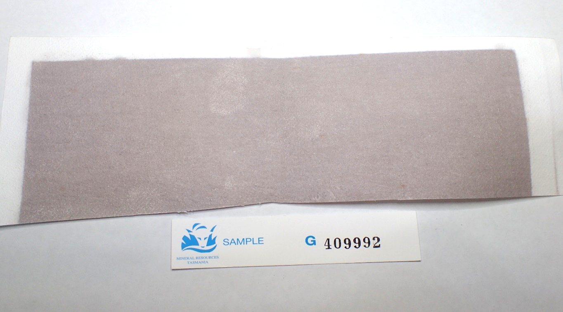
Figure 1. Dust sample G409992; the MRT label size is 85mm.

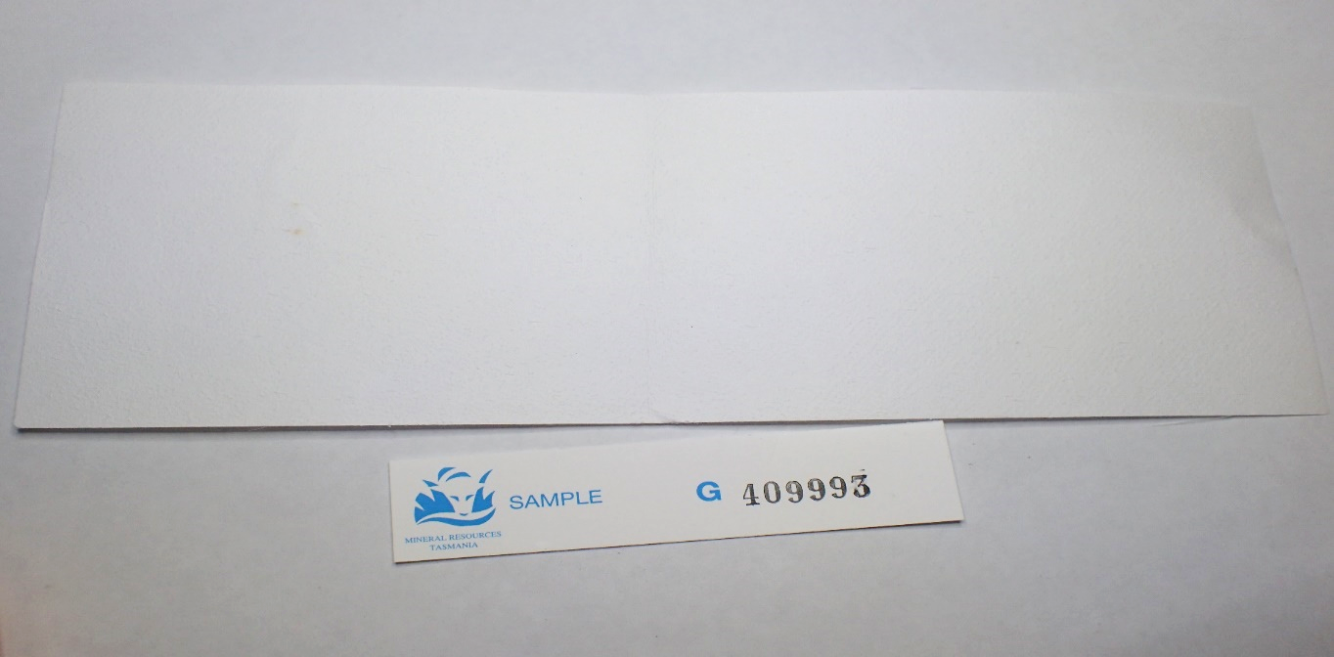 Figure 2. Dust sample G409993; the MRT label size is 85mm.

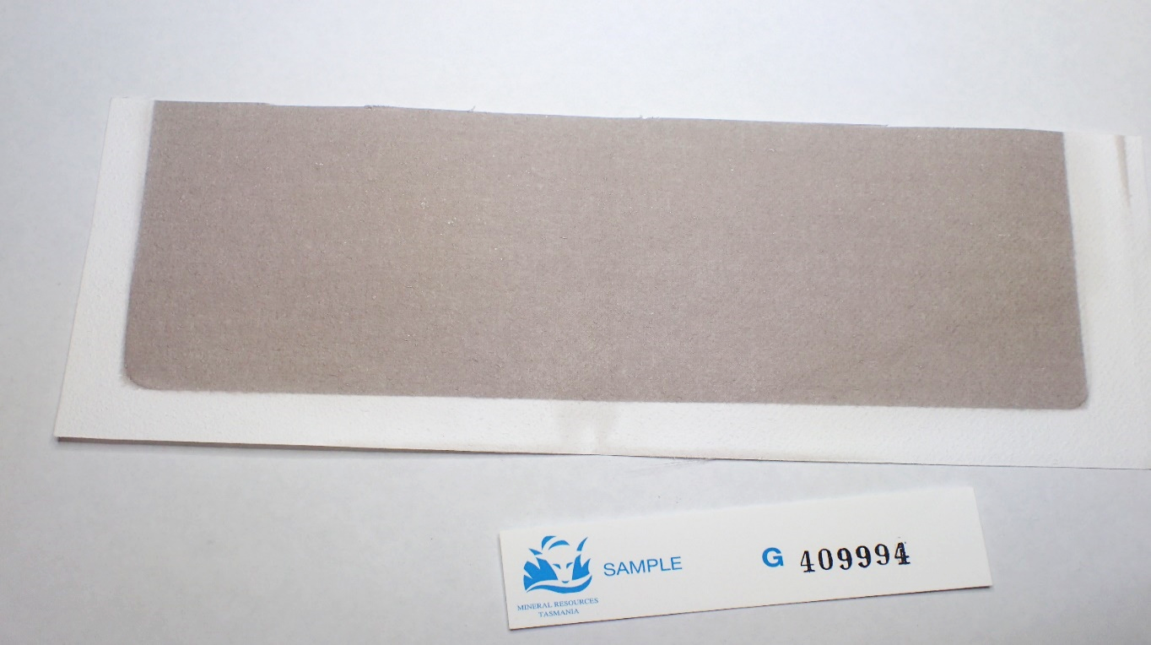
Figure 3. Dust sample G409994; the MRT label size is 85mm.

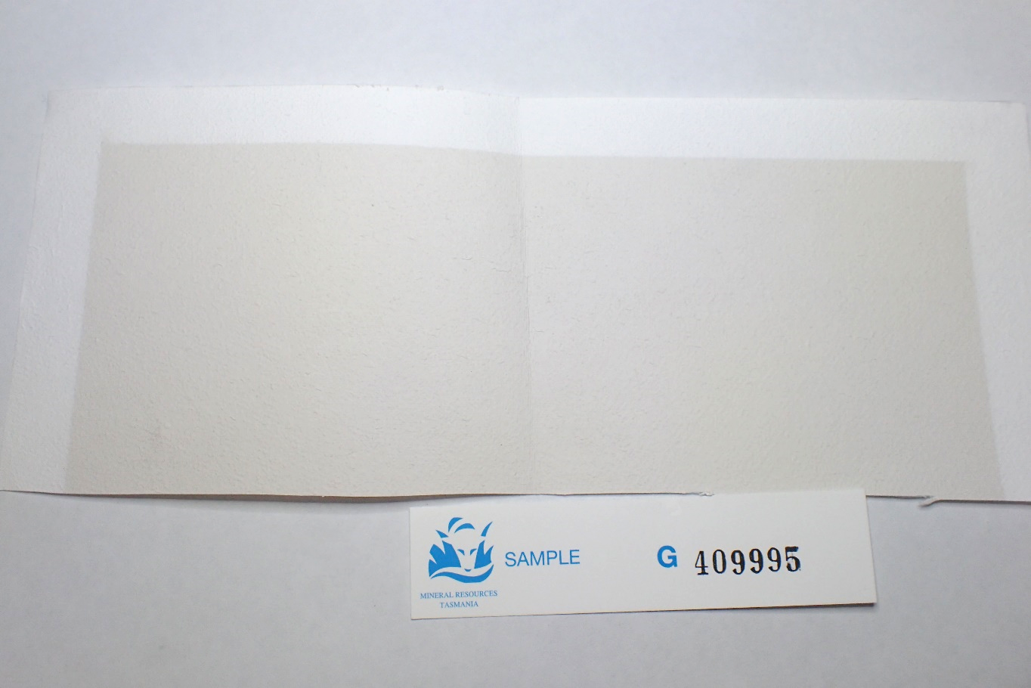
Figure 4. Dust sample G409995; the MRT label size is 85mm.

Analytical techniques
The samples were examined and prepared by cutting out a section of the filter paper and analysing by XRD (Powder X-ray diffraction) in the Mineral Resources Tasmania (MRT) laboratories, Rosny Park, Tasmania.

XRD analyses
The samples were run on a Rigaku Miniflex 600 X-Ray Diffractometer system: a 600W generator 150mm goniometer with a Cu tube; 40kV/15mA, sample spinner and a Scintillation counter (SC) with Be window, 3º to 63º 2Theta scanning range and 3° – 63° 2Theta measuring range, a scanning speed of 0.5° /min, a graphite monochromator and a Kß Ni- filter. The software used for mineral identification is the PDXL2 using the ICCD database.
The filter samples were analysed along with a blank filter sample for subtraction of its background contribution. Quantification is largely manual, using a series of prepared standards of the more common minerals to enable some semi-quantitative analysis. Our semi-quantitative results are calculated using single-peak calibration factors derived from scans of known mixtures of minerals.

XRD RESULTS
The results are shown in Appendix 1, summarized in Table 2. Two samples are rich in iron oxides as discussed below.

Table 2: Summary XRD results. ND: not detected.
 | Halite | Hematite | Magnetite
G409992 | present | present | present
G409993 | present | ND | ND
G409994 | present | present | ND
G409995 | present | ND | ND

Halite is present on all the filters. Two also contain detectable Hematite and one contains detectable magnetite.

Discussion and Conclusions
Halite probably comes from sea spray. The iron oxides hematite and magnetite in two of the dust samples probably both derive from the Pt Latta iron ore plant.

R.S. Bottrill L Unwin
MINERALOGIST/PETROLOGIST TECHNICAL OFFICER

Disclaimers
While every care has been taken in the preparation of this report, no warranty is given as to the correctness of the information and no liability is accepted for any statement or opinion or for any error or omission. No reader should act or fail to act on the basis of any material contained herein. Readers should consult professional advisers. As a result the Crown in Right of the State of Tasmania and its employees, contractors and agents expressly disclaim all and any liability (including all liability from or attributable to any negligent or wrongful act or omission) to any persons whatsoever in respect of anything done or omitted to be done by any such person in reliance whether in whole or in part upon any of the material in this report. The MRT laboratories are not NATA registered but work to similar standards. This and other data collected in MRT laboratories may enter the MRT databases but every attempt will be made to ensure it remains closed file and not be available externally, unless at your request.

Laboratory Details
Mineral Resources Tasmania (MRT) operates a laboratory facility at its offices at Rosny Park and Mornington, Tasmania. In the interests of full disclosure, these laboratories do not have NATA accreditation. However, all tests are performed according to relevant Australian Standards cited in the report and subject to internal peer review processes. The analytical facilities at MRT are periodically compared against other similar laboratories in other jurisdictions with favourable results.

Appendix 1: Laboratory Report: XRD Analyses

Client: Grange
Sample location:
Job Number: LJN2021-111
Analysis:
Method: XRD
Analyst: Lia Unwin
Lab manger: R Bottrill
Date: 23/12/2021

Measurement conditions
X-Ray: | 40 kV , 15 mA | Scan speed / Duration time: | 0.5000 deg/min
Goniometer: | MiniFlex600 | Step width: | 0.0200 deg
Attachment: | ASC-6 | Scan axis: | Theta/2-Theta
Filter: | None | Scan range: | 3.0000 - 63.0000 deg
CBO selection slit: | - | Incident slit: | 1.250deg
Diffracted beam mono.: | Bent | Length limiting slit: | 10.0mm
Detector: | SC-70 | Receiving slit #1: | 1.250deg
Scan mode: | Continuous | Receiving slit #2: | 0.3mm

XRD Results-G409992-LJN2021-111-GFilters-23/12/2021

General Information

Measurement date: | 22/12/2021 | Interpretative date: | 23/12/2021
Job Number/Client: | LJN2021-111 GFilters | XRD | Rigaku Miniflex 600
Registration Number: | G409992 | Analyst: | LUnwin
Quantitative Method: | Mineralogy Only | Process Medium: | Filter Paper
Sample Holder: | Standard | Speed (deg/min): | 0.5
Comment: | Shifted -0.28 Quartz added for calibration

Analysis Results

Phase name | Formula
Halite | Na Cl
Hematite | Fe₂O₃
Magnetite | Fe²⁺Fe³⁺₂O₄
Filter Substrate
Sample Holder

Notes
Peak overlap may interfere with identifications and quantitative calculations.
Amorphous minerals and minerals present in trace amounts may not be detected.

Peak List
No. | 2-theta(deg) | d(ang.) | Phase name | Rel. int. I(a.u.)
1 | 18.085(16) | 4.901(4) | Filter Substrate | 100.00
2 | 31.64(4) | 2.826(3) | Halite(2,0,0) | 11.59
3 | 33.13(7) | 2.702(5) | Hematite(1,0,4) | 8.24
4 | 35.377 | 2.53519 | Hematite(1,1,0) | 10.66
5 | 35.6483 | 2.51652 | Magnetite(3,1,1) | 6.69
6 | 37.539(4) | 2.3940(3) | Sample Holder | 58.15
7 | 43.735(5) | 2.0681(2) | Sample Holder | 37.23

Phase Data Pattern

XRD Results-G409993-LJN2021-111-GFilters-23/12/2021

General Information

Measurement date: | 22/12/2021 | Interpretative date: | 23/12/2021
Job Number/Client: | LJN2021-111 GFilters | XRD | Rigaku Miniflex 600
Registration Number: | G409993 | Analyst: | LUnwin
Quantitative Method: | Mineralogy Only | Process Medium: | Wholerock
Sample Holder: | Standard | Speed (deg/min): | Filter Paper
Comment: | Shifted -0.55, Quartz added for calibration

Analysis Results

Phase name | Formula
Halite | Na Cl
Filter Substrate
Sample Holder

Notes
Peak overlap may interfere with identifications and quantitative calculations.
Amorphous minerals and minerals present in trace amounts may not be detected.

Peak List
No. | 2-theta(deg) | d(ang.) | Phase name | Rel. int. I(a.u.)
1 | 18.04(2) | 4.914(5) | Filter Substrate | 100.00
2 | 31.4842 | 2.8392 | Halite(2,0,0) | 13.70
3 | 37.502(4) | 2.3963(2) | Sample Holder | 77.74
4 | 43.717(11) | 2.0689(5) | Sample Holder | 20.72

Phase Data Pattern

XRD Results-G409994-LJN2021-111-GFilters-23/12/2021

General Information

Measurement date: | 22/12/2021 | Interpretative date: | 23/12/2021
Job Number/Client: | LJN2021-111 GFilters | XRD | Rigaku Miniflex 600
Registration Number: | G409994 | Analyst: | LUnwin
Quantitative Method: | Mineralogy Only | Process Medium: | Wholerock
Sample Holder: | Standard | Speed (deg/min): | Filter Paper
Comment: | Shifted -0.33 Quartz added for calibration

Analysis Results

Phase name | Formula
Halite | Na Cl
Hematite | Fe₂O₃
Filter Substrate
Sample Holder

Notes
Peak overlap may interfere with identifications and quantitative calculations.
Amorphous minerals and minerals present in trace amounts may not be detected.

Peak List
No. | 2-theta(deg) | d(ang.) | Phase name | Rel. int. I(a.u.)
1 | 18.117(17) | 4.893(5) | Filter Substrate | 4.24
2 | 31.7517 | 2.81589 | Halite(2,0,0) | 0.47
3 | 33.2618 | 2.69141 | Hematite(1,0,4) | 0.21
4 | 37.719(3) | 2.38296(16) | Sample Holder | 100.00
5 | 43.948(3) | 2.05859(12) | Sample Holder | 22.31

Phase Data Pattern

XRD Results-G409995-LJN2021-111-GFilters-23/12/2021

General Information

Measurement date: | 22/12/2021 | Interpretative date: | 23/12/2021
Job Number/Client: | LJN2021-111 GFilters | XRD | Rigaku Miniflex 600
Registration Number: | G409995 | Analyst: | LUnwin
Quantitative Method: | Mineralogy Only | Process Medium: | Wholerock
Sample Holder: | Standard | Speed (deg/min): | Filter Paper
Comment: | Shifted -0.35 Quartz added for calibration

Analysis Results

Phase name | Formula
Halite | Na Cl
Filter Substrate
Sample Holder

Notes
Peak overlap may interfere with identifications and quantitative calculations.
Amorphous minerals and minerals present in trace amounts may not be detected.

Peak List
No. | 2-theta(deg) | d(ang.) | Phase name | Rel. int. I(a.u.)
1 | 18.024(10) | 4.918(3) | Filter Substrate | 6.05
2 | 31.564(4) | 2.8322(4) | Halite(2,0,0) | 2.04
3 | 37.684(3) | 2.38510(15) | Sample Holder | 100.00
4 | 43.913(3) | 2.06016(11) | Sample Holder | 24.64

Phase Data Pattern

