Appendix 6 – Summary of data for time series gauges
Information and definitions for gauge data summary table
The accompanying table contains location information and summary data for the arbitrarily defined ‘tsunami gauges’. The purpose of these gauges was to provide time series data of water level and current speed at specific points of interest around the modelling domain. The raw data table is provided digitally. Additionally, time series graphs for each gauge are provided in Appendix 7, while this table contains maximum values, times for tsunami arrival and further hydrodynamic information inferred from this data.
The terms are reproduced as requested from the Australian Maritime College in relation to the Maritime Hazard Assessment and, as such, may differ slightly from more general terms used in the main body of this report. Definitions are as follows (with some visualised in Figure 1):
Stage height – The level of the water surface above highest astronomical tide (hat)
Time of arrival – The duration (hours, minutes, seconds) between the earthquake event and the arrival of the first wave.
End time – The time (hours, minutes, seconds; since the earthquake) at which the water level fluctuation has dropped beneath the order of 1 m from peak to trough.
Max wave height – The distance from peak to trough of the wave that generated the highest water level in the time series.
MWH time – The time (hours, minutes, seconds; since the earthquake) at which the maximum water level occurs.
Wave length – An approximate value calculated from the velocity and 2 x the time period between the maximum peak and its associated trough.
Time max current – The time (hours, minutes, seconds; since the earthquake) that the maximum current velocity occurs.
Max current – The maximum current velocity, provided in both ms⁻¹ and knots. This value represents the absolute particle movement throughout time (i.e. a persistent induced current).
Wave speed – The maximum celerity (wave speed), provided in both ms⁻¹ and knots, derived from the water depth by the formula c = √gd. This is the instantaneous speed encountered as the wave passes a point. The effect of tsunami wave speed on marine craft is difficult to quantify and will depend on the length and draw of the boat (as with normal wind-waves).
Upper velocity – The maximum total velocity encountered (celerity + current velocity), provided in both ms⁻¹ and knots.
Turbulence – Represents the shoaling and breaking of the wave(s). The Y/N value in the table is calculated from a ratio of maximum wave height to water depth, where values exceeding 0.72 generate a breaking wave (Y).

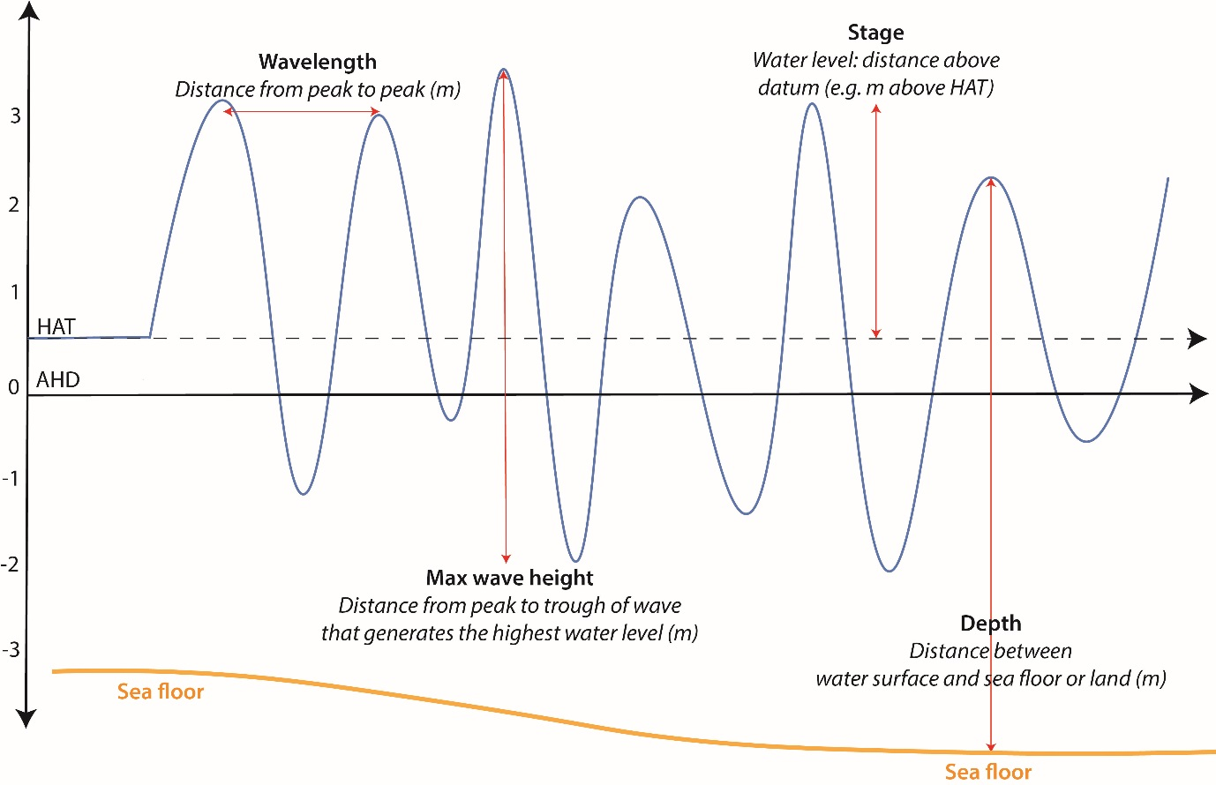
Figure 1. Part of a tsunami water level time series, showing a visual representation of key definitions described above.

