MHM EL3/2007
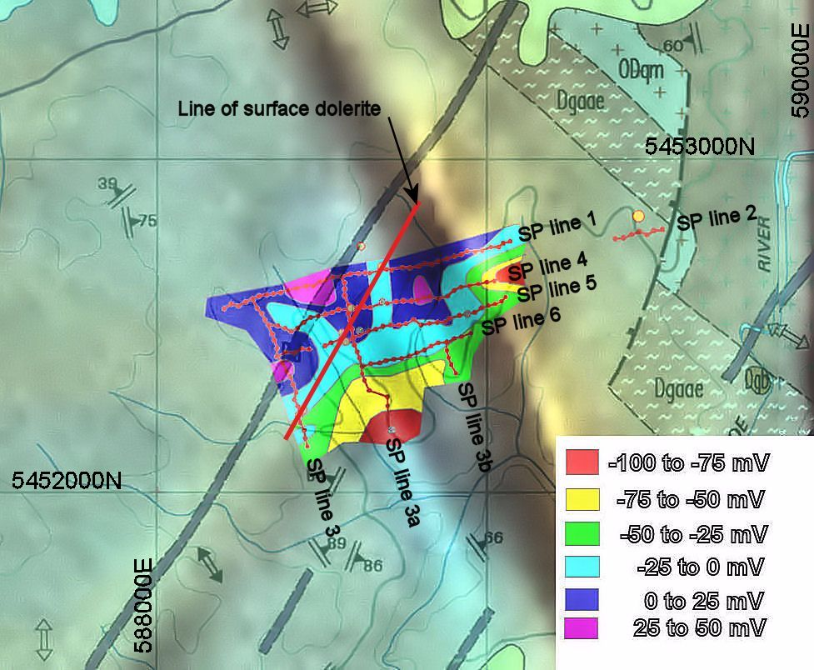
AMG 66 coordinates for Old Chum Dam SP survey

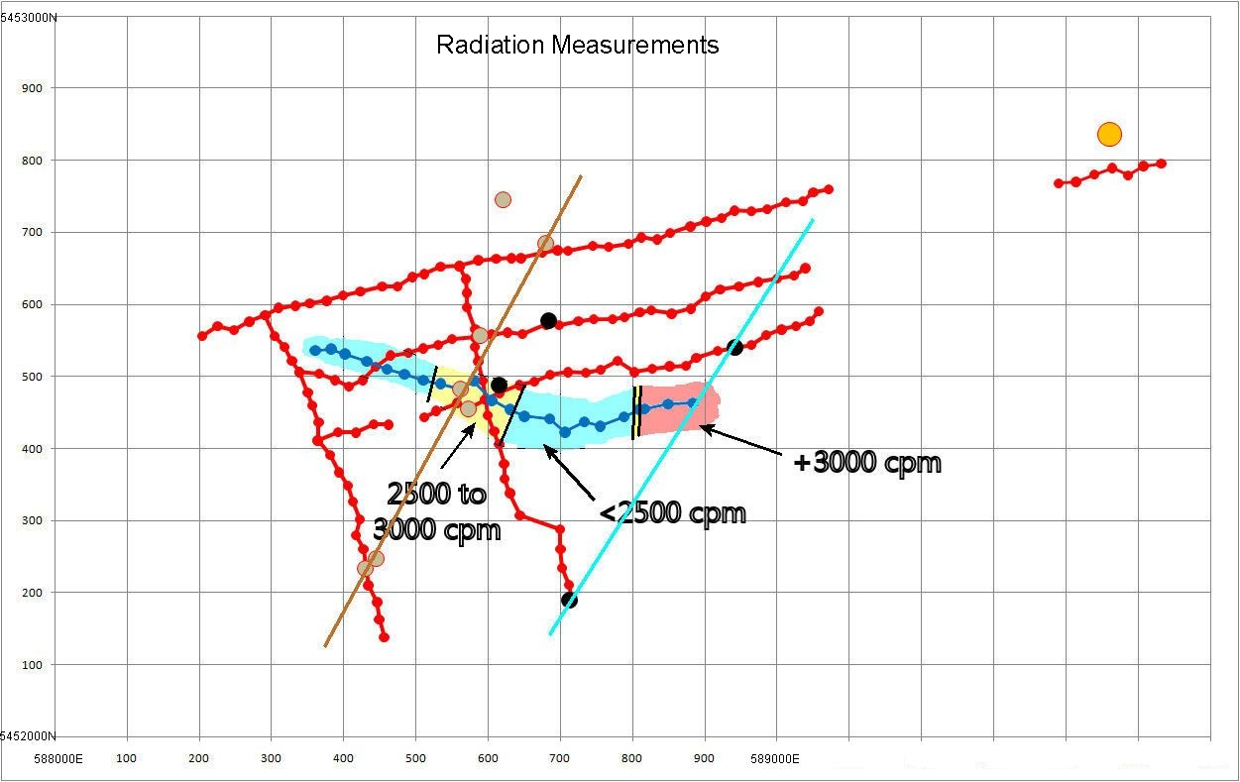

Radiation
(Using a Technical Associates Model PUG-1)
E N (cpm)
588360 5452536 2200
588382 5452538 2200
588402 5452531 1500
588432 5452521 2300
588460 5452510 2300
588484 5452503 2200
588510 5452495 2700
588534 5452490 2500
588562 5452482 2900
588580 5452494 2100
588605 5452467 2000
588630 5452454 2600
588650 5452445 2500
588685 5452441 2700
588706 5452423 2600
588733 5452437 2400
588755 5452431 1900
588788 5452444 2000
588809 5452454 2700
588817 5452455 3200
588849 5452462 3200
588883 5452463 3000

Self Potential Line 1 E N Reading Cum. value
588204 5452556 0 0
588225 5452570 7.8 7.8
588248 5452564 3.8 11.6
588269 5452576 -1.8 9.8
588291 5452585 12.4 22.2
588310 5452595 -21 1.2
588333 5452598 7 8.2
588353 5452601 1.9 10.1
588376 5452605 -10.8 -0.7
588399 5452612 15 14.3
588423 5452618 55 69.3
588453 5452625 -67.6 1.7
588474 5452625 46.7 48.4
588495 5452638 -3.2 45.2
588511 5452642 -38.9 6.3
588534 5452652 32.2 38.5
588560 5452653 -25.1 13.4
588586 5452661 4 17.4
588611 5452663 9 26.4
588632 5452664 -15.1 11.3
588645 5452664 -22.1 -10.8
588675 5452672 5.3 -5.5
588696 5452675 7 1.5
588710 5452674 1.4 2.9
588745 5452681 1.1 4
588767 5452680 14.6 18.6
588794 5452684 -1.1 17.5
588812 5452693 -2.8 14.7
588834 5452690 -12.3 2.4
588852 5452699 20.8 23.2
588880 5452708 -34.2 -11
588902 5452715 1.6 -9.4
588923 5452720 21.6 12.2
588941 5452730 4.9 17.1
588964 5452729 -25 -7.9
588986 5452732 13 5.1
589012 5452742 -2 3.1
589036 5452743 3.1 6.2
589050 5452755 -23.6 -17.4
589071 5452760 7.5 -9.9

SP line 2
Easterly Northerly Reading Cum. value
589390 5452768 0 0
589414 5452770 -2.8 -2.8
589439 5452780 2.5 -0.3
589464 5452789 -13.7 -14
589486 5452779 19.5 5.5
589507 5452792 -2.7 2.8
589532 5452795 26.7 29.5

SP line 3
Note: Cum. value starts at 588291E 5452585N on line 1

Easterly Northerly Reading Cum. value
588291 5452585 0 22.2
588304 5452556 28.9 -6.7
588318 5452541 -12.4 5.7
588328 5452522 -2.5 8.2
588338 5452506 -6 14.2
588350 5452478 -5.3 19.5
588356 5452460 19.6 -0.1
588365 5452436 -18.2 18.1
588364 5452411 -9.1 27.2
588381 5452391 1.1 26.1
588393 5452367 5.7 20.4
588406 5452348 -10.1 30.5
588413 5452326 0.8 29.7
588422 5452302 36.9 -7.2
588417 5452280 3.2 -10.4
588427 5452260 2.3 -12.7
588430 5452235 17.6 -30.3
588434 5452210 -2.1 -28.2
588446 5452187 7.4 -35.6
588449 5452163 -28.2 -7.4
588456 5452138 9.1 -16.5

SP line 3a
Note: Cum. value Starts at 588560E 5452653N on line 1

Easterly Northerly Reading Cum. value
588560 5452653 0 13.4
588569 5452635 -12.1 25.5
588570 5452616 23.3 2.2
588570 5452596 17.1 -14.9
588582 5452566 -28.1 13.2
588581 5452541 4.3 8.9
588586 5452521 -3 11.9
588592 5452494 12.7 -0.8
588596 5452468 -21.1 20.3
588599 5452446 33.5 -13.2
588608 5452424 -15 1.8
588615 5452406 11 -9.2
588622 5452379 -16.1 6.9
588623 5452358 97.5 -90.6
588630 5452338 -27.7 -62.9
588644 5452307 7 -69.9
588699 5452288 4.4 -74.3
588700 5452260 -13.6 -60.7
588702 5452234 36.7 -97.4
588712 5452211 -23.6 -73.8
588716 5452189 8.1 -81.9

SP line 3b
Note: Cum. value starts at 588879E 5452454N on line 6

Easterly Northerly Reading Cum. value
588879 5452454 0 -11.3
588879 5452428 26.5 -37.8
588885 5452406 20.6 -58.4
588893 5452385 -19.6 -38.8
588907 5452360 -6.5 -32.3

SP Line 4
Note: Cum. value starts at 588338E 5452506N on line 3

Easterly Northerlly Reading Cum. value
588338 5452506 0 14.2
588366 5452504 -37.6 -23.4
588388 5452495 25.5 2.1
588407 5452486 5.5 7.6
588426 5452495 -9.3 -1.7
588444 5452513 -13 -14.7
588465 5452529 5.7 -9
588489 5452533 1.7 -7.3
588510 5452539 5.1 -2.2
588531 5452544 14.1 11.9
588550 5452552 37 48.9
588582 5452554 -45.4 3.5
588605 5452558 -3.2 0.3
588627 5452561 19.7 20
588647 5452559 -31 -11
588680 5452572 -5.3 -16.3
588698 5452571 10.2 -6.1
588725 5452577 21.2 15.1
588746 5452579 -14.1 1
588772 5452579 49 50
588789 5452582 -35.5 14.5
588810 5452589 54.6 69.1
588826 5452592 -70.4 -1.3
588854 5452587 23.3 22
588881 5452594 -50.2 -28.2
588901 5452611 15.3 -12.9
588921 5452621 14.1 1.2
588947 5452625 -29 -27.8
588974 5452631 -29.9 -57.7
677000 5452636 -2.6 -60.3
588023 5452640 -30.8 -91.1
588039 5452650 9.2 -81.9

SP Line 5
Note: Cum. value for start of western segment starts at 588364E 5452411N on line 3, and for western segment, where it crosses line 3a at 588596E 5452468N.

Easterly Northerly Reading Cum. value
588364 5452411 0 27.2
588392 5452423 -19 8.2
588417 5452422 -3.6 4.6
588441 5452434 20.4 25
588462 5452433 -30.5 -5.5

588511 5452443 -13.1 5.3
588528 5452452 5.8 -7.8
588557 5452463 -11.2 -2
588573 5452455 33.5 -13.2
588596 5452468 0 20.3
588616 5452477 -12 8.3
588643 5452488 -5.7 2.6
588664 5452493 7.2 9.8
588686 5452502 -23.6 -13.8
588710 5452506 23.5 9.7
588735 5452505 -20.4 -10.7
588756 5452509 23.6 12.9
588779 5452522 -19.8 -6.9
588802 5452506 -6.2 -13.1
588827 5452511 -8.4 -21.5
588851 5452514 17.8 -3.7
588874 5452515 -0.8 -4.5
588888 5452526 12.2 7.7
588918 5452535 -10.4 -2.7
588942 5452540 -4.2 -6.9
588964 5452544 -12.1 -19
588985 5452557 5.8 -13.2
589006 5452565 -22 -35.2
589026 5452570 10.6 -24.6
588045 5452577 -3.7 -28.3
588058 5452590 -6.8 -35.1

SP Line 6
Note: Cum. value starts at 588622E 5452379N on line 3a

Easterly Northerly Reading Cum. value
588622 5452379 0 6.9
588649 5452388 -23.1 -16.2
588676 5452391 6.2 -10
588695 5452398 9.3 -0.7
588719 5452402 -20.5 -21.2
588742 5452405 14.6 -6.6
588767 5452412 10.6 4
588789 5452422 -20.5 -16.5
588811 5452430 17.5 1
588832 5452442 -23 -22
588853 5452452 8.9 -13.1
588879 5452454 1.8 -11.3
588902 5452465 1.2 -10.1
588923 5452471 -11.6 -21.7
588952 5452481 -21 -42.7

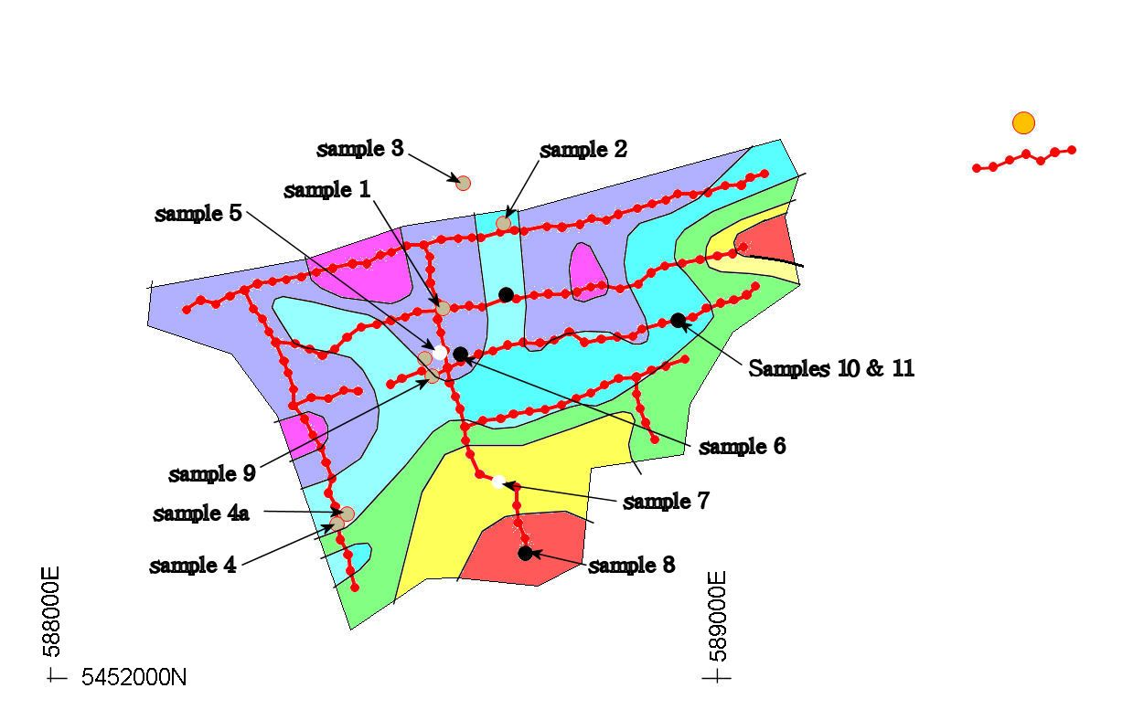
Surface rock samples

Sample no. Rock E N
1 dolerite 588589 5452557
2 dolerite 588680 5452685
3 ? 588620 5452745
4 dolerite 588430 5452233
4a dolerite 588440 5452243
5 weathered granite 588592 5452494
6 Aplite?? 588610 5452480
7 weathered granite 588670 5452309
8 microgranite 588730 5452189
9 dolerite 588573 5452455
10 microgranite 588942 5452540
11 microgranite 588942 5452540

Surface rock sample NITON analysis
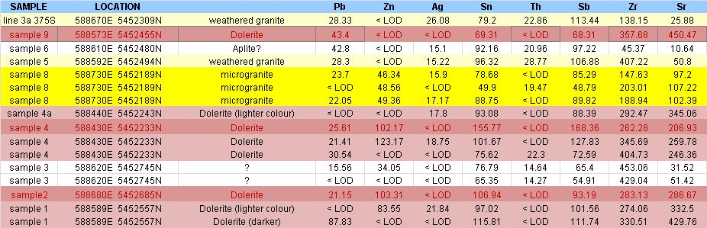

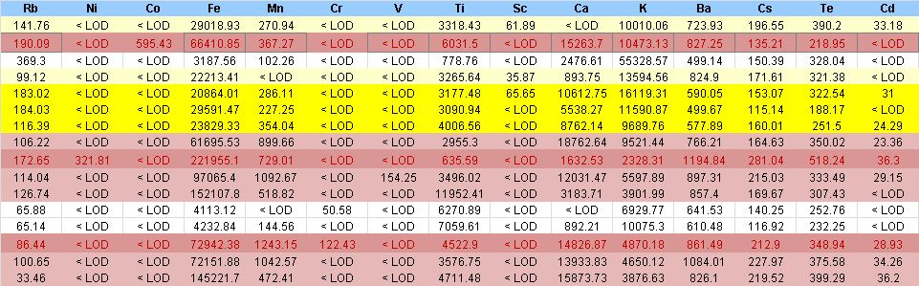

Niton Analysis along line 1

Line 1 Soil
Units SAMPLE LOCATION As Pb Cu Zn Ag Sn
ppm sp1 550 588794E 5452684N < LOD 15.47 < LOD < LOD < LOD 50.89
ppm sp1 675 588902E 5452715N < LOD < LOD < LOD < LOD < LOD 55.06
ppm sp1 700 588923E 5452720N < LOD < LOD < LOD < LOD < LOD 30.23
ppm sp1 725 soil 588941E 5452730N < LOD < LOD < LOD < LOD < LOD 51.38
ppm sp1 750 soil 588964E 5452729N < LOD < LOD < LOD < LOD < LOD 43.15
ppm sp1 775 soil 588986E 5452732N < LOD < LOD < LOD < LOD < LOD 53.01
ppm sp1 800 soil 589012E 5452742N < LOD < LOD < LOD < LOD < LOD 41.48
ppm sp1 825 soil 589036E 5452743N < LOD < LOD < LOD < LOD < LOD 56.27
ppm sp1 850 soil 589050E 5452755N < LOD < LOD < LOD < LOD < LOD 38.19
ppm sp1 870 soil 589071E 5452760N < LOD < LOD 85.99 < LOD < LOD 28.97

W Th Mo Sb Zr Sr U Rb Se Hg Ni Co Fe
< LOD 29.72 < LOD 61.58 909.7 29.58 < LOD 64.33 < LOD < LOD < LOD < LOD 2435.82
< LOD 17.52 < LOD 68.3 786.58 11.72 < LOD 11.01 < LOD < LOD < LOD < LOD 4236.46
< LOD 27.6 < LOD 42.8 697.94 14.88 < LOD 27.56 < LOD < LOD < LOD < LOD 17953.63
< LOD 14.09 < LOD 52.14 483.07 48.76 < LOD 61.7 < LOD < LOD 85.76 < LOD 6150.3
< LOD 14.29 < LOD 51.41 454.72 14.57 < LOD 27.37 < LOD < LOD < LOD < LOD 2935.49
< LOD < LOD < LOD 65.34 590.92 13.28 < LOD 15.58 < LOD < LOD < LOD < LOD 1632.64
< LOD 15.65 < LOD 52.54 524.93 16.21 < LOD 26.28 < LOD < LOD < LOD < LOD 1926.64
< LOD 11.32 < LOD 58.96 578.02 8.33 < LOD 11.79 < LOD < LOD < LOD < LOD 1250.51
< LOD < LOD < LOD 51.15 516.46 < LOD < LOD < LOD < LOD < LOD < LOD < LOD 464.47
< LOD < LOD < LOD 34.76 319.32 10.11 < LOD < LOD < LOD < LOD < LOD < LOD 796.48

Mn Cr V Ti Sc Ca K S Ba Cs Te Cd Pd
< LOD < LOD < LOD 5212.79 < LOD 759.67 26206.9 < LOD 449.64 109 206.1 < LOD < LOD
107.08 < LOD < LOD 7484.29 < LOD < LOD 3794.45 < LOD 421.82 127.77 169.14 19.63 < LOD
< LOD < LOD < LOD 8086.62 < LOD < LOD 5805.26 < LOD 324.65 81.5 126.15 < LOD < LOD
< LOD < LOD < LOD 5221.91 < LOD 1538.59 19035.26 < LOD 406.85 101.34 203.69 < LOD < LOD
< LOD < LOD < LOD 3269.82 < LOD < LOD 9047.21 < LOD 359.32 104.03 178.28 < LOD < LOD
< LOD < LOD < LOD 3793.29 < LOD 409.57 6132.44 < LOD 322.18 96.96 170.73 < LOD < LOD
< LOD < LOD < LOD 5634.77 < LOD 337.22 13246.07 < LOD 265.56 67.47 145.4 < LOD < LOD
< LOD < LOD < LOD 4281.97 < LOD < LOD 7056.08 < LOD 359.69 103.46 194.94 < LOD < LOD
< LOD < LOD < LOD 3606.4 < LOD < LOD 2038.07 < LOD 293.02 94.42 202.33 < LOD < LOD
< LOD < LOD < LOD 2385.12 < LOD 1029.41 2922.96 < LOD 186.13 60.3 121.47 < LOD < LOD

Line 1 Rock
Units SAMPLE LOCATION (within 2m radius of) As Pb Cu Zn Ag Sn
ppm sp1 50w rock 588248E 5452564N < LOD 18.3 < LOD 56.47 < LOD 31.57
ppm sp1 50w rock 588248E 5452564N < LOD 30.32 < LOD < LOD < LOD 91.63
ppm sp1 50w rock 588248E 5452564N < LOD < LOD < LOD < LOD 15.65 70.46
ppm sp1 50w rock 588248E 5452564N < LOD 14.53 < LOD < LOD < LOD 50.28
ppm sp1 50w rock 588248E 5452564N < LOD 17.33 < LOD < LOD < LOD 75.83
ppm sp1 25w rock 588269E 5452576N < LOD < LOD < LOD < LOD 24.8 93.01
ppm sp1 25w rock 588269E 5452576N < LOD 23.43 < LOD 27.64 < LOD 65.44
ppm sp1 25w rock 588269E 5452576N < LOD 19.6 < LOD < LOD < LOD 95.24
ppm sp1 0w granite 588291E 5452585N < LOD 34.56 < LOD 43.23 23.1 85.73
ppm sp1 0w granite 588291E 5452585N < LOD 37.17 < LOD 58.82 19.6 111.54
ppm sp1 0w granite 588291E 5452585N < LOD 41.32 < LOD < LOD 35.92 161.87
ppm sp1 0w granite 588291E 5452585N < LOD 27.16 < LOD 32.83 < LOD 63.78
ppm sp1 0w granite 588291E 5452585N < LOD 26.42 < LOD 58.65 < LOD 66.51
ppm sp1 0w granite 588291E 5452585N < LOD 55.58 < LOD < LOD 20.45 93.15
ppm sp1 0w granite 588291E 5452585N 21.56 47.63 < LOD < LOD 15.81 82.77
ppm rock n of line 1 0w 588291E 5452590N < LOD 34.33 < LOD < LOD < LOD 70.68
ppm rock n of line 1 0w 588291E 5452590N < LOD 42.8 < LOD < LOD < LOD 82.59
ppm sp1 725 granite 588941E 5452730N < LOD 20.62 < LOD < LOD < LOD 82.84
ppm sp1 750 granite 588964E 5452729N < LOD 19.02 < LOD 25.16 17.47 85.91
ppm sp1 870 granite 589071E 5452760N < LOD < LOD < LOD < LOD < LOD 55.08

W Th Mo Sb Zr Sr U Rb Se Hg Ni Co Fe
< LOD < LOD < LOD < LOD 111.22 221.5 < LOD 136.22 < LOD < LOD < LOD < LOD 10724.17
< LOD 22.06 12.97 77.05 241.75 115.55 < LOD 107.59 < LOD < LOD < LOD < LOD 56059.98
< LOD < LOD < LOD 60.33 83.17 121.21 < LOD 75.41 < LOD < LOD < LOD < LOD 4915.7
< LOD < LOD < LOD 64.76 146.47 66.38 < LOD 98.85 < LOD < LOD < LOD < LOD 7129.92
< LOD < LOD < LOD 72.34 132.19 189.54 < LOD 127.34 < LOD < LOD < LOD < LOD 3729.46
< LOD < LOD < LOD 71.72 83.01 173.81 < LOD 225.88 < LOD < LOD < LOD < LOD 5201.58
< LOD < LOD < LOD 61.19 225.92 148.3 < LOD 234.66 < LOD < LOD < LOD < LOD 17165.61
< LOD < LOD < LOD 73.86 64.26 74.42 < LOD 68.67 < LOD < LOD < LOD < LOD 66866.75
< LOD 31.6 < LOD 127.53 241.87 54.27 < LOD 243.32 < LOD < LOD < LOD < LOD 26542.45
< LOD < LOD < LOD 112.34 168.85 102.05 < LOD 224 < LOD < LOD < LOD < LOD 26293.01
< LOD < LOD < LOD 163.12 42.06 131.64 < LOD 274.24 < LOD < LOD < LOD < LOD 6908.69
< LOD 16.02 < LOD 33.36 394.17 92.82 < LOD 135.08 < LOD < LOD < LOD < LOD 15829.66
< LOD 20.54 < LOD 39.14 590.51 100.83 < LOD 213.39 < LOD < LOD < LOD < LOD 18582.96
< LOD < LOD < LOD 101.11 84.31 137.51 < LOD 296.5 < LOD < LOD < LOD < LOD 6609.15
< LOD < LOD < LOD 99.19 82.32 113.82 < LOD 248.45 < LOD < LOD < LOD < LOD 14413.89
< LOD 25.06 < LOD 52.39 160.94 40.8 < LOD 258.36 < LOD < LOD < LOD 614.24 56519.86
< LOD 37.43 < LOD 67.42 222.17 39.97 < LOD 236.67 < LOD < LOD < LOD 1063.85 89472.94
< LOD < LOD < LOD 90.89 239.67 113.07 < LOD 108.1 < LOD < LOD < LOD < LOD 15241.94
< LOD < LOD < LOD 91.13 131.71 187.47 < LOD 91.6 < LOD < LOD < LOD < LOD 8647.91
< LOD 23.26 < LOD 47.44 1182.55 12.69 < LOD 20.44 < LOD < LOD < LOD < LOD 834.97

Mn Cr V Ti Sc Ca K S Ba Cs Te Cd Pd
403.97 < LOD < LOD 2156.92 < LOD 13007.26 13233.15 < LOD 514.8 100.94 138.53 < LOD < LOD
226.11 < LOD < LOD 3191.77 < LOD 4412.53 8288.04 < LOD 746.24 158.41 249.11 < LOD < LOD
< LOD < LOD 99.13 2044.17 < LOD 4850.75 10577.36 < LOD 502.17 131.6 255.12 < LOD < LOD
< LOD < LOD < LOD 1931.5 < LOD 3275.9 12451.14 < LOD 543.29 119.39 226.93 < LOD < LOD
125.55 < LOD < LOD 1093.17 < LOD 12997.47 20567.44 < LOD 591.95 136.81 255.26 21.8 < LOD
128.21 < LOD < LOD 1761.29 42.64 7781.7 26683.88 < LOD 739.7 149.48 269.33 27.36 < LOD
389.1 < LOD < LOD 4414.94 < LOD 15982.39 14926.06 < LOD 580.14 144.22 233.9 < LOD < LOD
506.11 < LOD < LOD 4880.98 < LOD 5786.88 6343.56 < LOD 773.7 177 290.2 20.76 < LOD
529.86 < LOD < LOD 2924.62 < LOD 2187.75 26908.66 < LOD 886.42 201.21 337.27 36.89 < LOD
486.76 < LOD < LOD 2845.28 56.36 4689.17 18144.91 < LOD 1155.04 221.44 455.19 36.26 24.61
< LOD < LOD < LOD 858.68 31.35 1798.34 35758.13 < LOD 1528.85 298 545.09 55.52 40.44
308.04 < LOD < LOD 5969.34 < LOD 10821.15 12735.6 < LOD 393.5 108.63 193.08 < LOD < LOD
315.84 < LOD < LOD 3255.09 57.13 11169.34 10712.11 < LOD 499.91 134.59 202.13 < LOD < LOD
125.22 < LOD < LOD 1253.27 < LOD 2906.78 72702.39 < LOD 1189.82 191.82 330.7 25.32 < LOD
< LOD < LOD < LOD 2858.49 < LOD 1146.01 45820.73 < LOD 1042.46 193.07 375.49 < LOD 25.83
< LOD 87.31 < LOD 3877.34 < LOD < LOD 36157.35 < LOD 1266.56 146 254.89 < LOD < LOD
285.14 79.95 152 5533.54 < LOD < LOD 27176.08 < LOD 1230.07 174.15 268 < LOD < LOD
456.34 < LOD < LOD 2312.41 < LOD 5156.13 25750.91 < LOD 590.51 156.39 298.73 < LOD < LOD
150.43 103.84 < LOD 1603.08 55.27 11041.63 15506.86 < LOD 614.02 156.84 274.27 24.74 21.48
< LOD < LOD < LOD 8306.8 < LOD 721.36 7938.37 < LOD 333.74 95.45 182.45 < LOD < LOD

Gunns Quarry sites
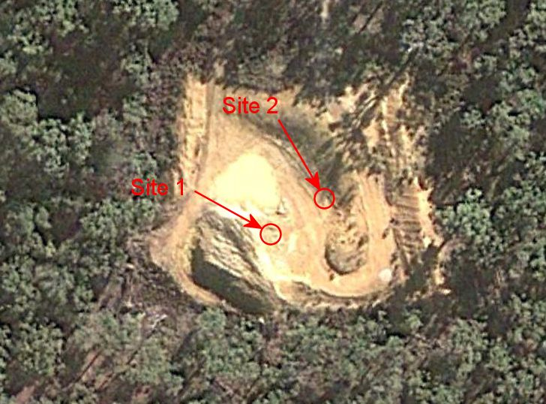

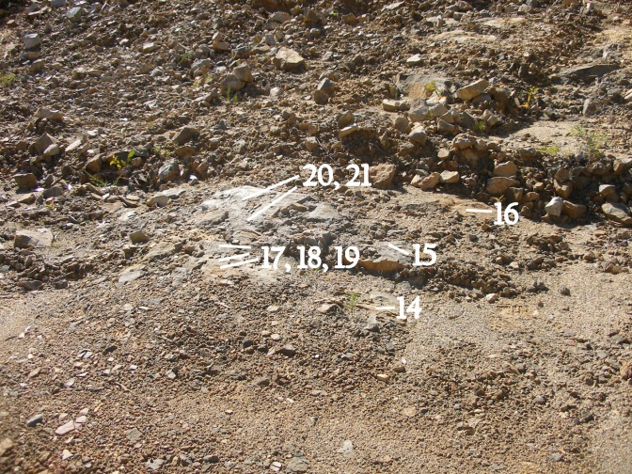
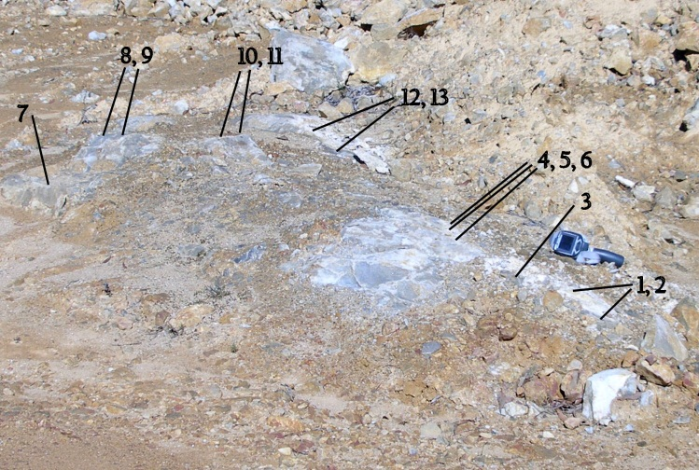

Site 1: (589487E 5452837N) Site 2: (589499E 5452854N)

The “white vein loose samples” were samples around site 1 that someone had chipped free.

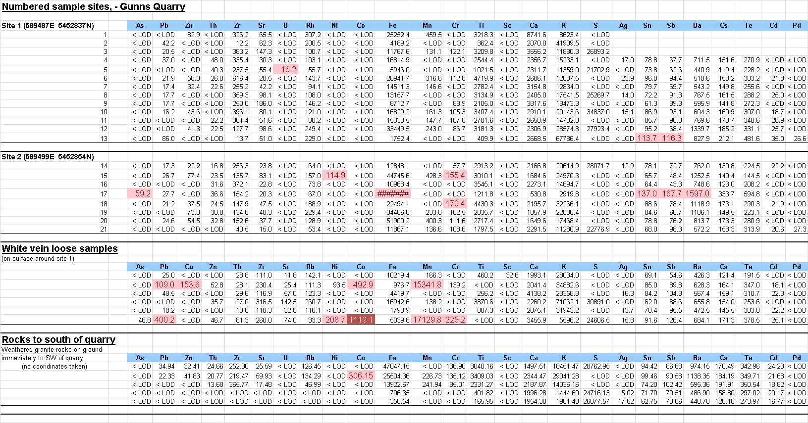

Hand samples from quarry stockpile, just W of site 1.

