Old Chum Dam Anomalies in NE Context
(May 2010)
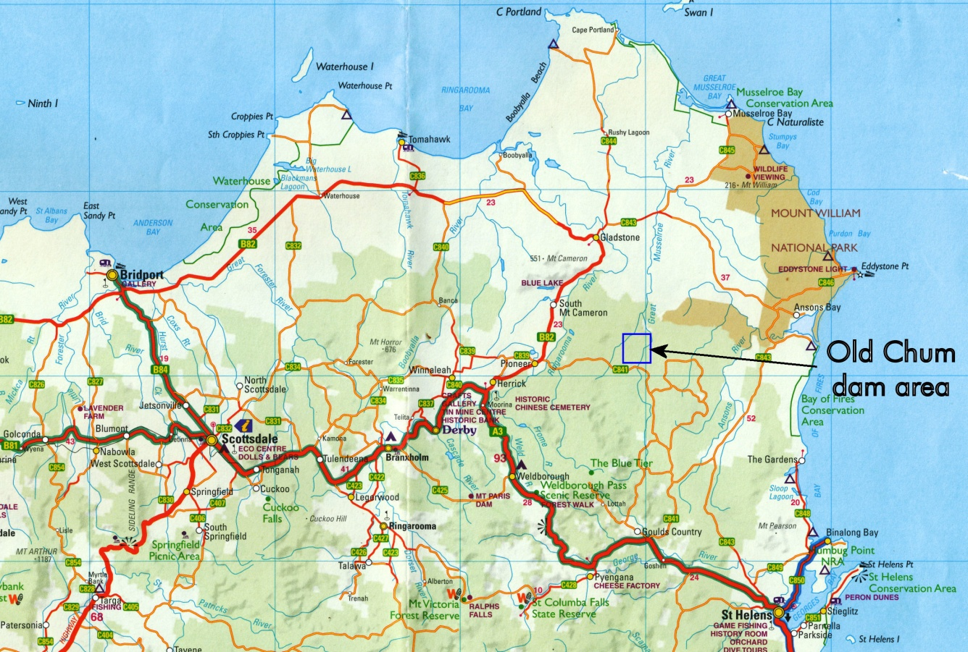
N. R Allen

Summary
The exploration of the Old Chum dam magnetic anomalies, in addition to identifying two interesting mineralised target areas for further and more detailed investigation, has both expanded on and been expanded by previous exploration over two other areas; specifically the Star Hill addit area and an older EL11/96 exploration project (MRT Open File 01-4550).
Considered in conjunction with the above other areas, the NE of the Old Chum dam target areas may reasonably be expected to favour mineralisation from a mafic source, including Cu, Ni, Cr, Co and possibly Au, while the SW target area would be expected to favour minerals from an aplite/Sn-greisen environment. However, the proximity of the two areas would imply some interaction.
In addition to the above, the exploration results have also identified a type of mineralisation and its genesis (whatever it turns out to be) that will be characteristic across at least the northern area of the Poimena pluton. Therefore the results of further exploration of the Old Chum dam anomalies, as well as proving or disproving a viable economic deposit in the Old Chum dam area, are also going to provide exploration information applicable across a wide area of northeast Tasmania.
It is therefore the recommendation of the author that further exploration of the target areas, including geochemistry, electromagnetism and drilling be considered, keeping in mind that any deposit will be at depth, probably between 150 to 500m.
Contents
Summary …………………………………………………………………………… 1
Introduction ………………………………………………………..……………. 2
The Old Chum Dam Anomalies. Strategic Location……………. 4
The Old Chum Dam Anomalies. Exploration………………………. 6
The Old Chum Dam Anomalies. Conclusions…………….………… 10
In Context with other Poimena pluton areas ……………...…….. 10
Appendix A: (SP survey measurements)…………………………….. 14
Appendix B (radiation measurements)………………………….……. 18
Appendix C (NITON and AAS analyses)…………………….…………. 19
Appendix D: Dolerite sample 4 microphotographs……….……. 25
References ………………………………………….……… 26

Introduction
The NE of Tasmania, east of Scottsdale and north of St Helens, is currently, I think, in a period of mining limbo. Alluvial mining for tin is pretty much at a stage of just mopping up old tailings and small known alluvial remnants. Hard-rock mining, at Mathinna (gold) and Lotta (tin) have largely reached the stage of old miner bar-room myths of forgotten lodes, hidden leads, past management mistakes and new “absolute certainties”.

The surface areas of the NE are probably now of interest mainly to small private miners, with the only miner currently left standing in the NE being one small alluvial miner.

I think there are no “quick return” near-surface larger mining projects left in the NE to develop or manage.

Yet, over he past 20 years, and largely ignored by most (not all) of the larger companies seeking to explore in the NE, knowledge and understanding of the NE Tas. geological structure and history have really leaped ahead, due to geologists such as Reed, McClenaghan, Bottrill, Everard, Groves, Richardson and Keele. A most significant factor in this development has been the recent MRT publication of magnetics, gravity and radiometric maps of the NE, which have together revealed structures previously unsuspected. MRT work on the NE is continuing with structural modelling based on gravity and magnetics and with active investigation of newly revealed anomalies such as we are currently investigating near Old Chum Dam. Interest in the NE at the Uni of Tas. (within CODES) is also being maintained, under Prof. Ross Large and Dr. Gary Davidson, with variations on exploration models such as the Tennant Creek Cu, Au, Co type (Davidson & Large, 1998) and the Northern Chile Tropezon Cu, Au, Mo deposit (Tornos et al, 2010) being considered to explain some high Co values (some of our values are higher than theirs).

The NE of Tasmania is now set up for an increase in, or perhaps a start to, a new phase of “green-fields” exploration. I think the key to this exploration is the understanding, now rapidly expanding, of the structure of the NE and its geological history, and a realisation and acceptance that any economic deposit, while leaving clues on the surface, is not going to be on the surface, and, with the exception of the Alberton/Mathinna area, is not going to be the “normal” tin or gold deposit previously mined in the area.

The Old Chum Dam Anomalies. Strategic Location.

The small portion of MHM EL3 that covers the Old Chum Dam area sits over a number of the more significant intersecting anomalies and structures that characterise much of the northern part of the Poimena pluton. If there is going to be any significant mineralisation within the granite fractures or beneath the shallow part of the pluton, it should show up in this area.

There are three types of magnetic anomalies in this area (see figure 1). Two of them are NNW-trending and one is NNE-trending. The NNW-trend has magnetic anomalies that are both considerably higher and considerably lower in magnetism than the surrounding granites. Out of these two NNW-trending anomalies we have some idea what the magnetic low ones indicate, but we do not know what the magnetic high ones indicate, although it is reasonable to suppose that the two are related to the same geological event. It can also be seen in figure 1 that these two NNW types of anomalies are fairly common across the north-eastern quarter of the Poimena granodiorite.

In addition to the magnetic anomalies there is at least one Devonian dolerite dyke and a microgranite intrusion (probably a dyke) which both have the same trend as the NNE-trending magnetic anomaly (figures 1 & 2) and which both intersect the NNW-trending magnetic anomalies. The area shown in figure 1 is also close to the northern boundary of a deep low gravity trough (see figure 3) that may be indicating a layering of granites beneath the southern part of the Poimena granodiorite. This possible layering, or at least the extra granite depth, has had some effect on the NNW-trending magnetic anomalies as they tend to die out to the south over this low gravity area.

The mineralisation likelihood of such a structure system would seem to be quite high.

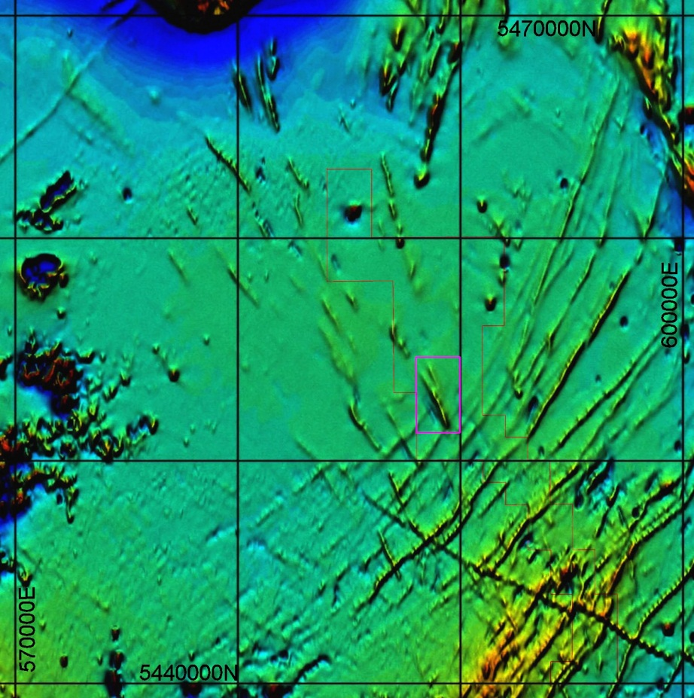

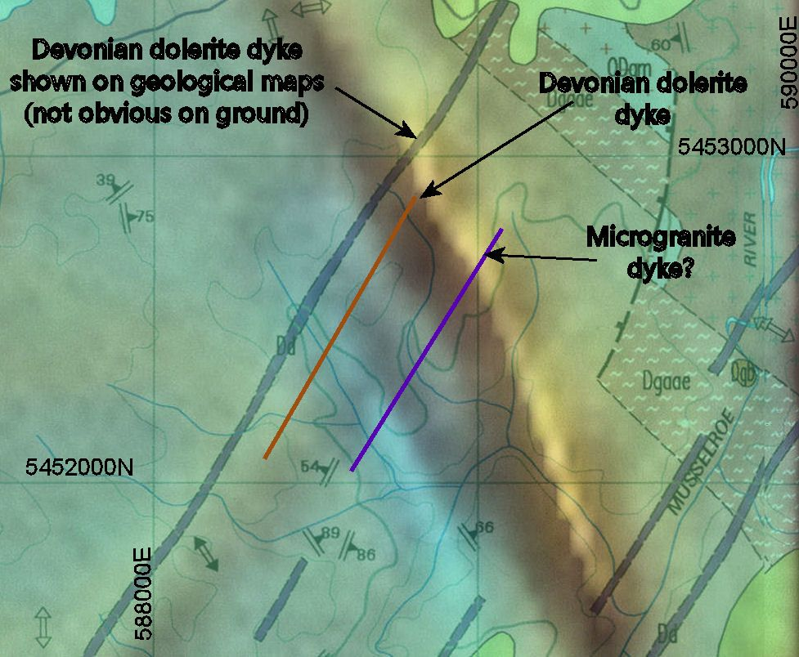
Figure 1. Part of the NE Tasmania magnetics. MHM lease area is shown as the black outline. The Old Chum Dam magnetic anomalies are shown within the pink outline. (10 km grid)

Figure 2. Location of dolerite and microgranite dykes on combined magnetics and geology of the Old Chum Dam area. (1 km grid)

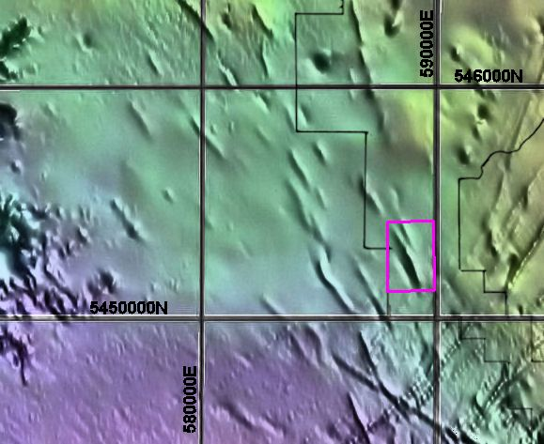

Figure 3. Old Chum Dam anomaly area (in red) in relation to low gravity basin (purple shading) (10 km grid)

The Old Chum Dam Anomalies. Exploration.

Exploration has so far been limited to:
1. Initial surface familiarisation (i.e. a lot of walking and looking)
2. A trial set of radiation (total) measurements (could now be expanded)
3. A Self Potential (SP) survey
4. Incidental and “point-of-interest” NITON analyses
SP survey
(Measurements in Appendix A)
SP measures the DC voltages that occur naturally in the ground as a result of mineral decomposition or alteration and its associated ion movement between oxidised and unoxidised regions. It is not a method that can be used in areas where there are lots of clays or where sulphides such as pyrite occur widely throughout layers such as shales. Thus it can not be used effectively across much of the Mathinna in the NE. However, in the granite areas of the NE it works quite well.
Like many electrical methods it will not pick up oxide minerals (e.g. cassiterite) unless these happen to be surrounded by more active minerals such as sulphides.
The SP survey results are shown in figure 4. The places of possible mineralisation are those that show up as most negative, and the contour colouring highlights the negative.
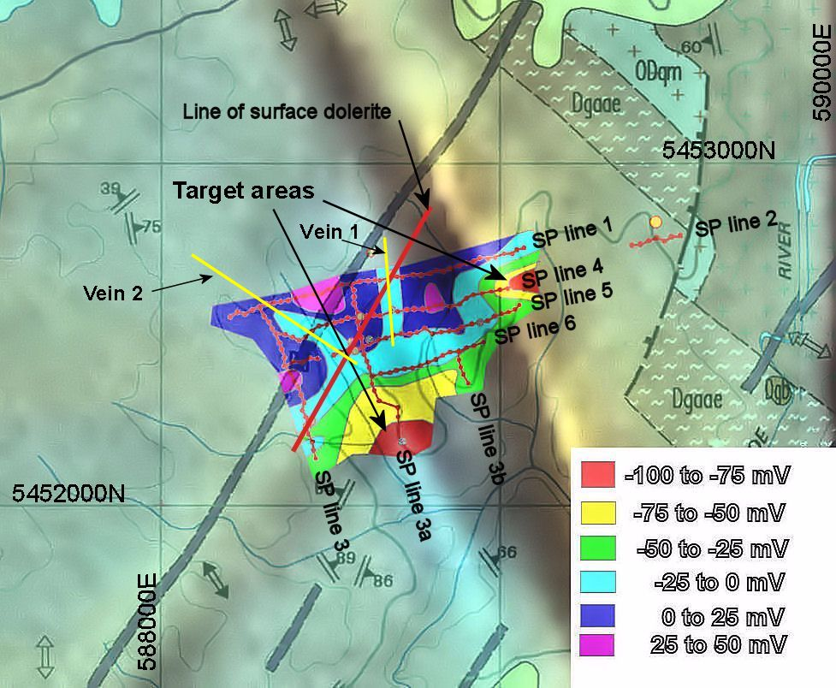

Figure 4. SP survey results, based on a 3-point moving average of the actual measurements, superimposed on combined magnetics/geology (1 km grid). The central and western area is the granodiorite of the Poimena pluton, while the area at upper right shows the western edge of the Gardens pluton, with some (probably shallow) Mathinna sediments trapped between the two plutons.
Two slightly negative N and NW-trending channels (light blue) can be seen in the results. These are probably indicating narrow veins (labelled veins 1 and 2) containing some mineralisation similar to that seen in the Star Hill Addit just south of Gladstone. In this context it is therefore interesting that some of the dolerite fragments, probably from near the outer wall of the dyke, where it intersects vein 2, do show some sulphide minerals (at least three, with one of these probably pyrite) associated with xenoliths.
Other than the above sulphides around and within xenoliths, the dolerite dyke does not show up in the current SP results as being of any exploration interest, but the xenoliths and sulphides within the dolerite suggest that the veins 1 and 2 preceded the dolerite intrusion.
The main exploration interest concerns the two much more negative areas, shaded as red in figure 4, which have been labelled as “target areas”. These occur at the intersection of the apparent microgranite dyke with both the magnetic high and magnetic low anomalies, with signs of a lower mineralisation channel between them. As the low magnetic anomaly is associated elsewhere (Star Hill) and indicated to be associated here (by limited NITON rock and soil analyses) with tin-greisen mineralisation, while the high magnetic anomaly must contain some quite magnetic minerals and is suspected by MRT to be some type of mafic dyke, we are probably looking at two different styles of mineralisation at the two target areas, with some interaction between them.
Radiation
(Measurements in Appendix B)
The initial trial radiation measurements (figure 5) were carried out prior to the SP survey, and show an increased radiation associated with both the dolerite dyke and the (then not recognised) microgranite, with the highest radiation being over the microgranite dyke. The high radiation over the dolerite dyke coincides approximately with the intersection of the dyke with vein 2 in figure 4. It would be interesting (curiosity satisfying) to know if this high radiation continues along the dyke.
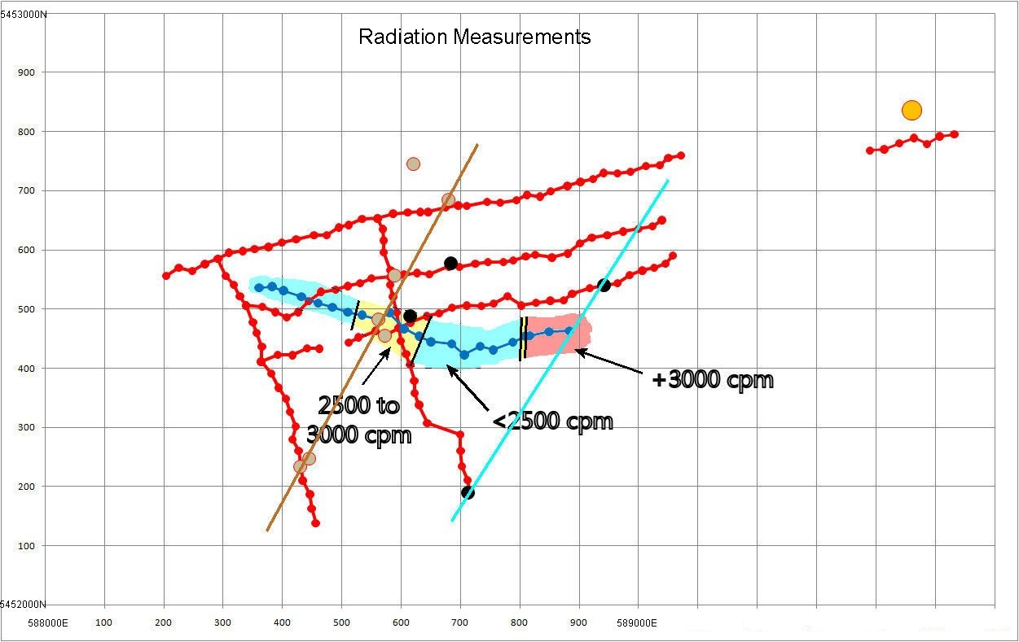

Figure 5. Initial trial radiation (total) measurements. Higher radiation occurs over both the dolerite (brown line) and microgranite (blue line) dykes. Background over the surrounding granodiorite is between 1200 and 1500 cpm.
The radiation looks more at the hydrothermal fluid activity than the dykes themselves and can be quite a useful method for locating breccia-filled and still-open fractures in the granite. One implication of the above radiation measurements is that soil geochemistry, which is not very productive for initially locating mineralisation in granite areas, could be used over at least the microgranite dyke to get some idea of the type of mineralisation below. In this case, and assuming hydrothermal activity all along the microgranite dyke, it may indicate differences between the two targets identified by the SP survey.
Analyses
(Analyses in Appendix C)
Some initial approximate rock analyses were carried out, with a NITON hand-held XRF analyser, at various points along SP line 1 where granite was exposed, and at the quarry a further half km east of the end of line 1. Because the equipment was no longer available after these measurements, the rock analyses were not able to be expanded for the more interesting rocks along later SP lines.
Rock exposures along SP line 1 are mainly limited to the west and eastern ends, with little or no rock exposed in the centre of the line. Rock values at the western end showed Sn between 100 and 160 ppm and Sb between 100 and 165 ppm, but at the eastern end the values had fallen to Sn between 50 and 80 ppm and Sb between 50 and 90 ppm. The values of these two elements seem to follow each other quite well. One suspicious-looking weathered brown/black rock at the western end of the line that may have once been either a basalt or a dolerite gave cobalt to 0.14%, but, although the rock was considerably more weathered, I suspect it came from the basalt road-making material used (from Derby?).
The above high Sn/Sb values coincide with the expected intersection of vein 2 with the SP line 1 (see figure 4), - although vein 2 was not known at the time.
Routine NITON soil analyses were tried, but too many of the line 1 sites had little near the surface except fairly barren coarse sand.
Rock analyses across a vein stockwork in an aplite-greisen environment exposed in the quarry were far more interesting, with values for Co (to 0.11%), Ni (to 208 ppm) and Cr (to 225 ppm), and occasional Sn and Sb values to 130 and 160 ppm respectively. Cu was normally less than error, but one reading of 150 ppm was obtained. The high Co values here appeared to be associated with thin films of manganese oxide, and were therefore not widespread.
Some high Co values (600 ppm) were also obtained later from surface rocks, near where the indicated dolerite dyke and vein 2 intersect (see figure 4). Interesting surface rocks were collected from a number of sites across the surveyed area, as shown in figure 6.

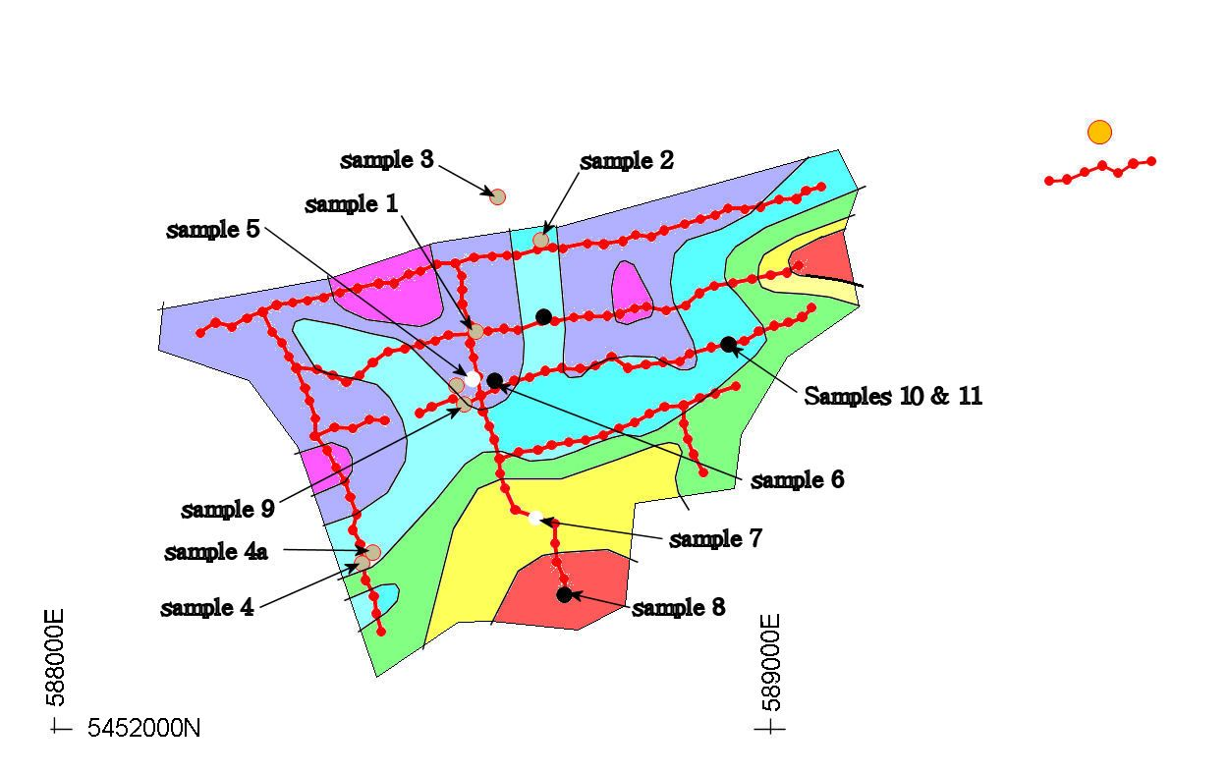

Figure 6. Location of the surface rocks collected across the survey area. Many of these were analysed by NITON, but the NITON was no longer available for others. The dolerite samples suggested a different location for the dolerite dyke than indicated on the geological map.

Rock sample locations
Sample no. Rock E N
1 dolerite 588589 5452557
2 dolerite 588680 5452685
3 ? 588620 5452745
4 dolerite 588430 5452233
4a dolerite 588440 5452243
5 weathered granite 588592 5452494
6 Aplite?? 588610 5452480
7 weathered granite 588670 5452309
8 microgranite 588730 5452189
9 dolerite 588573 5452455
10 microgranite 588942 5452540
11 microgranite 588942 5452540

The Old Chum Dam Anomalies. Conclusions.
In this granite environment, the SP method has been able to provide a meaningful and coherent picture of possible mineralisation sites. Even though SP lines 1, 3, 3a and 4 were each measured at different times, the rectangle formed by these lines, over a total distance of 800 m, had a closure error of only 10 to 13 mV at the intersection of lines 3a and 4. This gives considerable confidence in the overall survey results. The fit of the SP data with other data such as radiation, magnetics and observed surface features (dykes) adds further confidence.
While the earlier Star Hill SP results also showed similar accuracy, the deeper “Old Chum” mineralisation signal is almost four times that shown at Star Hill, indicating a mineralisation at the identified target areas many times greater (but deeper) than seen in the Star Hill addit. The vein 1 and 2 signal is comparable to (but a little deeper than) that measured over the vein stockwork seen in the Star Hill addit.
The SP survey here has achieved considerably more than just the identification of two mineralised target areas for future drilling. More importantly it has identified a combined structural and magnetic situation that can be expected to show mineralisation where it occurs elsewhere within the Poimena pluton.
Some auger sampling and geochemistry across the saddle just north of the southern target area, and also across the northern target area, could be a next step. A further step, prior to any drilling, could be some ground electromagnetics, as this would further define the nature of the SP source by including factors such as resistivity and frequency response.
Although there is not sufficient SP measurement across the indicated target areas to get a good idea of depth to target, I think it could be expected to be around 250 to 300m, with the depth to the vein 1 and 2 sources being probably about half that.

In Context with other Poimena pluton areas
Star Hill addit
This addit is located just south of Gladstone just east of a prominent low magnetism NNW-trending anomaly and above a much weaker low-magnetism anomaly, as illustrated in figure 6. It is an area of aplite and tin/tungsten greisen. The past history of the addit is not known.
It illustrates the type of mineralisation that was expected over the low magnetic anomaly at Old Chum dam, and which may exist below veins 1 and 2 shown in figure 4, but perhaps without the tungsten.

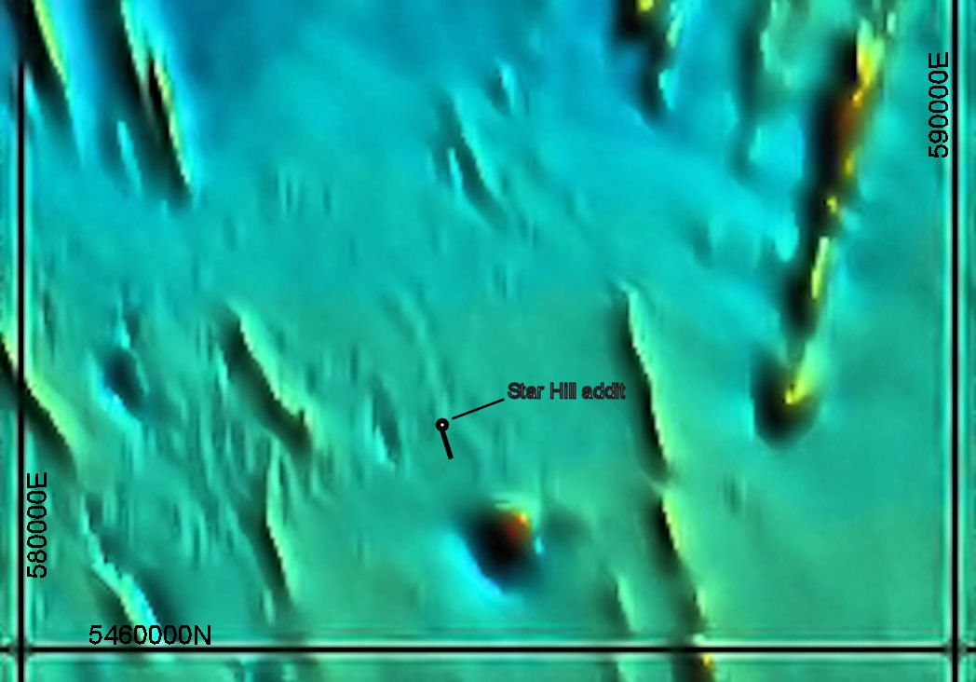
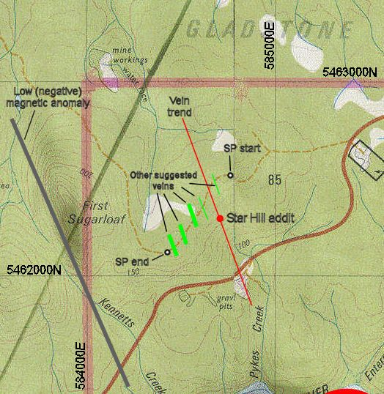

(b)

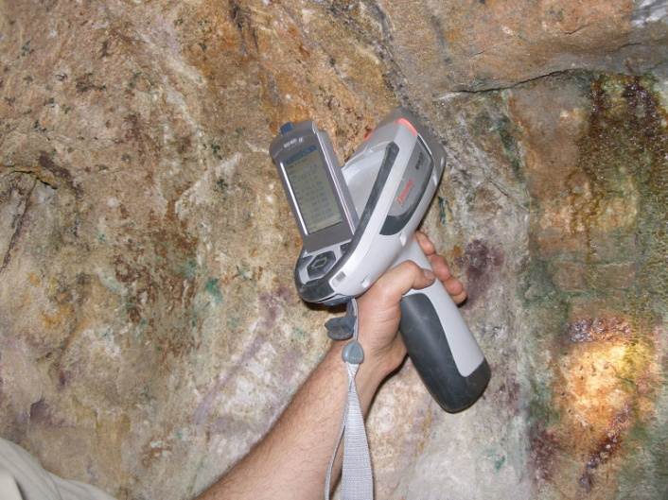
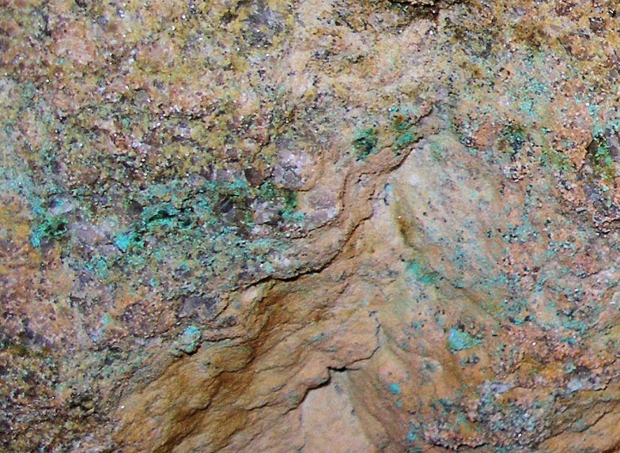
(a)

(c) (d)
Figure 6: Star Hill addit. (a) Location just south of Gladstone. (b) relationship of addit to magnetic features in the area. (c) malachite mineralisation in addit roof. (d) Sn/W veins in end of addit.

EL 11/96
This is an area about 7km west of Old Chum dam that was investigated between 1996 and 2001 for the somewhat anomalous occurrence of native metal particles. At the time nothing was known of any magnetic anomalies in the area. Quartz veins and breccia zones were identified which are now seen to have the same NNW-trend associated with the magnetic high and low anomalies of the Old Chum dam area, and two possible faults with trends that are now seen to have a similar trend to the dolerite and microgranite dykes of the Old Chum dam area. Microgranite was also found in the area, as shown in figure 7.

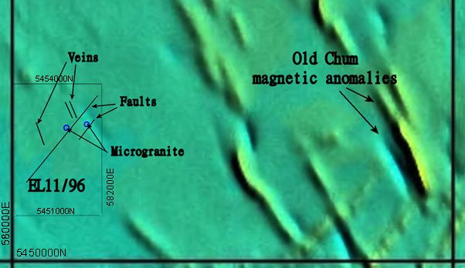

Figure 7. Location of EL11/96 in relation to the Old Chum dam area.
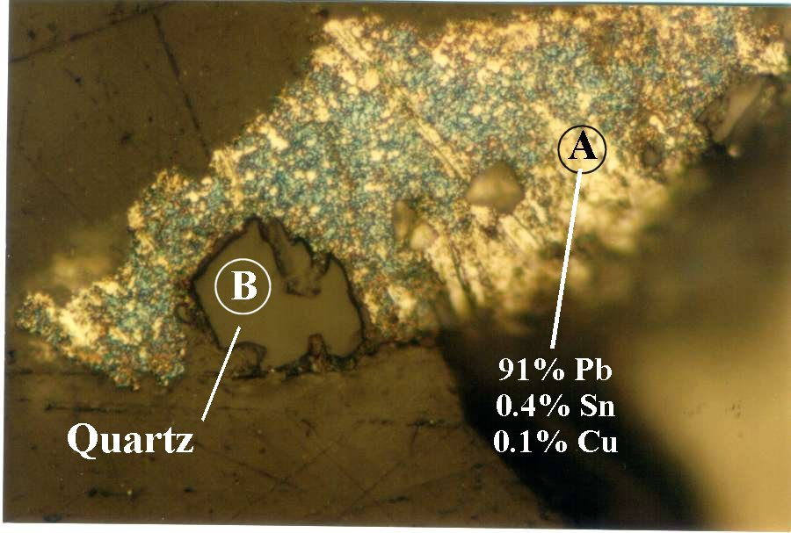
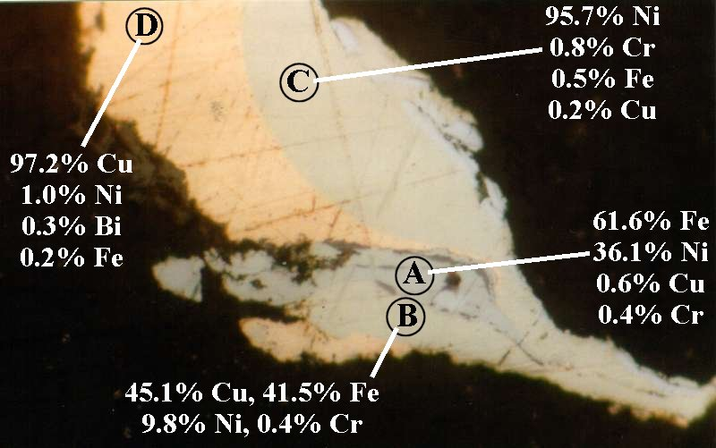
Native metals particles of Fe, Cu, Sn, Zn, Ni and Cr (identified by electron probe analysis) were found to be associated with the quartz veins and breccia zones (Allen at al, 2004), plus spinel that differed from that of the Tertiary basalts, and magnesian ilmenites. Spinel compositions were found to vary between locations (approximately NE to SW) and the native metal compositions varied from Zn/Cu/Pb in the NE to Ni/Cr in the SW. At the time these differences were quite a puzzle, but they can now be seen to fit with an expected (but reversed) difference in mineralisation along a SW trend in the Old Chum dam area.

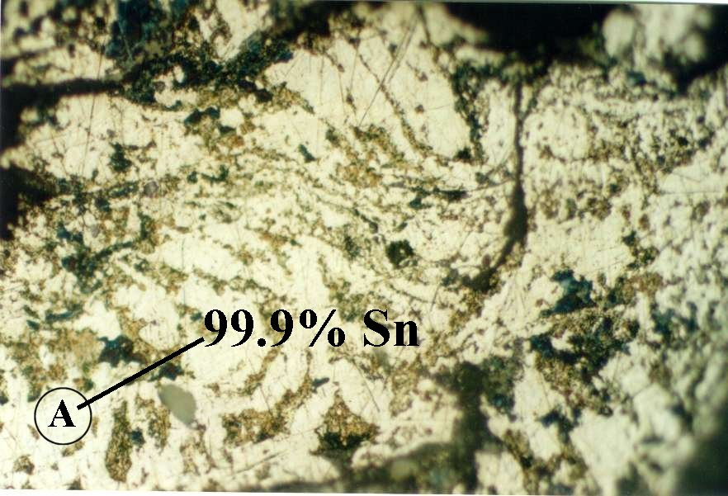
Figure 8. Some of the analysed native metal particles from EL11/96 (most were < 150 μm)

Appendix A: (SP survey measurements)
(+ve terminal always to E or to N. Pots at approx. 25m intervals and ‘leap-frogged’)
Self Potential Line 1 E N Reading Cum. value
588204 5452556 0 0
588225 5452570 7.8 7.8
588248 5452564 3.8 11.6
588269 5452576 -1.8 9.8
588291 5452585 12.4 22.2
588310 5452595 -21 1.2
588333 5452598 7 8.2
588353 5452601 1.9 10.1
588376 5452605 -10.8 -0.7
588399 5452612 15 14.3
588423 5452618 55 69.3
588453 5452625 -67.6 1.7
588474 5452625 46.7 48.4
588495 5452638 -3.2 45.2
588511 5452642 -38.9 6.3
588534 5452652 32.2 38.5
588560 5452653 -25.1 13.4
588586 5452661 4 17.4
588611 5452663 9 26.4
588632 5452664 -15.1 11.3
588645 5452664 -22.1 -10.8
588675 5452672 5.3 -5.5
588696 5452675 7 1.5
588710 5452674 1.4 2.9
588745 5452681 1.1 4
588767 5452680 14.6 18.6
588794 5452684 -1.1 17.5
588812 5452693 -2.8 14.7
588834 5452690 -12.3 2.4
588852 5452699 20.8 23.2
588880 5452708 -34.2 -11
588902 5452715 1.6 -9.4
588923 5452720 21.6 12.2
588941 5452730 4.9 17.1
588964 5452729 -25 -7.9
588986 5452732 13 5.1
589012 5452742 -2 3.1
589036 5452743 3.1 6.2
589050 5452755 -23.6 -17.4
589071 5452760 7.5 -9.9

SP line 2
Easterly Northerly Reading Cum. value
589390 5452768 0 0
589414 5452770 -2.8 -2.8
589439 5452780 2.5 -0.3
589464 5452789 -13.7 -14
589486 5452779 19.5 5.5
589507 5452792 -2.7 2.8
589532 5452795 26.7 29.5

SP line 3
Note: Cum. value starts at 588291E 5452585N on line 1

Easterly Northerly Reading Cum. value
588291 5452585 0 22.2
588304 5452556 28.9 -6.7
588318 5452541 -12.4 5.7
588328 5452522 -2.5 8.2
588338 5452506 -6 14.2
588350 5452478 -5.3 19.5
588356 5452460 19.6 -0.1
588365 5452436 -18.2 18.1
588364 5452411 -9.1 27.2
588381 5452391 1.1 26.1
588393 5452367 5.7 20.4
588406 5452348 -10.1 30.5
588413 5452326 0.8 29.7
588422 5452302 36.9 -7.2
588417 5452280 3.2 -10.4
588427 5452260 2.3 -12.7
588430 5452235 17.6 -30.3
588434 5452210 -2.1 -28.2
588446 5452187 7.4 -35.6
588449 5452163 -28.2 -7.4
588456 5452138 9.1 -16.5

SP line 3a
Note: Cum. value Starts at 588560E 5452653N on line 1

Easterly Northerly Reading Cum. value
588560 5452653 0 13.4
588569 5452635 -12.1 25.5
588570 5452616 23.3 2.2
588570 5452596 17.1 -14.9
588582 5452566 -28.1 13.2
588581 5452541 4.3 8.9
588586 5452521 -3 11.9
588592 5452494 12.7 -0.8
588596 5452468 -21.1 20.3
588599 5452446 33.5 -13.2
588608 5452424 -15 1.8
588615 5452406 11 -9.2
588622 5452379 -16.1 6.9
588623 5452358 97.5 -90.6
588630 5452338 -27.7 -62.9
588644 5452307 7 -69.9
588699 5452288 4.4 -74.3
588700 5452260 -13.6 -60.7
588702 5452234 36.7 -97.4
588712 5452211 -23.6 -73.8
588716 5452189 8.1 -81.9

SP line 3b
Note: Cum. value starts at 588879E 5452454N on line 6

Easterly Northerly Reading Cum. value
588879 5452454 0 -11.3
588879 5452428 26.5 -37.8
588885 5452406 20.6 -58.4
588893 5452385 -19.6 -38.8
588907 5452360 -6.5 -32.3

SP Line 4
Note: Cum. value starts at 588338E 5452506N on line 3

Easterly Northerlly Reading Cum. value
588338 5452506 0 14.2
588366 5452504 -37.6 -23.4
588388 5452495 25.5 2.1
588407 5452486 5.5 7.6
588426 5452495 -9.3 -1.7
588444 5452513 -13 -14.7
588465 5452529 5.7 -9
588489 5452533 1.7 -7.3
588510 5452539 5.1 -2.2
588531 5452544 14.1 11.9
588550 5452552 37 48.9
588582 5452554 -45.4 3.5
588605 5452558 -3.2 0.3
588627 5452561 19.7 20
588647 5452559 -31 -11
588680 5452572 -5.3 -16.3
588698 5452571 10.2 -6.1
588725 5452577 21.2 15.1
588746 5452579 -14.1 1
588772 5452579 49 50
588789 5452582 -35.5 14.5
588810 5452589 54.6 69.1
588826 5452592 -70.4 -1.3
588854 5452587 23.3 22
588881 5452594 -50.2 -28.2
588901 5452611 15.3 -12.9
588921 5452621 14.1 1.2
588947 5452625 -29 -27.8
588974 5452631 -29.9 -57.7
677000 5452636 -2.6 -60.3
588023 5452640 -30.8 -91.1
588039 5452650 9.2 -81.9

SP Line 5
Note: Cum. value for start of western segment starts at 588364E 5452411N on line 3, and for western segment, where it crosses line 3a at 588596E 5452468N.

Easterly Northerly Reading Cum. value
588364 5452411 0 27.2
588392 5452423 -19 8.2
588417 5452422 -3.6 4.6
588441 5452434 20.4 25
588462 5452433 -30.5 -5.5

588511 5452443 -13.1 5.3
588528 5452452 5.8 -7.8
588557 5452463 -11.2 -2
588573 5452455 33.5 -13.2
588596 5452468 0 20.3
588616 5452477 -12 8.3
588643 5452488 -5.7 2.6
588664 5452493 7.2 9.8
588686 5452502 -23.6 -13.8
588710 5452506 23.5 9.7
588735 5452505 -20.4 -10.7
588756 5452509 23.6 12.9
588779 5452522 -19.8 -6.9
588802 5452506 -6.2 -13.1
588827 5452511 -8.4 -21.5
588851 5452514 17.8 -3.7
588874 5452515 -0.8 -4.5
588888 5452526 12.2 7.7
588918 5452535 -10.4 -2.7
588942 5452540 -4.2 -6.9
588964 5452544 -12.1 -19
588985 5452557 5.8 -13.2
589006 5452565 -22 -35.2
589026 5452570 10.6 -24.6
588045 5452577 -3.7 -28.3
588058 5452590 -6.8 -35.1

SP Line 6
Note: Cum. value starts at 588622E 5452379N on line 3a

Easterly Northerly Reading Cum. value
588622 5452379 0 6.9
588649 5452388 -23.1 -16.2
588676 5452391 6.2 -10
588695 5452398 9.3 -0.7
588719 5452402 -20.5 -21.2
588742 5452405 14.6 -6.6
588767 5452412 10.6 4
588789 5452422 -20.5 -16.5
588811 5452430 17.5 1
588832 5452442 -23 -22
588853 5452452 8.9 -13.1
588879 5452454 1.8 -11.3
588902 5452465 1.2 -10.1
588923 5452471 -11.6 -21.7
588952 5452481 -21 -42.7

Appendix B (radiation measurements)
(Using a Technical Associates Model PUG-1)
E N (cpm)
588360 5452536 2200
588382 5452538 2200
588402 5452531 1500
588432 5452521 2300
588460 5452510 2300
588484 5452503 2200
588510 5452495 2700
588534 5452490 2500
588562 5452482 2900
588580 5452494 2100
588605 5452467 2000
588630 5452454 2600
588650 5452445 2500
588685 5452441 2700
588706 5452423 2600
588733 5452437 2400
588755 5452431 1900
588788 5452444 2000
588809 5452454 2700
588817 5452455 3200
588849 5452462 3200
588883 5452463 3000

Appendix C (NITON and AAS analyses)

Locations of Gunns Quarry numbered measurement sites.

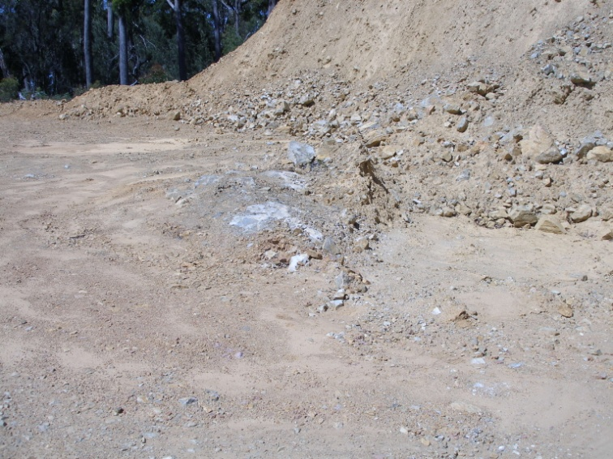
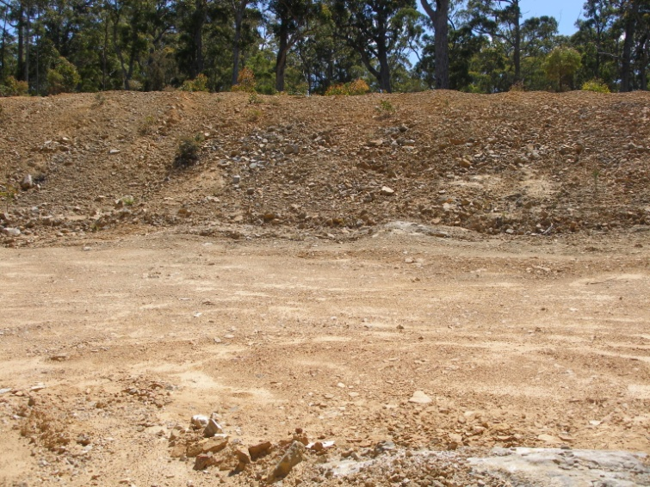

Western exposure Eastern exposure
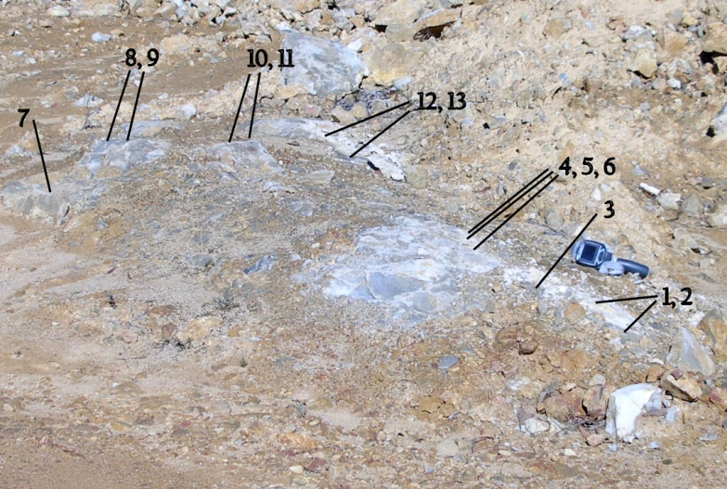
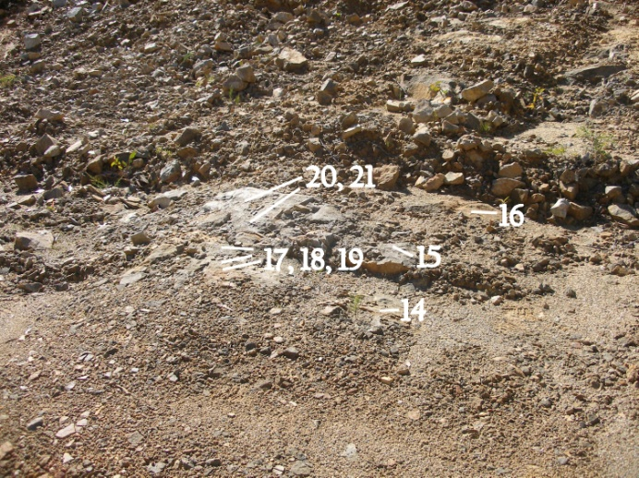

Sites 1 to 13 Sites 14 to 21

The ‘white vein’ samples listed in the results were taken from loose pieces of the above ‘western exposure’ vein material that someone else had gone to a fair amount of trouble to break free. In that context it is interesting that those were the samples that contained the cobalt.Some other ‘white vein’ hand samples were collected and later analysed by NITON (see next page).

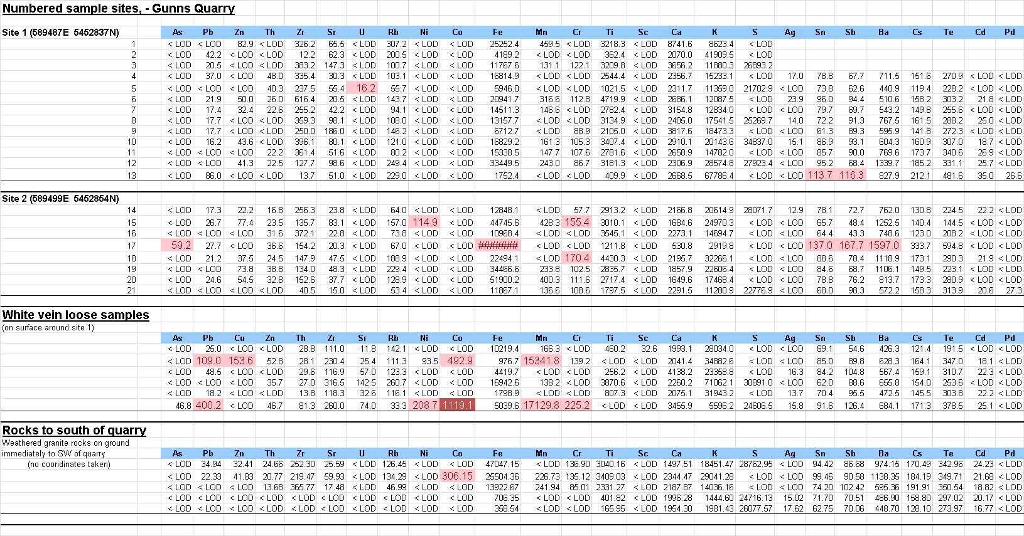

Hand samples fromGunns quarry stockpile, just W of site 1.
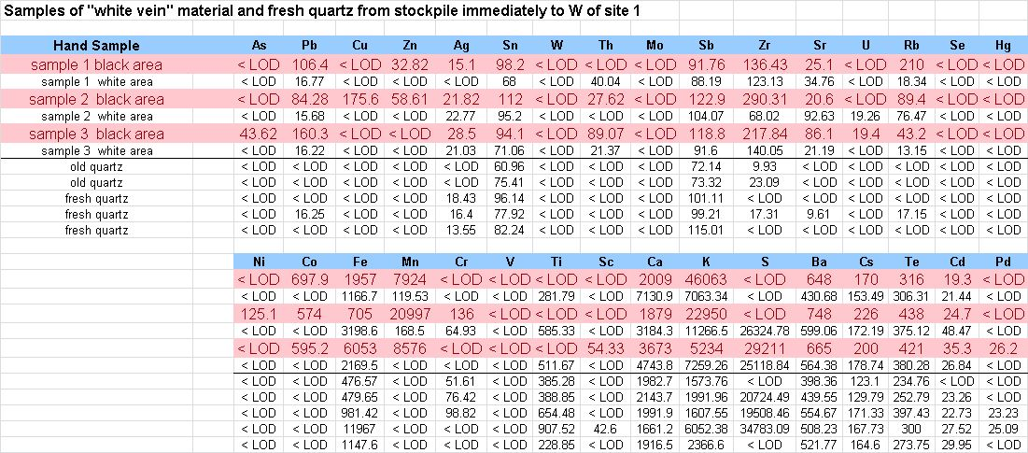

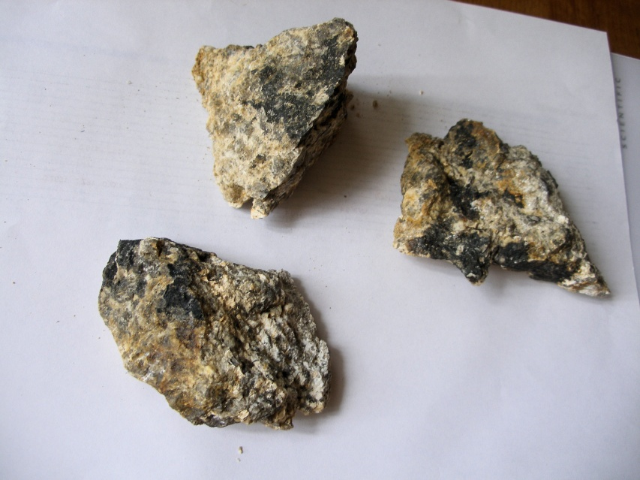

Left: The three ‘white vein’ samples.
The black areas consisted of usually thin black film, - probably of MnO, - which also contained the Co.

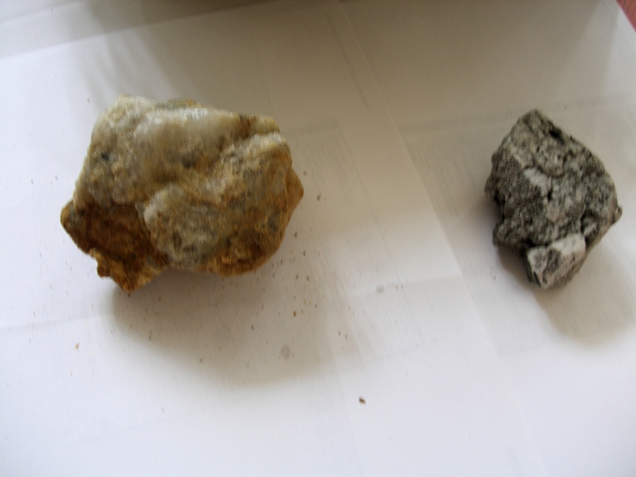

Right: ‘Fresh’ quartz (left) and ‘old’ quartz (right)
The two ‘old’ quartz samples came from just W of the quarry, while the three ‘fresh’ quartz samples came from the main stockpile in the quarry.

NITON rock analyses along SP line 1.
Line 1 Rock
Units SAMPLE LOCATION (within 2m radius of) As Pb Cu Zn Ag Sn
ppm sp1 50w rock 588248E 5452564N < LOD 18.3 < LOD 56.47 < LOD 31.57
ppm sp1 50w rock 588248E 5452564N < LOD 30.32 < LOD < LOD < LOD 91.63
ppm sp1 50w rock 588248E 5452564N < LOD < LOD < LOD < LOD 15.65 70.46
ppm sp1 50w rock 588248E 5452564N < LOD 14.53 < LOD < LOD < LOD 50.28
ppm sp1 50w rock 588248E 5452564N < LOD 17.33 < LOD < LOD < LOD 75.83
ppm sp1 25w rock 588269E 5452576N < LOD < LOD < LOD < LOD 24.8 93.01
ppm sp1 25w rock 588269E 5452576N < LOD 23.43 < LOD 27.64 < LOD 65.44
ppm sp1 25w rock 588269E 5452576N < LOD 19.6 < LOD < LOD < LOD 95.24
ppm sp1 0w granite 588291E 5452585N < LOD 34.56 < LOD 43.23 23.1 85.73
ppm sp1 0w granite 588291E 5452585N < LOD 37.17 < LOD 58.82 19.6 111.54
ppm sp1 0w granite 588291E 5452585N < LOD 41.32 < LOD < LOD 35.92 161.87
ppm sp1 0w granite 588291E 5452585N < LOD 27.16 < LOD 32.83 < LOD 63.78
ppm sp1 0w granite 588291E 5452585N < LOD 26.42 < LOD 58.65 < LOD 66.51
ppm sp1 0w granite 588291E 5452585N < LOD 55.58 < LOD < LOD 20.45 93.15
ppm sp1 0w granite 588291E 5452585N 21.56 47.63 < LOD < LOD 15.81 82.77
ppm rock n of line 1 0w 588291E 5452590N < LOD 34.33 < LOD < LOD < LOD 70.68
ppm rock n of line 1 0w 588291E 5452590N < LOD 42.8 < LOD < LOD < LOD 82.59
ppm sp1 725 granite 588941E 5452730N < LOD 20.62 < LOD < LOD < LOD 82.84
ppm sp1 750 granite 588964E 5452729N < LOD 19.02 < LOD 25.16 17.47 85.91
ppm sp1 870 granite 589071E 5452760N < LOD < LOD < LOD < LOD < LOD 55.08

W Th Mo Sb Zr Sr U Rb Se Hg Ni Co Fe
< LOD < LOD < LOD < LOD 111.22 221.5 < LOD 136.22 < LOD < LOD < LOD < LOD 10724.17
< LOD 22.06 12.97 77.05 241.75 115.55 < LOD 107.59 < LOD < LOD < LOD < LOD 56059.98
< LOD < LOD < LOD 60.33 83.17 121.21 < LOD 75.41 < LOD < LOD < LOD < LOD 4915.7
< LOD < LOD < LOD 64.76 146.47 66.38 < LOD 98.85 < LOD < LOD < LOD < LOD 7129.92
< LOD < LOD < LOD 72.34 132.19 189.54 < LOD 127.34 < LOD < LOD < LOD < LOD 3729.46
< LOD < LOD < LOD 71.72 83.01 173.81 < LOD 225.88 < LOD < LOD < LOD < LOD 5201.58
< LOD < LOD < LOD 61.19 225.92 148.3 < LOD 234.66 < LOD < LOD < LOD < LOD 17165.61
< LOD < LOD < LOD 73.86 64.26 74.42 < LOD 68.67 < LOD < LOD < LOD < LOD 66866.75
< LOD 31.6 < LOD 127.53 241.87 54.27 < LOD 243.32 < LOD < LOD < LOD < LOD 26542.45
< LOD < LOD < LOD 112.34 168.85 102.05 < LOD 224 < LOD < LOD < LOD < LOD 26293.01
< LOD < LOD < LOD 163.12 42.06 131.64 < LOD 274.24 < LOD < LOD < LOD < LOD 6908.69
< LOD 16.02 < LOD 33.36 394.17 92.82 < LOD 135.08 < LOD < LOD < LOD < LOD 15829.66
< LOD 20.54 < LOD 39.14 590.51 100.83 < LOD 213.39 < LOD < LOD < LOD < LOD 18582.96
< LOD < LOD < LOD 101.11 84.31 137.51 < LOD 296.5 < LOD < LOD < LOD < LOD 6609.15
< LOD < LOD < LOD 99.19 82.32 113.82 < LOD 248.45 < LOD < LOD < LOD < LOD 14413.89
< LOD 25.06 < LOD 52.39 160.94 40.8 < LOD 258.36 < LOD < LOD < LOD 614.24 56519.86
< LOD 37.43 < LOD 67.42 222.17 39.97 < LOD 236.67 < LOD < LOD < LOD 1063.85 89472.94
< LOD < LOD < LOD 90.89 239.67 113.07 < LOD 108.1 < LOD < LOD < LOD < LOD 15241.94
< LOD < LOD < LOD 91.13 131.71 187.47 < LOD 91.6 < LOD < LOD < LOD < LOD 8647.91
< LOD 23.26 < LOD 47.44 1182.55 12.69 < LOD 20.44 < LOD < LOD < LOD < LOD 834.97

Mn Cr V Ti Sc Ca K S Ba Cs Te Cd Pd
403.97 < LOD < LOD 2156.92 < LOD 13007.26 13233.15 < LOD 514.8 100.94 138.53 < LOD < LOD
226.11 < LOD < LOD 3191.77 < LOD 4412.53 8288.04 < LOD 746.24 158.41 249.11 < LOD < LOD
< LOD < LOD 99.13 2044.17 < LOD 4850.75 10577.36 < LOD 502.17 131.6 255.12 < LOD < LOD
< LOD < LOD < LOD 1931.5 < LOD 3275.9 12451.14 < LOD 543.29 119.39 226.93 < LOD < LOD
125.55 < LOD < LOD 1093.17 < LOD 12997.47 20567.44 < LOD 591.95 136.81 255.26 21.8 < LOD
128.21 < LOD < LOD 1761.29 42.64 7781.7 26683.88 < LOD 739.7 149.48 269.33 27.36 < LOD
389.1 < LOD < LOD 4414.94 < LOD 15982.39 14926.06 < LOD 580.14 144.22 233.9 < LOD < LOD
506.11 < LOD < LOD 4880.98 < LOD 5786.88 6343.56 < LOD 773.7 177 290.2 20.76 < LOD
529.86 < LOD < LOD 2924.62 < LOD 2187.75 26908.66 < LOD 886.42 201.21 337.27 36.89 < LOD
486.76 < LOD < LOD 2845.28 56.36 4689.17 18144.91 < LOD 1155.04 221.44 455.19 36.26 24.61
< LOD < LOD < LOD 858.68 31.35 1798.34 35758.13 < LOD 1528.85 298 545.09 55.52 40.44
308.04 < LOD < LOD 5969.34 < LOD 10821.15 12735.6 < LOD 393.5 108.63 193.08 < LOD < LOD
315.84 < LOD < LOD 3255.09 57.13 11169.34 10712.11 < LOD 499.91 134.59 202.13 < LOD < LOD
125.22 < LOD < LOD 1253.27 < LOD 2906.78 72702.39 < LOD 1189.82 191.82 330.7 25.32 < LOD
< LOD < LOD < LOD 2858.49 < LOD 1146.01 45820.73 < LOD 1042.46 193.07 375.49 < LOD 25.83
< LOD 87.31 < LOD 3877.34 < LOD < LOD 36157.35 < LOD 1266.56 146 254.89 < LOD < LOD
285.14 79.95 152 5533.54 < LOD < LOD 27176.08 < LOD 1230.07 174.15 268 < LOD < LOD
456.34 < LOD < LOD 2312.41 < LOD 5156.13 25750.91 < LOD 590.51 156.39 298.73 < LOD < LOD
150.43 103.84 < LOD 1603.08 55.27 11041.63 15506.86 < LOD 614.02 156.84 274.27 24.74 21.48
< LOD < LOD < LOD 8306.8 < LOD 721.36 7938.37 < LOD 333.74 95.45 182.45 < LOD < LOD

Niton Soil Analysis along SP line 1
Line 1 Soil
Units SAMPLE LOCATION As Pb Cu Zn Ag Sn
ppm sp1 550 588794E 5452684N < LOD 15.47 < LOD < LOD < LOD 50.89
ppm sp1 675 588902E 5452715N < LOD < LOD < LOD < LOD < LOD 55.06
ppm sp1 700 588923E 5452720N < LOD < LOD < LOD < LOD < LOD 30.23
ppm sp1 725 soil 588941E 5452730N < LOD < LOD < LOD < LOD < LOD 51.38
ppm sp1 750 soil 588964E 5452729N < LOD < LOD < LOD < LOD < LOD 43.15
ppm sp1 775 soil 588986E 5452732N < LOD < LOD < LOD < LOD < LOD 53.01
ppm sp1 800 soil 589012E 5452742N < LOD < LOD < LOD < LOD < LOD 41.48
ppm sp1 825 soil 589036E 5452743N < LOD < LOD < LOD < LOD < LOD 56.27
ppm sp1 850 soil 589050E 5452755N < LOD < LOD < LOD < LOD < LOD 38.19
ppm sp1 870 soil 589071E 5452760N < LOD < LOD 85.99 < LOD < LOD 28.97

W Th Mo Sb Zr Sr U Rb Se Hg Ni Co Fe
< LOD 29.72 < LOD 61.58 909.7 29.58 < LOD 64.33 < LOD < LOD < LOD < LOD 2435.82
< LOD 17.52 < LOD 68.3 786.58 11.72 < LOD 11.01 < LOD < LOD < LOD < LOD 4236.46
< LOD 27.6 < LOD 42.8 697.94 14.88 < LOD 27.56 < LOD < LOD < LOD < LOD 17953.63
< LOD 14.09 < LOD 52.14 483.07 48.76 < LOD 61.7 < LOD < LOD 85.76 < LOD 6150.3
< LOD 14.29 < LOD 51.41 454.72 14.57 < LOD 27.37 < LOD < LOD < LOD < LOD 2935.49
< LOD < LOD < LOD 65.34 590.92 13.28 < LOD 15.58 < LOD < LOD < LOD < LOD 1632.64
< LOD 15.65 < LOD 52.54 524.93 16.21 < LOD 26.28 < LOD < LOD < LOD < LOD 1926.64
< LOD 11.32 < LOD 58.96 578.02 8.33 < LOD 11.79 < LOD < LOD < LOD < LOD 1250.51
< LOD < LOD < LOD 51.15 516.46 < LOD < LOD < LOD < LOD < LOD < LOD < LOD 464.47
< LOD < LOD < LOD 34.76 319.32 10.11 < LOD < LOD < LOD < LOD < LOD < LOD 796.48

Mn Cr V Ti Sc Ca K S Ba Cs Te Cd Pd
< LOD < LOD < LOD 5212.79 < LOD 759.67 26206.9 < LOD 449.64 109 206.1 < LOD < LOD
107.08 < LOD < LOD 7484.29 < LOD < LOD 3794.45 < LOD 421.82 127.77 169.14 19.63 < LOD
< LOD < LOD < LOD 8086.62 < LOD < LOD 5805.26 < LOD 324.65 81.5 126.15 < LOD < LOD
< LOD < LOD < LOD 5221.91 < LOD 1538.59 19035.26 < LOD 406.85 101.34 203.69 < LOD < LOD
< LOD < LOD < LOD 3269.82 < LOD < LOD 9047.21 < LOD 359.32 104.03 178.28 < LOD < LOD
< LOD < LOD < LOD 3793.29 < LOD 409.57 6132.44 < LOD 322.18 96.96 170.73 < LOD < LOD
< LOD < LOD < LOD 5634.77 < LOD 337.22 13246.07 < LOD 265.56 67.47 145.4 < LOD < LOD
< LOD < LOD < LOD 4281.97 < LOD < LOD 7056.08 < LOD 359.69 103.46 194.94 < LOD < LOD
< LOD < LOD < LOD 3606.4 < LOD < LOD 2038.07 < LOD 293.02 94.42 202.33 < LOD < LOD
< LOD < LOD < LOD 2385.12 < LOD 1029.41 2922.96 < LOD 186.13 60.3 121.47 < LOD < LOD

Note: most sites in the centre of the line consisted only of barren leached coarse quartz sand, and no outcrop.

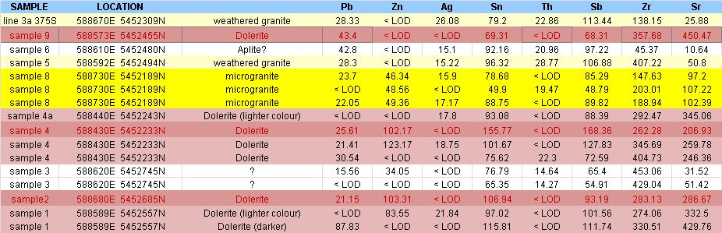
NITON analyses of rock samples across survey area (Fig 6).

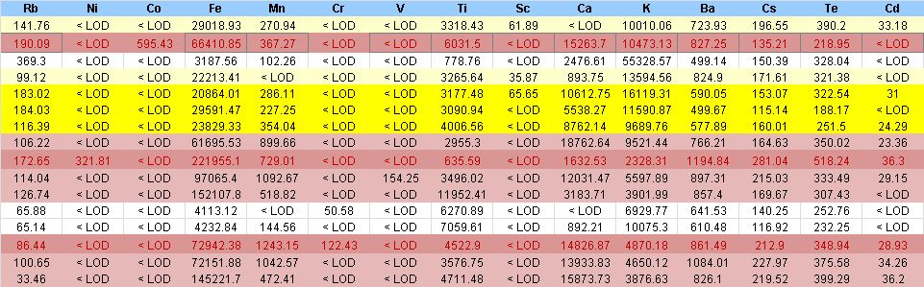

AAS (aqua regia digestion) bulk analysis of dolerite sample 4 (N. Allen)
Cu 72 ppm
Pb 24 ppm
Zn 112 ppm
Ni 32 ppm
Note: Portion of dolerite sample used did not include any in which sulphides could be seen.

Appendix D: Dolerite sample 4 microphotographs

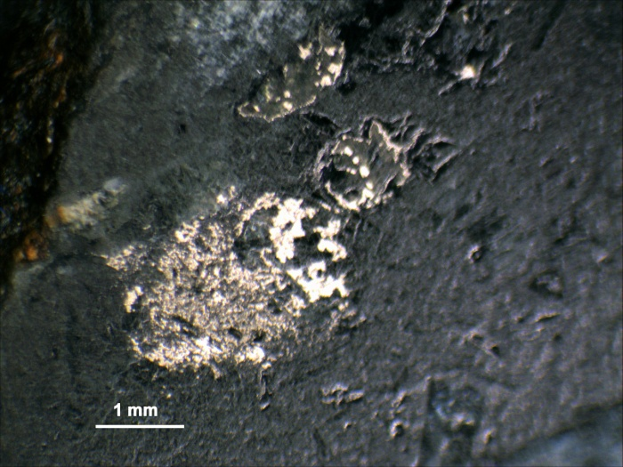
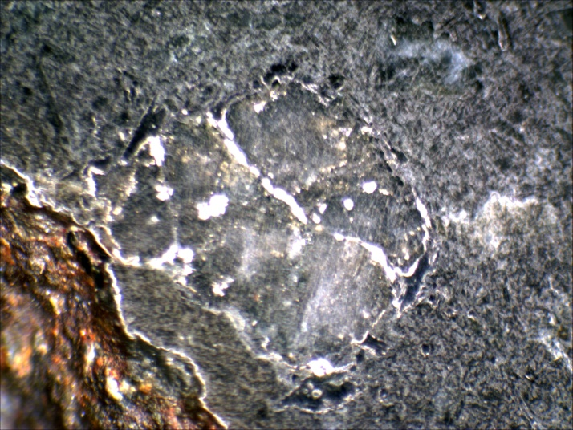
Low power

High power
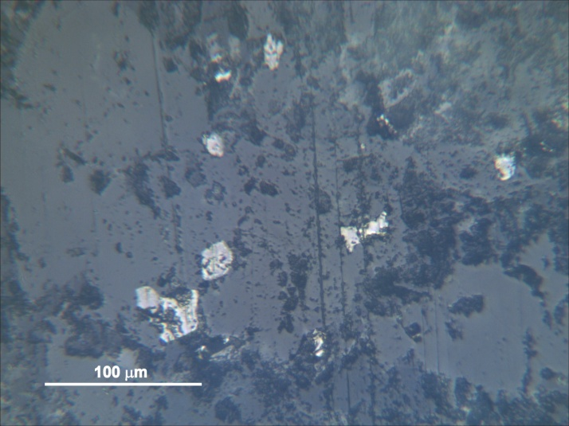
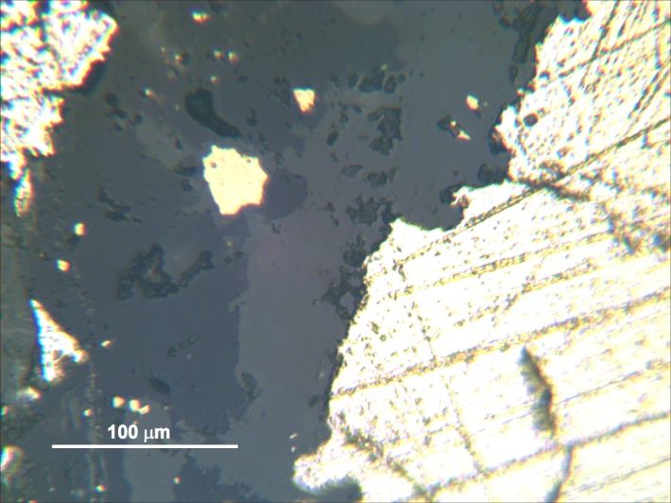

Note: The above sulphides(?) were only observed in one restricted area of sample 4, which was towards the outside of the sample.

References
01-4550. MRT Open File. (2001). Final Report of Exploration Activities May 1996 to May 2001. EL 11/96. N.R. Allen & J. & S. K. McCormack.
83_1893. MRT open file. (1983). Australian Anglo American – Triako. Ringarooma joint venture. E.L. 2/77. Quarterly report to the Department of Mines, Tasmania, for the period 8/9/82 to 7/12/82. Australian Anglo American Limited. Bruce D. Mellor.
Allen, N., Bottrill, R. and van Moort, J., 2004: Native metals in altered granites, northeastern Tasmania. Abstract in; Dynamic Earth: Past, Present and Future. 17th Australian Geological Convention Hobart. Geological Society of Australia, Abstracts 73, p47.
Black, L.P., McClenaghan, M. P., Korsch, R. J., Everard, J. L. And Foudoulis, C., 2005: Significance of Devonian-Carboniferous igneous activity in Tasmania as derived from U-Pb SHRIMP dating of zircon. Australian Journal of Earth Sciences. 52, 807-829.
Davidson,G. J., Large, R. R., 1998: Proterozoic copper-gold deposits. AGSO Journal of Australian Geology and Geophysics.17(4), 105-113.
Gascombe, B. D. and Findlay, R. H., 1989: Mega-kinking in the Mathinna beds, northeast Tasmania. Tasmania Department of Mines. Report 1989/42.
Groves, D. I., Cocker, J. D., Jennings, D. J., 1977: The Blue Tier Batholith. Tasmanian Department of Mines. Geological Survey Bulletin 55.
Kamenetsky, V. S., Crawford, A. J. and Meffre, S., 1999: Factors controlling chemistry of magmatic spinel: an empirical study of associated olivine, Cr-spinel and melt inclusions from primitive rocks. Journal of Petrology, 42, 4, pp 655-671.
Keele, R. A, Taylor, B. And Davidson, G. J., 1994: Relationships between Devonian thrusting and gold mineralisation in northeastern Tasmania. In: Contentious Issues in Tasmanian Geology: a Symposium. Geological Society of Australia, Tasmanian Division. pp 59-60.
McClenaghan, M. P., 1984: The petrology and mineralogy of the Gardens and Pyengana granodiorites, the Hogans Road diorite and the dolerite dykes of the Blue Tier Batholith is described. Geochemical data on these bodies are presented and their petrogenesis is discussed. It is suggested that there is a genetic link between these rock bodies. Tasmanian Geological Survey Record 1984/04.
Reed, A. R., (1999): The potential for structurally controlled lode-style gold mineralisation in the Badger Head Block, northern Tasmania. Mineral Resources Tasmania Newsletter 13, 12-13.
Reed, A. R., 2001: Pre-Tabberabberan deformation in eastern Tasmania: a southern extension of the Benambran Orogeny. Australian Journal of Earth Sciences 48, 785-796.
Reed, A. R., 2004: Gold mineralisation and regional Palaeozoic structure of the Mathinna supergroup, eastern Tasmania. Tasmanian Geological Survey Record 2004/01.
Tornos, F., Velasco, F., Barra, F., Morata, D., 2010: The Tropezpn Cu-Mo-(Au) deposit, Northern Chile: the missing link between IOCG and porphyry copper systems? Mineralium Deposita (2010) 45:313-321.
Twelvetrees, W. H., 1916: The Gladstone Mineral District. Geological Survey Bulletin No. 25. Tasmanian Department of Mines.
Taheri, J. And Bottrill, R. S., 1994: A study of the nature and origin of gold mineralisation, Mangana-Forester area, northeastern Tasmania. Mineral Resources Tasmania Report 1994/05.
Veevers, J. J., 2001: Atlas of Billion-year history of Australia and neighbours in Gondwanaland. Gemoc Press. Sydney. 2001.

