
Author:
Charles Hughes BSc (Hons).
Senior Geologist
Perth, WA
21.10.2011

Annual Report
EL51/2008
For Period 16 December 2010 to 15 December 2011
Tasmania

Copies to:

MRT
Corona Gold Ltd
Jaguar Minerals Ltd

Table of Contents

1.0 Introduction……………………………………………………………………………………………………………………………5

2.0 Tenure…………………………………………………………………………………………………………….………………………5

3.0 Access……………………………………………………………………………………………………………………………………..7

4.0 Geology…………………………………………………………………………………………………………………………………..7

5.0 Mineralisation…………………………………………………………………………………………………………………………7

6.0 Structure…………………………………………………………………………………………………………….…………………..7

7.0 Exploration Philosophy…………………………………………………………………………………….……………………..7

8.0 Exploration History………………………………………………………………………………………..………………………..9

9.0 Work Completed This Reporting Period……………………………………………..……………………………….….9
9.1 Helicopter Supported VTEM and magnetic survey……………………………………….……………..9
9.2 Modelling of data collected in the 2011 Corona survey…………….………………….……………12
9.2.1 Modelling at the South Darwin Prospect……………………………………………………12
9.2.2 Modelling at the Garfield Prospect…………………………………………………………….12
9.3 Review of Historical geophysical data at the Garfield Prospect………………………………….15
9.4 Prepared Access………….…………………………………………………………………………………………….15
9.5Geochemical Sampling………………………………………………………………………………………….…..18
9.6 Petrology………………………………………………………………………………………………………………….18
9.7 Diamond Drilling……………………………………………………………………………………………………….18

10.0 Discussion/Conclusions……………………………………………………………………………….……………….……..20

11.0 Environment………………………………………………………………………………………………….……………………20

12.0 Expenditure…………………………………………………………………………………………………………………………20

13.0 References…………………………………………………………………………………………………….…………………….20

Figures

Figure 1: Tenure……………………………………………………………………………………………………………………………6

Figure 2: Geology………………………………………………………………………………………………….………………………8

Figure 3: Survey flight lines………………………………………………………………………………………………………….10

Figure 4: TMI EagcsL Magnetics image of EL51/2008.……………………………………………………..…………..11

Figure 5: Modelled magnetic bodies in the South Darwin Prospect………..……………………………………13

Figure 6: RTP 1VD Magnetics image of the Garfield Prospect……………………………………………………….14
Figure 7: Access prepared at the South Darwin Prospect…………………………………………………………….16

Figure 8: Access prepared at the Garfield Prospect………………………………………………………………………17

Figure 9: Location of Diamond Drill holes SDD001 and SDD002……………………………………………………19

Tables

Table 1: Expenditure……………………………………………………………………………………………………..…………….20

Appendices

Appendix 1: Geotech Airborne Pty Ltd Final Data Set

Appendix 2: Southern Geoscience Consultants Data Set

Appendix 3: Garfield Geophysical Review

Appendix4: Geochemical results from Burnie Laboratories

Appendix 5: Geochemical Results from ALS Brisbane Laboratories

Appendix 6 Petrological report from Pathfinder Exploration

List of Digital Files Accompanying this Report

EL512008_201111_01 Text

EL512008_201111_02 Appendix 1

EL512008_201111_03 Appendix 2

EL512008_201111_04 Appendix 3

EL512008_201111_05 Appendix 4

EL512008_201111_06 Appendix 5

EL512008_201111_06 Appendix 6

Executive Summary

Principal exploration activities on EL51/2008 within the reporting period have been the completion of a helicopter borne Versatile Time-domain Electromagnetic (VTEM) and Aeromagnetic survey, extensive modelling of the magnetic data collected in the survey, a comprehensive review of historical geophysical data collected at the Garfield Prospect and the commencement of a diamond drilling program at the South Darwin Prospect, which is, in part targeting magnetic anomalies and models generated by the Corona airborne survey.

Unfortunately at the time of writing no assays from the drilling program have been received and the first hole, SDD001, has not been fully logged. As such the hole will be fully reported on in the next annual report, but will be summarily reported on here.

SDD001 was designed to test 50m below the historic Prince Darwin adit and the northern extent of a modelled magnetic body with a magnetic susceptibility of 1 (equivalent to 30% magnetite) and rough dimensions of 75m (width) X 275m (length) x >500m (depth). The hole intersected ~230m of strong alteration and chalcopyrite-magnetite mineralisation in a hydrothermal breccia. Alteration is chlorite-silica-carbonate, with possible fluorite and apatite (although this is yet to be corroborated by petrology).
1.0 Introduction

EL51/2008 is located due south of Queenstown on the West Coast of Tasmania. The Eastern boundary abuts the Gorgon Franklin National Park.

Corona Gold Ltd (“Corona”) entered into a Joint Venture agreement (JV) with Jaguar Minerals Ltd (“Jaguar”) in July 2010 to explore EL51/2008.

Corona has since earned 51% of the tenement and is the operator of the tenement.

2.0 Tenure

EL51/2008 encompasses 130km². Tenure is composed of Crown Land, State Forest, Regional Reserve, Hydro Tasmania Land.

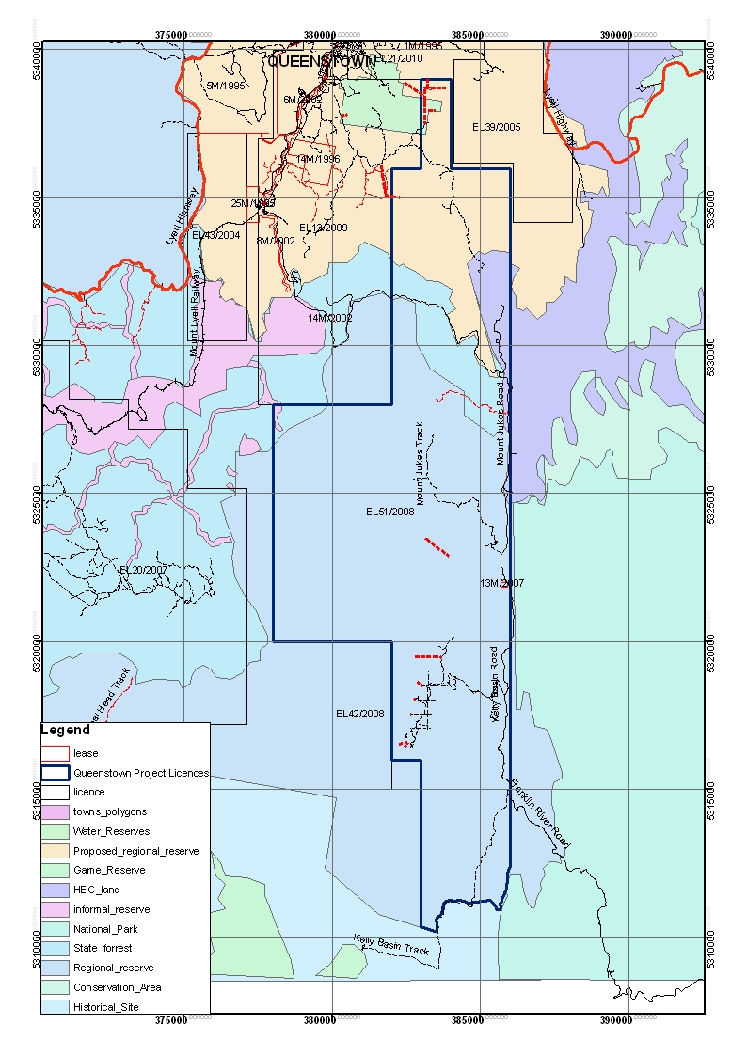
FIGURE 1:

TENURE

3.0 Access

Access within the tenement is good. Main access is roughly North-South bituminised Lynchford Road heading out of South Queenstown with numerous gravel tracks running east into the tenement, and a bituminised Hydro Tasmania road that runs south throughout the tenement. Several generations of explorers have left gravel tracks throughout the tenement that are mostly unusable.

4.0 Geology

The oldest rocks on the tenement are the Miners Ridge basalt and the Miners Ridge Sandstone, reputed to be of late Proterozoic or early Cambrian age, and are exposed in the core of a major anticline.
The mid-late Cambrian Mount Read Volcanics (MRV) dominate the tenement. The volcanic succession is composed of Central Volcanic Complex (CVC) rhyolites, Western Volcano Sedimentary (WVS) volcaniclastic and epiclastic sequences, and Tyndal group volcaniclastic sequences. The WVS sequence is host to several andesite-basalt units which appear to be contemporaneous with minerlisation throughout the MRV.
Ordovician aged Owen group siliciclastic conglomerates and sandstones are found throughout the tenement, and a thin unit of Gordon Limestone is found in the east.
Silurian aged Eldon group shales sandstones and minor conglomerates are found in the east of the tenement. A more comprehensive geological overview can be located in Hughes (2009).

5.0 Mineralisation

Ninety four historical prospects are known within the tenement, the majority are copper-gold workings within the MRV, spatially associated with the CVC-Tyndal contact. Several styles of mineralisation are thought to be present, including Prince Lyell analogues at the Garfield Prospect, structurally controlled gold mineralisation at the Norms Load prospect, carbonate or black shale hosted strataform zinc mineralisation a the Pearls Find prospect, including others.

6.0 Structure

Predominant structure has a north west orientation. Several phases of folding starting in the late Cambrian, throughout the Ordovician and during the Devonian Tabberaberan orogeny have created complex structural relationships. It is thought a major NNE structure runs through the South Darwin Prospect.

7.0 Exploration Philosophy

EL51/2008 was targeted for VHMS and related mineralisation, with a focus on copper-gold mineralisation analogous to the Mt Lyell field.

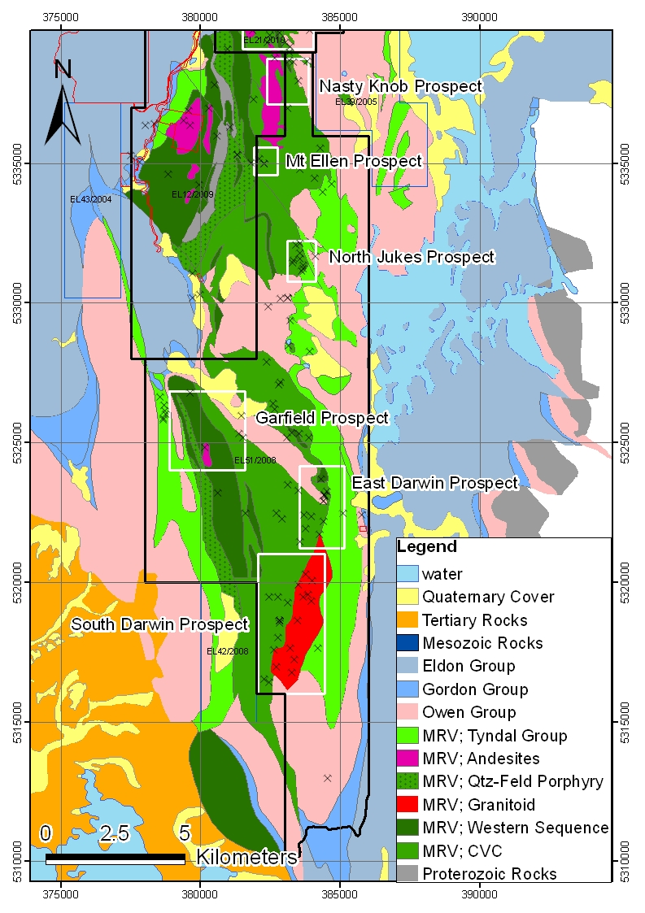
FIGURE 2:

GEOLOGY

8.0 Exploration History.

For a comprehensive summary of past exploration visit Hughes (2009).

9.0 Work Completed This Reporting Period

Principal exploration activities on EL51/2008 within the reporting period have been the completion of a helicopter borne Versatile Time-domain Electromagnetic (VTEM) and Aeromagnetic survey, extensive modelling of the magnetic data collected in the survey, a comprehensive review of historical geophysical data collected at the Garfield Prospect and the commencement of a diamond drilling program at the South Darwin Prospect, which is, in part targeting magnetic anomalies and models generated by the Corona airborne survey. Limited geochemical sampling and petrology were also undertaken. Re-clearing of access into the Garfield Prospect was undertaken to begin preparing for a drilling program which is scheduled to start in 2012. Access preparation and the establishment of a field camp to facilitate the diamond drilling program within the South Darwin Prospect were also undertaken.

9.1 Helicopter supported VTEM and Aeromagnetic Survey

Geotech Airborne Pty Ltd (“Geotech”) were contracted to undertake a helicopter borne Versatile Time-domain Electromagnetic (VTEM) and aeromagnetic survey. The survey on EL51/2008 was conducted between 23rd January and the 7th March 2011 as part of a larger survey covering EL12/2009, EL51/2008 and EL21/2010, Southern Geoscience Consultants (SGC) were contracted to act as project managers and data processors. Nine hundred and twenty five (925) line km were flown in the survey as a whole. All survey lines within EL 51/2008 were oriented east-west, primary survey lines were on 250m spacing’s, with infill lines on 125m spacing’s. Figure 3 shows the completed flight lines for the survey and Figure 4 shows the Total Magnetic Intensity, First Vertical Derivative magnetics image for EL51/2008. No significant conductors were discovered within EL51/2008 but significant magnetic anomalies were delineated in both the Garfield Prospect and the South Darwin Prospect. Magnetic anomalies of interest were modeled by SGC.

Specifics of the survey can be found in Appendix 1- “Geotech Airborne Pty Ltd Survey and Logistics report on a helicopter borne VTEM survey”. Final data from Geotech can be found in Appendix 1.

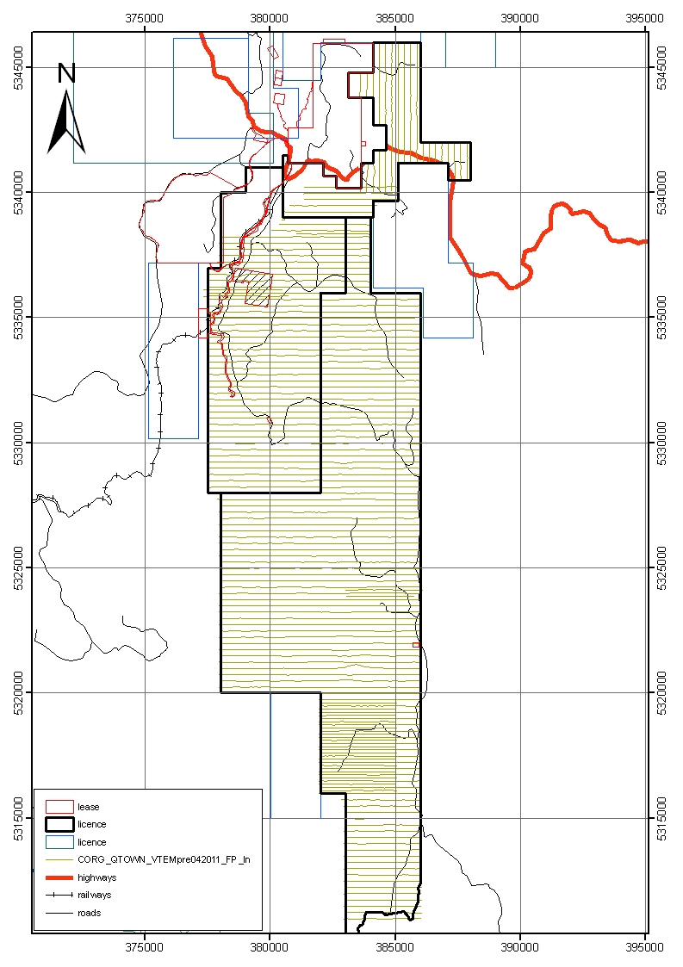
FIGURE 3:

Survey flight lines
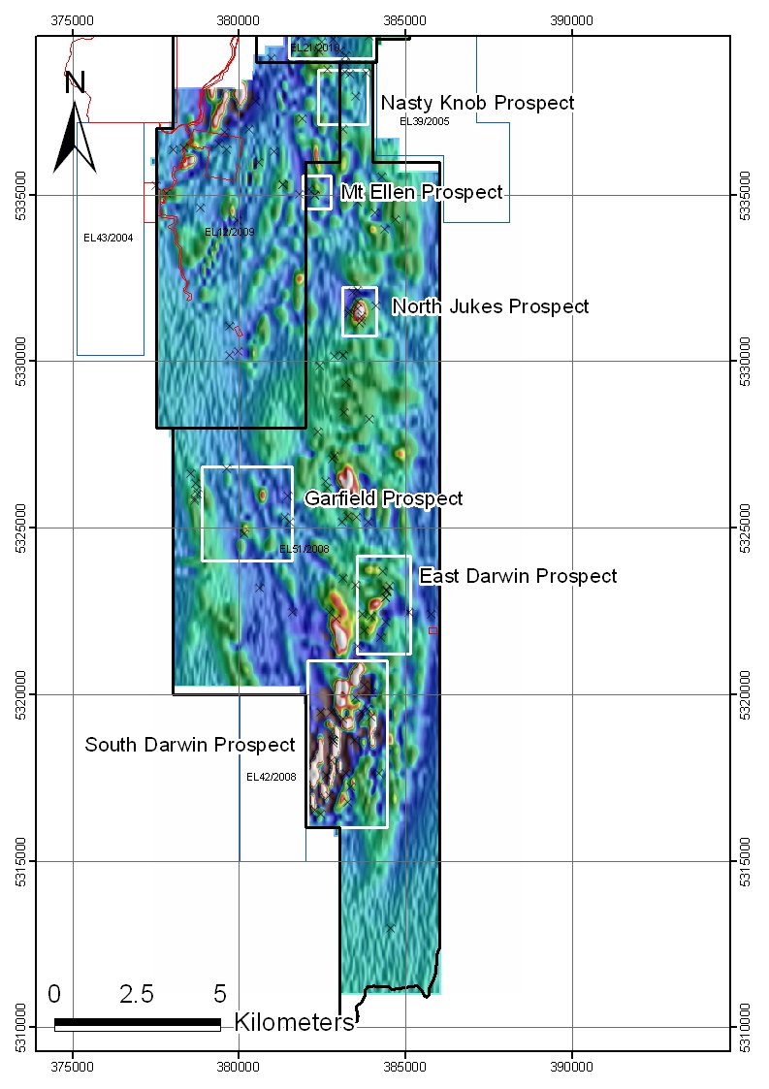
FIGURE 4:

TMI1VDEagcsL magnetics image

9.2 Modelling of magnetic data collected in the 2011 Corona survey

Southern Geoscience Consultants Pty Ltd (“SGC”) was contracted to process and model the VTEM and magnetic data collected in the 2011 Corona airborne survey.

9.2.1 Modelling at the South Darwin Prospect

Twenty eight (28) magnetic bodies were modelled in the South Darwin Prospect. Strike is generally north-north-east; dip of these bodies is variable but generally sub-vertical. The positions of these anomalies are displayed in Figure 5. Magnetic susceptibility varies from 1 (e.g. SD-01 Body 1) to 0.05 (e.g. SD-03 Body 6). Combined strike length of these bodies is ~6.5km. Further information on these models can be found in Appendix 2.

SD-01 Body1 is the principle magnetic body being the strongest and largest in terms of dimensions (Magnetic susceptibility of 1, 75m width X 275m length X by >500m depth). The body is modelled to have a steep easterly dip. This has been subject to one diamond drill hole, SDD001, results are not available to be reported at this stage but further comments are made in section 9.4 Drilling.

9.2.2 Modelling at the Garfield Prospect

The principle Garfield magnetic anomaly which was subject to RGC drilling in the early 1990’s (e.g. Halley, 1996) registered as an anomaly in the Corona survey. Modelling of this anomaly by SGC suggests an easterly dip as opposed to the westerly dip modelled from the RGC magnetics.

In addition to this other magnetic anomalies within the Garfield valley have been delineated that have a similar signature to the Garfield body. Figure 6 shows first vertical derivative, reduced to pole magnetics of the Garfield valley, generated from the Corona survey. Details of the modelling can be found in Appendix 2.

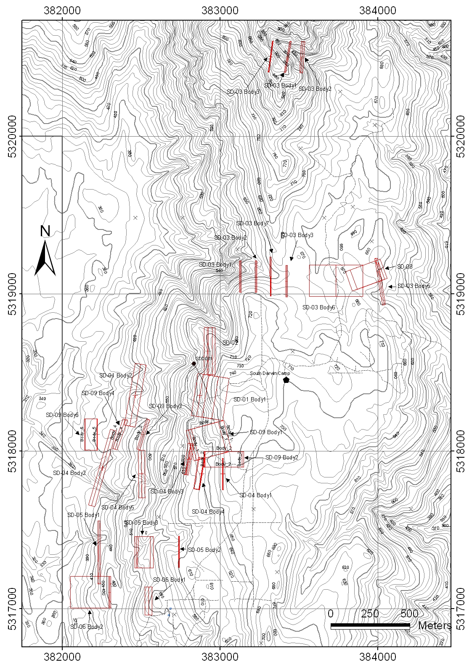
FIGURE 5:

South Darwin Prospect Modelled magnetic bodies
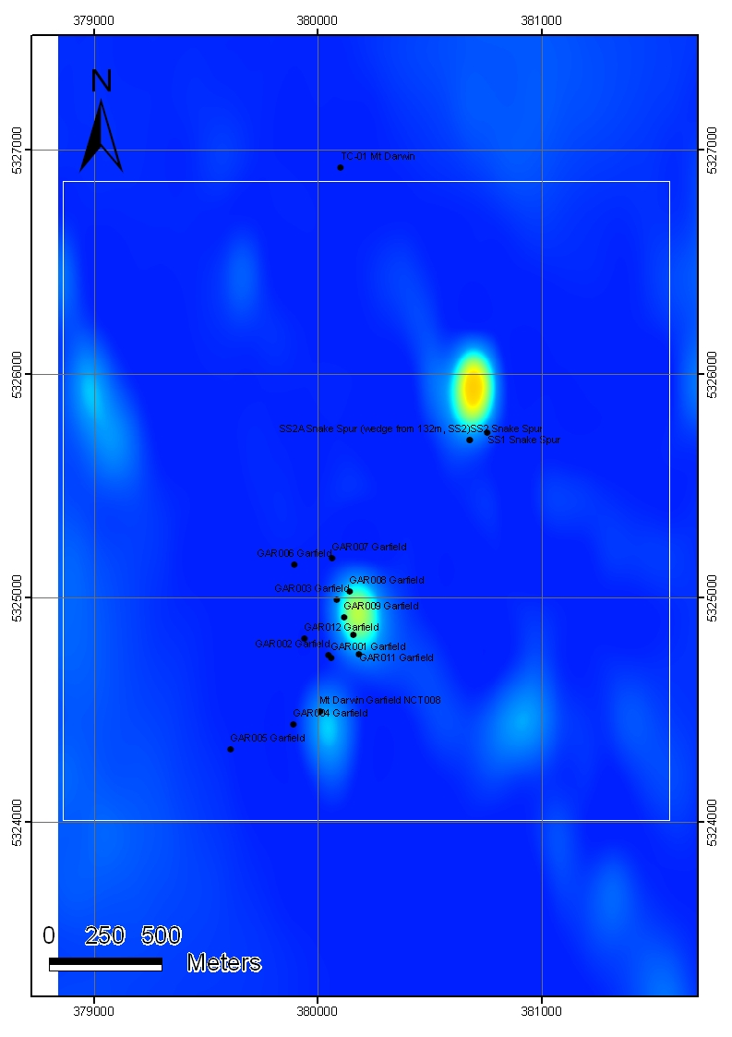
FIGURE 6:

Garfield Prospect RTP1VD_NL magnetics image showing significant magnetic anomalies and drilling within the Garfield Prospect.
9.3 Review of Historic geophysical data at the Garfield Prospect

Southern Geoscience were contracted to undertake a comprehensive review of historical geophysical data acquired by RGC during their exploration of the Garfield prospect in the early to mid-1990’s. The objective of the exercise was to assess how thoroughly RGC had tested the magnetic and IP anomalies that were generated.

The results of the review indicate that RGC did not fully test the I.P and magnetic anomalies generated at the Garfield deposit. The centre of the magnetic anomaly was not tested, a strong dipole-dipole I.P anomaly was not tested to the south west of the main mineralised zone and a strong dipole-dipole and gradient array I.P anomaly was not tested to the north of the mineralised zone where it is associated with outcropping, altered andesite.

For a full report on the Geophysical Review visit Appendix 3.

9.4 Prepared Access

A total of 5.2km of access has been prepared in the reporting period, all by Rogers Exploration Services.

To access the drilling pad and find the historical Prince Darwin adit on the South Darwin Prospect 1.4km of access was required to be prepared.

In order to start preparations for a drilling program on the Garfield Prospect scheduled to start next year, 3.8km of the old base line was re-cleared.

Figures 7 and 8 show the access prepared for the South Darwin and Garfield Prospects respectively.

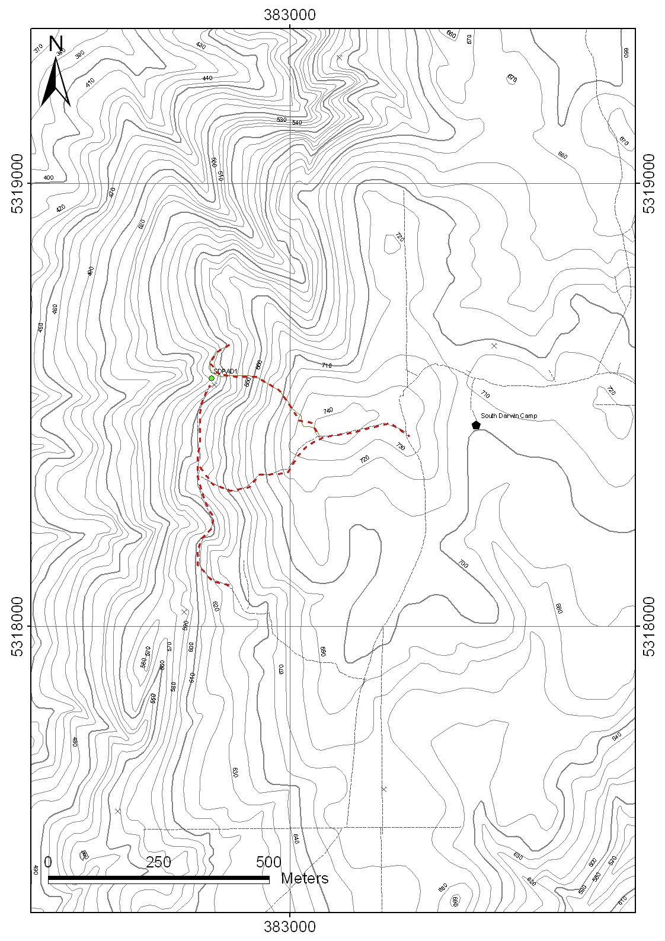
FIGURE 7:

Access prepared at the South Darwin Prospect
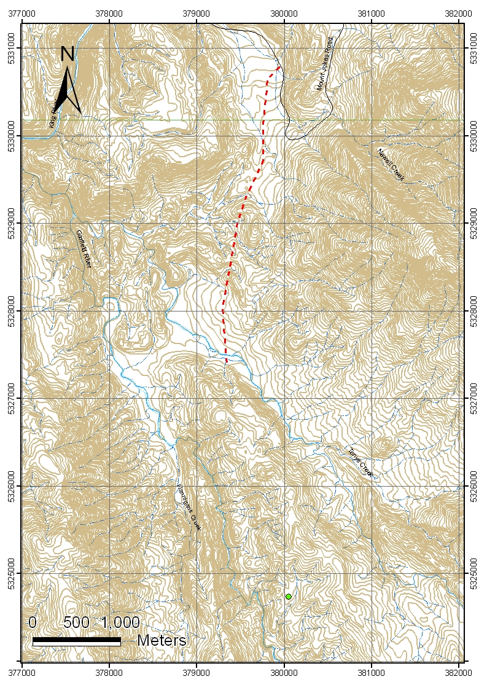
FIGURE 8:

Access prepared at the Garfield Prospect
FIGURE 8:

Access prepared at the Garfield Prospect
RGC Camp site
9.5 Geochemical sampling

Thirty one rock chip samples were taken in the reporting period. The bulk of these were assayed at the Burnie lab. Results in ascii format are to be found in Appendix 4.

Check samples and detailed geochemical investigations of a limited number of samples were conducted at ALS Brisbane. Results of these investigations are to be found in Appendix 5.

Of note it emerged that sampling quality at Burnie Labs was poor, especially for gold. Detailed geochemical investigations of mullock from the Prince Darwin returned an assay of 0.5% TREO in addition to 0.2% Cu, 0.1 g/t Au and >50% Fe.

9.6 Petrology

One sample, PD1, mullock from the Prince Darwin adit was submitted to Craig Rugless of Pathfinder Exploration for petrological examinations. Reports are appended in Appendix 6. The petrological examinations indicate mineralisation is associated with a period of brittle fracturing of the host quartz-feldspar porphyry.

9.7 Diamond Drilling

A diamond drilling program has commenced on the South Darwin Prospect. The program will be for 1000m. The program is wholly Helicopter supported. Van Dieman Holdings Pty Ltd have been contracted to carry out the drilling utilising a Longyear 38 rig and a double shift, 5 on 2 off roster. Helicopter support is provided by Tasmania Helicopters and Strahan Seaplanes and Helicopters. Core is flown to the Hydro Tasmania Surge Pond on the Mt Jukes road and then driven to Queenstown where it is processed in the Corona yard. Visually mineralised Core is being sampled to lithology with nominal sample intervals being 1m where possible. Core is cut and half core dispatched where visually mineralised, where not visually mineralised samples are 5m composite “slices”. Assays are being dispatched to Intertek Genalysis Adelaide by TasFreight via Sergeants in Burnie and assayed for Ag, Al, As, Ba, Bi, Ca, Cd, Ce, Co, Cr, Cu, Fe, K, La, Li, Mg, Mn, Mo, Na, Ni, P, Pb, S, Sb, Sc, Sn, Sr, Te, Ti, Tl, V,W, Zn, Zr by ICP-OES with a four acid digest and Au via a lead collection fire assay.

The first drill hole SDD001 has been completed to a depth of 376m testing below the Prince Darwin adit at a depth of ~50m, and also testing the northern extent of the Mag Body: SD-01 Body1. The hole has not been fully logged at the time of reporting, therefore will be properly reported on in next year’s Annual Report. The first 250m of core has been dispatched for assay, although results are not ready at the time or writing.

Drilling of SDD002 has commenced, 230m south of SDD001.

Visual inspection of SDD001 indicates the first 230m of core to be mineralised with principle mineralisation occurring as magnetite-pyrite-chalcopyrite associated with strong chlorite-silica-carbonate alteration in a hydrothermal breccia. Host rocks are a package of coherent felsic volcanics, but are unidentifiable in places due to intense alteration. Foliated and mildly sericitised narrow granitic dykes cut the mineralisation in places. Native copper and minor covellite is seen in the upper 50m of the hole. Fluorite has been tentatively identified associated with late stage carbonate veining. Low angle quartz-carbonate-chlorite veins carry significant amount of chalcopyrite in areas
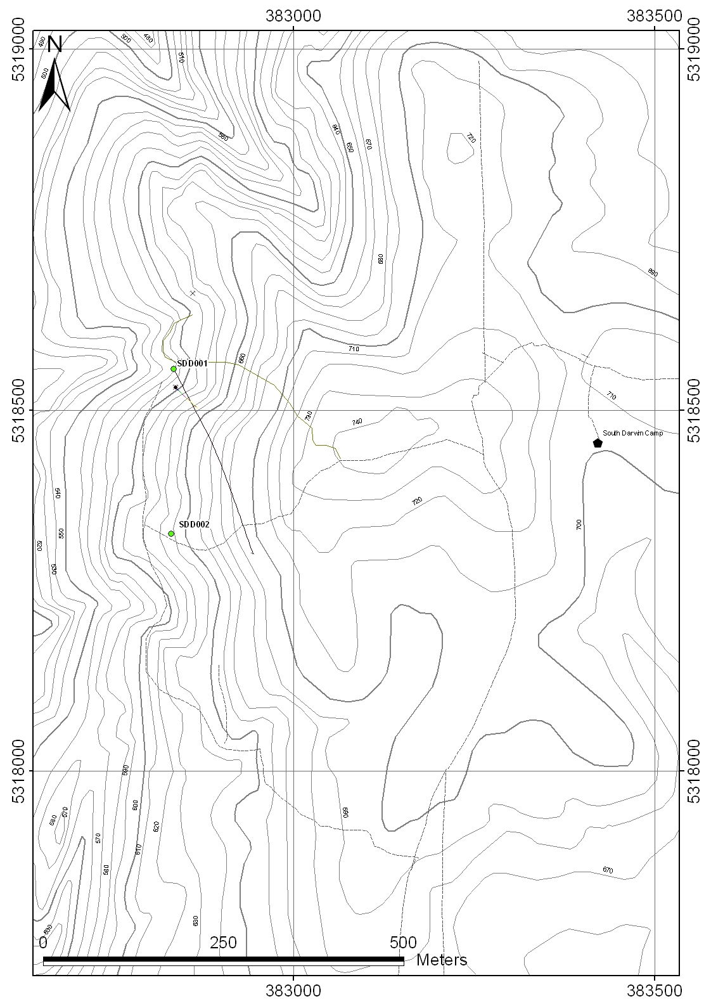
10.0 Discussion/Conclusion

Exploration on EL51/2008 has culminated in a drilling program at the South Darwin Prospect targeting a magnetic anomaly and modelled magnetic body and testing the historic Prince Darwin adit at a depth of 50m.

Visual inspection of the core is encouraging, with mineralisation observed over the first 230m of SDD001. This hole is oblique to the trend of the mineralisation but it is not known by how much. The hole has been collared in mineralisation and it is not known where this mineralisation ends to the west, north or south of the hole. The significant dimensions of the modelled magnetic body SD-01 Body1 represent a large tonnage exploration target. Drilling on the South Darwin Prospect is still under way and is scheduled to finish late December 2011 / early January 2012.

A data review of Garfield and magnetic modelling of aeromagnetic data collected by Corona has indicated that there may be further potential for exploration success at Garfield. Several I.P anomalies were not tested, and Corona modelling indicates a steep easterly dip to the Garfield magnetic anomaly as opposed to a westerly dip generated from RGC magnetic data. Also Corona consider the Garfield “deposit” as outlined by RGC drilling in the mid 1990’s not to have been properly tested at depth with only one hole being drilled to test for depth extensions (GAR012; Halley, 1996).

11.0 Environment.

A drill pad was cleared to accommodate for SDD001. The pad was constructed in moderately dense small eucalypt growth, in steep terrain. The area is directly adjacent to an historic adit. Rehabilitation of this site has not been conducted at the time of writing as the rig has only just been moved off. Corona will assess the potential for further drilling from the pad before rehabilitation is undertaken.

12.0 Expenditure

ITEM | Cost
Salaries and wages | $113,566
Airborne Geophysical Survey | $160,878
Goephysical review | $9,705
Survey and Gridding | $23,900
Assays | $3,975
Petrology | $425
Accomodation | $21,310
Consumables | $34,218
Hire vehicles | $7,633
Travel | $7,301
Helicopter Hire | $77,063
Drilling | $85,354
Sub Total | $545,328
Office Costs @ 10% | $54,532
 |  | Total | $599,860

13.0 References

Halley, S.W, Vicary, M.J, Corlett, S.J, Wyman, B. 1996. Annual Report Tasmanian Base metals, EL’s 102/87, 55/89, 12/92, Queenstown, Mt Darwin, Queenstown South. RGC Exploration Pty Ltd. Unpublished Unpublished annual report for Tasmanian Mines Dpartment. MRT Report number: 96-3834.

Hughes, C. E. D., 2009. Mt Jukes Project, EL51/2008. Annual report for period 16 December 2008 to 15 December 2009. Annual technical report for Jaguar Minerals Ltd.

