
Author:
Charles Hughes Bsc (Hons).
Senior Geologist
Perth, WA
21.11.2011

Annual Report
EL12/2009
For Period 21 December 2010 to 20 December 2011
Tasmania

Copies to:

MRT
Corona Gold Ltd
Jaguar Minerals Ltd

Table of Contents

1.0 Introduction……………………………………………………………………………………………………………………………4

2.0 Tenure…………………………………………………………………………………………………………….………………………4

3.0 Access……………………………………………………………………………………………………………………………………..6

4.0 Geology…………………………………………………………………………………………………………………………………..6

5.0 Mineralisation…………………………………………………………………………………………………………………………6

6.0 Structure…………………………………………………………………………………………………………….…………………..6

7.0 Exploration Philosophy…………………………………………………………………………………….……………………..6

8.0 Exploration History………………………………………………………………………………………..………………………..8

9.0 Work Completed This Reporting Period……………………………………………..………………………….………10
9.1 VTEM and Aeromagnetics Survey…..…………………………………………………………………….……10
9.2 VTEM Modelling……………………………………………………………………….………………….……………13

10.0 Conclusion……………………………………………………………………………………………………….………………….15

11.0 Environment………………………………………………………………………………………………….……….…………..15

12.0 Expenditure………………………………………………………………………………………………….…………….……….15

13.0 References…………………………………………………………………………………………………………………………..16

Figures

Figure 1: Tenure……………………………………………………………………………………………………………………………5

Figure 2: Geology………………………………………………………………………………………………….………………………7

Figure 3: VTEM Flight Lines……………………………………………………………………………….………………………..11

Figure 4:TMI1VDEagcsL Magnetics Image for EL12/2009…………………………………………………………….12

Figure 4: Mid channel VTEM response…………………………………………………………………….……..…………..14

Tables

Table 1: Expenditure……………………………………………………………………………………………………..…………….15

Appendices

Appendix 1: Geotech Airborne Pty Ltd Survey and Logistics Report

Appendix 2: Geotech Airborne Pty Ltd Processed final data

Appendix 3: VTEM Modelling for anomaly near Diorite Hill

Appendix 4: VTEM Modelling for Specimen Creek anomaly

List of Digital Files Accompanying this Report

EL122009_201111_01 Text

EL122009_201111_02 Appendix 1

EL122009_201111_03 Appendix 2

EL122009_201111_04 Appendix 3

EL122009_201111_05 Appendix 4
1.0 Introduction

EL12/2009 is located due south of Queenstown on the West Coast of Tasmania.

Corona Gold Ltd (“Corona”) entered into a Joint Venture agreement (JV) with Jaguar Minerals Ltd (“Jaguar”) on 9 June 2010 to explore EL12/2009.

Corona has since earned 51% of EL12/2009, and is the operator of the tenement.

The principal exploration activities conducted on EL12/2009 in the reporting period have been a helicopter borne Versatile Time-domain Electromagnetic (VTEM) and aeromagnetics survey. Geotech Airborne Pty Ltd were contracted to fly the survey over EL12/2009 as part of a larger survey covering EL51/2008 and EL21/2010 also. The survey was completed between 23 January 2011 and 7 March 2011.

One small late time conductor that is not attributable to any known cultural features has been delineated in an area that was targeted by past explorers for exhalative VHMS mineralisation of the Hellyer or Rosebery type.

2.0 Tenure

EL12/2009 encompasses 55km². Tenure is composed of Crown Land and Forestry land.

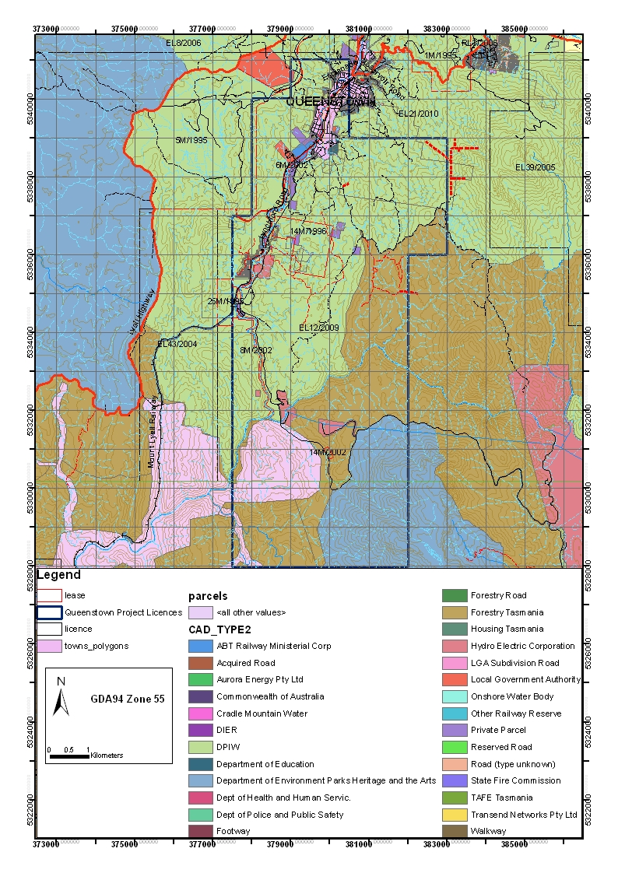
FIGURE 1:

TENURE

3.0 Access

Access within the tenement is good. Main access is roughly North-South bituminised Lynchford Road heading out of South Queenstown with numerous gravel tracks running east into the tenement.

4.0 Geology

The oldest rocks on the tenement are the Miners Ridge basalt and the Miners Ridge Sandstone, reputed to be of late Proterozoic or early Cambrian age, and are exposed in the core of a major anticline.
The mid-late Cambrian Mount Read Volcanics (MRV) dominate the tenement. The volcanic succession is composed of Central Volcanic Complex (CVC) rhyolites, Western Volcano Sedimentary (WVS) volcaniclastic and epiclastic sequences, and Tyndal group volcaniclastic sequences. The WVS sequence is host to several andesite-basalt units which appear to be contemporaneous with minerlisation throughout the MRV. The Lynchford Tuff is host to the exhalative Pb-Zn massive sulphide bodies at Comstock and Tasman Crown within the Mt Lyell mining lease and composes the lower most Tyndal group within EL12/2009
Ordovician aged Owen group siliciclastic conglomerates and sandstones are found in the south east of the tenement, and a thin unit of Gordon Limestone is found in the west.
Silurian aged Eldon group shales sandstones and minor conglomerates are found in the west of the tenement.

5.0 Mineralisation

20 historical prospects are known within the tenement, the majority are gold workings within the MRV, spatially associated with a major North-West trending fault.

6.0 Structure

Predominant structure has a north west orientation. Several phases of folding starting in the late Cambrian, throughout the Ordovician and during the Devonian Tabberaberan orogeny have created complex structural relationships.

7.0 Exploration Philosophy

EL12/2009 was targeted for VHMS and related mineralisation, with a focus on the apparent association of gold workings and a major North West trending structure. Previous work by Newcrest (Kitto, 2008) recorded a 20 m zone of anomalous gold mineralisation (~0.2 g/t) 400m vertically below the Mt Ellen gold mine (on the adjacent EL51/2008 tenement also operated by Corona), associated with albite-silica alteration. Corona hypothesised this could represent a distal setting to a system similar to Henty.

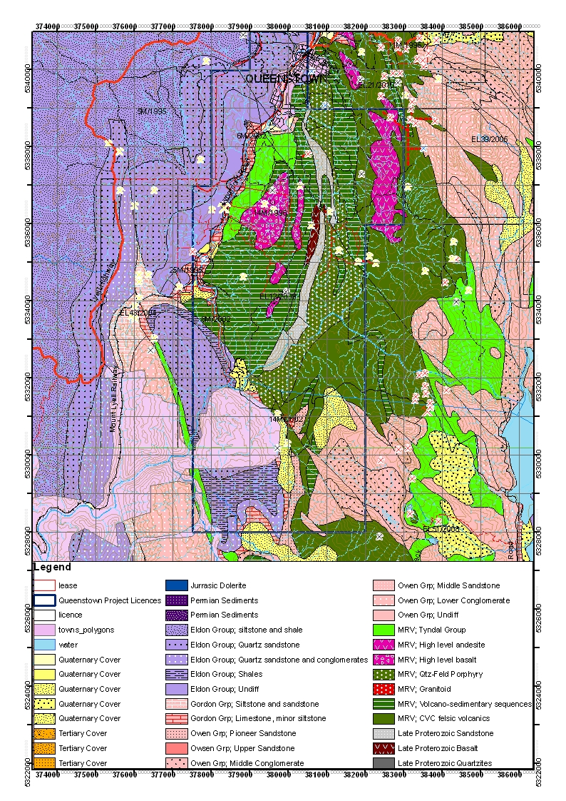
FIGURE 2:

GEOLOGY

8.0 Exploration History.

Mineral exploration in and around EL12/2009 began in the 1880’s, with the discovery of gold in the Lynchford area predating the discovery of the Mt Lyell system.

Modern exploration began in earnest in the 1960’s, and has been intermittent since then. Summary of historical exploration (adapted from Bates, 2009) is presented below:

Date: 1965-1967
Company: Picklands Mather International
Exploration Philosophy: Targeting VHMS deposits.
Work Completed: Drainage and soil grid, plus ground magnetic survey.
Results and Conclusions: Only background levels of base metals in MRV.
Report: 68_0512

Date: 1971-1972
Company: Cyprus Mines Corporation EL47/70
Exploration Philosophy: Targeting VHMS deposits.
Work Completed: Auger soil and rock chip sampling, petrographic samples, IP, ground
magnetics and geological mapping of area between Lynch Creek and Roaring Meg Creek,
including the King Gold Mine. Prospective MRV mapped in area with significant alteration of
volcanics.
Results and Conclusions: Broad Cu in soil anomaly +100ppm.
Report: 71_0814 and 72_0858

Date: 1979-1981
Company: Mt Lyell Mining and Railway Company Limited EL9/66
Exploration Philosophy: Targeting VHMS deposits MRV.
Work Completed: 24km airborne Dighem EM survey and limited IP over old Cyprus Mines
grid. Re-interpretation of Dighem data by consultant geophysicist produced 11 very small
anomalies of minor significance.
Results and Conclusions: No significant anomalies defined.
Report: 81_1519 and 84_2258

Date: 1985-1988
Company: CRA Exploration Pty Ltd EL47/83
Exploration Philosophy: Targeting VHMS base metal deposits.
9 | P a g e
Work Completed: Compilation evaluation of previous exploration. Regional drainage survey
and ground EM survey, then stream sediment and soil sampling.
Results and Conclusions: No significant results from Lynch Creek or Harris Reward areas.
Minor zones of Cu-Zn-Ba soil geochemistry was identified in Specimen Creek related to
fuchsite-sericite-pyrite tuff outcropping in area, but no gold.
Report: 87_2636

Date: 1988-1994
Company: Aberfoyle Resources Ltd (CRAE JV) EL47/83
Exploration Philosophy: Targeting Hellyer-style VHMS deposits.
Work Completed: Geological mapping, gridding, rock chip and soil sampling, petrographic
studies, UTEM ground survey, ground magnetic survey, helimag survey, grab sampling and drilling of one diamond drill hole for 697m.
Results and Conclusions: At Specimen Creek a Ba/As + low order Au in soil anomaly
outlined. Soil anomalism followed-up with costeaning. One costean north of Fu/Se/Py/Cb
alteration zone returned peak Ba 3.6% and 9775ppm Pb. Ground magnetics delineated mafic
bodies and outlined extent of Tyndall Group lapilli volcaniclastic (Comstock Tuff).
Later, the helimag survey allowed reinterpretation of the Specimen Creek alteration zone with
geometry indicative of a structurally controlled dispersion halo. Two conceptual targets were
recommended with the prioritized FW target testing the Lynchford Tuff-Lower Tyndall Group
correlate and stratigraphic contact between the Lynchford Tuff and altered mafic Lynch
Creek Basalt due to stratigraphic correlation with Rosebery and Comstock-style VHMS
mineralisation. This target was drilled in 1994 but intersected no significant mineralisation,
nor did it reach the Lynch Creek Basalt contact despite end of hole at 697m. Further to this
DHEM failed to detect any off-hole conductors.
Report: 89_2977, 90_3152, 94_3539 & 95_3706.

Date: 1991-1995
Company: Pasminco Exploration EL11/85
Exploration Philosophy: Targeting VHMS deposits
Work Completed: Detailed mapping, radiometric survey and UTEM survey Lynchford area.
Results and Conclusions: Mapping at Lynchford outlined several weakly mineralized units
which could correlate to Rosebery-Hercules host rock stratigraphic position. Geochemical
similarities with Que-Hellyer volcanics also previously recognized. UTEM identified several
bedrock responses, one of which (G) was associated with a broadly coincident Ba/As/Pb soil
anomaly. Anomalism is interpreted to be associated with sheared and veined graphitic
siltstone and not considered part of a volcanogenic massive sulphide system.
Aeromagnetics highlighted a major east-west oriented structural corridor reflecting deep
seated fracture and potential mineralisation feeder system.
Report: 91_3278

Date: 1994-1999
Company: RGC Exploration EL2/94
Exploration Philosophy: Targeting Prince Lyell-style Cu/Au, Henty-style Au and base metal
mineralisation.
Work Completed: Evaluation of magnetic anomaly in Miners Ridge area. Work included soil
and rock chip grid, 1:5000 scale geological mapping, a helimag survey to define geological
boundaries and faults in areas of poor exposure and diamond drilling.
Results and Conclusions: Weak Cu in soil levels coincide with bulls-eye magnetic anomaly
and weak Pb and Zn results rim the low level Cu anomalism. Drill hole LF002 failed to
intersect a magnetic source to explain the magnetic target. Drill hole LF005 intersected
significant quantities of magnetic pyrrhotite which may explain the magnetic anomaly. Rare
sulphides (Py-Sp) intersected in either hole were interpreted to be epigenetic and hence not
related to a Cambrian hydrothermal event.
DHEM is recommended.
Report: 95_3732, 97_4016 and 98_4200

Date: 2005-2008
Company: Bass Metals Ltd EL2/2005
Exploration Philosophy: Targeting VHMS mineralization
Work Completed: target generation using ASTER alteration mapping, two rock chip samples.
Results and conclusions: EL2/2005 is not prospective for Hellyer or Rosebery style VHMS mineralisation.
Report: 09_5799.
9.0 Work Completed This Reporting Period

A helicopter supported VTEM and aeromagnetic survey and modeling of VTEM results has been conducted this reporting period. Two small VTEM anomalies were delineated, one between Diorite Hill and Nasty Knob (anomaly one), and one on the western boundary with 14M/1996 in the vicinity of specimen creek (anomaly two). Both anomalies were modeled by SGC and are discussed below. Both anomalies warrant follow up work.

9.1 VTEM and Aeromagnetics Survey.

Geotech Airborne Pty Ltd (“Geotech”) were contracted to undertake a helicopter borne Versatile Time-domain Electromagnetic (VTEM) and aeromagnetic survey. The survey on EL12/2009 was conducted between 23rd January and the 7th March 2011 as part of a larger survey covering EL12/2009, EL51/2008 and EL21/2010, Southern Geoscience Consultants (SGC) were contracted to act as project managers and data processors. Nine hundred and twenty five (925) line km were flown in the survey as a whole. All survey lines within EL 12/2009 were oriented east-west, primary survey lines were on 250m spacing’s, with infill lines on 125m spacing’s. Figure 3 shows the completed flight lines for the survey and Figure 4 shows the Total Magnetic Intensity, First Vertical Derivative magnetics image for EL12/2009. Specifics of the survey can be found in Appendix 1- “Geotech Airborne Pty Ltd Survey and Logistics report on a helicopter borne VTEM survey”. Final data from can be found in Appendix 2
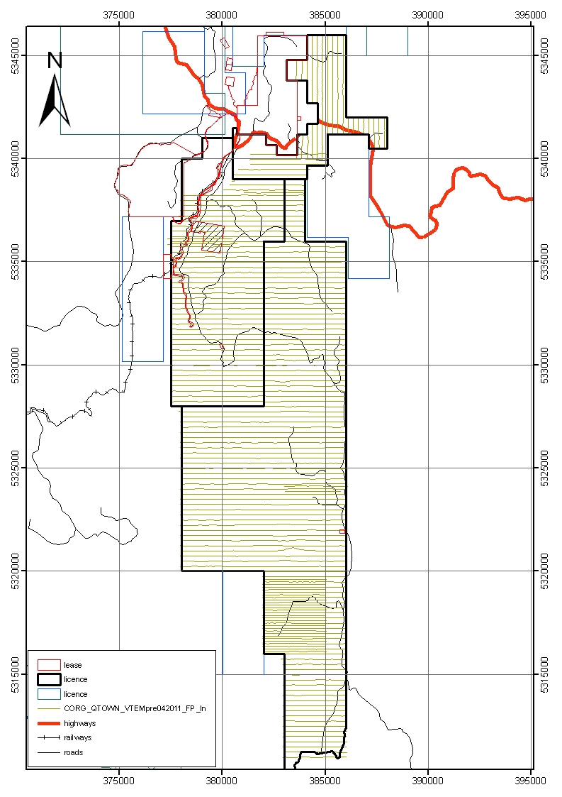
EL12/2009
FIGURE 3:

VTEM FLIGHT LINES

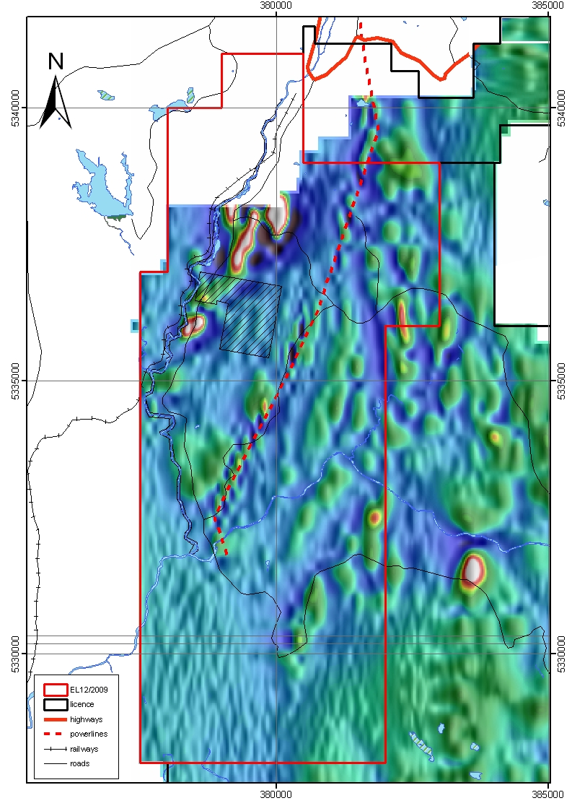
FIGURE 4:

TMI_1VD_EagcsL Magnetics Image for EL12/2009
9.2 VTEM Modelling

Modelling of two small VTEM anomalies (shown on Figure 4 overleaf) within EL12/2009 was undertaken by SGC.

Anomaly One, in the east of the tenement between Diorite Hill and Nasty Knob has a flat lying morphology and is very limited in size and strike. The conductor is modelled to lie 30m below surface. A package of mildly sericitised, weathered, interbedded andesitic agglomerates and fine cherty mudstones with occasional ferruginous staining and limonite are seen at surface with a sub vertical dip. Modelling details for this anomaly are presented in Appendix 3.

Anomaly Two, on the boundary between EL12/2009 and 14M/1996 has an easterly dip of 60 and is expressed either at surface or very close to it. The anomaly is part of a trend of low order anomalism trending over 400m. This anomaly is in an interesting geological position, associated with an area of extensively altered volcanics, targeted previously by Aberfoyle for VHMS style mineralisation (Noonan, 1990). Modelling details for this anomaly are presented in Appendix 4, but are not final copies as these have yet to be received from SGC.
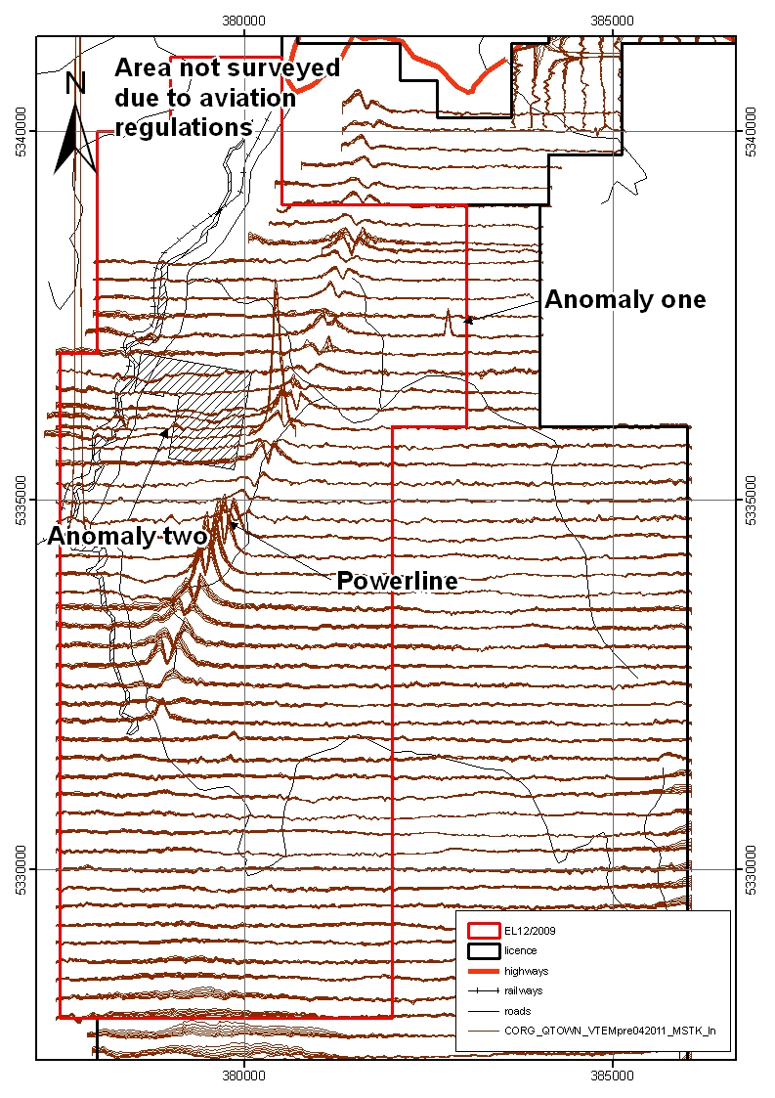
14M/1996
FIGURE 5:

VTEM response, mid-time

10.0 Discussion/Conclusion

Exploration by Corona to date within EL12/2009 has delineated two VTEM anomalies. The anomaly near Specimen Creek is more interesting considering the geological setting and slight trend in the anomalism.

Further work needs to be undertaken to compile the historical exploration data in the specimen creek area before further ground based work is attempted.

In the search for further Garfield style mineralisation, magnetic anomalies within EL12/2009 will be ranked against those already modelled in EL51/2008 and will be systematically checked.

11.0 Environment

No environmental disturbance occurred during the reporting period

12.0 Expenditure

ITEM | Cost
Wages and Salaries | $29091
Airborne Geophysical Survey | $56,976
Survey and gridding | $6,271
Accomodation | $2,589
Consumables | $3,420
Travel | $1,883
Vehicle hire | $3,172
Sub Total | $103,372
Office Costs @ 10% | $10,337
 |  | Total | $113,709

12.0 References

Anon, 1971. Results of Initial Reconnaissance Program for El47/70, West Tasmania, October
– November 1971. Cyprus Mines Corporation. Annual Report to Tasmanian Mines Department
(71_0814)
Anon, 1972. Queenstown Prospect, Results of Exploration Programme, Lynch Creek Area
EL47/70, Tasmania, Australia, January to March 1972. Cyprus Mines Corporation. Annual Report
to Tasmanian Mines Department (72_0858)
Bates, 2009. Lynchford Project (Pieman River Group) Tasmania EL2/2005. Final report 1st July 2008- 20th January 2009. Bass Metals Ltd, Annual Report to Tasmania Mines Department (09_5799).
Denwer, K. & Gregory, D., 1997. Tasmanian Base Metal Project EL2/94 Lynchford Volume 1 of 1. RGC Exploration. Report to the Tasmanian Mines Department (88_2777)
Funnel, F.R., 1988. EL47/83 Lynchford, Western Tasmania, Report of Exploration for 12 months
to February 1988. CRA Exploration Pty Ltd. Report to the Tasmanian Mines Department (88_2777)
LTIS 1:100,000 Map Series – Franklin No.8013. Edition 2, 1993
Lewis, R., 1995. Lynchford EL47/83, Tasmania, Relinquishment Report. Volume 1 of 1. Report to
Tasmanian Mines Department (95_3706)
Meares, R.M.D., Walter, A.C. & Hutton, M.J., 1979. Exploration Licence 9/66 Annual Report
1979-1980. Mt Lyell Mining and Railway Company Limited. Report to Tasmanian Mines
Department (81_1519)
Noonan, D.J., 1989. Exploration Licence 47/83 Lynchford Tasmania, Progress Report for year
ended 30th April 1989. Aberfoyle Resources Ltd. Report to Tasmanian Mines Department
(89_2977)
Noonan, D.J., 1990. Exploration Licence 47/83 Lynchford Tasmania, Progress Report for year
ended 20th June 1990. Aberfoyle Resources Ltd. Report to Tasmanian Mines Department
(90_3152)
Poltock, R.A., 1991. EL11/85 Yolande Joint Venture Annual Report for 12 months to July 1991.
Pasminco Exploration. Report to Tasmanian Mines Department (91_3278)
Seymour,D.B.,Green,G.R.,Calver,C.R.,2006. The Geology and Mineral Deposits of Tasmania.
Bulletin 72 Tasmanian Mines Department.
Sharpe, R., 1994. Lynchford EL47/83 Technical Progress Report for the period March 1993 to
March 1994. Aberfoyle Resources Ltd. Report to Tasmanian Mines Department (94_3539)
Sheppard, W.A., 1987. EL47/83 Lynchford, Western Tasmania, Report of Exploration for 12
months to February 1987. CRA Exploration Pty Ltd. Report to the Tasmanian Mines Department
(87_2636)
Stockwell, R., 1998. Tasmanian Base Metals Project EL2/94 Lynchford Volume 1 of 1. RGC
Exploration. Report to the Tasmanian Mines Department (97_4200)
Vicary, M. & Corlett, S., 1995. Tasmanian Base Metals Project EL2/94 Queen River, Vol 1 of 1.
RGC Exploration. Report to the Tasmanian Mines Department (95_373

