Appendix F

Soil Sample Plan and Results – EL18 Northwest Grid

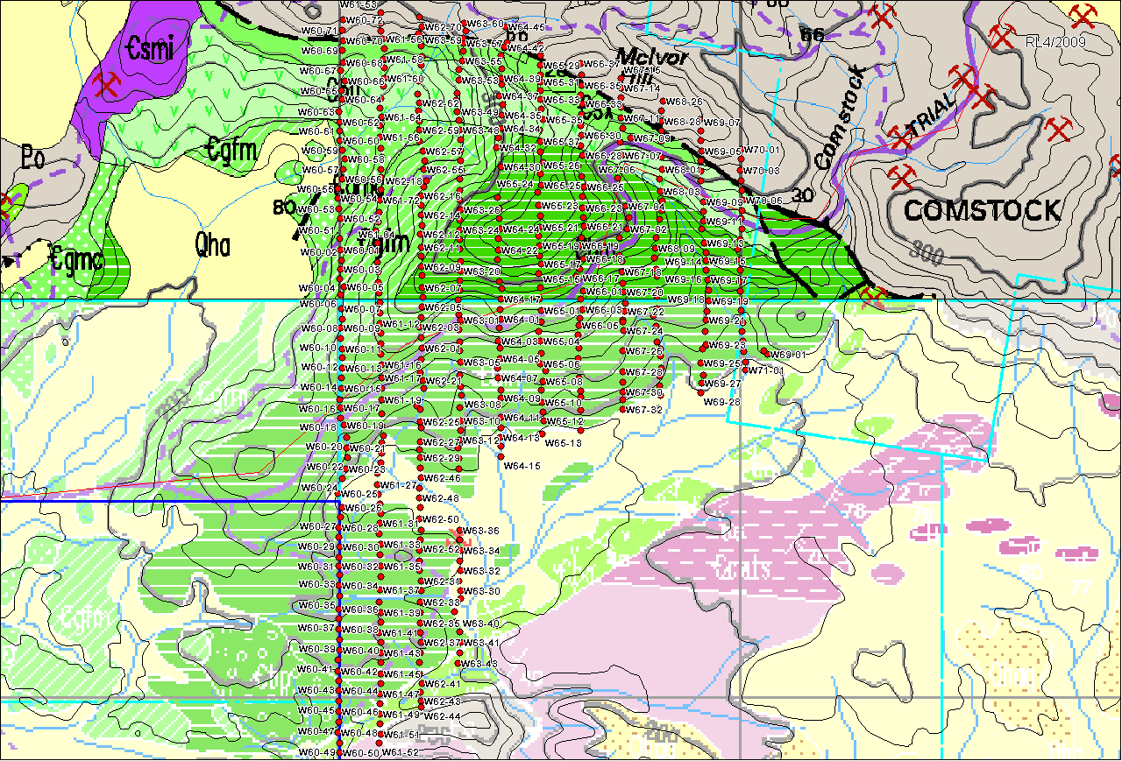
Soil Sample Plan EL18 North

