Comments on Hill 99 Geochemistry (Michael Vicary and John Everard)

Three distinct geochemical groups are present in the data. These are shown in figure 1.

- MRV type Samples: 2177, 2178
Probably are transitional between Suite 1 and Suite 2. Are a bit strange in that they have relatively high Ti/Zr at such high SiO2 values. High P2O5/Zr is more suggestive of Suite 2 composition. Similar patterns (with negative Eu anomalies) are shown by other dacites from the Noddy Creek Volcanics collected by Brown from the Montgomery sheet (See attached spread sheet).

The Noddy Creek Volcanics have a wide range in chemistry and unfortunately this prevents direct correlation with other parts of the MRV. See discussions in a recent paper by Brown.
(http://www.mrt.tas.gov.au/webdoc/servlets/com.geometryit.manager.ActivityManager?f_actName=docDetails&f_actEvent=homeDominfo&f_reportId=92770).

Figures 10 to 15 are part of a work in progress for the new Geology of Tasmania showing how to subdivide the MRV into several subgroups. This may prove useful when you have more data to play with.

The two other groups predate the MRV and are related to the allochthonous ultramafic sequences. They are:-

- Low Ti Tholeiites Samples: 2173, 2174, 2179, 2180, 2186
These are LREE-depleted and have similar patterns to Early Cambrian low Ti tholeiites elsewhere in western Tasmania (see attached spreadsheet), particularly from those from the McIvors Hill Complex and some from Black Hill, associated with the Serpentine Hill Complex. They are less depleted, probably due to fractionation, than than those from around Heazlewood and from Melba Flats near Zeehan. It's interesting that four of the five samples have a small kick or reversal of trend at La (i.e LaN > CeN), suggesting a transitional relationship to the low Ti tholeiites.

- Boninites Samples: 2175, 2176, 2181, 2182, 2183, 2184, 2185
They are more diverse but have concave patterns, and resemble the boninites ("high magnesium andseites") e.g. from the Heazlewood, Magnet, Stonehenge and Ragged Basin (near Adamsfield) areas (see attached spreadsheet). I note some were described in the field as gabbro and even bedded siltstone. (From what I've seen of boninites in western Tasmania, they can be nondescript=looking and easily mistaken for weathered sediments. Or the 'siltstones" might be volcaniclastics derived from boninites). On the basis of certain trace element ratios, most probably belong to the "Group 2" boninites of Brown and Jenner, considered to be the main type at Stonehenge and also occur at heazlewood. Group 2 are supposed to have higher Ti/Y (150-220) and Ti/Zr and lower Zr/Y (1-1.9) than "Group 1", and are transitional to the low-Ti tholeiites. Brown & Jenner had no REE data for "Group 2" , but on the basis of this new data, the REE don't look any different from Group 1.

Hill 99 MRV
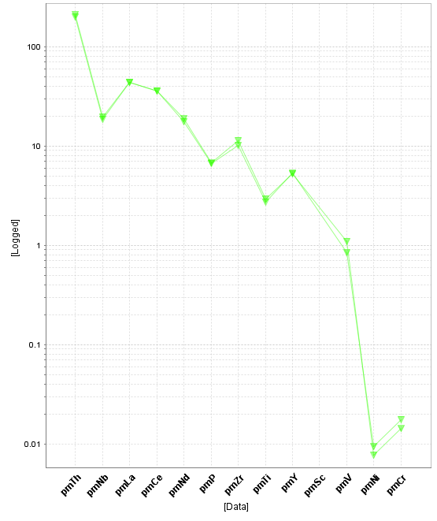
Hill 99 Boninite
Hill 99 Low Ti Tholeiite
Hill 99 MRV
Hill 99 Boninite
Hill 99 Low Ti Tholeiite

Figure 10. Primitive mantle (Sun and McDonough, 1989) normalised spiderplots for representative samples of the Mt Read Volcanics and associated rocks.
Figure 11. Chondrite (Boynton, 1984) normalised spiderplots for representative samples of the Mt Read Volcanics and associated rocks.
Figure 12. SiO2 v Ti/Zr plot for the Mt Read Volcanics.

Figure 14. MgO v P2O5/Zr plot for the Mt Read Volcanics showing fields discriminating Suites 1, 2 and 3.
Figure 13. P2O5 v MgO plot for the Mt Read Volcanics showing fields defining the compositional variation from a suite of modern arc volcanics (Crawford et al, 2007).
Figure 15. Ti/Zr v La/Y plot for the Mt Read Volcanics.

