Overseas Energy Holdings Limited
SEL 5/2005 Annual Report September 2012



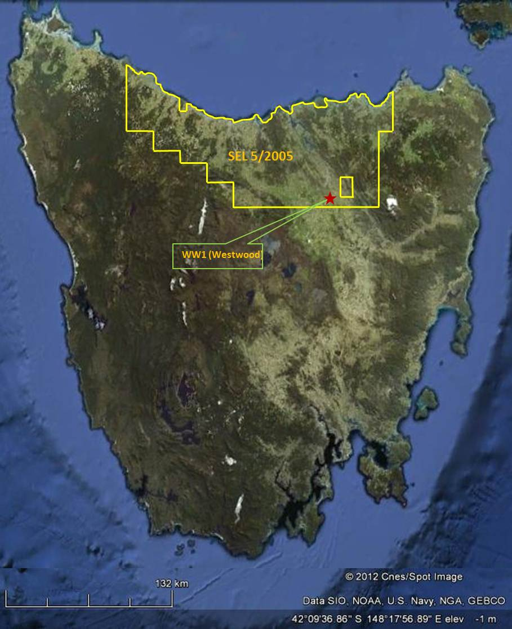

SEL 5/2005 Annual Report

Overseas Energy Holdings Limited
7 / 41 York Street
Launceston, TAS 7250
Phone: (+61) 3 6333 0425
Fax: (+61) 3 6333 0429

And

124 Aldersgate Street
London EC1A 4 JQ
Tel - +44 207 780 7254
Prepared by:
Michael Roberts
CEO
September 2012

Abstract
Overseas Energy Holdings Limited (OEHL) has developed a unique theory of oil accumulation on Tasmania. The proposition that underlies the acquisition of the SEL and the exploration activities that OEHL has carried out is that oil has migrated from the proven Bass Basin source rock through deep fissures or fractures into shallower Tasmania Basin reservoirs. To identify locations where these fissures may contain commercial quantities of hydrocarbons, OEHL has correlated regional and local geology with fracture and fault systems found onshore Tasmania.
During the first 5 years of exploration in SEL 5/2005, OEHL has conducted extensive research and various geological surveys over the whole of the license area. Data derived from seismic and other sources of geological work, including local mapping in addition to knowledge derived from shallow boreholes were extensively reviewed by the Company’s management and a number of highly prospective areas identified.
OEHL’s plan has been to drill a number of exploration wells as a precursor to further seismic and other types of investigation of the hydrocarbon potential of Northern Tasmania. OEHL drilled exploration well Westwood 1 from October 2009 to January 2010 approximately 12.5 kilometres southwest of Launceston. The well was planned to be drilled to a total depth of 2,000m but did not achieve the reservoir target due to difficult geology and drilling conditions.
OEHL has surrendered approximately 55% of the SEL 5/2005 license territory so as to focus on exploration of priority prospective locations and has carried out gravimetric and seismic survey to provide further data to support the drilling of additional exploration wells.
During a 9-month period leading to September 2012 OEHL has spent a further AUD 1.2 million excluding administrative costs, on a Gravimetric Survey plus associated Interpretation Report and this has been followed up by a targeted Seismic Survey over key prospective areas. The Processing and Interpretation of these results by the initial G&G sub-contractor was unsatisfactory and a second round of processing and interpretation is in progress with a new contractor at the date of this report. The final report is due by the end of October 2012 with the associated Competent Persons Report available by the end of 2012.
The results of the seismic interpretation and the Competent Persons Report will inform the next phase of the drilling programme and be vital to support the necessary investment funding.

Contents

Abstract 1
Contents 2
Introduction 3
Review of Previous Work 4
Exploration Completed During the Report Period 6
OEHL Exploration Strategy 2012/3 7
Risk Factors………………………………………………………………………………………………………………………………………7
Conclusions 9
Environment 9
Expenditure 10
Appendixes 12

Tables
Table 1: OEHL Expenditure 10

Figures
Figure 1: SEL 5/2005 3
Figure 2: GSLM Regional 2D Seismic Survey (from GSLM SEL 13/1998 2002 Annual Report 4
Figure 3: AGSO 148 5
Figure 4: Terrex Seismic Equipment at work in Tasmania 6
Figure 5: Hunt Rig #3 8

Introduction
An Extension License for SEL 5/2005 for a further 5 years was granted in September 2010 over a total of 6,885 sq km of Northern Tasmania as set out in the Licence. OEHL is the sole participant in SEL 5/2005.
This report covers the period to 30th September 2012.
The license territory encompasses and in the districts of Wellington, Russell, Lincoln, Devon, Dorset, Westmorland, Cornwall and Glamorgan in northern Tasmania and is shown in figure 1 below.
Figure 1: SEL 5/2005, showing the location of Well Westwood #1

Review of Previous Work
Very little or no petroleum exploration was carried out in Tasmania prior to OEHL’s efforts in their current tenement. The previously drilled wells were mostly stratigraphic wells and drilled to depths less than 1,000m.
Great South Land Minerals Limited carried out a 2D regional seismic survey over north central Tasmania from March to June 2001. The survey area is shown in Figure 2.
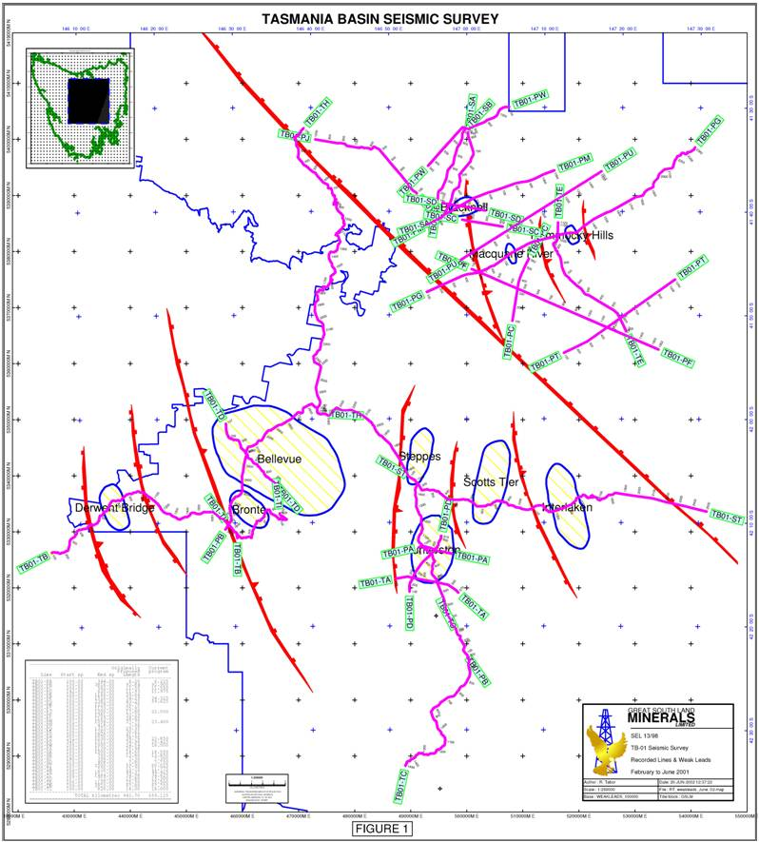
Figure 2: GSLM Regional 2D Seismic Survey (from GSLM SEL 13/1998 2002 Annual Report)
In 1995 the Australian Geological Survey Organization (AGSO) carried out program of deep seismic profiling. The survey was designated AGSO 148 and was carried out offshore, around Tasmania. Fifteen lines were shot and are shown figure 3.
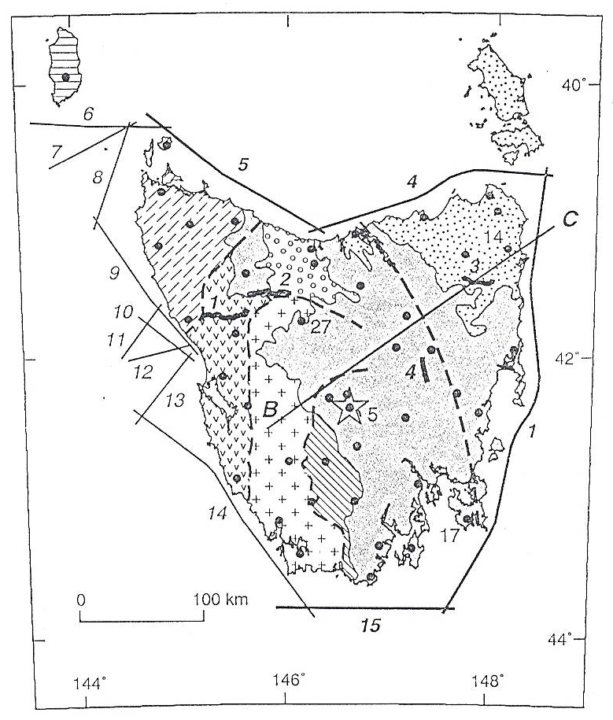
Figure 3: AGSO 148
During their tenure in the current tenement, OEHL reviewed the theories for oil accumulation in sedimentary basins in Tasmania. Onshore Tasmania is believed to have two sedimentary rock successions prospective for hydrocarbons:
- The Parmeener Supergroup, a flat-lying Carboniferous to Triassic succession that comprises the sedimentary fill of the Tasmania Basin. Marine sandstone and limestone units are the best potential reservoirs of the Upper Parmeener Supergroup while the Lower Freshwater Sequence, the Liffey Group, Mersey Coal Measures and Perolenna Coal Measures in northern Tasmania are believed to be the main potential reservoirs in the Lower Parmeener Supergroup.
- In the Wurawina Supergroup, a folded Ordovician carbonate source (the Gordon Limestone) is believed to have charged lower Paleozoic reservoirs and sub-Dolerite traps.
In addition to the above discussed theories for hydrocarbon accumulation in Tasmania, OEHL argues that deep fissures formed during the Paleocene, when Tasmania was separating from Australia, which in turn created migratory pathways for charging older but shallower traps in the Tasmania Basin with the oil generated in the Bass Basin.
OEHL’s belief is that the movement of hydrocarbon fluids into and within the Tasmania Basin was assisted by the pre-existing network of major faults. These faults were mainly the result of Cambrian and Devonian orogenesis and predated oil and gas formation in the Bass Basin.
OEHL postulates that during or since the separation of Tasmania and Australia hydrocarbons migrated through the created fractures into the older but shallower reservoirs of the Tasmanian Basin possibly via the Chat Accommodation Zone.

Exploration Completed During the Report Period
In early 2011 OEHL received permission to conduct a gravity survey if the central portion of the Block and appointed Dynamic Satellite Surveys pty ltd (DSS) to conduct the work. The work was completed early in February and the final report received in May 2011.
The conclusion of the report was that there were a number of clear gravimetric anomalies showing a high degree of correlation with the geological work previously undertaken. The main purpose of the gravity survey was to assist in defining a seismic programme by providing further evidence as to the optimum locations for that survey. It was thought such refinement would also reduce the disruption to the general public, which tend to arise from wide-area speculative surveys.
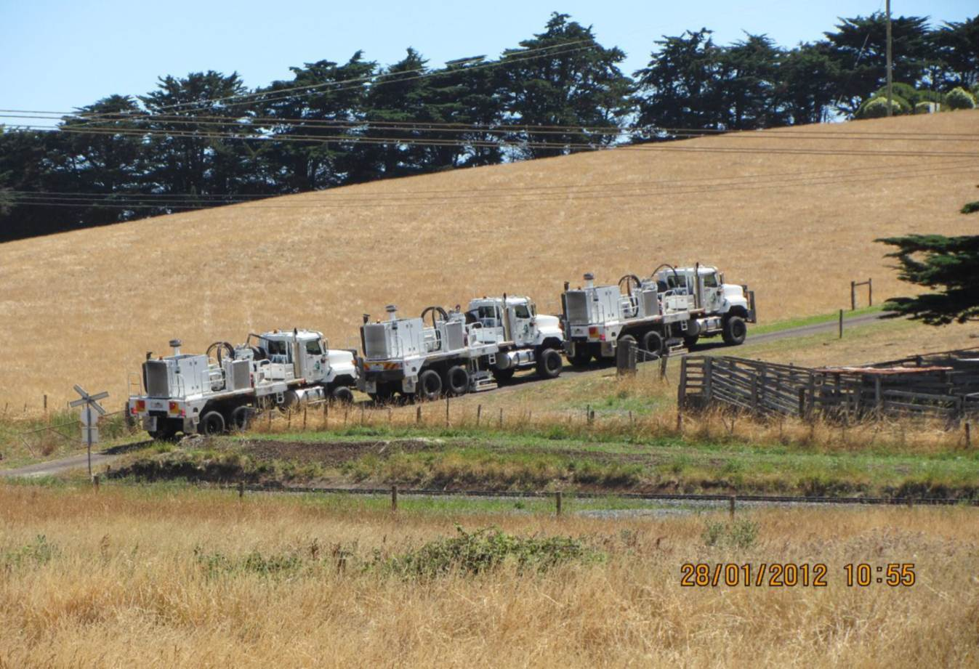
Accordingly based on the Report submitted by DSS, a proposal with recommendations for a Seismic Acquisition Survey was obtained from MX Consulting Limited on 14th June 2011. A variety of options as to the number of line kilometres to be acquired were proposed, but all variants included the most prospective sites so far identified at Bass Highway, Weymouth Road and Westwood.
Figure 4: Terrex Seismic Vibro-seis Equipment in SEL 5/2005
After raising a further AUD $1.2 million from shareholders an international tender was issued to invite various seismic contractors to bid for the work. At the same time Bartels Consulting of Hobart (Tas.) was approached to generate the necessary information and approvals for the Seismic Survey from the MRT.
The tender results were disappointing. Although costs were broadly in line with expectation the earliest firm starting date offered was February 2012. After negotiation agreement was eventually reached with Terrex Seismic of Brisbane who offered to bring the programme forward if at all possible.
Walcott & Associates pty ltd was appointed as OEHL’s project manager for the duration of the on-site programme. The approval from the MRT was received and the full seismic acquisition programme was achieved between December 2011 and end January 2012. The survey was conducted without any major incidents and was professionally managed by the Project Manager and the contractors.
A tender was held for the Processing and Interpretation of the raw seismic data gathered and the work was awarded to an associate of Terrex Seismic, Down Under Geology pty limited of Brisbane (DUG).
The raw stacks were provided to DUG who embarked on the Processing phase. Regular progress reports were received from DUG and a number of conference calls were held with OEHL’s technical staff. After 4months and over 6 weeks behind schedule it became increasingly apparent that the complexities of the task were beyond the capacity and resources of this company. However a final settlement, where DUG and Terrex admitted their results were not satisfactory, was not reached until the end of July 2012.
A new Interpretation and Processing tender was therefore issued and the contract awarded to C-A Petrol Danişmanlik Hiz. San. Tic. Ltd. Şti of Ankara Turkey (CAPD), who are now due to report by the end of October 2012. This company was selected on the basis of both its recent relevant experience (CAPD Senior Geoscientist worked in Tasmania in 2007) and the technical and computing resources that it had available.

OEHL Strategy for 2012/3
To produce a fully processed and interpreted 2D Seismic that is of an internationally acceptable standard. A comprehensive report of high quality is the key to the next stages:
- To confirm the most prospective well locations within the block – at present there are eight possible locations and the Seismic interpretation will enable selection of the three most prospective sites. A secondary criterion is to spread the wells to the extremities of the block as far as practicable for the purpose of ensuring that the geological information produced from the well logs will materially assist with understanding the regional geology even if the well is not commercially successful.
- To obtain a Competent Persons Report – for the purpose of raising additional funding for exploration drilling – where a three well programme is being proposed to investors.

Risk Factors
The main issues facing a successful implementation of the Strategy are:
- Funding
The world capital markets are under stress and raising capital on almost any terms for higher risk ventures is testing. However the worldwide connections of OEHL give a level of confidence that the funding will be attracted on acceptable terms. Much preparatory work has already been undertaken with some potential funding sources. However, see other concerns under “Drilling Approvals” below.
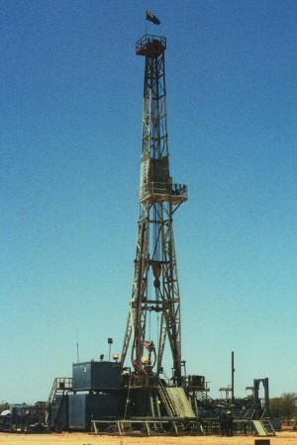
- Availability of Contractors
Figure 5: Hunt Energy Rig 3 at Westwood #1 Location
Availability of suitably qualified and resourced drilling and exploration contractors is an issue in attracting competitive tenders. The level of exploration activity in Australia continues to put exploration in Tasmania at a disadvantage from a point of view of cost and timing. Inevitably OEHL’s programme will not be considered as attractive as many on the Mainland and thus it is harder to secure the leading contractors on acceptable terms. Moreover, the experience with the Westwood 1 well emphasises how important ‘correct equipment’ is to ensure that the well can reach its “Target Depth” without significant deviation and in an acceptable time frame.
- Drilling Approvals
Although the regulatory and approval regime in Tasmania is clearly supportive of exploration efforts there are political and other factors that can have a material impact on investor perception and therefore on our timing.

Environmental Protection
OEHL carried out aquifer protection, ecological, noise assessment and heritage assessment studies prior to drilling operations at Westwood 1. OEHL was in full compliance with the recommendations of each study during the whole of drilling operations.
Westwood 1 has been plugged and abandoned.
Neither the gravimetric nor the seismic surveys have required any post operational remediation or other activity to comply with the terms of the permissions.

Conclusions
OEHL has identified eight drilling locations to date within the SEL 5/2005. Westwood 1 was drilled but as it did not reach its target depth and thus was unable to confirm the OEHL theory of oil migration into Tasmania. OEHL is planning its next three wells based on the Seismic Interpretation Report. OEHL anticipates that the report will confirm Bass Highway 1, on the coast in north central Tasmania and Weymouth Road 1, in north eastern Tasmania near the coast, as highly prospective candidates and that drilling these locations will enable the widest capture of geological information in the key areas of the tenement.
Bass Highway 1 has been proposed as exploration well site in the Tasmanian basin in north central Tasmania due to its proximity to its perceived hydraulic connections to the Bass Basin. There is little information for this area of the basin, especially at depth.
The objectives of the Bass Highway 1 are to:
- Confirm the anticipated stratigraphic column based on the gravimetric survey and Westwood 1 well log.
- Investigate presence of potential hydrocarbon bearing formations in the Parmeener Super group;
- Investigate presence of potential hydrocarbon bearing formations in the Gordon Limestone or intercept and confirm existence of an oil saturated fracture system.
The objectives of the Weymouth Road 1are to:
- Intersect an oil saturated fracture system in early Ordovician formations at approximately 3,000m.
- Intersect the secondary hydrocarbon play located within the Gordon Group limestone if present;
- Define any tertiary targets intersected by the well;
- Delineate the oil source rocks within the intersected lithology.

OEHL is investigating potential additional gravimetric and magnetotelluric surveys at the proposed locations for Bass Highway 1 and Weymouth Road 1 prior to applying for the relevant permissions before commencing drilling activities.

Expenditure
OEHL expenditures for exploration activities on SEL 5/2005 are presented in the following table.
Table 1: OEHL Expenditures
All AUD$ to 12/2011 to 3/2012 to 6/2012 to 9/2012 TOTAL
Geoscientific costs | Geology | 3,000 | 745,413 | 27,273 | 14,861 | 1,447,981
 | Geophysics |  |  |  |  | 242,168
Drilling and gridding costs | Drilling |  |  |  |  | 5,837,376
Land access costs |  |  |  |  |  | 168,699
Rehabilitation costs |  |  |  |  |  | 165,176
Feasibility study costs |  |  |  |  |  | 366,900
Other costs |  | 1,306 | 998 | 1,097 | 43,810 | 64,392
Administration costs |  | 431 | 74,641 | 2,837 | 5,867 | 831,201
Total costs 2011/12 |  | 4,737 | 821,052 | 31,207 | 64,538 | 9,123,693
Cumulative Costs since 2005 |  | 8,206,896 | 9,027,948 | 9,059,155 | 9,123,693

These are the costs that correspond to the quarterly returns submitted to the MRT.
In the current reporting period the total amount expended amounts to $ 916,797.

Appendixes
Appendix 1 – 5/2005 Gravimetric Survey
See Attached Report from DSS

Appendix 2 – Seismic Survey Recommendation - MX Consulting Report
See attached Report

