EL 37/2010 Westbury Partial Relinquishment Areas
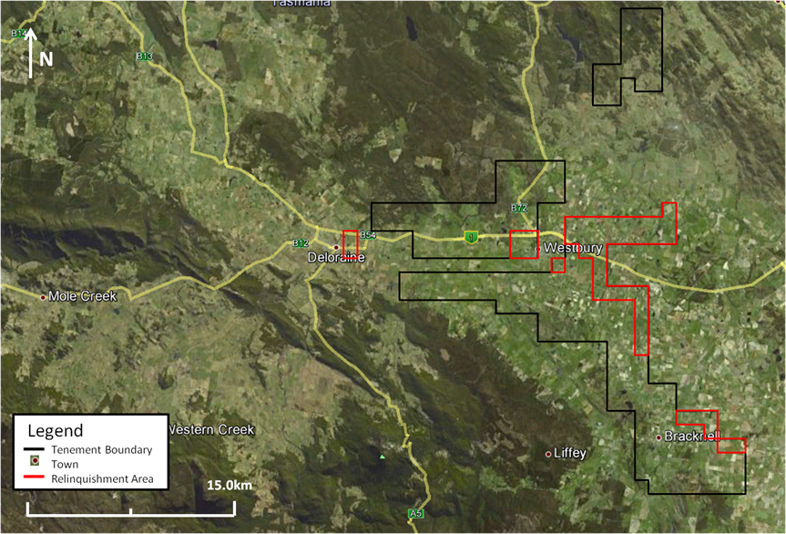
ABx4 is partially relinquishing 44sq km of the tenement with the focus on removing towns, settlements, rivers, mountains and exclusion areas from the tenement. These areas are unlikely to have bauxite and would constrain any potential future developments.
Map – EL37/2010 relinquishment areas marked by red outline

