Latrobe Project - EL 20/2004

Tasmanite Oil Shale Resource Potential

Boss Resources Limited
(ABN: 38 116 834 336)

Leigh Ryan, July 2013

Executive Summary
The Tasmanite oil shale horizon(s) within Boss Resources 100% owned Latrobe Oil Shale Project in Tasmania (E20/2004) has already produced 1.13 million litres of oil from historical underground mining operations. Historic and recent drilling campaigns within the License have demonstrated a continuity of the horizon(s) over a very large area.
Recent drilling and interpretation work by Boss Resources has confirmed an Exploration Target (ET) of 38 to 72 million tonnes of oil shale equating to between 27 million and 50 million barrels of oil. The ET includes 38 million tonnes (27 million barrels) defined by 310 recent and historic drill holes. The remaining 34 million tonnes of the ET is a direct extension of the drilled horizons but has not been drill tested. Additional drilling is required in order to confirm the extent of the ET and convert the resource into an inferred JORC compliant status.
With some additional oil shale analysis work, the recent drilling conducted by Boss Resources at the China Bush prospect will enable an inferred JORC complaint resource of 1.7 million tonnes (~1.7 million barrels). This estimation uses an SG of 2.0 within a wireframe created from ore blocks digitized on a complete set of cross sections through the prospect area, and does not extend below 30m from surface.
The variety of oil shale found within the Latrobe Oil Shale Project is unique to Tasmania and has advantages over other Australian oil shales in that it can be used as a source of bitumen as well as oil and power generation.
The Latrobe project oil shale is comparable to the Fushun oil shale with respect to physical, chemical and retorting product characteristics. The processing produces a benign, sterile ash product suitable for fertilizer, soil improvement product, building and insulation materials or filler suitable for an additive at the huge Railton cement factory just 1.8 kilometres to the southwest of the Project.
The Fushun Mining Group in China was sent a Memorandum of Understanding (MOU) early in 2012 with respect to sharing exploration, resource and processing information, and ultimately forming a Joint Venture on the Latrobe Project. A response to the MOU is still awaited.
A two stage 530 hole (26,000m) drilling program with an estimated cost of $1,500,000 has been designed in order to increase the confidence level of the entire 72 million tonne ET to a JORC compliant inferred resource status from surface down to a depth of ~160m below surface.

Land tenure and infrastructure
The Latrobe area is a mixture of farmland, Crown Land, State Forest and State forest under management as pine plantation. Much of the pine plantation area has been recently harvested, or contains young trees, so access to the area is generally good. Compensation issues need to be managed where exploration impacts on the economic performance of the plantation. Two exclusion areas (unavailable under MRDA) are located within EL20/2004 including a forest reserve (2.3km²) and a Private Reserve (0.4 km²).
The license is dissected in a NW-SE orientation by the Mersey River, and the sealed Railton Road and Bass Highway (Figure 1). Numerous graded gravel plantation roads and tracks are networked throughout the license and provide good vehicle access throughout. A High Voltage 220kV electricity transmission line cuts through the China Bush area, and a gas pipeline runs along the south-western edge of the tenement.
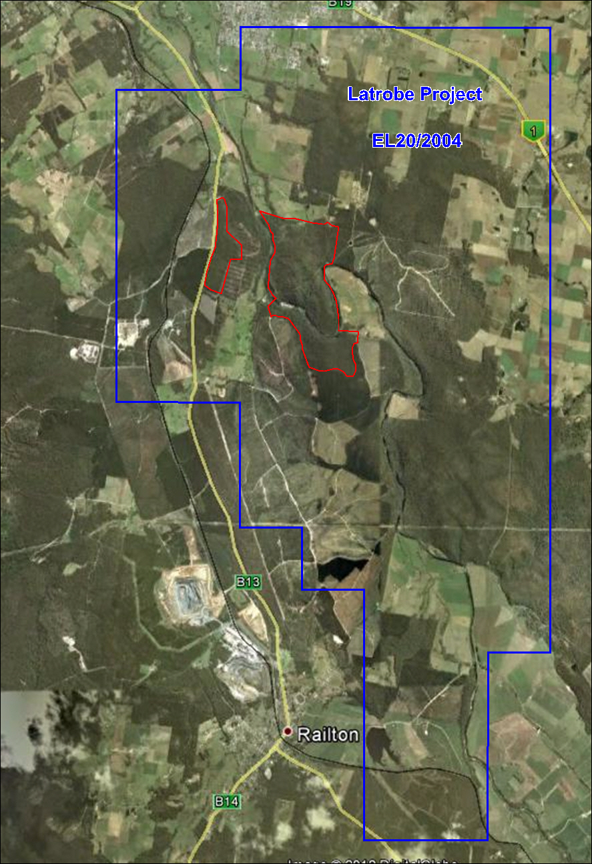
Figure 1: Latrobe tenement outline (EL20/2004) and exclusion areas (red) over satellite imagery.

Geology and Geological Constraints
The Tasmanite oil shale horizon(s) and some thin coal seams have been found to occur in two stratigraphic intervals within the Permian Parmeener Supergroup within the Tasmania Basin. The Parmeener Supergroup is up to two kilometres thick, and has been subdivided into Lower Parmeener (predominantly marine) and Upper Parmeener (predominantly freshwater) sedimentary sequences. The oil shale horizons occur towards the base of the Lower Parmeener Supergroup above tillites in a restricted marine environment (Figure 2).
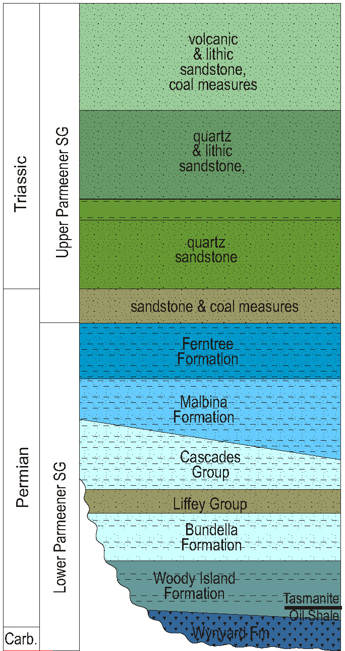
Figure 2: Generalised stratigraphic column and nomenclature for the Parmeener Supergroup (from Reid & Burrett, 2004). The Parmeener Supergroup nomenclature follows Forsyth (1989).
The Tasmanite oil shale horizons are found with a NNW-SSE trending sequence of Permian sedimentary rocks of the predominantly marine Lower Parmeener Supergroup (Figure 3). The oil shale is located within the early Permian Woody Island Formation. To the West and East of this formation are Ordovician and Pre-Cambrian sedimentary sequences, which are older than the Permian Tasmanite shale host rocks, and are generally not prospective. Thin flat lying Tertiary and Jurassic sedimentary sequences are present on the eastern side of Area I. Several NE-trending dolerite dykes or sills cut through the License. The surface extent of the dolerite ranges from ~10 metres to a maximum of ~300m across in Area II.
Localized recent erosion within the moderately hilly topography impacts on the depth and lateral extent of the flat lying Tasmanite ore seams.
Latrobe Oil Shales
The oil shale is Tasmanite Oil Shale, which occurs only in a few places world-wide. The kerogen (oil) of Tasmanite occurs as particulate amber-coloured discs (in reality, flattened sacs), having a distinct structure and clearly defined cell walls. The oil shale is thought to have formed in a quiet ecosystem of shallow bays, inlets and river estuaries in which the algae were free to multiply. The kerogen resulted from prodigious algae blooms when conditions were favourable for completion of the life cycle and "spore" build-up in the marginal marine waters.
Oil Shale Resource Potential and Exploration Target
To date 310 holes have been drilled by various companies including CRAE, Endeavour Resources, ASO Corporation, Tasmanian Mines Department, Latrobe Shale Oil Company, Boss Energy and Boss Resources for a total of 10,096m (including 264 diamond holes for 8,957m). A Microsoft Access database was carefully compiled from all available drill logs found within a variety of historic annual and company reports. Where reports containing drill logs could not be found the hole locations and shale intercept and analysis information down the side of the CRAE map of the Latrobe area was used (Plan No. TASh 581, Clementson, 1981). Drill hole locations were digitized off this map in MapInfo to determine comparatively accurate coordinates. Of the 313 holes drilled within EL20/2004 to date, 226 holes intercepted shale with an average depth to shale of 31m.
Boss Resources Limited has recently revised the Exploration Target (ET) for Latrobe to between 38 million and 72 million tonnes of oil shale equating to between 27 million and 50 million barrels of oil. The ET is divided into drilled and undrilled areas that have been further sub-divided into seven historically recognised prospect areas (Area I, II, III, V (China Bush), V China Flat), V (South) and Area VI). The drilled areas (drilled at variable hole spacings), form the lower range of the ET with the drilled and undrilled areas together forming the upper limit of the ET.
Ore blocking and subsequent wireframing of all Latrobe drill holes that intercepted oil shale was completed in order to obtain an idea of the resource tonnage potential of the Latrobe Project. Ore blocks were constructed on a complete set of sections throughout each prospect area. These sections have been saved as section files in a Latrobe Micromine Project folder. Wireframes were constructed from the ore blocks and checked/validated in Micromine.
A digital terrain model (DTM) was created by digitizing the 10m topographic contours of the relevant areas from the Railton and Latrobe 1:25,000 scale published topographic maps and then creating a 3D topo surface (DTM) from the contours in Micromine. This surface was used to check and adjust RL’s for each drill hole and crop all wireframes back to a relatively accurate surface level.
Oil shale tonnages for the Project were estimated in Micromine using the volume within the wireframes of each oil shale prospect area and a global SG of 2.0.
In 1931 Blake quoted a whole seam oil yield of 153-165l/t, an average thickness of 1.53m, and an SG of 2.0 for the Latrobe-Railton oil shales, (Maynard, 2007). Kurth (1932) demonstrated that the Latrobe Oil Shale is a variable raw material with ash contents ranging from 61.9% to 93.5%, SG’s ranging from 1.71 to 2.65 and oil content from 2.7 gal/ton to 65gal/ton (11-270l/t). Analyses from CRAE exploration in 1981 gave a range of oil yields from 109-177 l/t with an average yield of 143 l/t (Clementson, 1982). Work involving drill cores the specific gravity of whole seam raw material was accepted as 2.25gm/cc and the conservative average oil yield was stated to be 130l/t (Maynard, 2007).
The litres of oil estimations stated in this report use an average oil content figure determined from all available oil shale drill hole analyses for each area (litres/tonne). The total litres of oil / tonne figure was converted to barrels using 1 barrel (BBL) = 159 Litres. Results and number of analyses used for each prospect can be found in a spreadsheet called “Boss Latrobe Exploration Target Inventory Coal Calcs.xlsx”. Accordingly the drilled prospects are estimated to contain 37.6 million tonnes (26.9 million barrels) of the ET.
The remainder of the ET is comprised of reasonable down dip and along strike extensions of the oil shale wireframes within topographically accessible areas mapped as the host formation (Permian sediments) within the license (Figure 2). The surface area (m²) of the undrilled portions of each prospect was determined in MapInfo with the thickness for each area estimated using the average oil shale drilling intercept thickness for each prospect. Combined, these areas are estimated to contain 34.6 million tonnes (22.7 million barrels) of the ET.
Additional drilling is planned in order to increase the confidence level of the entire ET to a JORC complaint inferred resource status. Figures 2 and 3 show the Latrobe oil shale ET areas including what can currently be classified as an “inventory coal” area at Area5 (China Bush).
Recent drilling conducted by Boss Resources at the China Bush prospect has produced an “inventory coal” JORC complaint resource of 1.7 million tonnes (~1.71 million barrels). This resource estimate uses an SG of 2.0 within a wireframe created from ore blocks digitized on a complete set of cross sections through the prospect area. The entire horizon does not extend below 30m from surface. The DTM model was used to crop the wireframes with respect to surface topography. With some additional oil shale analysis and SG determination work the China Bush prospect would become an inferred JORC complaint resource.
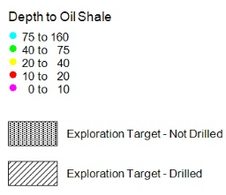
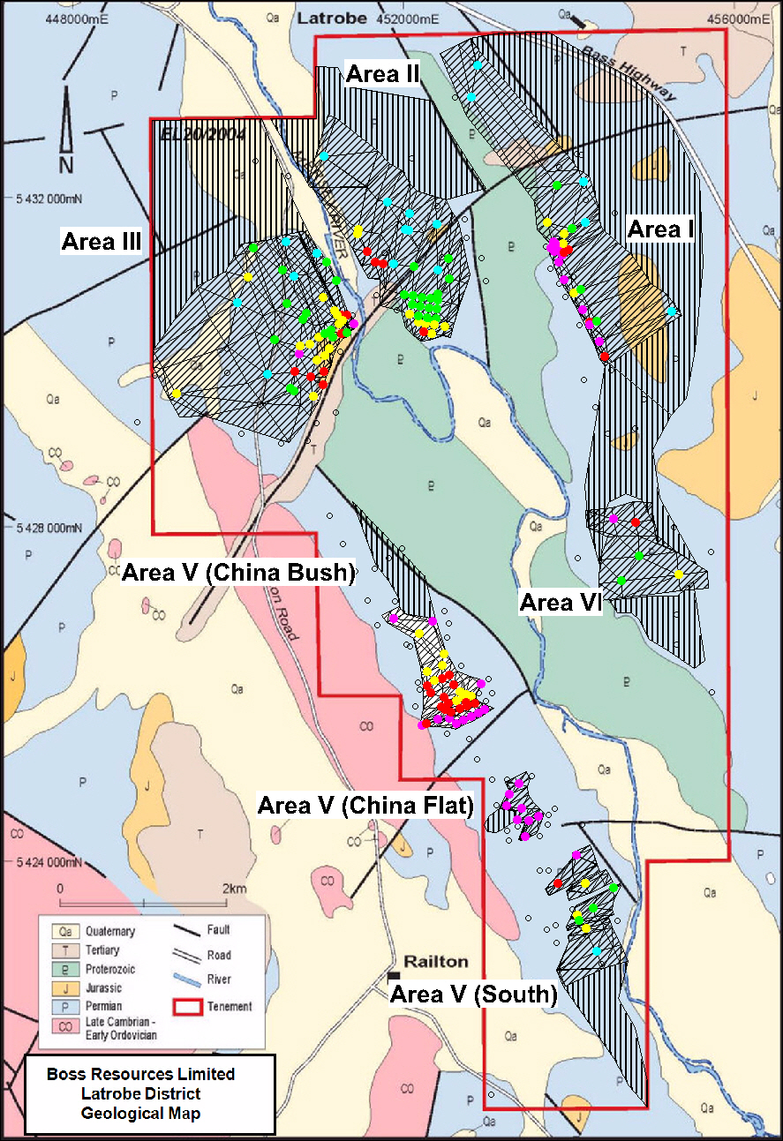
Figure 3: Latrobe license existing drilling (coloured by depth of oil shale horizon) and drilled (wireframed) and undrilled exploration targets over geology interpretation.

Potential shale tonnages are shown in Table 1 below:
Prospect Area | Status | Volume Method | SG | Average Oil Content | Tonnes | Barrels Oil  (159 lt/bbl)
Area I | Drilled | <30m Wireframe | 2.0 | 76.9 | 1,861,173 | 899,961
Area II | Drilled | <30m Wireframe | 2.0 | 100.3 | 760,766 | 480,121
Area III | Drilled | <30m Wireframe | 2.0 | 160.2 | 755,248 | 760,977
Area V (China Bush) | Drilled | <30m Wireframe | 2.0 | 159.7 | 1,702,879 | 1,710,908
Area V (China Flat) | Drilled | <30m Wireframe | 2.0 | 178.4 | 586,034 | 657,619
Area V (South) | Drilled | <30m Wireframe | 2.0 | 72.5 | 669,532 | 305,402
Area VI | Drilled | <30m Wireframe | 2.0 | 81.6 | 955,035 | 490,037
Total | Drilled | <30m |  |  | 7,290,666 | 5,305,024
Area I | Drilled | All Wireframe | 2.0 | 76.9 | 9,715,478 | 4,697,872
Area II | Drilled | All Wireframe | 2.0 | 100.3 | 8,591,202 | 5,421,924
Area III | Drilled | All Wireframe | 2.0 | 160.2 | 11,732,703 | 11,821,702
Area V (China Bush) | Drilled | All Wireframe | 2.0 | 159.7 | 1,702,879 | 1,710,908
Area V (China Flat) | Drilled | All Wireframe | 2.0 | 178.4 | 591,343 | 663,577
Area V (South) | Drilled | All Wireframe | 2.0 | 72.5 | 2,468,512 | 1,125,993
Area VI | Drilled | All Wireframe | 2.0 | 81.6 | 2,773,592 | 1,423,155
Total | Drilled | All Wireframe | 2.0 |  | 37,575,710 | 26,865,131
Potential Areas |  | Area (m2) |  | Avg Thickness
Area I | Not Drilled | 4,771,010 | 2.0 | 1.34 | 12,759,984 | 6,170,028
Area II | Not Drilled | 1,748,500 | 2.0 | 1.67 | 5,842,176 | 3,687,008
Area III | Not Drilled | 3,058,180 | 2.0 | 1.37 | 8,376,355 | 8,439,895
Area V (China Bush) | Not Drilled | 442,105 | 2.0 | 1.13 | 999,802 | 1,004,515
Area V (China Flat) | Not Drilled | 71,010 | 2.0 | 1.26 | 178,709 | 200,538
Area V (South) | Not Drilled | 689,200 | 2.0 | 1.15 | 1,583,628 | 722,360
Area VI | Not Drilled | 2,115,360 | 2.0 | 1.15 | 4,844,174 | 2,485,590
Total | Not Drilled | 12,895,365 |  | 1.34 | 34,584,828 | 22,709,934
Global Total (Max ET) |  |  |  |  | 72,160,538 | 49,575,065
Processing Potential
In 2010 Boss engaged the Fushun Mining Group to conduct trials on and determine the suitability of the Fushun Vertical Retort Technology to process the Tasmanite oil shale from the Latrobe project. A 500 kg sample of oil shale was shipped to Fushun to ensure ample product for the various tests. Each test was repeated as part of Fushun’s quality control process. The Fushun tests mimicked the various internal processes of retorting. Products from retorting, which include oil, water, semi-coke and ash, were then analysed to determine various chemical and physical properties as detailed in Sitharamarao, 2010.
The Fushun technology was chosen because the Fushun Mining Group currently operates an established commercial oil shale to oil process and are currently the world’s largest processor of oil shale to shale oil. The modularity of the process equipment indicates that capital investment could be staggered. All produced water is used within the process and there is no water discharge. Fushun’s Energy Testing Research Centre is the only nationally accredited testing facility in China for oil shale and being nationally accredited, the oil shale test results are internationally accepted
The Fushun tests on the Latrobe oil shale highlighted the following points:
- The physical / chemical parameters of Tasmanian oil shale of the Latrobe project are similar to Fushun’s oil shale and can easily be processed and treated using Fushun Retort technology.
- The oil content of the sample was 93.3 kg per dry tonne of oil shale, which compares favourably with other Australian oil shales and Fushun oil shale.
- Oil from Latrobe oil shale can be classified as a wax-free crude oil with light crude fraction of 10% and diesel fraction of 50%
- Oil from Latrobe oil shale has a low pour point (-22⁰C) and a heating value of 42.4 MJ/kg (conventional crude oil is 42.7 MJ/kg)
- Light crude content of the oil is high and it can be used directly as a fuel oil
- The tests indicate that Latrobe oil shale can be retorted at lower temperatures than standard retorting temperatures, which are about 450⁰C; majority of the oil was released between 170⁰C and 480⁰C
- The process has sufficient energy to be self-sustaining
- Tasmanian oil shale would produce less gas than Fushun oil shale, but has a significantly higher heating value (a little over 20 MJ/m³)
- The water content (11.2%) was lower than the threshold moisture content for the Fushun process (15%), implying that external drying would not be required prior to retorting
- Low dust is produced during crushing operations owing to moisture content
The Latrobe project oil shale sample is comparable to the Fushun oil shale in physical and chemical characteristics, and the products from retorting are also very similar. The processing produces a benign, sterile ash product that would be suitable for a variety of products such as fertilizers, soil improvement products, and building and insulation materials. The ash would also be suitable for use as an additive at the huge Railton cement factory just 1.8 kilometres to the southwest of the China Bush Prospect.
Suggested Drilling Program
A 530 hole (26,000m) drilling program based on a 200m x 200m hole spacing has been planned for the entire Latrobe exploration target, including all prospect areas (I-VI). Numerous historic drill holes were not drilled deep enough and therefore did not intercept the shale horizon. These holes will be re-drilled to correct depths. The drill program will include both RC and diamond core drilling and has an estimated cost of $1,500,000. It is suggested that the program be drilled at 400m x 400m spacing initially, then revised and tightened to a 200m x 200m spacing where required. The most economically prospective areas identified to date are China Bush, China Flat and the western side of Area I. On completion of the entire program (including associated oil analysis work and SG determinations) the upper limit of the exploration target should be at a JORC compliant inferred resource status from surface down to a depth of ~160m below surface.
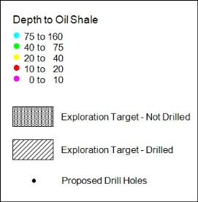
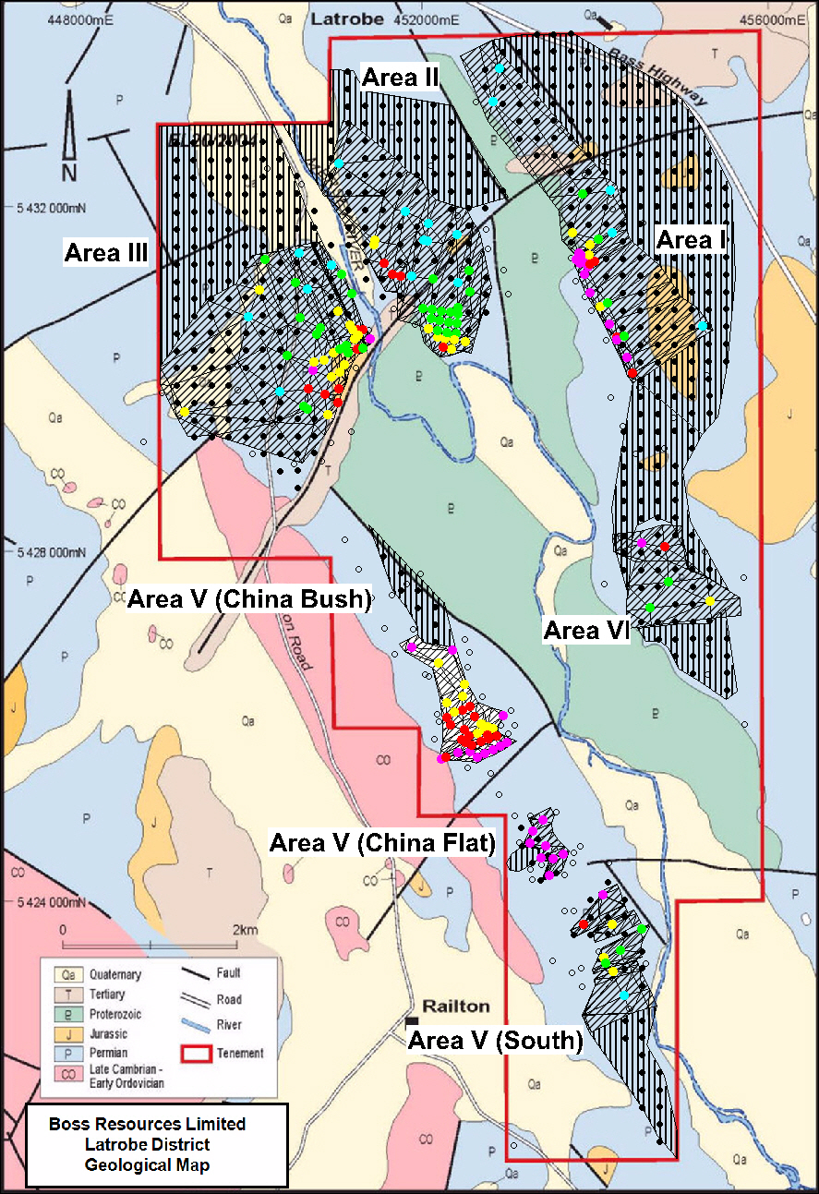
Figure 4: Latrobe license existing and proposed drilling over exploration targets and geology interpretation.

Geochemical analysis
Samples from all recent and proposed diamond core should be submitted for the following analytical procedures to obtain information that will be usable to progress the project towards JORC compliance.
• Specific gravity determinations
• Hydrogen, Carbon, Nitrogen, Sulphur analysis
• Ash content
• Rock Eval hydrocarbon analysis
• Trace element analysis

Conclusions
The Latrobe Oil Shale Project in Tasmania has the potential to host 72 million tonnes of oil shale and produce 50 million barrels of oil. In order to achieve this Boss Resources Limited will require the Fushun Mining Group’s proven oil shale processing technology and commitment to the project in the form of a signed Memorandum of Understanding leading to a possible future Boss-Fushun Latrobe Joint Venture. The $1,500,000, 530 hole drilling program can commence after gaining Fushun’s support in this regard.

References
Australian guidelines for estimating and reporting of Inventory Coal, Coal Resources and Coal Reserves, prepared by The Coalfields Geology Council of New South Wales and the Queensland Mining Council.
Clementson, I.M., 1981, Railton EL 4/74 Interim Report on 1981 Drilling, CRA Exploration Pty. Ltd., MRT Report 82_1863.
Clementson, I.M., 1982, Railton EL 4/74 Final report on 1982 drilling, CRA Exploration Pty. Ltd., MRT Report 82_1789.
Kurth, E.E., 1933, Oil Shales of Tasmania and NSW, PhD. Thesis 1933, University of Tasmania.
Maynard, A., 2007, Independent Consulting Geologist’s Report on the Latrobe Oil Shale Deposit for Boss Energy Limited, Boss Energy Limited Prospectus, 2007.
Sitharamarao, S., 2010, Fushun Test Results, Boss Energy Limited Company Memorandum, November, 2010.

