CAMPBELLTOWN EXPLORATION PROGRAM

BOTANICAL & FAUNA HABITAT SURVEY OF PROPOSED DRILL

SITES ON THE PROPERTY OF “MEADOWBANK”

For ABx4 PTY LTD

20th October 2010

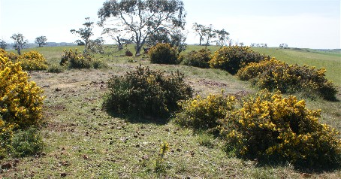

PHILIP MILNER LANDSCAPE CONSULTANT PTY LTD

144 Allisons Road, LOWER BARRINGTON
POSTAL: C/O Post Office, BARRINGTON, 7306
TASMANIA
Mobile: 0417 052 605
Home Phone: (03) 6492 3201

Email: philip.milner@bigpond.com A.B.N.No. 32 068 906 258

Introduction: ABx4 Pty Ltd the holder of Exploration Licences EL4; EL5; EL6; EL7; EL8; EL9; and EL14/2010, a wholly owned subsidiary of Australian Bauxite Ltd is undertaking an exploratory program in an area of the midlands between Launceston and Cranbrook and is undertaking a targeted drilling program in the area to the immediate west of Campbelltown on the property of “Meadowbank”.
The exploration program will involve numerous shallow drill holes which will not require the clearing and/or leveling of drill pad sites and so is expected to have a minimal impact on the ground surface and adjacent vegetation.
A botanical and fauna habitat survey is required of each drill pad site as part of the MRT license conditions to determine any likely impacts on threatened species or threatened vegetation communities.

Objectives: The objectives of this survey were to;
- Undertake a desktop survey to confirm the known biological records and the natural values present in the exploration target areas and in the vicinity.
- Undertake a field survey of the exploration target areas to observe and record the natural values present including the vegetation types and plant communities, the flora and in particular any threatened species and potential habitat for species of threatened fauna.
- Determine the possible impacts of the proposed exploration program on the natural values present and make recommendations on how those impacts can be minimized.

Location of Study Areas:

MAP REF: Tasmap 1:25,000, Sheet No. 5236, Conara

BIOREGION: Northern Midlands

- Campbelltown “Meadowbank” target area: proposed drill site locations.

DRILL PAD GRID REFERENCES

No. 220 : 537569E – 5360885N

221 : 537621E – 5360906N

222: 537643E – 5360963N

223 : 537667E – 5361015N

224 : 537706E – 5361055N

225 : 537736E – 5361094N

226 : 537786E – 5361124N

227 : 537660E – 5361160N

228 : 537583E – 5361227N

229 : 537527E – 5361332N

. 230 : 537557E – 5361371N

231 : 537472E – 5361425N

232 : 537507E – 5361600N

233 : 537511E – 5361646N

234 : 537472E – 5361631N

235 : 537429E – 5361608N

264 : 537262E – 5361627N

265 : 537415E – 5361549N

266 : 537414E – 5361468N

267 : 537442E – 5361490N

268 : 537469E – 5361378N

269 : 537495E – 5361294N

270 : 537532E – 5361229N

271 : 537576E – 5361160N

272 : 537602E – 5361114N

273 : 537601E – 5361017N

274 : 537658E – 5361081N

275 : 537727E – 5360958N

276 : 537668E – 5360871N

277 : 537642E – 5360840N

278 : 537713E – 5360806N

279 : 537784E – 5360876N

280 : 537832E – 5360884N

281 : 537872E – 5360932N

282 : 537944E – 5360756N

283 : 537906E – 5360762N

284 : 537888E – 5360717N

285 : 537958E – 5360602N

286 : 538002E – 5360650N

287 : 537904E – 5360583N

289 : 538054E – 5360367N

290 : 538077E – 5360423N

291 : 538082E – 5360458N

292 : 538122E – 5360478N

293 : 538220E – 5360373N

294 : 538266E – 5360316N

295 : 538258E – 5360245N

296 : 538219E – 5360198N

297 : 538210E – 5360289N

298 : 538169E – 5360262N

299 : 538151E – 5360348N

300 : 538104E – 5360320N

(All Grid References MGA Zone 55 GDA94)

Site Description: All of the above proposed drill pad sites are within the property of “Meadowbank” to the immediate west of Campbelltown and are to be accessed from Macquarie Road.

Desktop Survey of Natural Values: The DPIW database “The Natural Values Atlas” was accessed for the known biological records of the locality and environs. Records of threatened species of flora and fauna known to occur within a 5,000 metre radius of the location were also accessed. Data sourced included the vegetation types and plant communities, the occurrence of any threatened vegetation communities, the recorded locations of any threatened species of plants and threatened fauna known or expected to occur in the vicinity.

REFERENCE POINT for the locality: Drill site No.268: GRID REF: 537469E – 5361378N

Desktop Survey Results:

VEGETATION COMMUNITIES:

The following vegetation communities are mapped under the TasVeg mapping program as occurring within 1,000 metres of the study area reference point.

VEGETATION COMMUNITY | TasVeg Code / Map colour | EXTENT IN STUDY AREA
Midlands Woodland Complex | DMW / pale green with “v” | Small scattered remnants across the study area
Lowland Grassland Complex | GCL / bright yellow/green | Two small areas in the west & SW quadrats of the study area
Agricultural Land | FAG / cream | Almost all of the study area comprises agricultural land

TABLE 1: Vegetation Communities and extent within the study area as per TasVeg mapping program.

FIGURE 1: Vegetation communities as per TasVeg mapping program within 1,000 metres of reference

point Drill Site 268: GRID REF: 537469E – 5361378N

CODE: DMW …………...Midlands Woodland Complex
GCL ……………Lowland Grassland Complex
FAG ………….. Agricultural Land

THREATENED VEGETATION COMMUNITIES:
- One natural vegetation communitiy which is mapped within the study area is listed as threatened under the Tasmania Nature Conservation Act 2002. Midlands Woodland Complex is listed as an endangered community under the Act and is mapped as occurring as small scattered remnants across the study area.
- Lowland Grassland Complex is listed as a threatened vegetation community under the Commonwealth Environment Protection and Biodiversity Conservation Act 1999. There are two localized areas of this vegetation mapped about 800 metres to the west and south-west of the reference point.

VEGETATION COMMUNITIES OF CONSERVATION SIGNIFICANCE
No other natural vegetation communities of conservation significance are mapped as occurring within the study area.

THREATENED FLORA:
One species of threatened flora listed under the Tasmanian Threatened Species Protection Act 1995 and/or the Commonwealth Environment Protection and Biodiversity Conservation Act 1999 is recorded on the “Natural Values Atlas” database as occurring within 1,000 metres of the study area reference point.
- Scleranthus fasciculatus Spreading Knawel is listed under the Tasmanian act as being vulnerable. There is one 1994 record from the southern side of Macquarie Road. There are a further three records from within 3,000 metres.

Three species are recorded from within 2,000 metres of the study area reference point.
- Dianella amoena the Grassland Flaxlily is listed as being rare under the Tasmanian Act and endangered Nationally. There is one undated record on the western side of the Midlands Highway about 1,800 metres from the study area reference point. There are a further three records from within 3,000 metres and three within 5,000 metres.
- Vittadinia gracilis the Woolly New-Holland Daisy is rare in Tasmania. There is one undated record from the same location as the Grassland Flaxlily above. There are a further four records of the species within 3,000 metres and 5 within 5,000 metres.
- Xerochrysum bicolor the East-coast Everlasting is listed as being rare under the State Act. There is one 1984 record from the southern side of Macquarie Road about 1,800 metres from the study area reference point. There are a further three records from within 3,000 metres.

A further 17 species of threatened flora are recorded on the database as occurring within 3,000 metres of the study area reference point.
- Asperula scoparia var scoparia the Prickly Woodruff is listed as rare under the Tasmanian Act. There is one undated record from the area.
- Austrostipa bigeniculata the Double-jointed Speargrass is listed as rare under the Tasmanian Act. There are two 1984 records on the database.
- Austrostipa nodosa the Knotty Speargrass is listed as being rare under the Tasmanian Act. There are two undated records from the area and a further 3 records within 5,000 metres from between 1984 and 1994.
- Carex tasmanica Curly Sedge is listed as being vulnerable nationally although it is not listed under the Tasmanian Act. There are two records, one dated 1948 and one undated, and a further 3 records from within 5,000 metres.
- Colobanthus curtisae the Grassland Cupflower is listed as being rare under the Tasmanian Act and vulnerable nationally. There are two 1996 records from the area and a single record from within 5,000 metres.
- Glycine latrobeana the Clover Glycine is listed as being vulnerable under both the Tasmanian and the Commonwealth Acts. There is one record from 1996 and two from 2009 and a further single record from within 5,000 metres.
- Haloragis heterophylla the Variable Raspwort is a species which is listed as being rare under the State Act. There is one 2001 record from the locality.
- Prasophyllum incorrectum the Golfers Leek Orchid is largely restricted to the Campbelltown Golf Course and is considered to be endangered under the State Act and critically endangered nationally. One record from 1999.
- Prasophyllum tunbridgense the Tunbridge Leek Orchid is restricted to two small areas,one near Tunbridge and one north of Campbelltown. The species is listed as endangered under both State and Commonwealth Acts. There is one record from this locality from between 1996.
- Pterostylis zeigleri Cape Portland Greenhood is an orchid which is considered to be vulnerable both in Tasmania and nationally. There is one 1996 record from the locality and a further 6 records within 5,000 metres..
- Pultenaea prostrata the Silky Bushpea is considered to be vulnerable in Tasmania. There are two 1996 records from the area.
- Scleranthus diander the Tufted Knawel is listed as being vulnerable in Tasmania. There is one undated record from the locality.
- Senecio squarrosus the Leafy Fireweed is listed as being rare in Tasmania and there is a single 2001 record from the area.
- Stackhousia subterranea (syn. S. gunnii) Grassland Candles is an endangered species in Tasmania. There are 5 records from the area from between 1984 and 2009 and a further 4 records from within 5,000 metres.
- Stuckenia pectinata Fennel Pondweed is rare in Tasmania with two 1948 records.
- Triptilodiscus pygmaeus (syn Helipterum australe) the Dwarf Sunray is considered to be vulnerable in Tasmania. There is a single 2009 record from the area.
- Vittadinia muelleri the Narrow-leaf New-Holland Daisy is also rare in Tasmania. There are two undated records from the area, and a further two records from within 5,000 metres.

A further 9 species of threatened flora are recorded on the database as occurring within 5,000 metres of the study area reference point.
- Acacia axillaris the Midlands Wattle is listed as being vulnerable under both the Tasmanian and Commonwealth Act.There are 5 records of the species within 5,000 metres from between 1982 and 1994.
- Austrostipa scabra Rough Spear-grass is rare under the State Act. There are 3 records from 2005.
- Caladenia anthracina Black-tip Spider Orchid is listed as being endangered under the Tasmanian Act and critically endangered nationally. There are 4 records from between 1996 and 2007.
- Calocephalus lacteus Milky Beautyheads are listed as being rare in Tasmania although it may qualify for delisting after further surveys as it is relatively widespread. One record from 1992.
- Epacris acuminata the Claspleaf Heath is listed as being rare in Tasmania and vulnerable nationally. There is one 1990 record from the locality.
- Ranunculus prasinus the Midlands Buttercup is listed as being endangered under both the State Act and the Commonwealth Act. There are 3 records from between 1993 and 2004.
- Velleia paradoxa the Spur Velleia is considered to be vulnerable in Tasmania. There are 4 records from between 1992 and 2009.
- Vittadinia cuneata var cuneata the Fuzzy New-holland Daisy is considered to be rare in Tasmania. There are two records from 1992 and 1993.
- Wilsonia rotundifolia the Roundleaf Wilsonia is rae in Tasmania. There is one 1978 record and 3 from 2005.

THREATENED FAUNA:
Three species of threatened fauna listed under the above Acts are recorded on the database as occurring within 5,000 metres of the study area. No species have been recorded from within 1,000 metres of the study area reference point
- The Tasmanian Devil Sarcophilus harrisii is now listed as being endangered under both State and Commonwealth Acts. There are 4 records from between 1974 and 1980. The accuracy of the recorded locations is vary from 1850 to 4000 metres.
- The Spotted-tailed Quoll Dasyurus maculatus subsp maculatus is Listed as being rare in Tasmania and vulnerable under the Commonwealth Act. There is one 1991 record from the locality.
- The Eastern-barred Bandicoot Parameles gunnii is relatively widespread in Tasmania but considered to be vulnerable nationally. There is one 1992 record from the locality.

The following species of threatened fauna could occur in the locality based on habitat mapping and of the known geographical range of each.
- The Tasmanian subspecies of Wedge-tailed Eagle Aquila audax subsp fleayi. The bird is listed as being endangered under both State and Commonwealth Acts and requires large trees within tracts of old-growth forest for nesting.
- The Tasmanian subspecies of Masked Owl Tyoto novaehollandiae subsp castanops is provisionally listed as being endangered in Tasmania and provisionally listed as being vulnerable nationally. This bird requires large hollows for nesting and old-growth forest as habitat.
- The White (Grey) Goshawk Accipiter novae hollandiae is endangered in Tasmania. The species requires mature wet forest as habitat.
- The Swift Parrot Lathamus discolor is listed as endangered both in Tasmania and nationally and inhabits mature Blue Gum forests (Eucalyptus globulus) and Eucalyptus ovata Forest and requires tree hollows for nesting.
- The Swan Galaxia Galaxias fontanus is considered to be endangered in Tasmania and nationally. The species is endemic to Tasmania.
- The Green and Gold Frog Litoria raniformis is listed under both State and Commonwealth Acts as being vulnerable. There is one record from about 1960 from the area.
- The Catadromus Carabid Beetle Catadromus lacordairei is listed as a vulnerable species under the Tasmanian Act.

Field Survey:
The field survey was undertaken on Thursday the 14th of October 2010.

Methodology: Each of the proposed previously plotted drill sites were surveyed. An area of 20 metres diameter was surveyed around any site with remnant native vegetation. The target area and proposed drill sites was accessed from existing roads, vehicular tracks across paddocks.
Vascular plant species were recorded, vegetation communities were observed and cross-referenced with the TasVeg map sourced from the Natural Values Atlas database.

Limitations: This survey was conducted in early spring when many grassland species are not yet in flower or fruit. No botanical survey can guarantee that all flora will be observed and recorded in a single survey in one year due to seasonal and annual variation in abundance and the possible absence of flowers and fertile material for identification. Ephemeral species which may have been present includes species of orchids, lilies, herbs, grasses and other graminoids. However all significant species known to occur in the study areas and their environs have been considered in this report.

Field Survey Results:
VEGETATION COMMUNITIES:
All proposed drill sites grid referenced on the “Meadowbank” property except for those referred to below are located within areas of improved pasture which has been previously ploughed and cultivated, and sown with pasture grasses.
No remnant indigenous vegetation was present within a 20 metre diameter of each of these drill pad sites.
None of the proposed drill sites will impact on the remnant trees or on any remnant ground stratum vegetation.

DRILL SITE 282 and the nearby 283 and 284 are located adjacent to the ridge where the soil was obviously too shallow and the site too rocky to plough. A small area of remnant native grassland remains in this location although it has been heavily impacted by sheep grazing. The location of each of the three drill hole sites should be adjusted if necessary to ensure they are no closer than 20 metres to the edge of the native grass community.
282: GRID REF: 537944E – 5360756N
283: GRID REF: 537906E – 5360762N
284: GRID REF: 537888E – 5360717N

THREATENED VEGETATION COMMUNITIES:
One vegetation community listed under the Tasmanian Nature Conservation Act 2002 was present on the site. The community known as Midlands Woodland Complex was present as scattered remnants across the survey area but has been heavily impacted by agricultural activities and reduced to an occasional scattered tree across the survey area, some of which had a localized skirt of remnant grasses at the base of the trunk. All the trees are mature, some are in decline and a few are dead standing trees.
A small area of remnant ground stratum grassy vegetation was present on the crest of the hill where site conditions were not condusive to ploughing and cultivation but was heavily impacted by sheep grazing so identification was not possible. Drill sites 282, 283 and 284 are adjacent to this area.
Two small dolerite outcrops located within the survey area also retained some remnant vegetation but were heavily impacted by stock and by the invasion of Gorse. The dolerite outcrops are not included in the proposed drilling program.
The main species of remnant tree on the site was Cabbage Gum Eucalyptus pauciflora and a few smaller trees of Black Wattle Acacia mearnsii were also present.
The native grasses had been heavily grazed and were not flowering but were most likely species of Austrostipa spp and Austrodanthonia spp.

VEGETATION COMMUNITIES OF CONSERVATION SIGNIFICANCE:
No other native vegetation community was observed during the field survey.

THREATENED FLORA:
No plant species listed under the Tasmanian Threatened Species Conservation Act 1995 and/or the Commonwealth Environment Protection and Biodiversity Conservation Act 1999 was observed or recorded during the field survey.

THREATENED FAUNA:
No species of fauna listed under the above Acts was observed during the field survey.

THREATENED FAUNA HABITAT:
There is very limited potential habitat for threatened fauna within the survey area. The patches of Gorse could provide cover for a ground dwelling species such as the Eastern-barred Bandicoot and the dolerite outcrops could provide habitat for small reptiles or ground invertebrates. A few of the remnant old-growth paddock trees contain hollows which may be potential nest sites however there is very little surrounding vegetation and the location is considered marginal at best.
The proposed exploration program will not impact on any remnant trees, the dolerite outcrops or the established Gorse and will have no impact on any potential habitat for threatened fauna on the site.

ENVIRONMENTAL WEEDS:
One significant environmental weed was observed during the survey. Gorse Ulex europa is well established on the uncultivated areas of the site.
Care will be needed during the drilling program to avoid the inadvertent moving of soil which may contain Gorse seeds from this site to other locations.
Other weed species observed during the survey included Capeweed Arctotheca calendula, Wild Mignonette Reseda luteola, and Spear Thistle Cirsium vulgare.

PHYTOPTHORA: There was no symptomatic field evidence observed of the root pathogen Phytophthora cinnamomi during this field survey.

Recommendations:
VEGETATION COMMUNITIES:
The proposed drilling program will not impact on any native vegetation community, however care should be taken in the vicinity of Drill Pad Sites 283, 284 and 285 to ensure that a distance of at least 20 metres is maintained between the drill sites and the edge of the native grassland remnant. This may involve some adjustment to the drill site locations.
Any proposed drill site in proximity to existing remnant trees should be located no closer than the outer drip line of the branch canopy.
Ensure the adequate containment within each drill pad site of all silt, sediment and other contaminants resulting from the drilling program to avoid impacting on adjacent soils and vegetation.

THREATENED VEGETATION COMMUNITIES:
One threatened vegetation community Midlands Woodland Complex, was observed during the field survey. However there will be no impact on this community with the proposed exploration program and no specific action is required in addition to the recommendations made under vegetation communities (above).

THREATENED FLORA:
No species of threatened flora was observed or recorded during the field survey and no specific action is required.

THREATENED FAUNA:
No species of threatened fauna was observed or recorded during the field survey and no specific action is required.

THREATENED FAUNA HABITAT:
The proposed exploration program will not impact on any potential habitat for threatened species of fauna and no specific action is required.

ENVIRONMENTAL WEEDS:
In order to prevent the introduction of weeds into weed free areas all equipment and machinery should be subject to a wash-down procedure to remove any soil or mud which could contain weed seeds before being transported into and out of the exploration target area.
Drill sites located in proximity to existing Gorse Ulex europaeus should be drilled last in order to avoid the inadvertent transfer of soil with the risk of soil borne seed being present and being taken to other parts of the property.
Washdown procedures should then be followed before the drill rig is transferred to another exploration location.

PHYTOPHTHORA:
Accepted protocols in regard to hygiene and wash-down procedures for all machinery and equipment, including the drill rig itself should be followed, to ensure that the pathogen is not inadvertently introduced into disease free locations by way of extraneous soil, mud and gravel adhered to tyres, work-boots and equipment.

Philip Milner

Vegetation Consultant

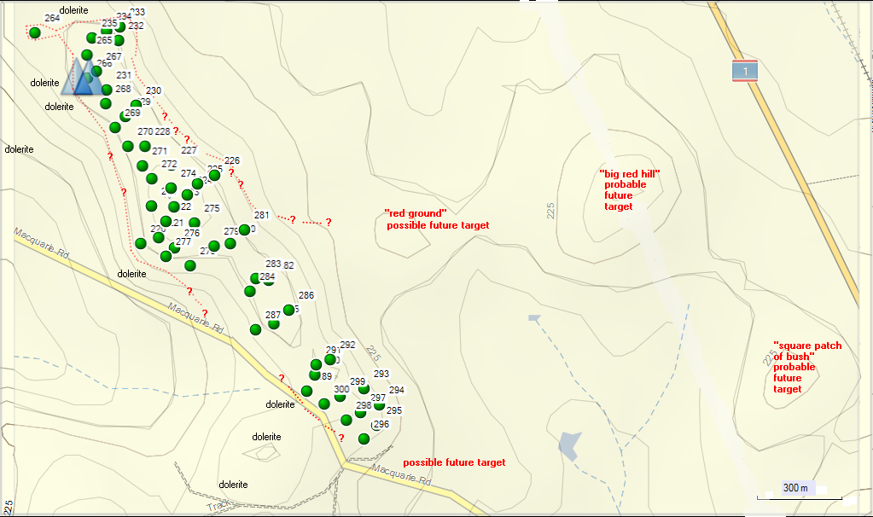
Base Camp Map - South Part (northern, central and southern sector of Meadowbank) – map produced by merging the 5m topo contour and the Topo Australia v2 maps
- dotted red outline: probable or possible extent of bauxite (bauxite outcrops and abundant rubble was observed in red soil throughout the target so that high parts of terrain are probably comprised of bauxite that was erosion resistant – similar to classic bauxite exposure under the water reservoir in Campbell Town)
- proposed drill sites for 1st stage shown as green spots (sites surveyed by me on 5 Oct 2010) - NB: all sites still need to be surveyed by Phillip Milner
- probable and possible future targets: the probable and possible targets to the SE of proposed drill sites have not been traversed as yet but from distance one can observe red soil and boulders of what may be bauxite; if results of drilling in 1st stage are encouraging, the the probable and the possible target can be drill tested in 2nd stage.
MAP 1: Proposed drill sites on the “Meadowbank” property at Campbelltown.

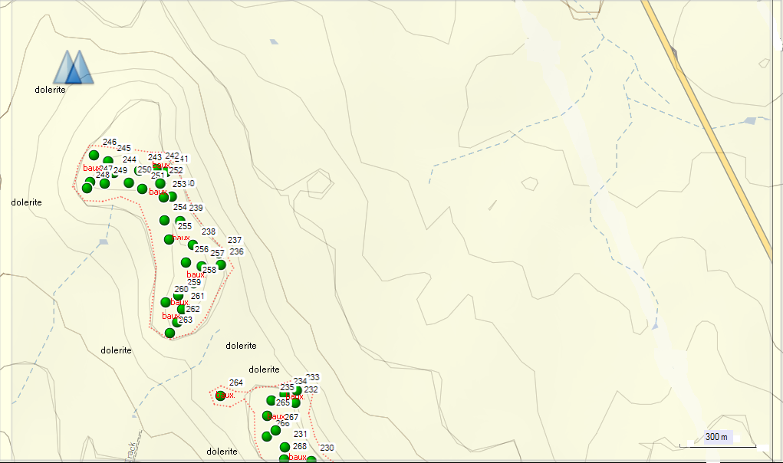

Base Camp Map - North Part ( Rosedale and northern sector of Meadowbank) – map produced by merging the 5m topo contour and the Topo Australia v2 maps
- dotted red outline: probable or possible extent of bauxite (bauxite outcrops and abundant rubble was observed in red soil throughout the target so that high parts of terrain are probably comprised of bauxite that was erosion resistant – similar to classic bauxite exposure under the water reservoir in Campbell Town)
- proposed drill sites for 1st stage shown as green spots (sites surveyed by me on 5 Oct 2010)
MAP 2: Proposed Drill Sites northern end of “Meadowbank” property Campbelltown and “Rosedale” as a future
stage.

MAP 3: Exploration License Area with target area immediately west of Campbelltown

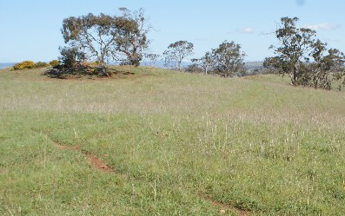
PHOTO 1 ………. Crest of hill with remnant vegetation and Gorse in background.

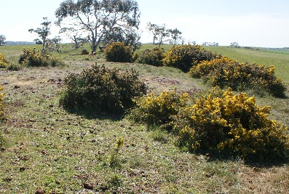

PHOTO 2 ……. Crest of hill in the vicinity of Drill Site 282, with remnant grassland and Gorse

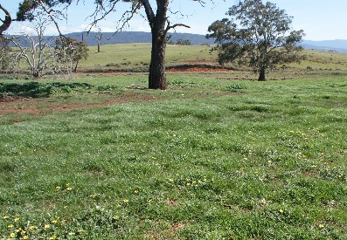

PHOTO 3 ……… Improved pasture and remnant Eucalypts.

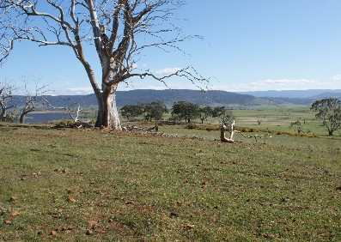

PHOTO 4… “Improved pasture” dead standing tree and dolerite outcrop with Gorse in background

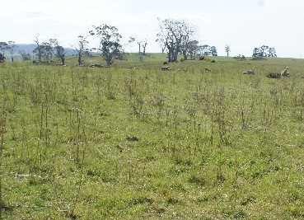

PHOTO 4 . Improved pasture with dead stems of the weed Wild Mignonette and remnant Eucalypts
in background

