MEADOWBANK TARGET AREAS, CAMPBELLTOWN for ABX4
FLORA & FAUNA HABITAT SURVEY
REPORT SUMMARY
18th March 2013

A summary of the flora and fauna habitat survey of the target areas on the “Meadowbank” property near Campbelltown undertaken on the 7th March 2013 is as follows.
This summary report should cross-referenced with the Google earth images attached.
A previous survey in a portion of the area was undertaken in October 2010 and the report is dated the 20th of that month. This summary should be read in conjunction with that report.

SURVEY AREA 1: South of Macquarie Road and north of the Elizabeth River about 2 km west of Campbelltown, A large farm dam is located to the immediate west of the target area. Study Area Grid Reference Point: 537873E – 5359970N.
The area consisted of undulating paddocks with the hilltops maintained as native pasture and most of the slopes and swales consisted of stubble from a cultivated but un-irrigated cereal crop.
The native pasture and cropped areas are relatively well defined on the attached Google earth image.
There were some remnant Eucalypts present as individuals and small groups across the survey area.

SURVEY AREA 2: Located to the north of the previous survey area and to the north of Macquarie Road. Study Area GRID REF: 537500E – 5361600N.
This target area also consisted of undulating paddocks consisting mainly of native pasture although the surrounding less undulating paddocks were under cultivation with previously irrigated crops. These areas are also well defined on the attached Google earth image.

VEGETATION COMMUNITIES:
The native pasture in both locations has been heavily grazed by sheep and conditions at the time of the survey were exceedingly dry. Little green material was present in the ground layer vegetation at the time.Where remnant trees remain the vegetation is mapped by TasVeg as being Midlands Woodland Complex (DMW) a grassy woodland community which is now severely depleted throughout most of the Tasmanian midlands. The grassland communities were mapped on TasVeg as being Lowland Grassland Complex (GCL), Lowland Themeda (Kangaroo Grass) Grassland (GTL) and as Lowland Poa labillardierei Grassland (GPL). The first two grassland communities were difficult to distinguish given the current site conditions but the community was considered to be mainly Lowland Grassland Complex on the hill-tops and upper slopes which had not been previously cultivated. The Poa tussock grassland however, was evident, mainly along the uncultivated swales and nearby creek-lines.

THREATENED VEGETATION COMMUNITIES: One vegetation community listed as threatened under the Tasmanian Nature Conservation Act 2002 was present in the areas surveyed.
- Midlands Woodland Complex (DMW) occurred where remnant Eucalypts were present as scattered individuals or groups although the ground layer grassy vegetation surrounding these trees had been heavily impacted by grazing and by the current dry conditions. The proposed drilling program will not impact on any remnant trees and will have limited impact on the ground layer vegetation.

THREATENED FLORA: No species of flora listed under the Tasmanian Threatened Species Protection Act 1995 or the Commonwealth Environment Protection & Biodiversity Conservation Act 1999 were observed during the survey.
Two species of threatened flora are recorded on the Natural Values Atlas database from this survey area but were not observed during the field survey of the target locations.
- Scleranthus fasciculatus the Spreading Knawel is listed as being vulnerable under the Tasmanian Act. There is one 1994 record from along Macquarie Road.
- Xerochrysum bicolor the East Coast Everlasting is listed as being rare under the Tasmanian Act. There is one 1984 record from along Macquarie Road.

THREATENED FAUNA: No species of threatened fauna was observed during the survey and no evidence of the presence of threatened species such as scats of Tasmanian Devil Sarcophilus harrisii or Spotted-tailed Quoll Dasyurus maculatus, or diggings of Eastern-barred Bandicoot Parameles gunnii were observed.
The Spotted-tailed Quoll, Tasmanian Devil and the Eastern-barred Bandicoot have all been recorded on the Natural Values Atlas database in the past from within 5,000 metres of the survey area reference point.
The Natural Values Atlas database lists the Tussock Skink Pseudomoia pagenstecheri, Green and Golden Frog Litoria raniformis and the Green-lined Beetle Catadromus lacordairei as having potential to occur in the locality, however no potential habitat for each of these species will be impacted by the proposed drilling program.
There are no recorded raptor nest trees including the Wedge-tailed Eagle Aquila audax subsp fleayi within 5,000 metres of the locality.

THREATENED FAUNA HABITAT: No specific threatened fauna habitat was observed in either of the two survey areas however some of the remnant paddock trees possessed hollows and these would provide potential fauna habitat including for some threatened species. No mature tree however will be directly impacted by the proposed exploration program so there will be no threat to any such potential habitat.
The heavy grazing of the paddocks would limit the availability of suitable grassy and ground layer habitat for any of the threatened species with potential to occur in the locality. No wetlands or creek-lines are included within the proposed drilling target areas.

ENVIRONMENTAL WEEDS: Gorse Ulex europeus is widespread in the uncultivated parts of the two areas with some large patches adjacent to survey area 2. Proposed drill sites in the vicinity of Gorse patches should be drilled last in order to prevent the spread of soil borne seed into weed free areas.
Horehound Marrubium vulgare was also observed during the survey however it is a common weed throughout the midlands.

CONCLUSIONS: Native grasslands are adapted to localized disturbances and the remnant grasslands within the survey areas have been heavily impacted by recent sheep grazing. The proposed drilling program will have very limited additional impact on the remnant native grasslands in the location.
The proposed drilling program will not impact on any remnant trees and will therefore have minimal if any impact on the threatened vegetation community, Midlands Woodland Complex (DMW). No threatened species of flora were observed during the survey however the grazing pressure and very dry conditions would have precluded any such species being visible or identifiable. The drilling program as proposed is unlikely to impact on any threatened species of flora, however if a more intensive drilling program is required in the future or a mining lease is to be applied for then a more detailed survey would be desirable during the main spring to early summer flowering season when most plants would be evident.
No threatened species of fauna were observed and no potential habitat for any of the threatened species known from the area or with potential to occur was observed within the two survey areas.
Gorse is a serious weed in the midlands and precautions will need to be taken when drilling in the vicinity of infestations in order to avoid spreading the weed by way of soil borne seed.

RECOMMENDATIONS:
- Undertake the drilling of sites in the vicinity of Gorse infestations last in the program in order to avoid spreading soil infested with seeds of the weed.
- Drill no closer than the drip line of any remnant trees in order to limit any impacts on tree roots and the threatened vegetation community Midlands Woodland Complex.
- A follow-up vegetation survey would be desirable should a more intensive exploration drilling program be considered and if an application for a mining lease is intended in the future. This follow-up survey should be undertaken in spring or early summer when most ground layer species are evident or in flower.

Philip Milner
Vegetation Consultant

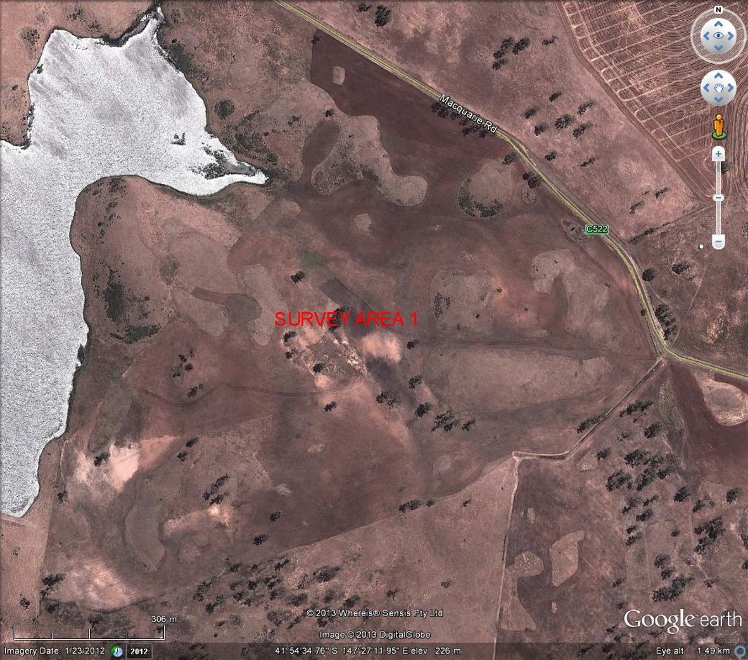

MAP No.1: Google earth image of Survey Area No.1. “Meadowbank” Campbelltown.

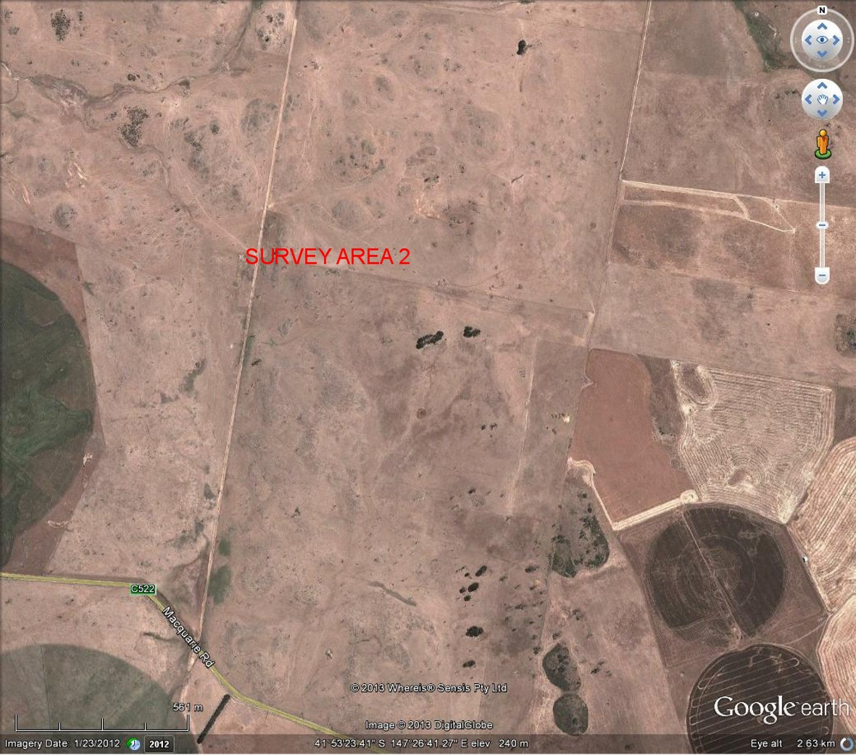

MAP No.2: Google earth image of Survey Area No.2. “Meadowbank” Campbelltown.

PHILIP MILNER LANDSCAPE CONSULTANT PTY LTD
144 Allisons Road, LOWER BARRINGTON
POSTAL: C/O Post Office, BARRINGTON
TASMANIA, 7306
Phone: (03) 6492 3201
Mobile: 0417 052 605
Email: philip.milner@bigpond.com ABN No. 32 068 906 258

