
Teale & Associates Pty Ltd
TA15-11

A Petrological and Mineragraphic Investigation of

Samples from Drill-holes ZS112, ZS113W and ZS120

Severn Deposit, Zeehan, Tasmania

PRELIMINARY ONLY

Graham S. Teale
May 2015

Copies: P. Blight
R. Hazeldene

Petrological Descriptions

Sample Number: ZS112 - 408.9m

Sample Locality: Severn Ore body, Zeehan

Rock Type: Tourmaline rich, Sn “lode”; tourmaline-quartz-pyrite-topaz-siderite-cassiterite-fluorite-unknown

Sample Description:

The sample exhibits a fabric with earlier developed chlorite replaced by later tourmaline. Cross-cutting carbonate-quartz veins post date alteration but do contain trace cassiterite. Coarser grained, “patchy” quartz + pyrite ± ?topaz are also present.

A visual estimate of the minerals present is:

Tourmaline ~31% Topaz ~ 5%
Pyrite ~15% Fluorite ~ 3%
Siderite ~12% Pyrrhotite ~ 2%
Vein carbonate ~12% Cassiterite ~ 1%
Quartz ~11% Rutile ~ 1%
Unknown ~ 6% Chalcopyrite trace

Cassiterite tends to be coarse grained (up to 0.5mm) and is located within tourmaline-rich domains. The cassiterite contains abundant acicular inclusions of tourmaline and can be intergrown with rutile. Cassiterite can also be located as inclusions in pyrite and is also present as “accidental” inclusions in some carbonate veins. Coarse grains are also found within quartz which develop as lenticular aggregates throughout tourmaline.
Tourmaline averages 40µ in length and is a yellow colour. It develops as a fine grained mesh-textured, almost monomineralic, aggregate often intergrown with siderite and quartz. Coarser grained material is also found as inclusions in a high relief unknown mineral and as inclusions in ?topaz. Minor fluorite can be found throughout the sample and usually contains tourmaline inclusions.
Pyrite is the dominant sulphide and idioblastic grains can be up to 1mm in size. It contains inclusions of quartz, tourmaline and rare cassiterite and pyrrhotite. Pyrite often encloses quartz-rich domains separating tourmaline plus siderite from the quartz. Pyrrhotite, along with chalcopyrite, is usually found as inclusions in siderite, quartz and possible topaz. Grains average 30µ in diameter. Siderite occurs as lenticular domains which follow the former fabric and as patchy aggregates associated with quartz rich areas.

Cross-cutting carbonate rich veins are sub-horizontal and are composed of carbonate and quartz.

Plate 1

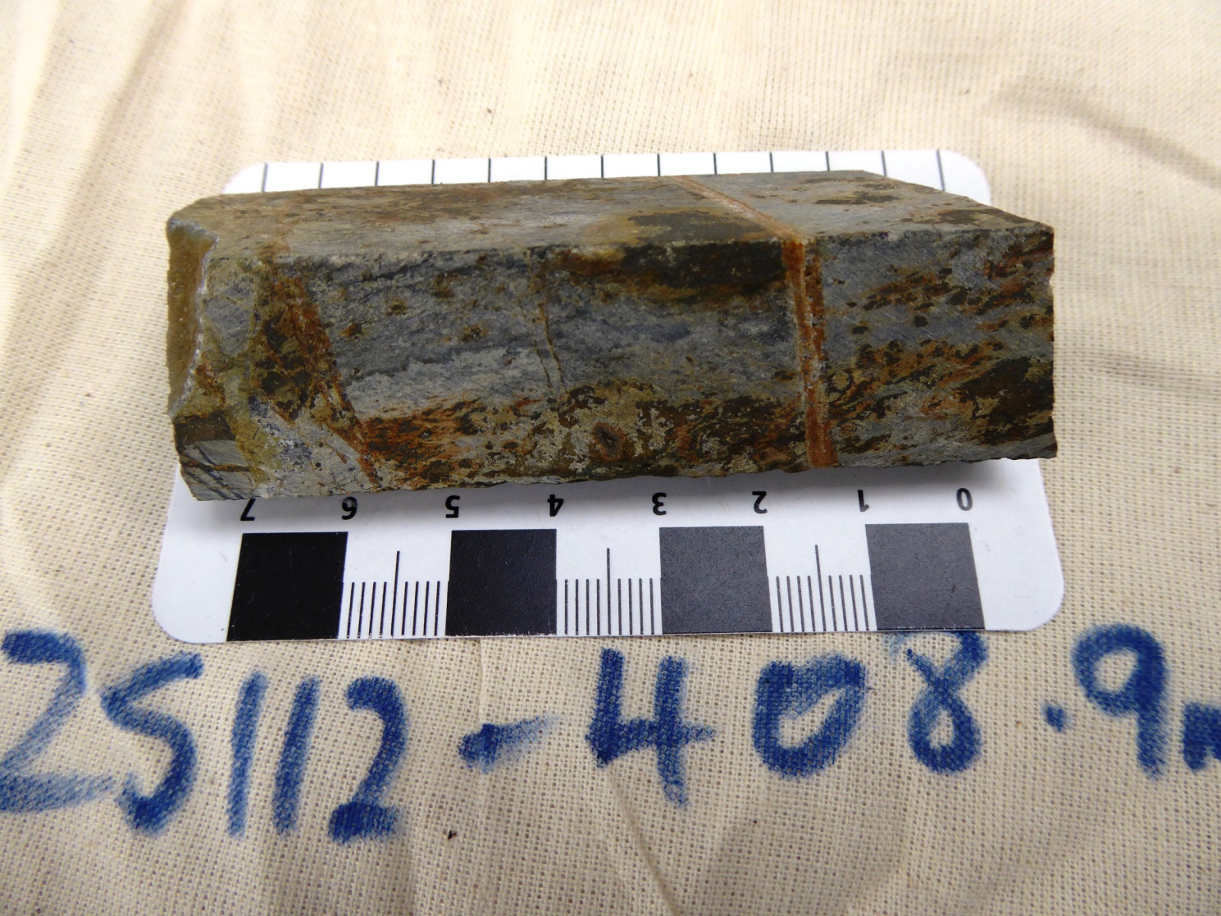

Sample ZS112 - 408.9m

The slab photograph shows a tourmaline-rich tin lode which contains abundant topaz, and tourmaline. Shallow dipping structures can be observed.

Plate 2

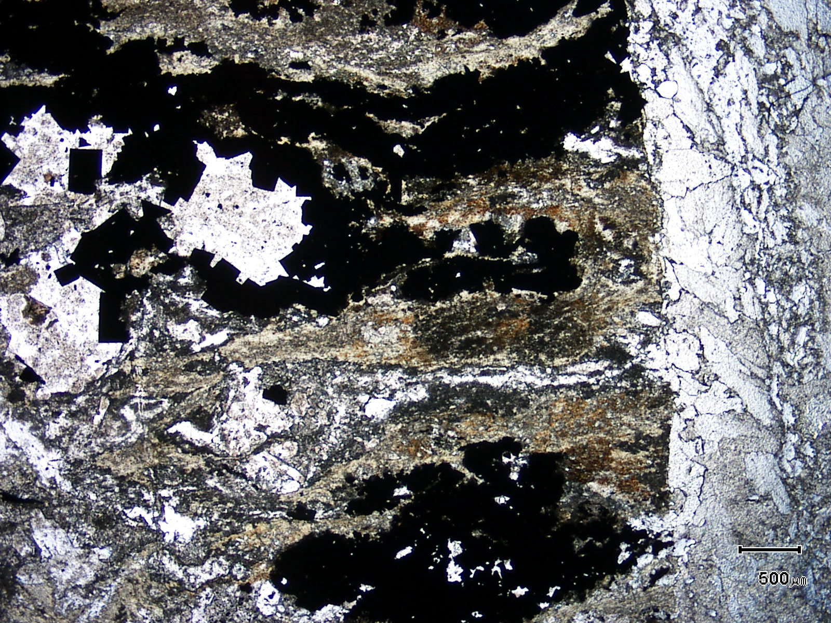
(Mag. x 20; scale bar = 500µ; PPL)

Sample ZS112 - 408.9m

The photomicrograph shows a general textural view of this sample. It contains ~17% pyrite + pyrrhotite as well as significant cassiterite. The cassiterite tends to develop within tourmaline-rich domains and contains abundant acicular inclusions. Note the cross-cutting carbonate-quartz vein.

Plate 3

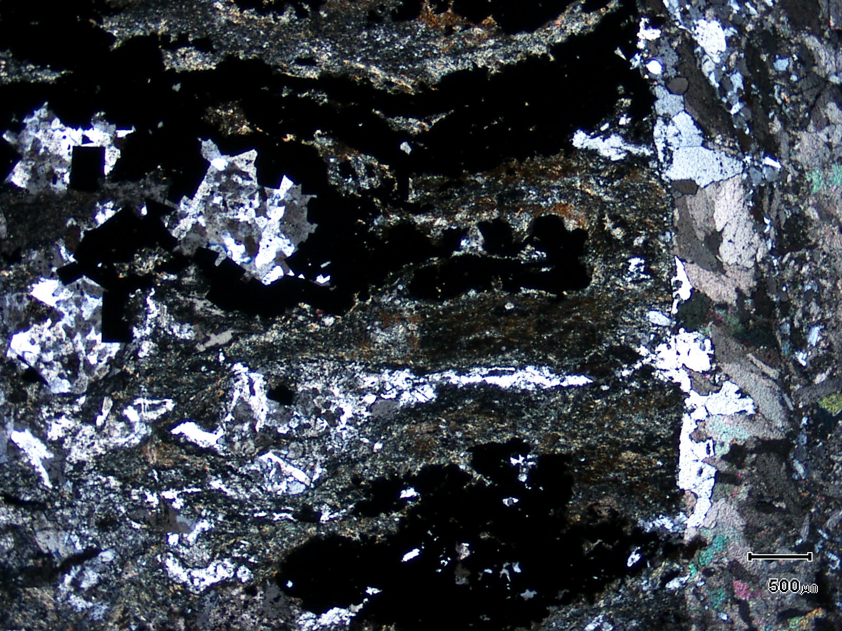
quartz
(Mag. x 20; scale bar = 500µ; crossed nicols)

Sample ZS112 - 408.9m

The photomicrograph shows a cross nicols view of Plate 2. Note the replacive quartz.

Plate 4

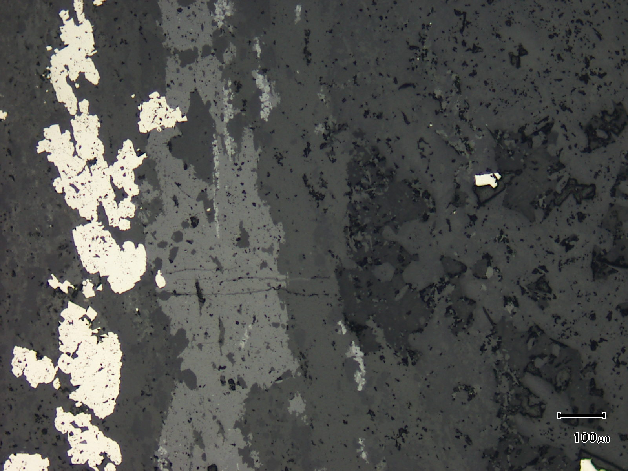
cassiterite
(Mag. x 100; scale bar = 100µ; reflected light)

Sample ZS112 - 408.9m

The reflected light photomicrograph shows an elongate accumulation of cassiterite. The white is pyrite.

Plate 5

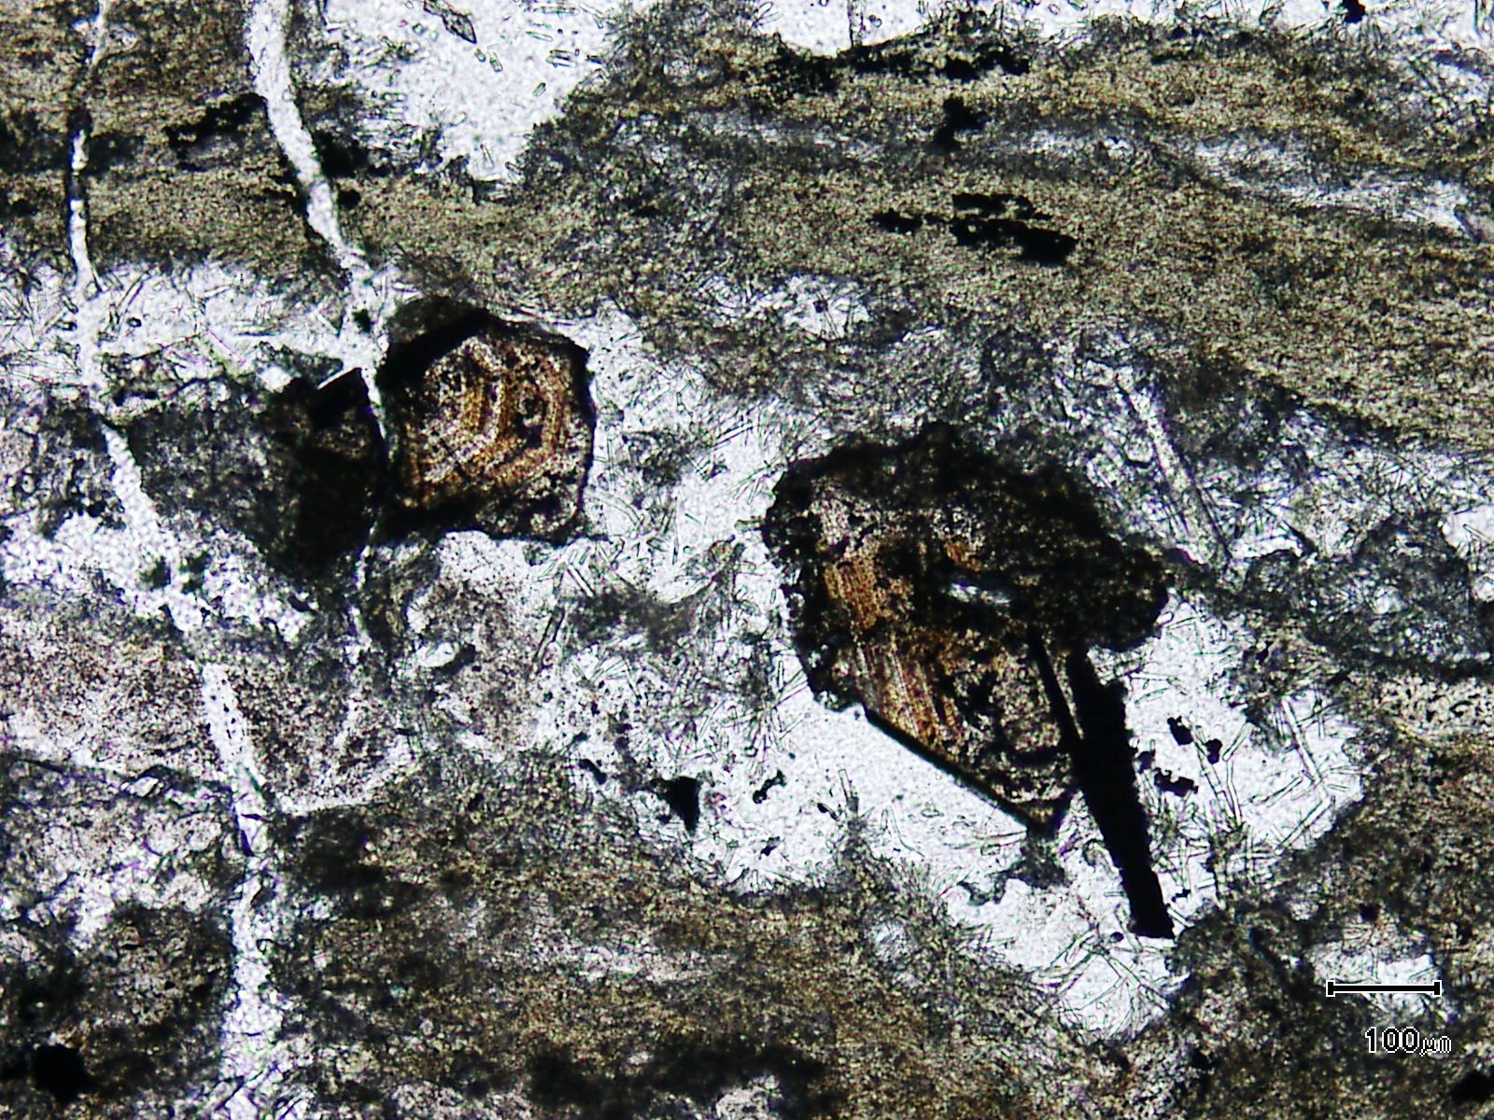
(Mag. x 100; scale bar = 100µ; PPL)

Sample ZS112 - 408.9m

Here, coarse grained, zoned cassiterite is associated with quartz and acicular tourmaline. Note the abundance of light green tourmaline in the top of the photomicrograph. It develops as a felted aggregate.

Plate 6

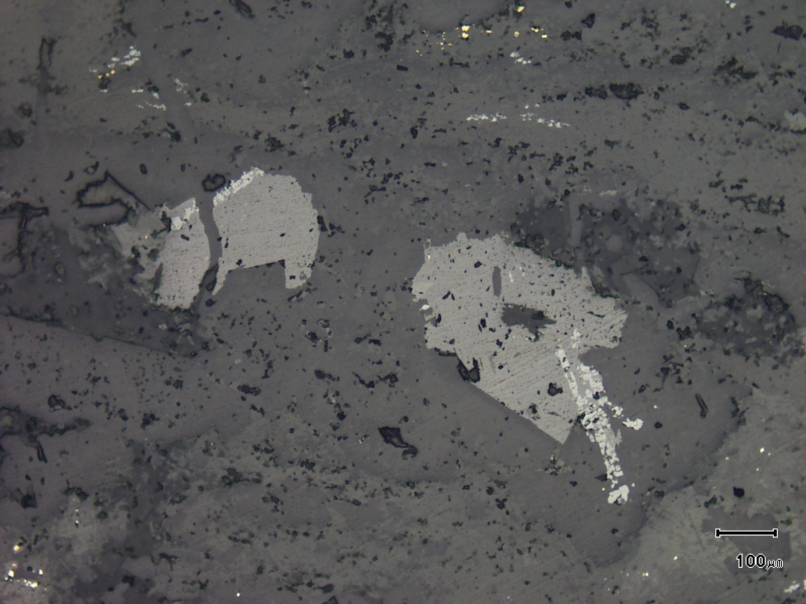
rutile
cassiterite
(Mag. x 100; scale bar = 100µ; reflected light)

Sample ZS112 - 408.9m

The photomicrograph shows a reflected light view of Plate 5. Note the elongate aggregate of rutile which may be replacing a former ilmenite grain in either a mafic volcanic or volcaniclastic.

Plate 7

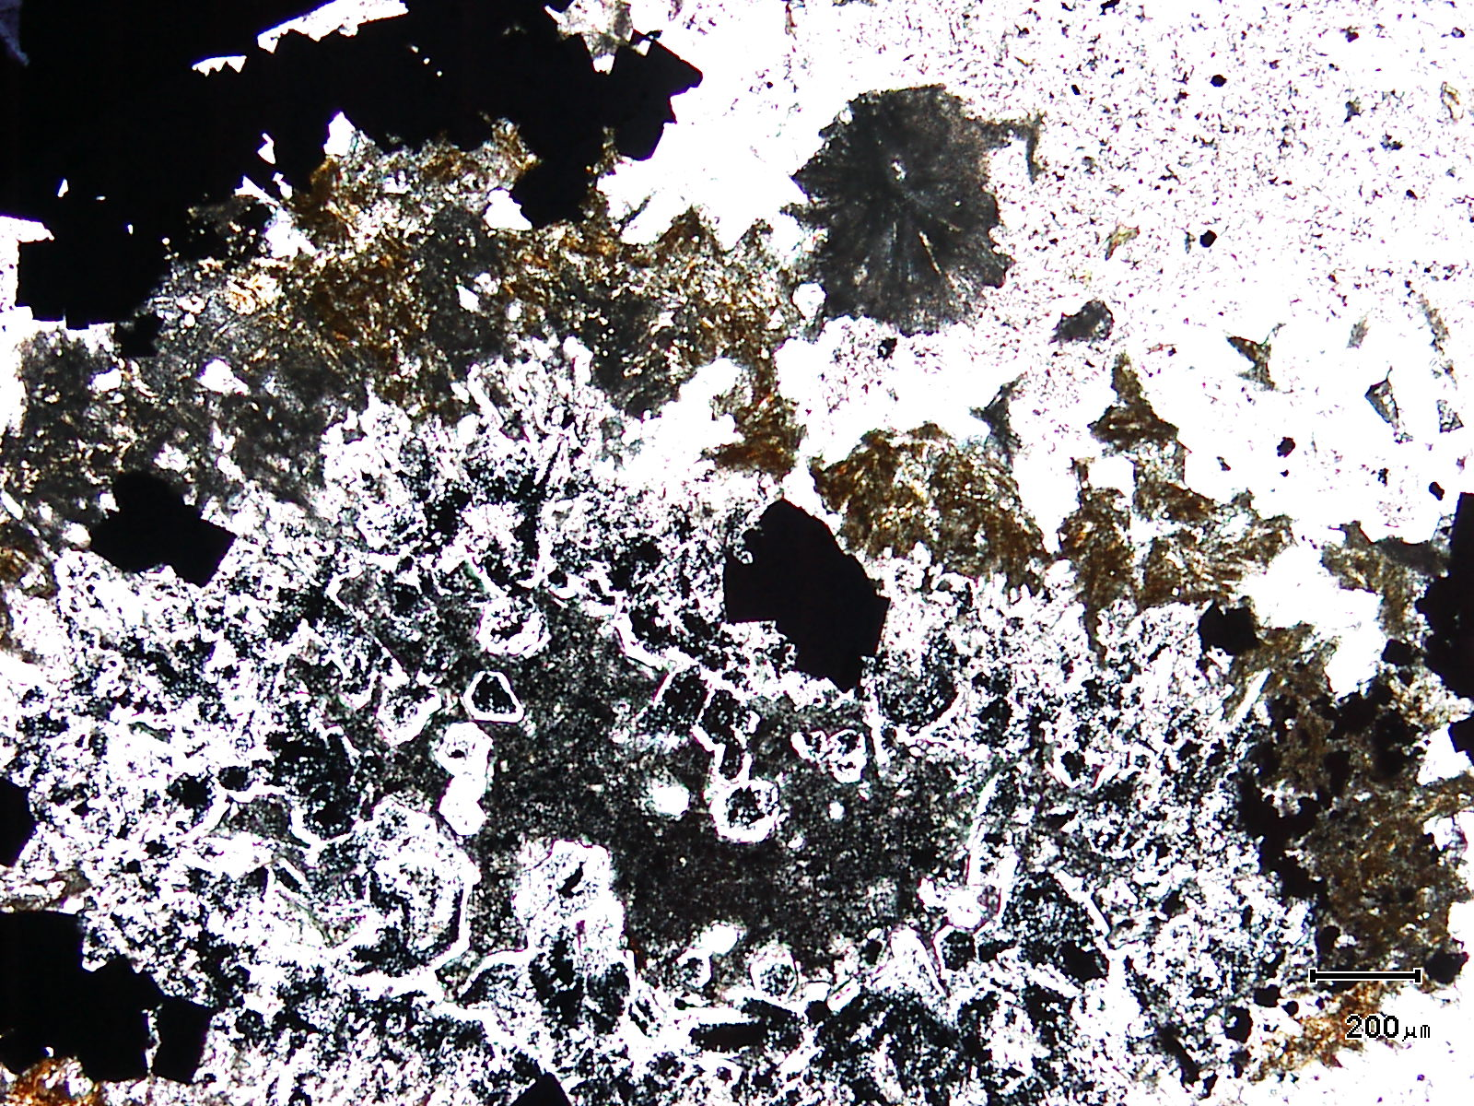
(Mag. x 50; scale bar = 200µ; PPL)

Sample ZS112 - 408.9m

This photomicrograph shows an unusual aggregate of idioblastic quartz and probable pyrobitumen (black).

Plate 8

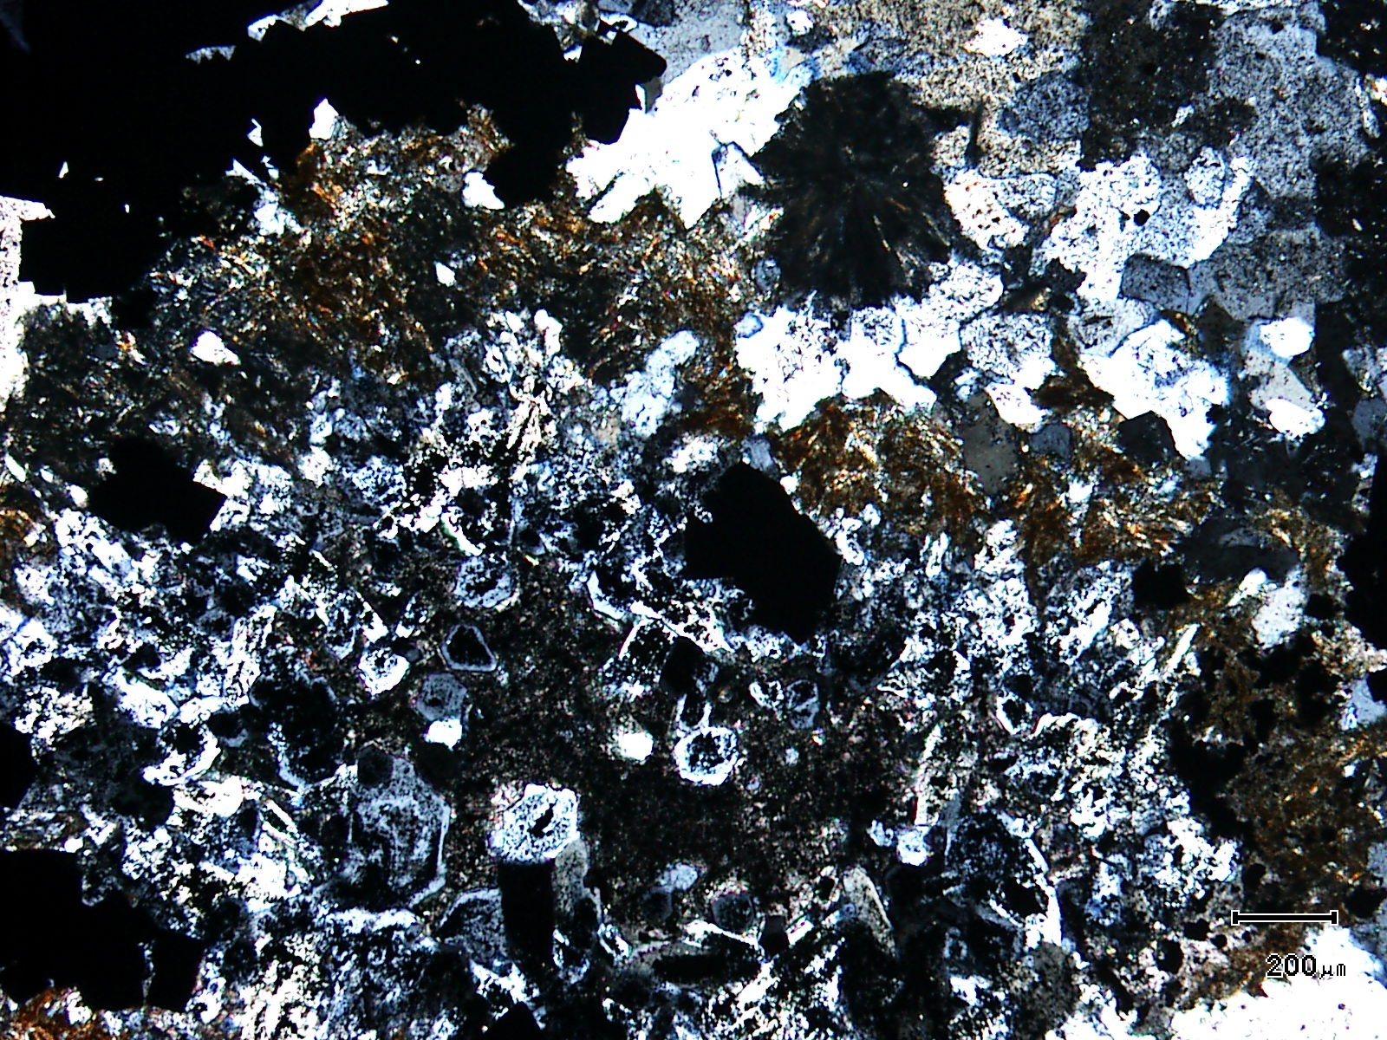
(Mag. x 50; scale bar = 200µ; crossed nicols)

Sample ZS112 - 408.9m

The photomicrograph shows a cross nicols view of Plate 7.

Plate 9

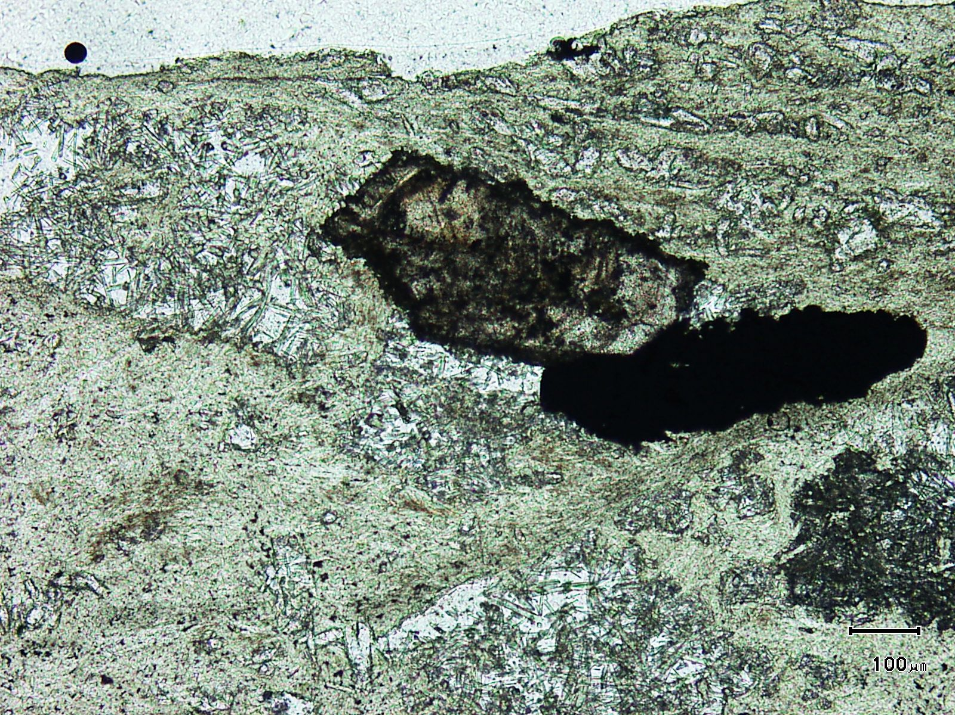
(Mag. x 100; scale bar = 100µ; PPL)

Sample ZS112 - 408.9m

This photomicrograph shows a large cassiterite grain associated with a large pyrite grain with both minerals sitting within a felted aggregate of pale green tourmaline + quartz.

Plate 10

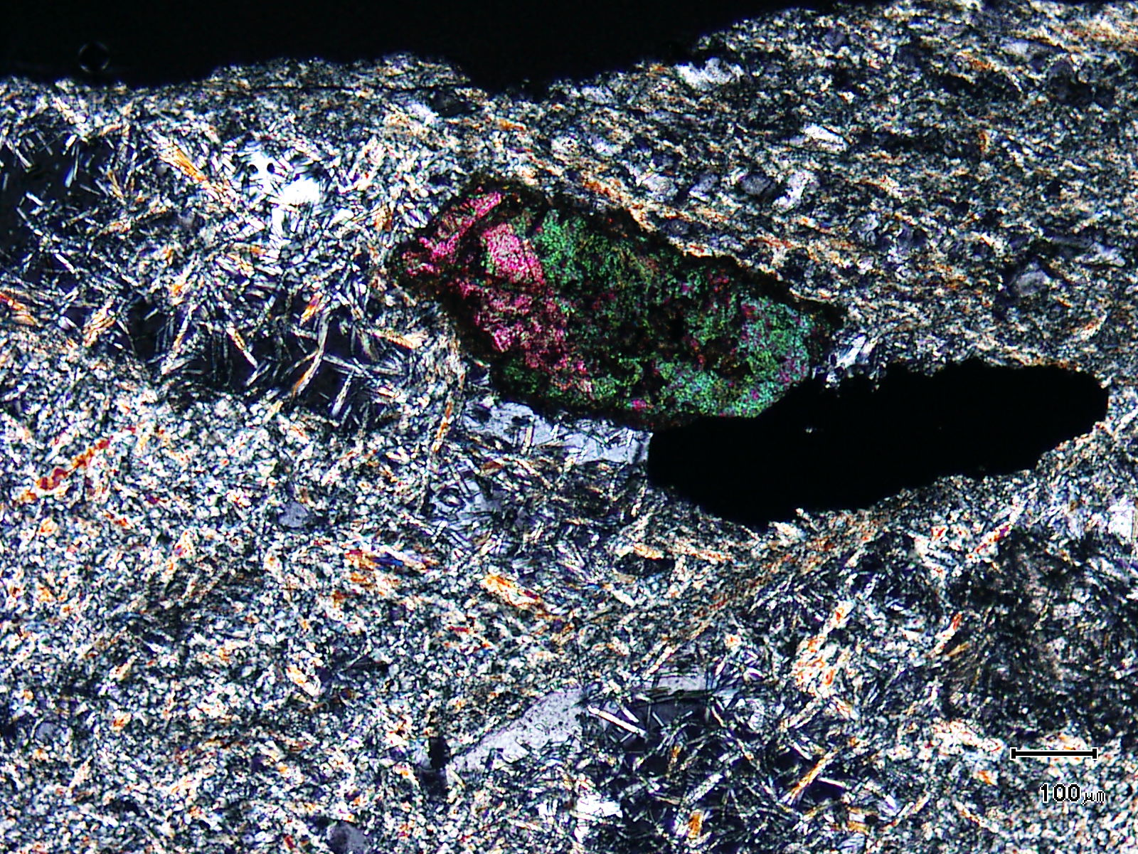
(Mag. x 100; scale bar = 100µ; crossed nicols)

Sample ZS112 - 408.9m

The photomicrograph shows a cross nicols view of Plate 9. Note the mesh-like nature of the tourmaline which exhibits no fabric.

Sample Number: ZS113W - 257.5m

Sample Locality: Severn Ore body, Zeehan

Rock Type: Pyritic, veined, carbonaceous meta-pelite

Sample Description:

The sample is rich in carbonaceous matter and exhibits a fabric that is sub-parallel to slightly siltier beds and bands. Idioblastic pyrite is associated with a colourless, possibly Mg-rich chlorite which is post tectonic.

A visual estimate of the minerals present is:

Quartz ~22%
Carbonaceous matter ~20%
Altered feldspars ~16%
Chlorite ~15%
Pyrite ~13%
“Sericite” ~ 6%
Anatase ~ 4%
Hydrated iron oxides ~ 2%
Detrital micas ~ 2%
(Probable illite or other clays may be present in groundmass.)

The meta-pelite is fine grained (<20µ) with detrital quartz between 30-40µ in diameter. The general groundmass is dominated by carbonaceous matter, quartz, altered ?feldspars, sericite and chlorite. Detrital micas tend to occur in the “siltier” bands. These bands contain detrital grains of quartz and altered ?feldspars which can be up to 80µ in size. They sit within a groundmass similar to the meta-pelite.
Pyrite grains range in size up to 0.35mm. Grains are idioblastic and contain ultra-fine grained inclusions. Anatase inclusions are common and the sample is rich in disseminated anatase. Pyrite often develops within chlorite which can be up to 0.25mm in length. The chlorite is randomly oriented and has not been affected by any deformation. Possible oxidised siderite veins also cut the sample.
Graphite can be observed within the oxidised siderite veins with no graphite (only carbonaceous matter) in the groundmass.

Plate 11

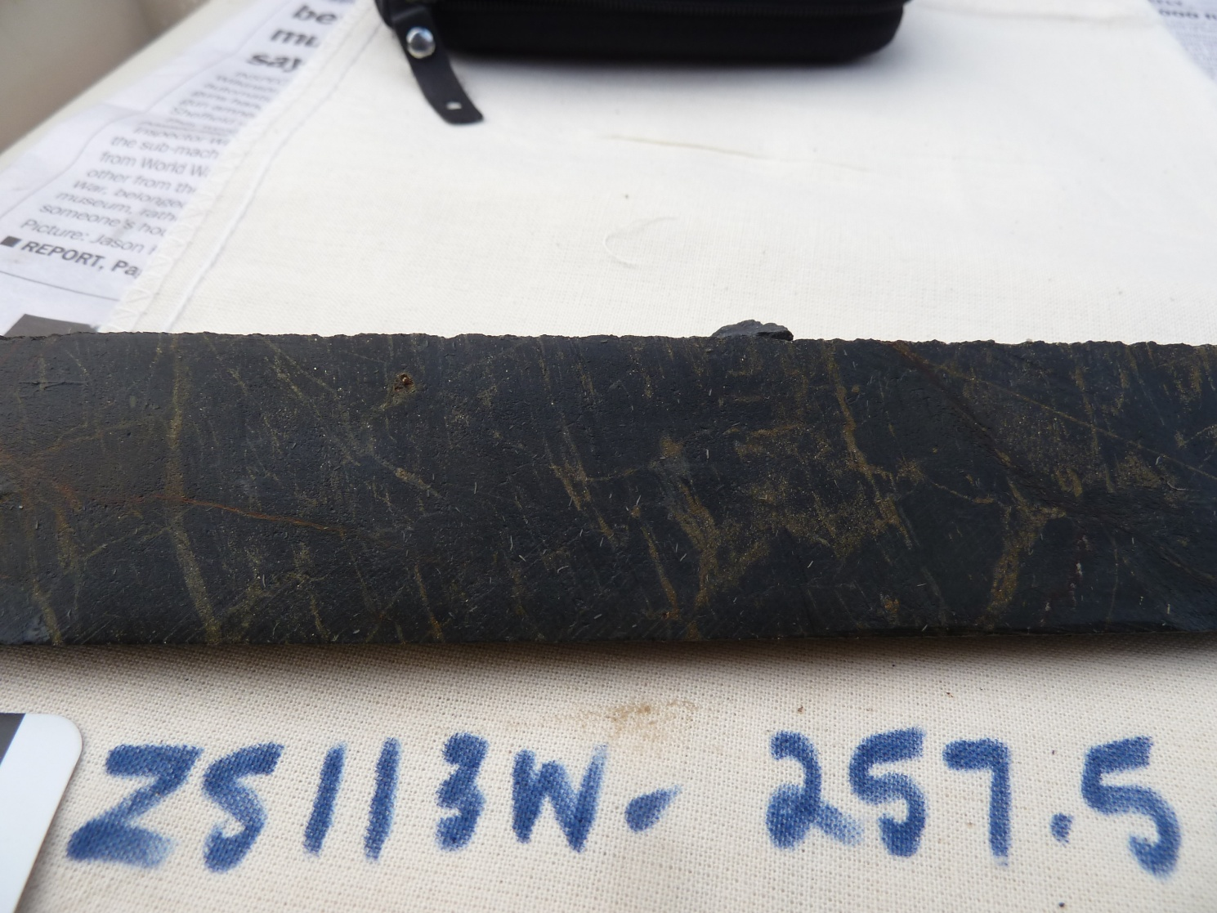

Sample ZS113W - 257.5m

The slab photograph shows a strongly carbonaceous meta-pelite which contains abundant chlorite and sericite and a high concentration (~ 4%) of anatase.

Plate 12

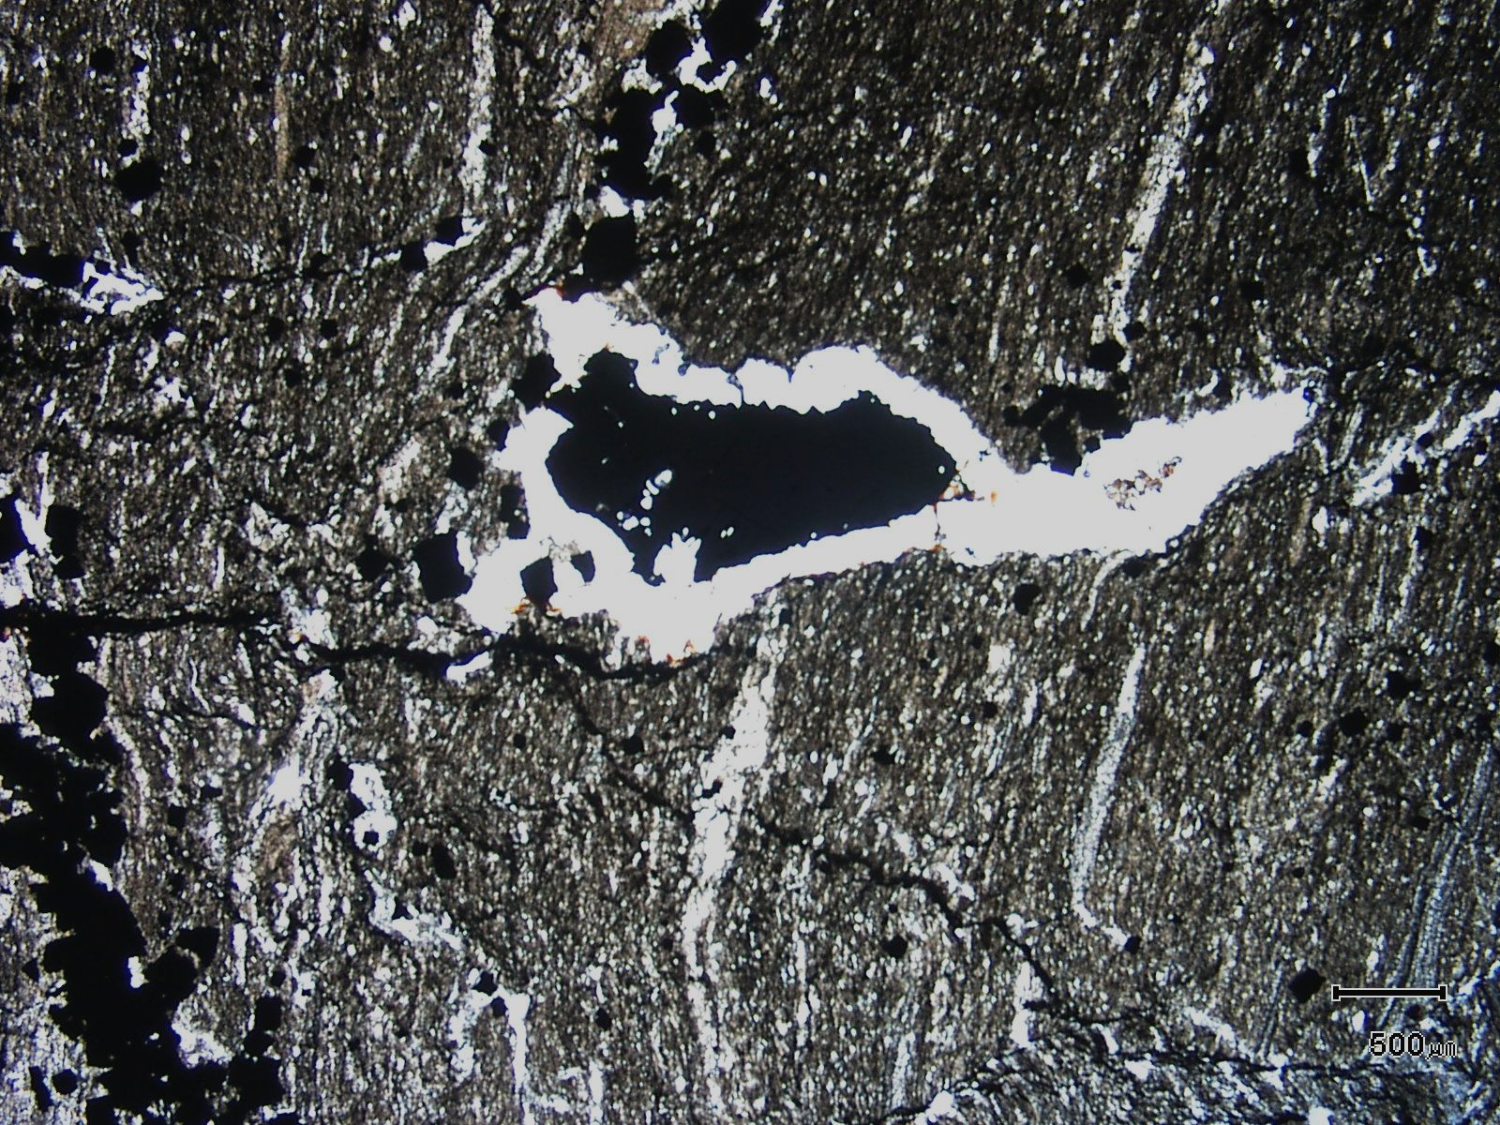
(Mag. x 20; scale bar = 500µ; PPL)

Sample ZS113W - 257.5m

The photomicrograph shows a general textural view of this sample which exhibits a relatively strong fabric. Note the unusual pyrite-chlorite vein.

Plate 13

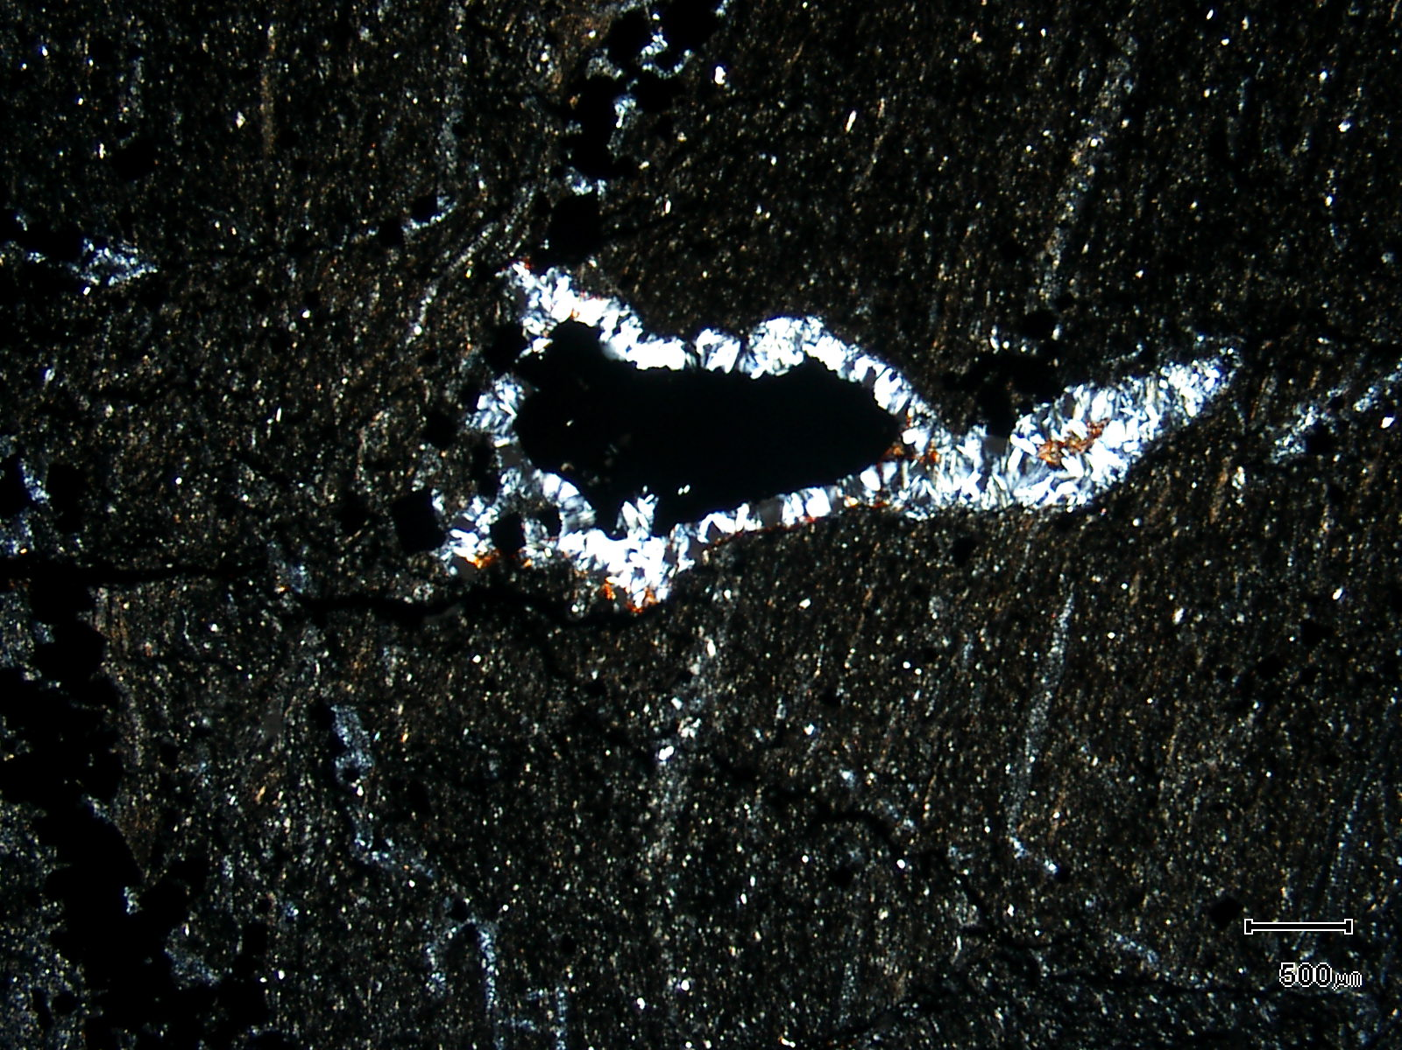
(Mag. x 20; scale bar = 500µ; crossed nicols)

Sample ZS113W - 257.5m

The photomicrograph shows a cross nicols view of Plate 12.

Sample Number: ZS113W - 258.0m

Sample Locality: Severn Ore body, Zeehan

Rock Type: Strongly veined, pyritic, weakly carbonaceous meta-pelite

Sample Description:

The meta-pelite bands in this sample are similar to those in the previous sample. The meta-pelite is less carbonaceous but is extensively networked with a variety of veins. The coarser grained lapilli tuff band is inundated with replacive silica and pyrite (see slab photograph, Plate 14). The tuff averages 1mm in size with these clasts (and lapilli) sitting within a carbonaceous, finer grained groundmass. Lapilli as well as clasts of devitrified volcanic glass, air-fall tuff fragments, quartz and various tuff clasts are present. Pyrite has been introduced into the coarser grained tuff bands with only minor pyrite located in the meta-pelite. Within the latter, the pyrite tends to be found within veins.

A visual estimate of the minerals present is:

Pyrite ~18% Vein goethite ~ 4%
Clasts ~18% Vein carbonate ~ 3%
Chlorite ~14% Rutile/anatase ~ 2%
Vein quartz ~14% Goethite ~ 2%
Quartz ~11% Chalcopyrite trace
Carbonaceous matter ~ 9% Pyrrhotite trace
“Sericite” ~ 4% Zircon trace

Pyrite grains can be up to 0.7mm in size and are idioblastic. Many grains have been shattered and brecciated. Quartz pressure shadows develop on many pyrite grains. Inclusions in pyrite are minor to significant with silicate inclusions and rutile common. Chalcopyrite and pyrrhotite are present as fine grains (~6µ) which tend to develop within fragments of devitrified volcanic glass. Throughout the sample pyrite is also found within veins. These veins are composed of quartz, siderite, rock fragments and goethite. Dilational positions along major veins contain “mini-breccias” which are pyritic. Open space domains can be infilled by colloform banded siderite + goethite. The breccias have a groundmass composed of fine grained chlorite. Quartz veins often exhibit breccias or shears along their margins and the vein quartz often exhibits undulose extinction and sub-grain development.

Chlorite, minor sericite and abundant carbonaceous matter are found in the general groundmass and rare acicular zircon grains (~0.1mm) are found in the tuff bands.

The introduction of pyrite and replacive silica into the more permeable tuff beds is a similar feature to that already described in other samples.

Plate 14

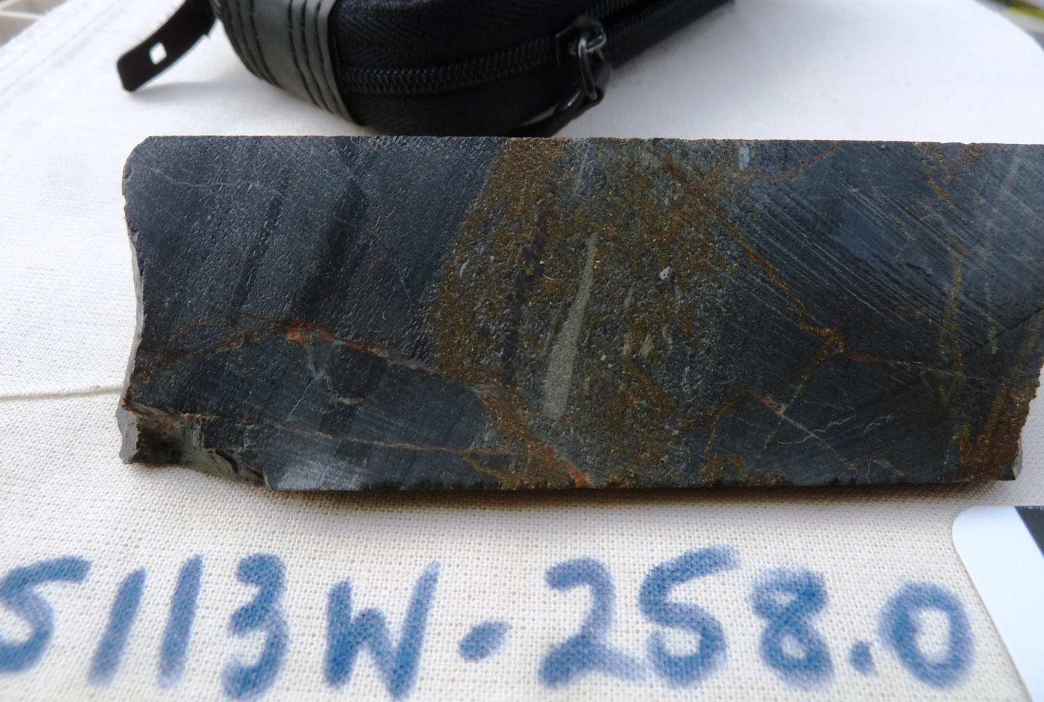

Sample ZS113W - 258.0m

The slab photograph shows a lapilli tuff bed sitting within carbonaceous pelites and silts. The tuff horizon contains not only abundant lapilli but also pyrite which has been emplaced along the more porous bed.

Plate 15

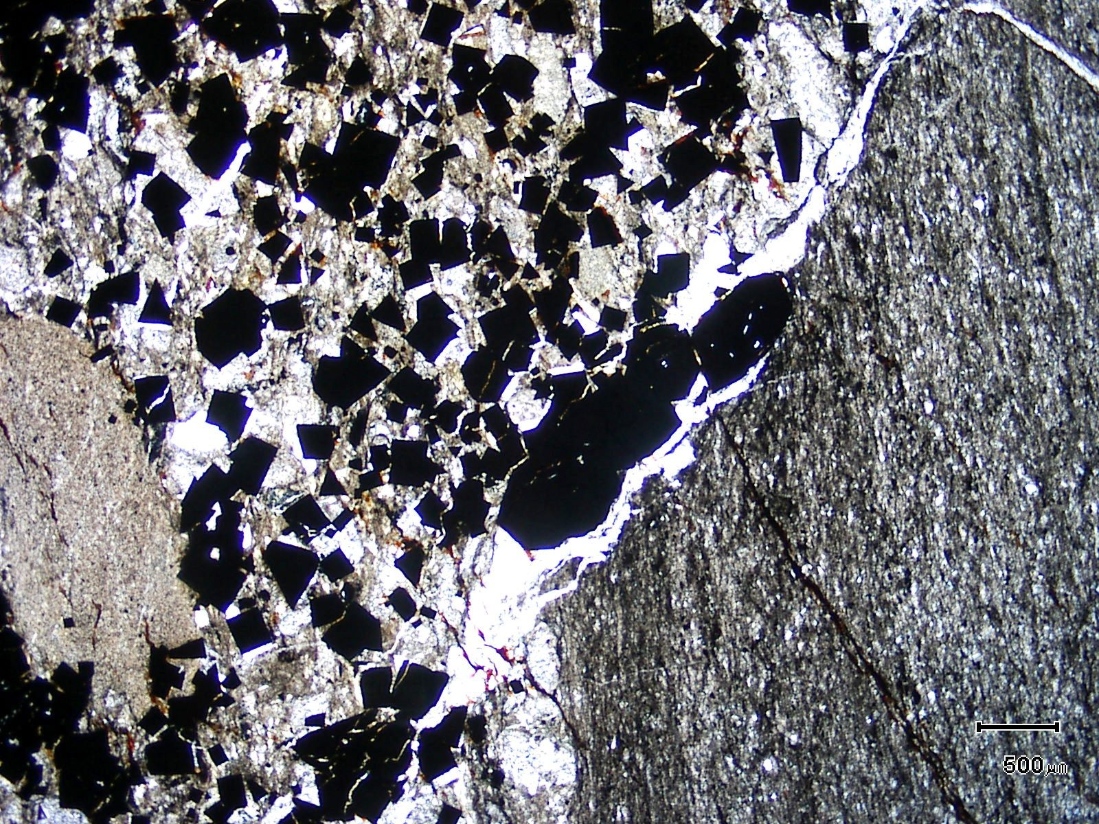
(Mag. x 20; scale bar = 500µ; PPL)

Sample ZS113W - 258.0m

The photomicrograph shows a general textural view of the tuff and adjacent meta-pelite.

Plate 16

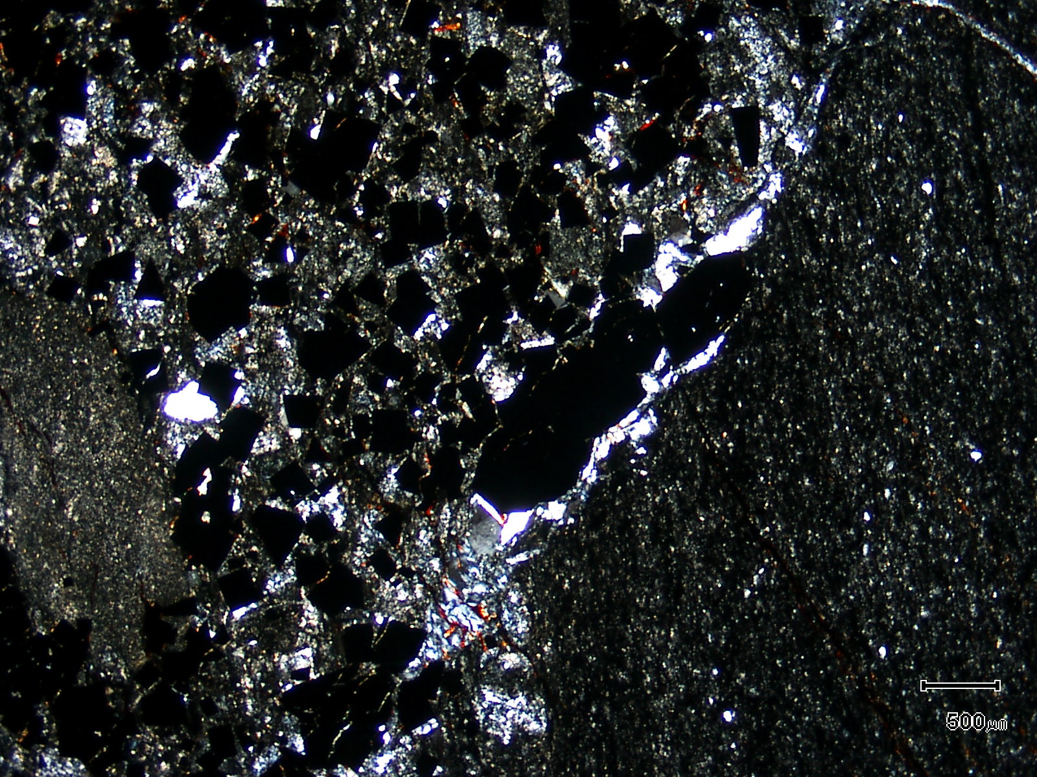
(Mag. x 20; scale bar = 500µ; crossed nicols)

Sample ZS113W - 258.0m

The photomicrograph shows a cross nicols view of Plate 15.

Plate 17

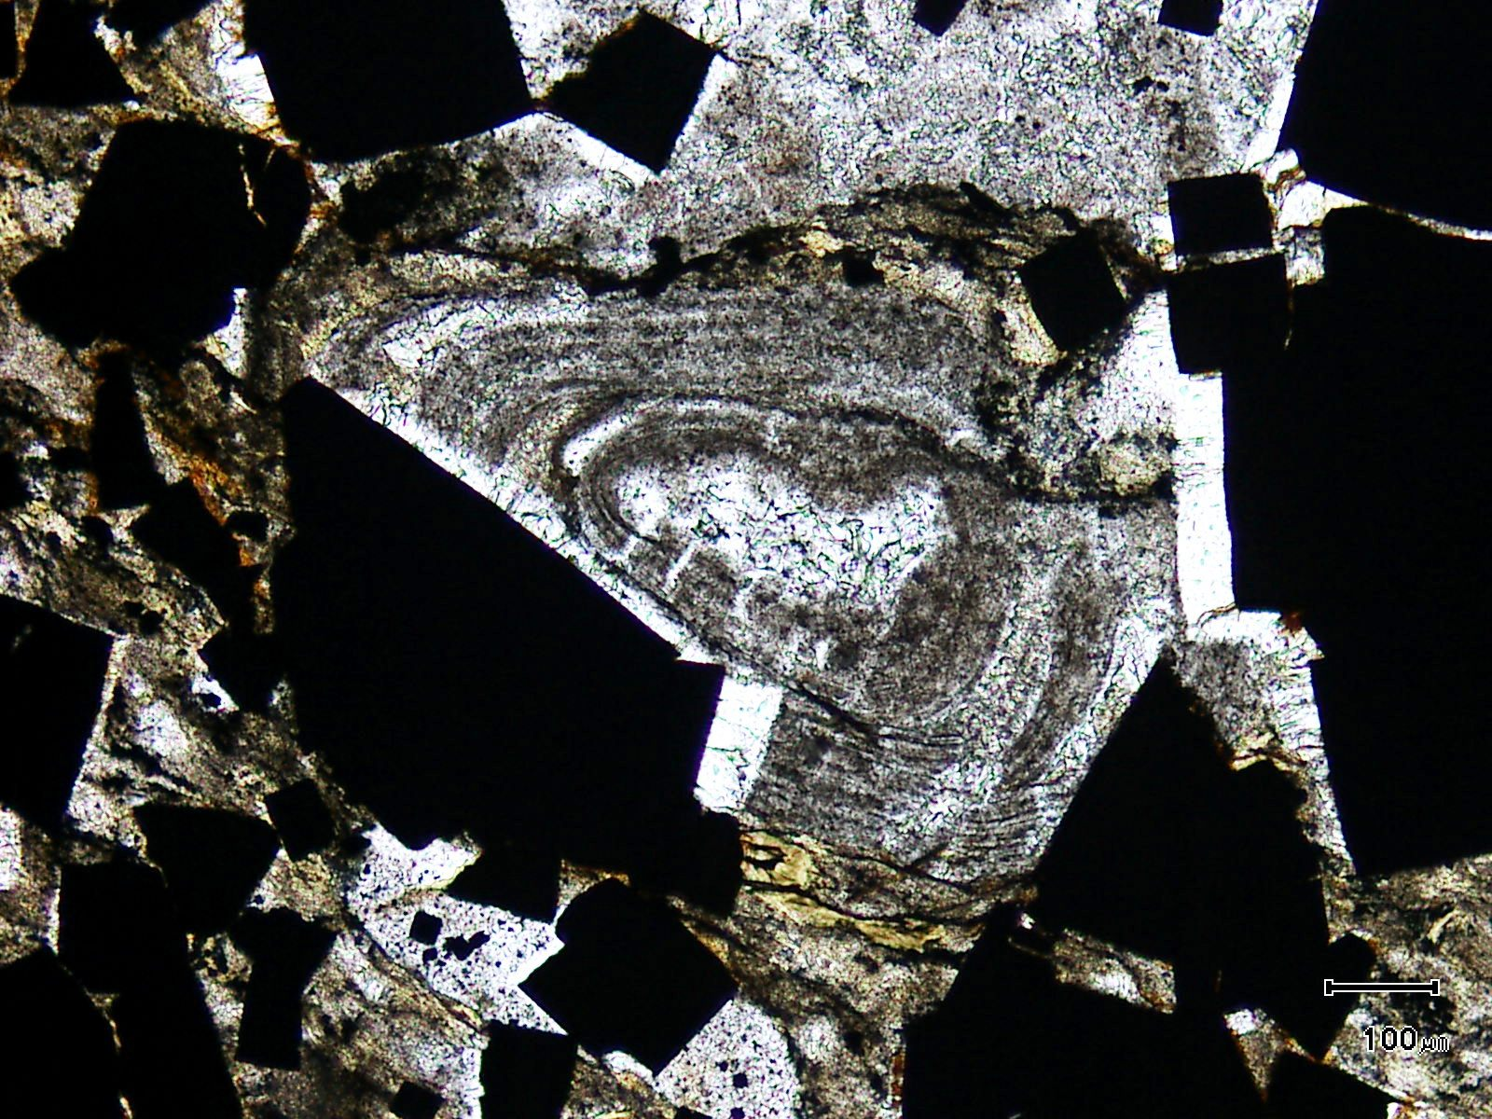
pressure shadows
(Mag. x 100; scale bar = 100µ; PPL)

Sample ZS113W - 258.0m

Here, a lapilli is intimately associated with pyrite. Note the pressure shadows adjacent to the pyrite.

Plate 18

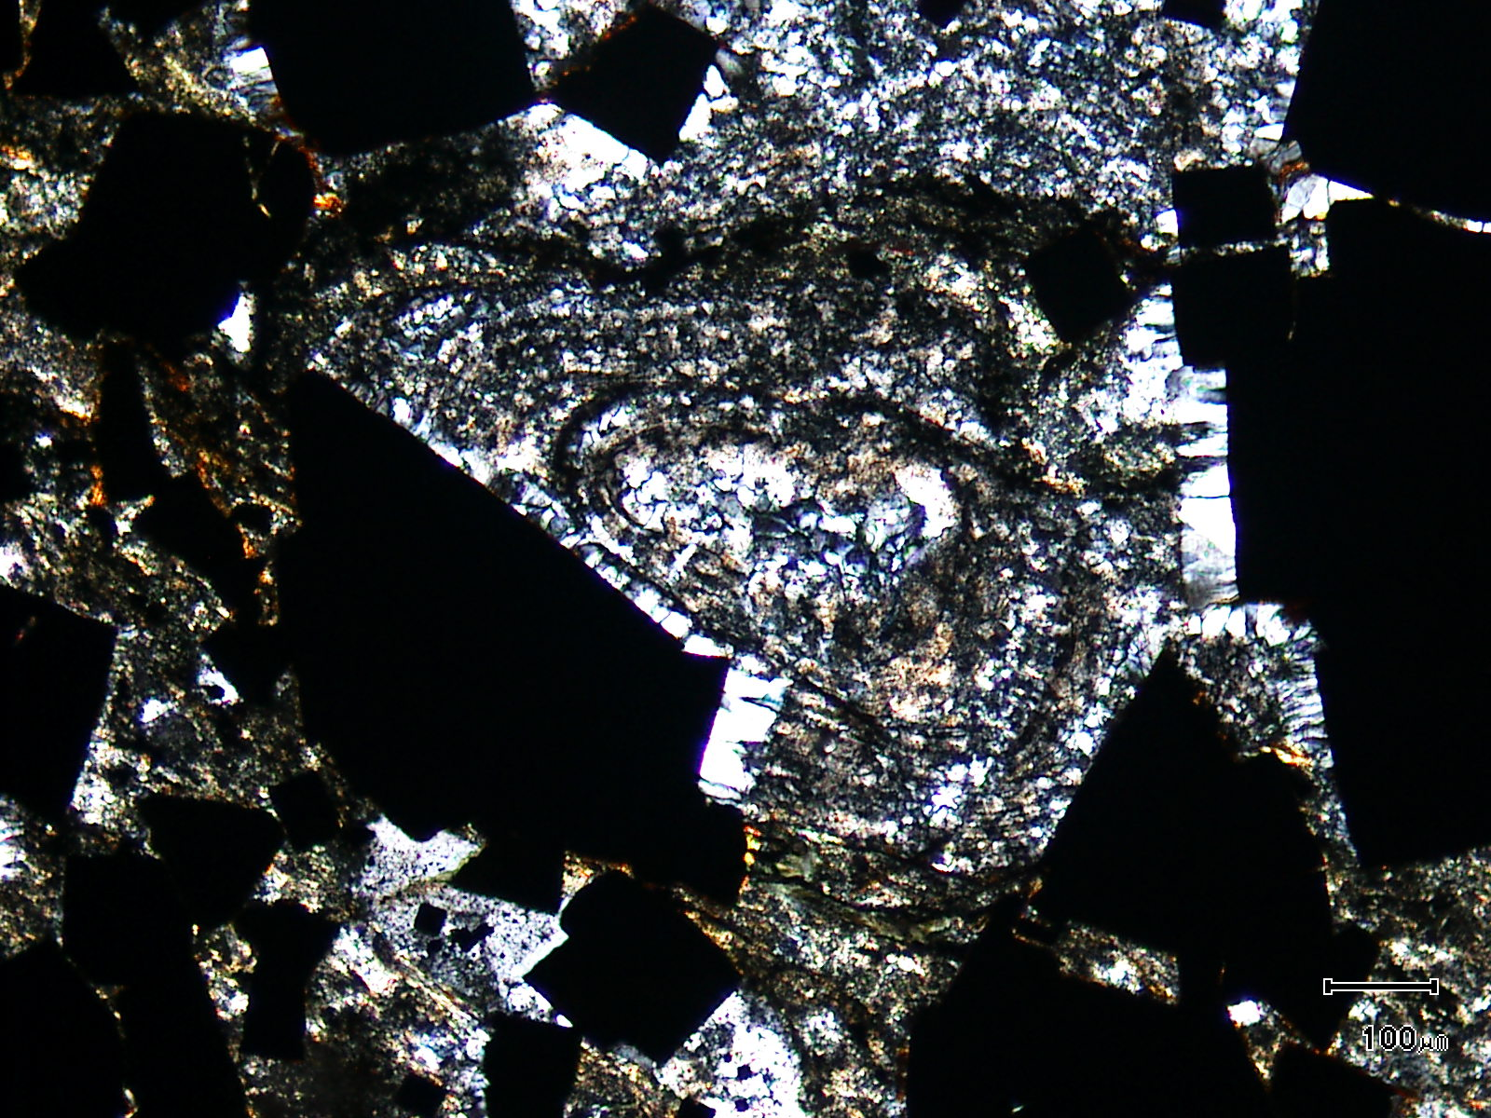
(Mag. x 100; scale bar = 100µ; crossed nicols)

Sample ZS113W - 258.0m

The photomicrograph shows a cross nicols view of Plate 17. The internal segments of the lapilli are replaced by quartz.

Plate 19

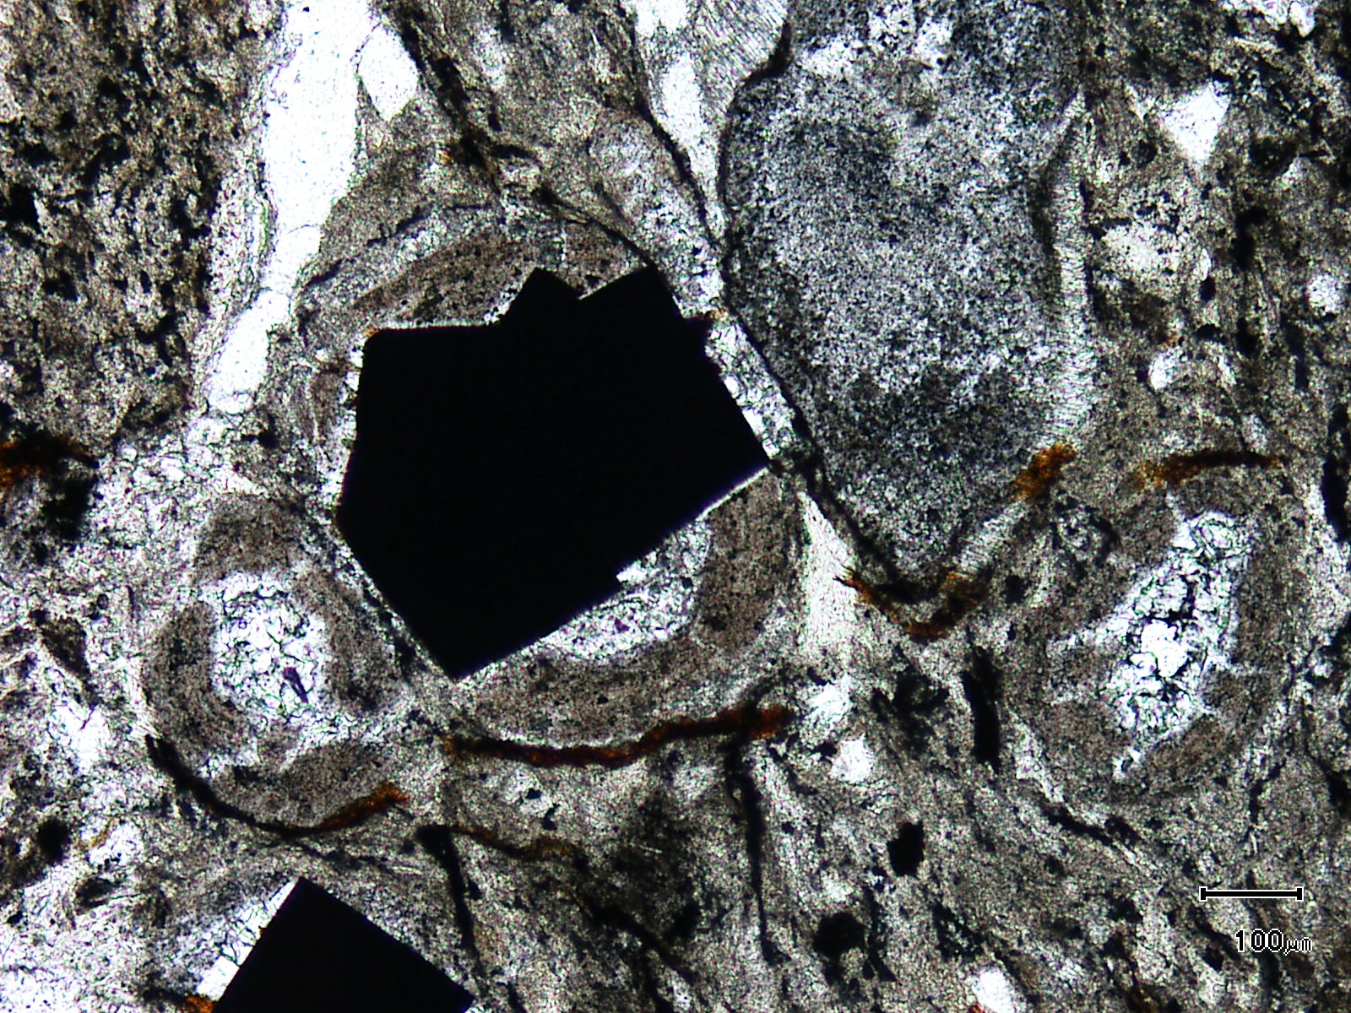
(Mag. x 100; scale bar = 100µ; PPL)

Sample ZS113W - 258.0m

The photomicrograph shows abundant accretionary lapilli with later pyrite growing within one lapilli.

Plate 20

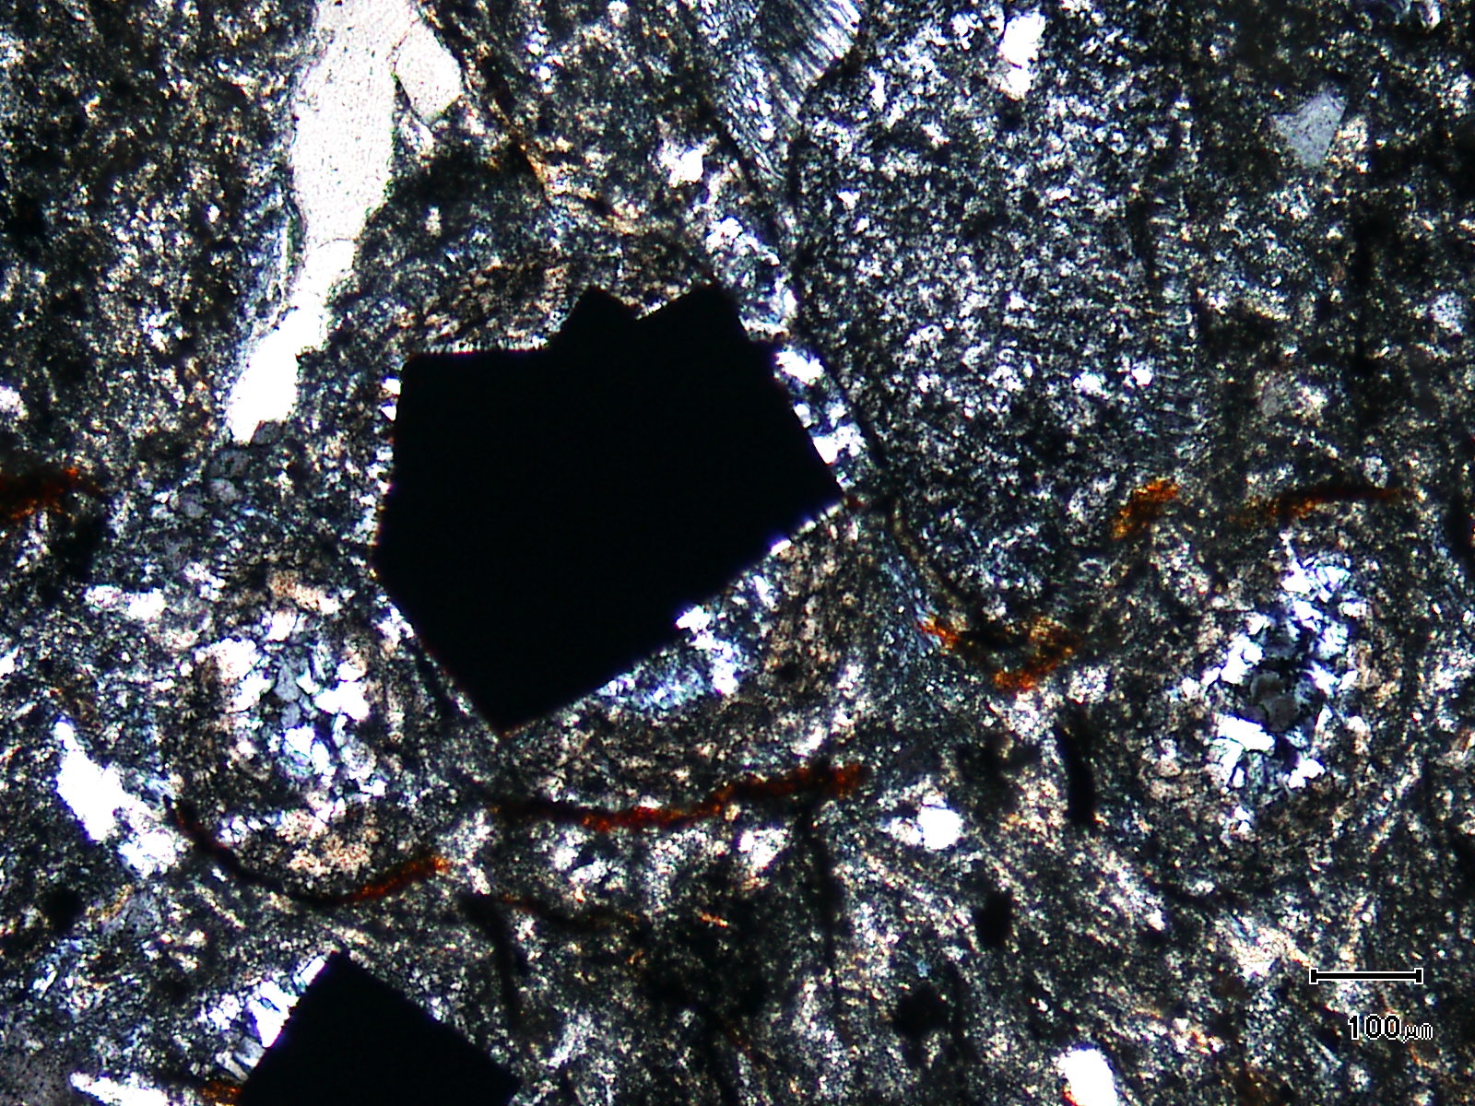
(Mag. x 100; scale bar = 100µ; crossed nicols)

Sample ZS113W - 258.0m

The photomicrograph shows a cross nicols view of Plate 19. Note that the lapilli are largely replaced by quartz.

Sample Number: ZS113W - 265.1m

Sample Locality: Severn Ore body, Zeehan

Rock Type: Quartz veined, highly carbonaceous meta-pelite exhibiting a strong fabric

Sample Description:

The sample is fine grained, being generally less than 5µ. It exhibits a strong domainal micro-fabric which hosts parallel, intensely recrystallised quartz-pyrite veins as well as later siderite-quartz-pyrite veins. Late, cross-cutting quartz veins are also present.

A visual estimate of the minerals present is:

Chlorite ~53% Rutile/anatase ~ 5%
Carbonaceous matter ~14% Pyrite ~ 3%
Quartz ~ 8% White mica ~ 1%
Carbonate ~ 7% Graphite/pyrobitumen ~ 1%
Vein quartz ~ 7% Chalcopyrite trace
Pyrrhotite trace

Siderite and pyrite only develop within veins in the sample, with graphite and/or pyrobitumen developing in some veins. Pyrite grains are often lenticular, xenoblastic and host myriad fine grained inclusions. Pyrrhotite (~30µ) and chalcopyrite (<4µ) can be found as inclusions in siderite which develops in veins and as lenticular aggregates associated with quartz. In the latter case, these lenticular aggregates develop parallel to the strong fabric.

The strongly carbonaceous groundmass is dominated by fine grained (<10µ) chlorite and small (up to 50µ) aggregates of rutile/anatase. Rounded aggregates of graphite/pyrobitumen occur within some veins with rare graphite in the groundmass.

The sample exhibits a strong fabric similar to the fabric observed in samples close to “infill” mineralisation elsewhere.

Plate 21

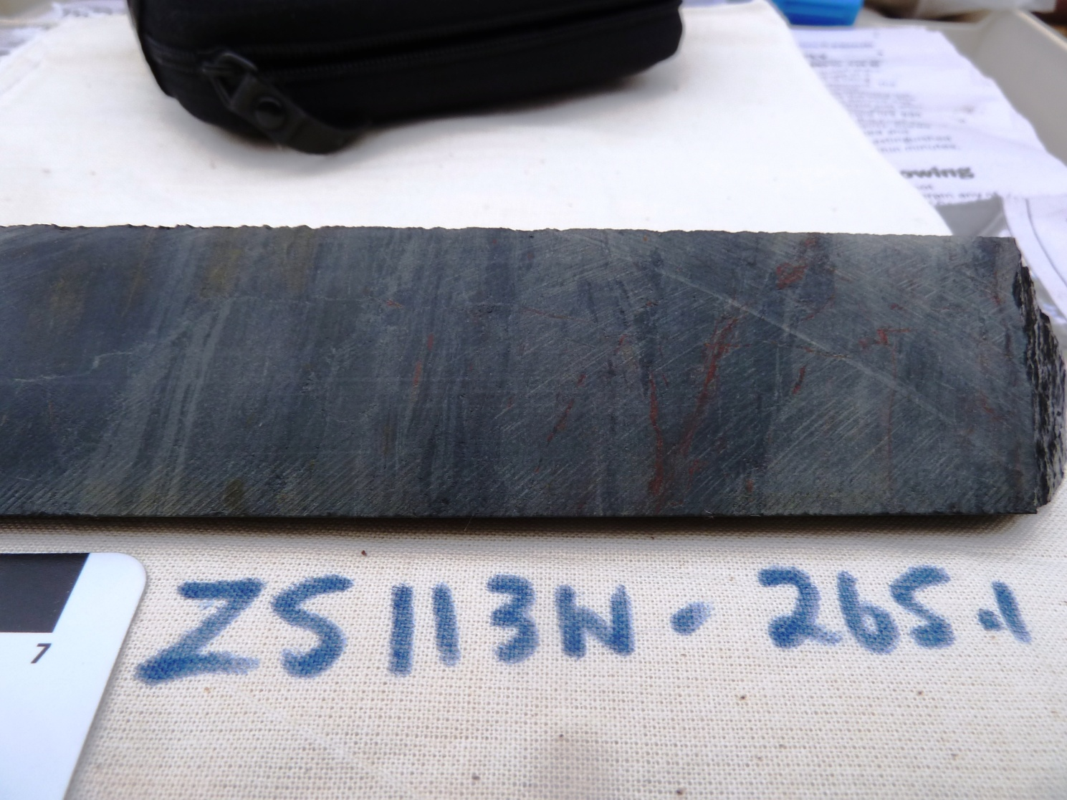

Sample ZS113W - 265.1m

The slab photograph shows a highly carbonaceous meta-pelite which has been intensely deformed and exhibits a strong fabric. It is chlorite-rich (~53%) and contains abundant anatase (~5%) indicating a mafic provenance.

Plate 22

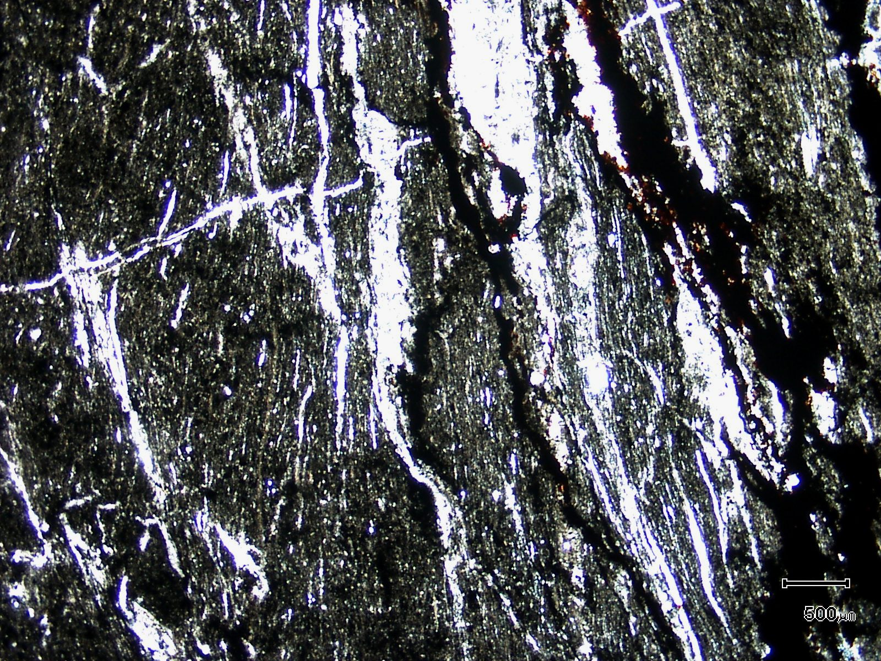
(Mag. x 20; scale bar = 500µ; PPL)

Sample ZS113W - 265.1m

The photomicrograph shows a general textural view of this sample. Note the quartz veins which have been intensely deformed and recrystallised.

Plate 23

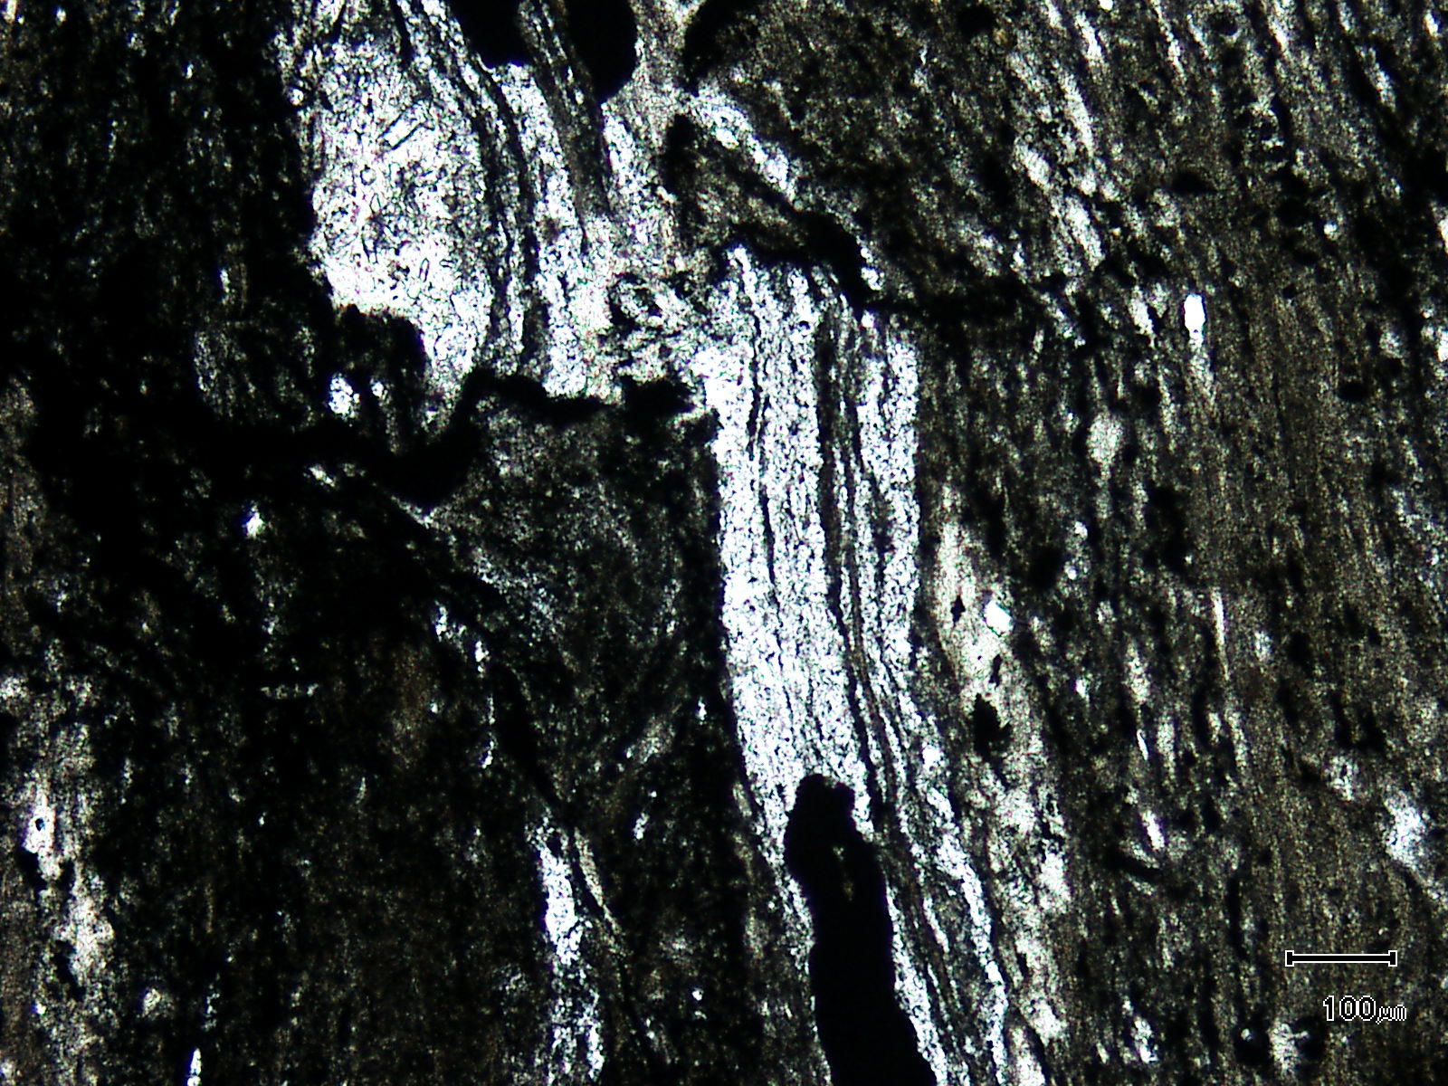
(Mag. x 100; scale bar = 100µ; PPL)

Sample ZS113W - 265.1m

Here, a higher magnification view of this sample shows mylonitic quartz veins which have been intensely recrystallised and are now composed of fine grained quartz.

Sample Number: ZS113W - 268.2m

Sample Locality: Severn Ore body, Zeehan

Rock Type: Cassiterite “lode”; fluorite-chlorite-cassiterite-siderite-pyrite-pyrrhotite

Sample Description:

The sample is dominated by pyrite, oxidised pyrrhotite, chlorite, siderite, fluorite and cassiterite. The chlorite appears to replace tourmaline.

A visual estimate of the minerals present is:

Chlorite ~29% Pyrrhotite ~ 2%
Pyrite ~17% Arsenopyrite ~ 1%
“Birds-eye” pyrite ~14% Biotite trace
Fluorite ~12% Chalcopyrite trace
Siderite ~11% Tourmaline trace
Cassiterite ~ 7% Apatite trace
Quartz ~ 4% Rutile trace
Marcasite ~ 2%

Cassiterite grains vary in size from 50µ to 150µ and most are idioblastic and strongly optically zoned. Cassiterite textures and location are as follows:
- almost monomineralic aggregates of cassiterite with interstitial pyrite, rare biotite and chlorite. The cassiterite does not contain sulphide inclusions.

- cassiterite grains and grain aggregates sitting within fluorite. This includes cassiterite-fluorite aggregates which are present as “inclusions” in pyrite and pyrrhotite.

- small cassiterite grains (10-30µ) present as inclusions in quartz (with rare acicular tourmaline). These quartz grains sit within Fe Sulphides.

- cassiterite grains (50-100µ) contained as inclusions in large (~0.35mm) apatite grains

- cassiterite grains contained within radiating chlorite aggregates (± fluorite) with these aggregates being up to 0.2mm in diameter. The chlorite is Fe-rich and is most likely replacing tourmaline. Cassiterite grains range in size from 5µ to 100µ.

- rare grains contained within pyrite and siderite.

Sample ZS113W - 268.2m contd.

Chalcopyrite is found as inclusions in pyrite and grains can be up to 200µ in size. Chalcopyrite is also found as inclusions in siderite (up to 200µ in size) and more rarely as small (~15µ) inclusions in fluorite. Pyrrhotite inclusions are common in pyrite however larger pyrrhotite grains are partially replaced by “birds-eye” textured pyrite. This secondary pyrite is then replaced by siderite. The siderite-secondary pyrite aggregates are often enclosed by another generation of secondary pyrite + marcasite.

Arsenopyrite is idioblastic and grains can be up to 0.5mm in size. It contains inclusions of siderite, cassiterite, pyrrhotite and chalcopyrite. The arsenopyrite tends to develop on the periphery of the Fe sulphides. Stannite was not observed. Idioblastic quartz sits within Fe sulphides and grains can be up to 1mm in length and contain inclusions of pyrrhotite and cassiterite with very rare acicular tourmaline. Biotite is rare, occurring within cassiterite rich aggregates and rutile is often intergrown with cassiterite.

Plate 24

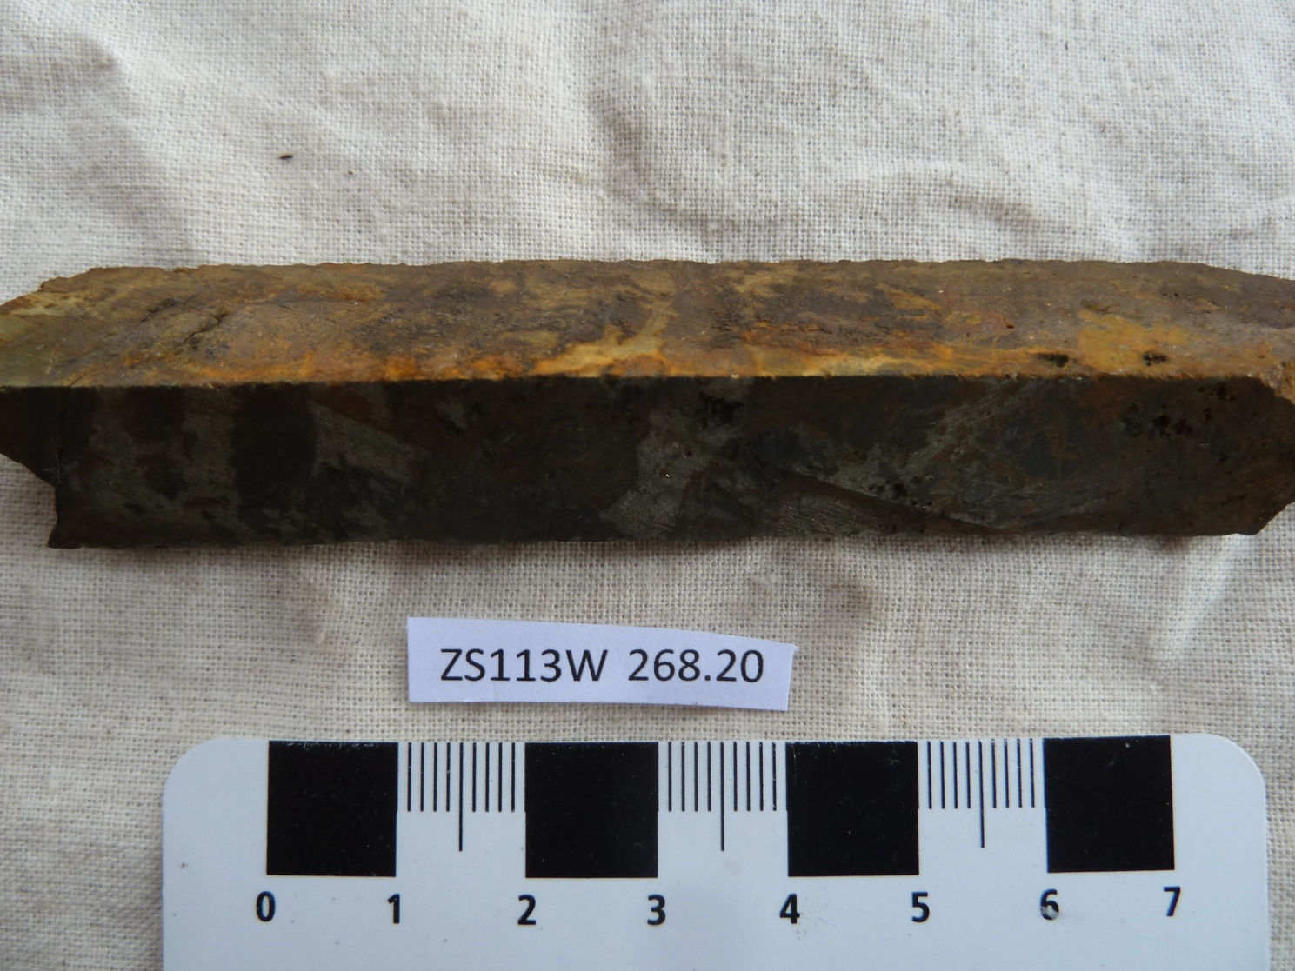

Sample ZS113W - 268.2m

The slab photograph shows a highly oxidised and cassiterite-rich (~7%) “lode”. It contains ~12% fluorite as well as ~29% chlorite, ~20% pyrite + pyrrhotite and ~16% “birds-eye” pyrite + marcasite. Significant arsenopyrite (~1%), tourmaline, chalcopyrite, biotite and apatite are present.

Plate 25

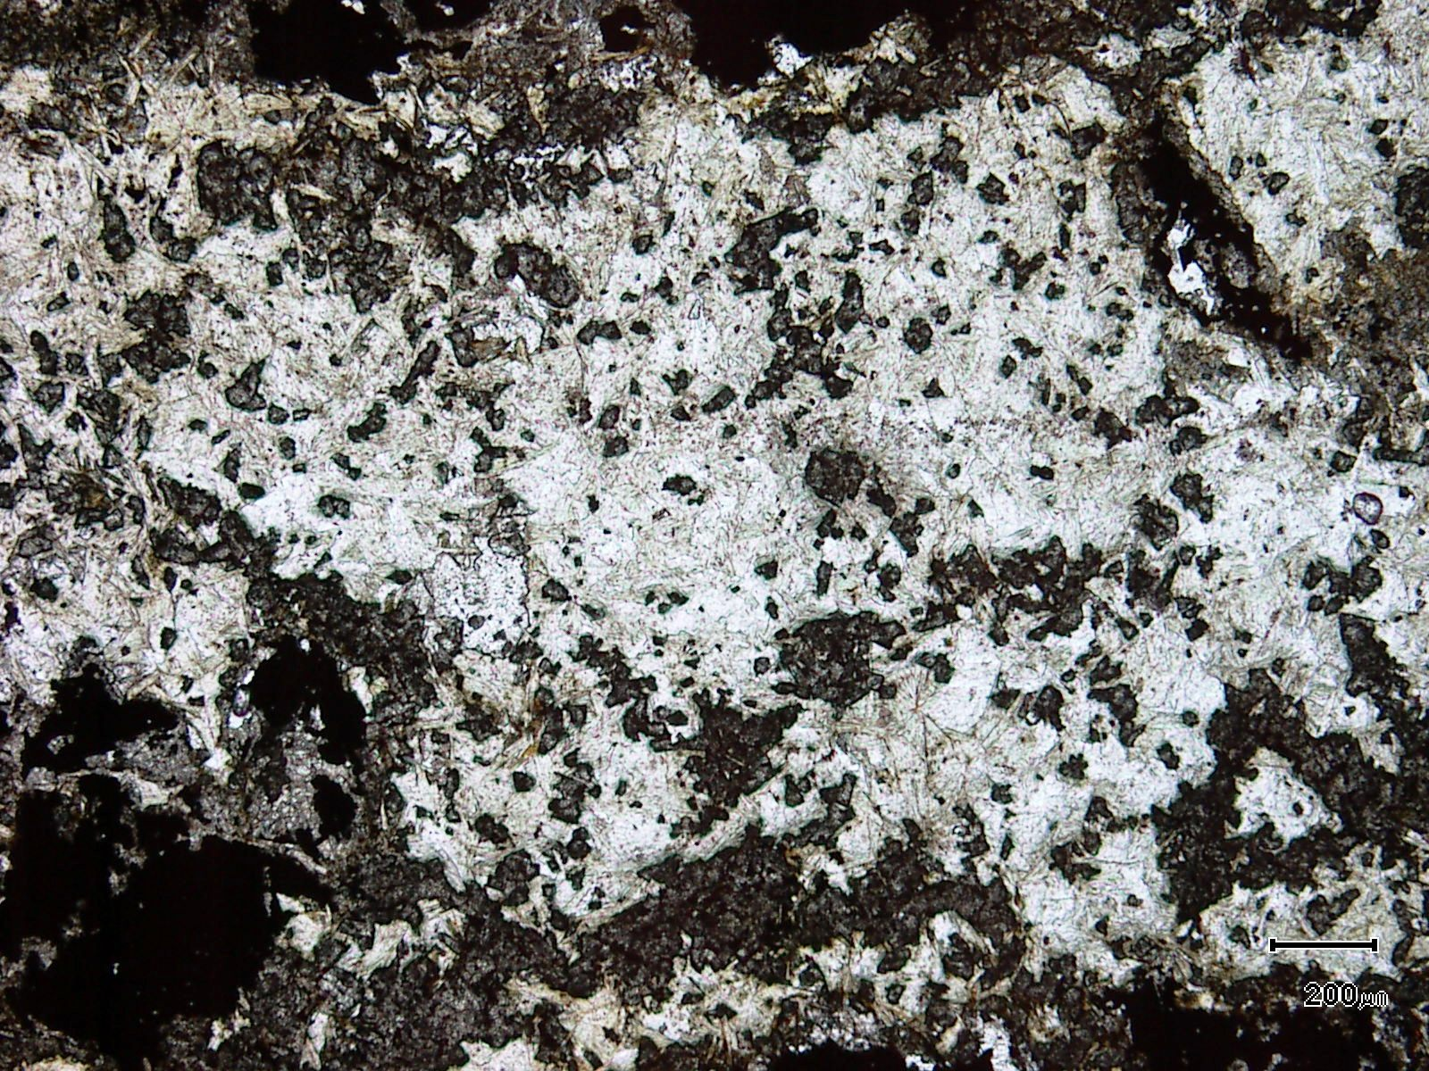
(Mag. x 50; scale bar = 200µ; PPL)

Sample ZS113W - 268.2m

The photomicrograph shows a general textural view of an area that is dominated by chlorite and cassiterite. The chlorite appears to replace former tourmaline and may also replace biotite.

Plate 26

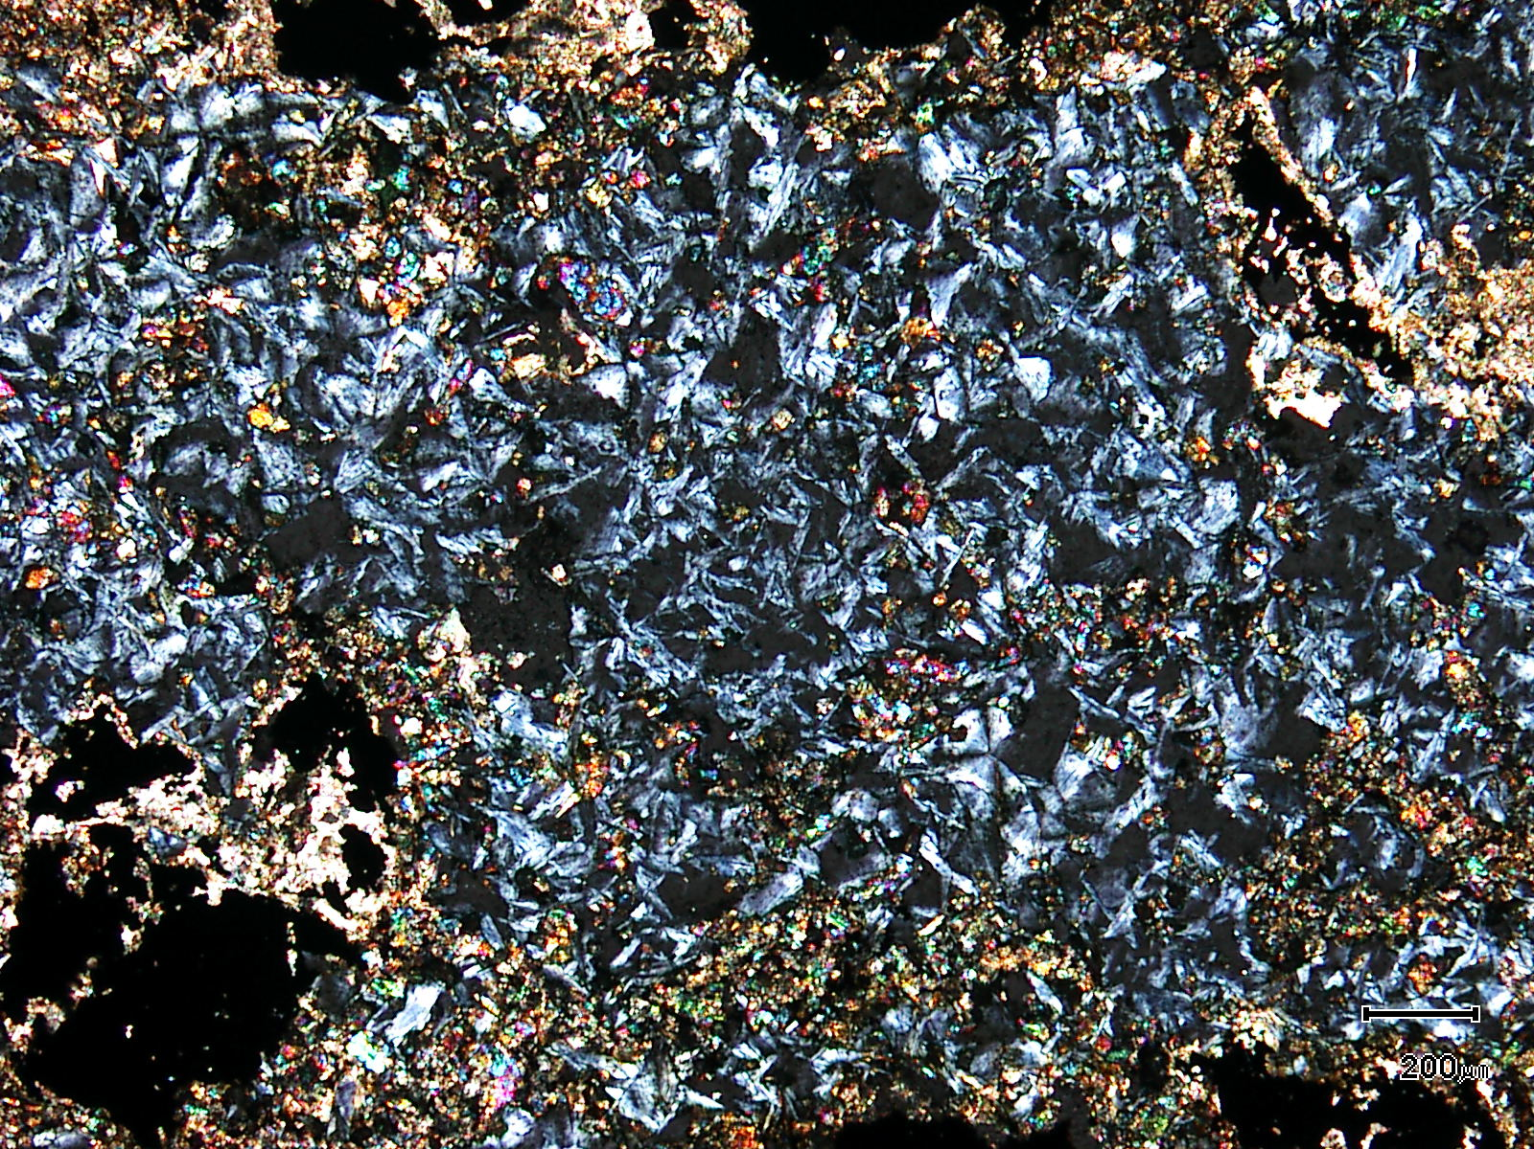
(Mag. x 50; scale bar = 200µ; crossed nicols)

Sample ZS113W - 268.2m

The photomicrograph shows a cross nicols view of Plate 25. Note the anomalous berlin blue interference colours of the chlorite.

Plate 27

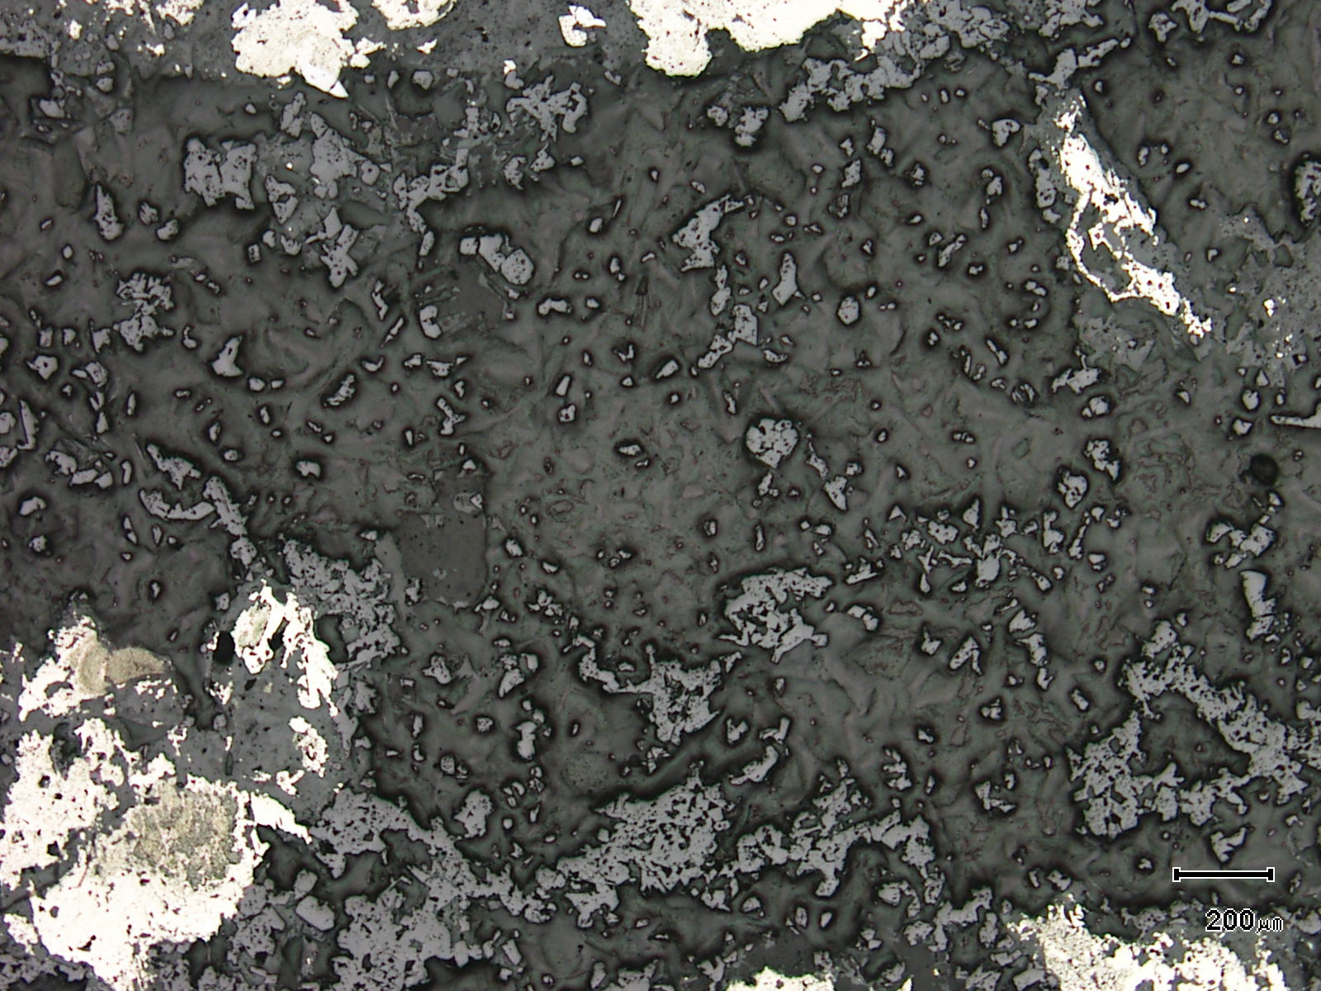
cassiterite
(Mag. x 50; scale bar = 200µ; reflected light)

Sample ZS113W - 268.2m

The photomicrograph shows a reflected light view of Plate 25. Cassiterite is more easily observed in reflected light.

Plate 28

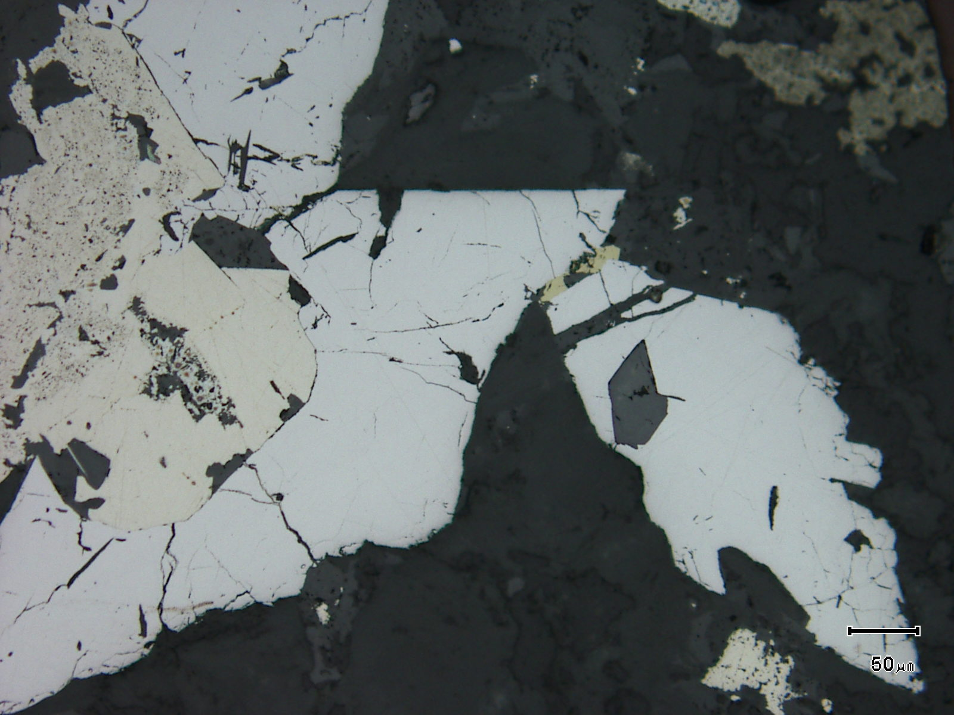
arsenopyrite
cassiterite
(Mag. x 200; scale bar = 50µ; reflected light)

Sample ZS113W - 268.2m

The reflected light photomicrograph shows relatively large arsenopyrite grains with one containing an idioblastic cassiterite grain.

Plate 29

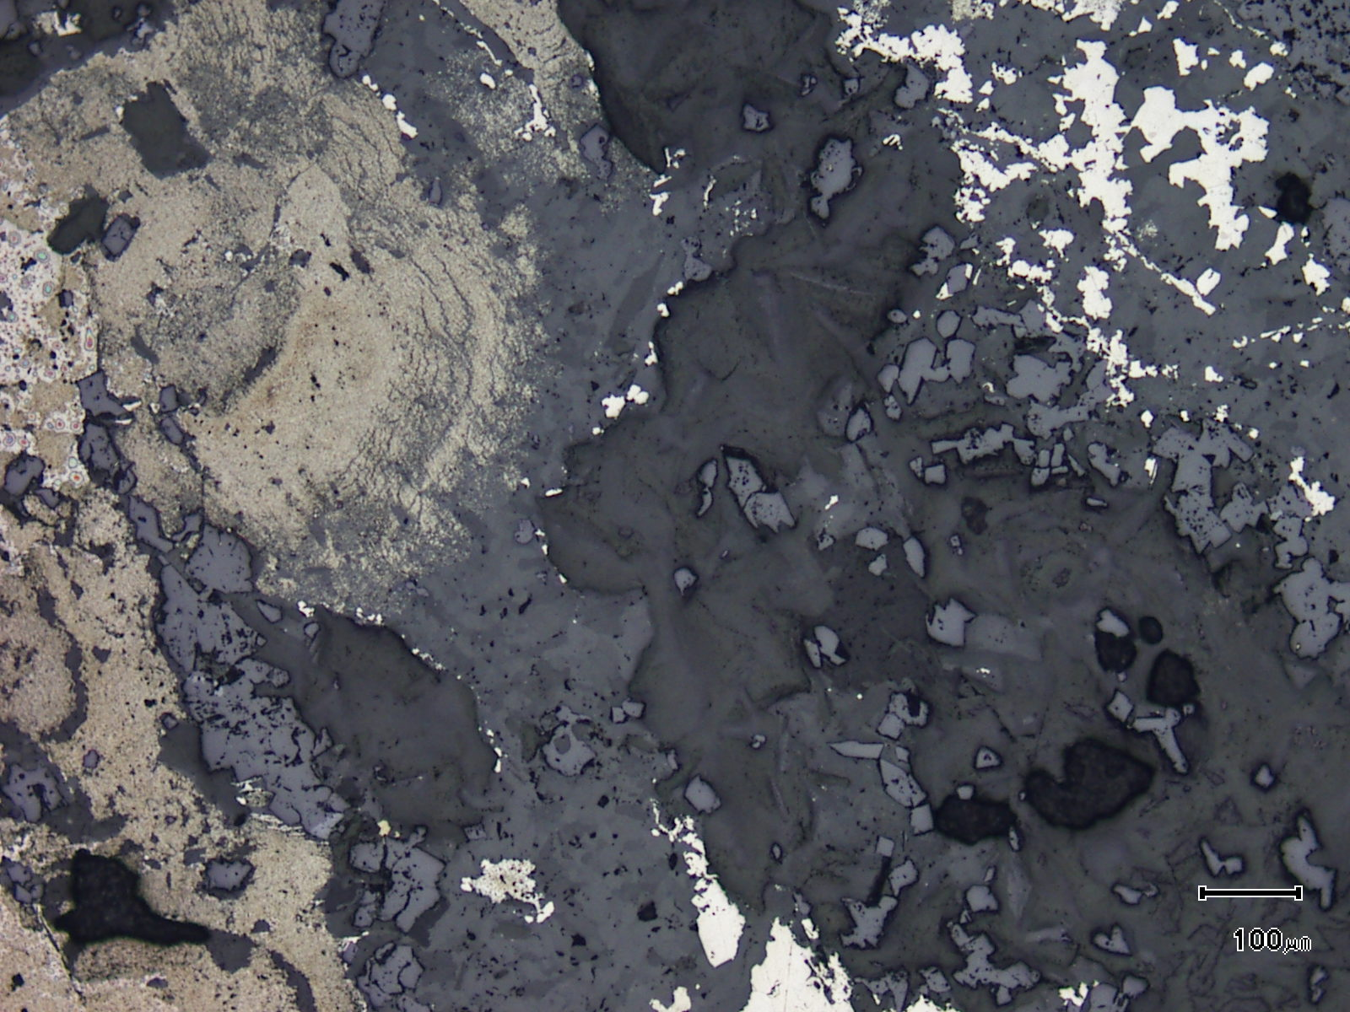
cassiterite
“birds-eye” pyrite
siderite
(Mag. x 100; scale bar = 100µ; reflected light)

Sample ZS113W - 268.2m

The reflected light photomicrograph shows an unusual texture with siderite replacing “birds-eye” pyrite and the siderite having a partial rim of secondary pyrite + marcasite. Note the abundance of cassiterite.

Plate 30

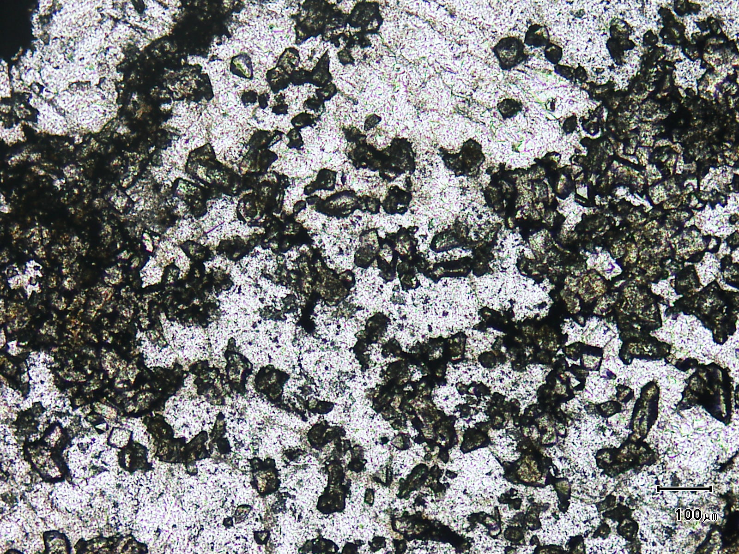
(Mag. x 100; scale bar = 100µ; PPL)

Sample ZS113W - 268.2m

Here, abundant cassiterite sits within massive fluorite.

Plate 31

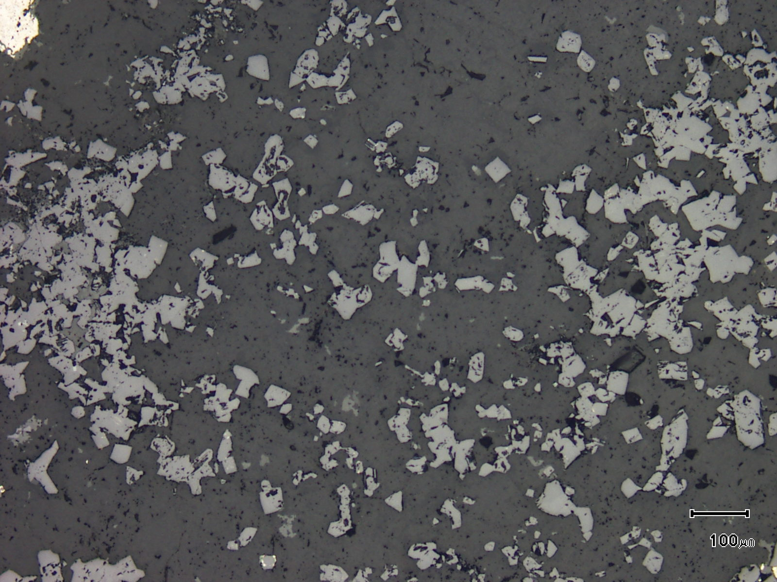
(Mag. x 100; scale bar = 100µ; reflected light)

Sample ZS113W - 268.2m

The reflected light photomicrograph shows Plate 30. The cassiterite grains (light grey) are easily observed sitting within the massive fluorite. Note the consistency of cassiterite grain size.

Plate 32

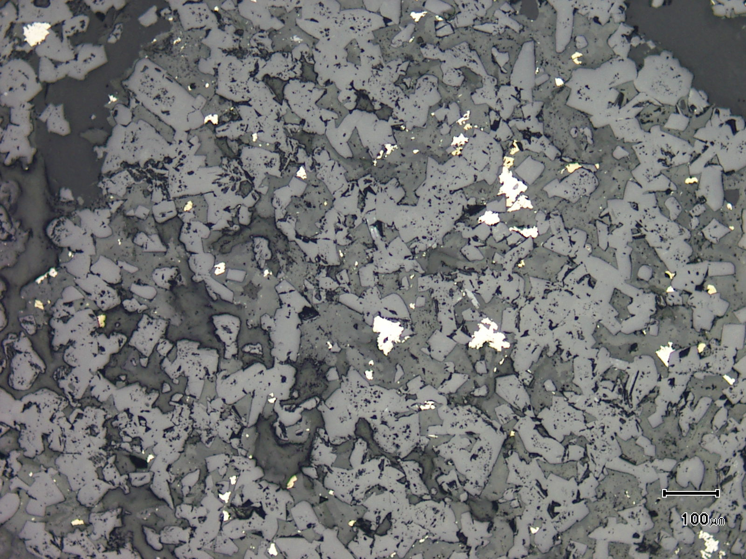
cassiterite
(Mag. x 100; scale bar = 100µ; reflected light)

Sample ZS113W - 268.2m

The slab photograph shows extremely cassiterite-rich material associated with trace pyrite (white) and chalcopyrite (yellow) sitting within fluorite.

Sample Number: ZS113W - 275.0m

Sample Locality: Severn Ore body, Zeehan

Rock Type: Pyritic, in part silicified, “infill”, cassiterite-rich mineralisation cut by a fluidised injection breccia

Sample Description:

The sample contains two domains, an infill, alteration domain which is rich in cassiterite and a cross-cutting breccia which is cassiterite-free. It should be noted that cassiterite is best developed immediately adjacent to the breccia and in the infill, altered domain.

A visual estimate of the minerals present in the breccia is:
Groundmass chlorite and clays ~34%
Clasts ~28%
Quartz ~14%
Siderite ~12%
Goethite ~ 7%
Pyrite ~ 4%
Chalcopyrite trace
The boundary between “infill” mineralisation and the breccia is sharp and well defined with cassiterite developed right up to the boundary. Clasts are abundant and are dominated by carbonaceous pelite with clasts up to 1.5mm. The carbonaceous pelite clasts can contain cross-cutting siderite veins and minor pyrite. Siderite clasts are common and the breccia contains idioblastic quartz grains. Chalcopyrite is associated with pyrite in siderite-pyrite clasts and there are clasts of replacive quartz.
The groundmass is composed of felted to radiating chlorite + clays which may replace tourmaline.
A visual estimate of the minerals present in the mineralised domain is:
Pyrite ~29% Rutile ~ 2%
Clay minerals ~27% Tourmaline ~ 1%
Quartz ~12% Pyrobitumen trace
Goethite ~ 8% Chalcopyrite trace
Siderite ~ 8% Pyrrhotite trace
Cassiterite ~ 7% Apatite trace
Hydrated iron oxides ~ 5% Stannite trace
Siderite veins cut across the sample. The cassiterite ranges in size from 30µ to 220µ and grains are idioblastic to subidioblastic. The grains tend to be inclusion-free but can contain inclusions of tourmaline and rare (<2µ) pyrobitumen.

ZS113W - 275.0m contd.

The cassiterite does not contain sulphide inclusions. Cassiterite is found in the following textural associations:
- grains contained within apatite (rare)

- grains (~20µ) present as inclusions in pyrite. Most cassiterite develops out of the pyrite and the presence of cassiterite inclusions is rare.

- abundant idioblastic grains (20µ to 150µ) contained within former tourmaline which has been replaced by clays and hydrated iron oxides

- as inclusions in siderite. Some siderite is present as coarse inclusions in pyrite and these siderite inclusions contain cassiterite.

- as minor inclusions within replacive silica.

Rutile can be intergrown with cassiterite but tends to develop as lenticular aggregates up to 0.2mm in length that develop in linear “trails” through the sample. These rutile aggregates appear to be intimately associated with pyrobitumen. Pyrrhotite, chalcopyrite and stannite are developed within siderite which flanks pyrite.

Plate 33

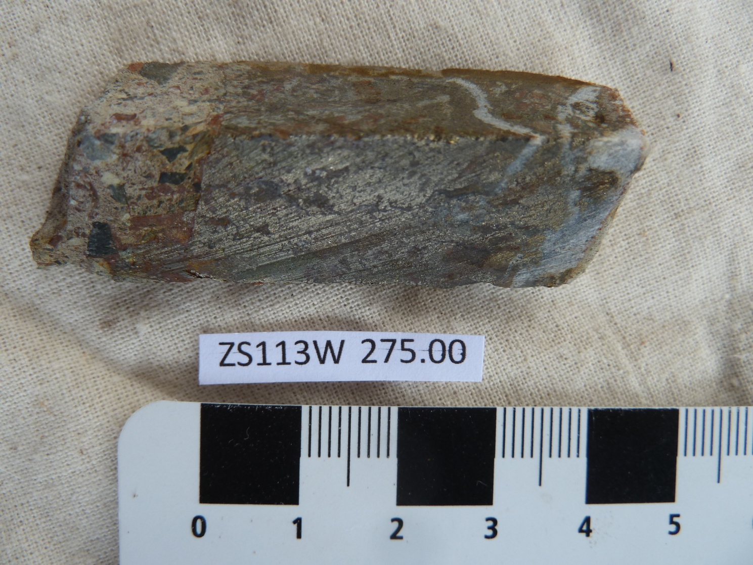

Sample ZS113W - 275.0m

This slab photograph shows a fluidised injection breccia (no cassiterite) cutting a tin-rich “lode”. The breccia dips shallowly to the south east.

Plate 34

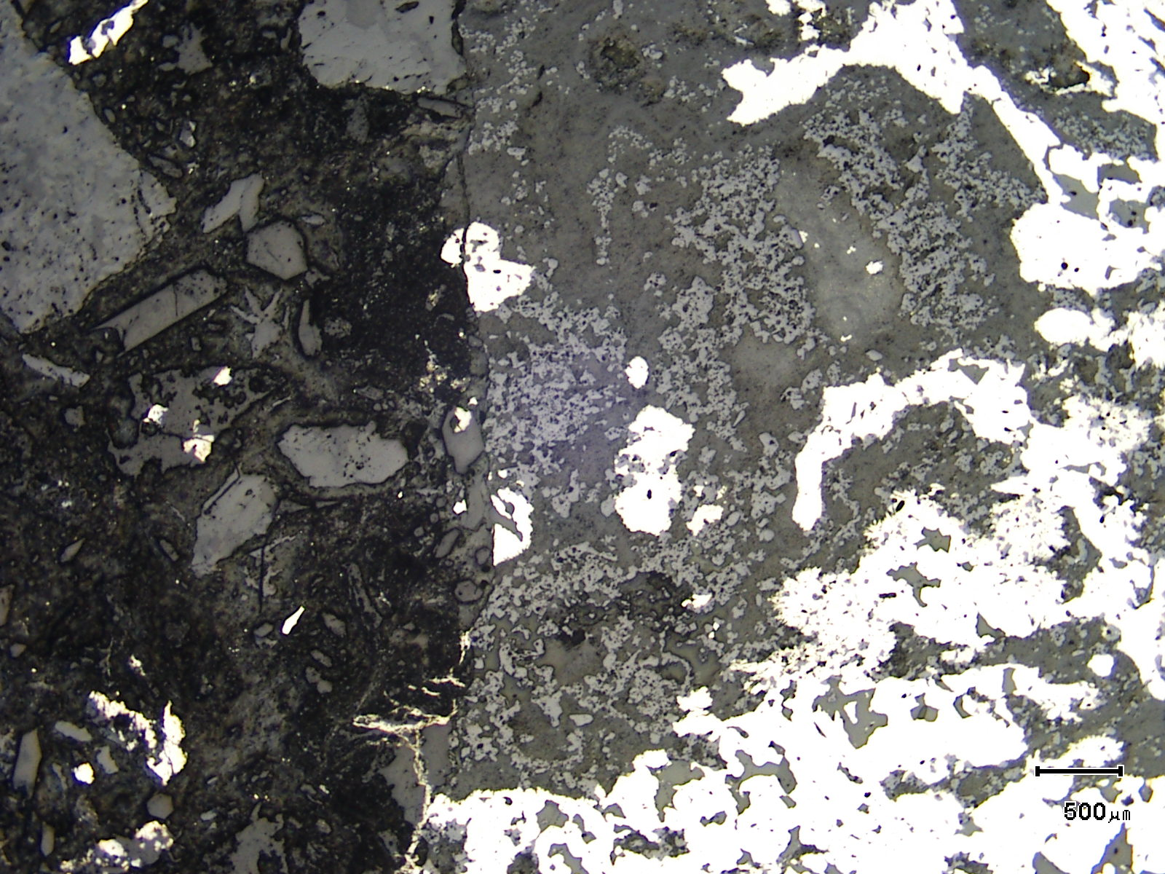
cassiterite-rich areas
(Mag. x 20; scale bar = 500µ; reflected light)

Sample ZS113W - 275.0m

The reflected light photomicrograph shows the contact between the breccia and the tin-rich lode. Note the abundance of cassiterite within the tin-rich lode and the absence of cassiterite in the chlorite-rich and siderite-rich breccia.

Plate 35

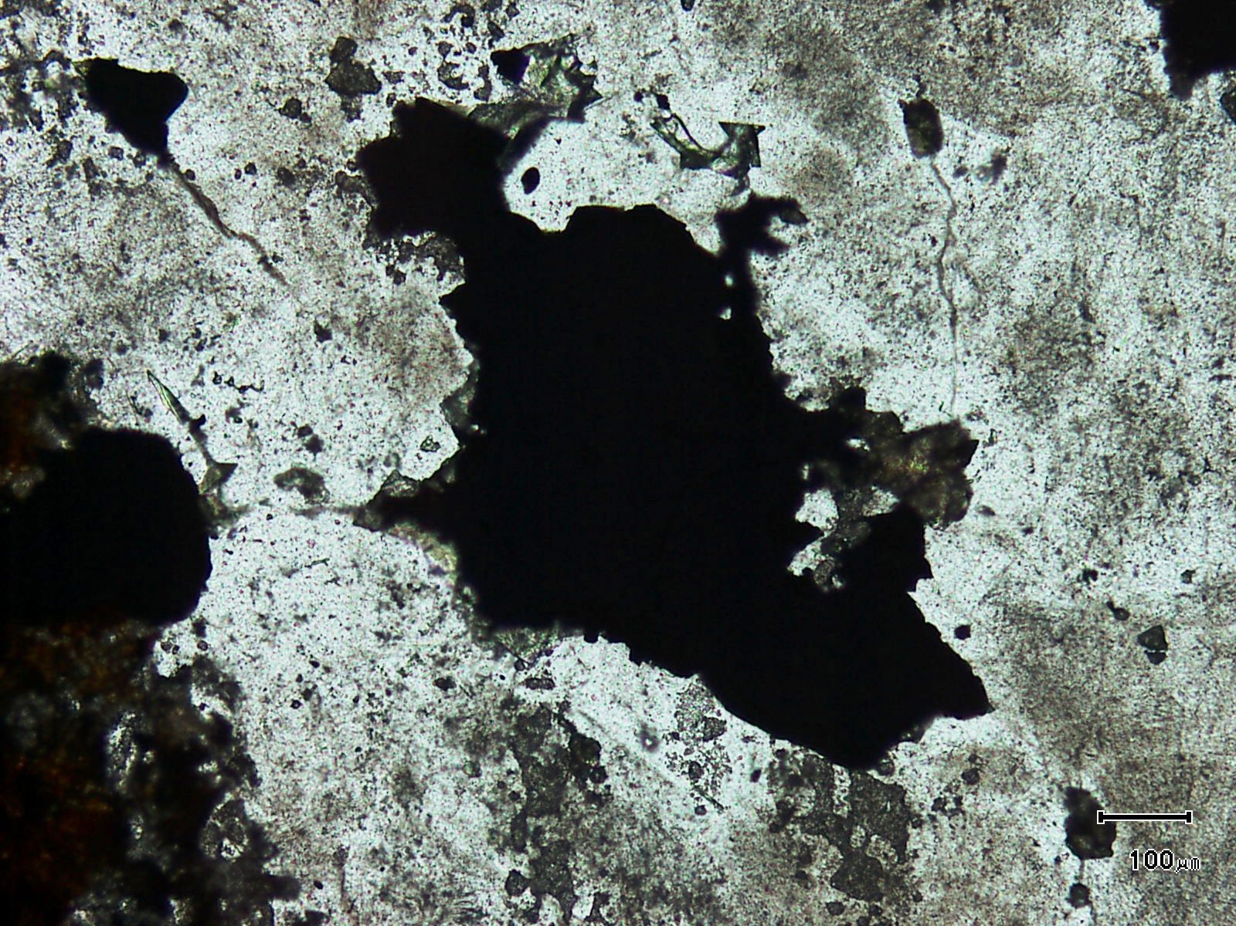
cassiterite
(Mag. x 100; scale bar = 100µ; PPL)

Sample ZS113W - 275.0m

The photomicrograph shows abundant cassiterite associated with pyrite in a quartz vein. Note the abundance of fluid inclusions which give the quartz a “dirty” appearance.

Plate 36

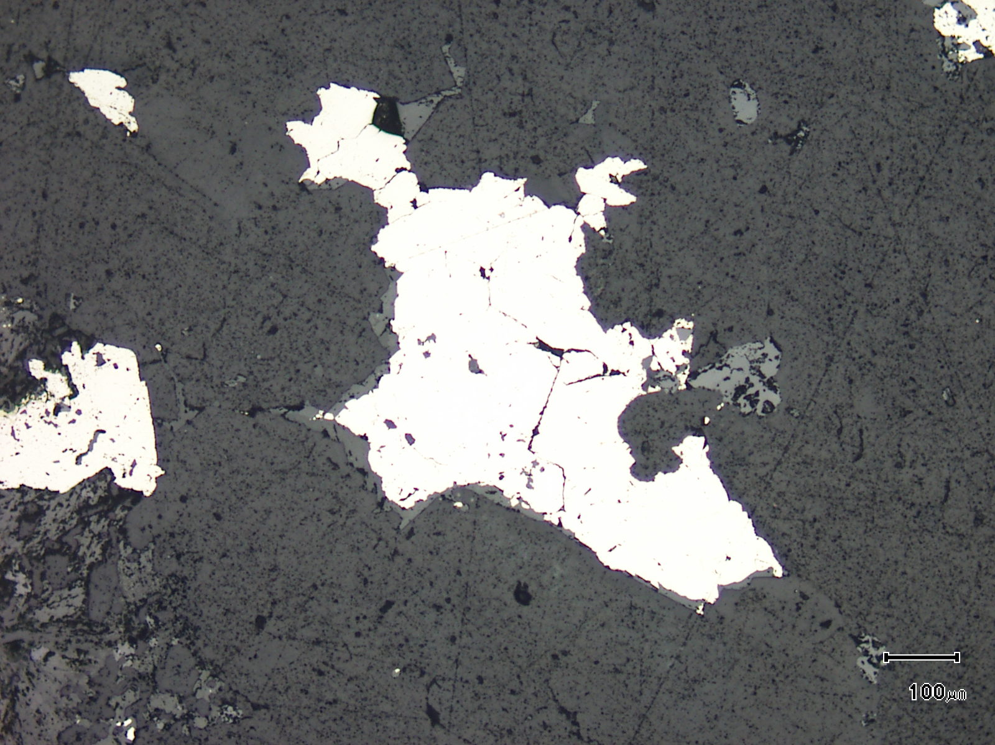
(Mag. x 100; scale bar = 100µ; reflected light)

Sample ZS113W - 275.0m

The photomicrograph shows a reflected light view of Plate 35.

Plate 37

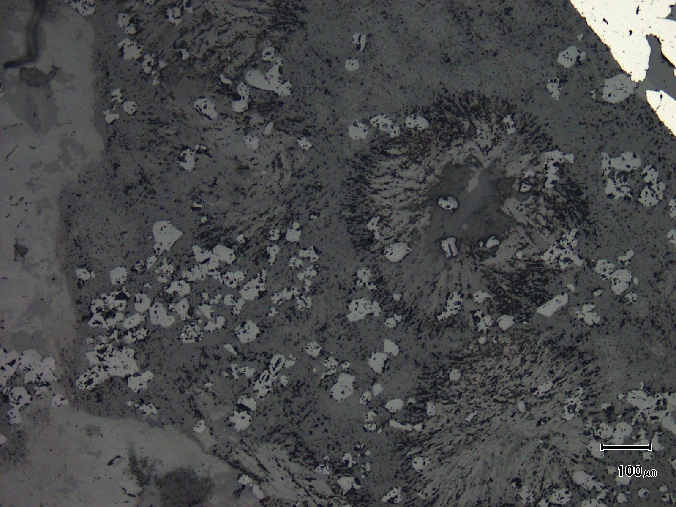
former tourmaline
cassiterite
(Mag. x 100; scale bar = 100µ; reflected light)

Sample ZS113W - 275.0m

The reflected light photomicrograph shows abundant cassiterite associated with goethite and clay mineral replaced former rosettes of tourmaline.

Sample Number: ZS113W - 275.5m

Sample Locality: Severn Ore body, Zeehan

Rock Type: Cassiterite rich, intensely quartz veined and silicified carbonaceous meta pelite

Sample Description:

The sample has been retrogressed with chlorite, clays and siderite replacing earlier formed minerals (perhaps tourmaline). Silicified carbonaceous pelite domains and abundant quartz veining cut the carbonaceous pelite. Cassiterite is intimately associated with the quartz veining.

A visual estimate of the minerals present is:

Vein quartz ~22% Hydrated iron oxides ~ 3%
Quartz ~15% Rutile ~ 3%
Pyrite ~14% Carbonaceous matter ~ 2%
Chlorite ~14% Chalcopyrite trace
Cassiterite ~13% Sphalerite trace
Clay minerals ~ 9% Pyrrhotite trace
Siderite ~ 4%
Cassiterite is present as subidioblastic to idioblastic grains which range from 20µ to 250µ. They tend to be inclusion-free and there are no sulphide inclusions. The cassiterite is present in the following textural associations:
- grains averaging 100µ sit with quartz and bladed chlorite. The chlorite appears to be iron rich and grains are randomly oriented and average 150µ in length.

- aggregates of pyrite contain cassiterite grains which range in size from 50µ to 200µ. These grains contain minor silicate inclusions and are idioblastic. Bladed aggregates of rutile project into pyrite and siderite ± quartz can be located interstitial to pyrite plus cassiterite. The cassiterite is often located as inclusions in the pyrite.

- idioblastic cassiterite grains averaging 100µ develop within quartz veins and within a selvedge adjacent to these veins.

- cassiterite grains develop within “patchy” quartz domains developed within banded, silicified carbonaceous pelite. These grains are xenoblastic and “ragged”.

- coarse grained (up to 0.4mm) cassiterite is almost monomineralic and develops within “embayments” in massive pyrite which develops adjacent to silicified pelite. The pyrite does not contain cassiterite.

ZS113W - 275.5m contd.
Rutile develops in linear bands of deformed carbonaceous-rich, iron stained meta-pelite. It is present as elongate aggregates of grains up to 0.4mm in length.
Pyrite is scattered throughout the sample and develops as subidioblastic to xenoblastic grains and aggregates. These are located within silicified and altered meta-carbonaceous pelite. The pyrite contains abundant carbonate and silicate inclusions and also composite inclusions of chalcopyrite plus pyrrhotite (up to 35µ in size). Smaller inclusions of pyrrhotite and chalcopyrite, present as discrete grains, are also present in the pyrite. Rare sphalerite with pyrrhotite inclusions is present and can be up to 100µ in size. They are associated with finer pyrite and chalcopyrite grains within siderite, often adjacent to stylolitic veining.
The sample exhibits a number of unusual cassiterite textural associations with vein quartz carrying cassiterite being just one of these.

Plate 38

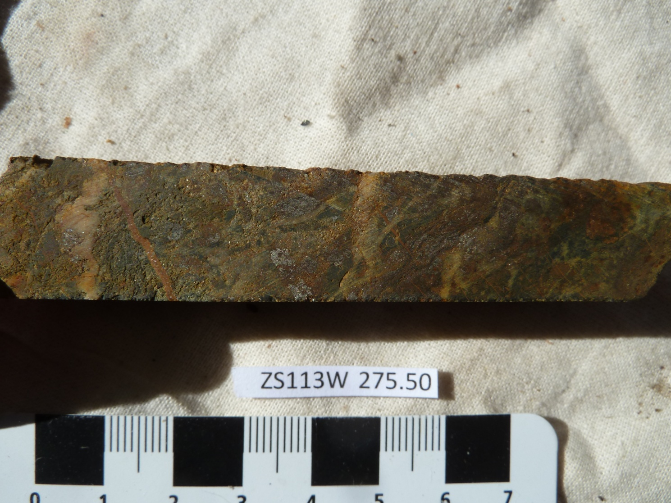

Sample ZS113W - 275.5m

The slab photograph shows a strongly pyritic, intensely quartz-veined and silicified, cassiterite-rich (~13%) carbonaceous meta-pelite.

Plate 39

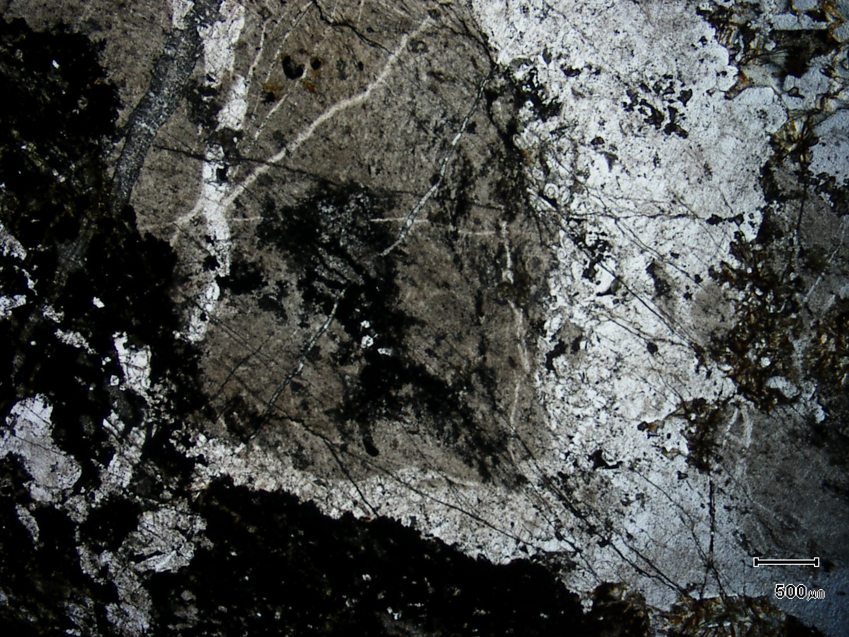
(Mag. x 20; scale bar = 500µ; PPL)

Sample ZS113W - 275.5m

The photomicrograph shows a general textural view of this sample. Here, the carbonaceous meta-pelite is being veined and replaced by quartz (white).

Plate 40

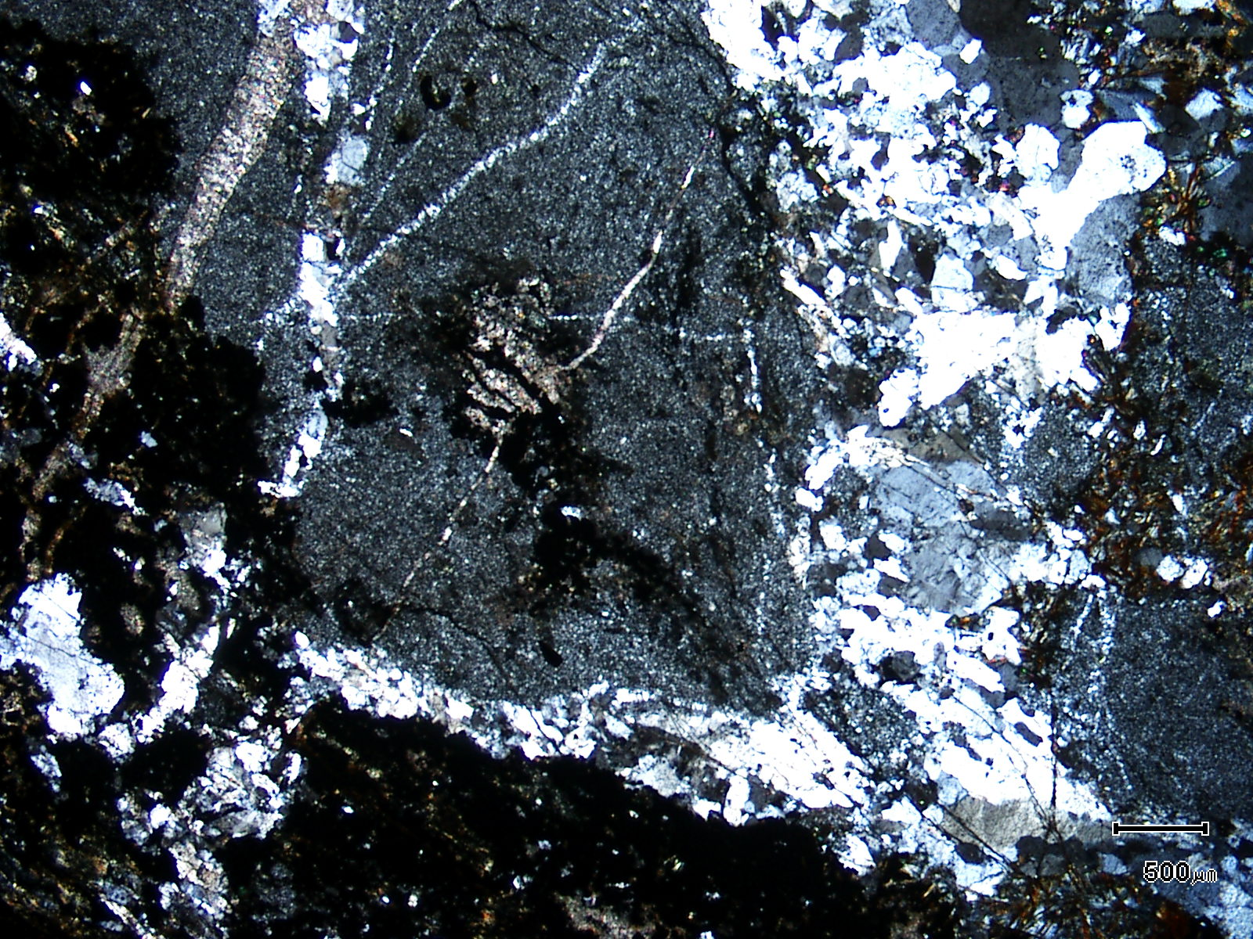
(Mag. x 20; scale bar = 500µ; crossed nicols)

Sample ZS113W - 275.5m

The photomicrograph shows a cross nicols view of Plate 39. Note the fine grained nature of the meta-pelite.

Plate 41

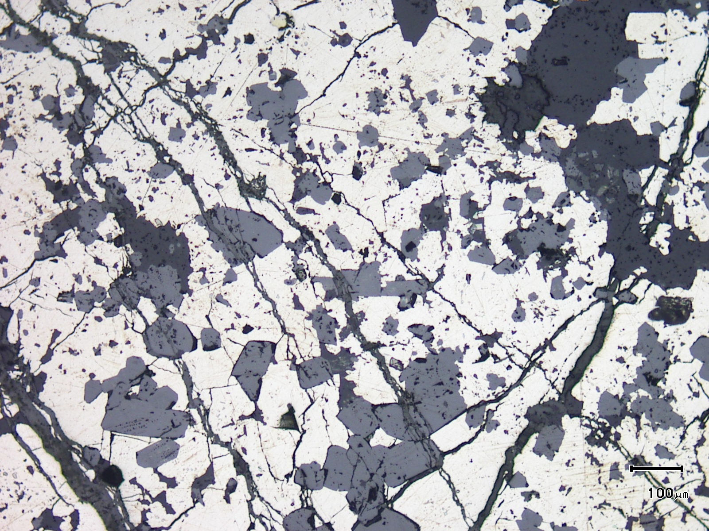
(Mag. x 100; scale bar = 100µ; reflected light)

Sample ZS113W - 275.5m

The reflected light photomicrograph shows idioblastic cassiterite grains sitting within pyrite.

Plate 42

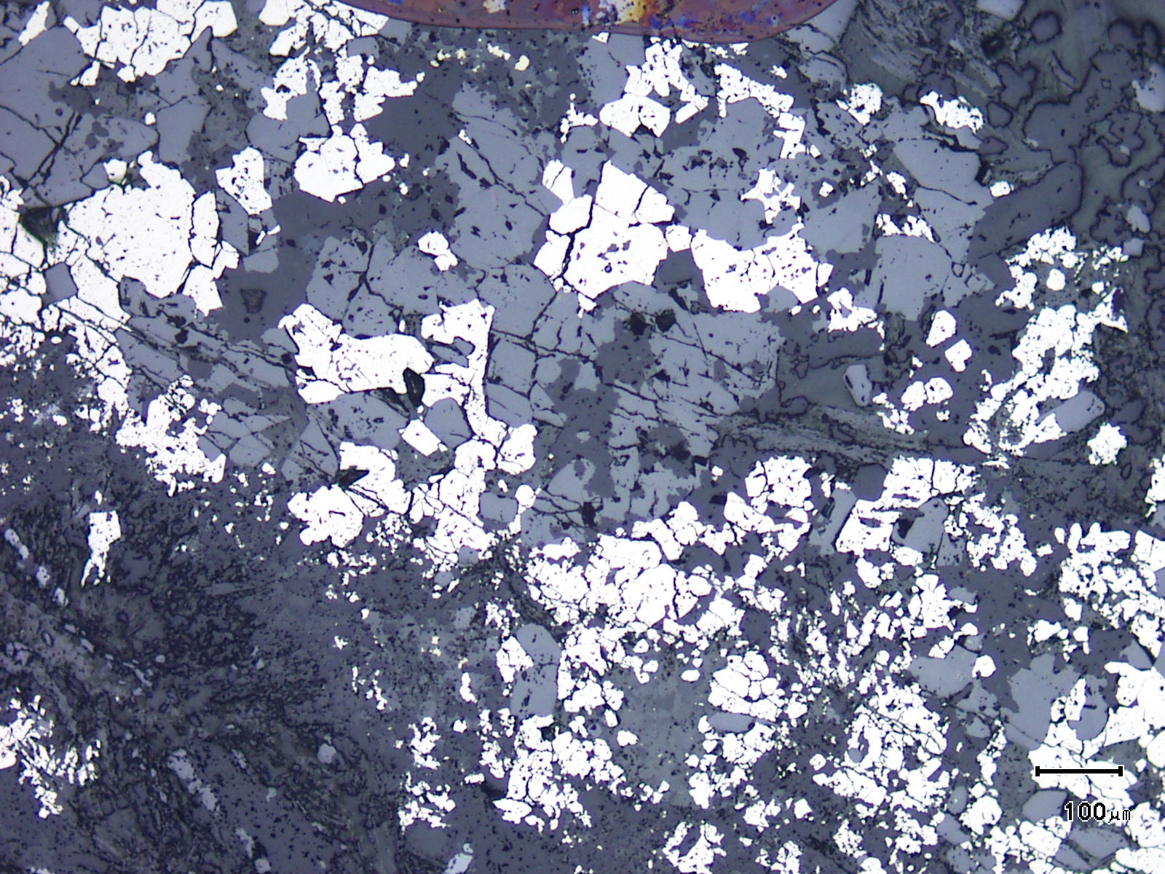
cassiterite
(Mag. x 100; scale bar = 100µ; reflected light)

Sample ZS113W - 275.5m

The reflected light photomicrograph shows a general textural view of cassiterite and pyrite (white) association.

Plate 43

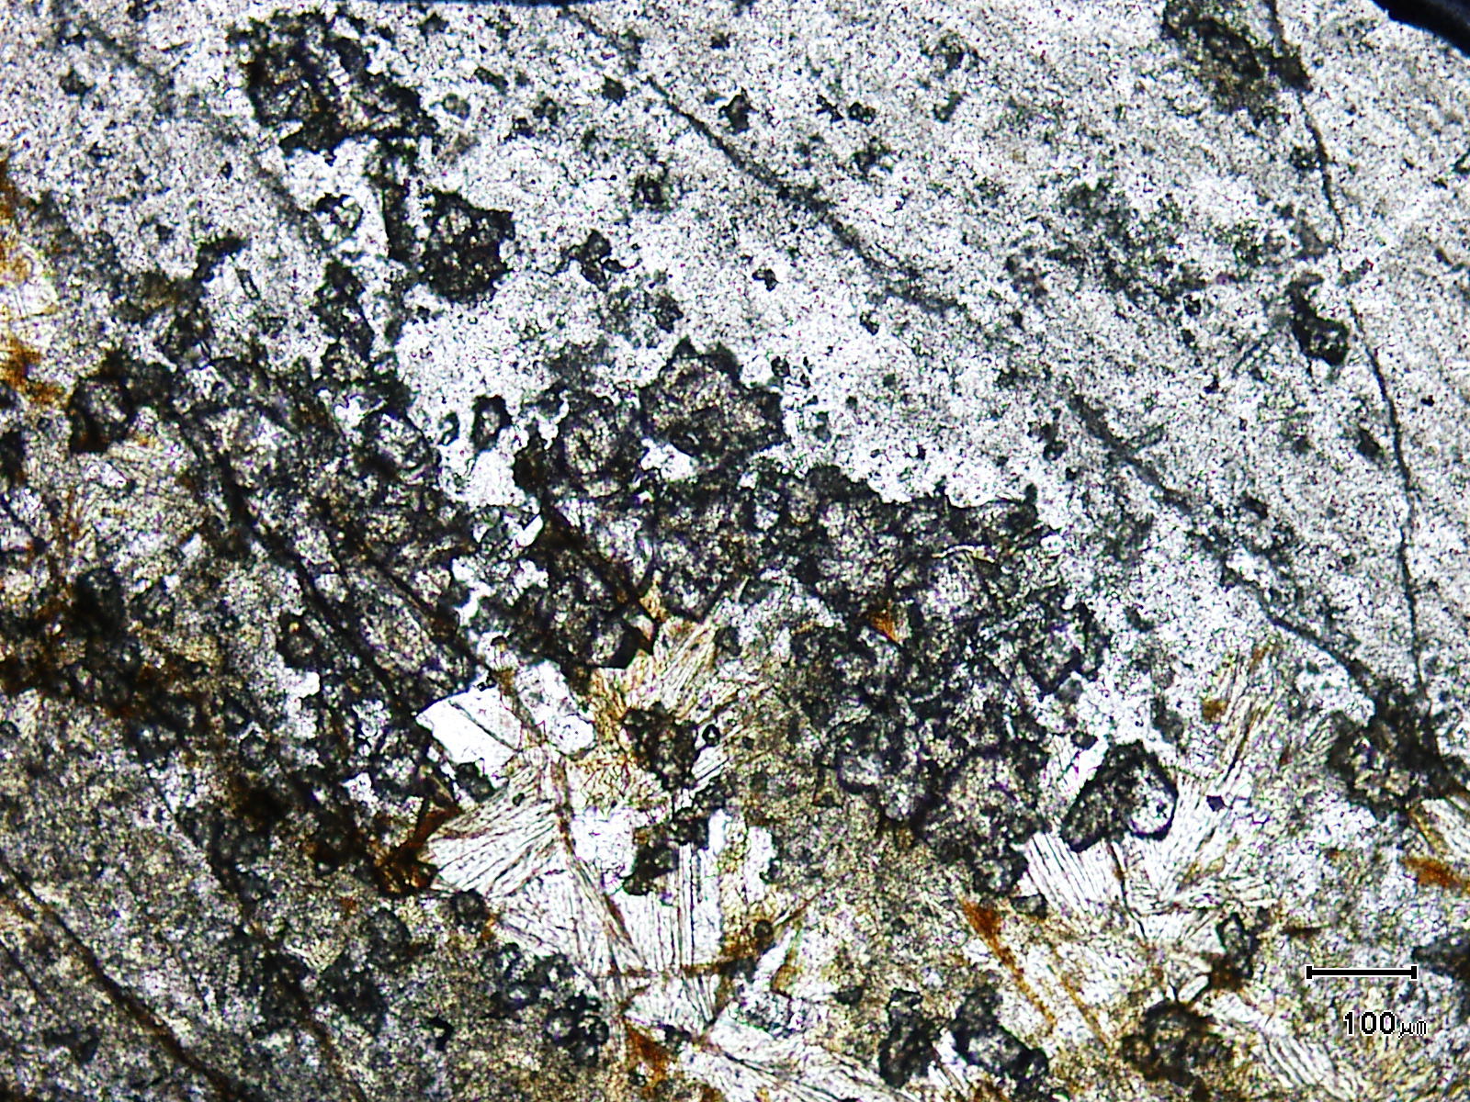
chlorite
cassiterite
(Mag. x 100; scale bar = 100µ; PPL)

Sample ZS113W - 275.5m

The photomicrograph shows a general textural view of cassiterite developed within replacive quartz. The cassiterite sits adjacent to retrograde chlorite.

Plate 44

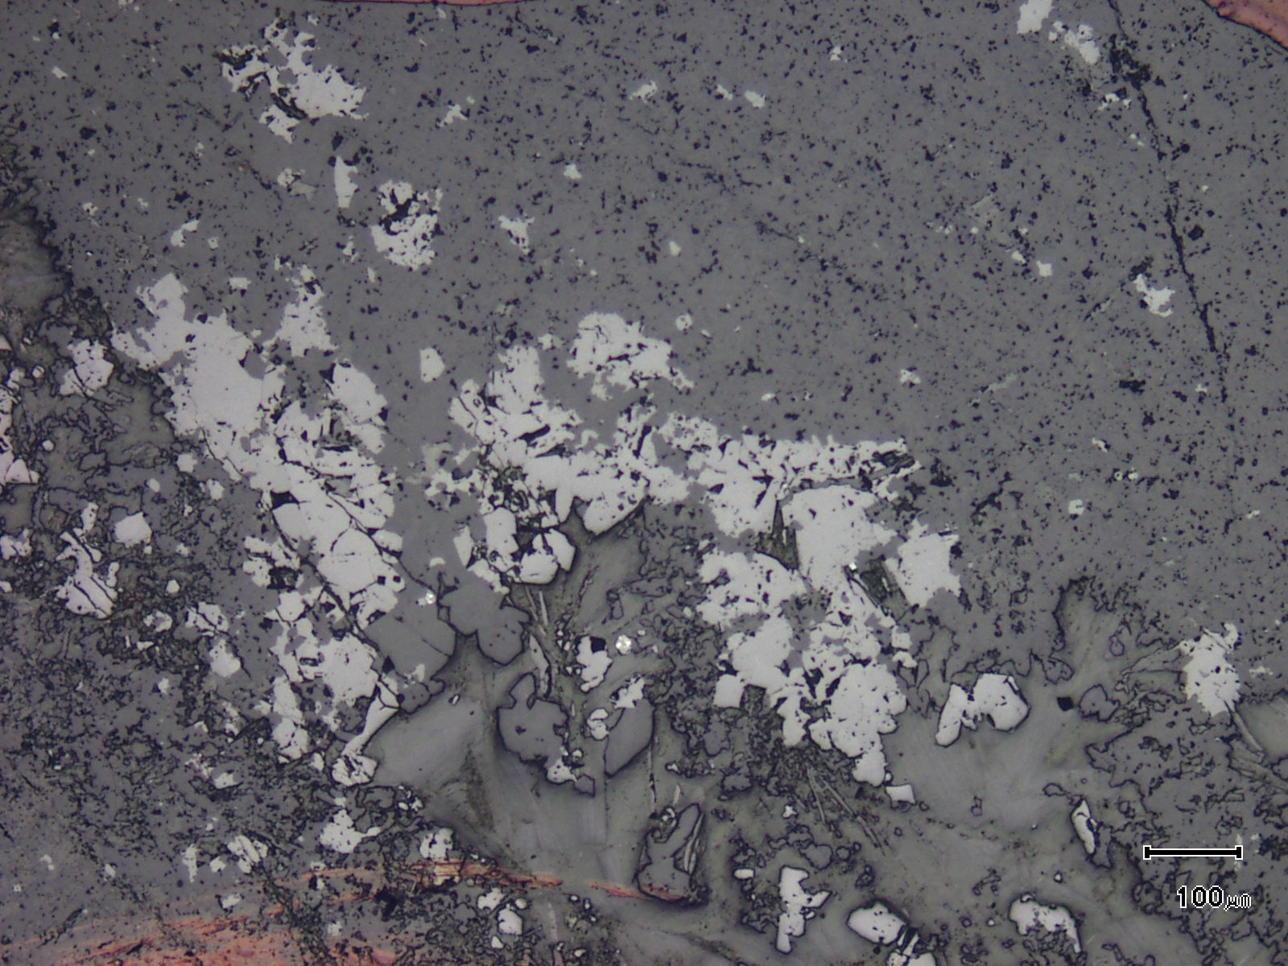
(Mag. x 100; scale bar = 100µ; reflected light)

Sample ZS113W - 275.5m

The photomicrograph shows a reflected light view of Plate 43. The cassiterite is now easily observed.

Plate 45

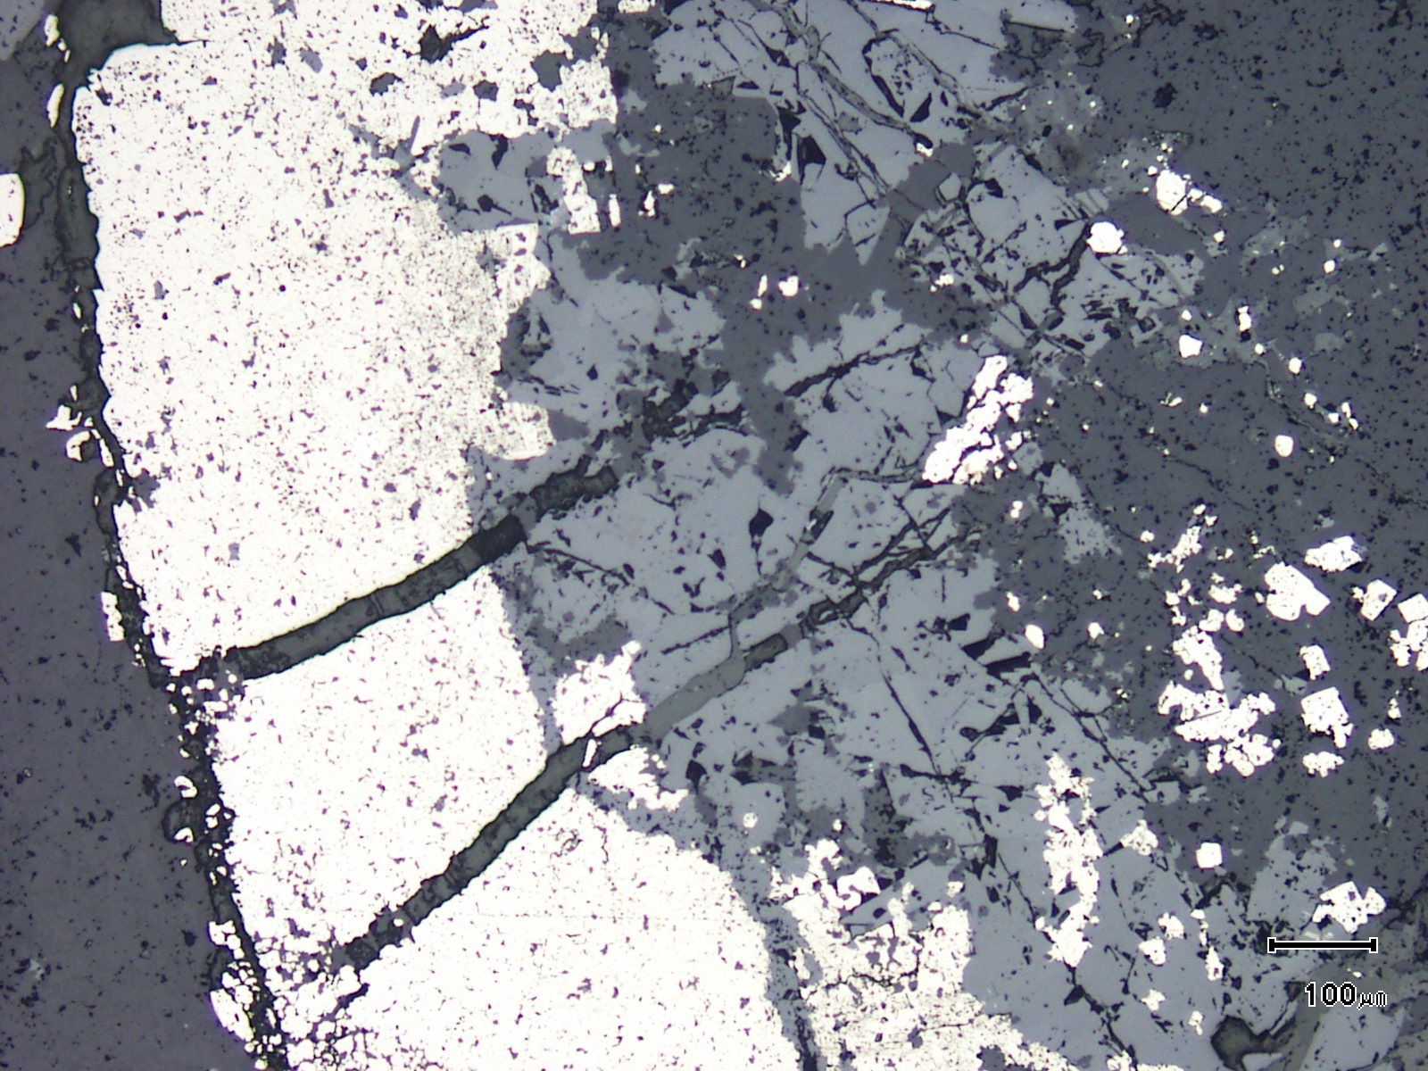
cassiterite
(Mag. x 100; scale bar = 100µ; reflected light)

Sample ZS113W - 275.5m

The reflected light photomicrograph shows massive cassiterite developing within an embayment in a pyrite lens.

Plate 46

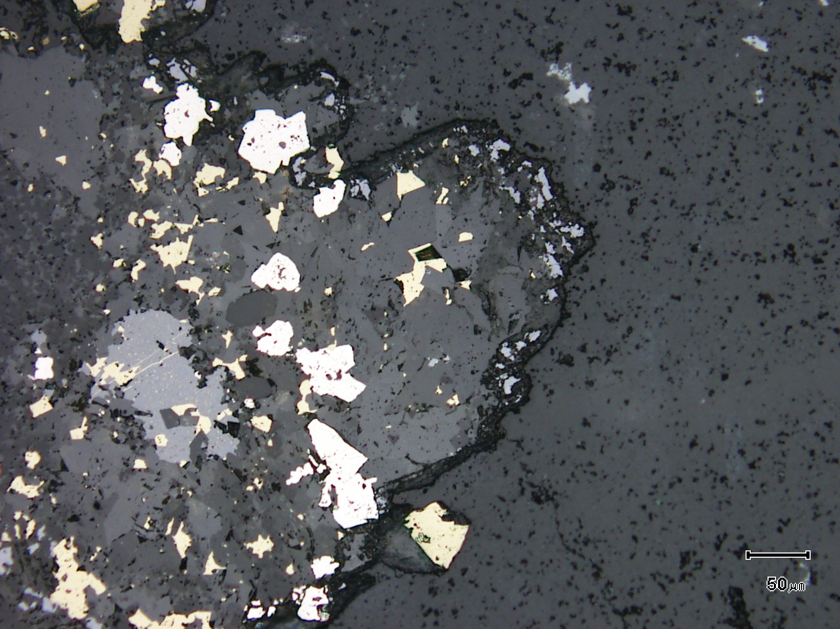
sphalerite
(Mag. x 200; scale bar = 50µ; reflected light)

Sample ZS113W - 275.5m

This unusual reflected light photomicrograph shows a stylolite-like vein within quartz. The stylolite is intimately associated with chalcopyrite, pyrite and sphalerite which develop within siderite.

Plate 47

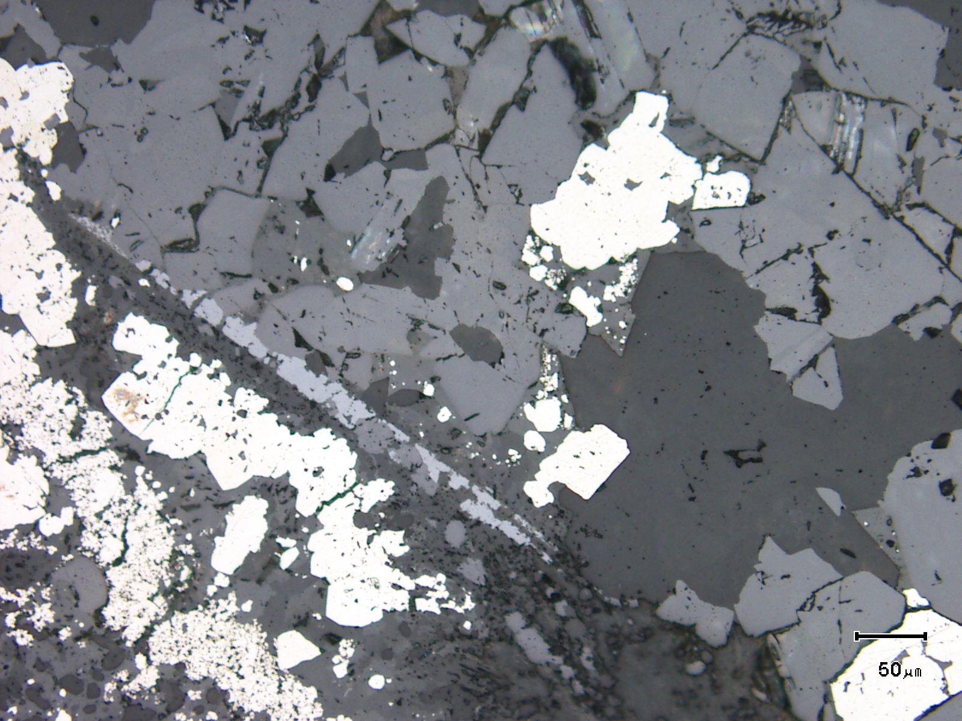
cassiterite
rutile
(Mag. x 200; scale bar = 50µ; reflected light)

Sample ZS113W - 275.5m

The reflected light photomicrograph shows a needle-like rutile aggregate which is associated with coarse grained cassiterite.

Sample Number: ZS113W - 276.2m

Sample Locality: Severn Ore body, Zeehan

Rock Type: Cassiterite rich, quartz veined, in part brecciated “lode”

Sample Description:

The sample is extremely cassiterite-rich and contains quartz veins as well as fragments and clasts of vein quartz.

A visual estimate of the minerals present is:

Pyrite ~32% Kaolinite ~ 3%
Vein quartz ~17% Tourmaline ~ 3%
Cassiterite ~17% Chalcopyrite trace
Siderite ~14% Stannite trace
Quartz ~ 7% Pyrrhotite trace
Chlorite ~ 3% Rutile trace
Hydrated iron oxides ~ 3%
(Some sericite and clays may also be present replacing tourmaline)
Cassiterite develops in numerous textural and mineralogical associations within the sample. Grains can range in size from less than 10µ to 300µ. The fine-grained material develops as xenoblastic, almost monomineralic aggregates that develop as linear bands within the sample. The cassiterite is associated with the following:
- cassiterite grains in the range of 20µ to 120µ develop as idioblastic grains within vein quartz, often near pyrite. The interlocking quartz grains (up to 0.5mm) can host granular aggregates of cassiterite to larger idioblastic, single cassiterite grains.

- monomineralic cassiterite aggregates which develop in linear bands contain grains which are usually less than 10µ in size. Minor siderite, chalcopyrite and stannite are present with the cassiterite.

- idioblastic cassiterite grains up to 0.2mm can be located within pyrite as inclusions.

- cassiterite grains up to 0.35mm develop within siderite ± tourmaline which develops along the margins of linear pyrite veins or aggregates. Tourmaline is present as acicular grains within siderite and also as pseudomorphed rosettes. The tourmaline can be replaced by clays, hydrated iron oxides and carbonate.

ZS113W - 276.2m contd.
Pyrite is coarse grained (up to 1mm), often idioblastic and contains minor inclusions. Stannite, chalcopyrite and pyrrhotite are present as inclusions with stannite often intergrown with chalcopyrite. Chalcopyrite also develops as wispy, cross cutting grains in the stannite. Chalcopyrite can rim stannite within pyrite and is also present in fractures cutting pyrite. Stannite grains can be up to 0.5mm in size with discrete chalcopyrite grains often finer grained. Rare pyrrhotite can be present as discrete grains or as composite grains with chalcopyrite.

Rutile develops as linear aggregates of grains, usually within former tourmaline-rich areas.

Plate 48

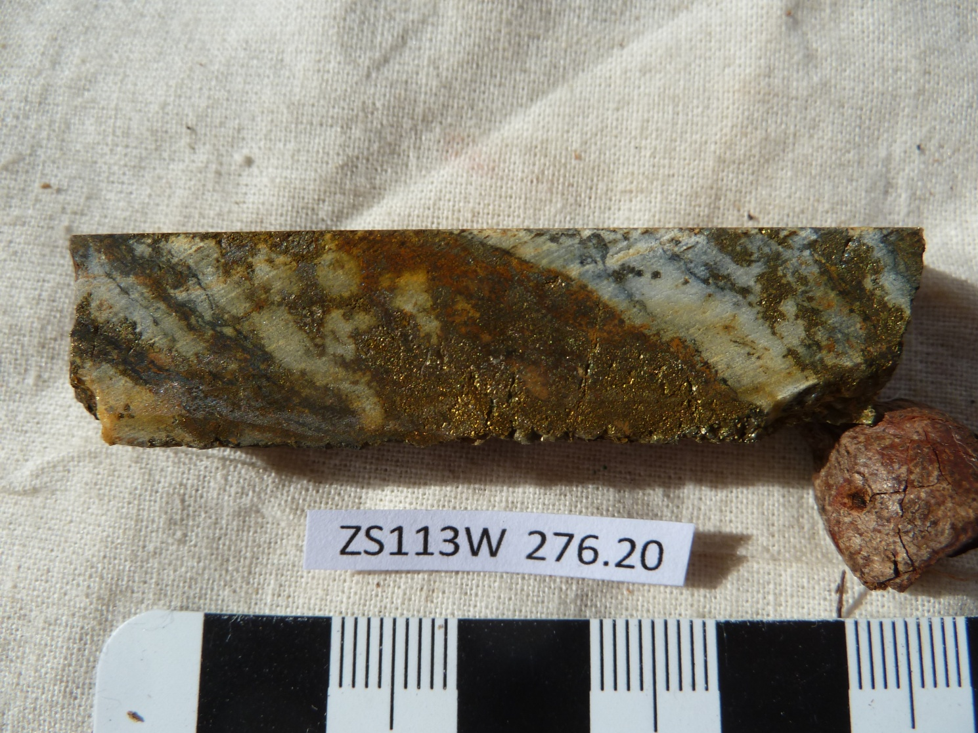

Sample ZS113W - 276.2m

The slab photograph shows a cassiterite-rich (~17%) quartz-veined and in part brecciated tin “lode”.

Plate 49

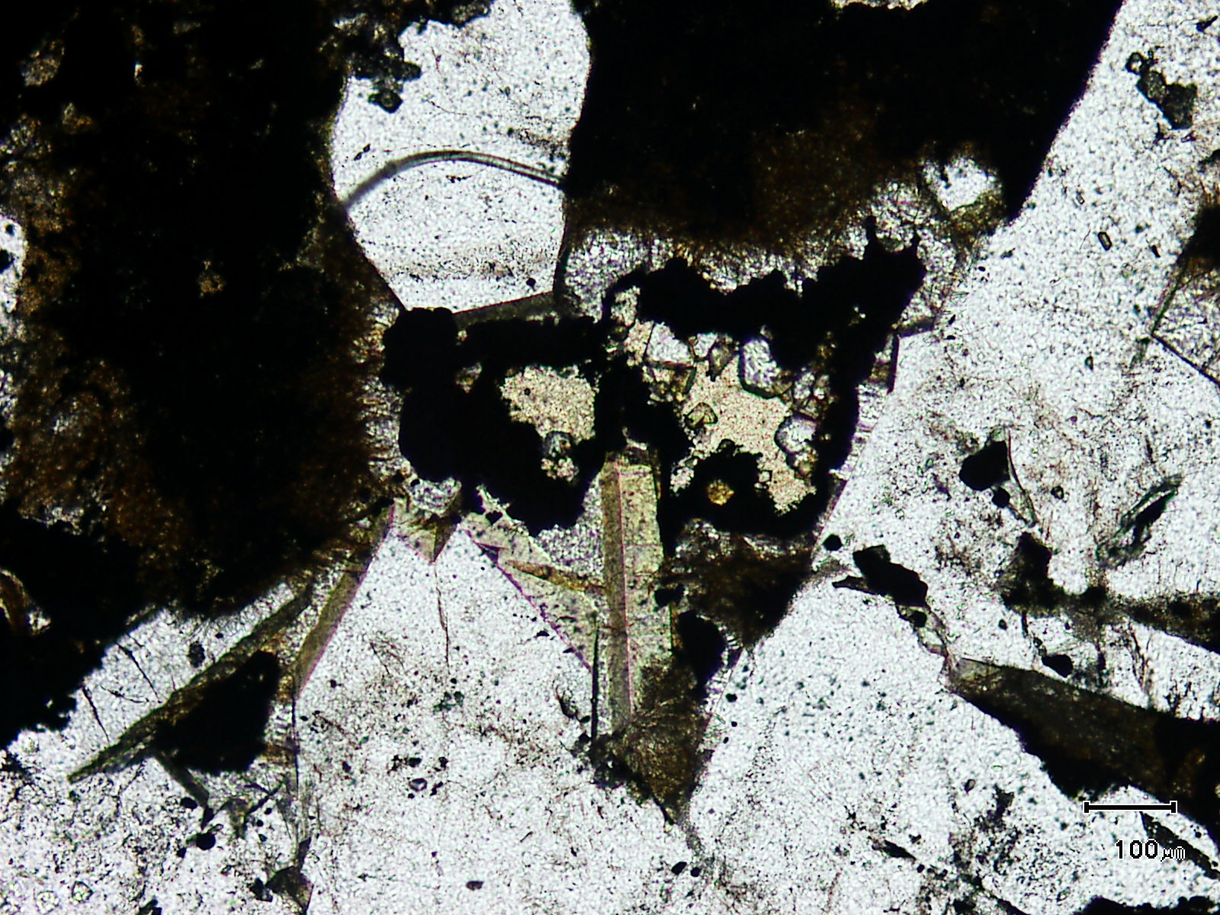
tourmaline
kaolinite
(Mag. x 100; scale bar = 100µ; PPL)

Sample ZS113W - 276.2m

The photomicrograph shows kaolinite rimmed by pyrite and associated with tourmaline.
The kaolinite is considered hypogene.

Plate 50

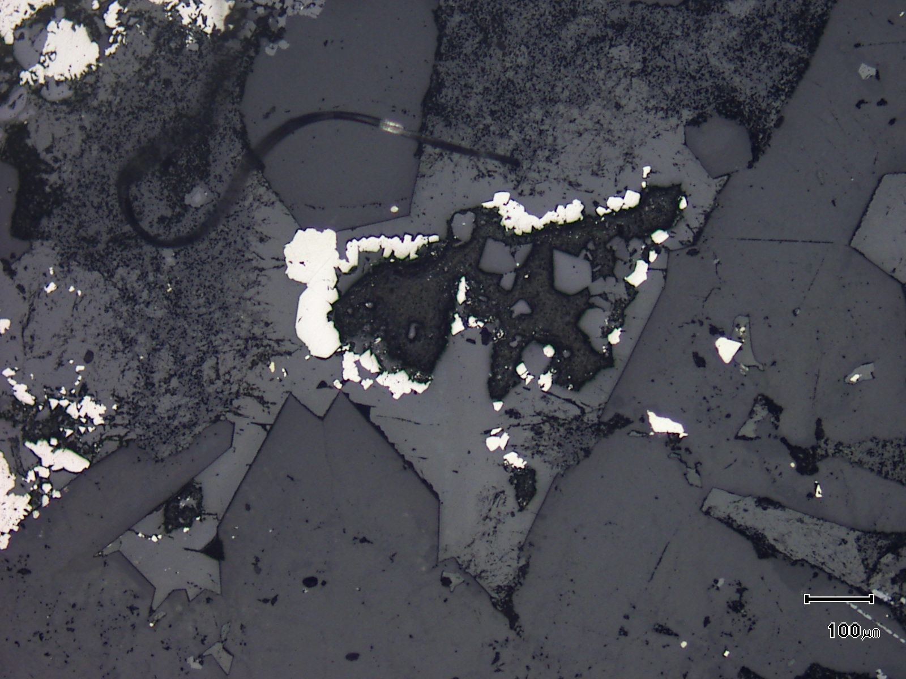
(Mag. x 100; scale bar = 100µ; reflected light)

Sample ZS113W - 276.2m

The photomicrograph shows a reflected light view of Plate 49.

Plate 51

cassiterite

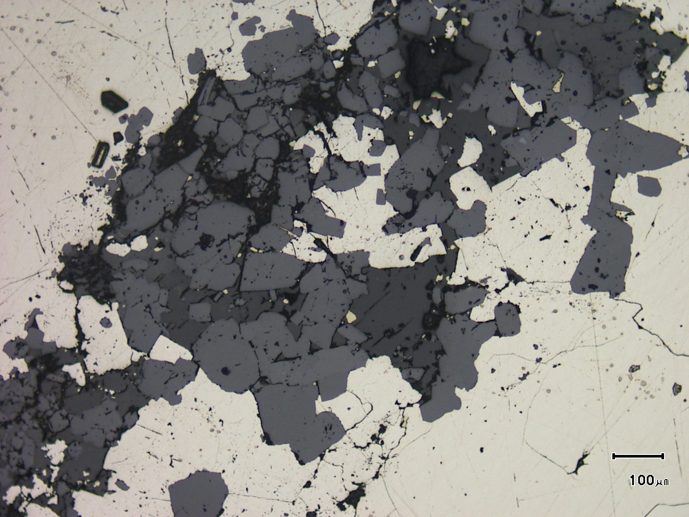
(Mag. x 100; scale bar = 100µ; reflected light)

Sample ZS113W - 276.2m

The reflected light photomicrograph shows abundant cassiterite sitting within pyrite. It should be noted however that the cassiterite has developed along a fracture within the pyrite.

Plate 52

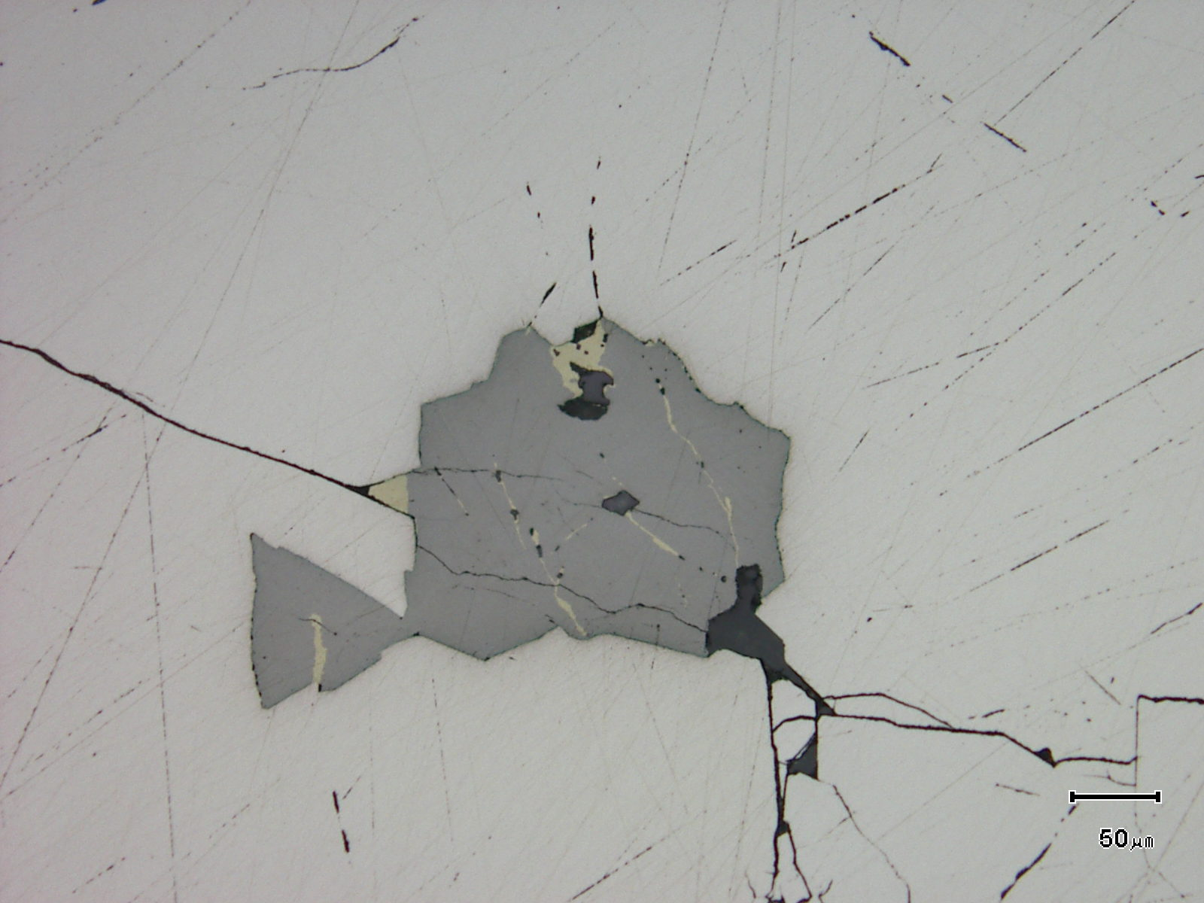
(Mag. x 200; scale bar = 50µ; reflected light)

Sample ZS113W - 276.2m

The reflected light photomicrograph shows a stannite grain associated with minor chalcopyrite and pyrrhotite sitting within pyrite. The stannite is also developing along major fractures within pyrite.

Plate 53

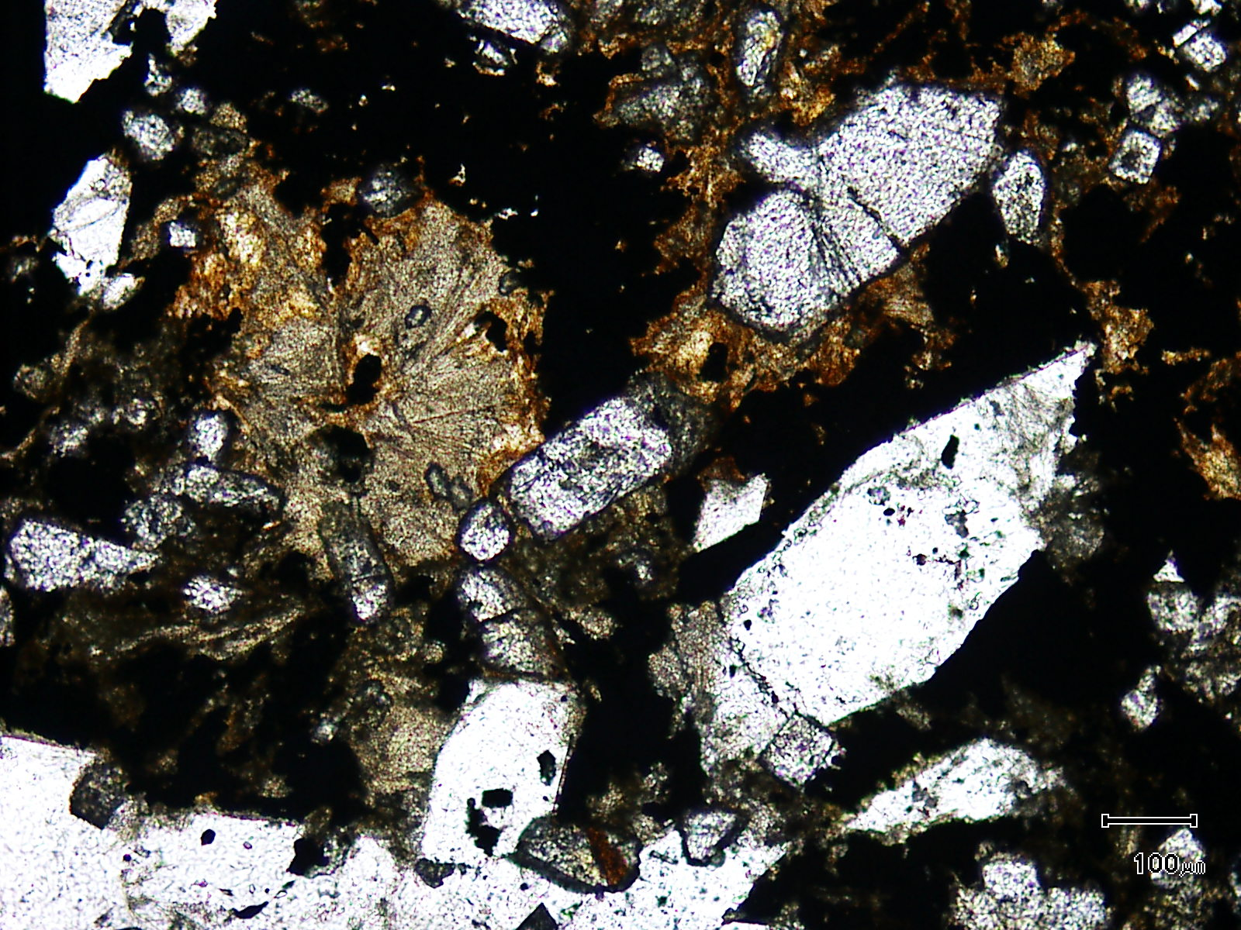
former tourmaline
cassiterite
(Mag. x 100; scale bar = 100µ; PPL)

Sample ZS113W - 276.2m

The photomicrograph shows a general textural view of coarse grained cassiterite associated with former tourmaline and idioblastic quartz.

Plate 54

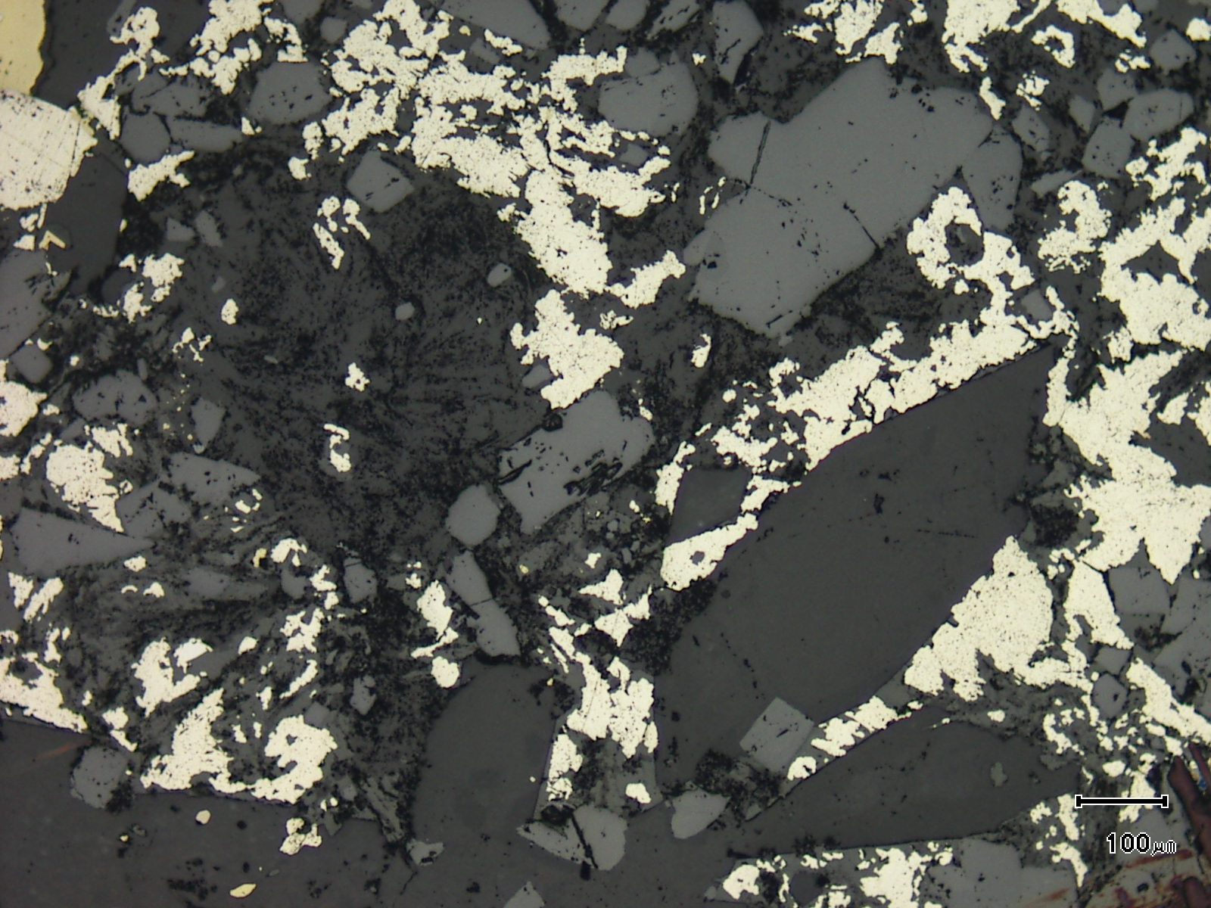
(Mag. x 100; scale bar = 100µ; reflected light)

Sample ZS113W - 276.2m

The photomicrograph shows a reflected light view of Plate 53.

Plate 55

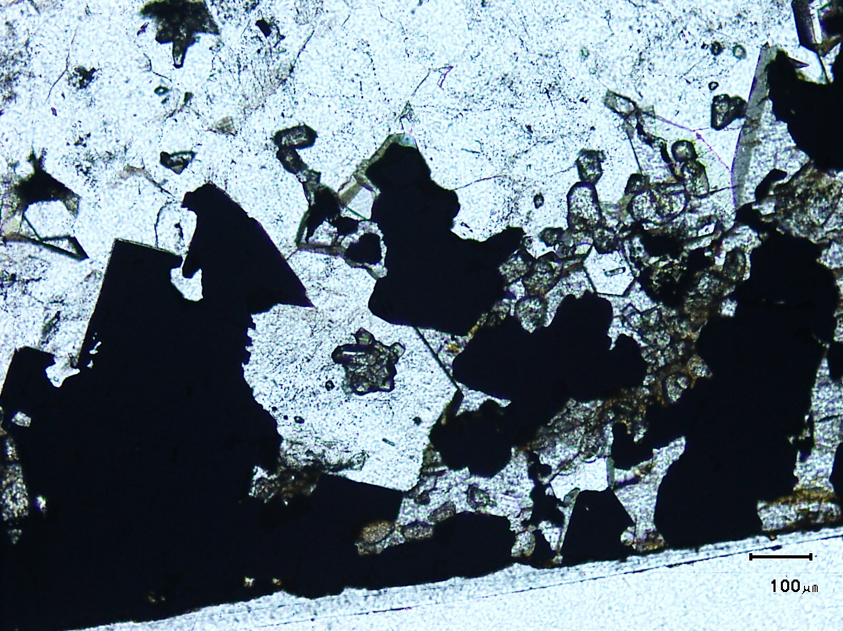
cassiterite
(Mag. x 100; scale bar = 100µ; PPL)

Sample ZS113W - 276.2m

The photomicrograph shows cassiterite developing within vein quartz and siderite. Note the cassiterite aggregate sitting within an idioblastic quartz grain.

Plate 56

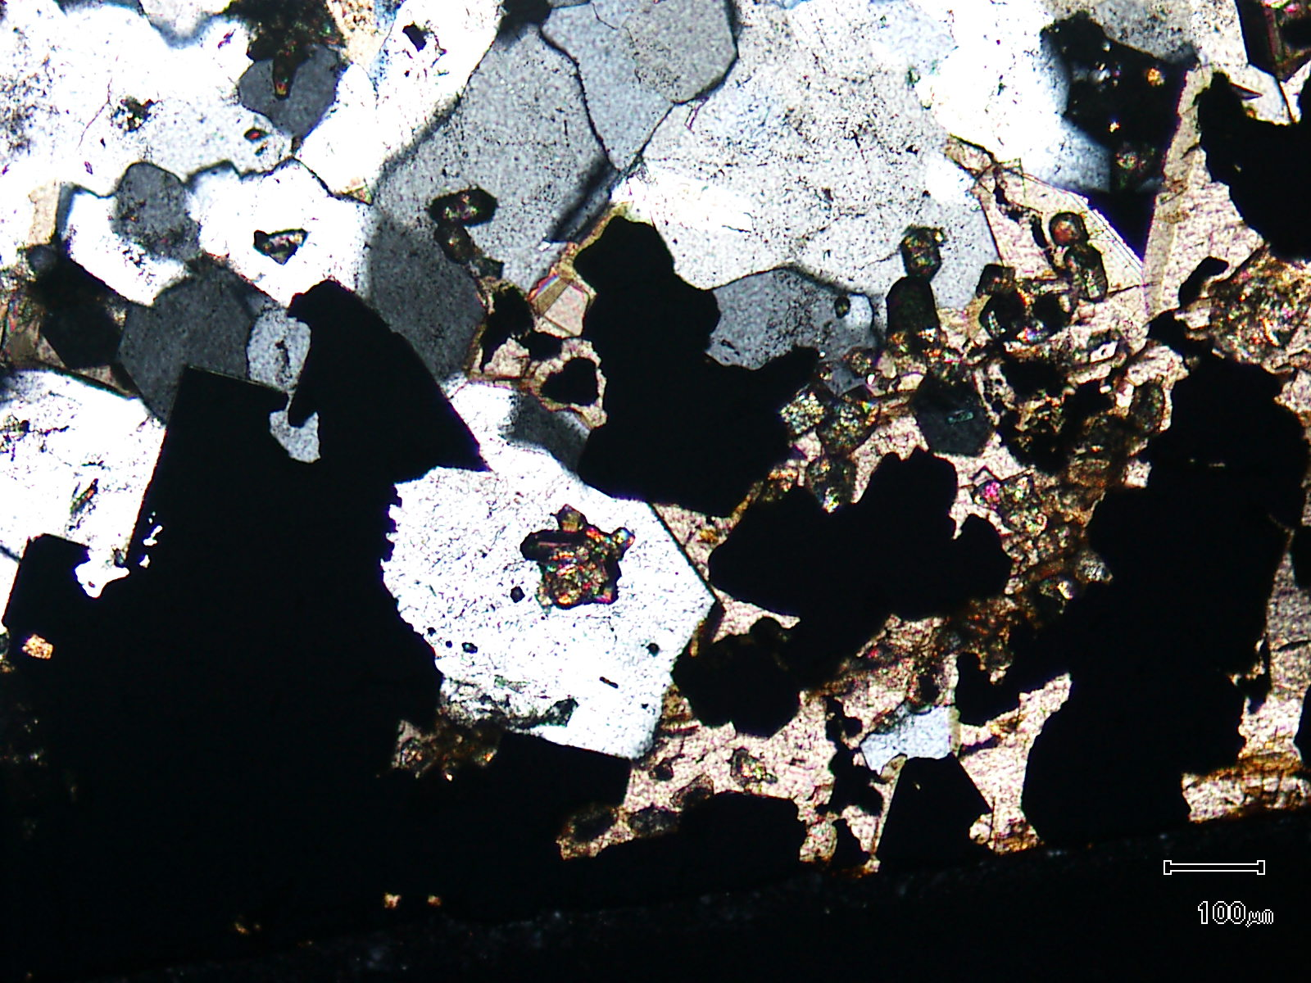
siderite
(Mag. x 100; scale bar = 100µ; crossed nicols)

Sample ZS113W - 276.2m

The photomicrograph shows a cross nicols view of Plate 55. Note the abundant siderite.

Plate 57

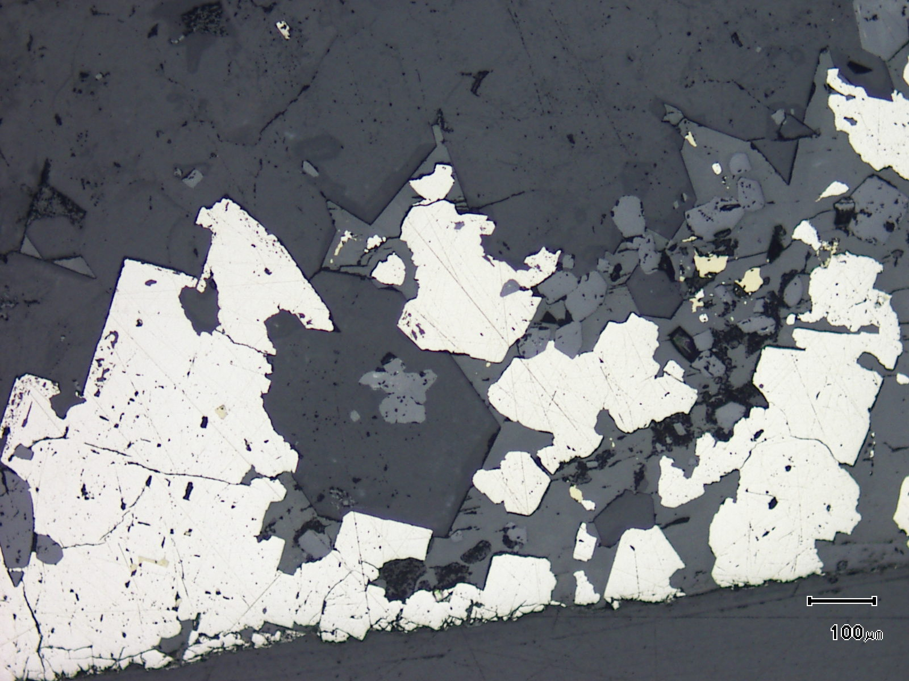
(Mag. x 100; scale bar = 100µ; crossed nicols)

Sample ZS113W - 276.2m

The photomicrograph shows a reflected light view of Plate 55.

Sample Number: ZS113W - 276.7m

Sample Locality: Severn Ore body, Zeehan

Rock Type: Quartz and pyrite veined, strongly deformed carbonaceous meta-pelite
Sample Description:

The sample contains an anastomosing network of pyrite and associated quartz veins. These develop sub-parallel to a strong fabric developed within a carbonaceous meta-pelite.

A visual estimate of the minerals present is:

Pyrite ~38% Hydrated iron oxides ~ 2%
Quartz ~26% Siderite ~ 1%
Vein quartz ~12% Cassiterite trace
Chlorite ~ 6% Chalcopyrite trace
Carbonaceous matter ~ 6% Stannite trace
Rutile ~ 5% Pyrrhotite trace
“Sericite” ~ 3% ?Magnetite trace

The strong fabric is dominated by intercalated carbonaceous matter and fine grained, recrystallised quartz. The quartz is fine grained and usually less than 5µ in size and appears to be replacive, introduced along the developing fabric. This fabric appears to be developing within a fold hinge and is axial planar. Within this fabric are abundant grains and grain aggregates of anatase/rutile.
Pyrite tends to develop within veins (± vein quartz) with these veins sub-parallel to parallel to the strong fabric. Earlier quartz replacement and veins are cut by these pyrite ± quartz veins. The pyrite veins average 1mm in thickness and have a central core that is generally inclusion-free but does contain chalcopyrite, stannite and pyrrhotite inclusions. The outer portions, or vein margins, are choked with fine grained inclusions (see Plate 60) and the margins of the veins are often enclosed by rutile/anatase rich bands.
Stannite inclusions in pyrite contain minute chalcopyrite inclusions. Chalcopyrite and pyrrhotite inclusions can be up to 50µ in size. Rare chalcopyrite also develops adjacent to veins and grains can be up to 200µ in diameter, Chalcopyrite and pyrrhotite composite inclusions in the vein pyrite are also present.
The vein quartz often exhibits high strain textures with ribbon quartz present. Rare cassiterite can be located in the vein quartz. Rare magnetite was observed at the pyrite vein margins.
Sericite and chlorite can be found in the groundmass, generally in areas close to or within pyrite veining. The grains are fine, being less than 6µ in size. Rare siderite is present as inclusions within the vein pyrite.
It would appear that this lithotype flanks cassiterite “infill” lodes.
Plate 58

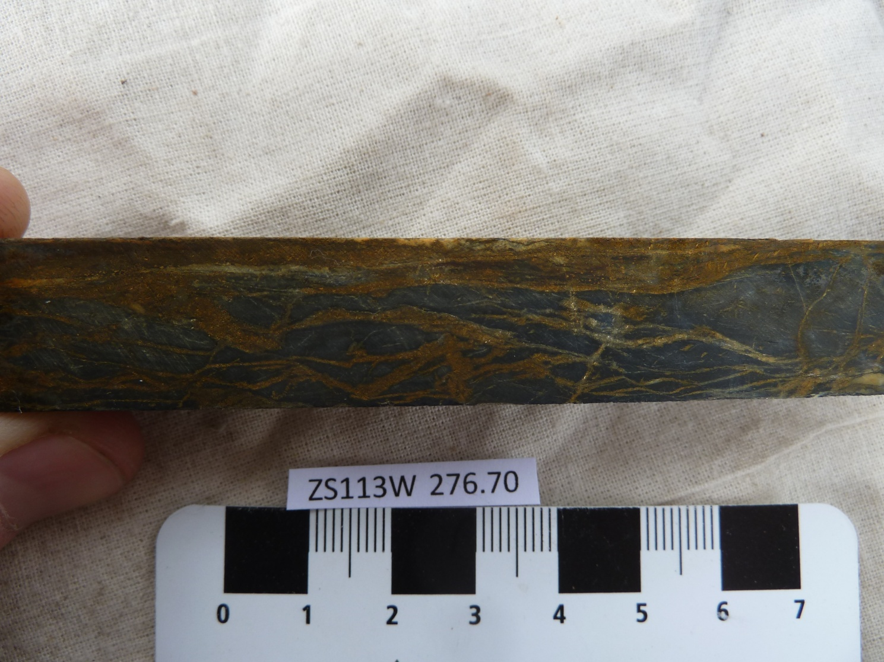

Sample ZS113W - 276.7m

The slab photograph shows an anastomosing network of pyrite and associated quartz veins which develop sub-parallel to a strong fabric.

Plate 59

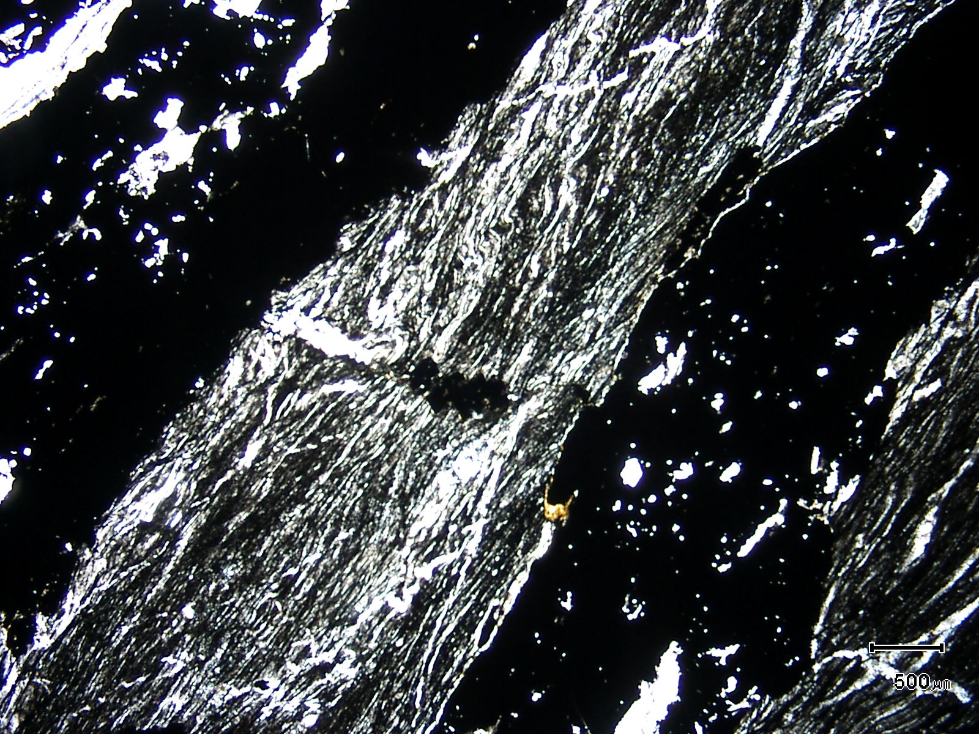
(Mag. x 20; scale bar = 500µ; PPL)

Sample ZS113W - 276.7m

Here, the strong fabric, with associated layer parallel quartz veining, is associated with inclusion-rich pyrite (black).

Plate 60

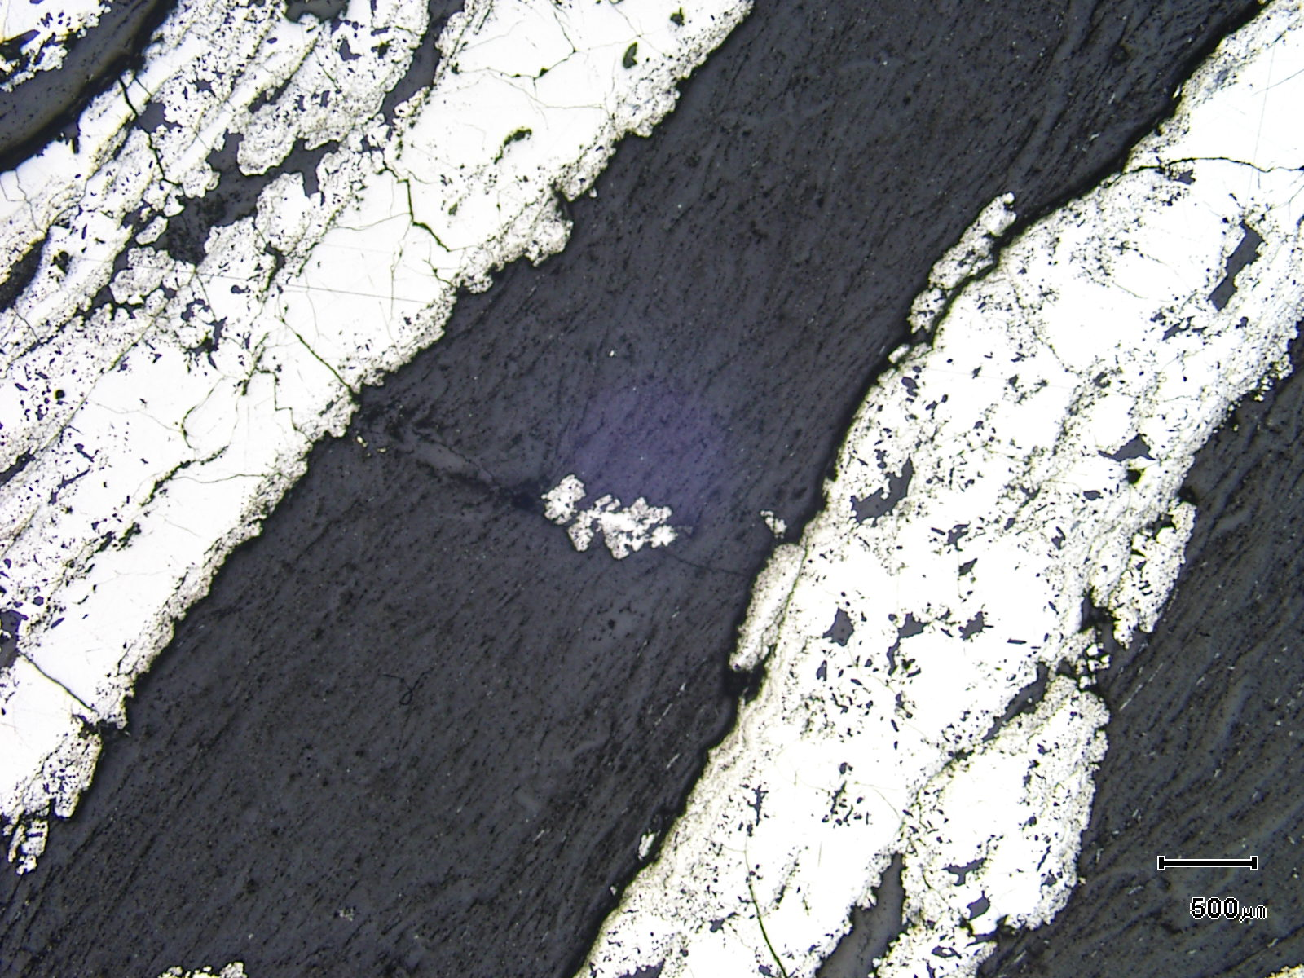
(Mag. x 20; scale bar = 500µ; reflected light)

Sample ZS113W - 276.7m

The photomicrograph shows a reflected light view of Plate 59.

Plate 61

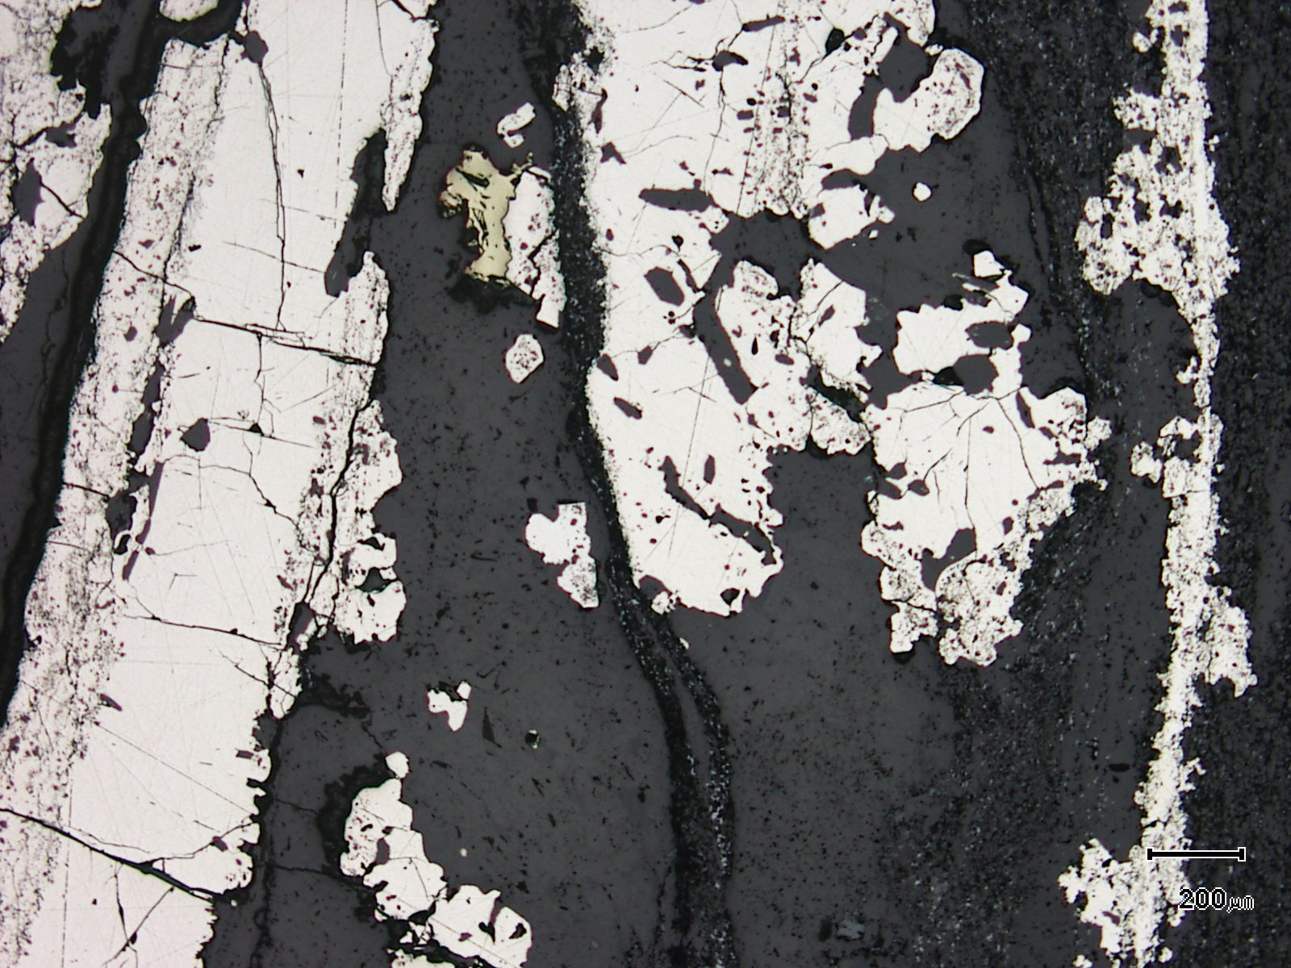
rutile-cassiterite band
chalcopyrite
(Mag. x 50; scale bar = 200µ; reflected light)

Sample ZS113W - 276.7m

The reflected light photomicrograph shows minor chalcopyrite associated with pyrite. Note the textures developed within the pyrite. Thin bands of rutile-rich material parallel the main fabric and contain trace cassiterite.

Sample Number: ZS113W - 282.4m

Sample Locality: Severn Ore body, Zeehan

Rock Type: Pyritic, siderite-chlorite altered, ?mafic volcaniclastic

Sample Description:

The sample is dominated by chlorite, siderite and quartz, with “patchy”, often vein like pyrite which is associated with siderite. Siderite aggregates throughout the sample can be choked with fine chalcopyrite grains.

A visual estimate of the minerals present is:

Chlorite ~28% Rutile ~ 4%
Quartz ~26% Chalcopyrite ~ 1%
Siderite ~22% Stannite trace
Pyrite ~12% Cassiterite trace
Hydrated iron oxides ~ 6% Pyrrhotite trace

Pyrite develops as wispy bands and veins which crudely follow a weak cleavage. It is possible that the pyrite exhibits a siderite-rich “spotting” adjacent to major accumulations. This sideritic halo is best observed using a hand lens and studying the off-cut. The pyrite is intimately associated with siderite and siderite often rims the pyrite. Pyrite is often choked with coarse inclusions and siderite is dominant. The pyrite contains inclusions of chalcopyrite and pyrrhotite with the latter being dominant. Grains can be up to 100µ in size.
Patchy siderite domains can be up to 2mm in length and contain abundant chalcopyrite. The chalcopyrite can be up to 150µ in size and there are also finer grained cassiterite and stannite.
There is a crude banding in the sample with chlorite-rich and quartz-rich groundmass material. The former contains a mesh textured network of intergrown, fine grained (~30µ) chlorite with lesser quartz, siderite and rutile/anatase. The latter is dominated by chlorite-rich domains with lesser chlorite and siderite-rich domains.
Rutile is abundant and develops in linear “trains” of grains cutting across the sample and parallel to the weak fabric.

Plate 62

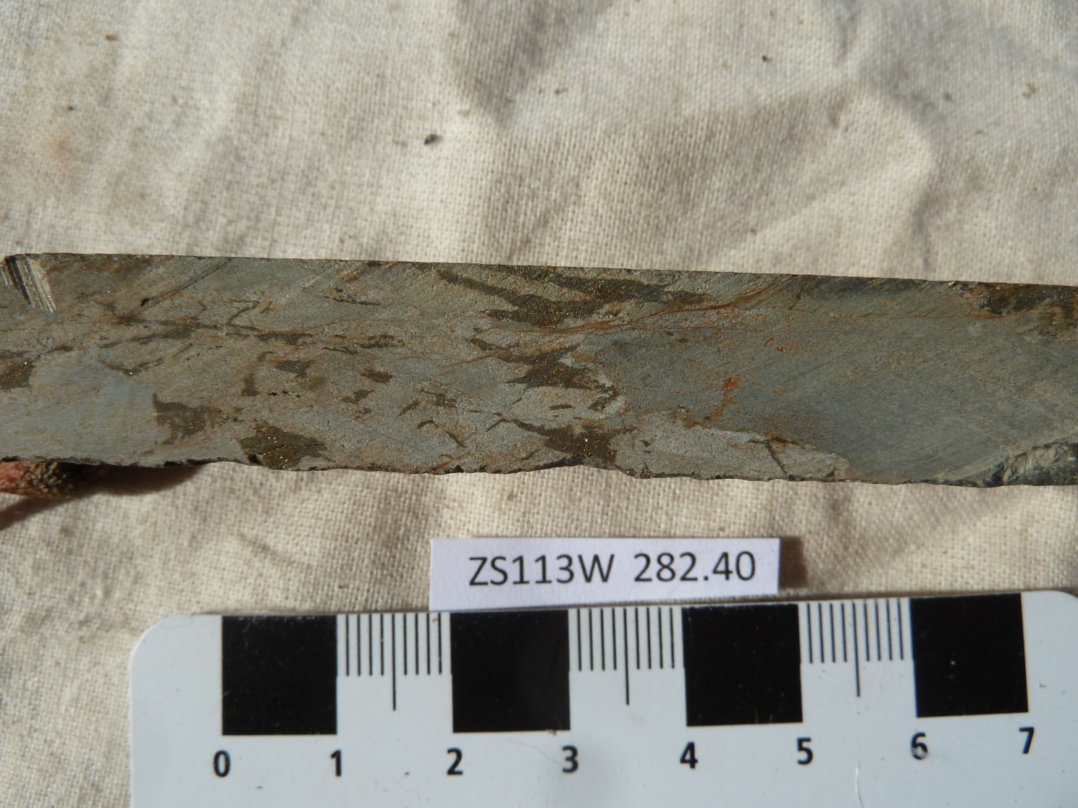

Sample ZS113W - 282.4m

The slab photograph shows a pyritic, siderite-chlorite-altered mafic volcaniclastic. It contains abundant siderite (~22%) and chlorite (~28%).

Plate 63

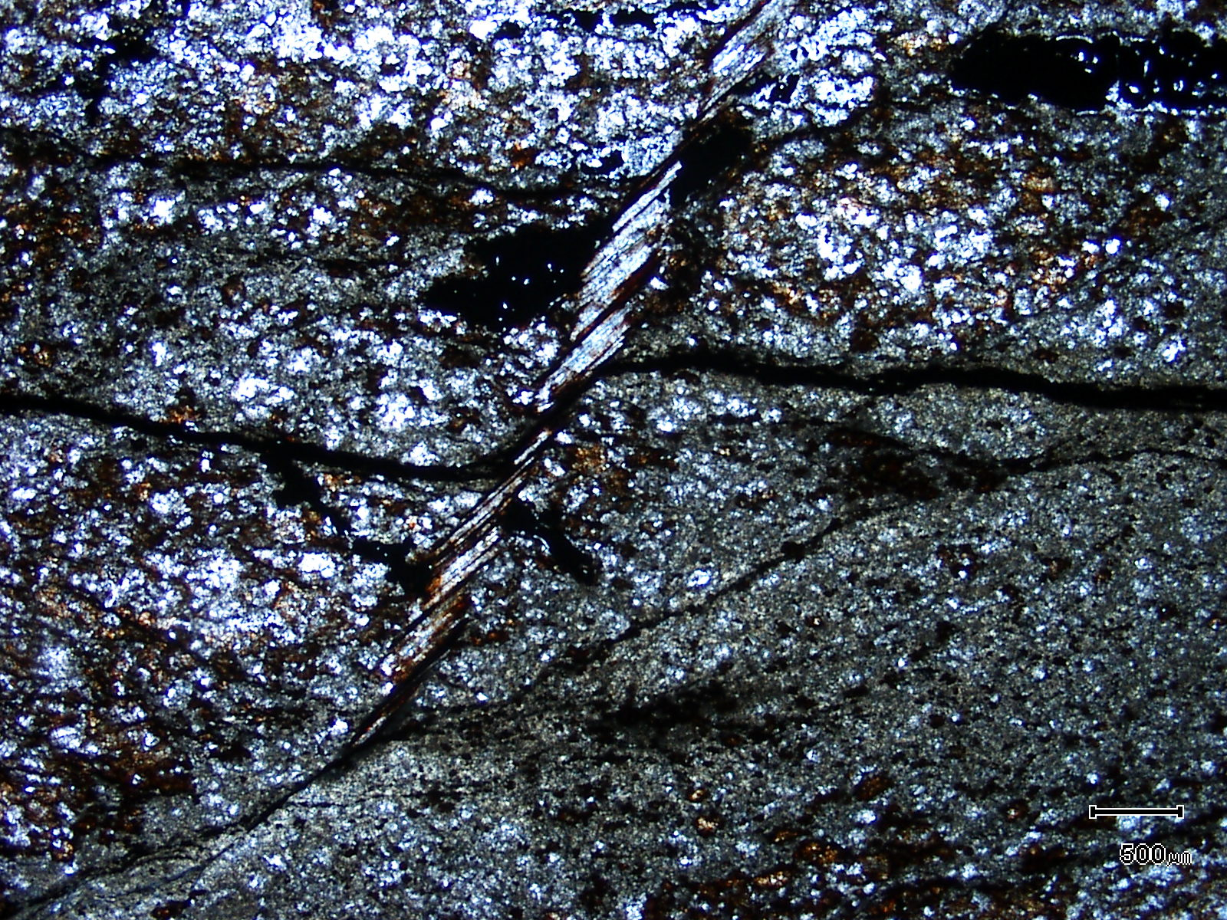
(Mag. x 200; scale bar = 500µ; PPL)

Sample ZS113W - 282.4m

The photomicrograph shows a general textural view of this sample.

Plate 64

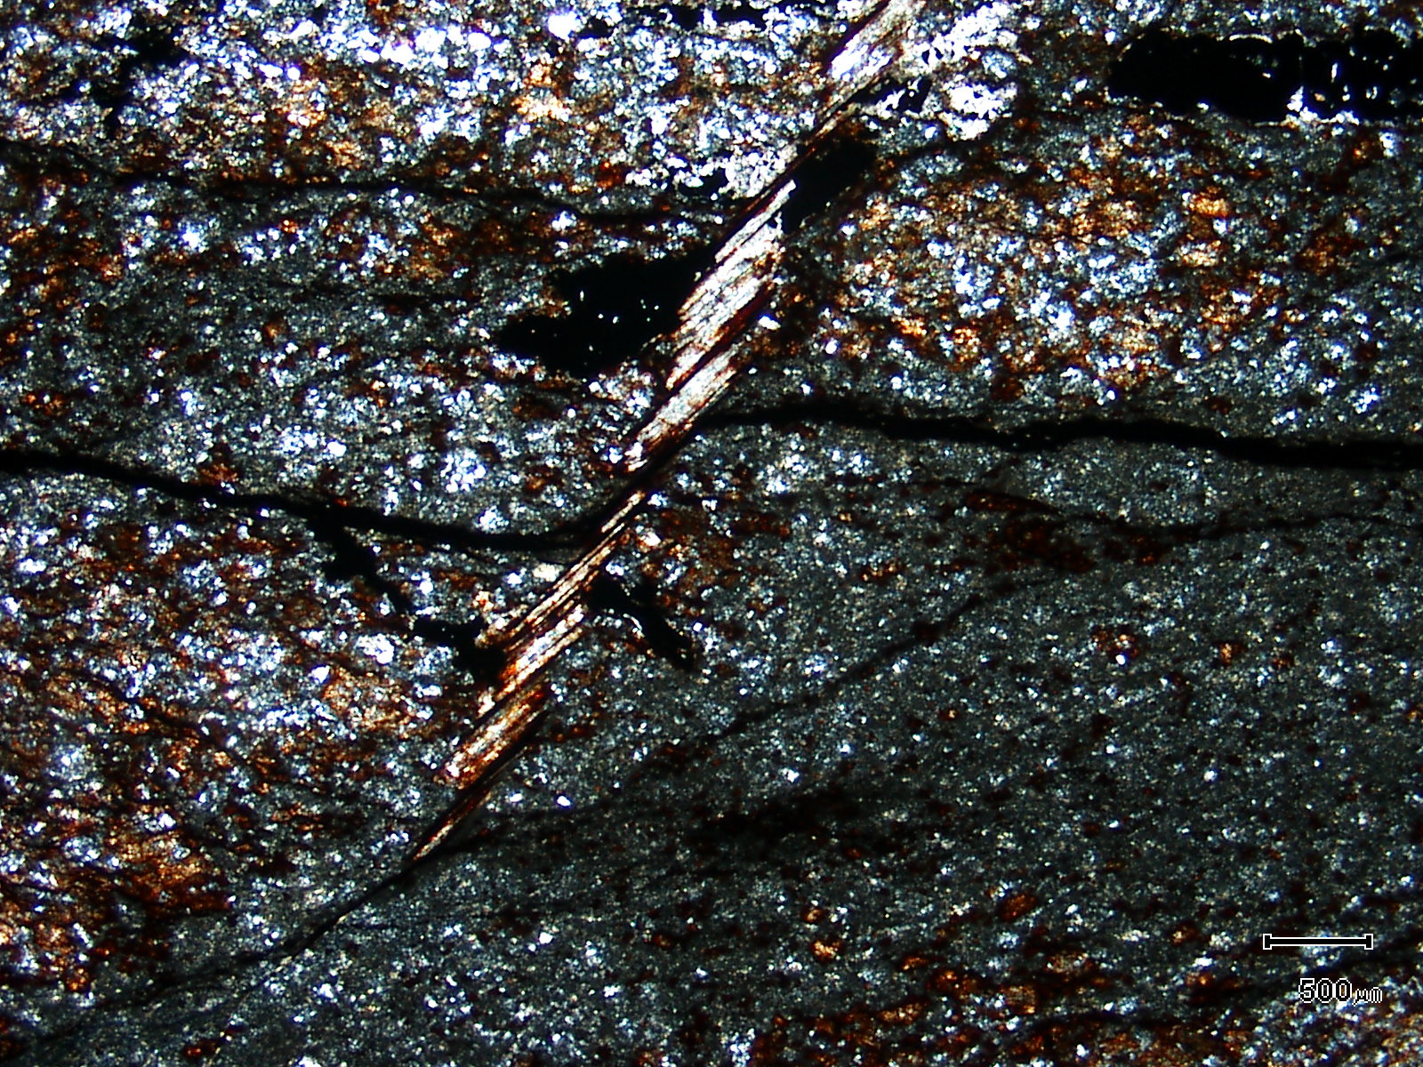
(Mag. x 20; scale bar = 500µ; crossed nicols)

Sample ZS113W - 282.4m

The photomicrograph shows a cross nicols view of Plate 63.

Sample Number: ZS113W - 287.5m

Sample Locality: Severn Ore body, Zeehan

Rock Type: Quartz altered, pyrrhotite veined, cassiterite rich meta mafic volcaniclastic

Sample Description:

The sample contains abundant pyrrhotite which is present in veins and as disseminations associated with siderite alteration. The pyrrhotite veins tend to be associated with zones of silicification and the pyrrhotite often contains exceptionally coarse grained (up to 0.8mm) cassiterite. The one metre interval 287m-288m contains 4.85% Sn, 990 ppm As and significant Cu.

A visual estimate of the minerals present is:

Quartz alteration ~28% Tourmaline ~ 5%
Pyrrhotite ~21% Fluorite ~ 2%
Chlorite/biotite ~18% Pyrite ~ 2%
Siderite ~10% Chalcopyrite ~ 1%
Cassiterite ~ 6% Arsenopyrite ~ 1%
Quartz ~ 5% Stannite trace

Cassiterite is coarse grained and averages 0.35mm. Grains can be fractured and some are micro-brecciated. Idioblastic grains are common and many contain inclusions of rutile. The cassiterite does not contain inclusions of sulphides. The cassiterite can be observed in the following textural and mineralogical associations:

- grains up to 250µ developed within siliceous domains and associated with iron stained chlorite and ?biotite

- grains up to 700µ (0.7mm) present as inclusions in pyrrhotite or intimately associated with pyrrhotite. These grains have inclusions of probable biotite and fractures are infilled by pyrrhotite. The cassiterite is idioblastic.

- idioblastic grains associated with disseminated pyrrhotite, stannite and chalcopyrite which are present within siliceous, quartz plus ?biotite domains. In these areas smaller grains can be totally enclosed within ?biotite (?stilpnomelane).

Pyrrhotite contains abundant inclusions of cassiterite, siderite, quartz and arsenopyrite. The latter can be up to 200µ in diameter. The arsenopyrite contains inclusions of chalcopyrite and pyrrhotite and wispy arsenopyrite infills fractures in the pyrrhotite. Chalcopyrite and stannite are also disseminated throughout the sample with stannite often rimmed by chalcopyrite.

ZS113W - 287.5m contd.
Patchy fluorite contains acicular inclusions of tourmaline and double terminated quartz idioblasts. The fluorite is replaced by siderite. Bladed tourmaline is also present throughout some areas of the sample and grains are green in colour and up to 0.2mm in length. The tourmaline can be replaced by quartz.

Plate 65

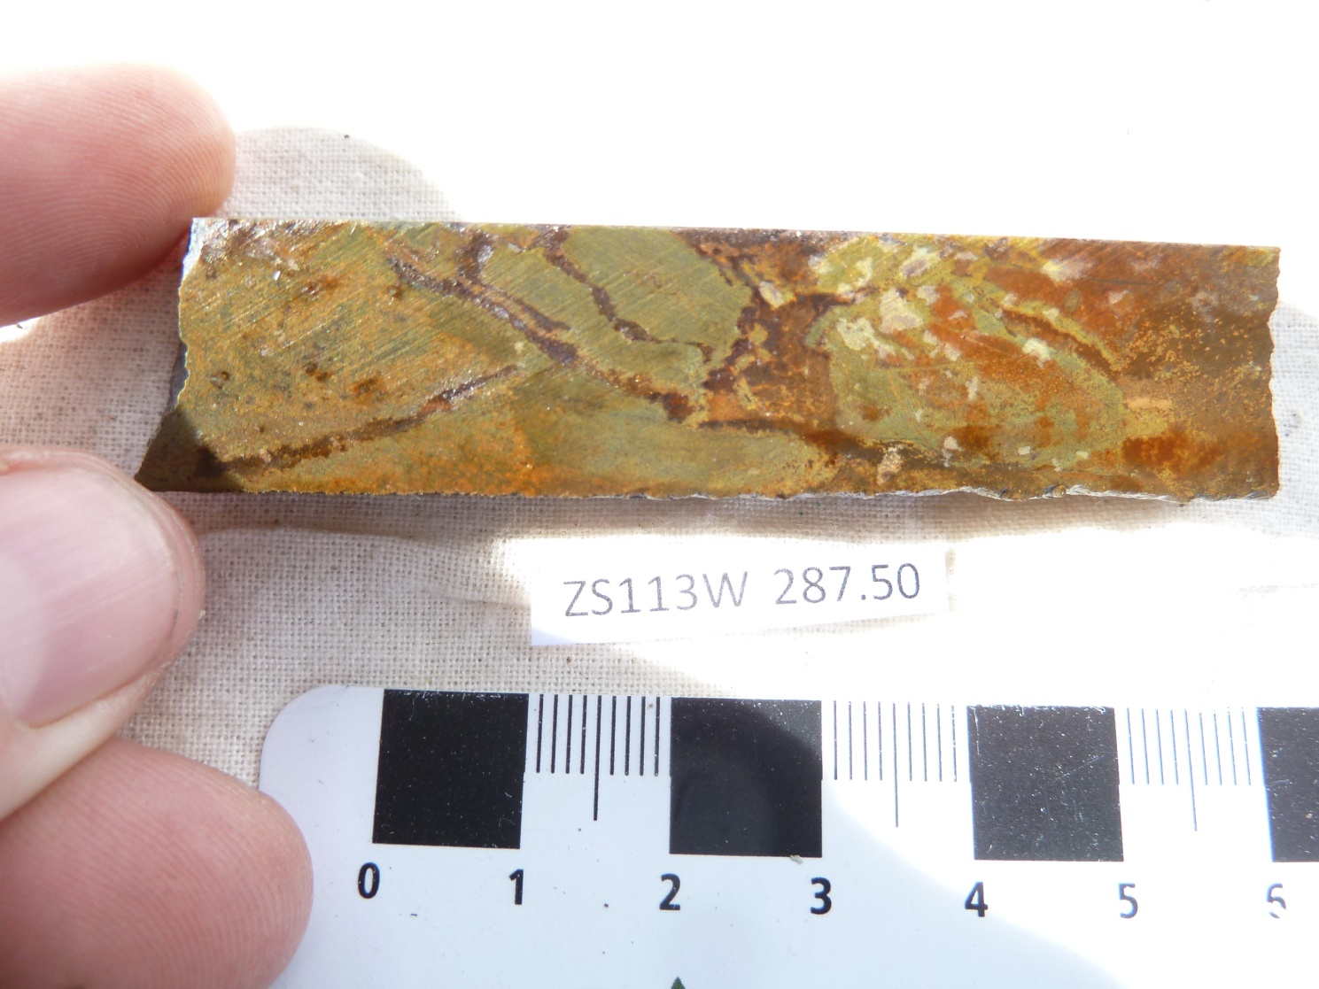

Sample ZS113W - 287.5m

The slab photograph shows a quartz-altered and pyrrhotite veined cassiterite-rich meta-mafic volcaniclastic. The cassiterite develops in numerous textural associations.

Plate 66

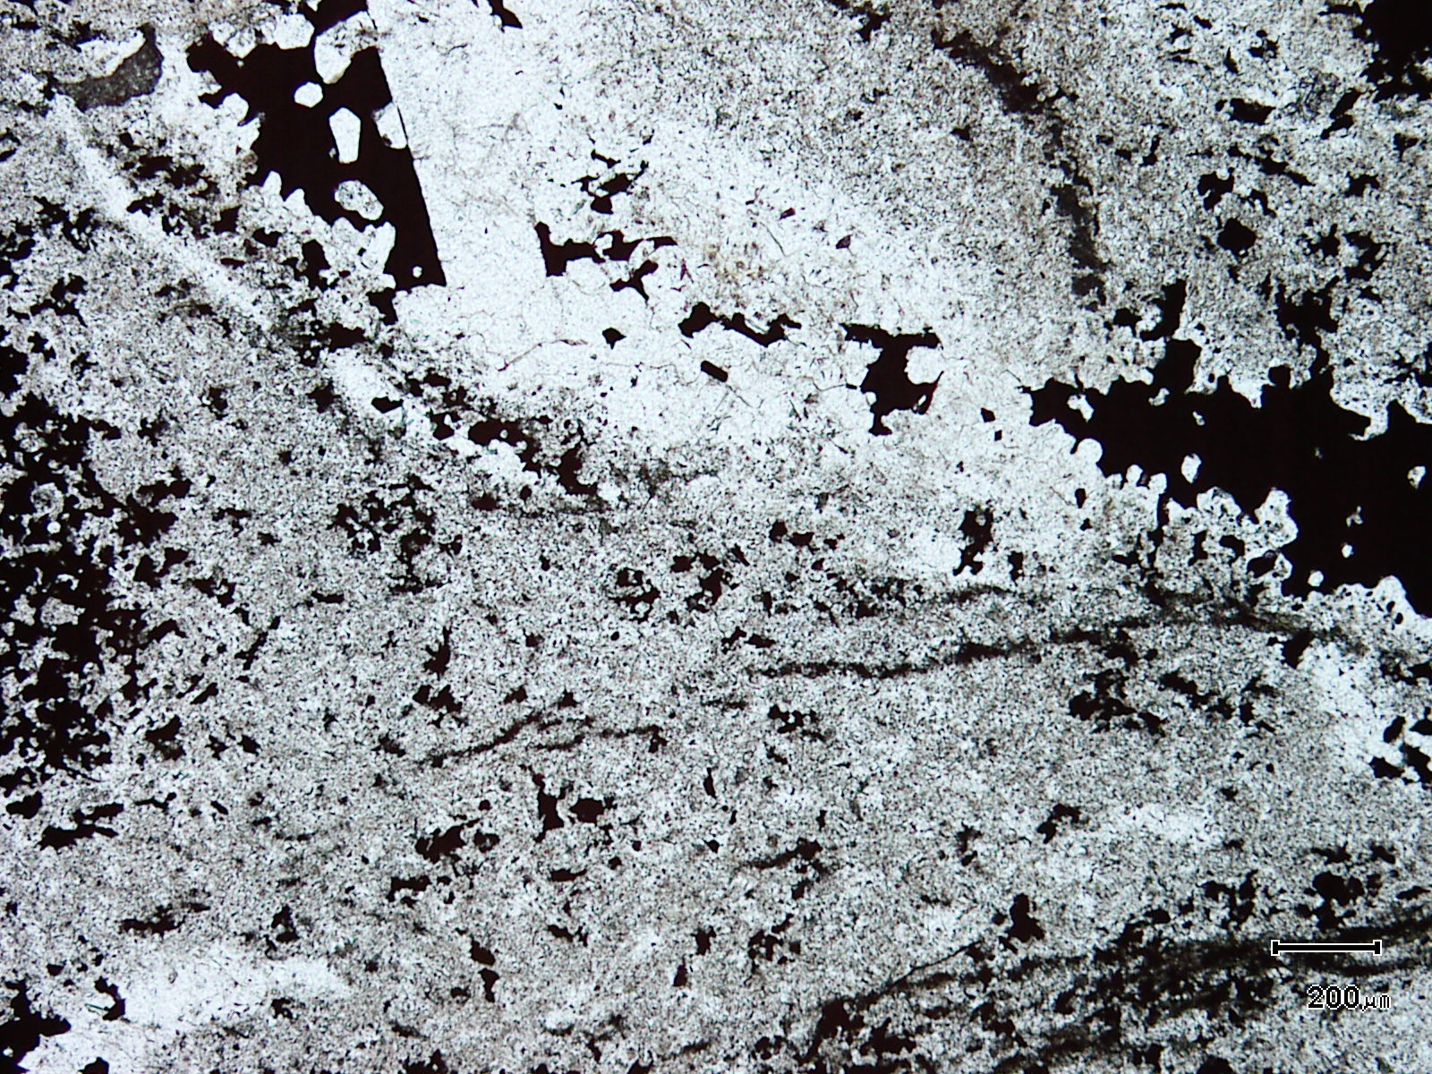
(Mag. x 50; scale bar = 200µ; PPL)

Sample ZS113W - 287.5m

The photomicrograph shows a general textural view of this quartz-altered sample.

Plate 67

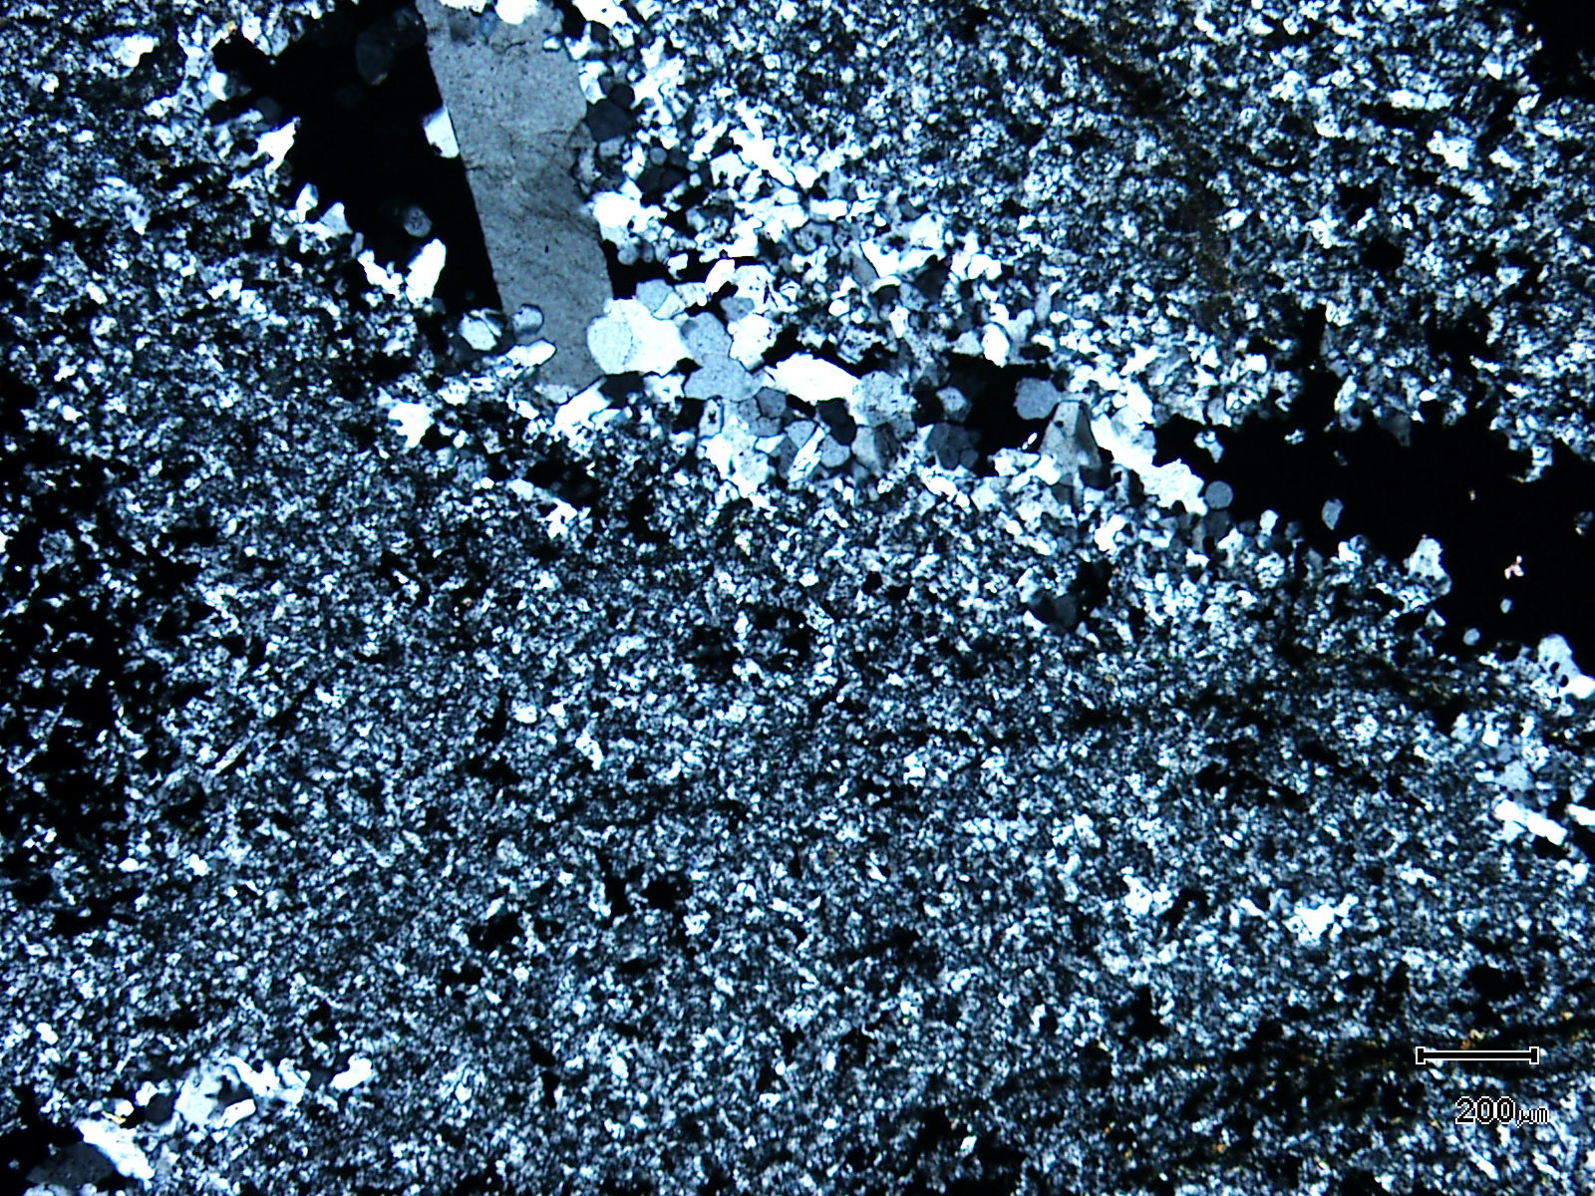
(Mag. x 50; scale bar = 200µ; crossed nicols)

Sample ZS113W - 287.5m

The photomicrograph shows a cross nicols view of Plate 66. Note the fine and coarse grained quartz which is replacing the former volcaniclastic.

Plate 68

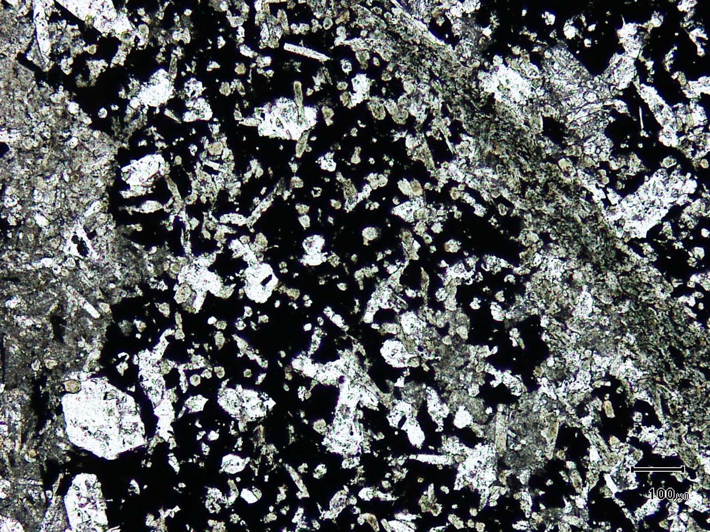
tourmaline
siderite
(Mag. x 100; scale bar = 100µ; PPL)

Sample ZS113W - 287.5m

Here, tourmaline and siderite and associated idioblastic quartz sit within pyrite as well as siderite.

Plate 69

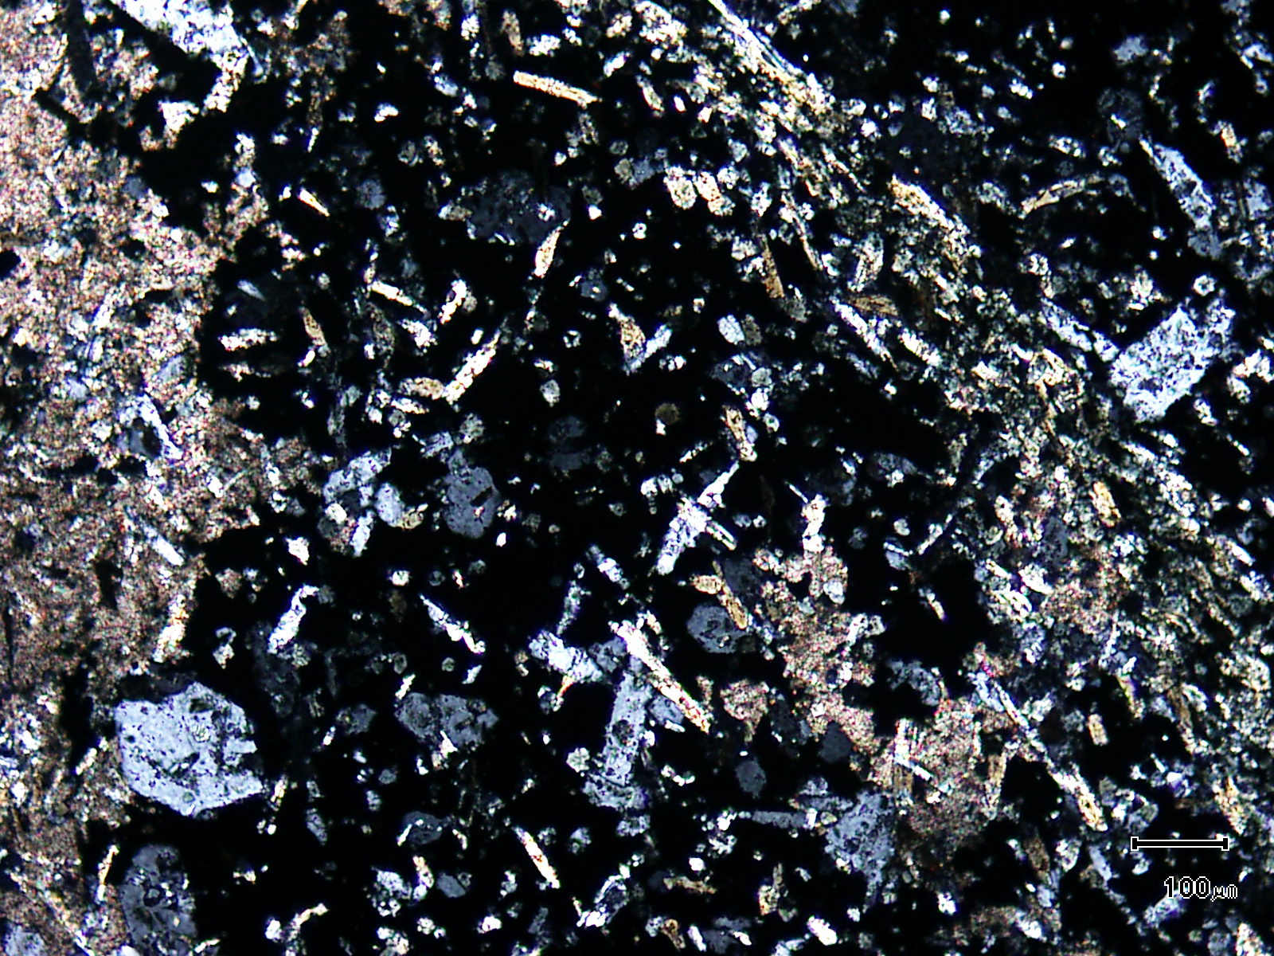
(Mag. x 100; scale bar = 100µ; crossed nicols)

Sample ZS113W - 287.5m

The photomicrograph shows a cross nicols view of Plate 68.

Plate 70

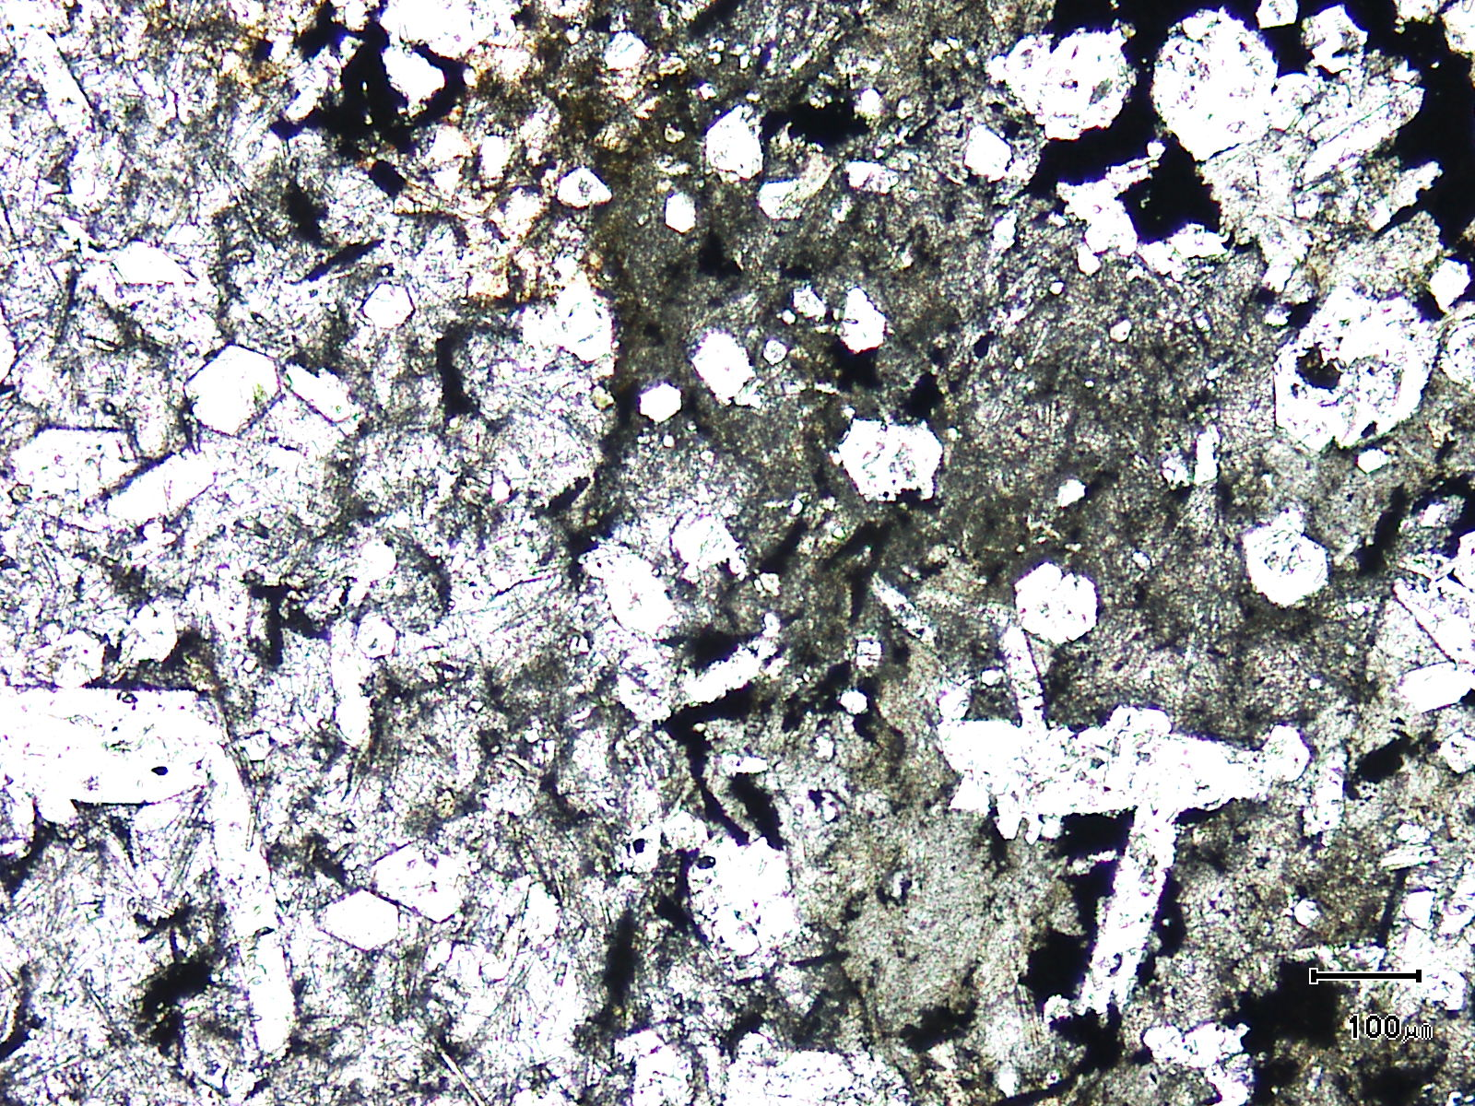
(Mag. x 100; scale bar = 100µ; PPL)

Sample ZS113W - 287.5m

The photomicrograph shows a general textural view of siderite replacing fluorite. The siderite forms the groundmass to the RHS of the photomicrograph with fluorite on the LHS. Idioblastic quartz is unaffected.

Plate 71

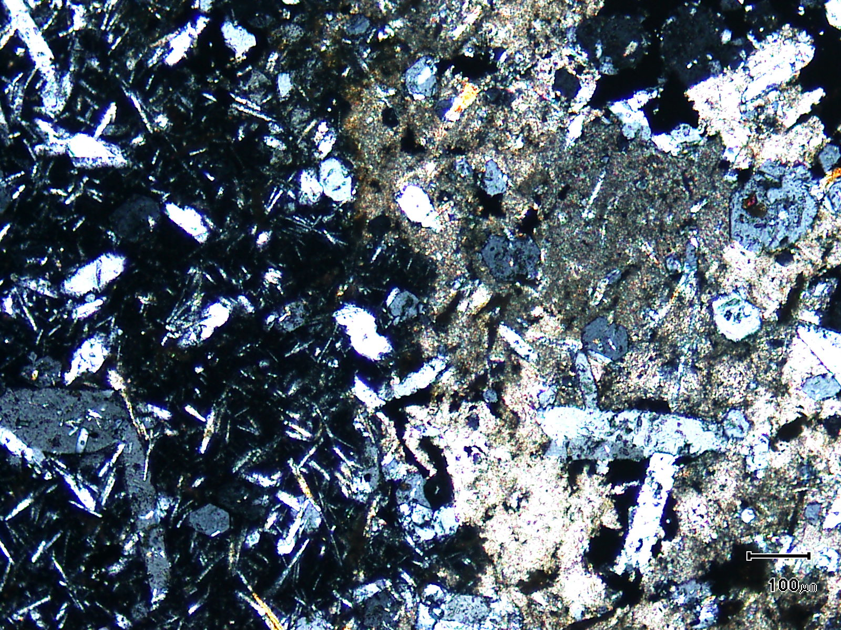
(Mag. x 100; scale bar = 100µ; crossed nicols)

Sample ZS113W - 287.5m

The photomicrograph shows a cross nicols view of Plate 70. The fluorite is isotropic (black).

Plate 72

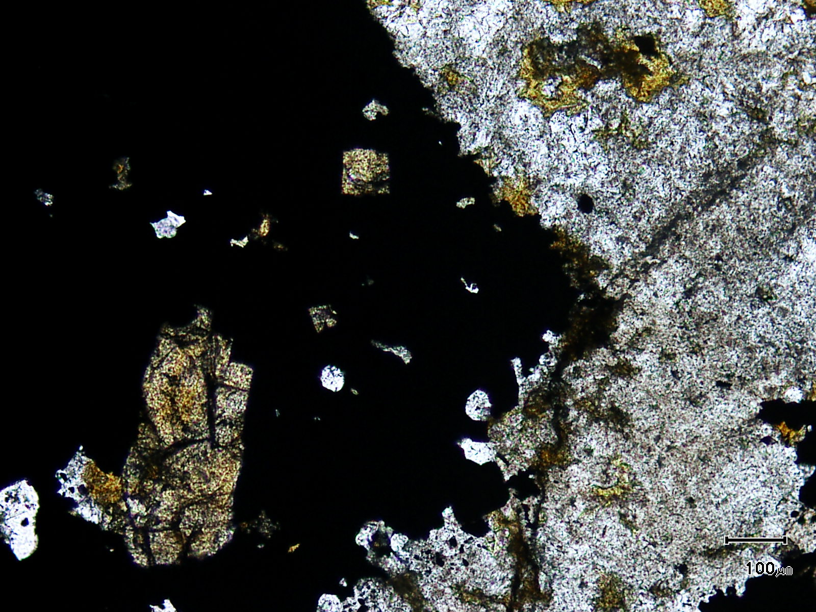
cassiterite
(Mag. x 100; scale bar = 100µ; PPL)

Sample ZS113W - 287.5m

Cassiterite sits within pyrite in this photomicrograph. The groundmass is composed of quartz, chlorite and acicular tourmaline.

Plate 73

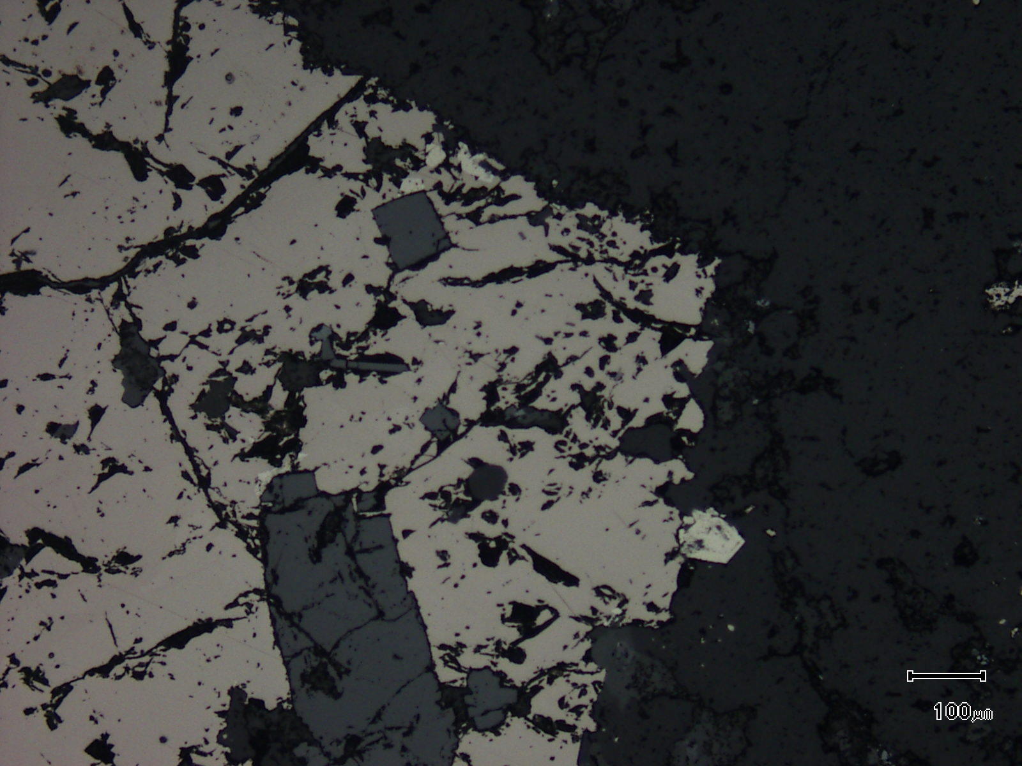
(Mag. x 100; scale bar = 100µ; reflected light)

Sample ZS113W - 287.5m

The photomicrograph shows a reflected light view of Plate 72. Note the coarse grained nature of the cassiterite.

Plate 74

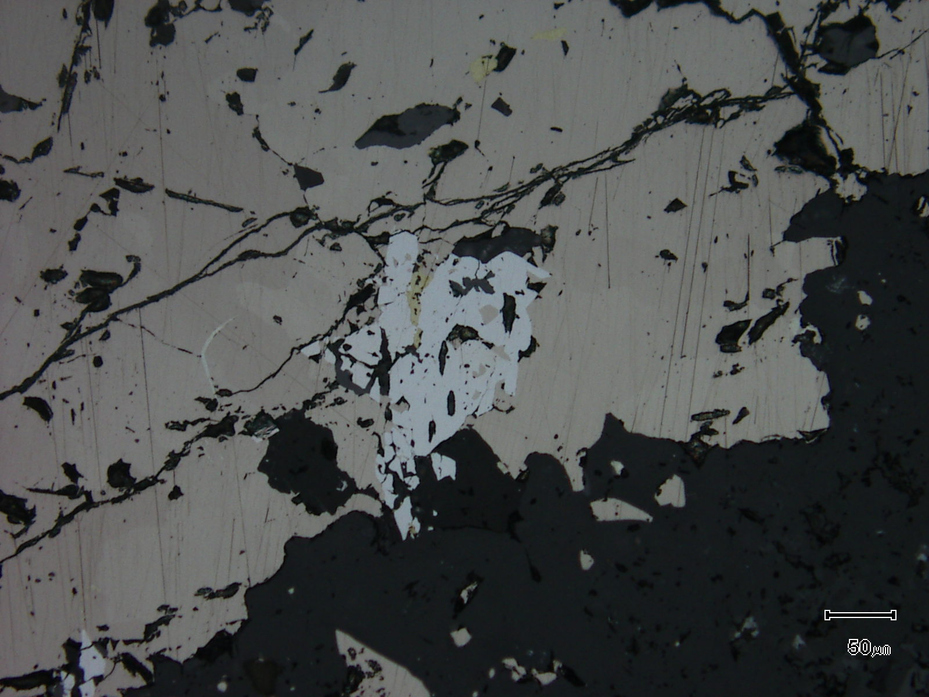
pyrrhotite
arsenopyrite
(Mag. x 200; scale bar = 50µ; reflected light)

Sample ZS113W - 287.5m

The reflected light photomicrograph shows an arsenopyrite grain sitting within pyrrhotite. The arsenopyrite contains inclusions of pyrrhotite and chalcopyrite and wispy arsenopyrite develops in the pyrrhotite.

Plate 75

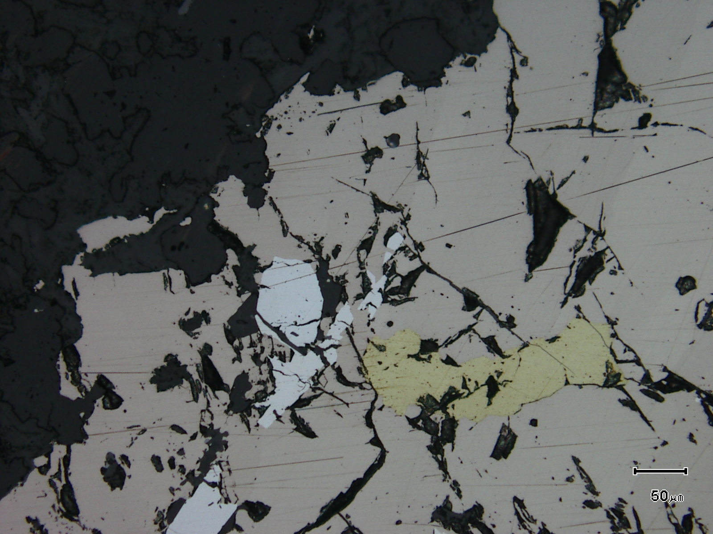
chalcopyrite
arsenopyrite
(Mag. x 200; scale bar = 50µ; reflected light)

Sample ZS113W - 287.5m

The reflected light photomicrograph shows arsenopyrite and chalcopyrite inclusions in pyrrhotite.

Sample Number: ZS113W - 294.2m

Sample Locality: Severn Ore body, Zeehan

Rock Type: Brecciated, siderite altered, sulphidic, former tourmaline rich “lode”

Sample Description:

The sample may have originally been a fluorite-tourmaline-rich lithotype with siderite replacing fluorite. It is sulphide rich with a possible clast of pyrrhotite-rich material present (see slab photo, Plate 76).

A visual estimate of the minerals present is:
Pyrrhotite ~28% Rutile ~ 5%
Siderite ~23% Arsenopyrite ~ 2%
Chlorite/sericite ~19% Chalcopyrite ~ 1%
Tourmaline ~ 9% Cassiterite ~ 1%
Pyrite ~ 6% Fluorite trace
Quartz ~ 5% Stannite trace
The sample contains abundant disseminated and vein pyrrhotite with the latter also containing abundant pyrite and lesser arsenopyrite. Rare fluorite-quartz-pyrrhotite-chalcopyrite veins are also present. Pyrite and arsenopyrite contain inclusions of pyrrhotite and chalcopyrite and pyrite tends to develop as relatively large (up to 1mm) idioblastic grains. Pyrrhotite grains are lenticular and can be up to 1mm in length. They contain inclusions of chalcopyrite and arsenopyrite. Rutile and lesser cassiterite are present within the pyrrhotite veins with rutile up to 40µ in diameter. Stannite is associated with chalcopyrite and is found within the groundmass along with disseminated pyrrhotite.
Chlorite and “sericite” appear to replace tourmaline and sit within siderite. The siderite is most likely replacing fluorite with rare relict fluorite still present. Tourmaline is acicular and is present throughout siderite. It is also found as inclusions in pyrrhotite. The tourmaline can be partially to totally pseudomorphed by chlorite-sericite. Idioblastic quartz develops in pyrrhotite veins and replacive quartz can be located within the siderite alteration.

Plate 76

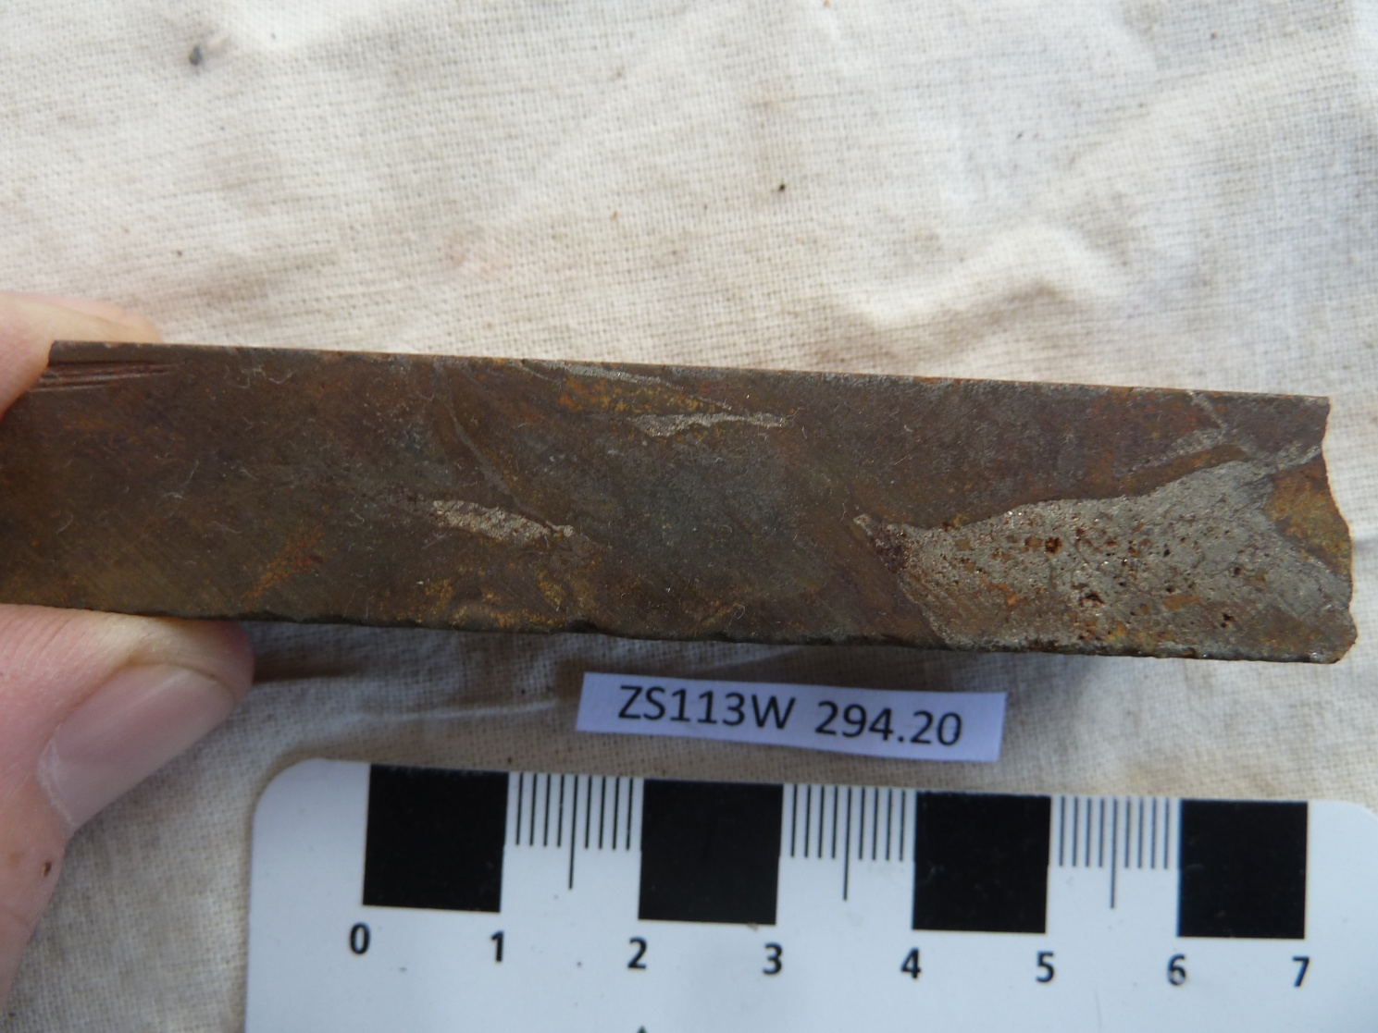

Sample ZS113W - 294.2m

The sample is a brecciated, siderite-altered and sulphidic, former tourmaline-rich lode.

Plate 77

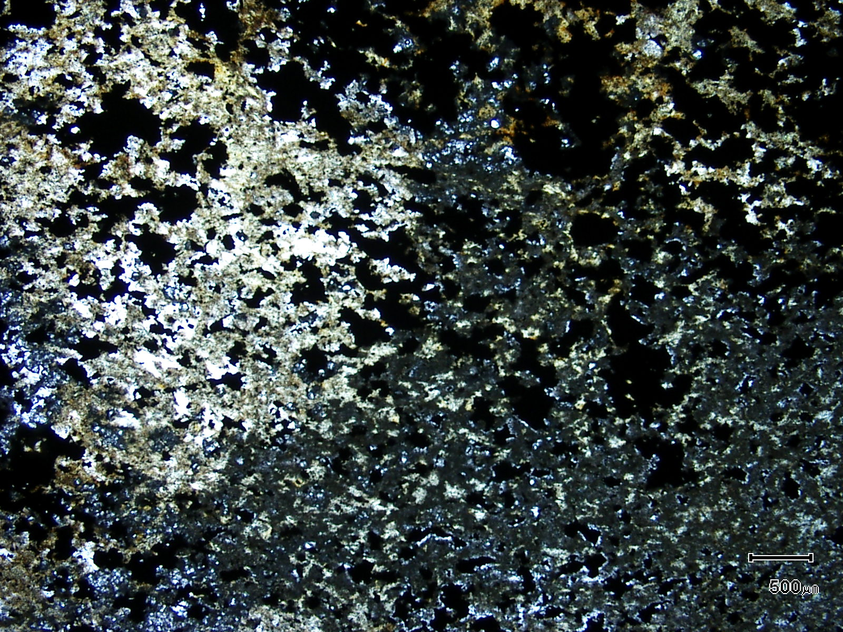
(Mag. x 20; scale bar = 500µ; PPL)

Sample ZS113W - 294.2m

The photomicrograph shows a general textural view of this sample which exhibits a pyrrhotite, siderite and tourmaline-rich groundmass.

Plate 78

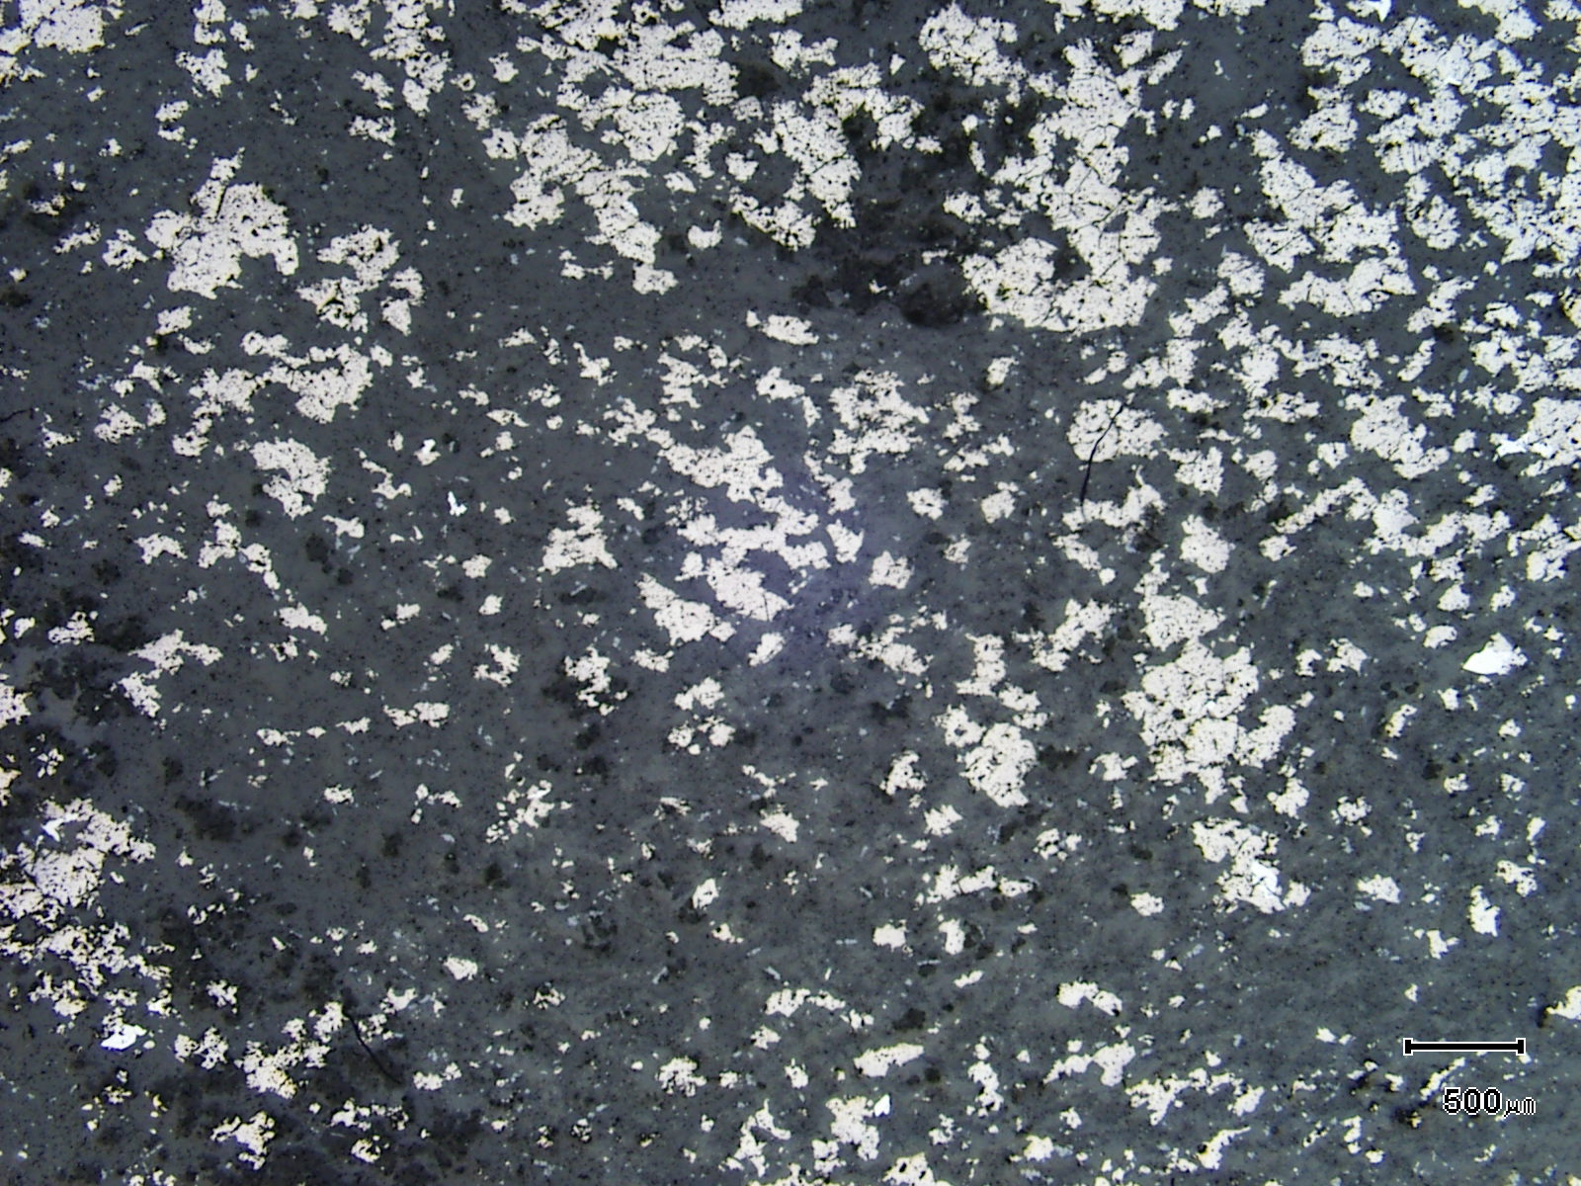
(Mag. x 20; scale bar = 500µ; reflected light)

Sample ZS113W - 294.2m

The photomicrograph shows a reflected light view of Plate 77. Note the abundance of pyrrhotite.

Plate 79

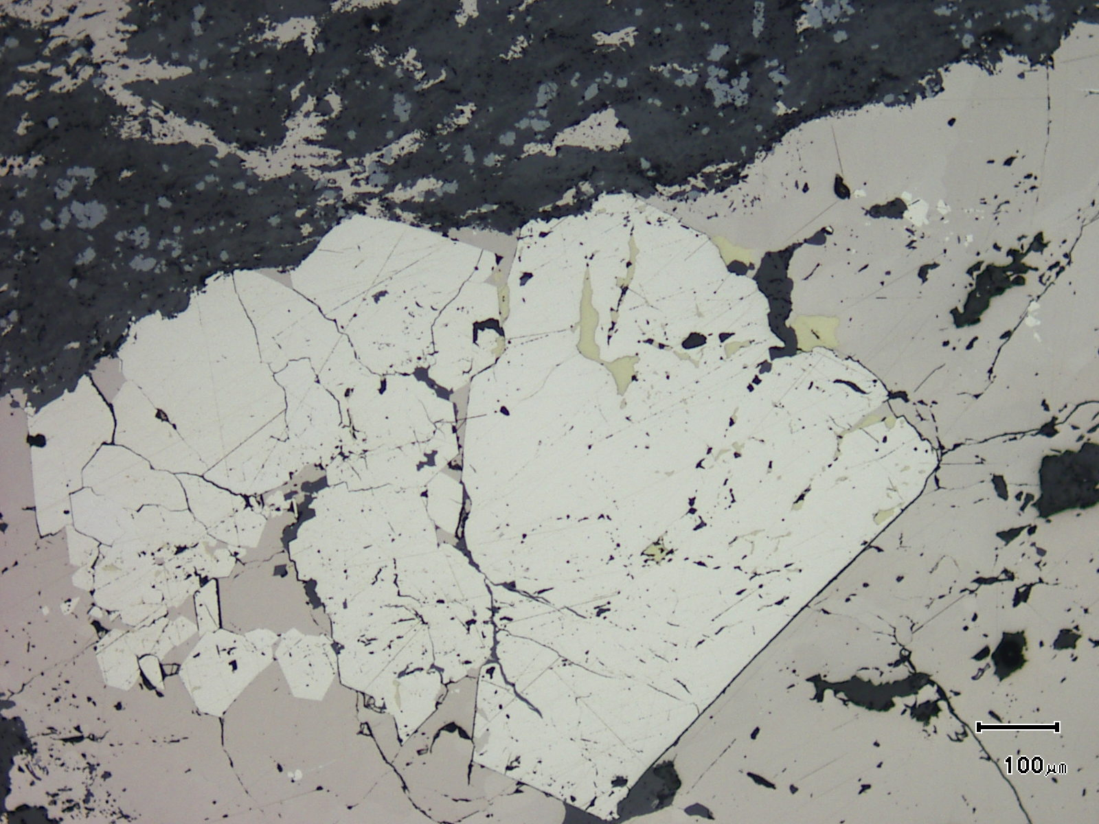
(Mag. x 100; scale bar = 100µ; reflected light)

Sample ZS113W - 294.2m

The reflected light photomicrograph shows a large, but brecciated, idioblastic pyrite grain containing chalcopyrite which anneals fractures. The pyrite sits within pyrrhotite.

Sample Number: ZS113W - 302.9m

Sample Locality: Severn Ore body, Zeehan

Rock Type: Anatase rich, sulphide veined, mafic volcaniclastic

Sample Description:

The sample is exceptionally rich in anatase containing approximately 8%. Early quartz veins, siliceous alteration and chlorite-siderite veins are cut by late pyritic veins. The latter exhibit parallel veins, somewhat oxidised with abundant iron sulphide developed between the two pyritic veins. The pyrite appears to be secondary, replacing pyrrhotite.

A visual estimate of the minerals present is:

Chlorite/sericite ~48%
Pyrite ~14%
Vein quartz ~ 8%
Anatase ~ 8%
Vein chlorite ~ 7%
Vein pyrite ~ 7%
Vein siderite ~ 4%
Altered tourmaline ~ 4%
Chalcopyrite trace
Stannite trace

Chalcopyrite tends to develop along the margins of the late veins and can also be located between the parallel pyritic vein sets. In the latter, the chalcopyrite develops within siderite and is associated with stannite. The stannite grains are lenticular and can be up to 0.1mm in diameter. Elsewhere pyrite veins contain stannite and grains can be up to 0.2mm and are rimmed by chalcopyrite.

Anatase is granular and can often develop as granular aggregates. The grains are usually less than 5µ in size. The abundance indicates a mafic provenance and an enrichment in TiO₂ in some way during alteration. Chlorite/sericite may replace tourmaline with some relict tourmaline present.

Plate 80

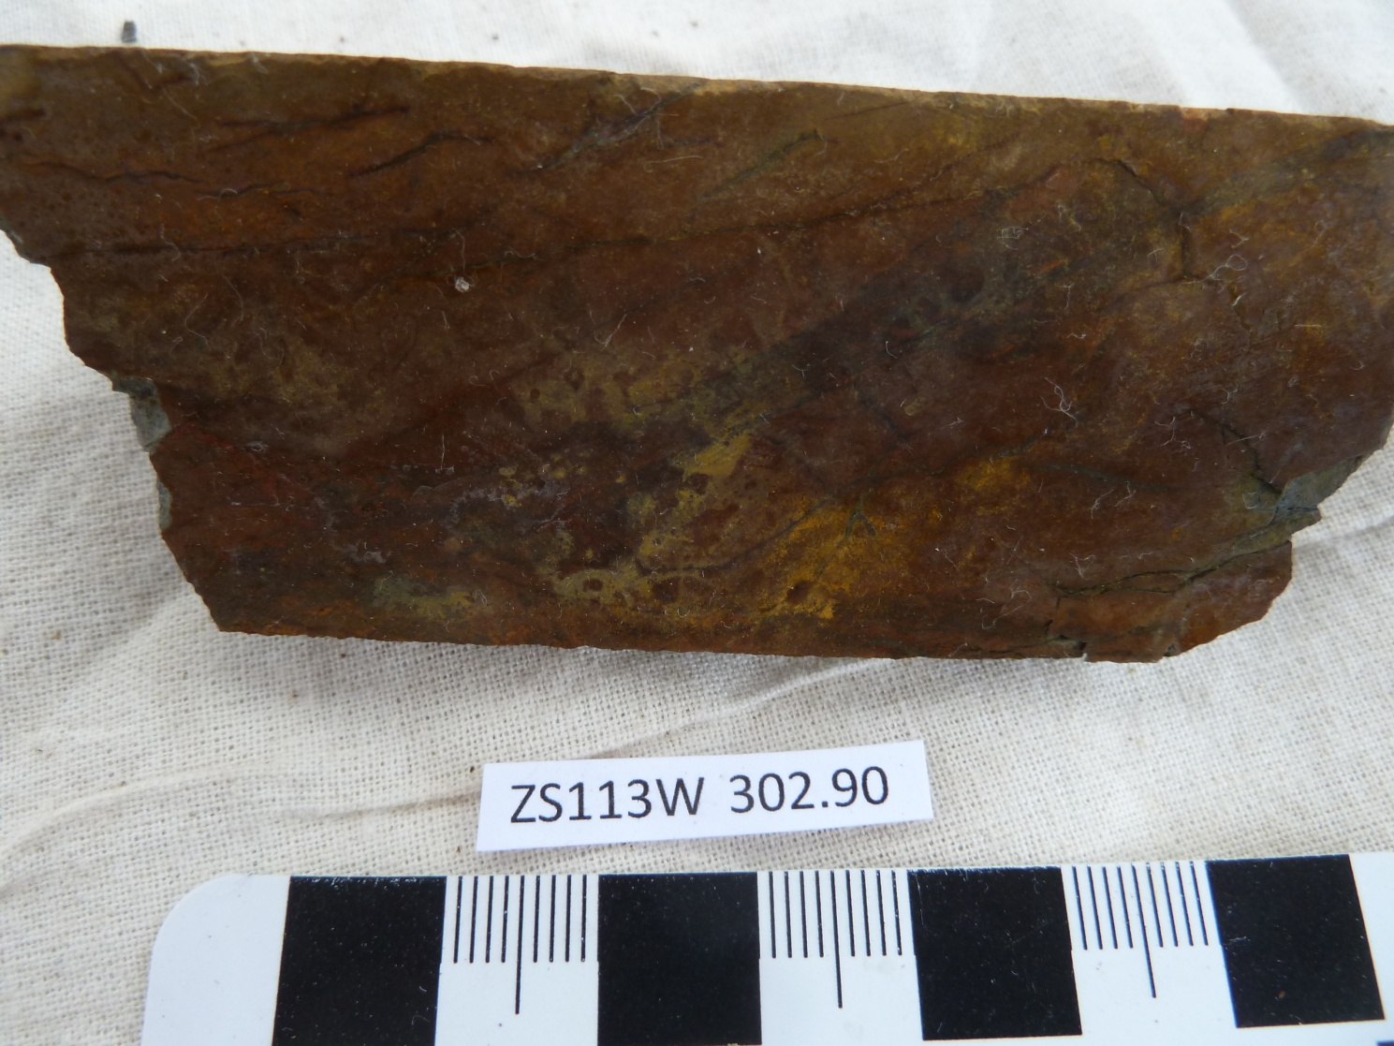

Sample ZS113W - 302.9m

This slab photograph shows a highly chloritic and sericitic rock-type which is anatase-rich (~8%) and pyritic. It is strongly veined.

Plate 81

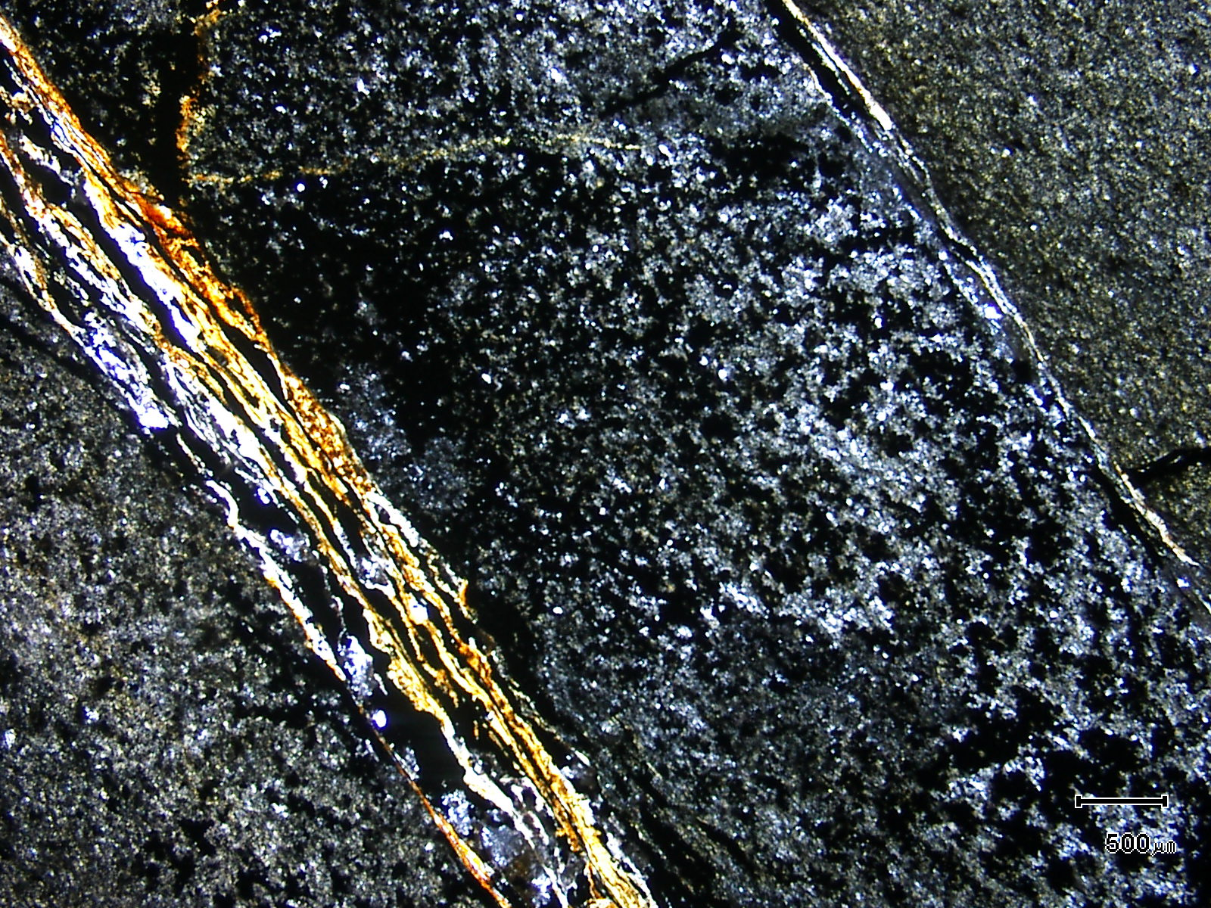
shears
(Mag. x 20; scale bar = 500µ; PPL)

Sample ZS113W - 302.9m

The photomicrograph shows parallel shears which contain abundant pyrite and there is abundant pyrrhotite and lesser chalcopyrite and pyrite between the shears.

Plate 82

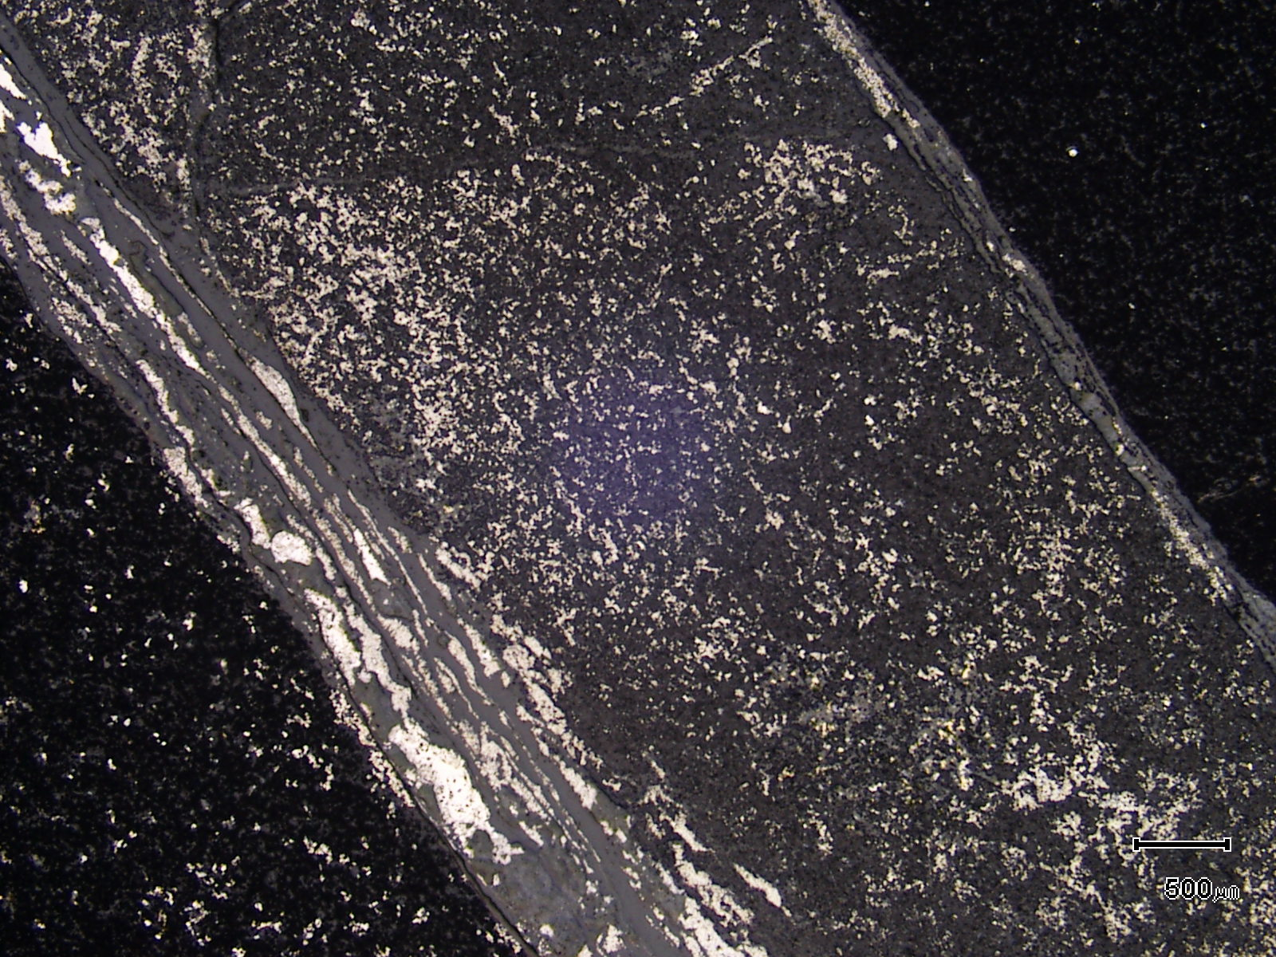
(Mag. x 20; scale bar = 500µ; reflected light)

Sample ZS113W - 302.9m

The photomicrograph shows a reflected light view of Plate 81. The abundance of sulphides between the shears can be noted as can be the absence of sulphides outside of the shears.

Sample Number: ZS113W - 306.2m

Sample Locality: Severn Ore body, Zeehan

Rock Type: Altered mafic sill or dyke (enriched in TiO₂)

Sample Description:

The sample is dominated by chlorite, carbonate, quartz and sericite. Relict igneous textures can still be observed with chlorite pseudomorphed plagioclase and anatase replaced titanomagnetite present.

A visual estimate of the minerals present is:

Chlorite ~61%
Siderite ~12%
Quartz ~ 9%
“Sericite” ~ 8%
Anatase ~ 6%
Albite ~ 3%
Pyrite trace
Chalcopyrite trace
Pyrrhotite trace

Chlorite is pale green in colour and is Fe-rich. It exhibits anomalous berlin blue interference colours and grains average 50µ. The chlorite replaces tabular plagioclase and, within more quartz-rich domains, is associated with “sericite”. The latter is iron-stained and intergrown with chlorite. Siderite is present as a vein fill and is also distributed throughout the groundmass.

Anatase replaces titanomagnetite with grains originally 0.6mm in size. Relict cleavage can still be observed in the pseudomorphs. Minor pyrite, pyrrhotite and chalcopyrite are present with the latter intimately associated with pyrrhotite. Grains can be up to 50µ in diameter. The sulphides sit within chlorite and quartz and pyrrhotite and pyrite can be partially rimmed by siderite.

Plate 83

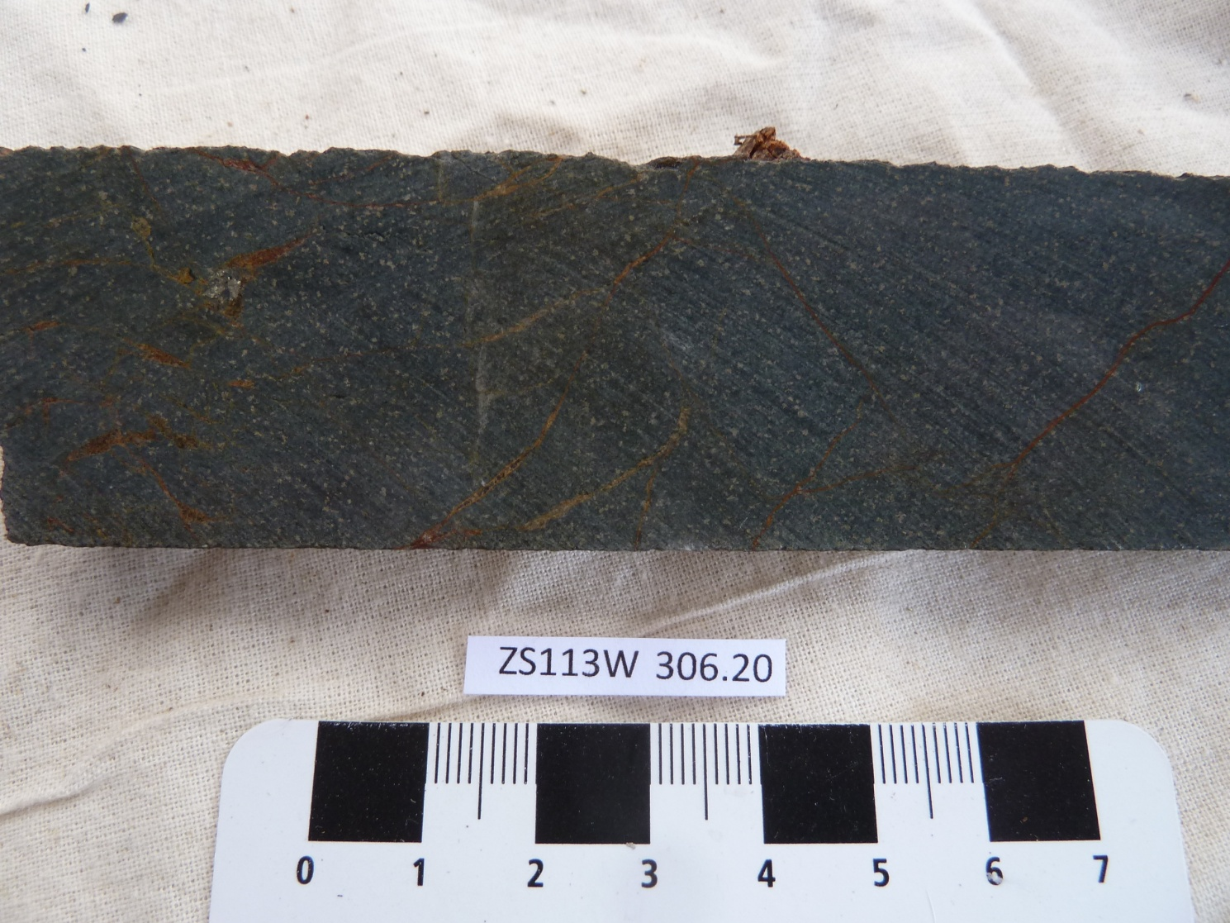

Sample ZS113W - 306.2m

The slab photograph shows a chlorite-carbonate altered mafic sill or volcanic.

Plate 84

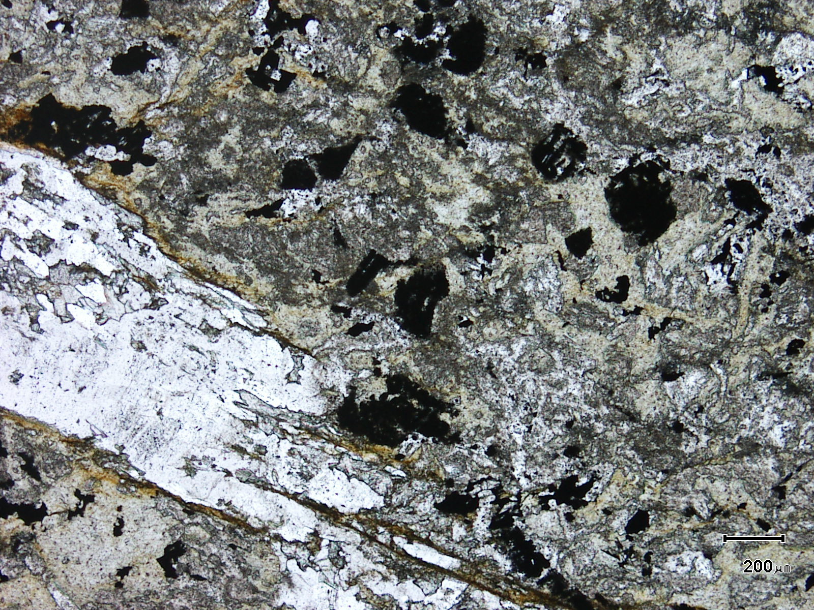
(Mag. x 50; scale bar = 200µ; PPL)

Sample ZS113W - 306.2m

The photomicrograph shows a general textural view of this sample. A probable feldspar (LHS) has been replaced by quartz and carbonate. The sample contains ~61% chlorite.

Plate 85

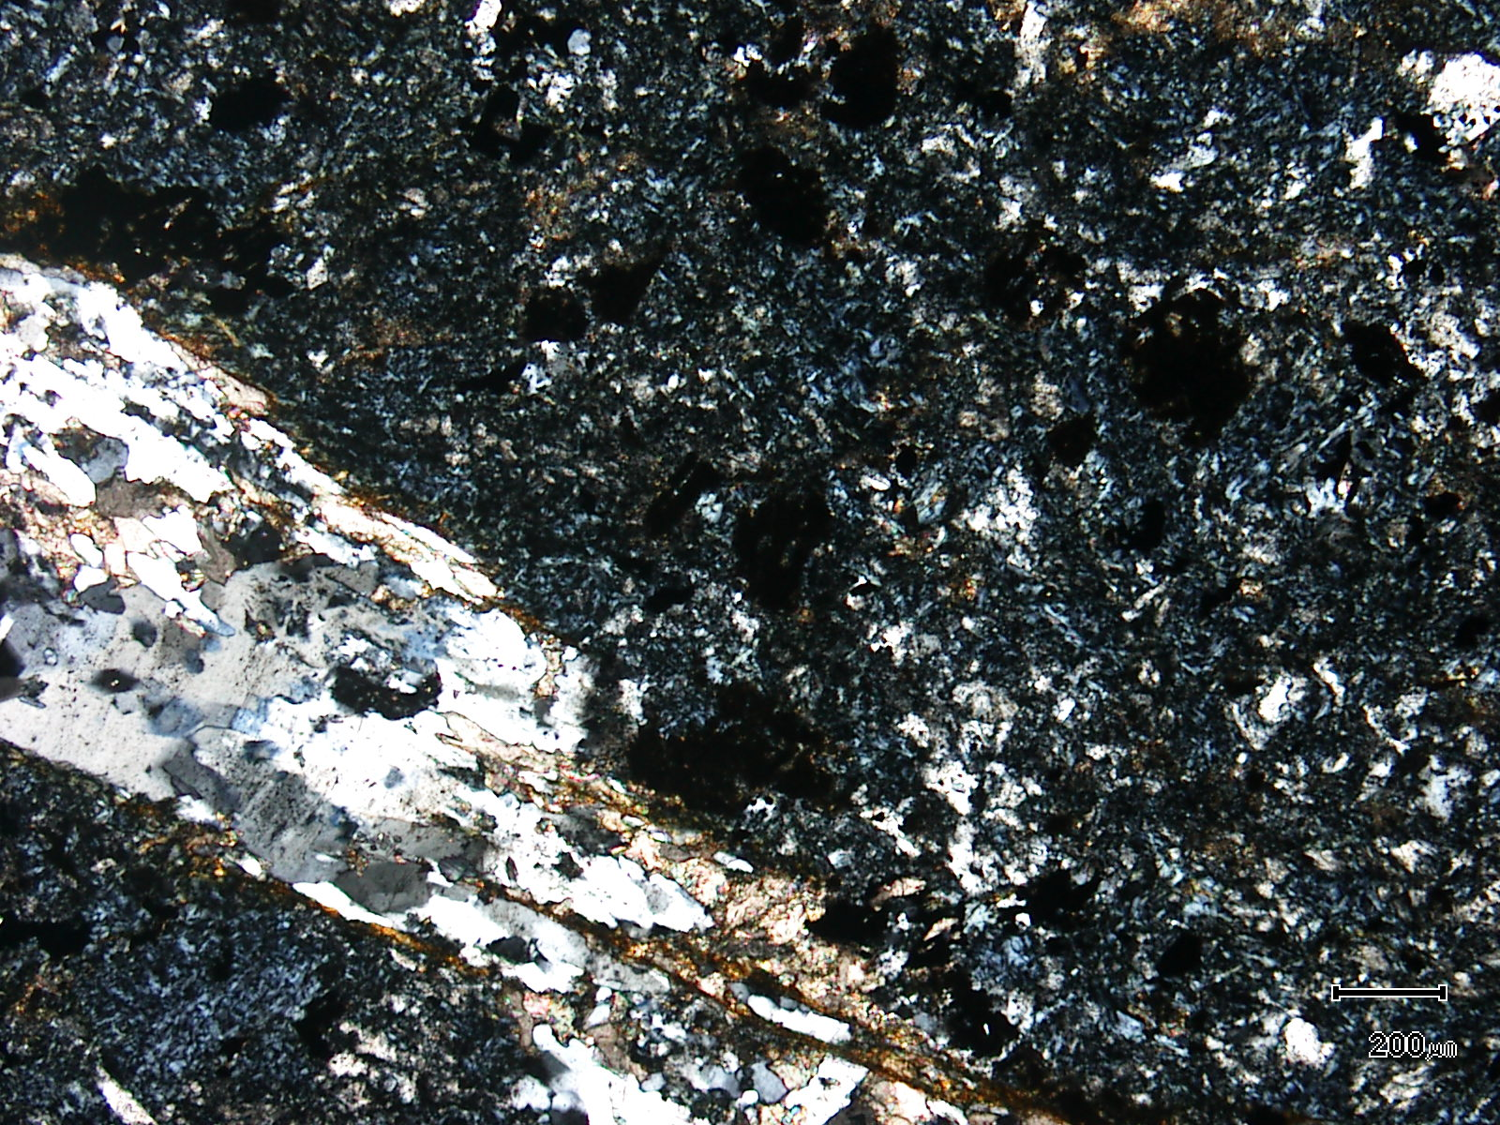
(Mag. x 50; scale bar = 200µ; crossed nicols)

Sample ZS113W - 306.2m

The photomicrograph shows a cross nicols view of Plate 84.

Plate 86

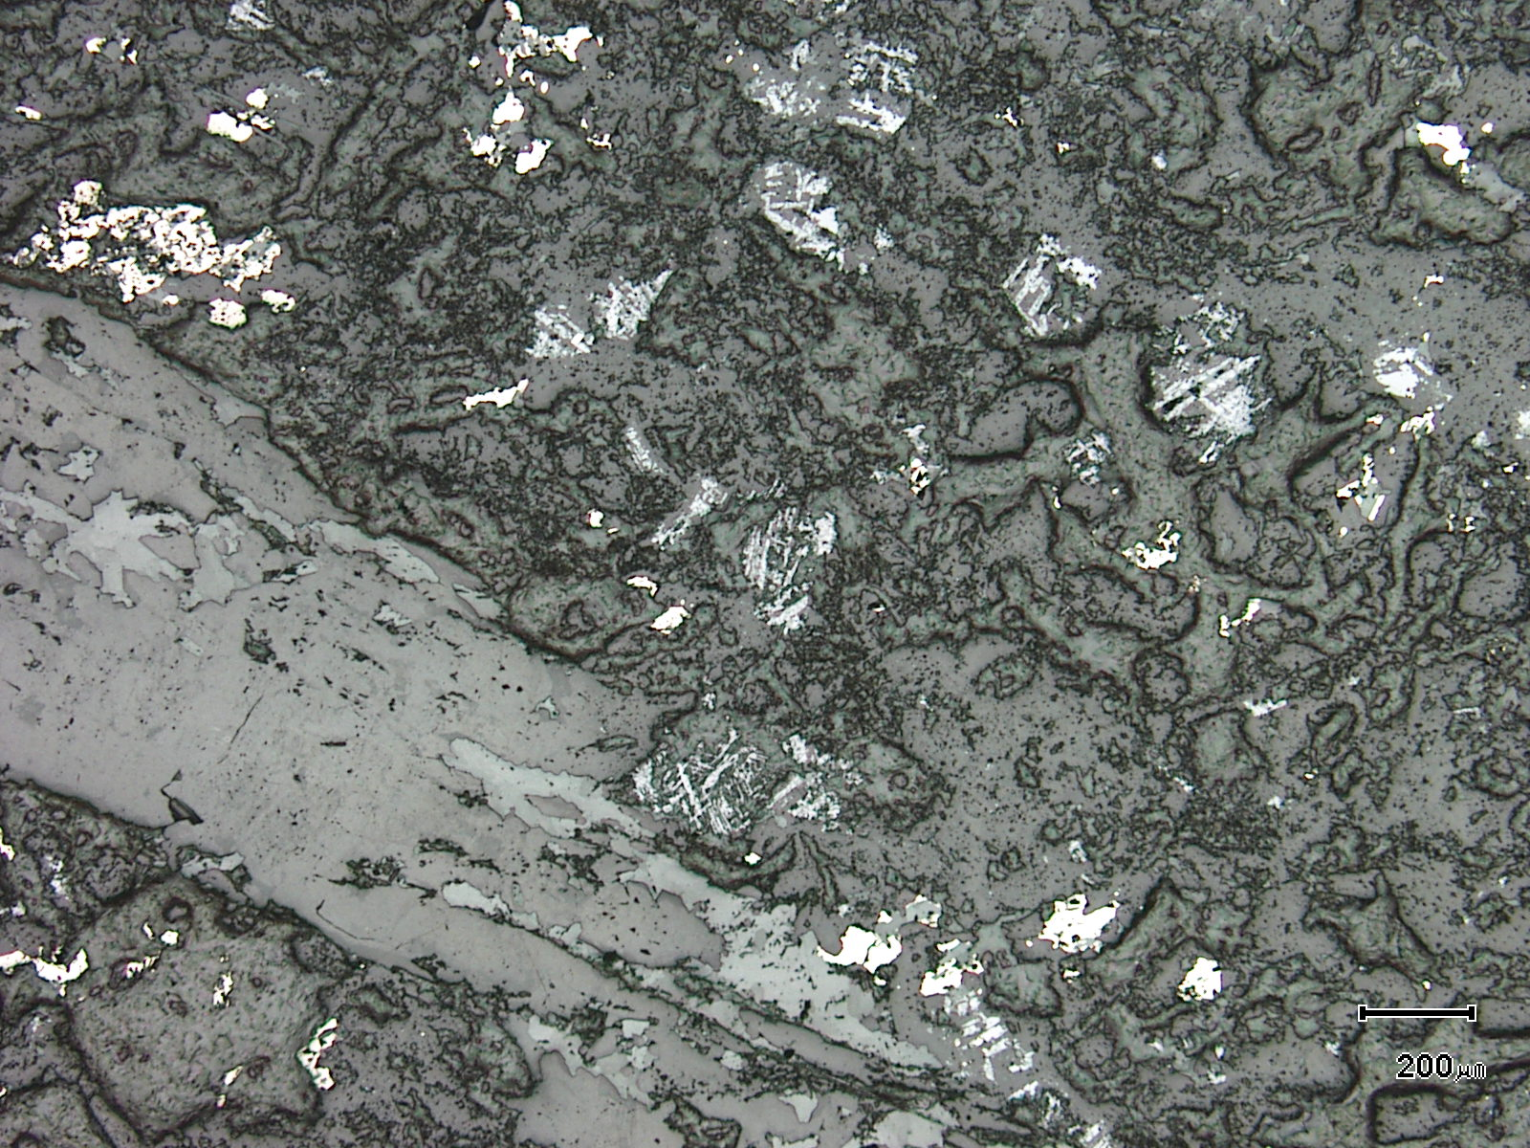
(Mag. x 50; scale bar = 200µ; reflected light)

Sample ZS113W - 306.2m

The photomicrograph shows a reflected light view of Plate 85. Note the former titanomagnetite grains with cleavage traces still present.

Plate 87

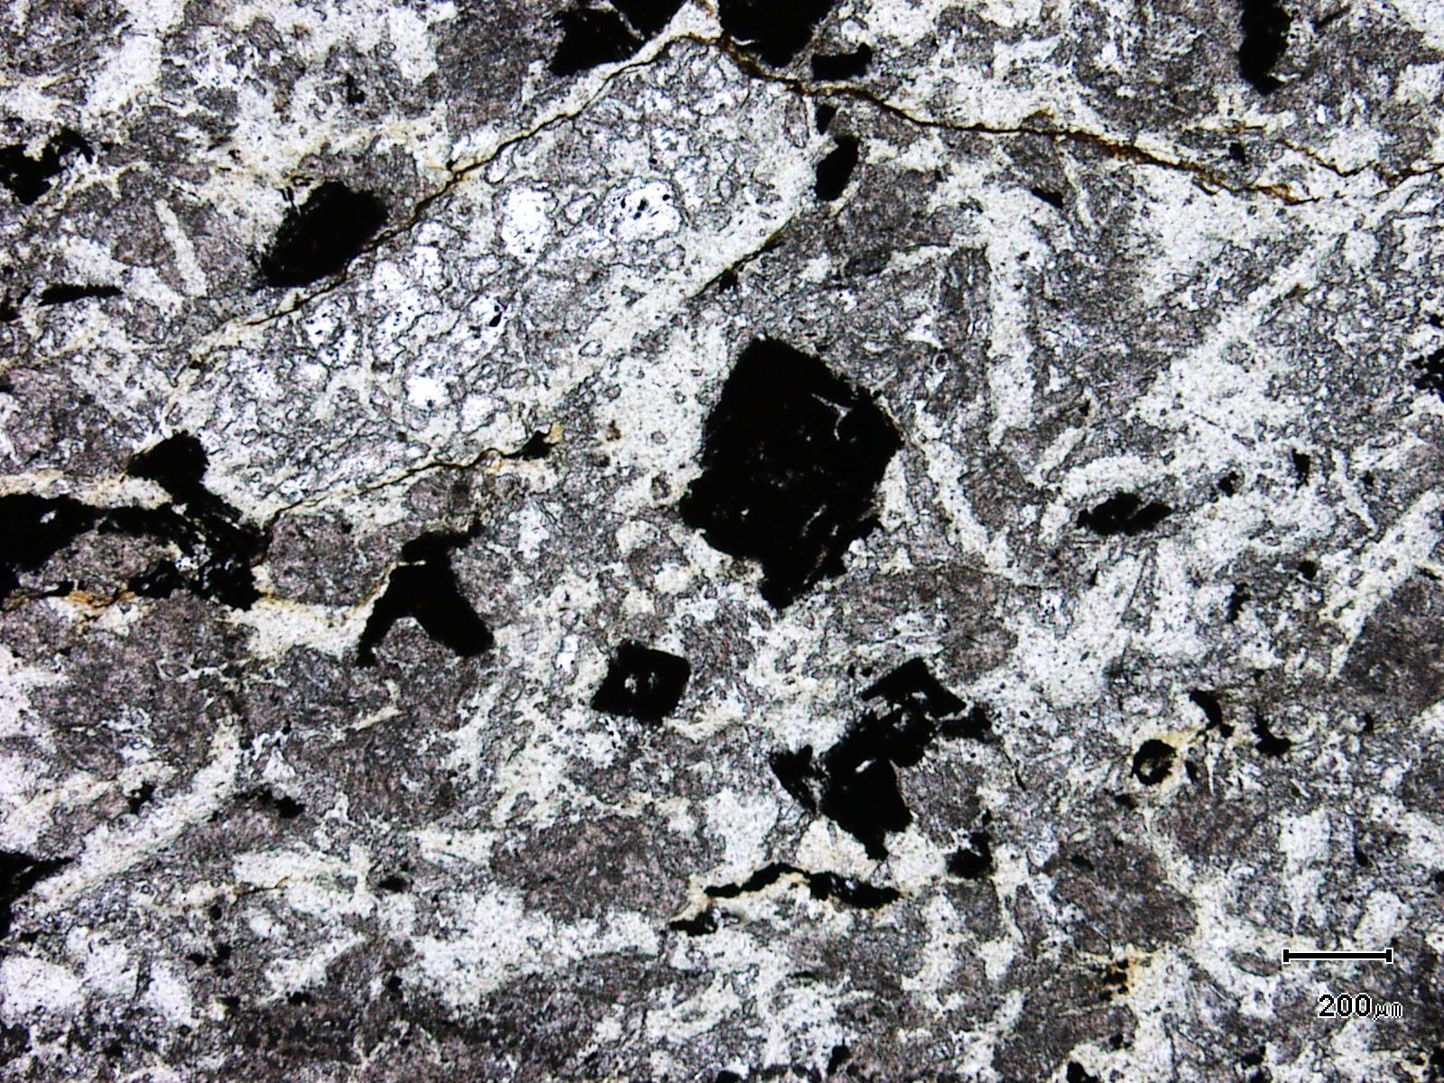
(Mag. x 50; scale bar = 200µ; PPL)

Sample ZS113W - 306.2m

The photomicrograph shows another general textural view of this sample. Note the former plagioclase phenocrysts.

Plate 88

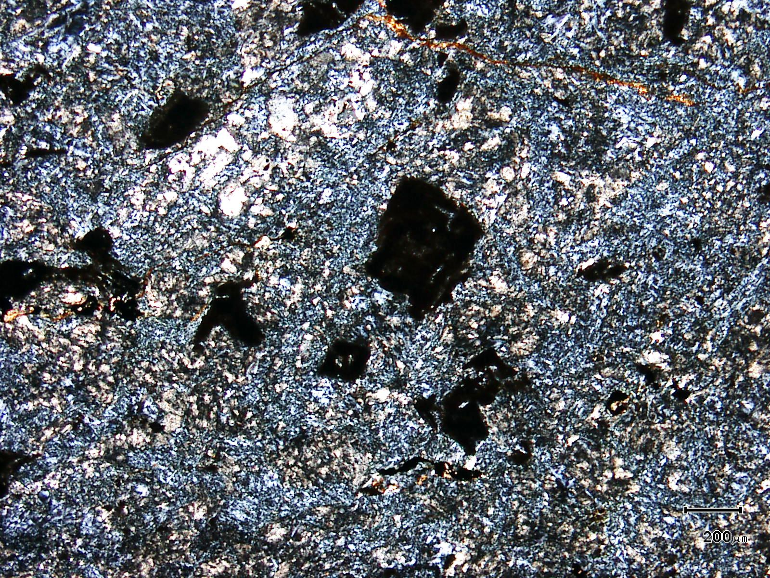
(Mag. x 50; scale bar = 200µ; crossed nicols)

Sample ZS113W - 306.2m

The photomicrograph shows a cross nicols view of Plate 87.

Plate 89

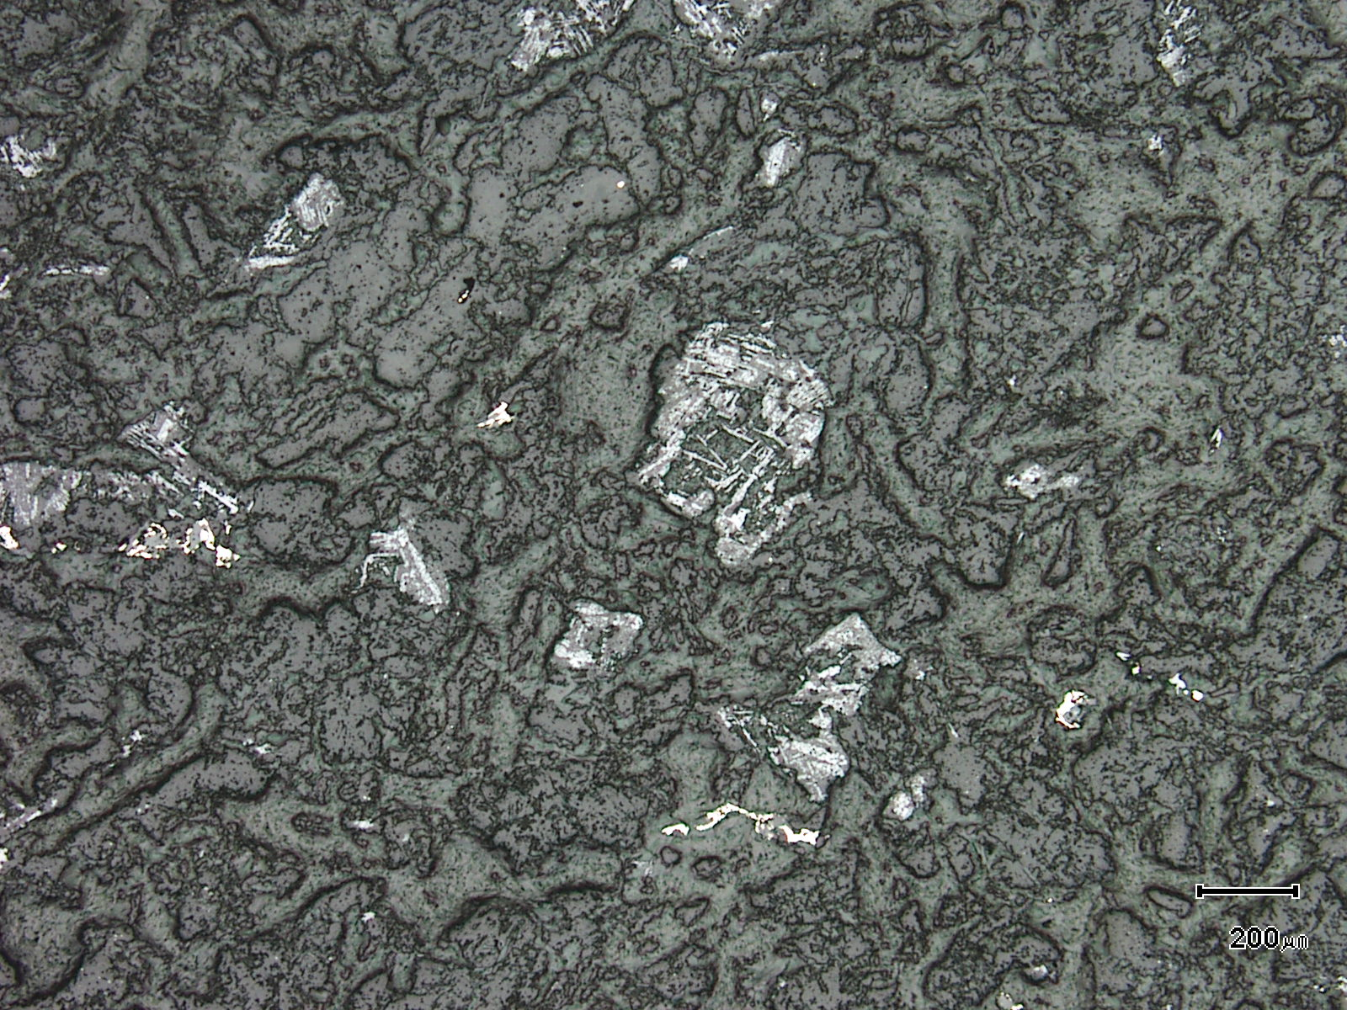
(Mag. x 50; scale bar = 200µ; reflected light)

Sample ZS113W - 306.2m

The photomicrograph shows a reflected light view of Plate 87.

Plate 90

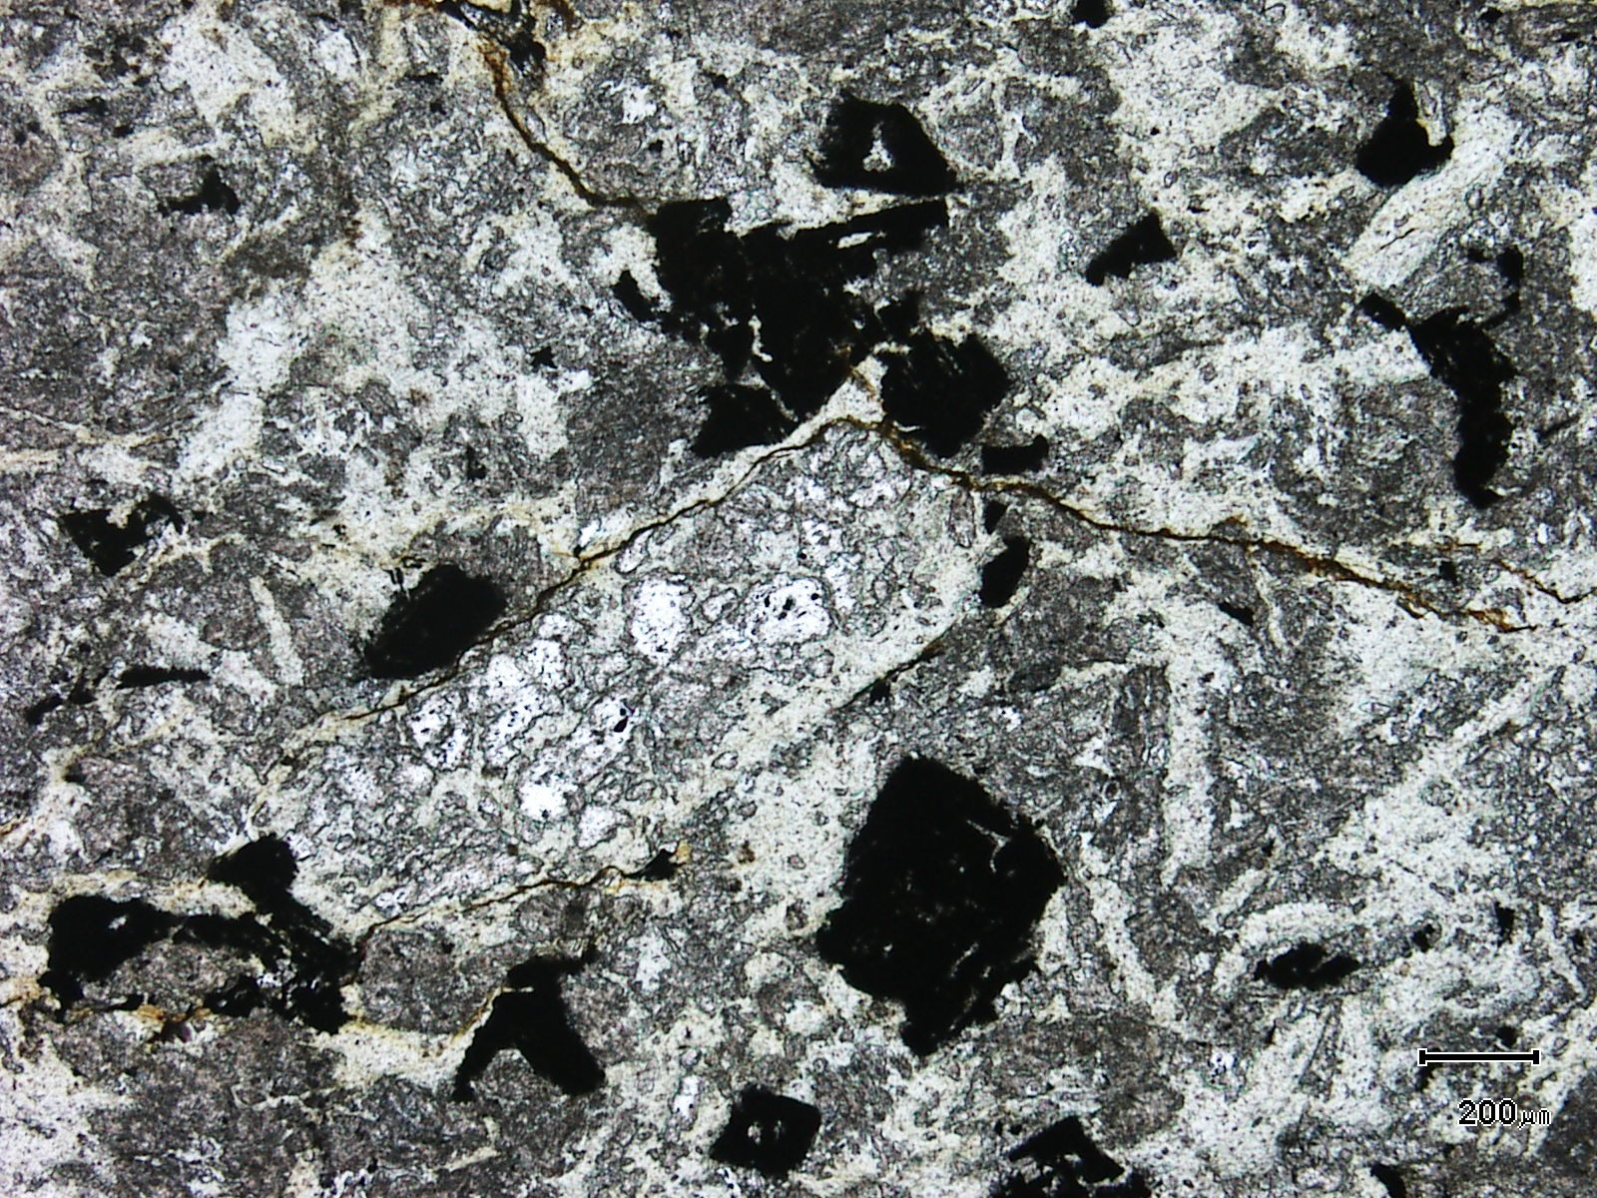
(Mag. x 50; scale bar = 200µ; PPL)

Sample ZS113W - 306.2m

The photomicrograph shows another textural view of this sample. Note the former titanomagnetite (black).

Plate 91

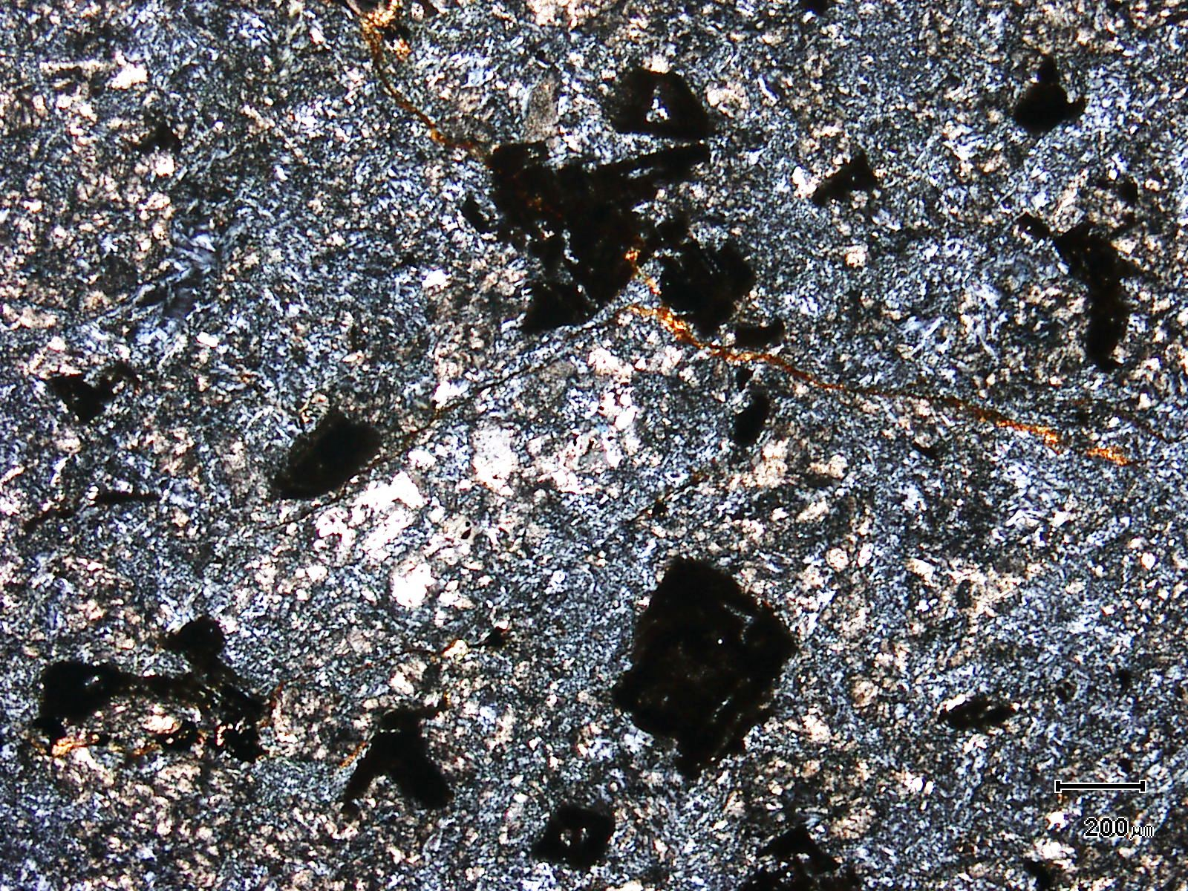
(Mag. x 50; scale bar = 200µ; crossed nicols)

Sample ZS113W - 306.2m

The photomicrograph shows a cross nicols view of Plate 90.

Sample Number: ZS120 - 506.2m

Sample Locality: Severn Ore body, Zeehan

Rock Type: Folded and boudinaged chlorite meta pelite intercalated with meta-silts

Sample Description:

The sample contains folded, transposed and boudinaged, ultra-fine grained, anatase-rich, chloritic ?air-fall tuff which is interfolded within a coarser grained meta-volcaniclastic.
- fine grained ?air-fall tuff: This lithotype is dominated by fine grained (<5µ) chlorite, anatase, quartz and rare sericite. The beds appear massive with little internal variation.

- coarser grained meta-volcaniclastic: This bed contains relatively coarse grained (up to 0.6mm) clasts which sit within a chloritic matrix. Clasts are composed of devitrified volcanic glass, exhibiting a micropoikilitic or “snow-flake” texture, probable fragments of quartz phenocrysts, chlorite altered feldspars, siliceous siltstone fragments and plagioclase clasts.

Wispy siderite and hydrated iron oxides cut across the sample and anatase is abundant in the groundmass of the volcaniclastic. Rare pyrite develops in some of the clasts but is not present in the groundmass.

Coarse grained chlorite-sericite-bearing veins tend to be sinuous and thicken and thin dramatically. The chlorite grains are randomly oriented, very pale green and up to 0.1mm in length. Rutile aggregates within the chlorite are lenticular and can be up to 0.11mm in length.

Plate 92

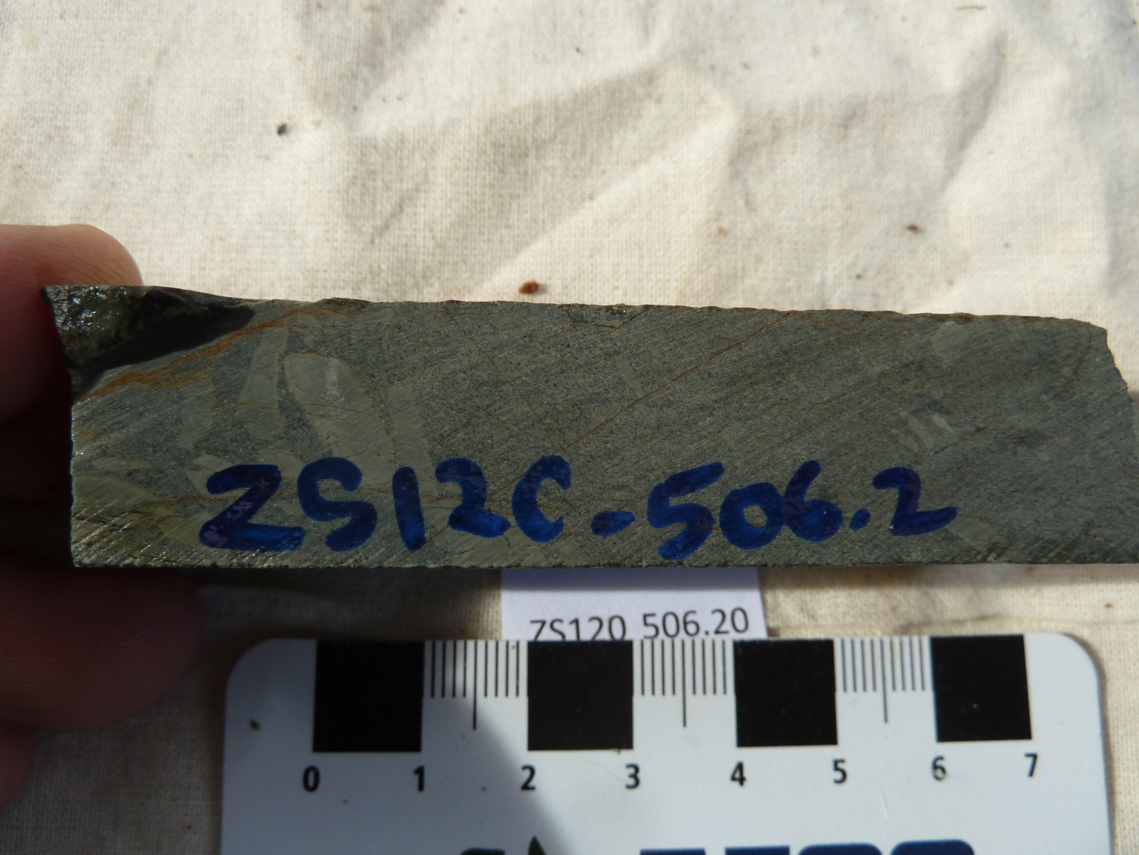

Sample ZS120 - 506.2m

This slab photograph shows a brecciated (slumped) chloritic meta-pelite which is associated with intercalated meta-silts.

Plate 93

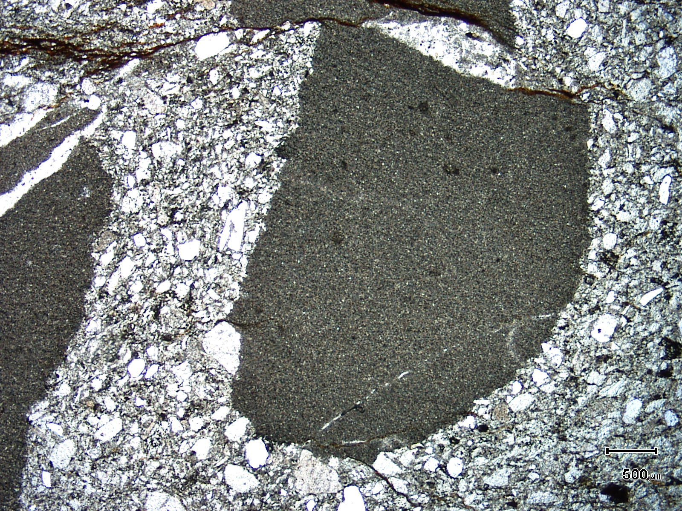
(Mag. x 20; scale bar = 500µ; PPL)

Sample ZS120 - 506.2m

The photomicrograph shows a general textural view of this sample with chloritic meta-pelite associated with chloritic meta-silts.

Plate 94

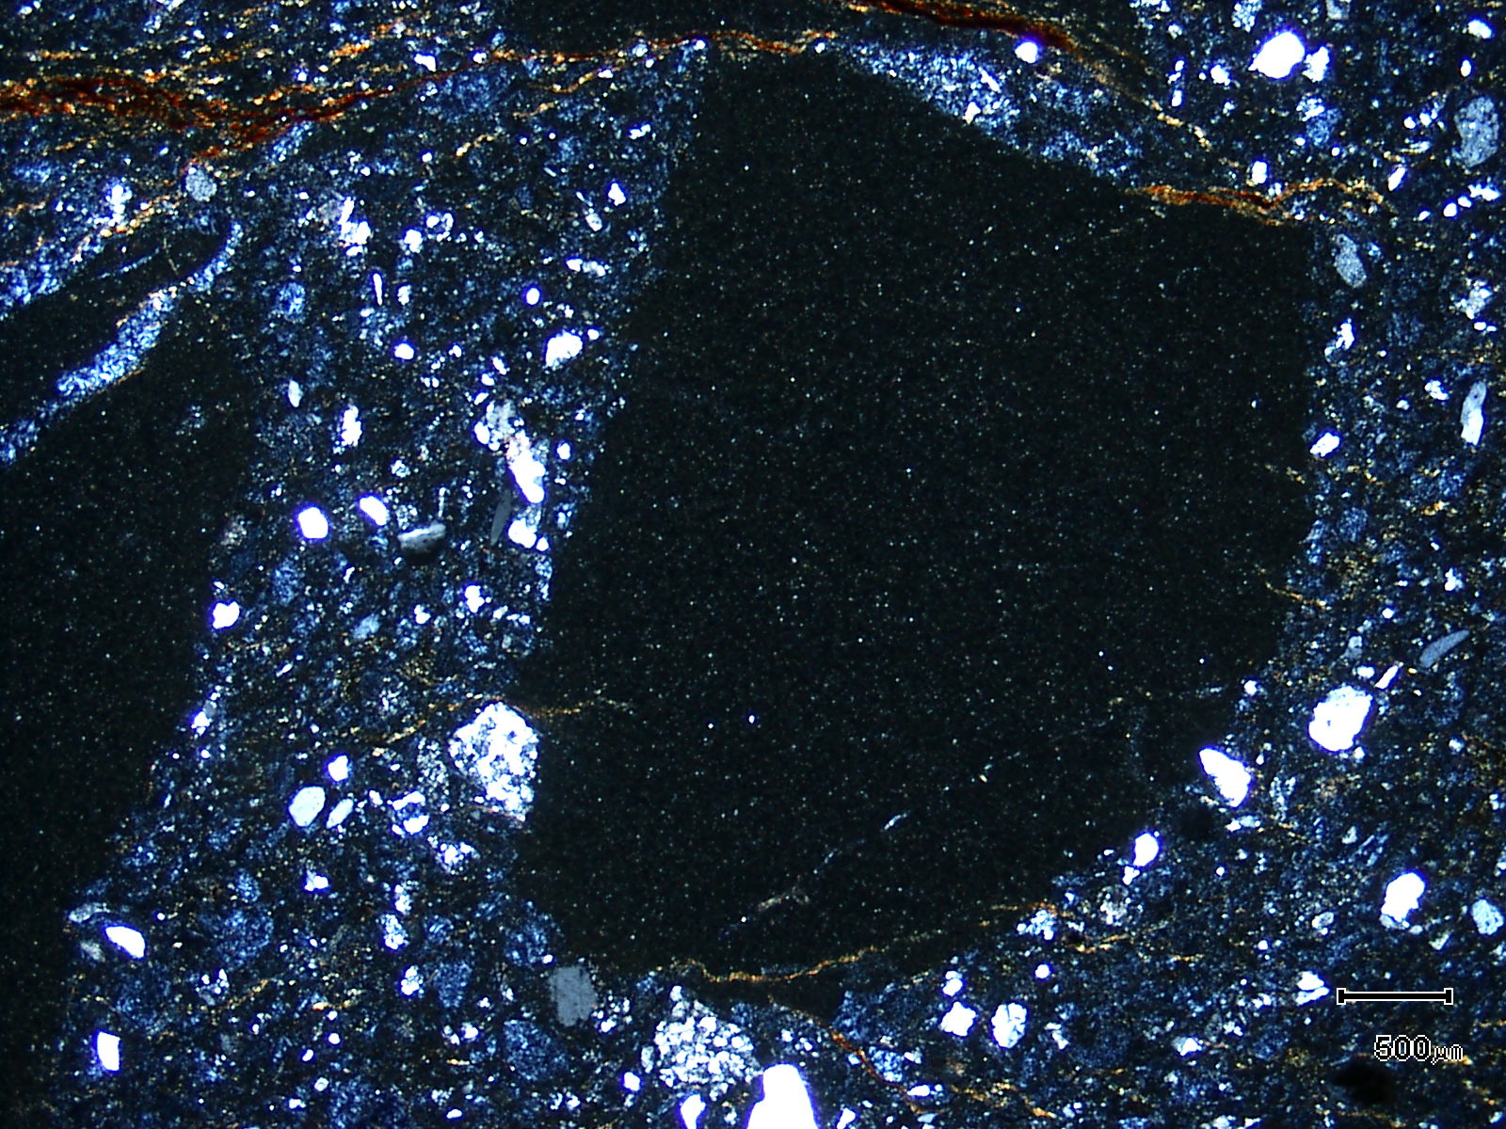
(Mag. x 20; scale bar = 500µ; crossed nicols)

Sample ZS120 - 506.2m

The photomicrograph shows a cross nicols view of Plate 93. Note the abundance of chlorite (berlin blue) in the matrix of the silt.

Sample Number: ZS120 - 516.3m

Sample Locality: Severn Ore body, Zeehan

Rock Type: Strongly veined and altered, pyritic, anatase-rich, fine grained mafic air-fall tuff

Sample Description:

The sample is extremely fine grained (<12µ) and the groundmass is dominated by chlorite/clays, quartz and anatase. This rock-type is cut by, and altered by, crosscutting early quartz veins, later tourmaline-pyrite veins and siderite veins which cut all of the above.

A visual estimate of the minerals present is:

Groundmass material ~31% Anatase/rutile ~ 3%
Tourmaline ~25% Pyrrhotite trace
Quartz ~17% Sphalerite trace
Vein pyrite ~ 9% Fluorite trace
Vein quartz ~ 7% Chalcopyrite trace
Vein siderite ~ 7%

Tourmaline develops within pyrite veins, with the pyrite often inclusion-choked and ragged. Chalcopyrite and pyrrhotite can be found as inclusions in the pyrite and also as discrete grains associated with the vein tourmaline or as aggregates of grains which develop along vein margins. Pyritic veins are also present and cut the tourmaline-rich veins. Tourmaline also develops as disseminated grains (up to 0.1mm in length) within the groundmass through to a network of almost monomineralic, yellow to green tabular grains which can be up to 0.2mm in length. Fluorite can be associated with this tourmaline as well as vein tourmaline.

Pyrrhotite, rare chalcopyrite and abundant rutile occurs throughout the groundmass as relatively coarse (~100µ) grains. Pyrrhotite can develop in quartz veins but is rare to absent in tourmaline-bearing veins. Chalcopyrite is rare to absent in the tourmaline veins. Rare sphalerite was observed with chalcopyrite in domains adjacent to tourmaline veining. Wispy, fine grained chalcopyrite veinlets are also present throughout the sample.

The sample contains abundant anatase/rutile which develops throughout the groundmass as fine grained (~10µ) aggregates or discrete grains (~2-5$µ$).

Plate 95

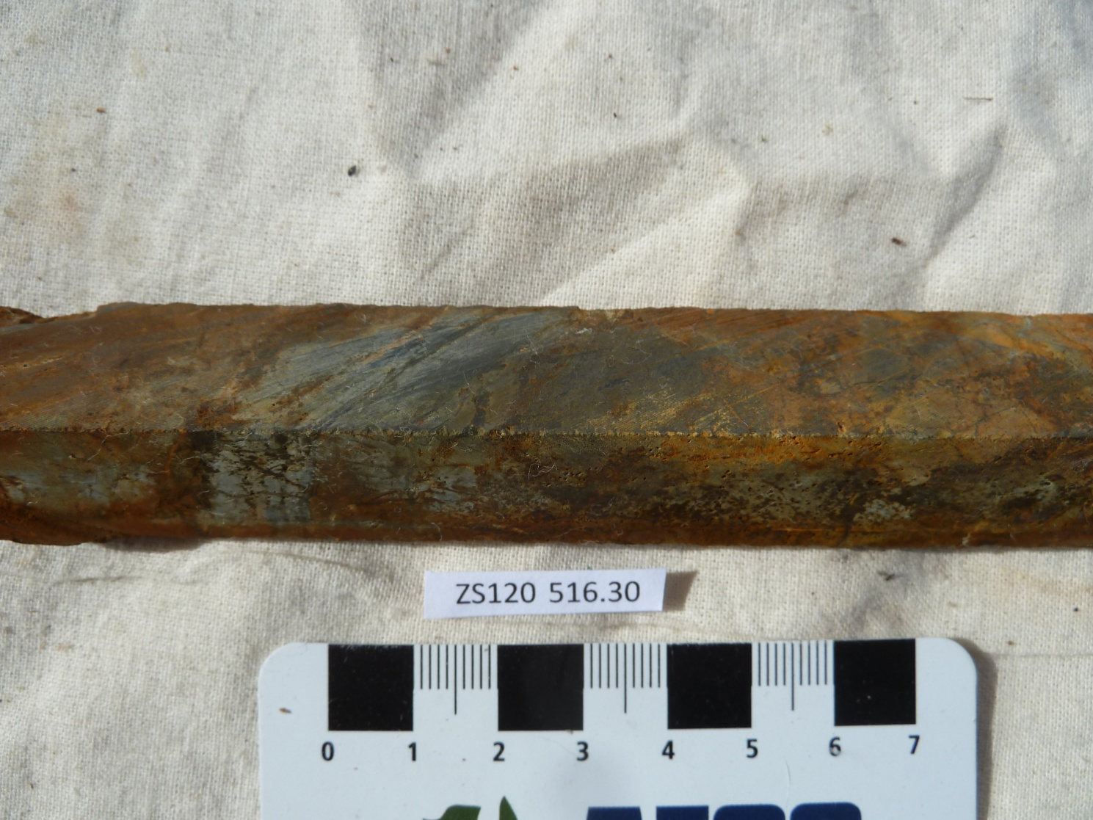

Sample ZS113W - 516.3m

The slab photograph shows a meta air-fall tuff which is highly tourmalinised and contains abundant tourmaline-pyrite-quartz veins.

Plate 96

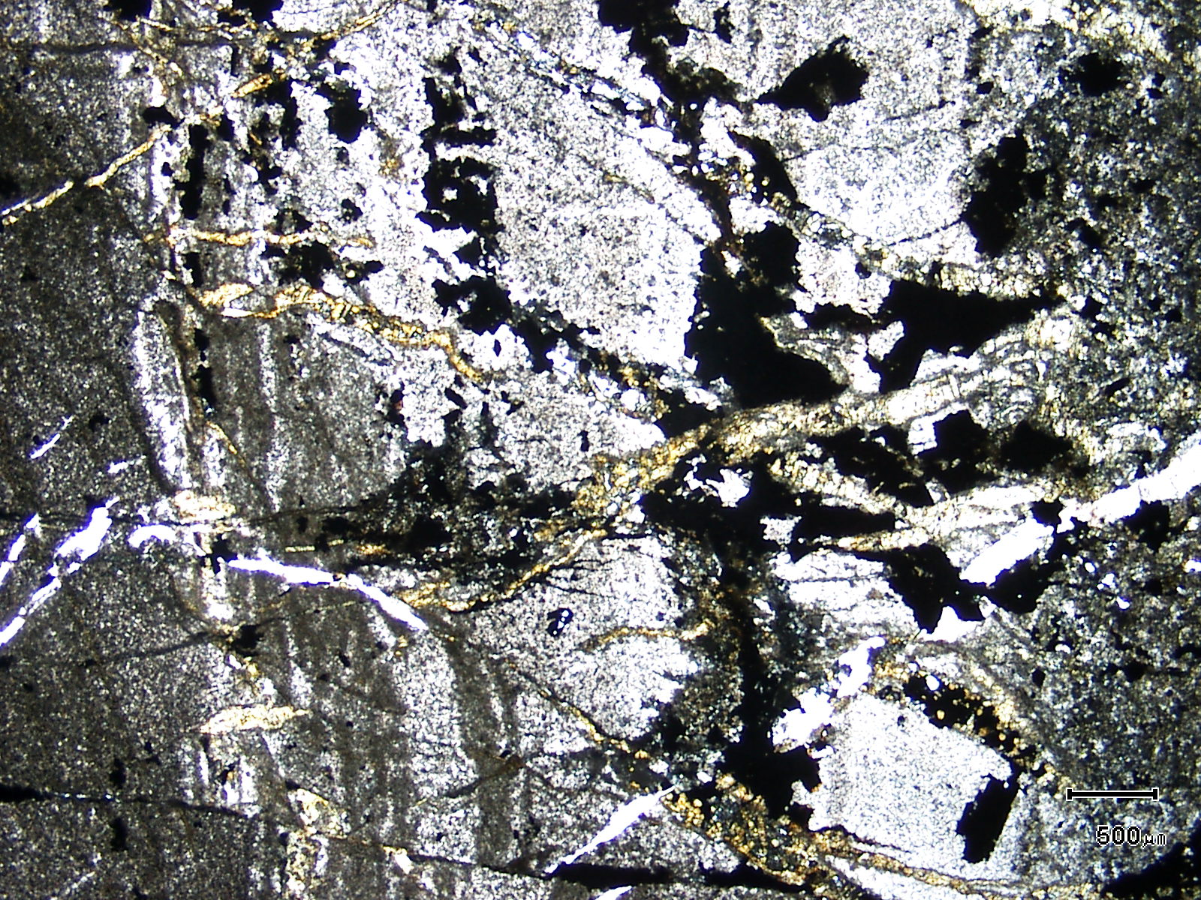
(Mag. x 20; scale bar = 500µ; PPL)

Sample ZS113W - 516.3m

The photomicrograph shows a general textural view of this sample which is a banded air-fall tuff. Note the abundance of tourmaline veining which is generally perpendicular to bedding.

Plate 97

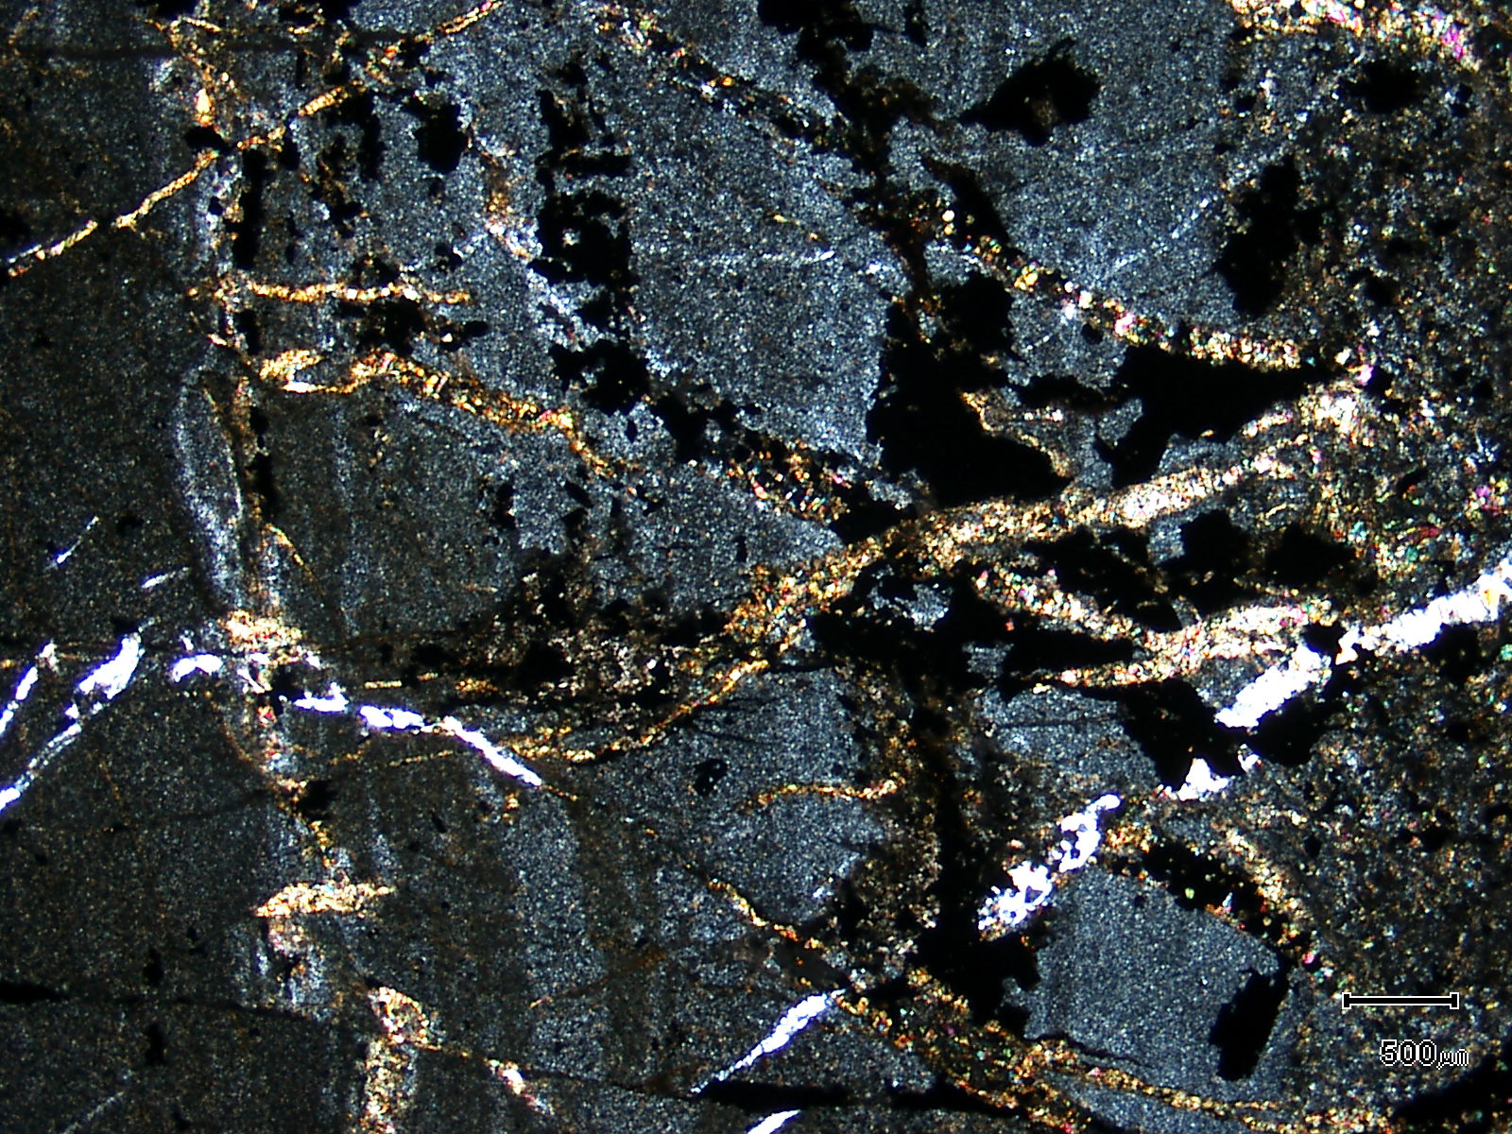
(Mag. x 20; scale bar = 500µ; crossed nicols)

Sample ZS113W - 516.3m

The photomicrograph shows a cross nicols view of Plate 96.

Plate 98

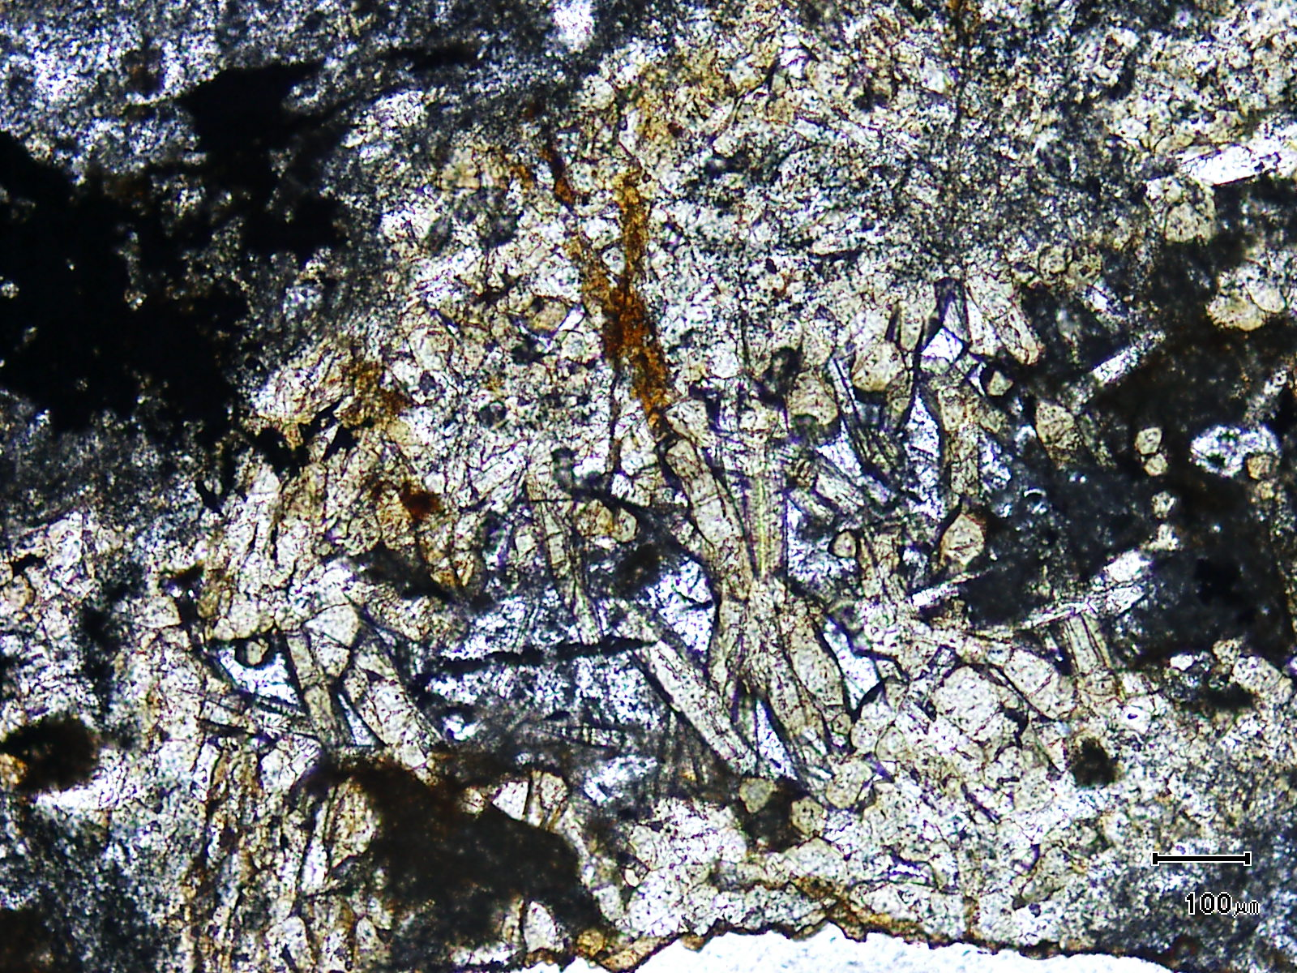
(Mag. x 100; scale bar = 100µ; PPL)

Sample ZS113W - 516.3m

The photomicrograph shows a higher magnification view of a coarse grained tourmaline-fluorite vein.

Plate 99

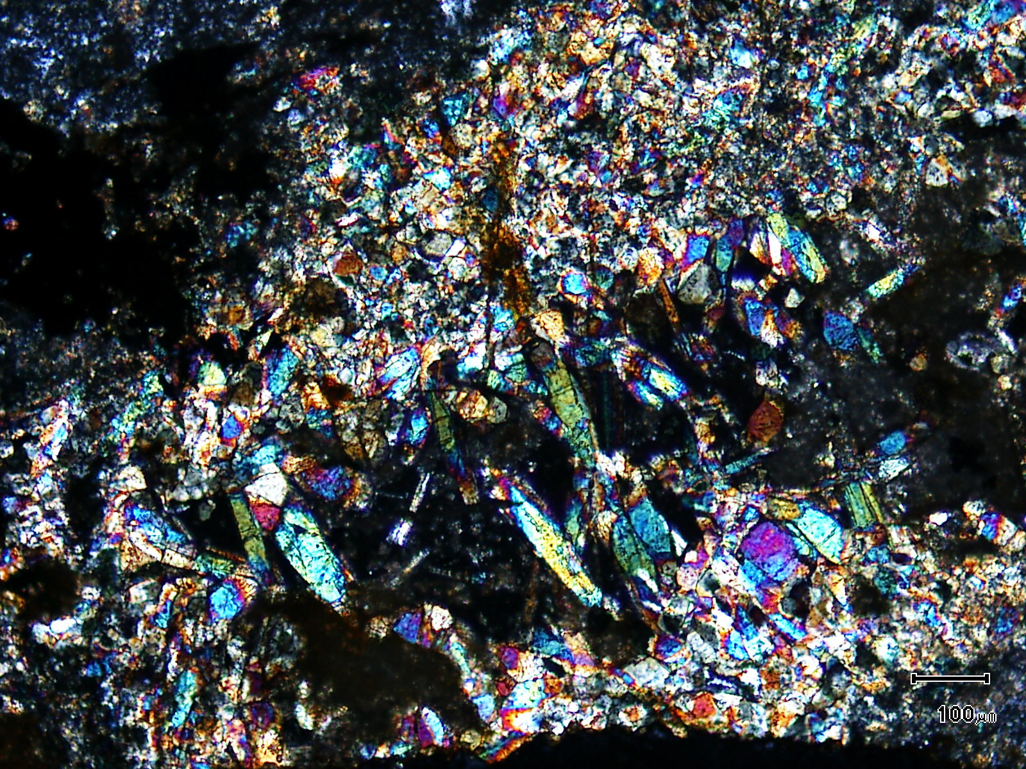
(Mag. x 100; scale bar = 100µ; crossed nicols)

Sample ZS113W - 516.3m

The photomicrograph shows a cross nicols view of Plate 98.

Sample Number: ZS120 - 535.3m

Sample Locality: Severn Ore body, Zeehan

Rock Type: Pyrite-veined, pyrrhotite-rich, tourmaline-sellaite altered
rock-type

Sample Description:

The sample tends to be fine grained (~100µ) but contains patchy coarse grained areas which have coarse grained (up to 1mm), highly birefringent (pale blue to intense purple-blue) Fe-phosphate grains.

A visual estimate of the minerals present is:

Tourmaline ~28% ?Topaz ~ 3%
Quartz ~21% Phlogopite ~ 2%
Pyrrhotite ~19% Arsenopyrite ~ 1%
Sellaite ~ 7% Cassiterite ~ 1%
Siderite ~ 6% Rutile ~ 1%
Pyrite ~ 5% Chalcopyrite ~ 1%
Fe-phosphate ~ 5% Stannite trace

Pyrrhotite with disseminated cassiterite, chalcopyrite and arsenopyrite develop throughout the groundmass of the sample. The sulphides average 0.1mm in diameter with pyrrhotite containing inclusions of rutile and rare chalcopyrite. The chalcopyrite can occur as discrete grains throughout the groundmass and occasionally contains inclusions of stannite. Chalcopyrite also develops as fine grains within siderite and this chalcopyrite often rims stannite. More rarely, coarse grained (~0.4mm) chalcopyrite and stannite can be located within siderite.

Poorly developed pyrite (± arsenopyrite) veins are present and can have chalcopyrite developed along the vein margins. Chalcopyrite veins are also present and these veins contain significant stannite.

Tourmaline and phlogopite exhibit a yellow-orange colour and grains average 50µ. The tourmaline is aluminous and magnesian and can be intergrown with sellaite and an iron phosphate mineral. Rare topaz appears to develop within quartz-rich areas of the sample.

The sample exhibits a more magnesian alteration assemblage than most other described samples. The presence of sellaite (MgF₂) and phlogopite confirms this.

Plate 100

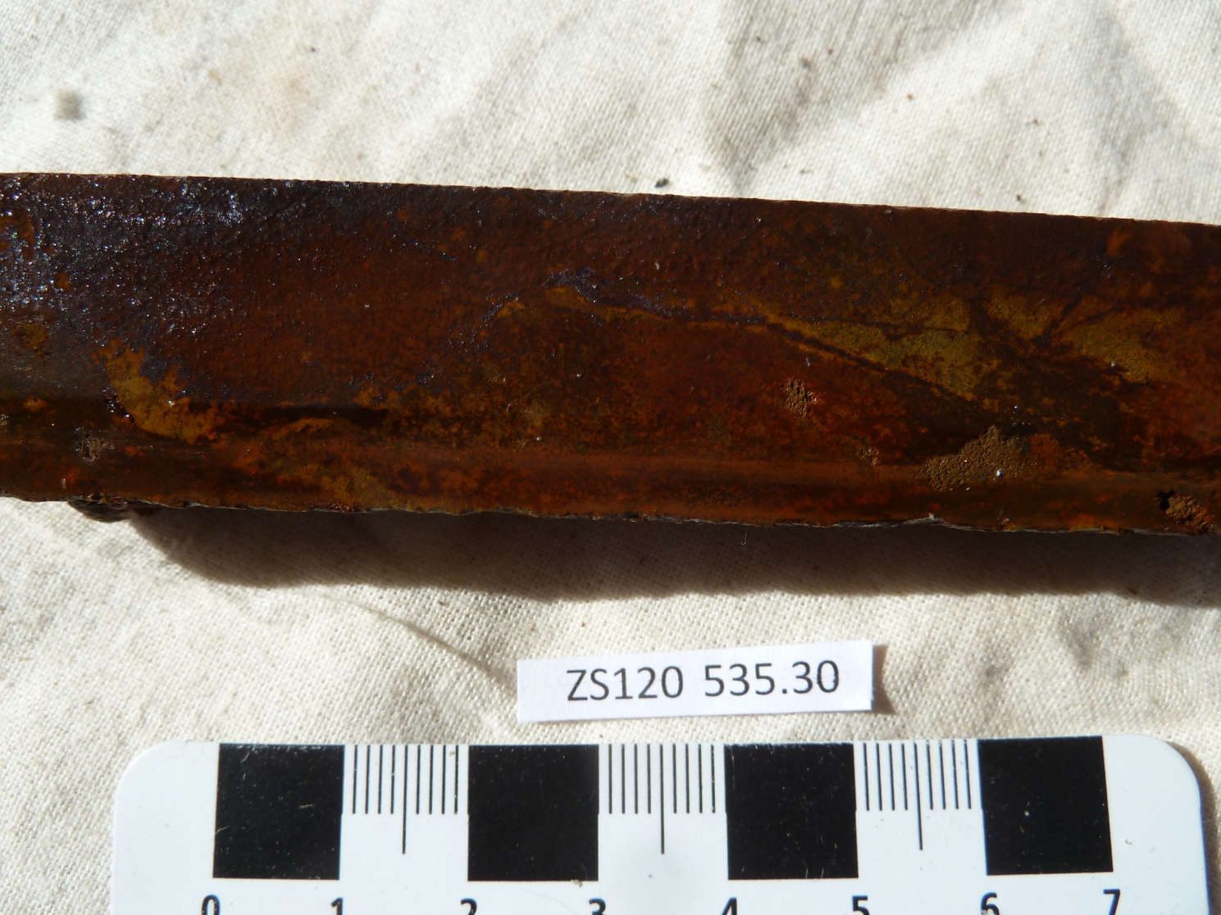

Sample ZS120 - 535.3m

The slab photograph shows a highly oxidised , pyrite veined rock-type which contains abundant Fe-phosphate, sellaite, phlogopite, topaz and pyrrhotite (~19%).

Plate 101

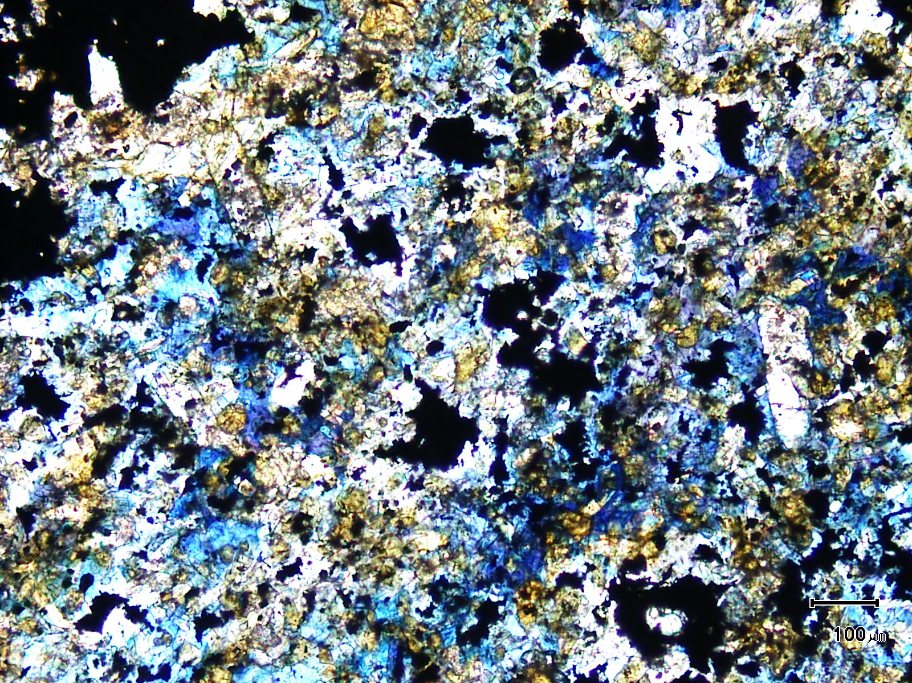
(Mag. x 100; scale bar = 100µ; PPL)

Sample ZS120 - 535.3m

The photomicrograph shows a general textural view of an Fe-phosphate domain within the sample. The blue mineral was originally thought to be lepidolite. Tourmaline and sellaite are also present with the phosphate.

Plate 102

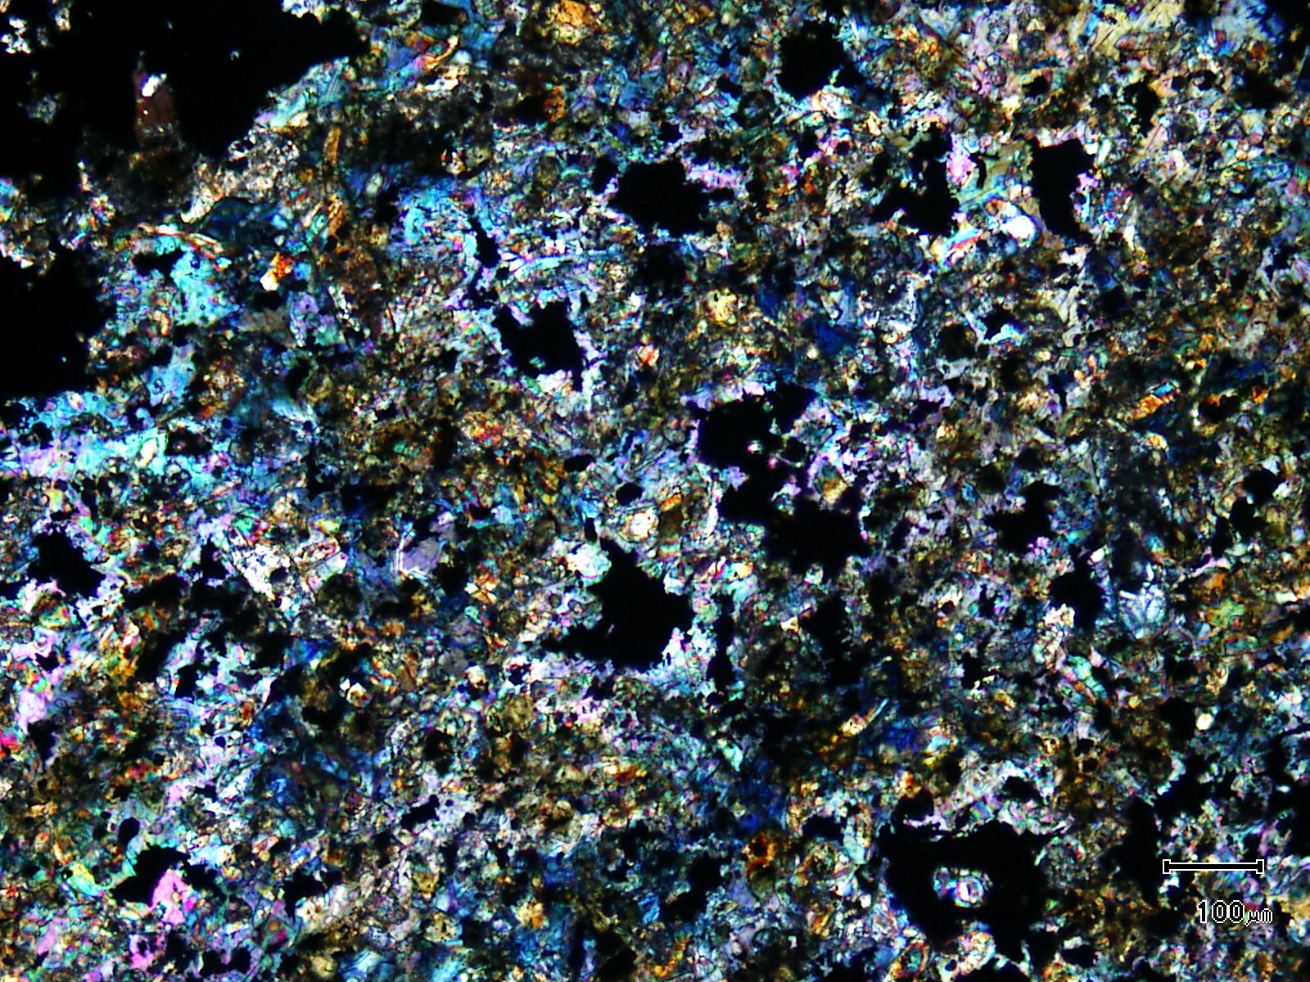
(Mag. x 100; scale bar = 100µ; crossed nicols)

Sample ZS120 - 535.3m

The photomicrograph shows a cross nicols view of Plate 101.

Sample Number: ZS120 - 541.4m

Sample Locality: Severn Ore body, Zeehan

Rock Type: Tourmaline-rich, intensely altered and tin-rich “infill” mineralisation

Sample Description:

The sample exhibits a crude layering with alteration minerals replacing an earlier, strong fabric. Idioblastic cassiterite is common and monomineralic “bands” of cassiterite are also present. The sample is relatively fluorite-rich with this phase hosting acicular tourmaline.

A visual estimate of the minerals present is:

Tourmaline ~39% Cassiterite ~ 5%
Siderite ~12% Fluorite ~ 3%
Pyrite ~11% Rutile ~ 3%
Pyrrhotite ~11% Arsenopyrite ~ 1%
Quartz ~ 9% Chalcopyrite ~ 1%
Hydrated Fe oxides ~ 5%

Cassiterite is usually coarse grained (up to 0.8mm), often idioblastic and, in some areas contains minor inclusions. Sulphide inclusions are not present although sulphides can be located in fractures in cassiterite. The location of cassiterite is as follows:

- coarse grains (~0.4-0.6mm) contained within fluorite

- as almost monomineralic “bands” (up to 7.5mm x 1mm) which are “encased” in pyrrhotite (replaced by secondary pyrite) grains. Cassiterite averages 0.1mm.

- grains located within pyrite, former pyrrhotite and arsenopyrite

- as discrete grains sitting within the tourmaline-rich groundmass. The cassiterite averages 0.1mm and is often entirely enclosed with coarse grained (0.4mm) tourmaline. These grains are xenoblastic

- as grains wholly contained within siderite.

Chalcopyrite is contained within former pyrrhotite (now “birds-eye” pyrite) with grains up to 0.3mm in diameter. Finer grained (~30-80µ) chalcopyrite often chokes groundmass siderite. Chalcopyrite stringers or micro-veinlets can also develop coming from the siderite and cutting adjacent quartz grains. Arsenopyrite grains can be up to 1.4mm in length and are idioblastic. They are often fractured and brecciated and contain inclusions of chalcopyrite and cassiterite.

Fluorite is minor and appears to have been replaced by tourmaline. Patchy “relicts” are present.
Plate 103

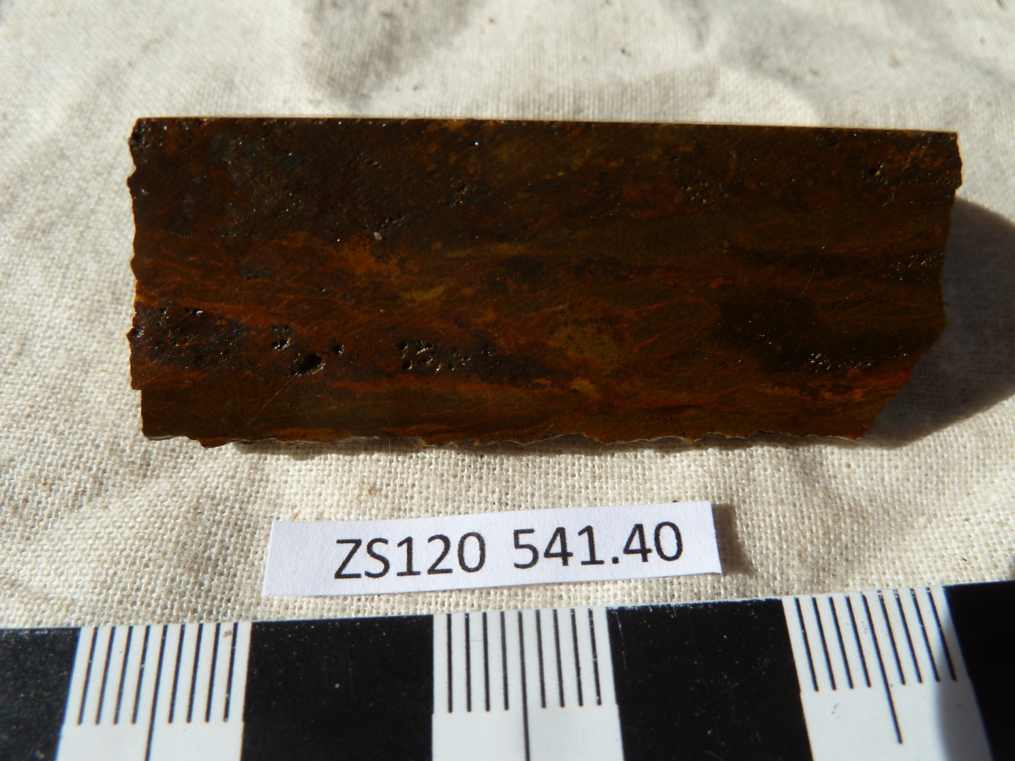

Sample ZS120 - 541.4m

The slab photograph shows another highly oxidised sample which contains ~22% pyrite + pyrrhotite in addition to ~39% tourmaline, ~3% fluorite and ~5% cassiterite.

Plate 104

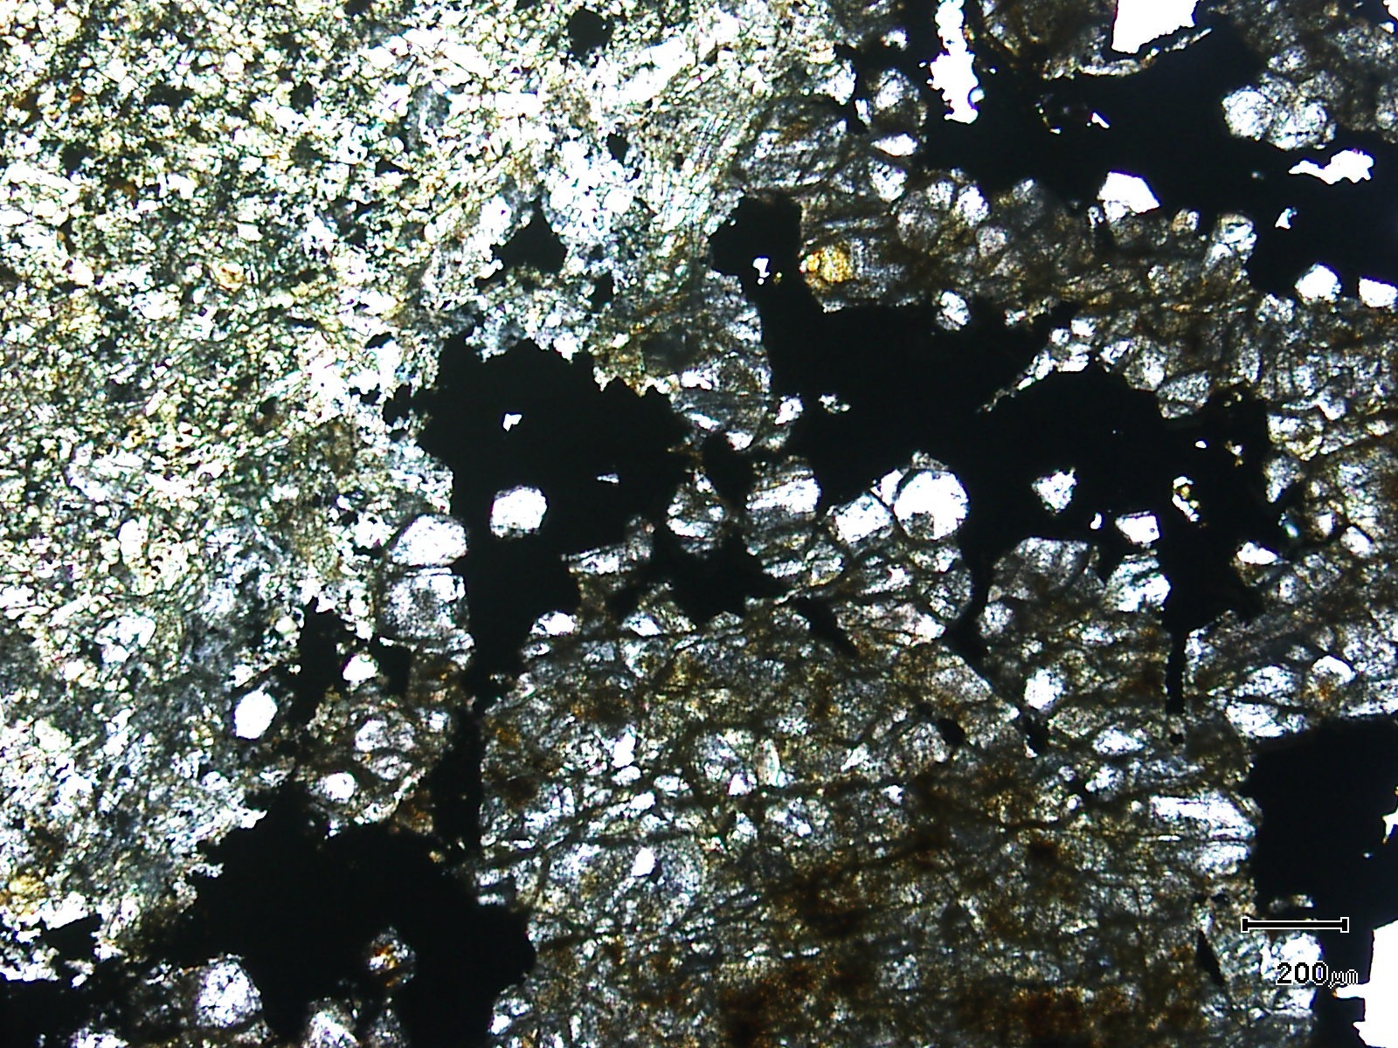
tourmaline
cassiterite
(Mag. x 50; scale bar = 200µ; PPL)

Sample ZS120 - 541.4m

The photomicrograph shows a general textural view of a cassiterite-rich domain flanked by tourmaline.

Plate 105

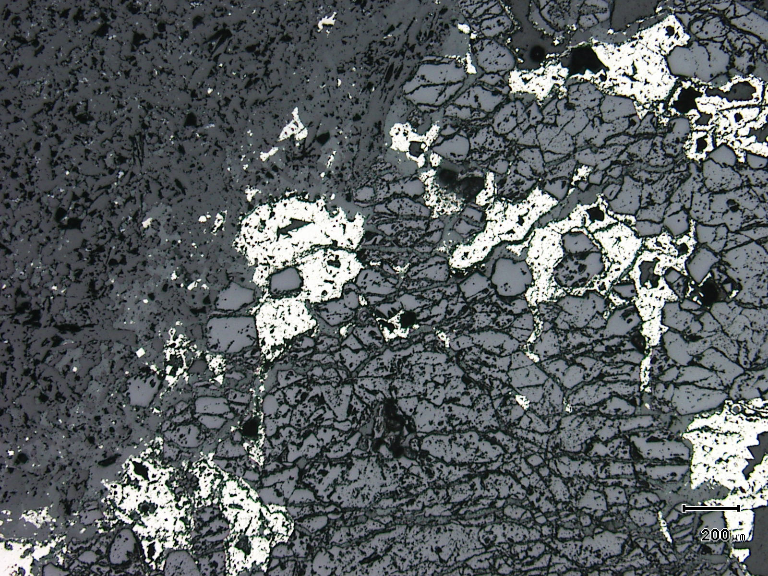
(Mag. x 50; scale bar = 200µ; reflected light)

Sample ZS120 - 541.4m

The photomicrograph shows a reflected light view of Plate 104. The cassiterite is now easily observed associated with minor pyrite.

Plate 106

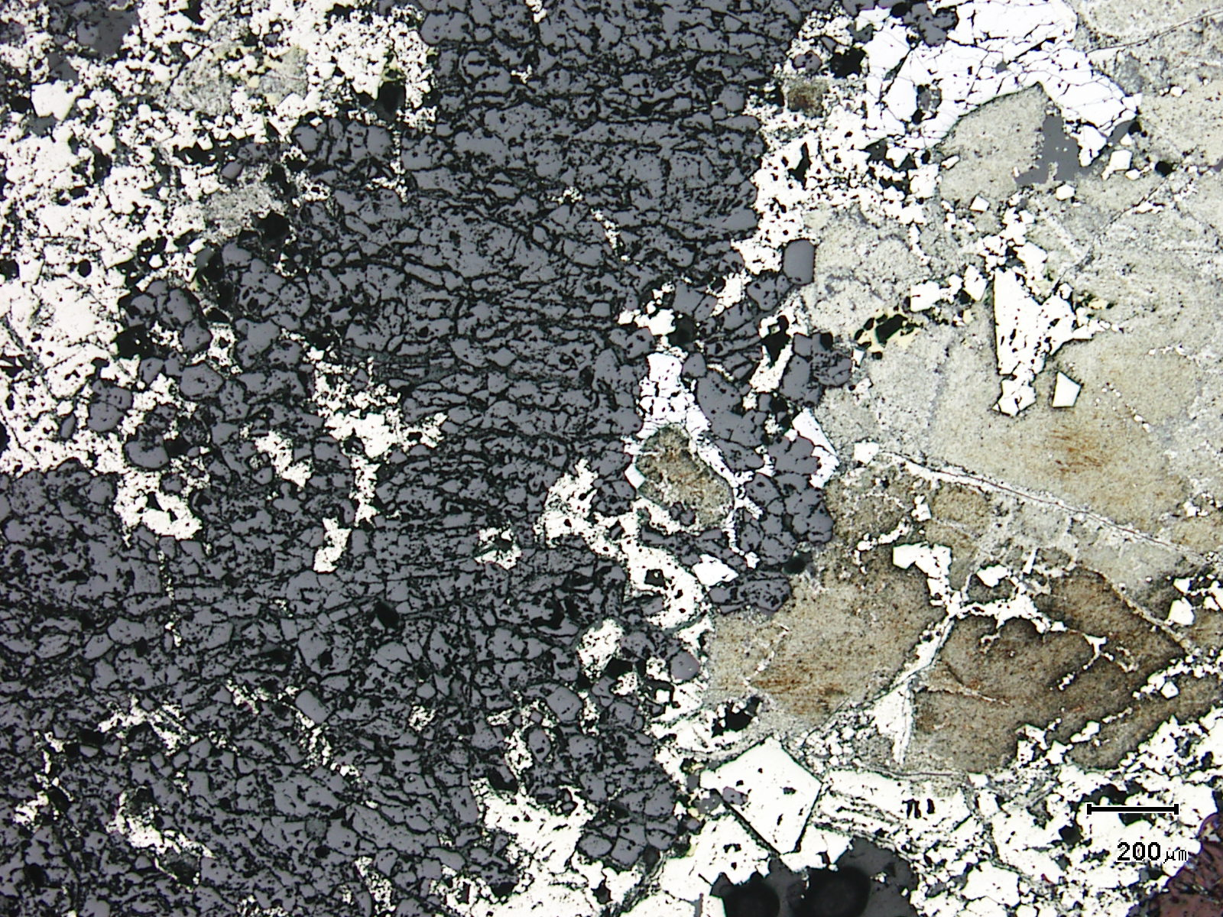
secondary pyrite
cassiterite
(Mag. x 50; scale bar = 200µ; reflected light)

Sample ZS120 - 541.4m

Here, an almost monomineralic band of cassiterite sits within pyrrhotite which has been altered to pyrite.

Plate 107

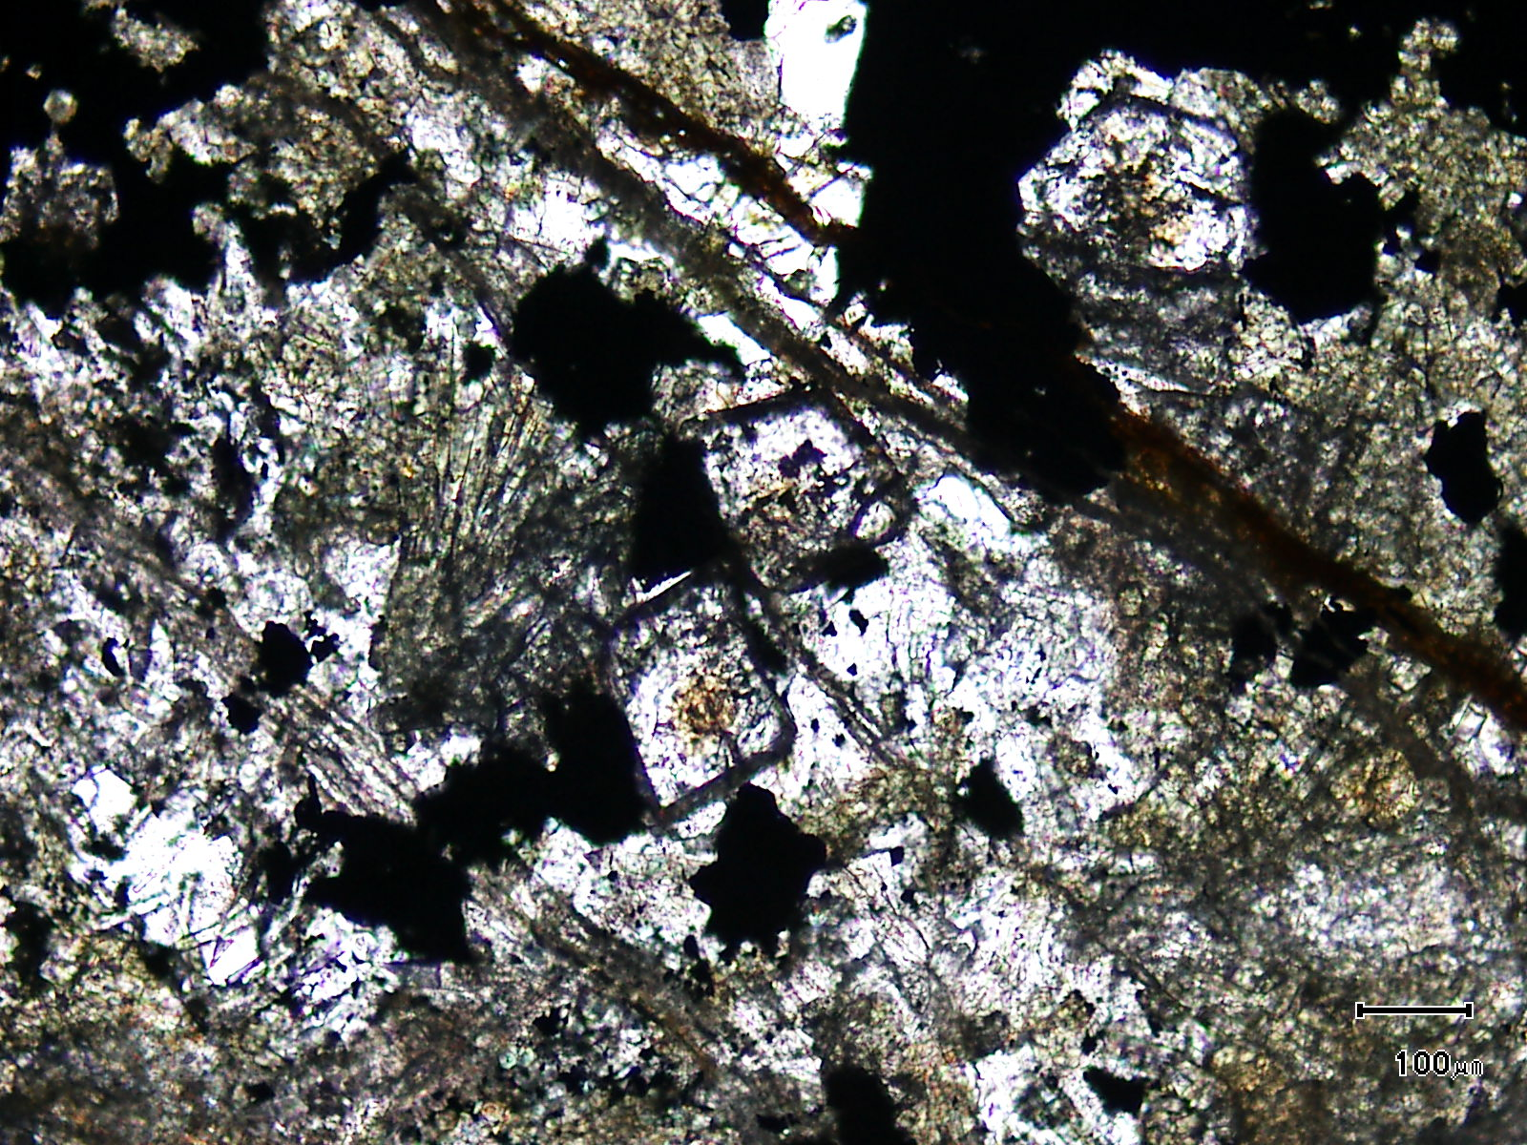
cassiterite
(Mag. x 100; scale bar = 100µ; PPL)

Sample ZS120 - 541.4m

The photomicrograph shows a general textural view of coarse grained cassiterite associated with quartz and tourmaline.

Plate 108

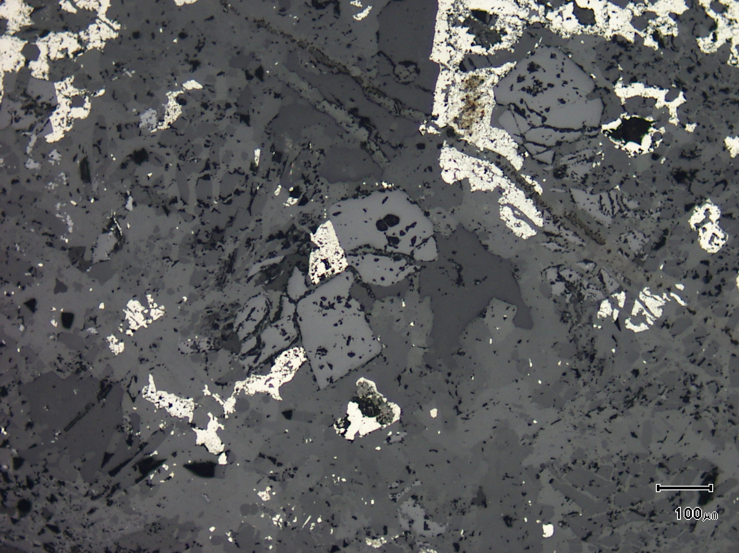
(Mag. x 100; scale bar = 100µ; reflected light)

Sample ZS120 - 541.4m

The photomicrograph shows a reflected light view of Plate 107.

Plate 109

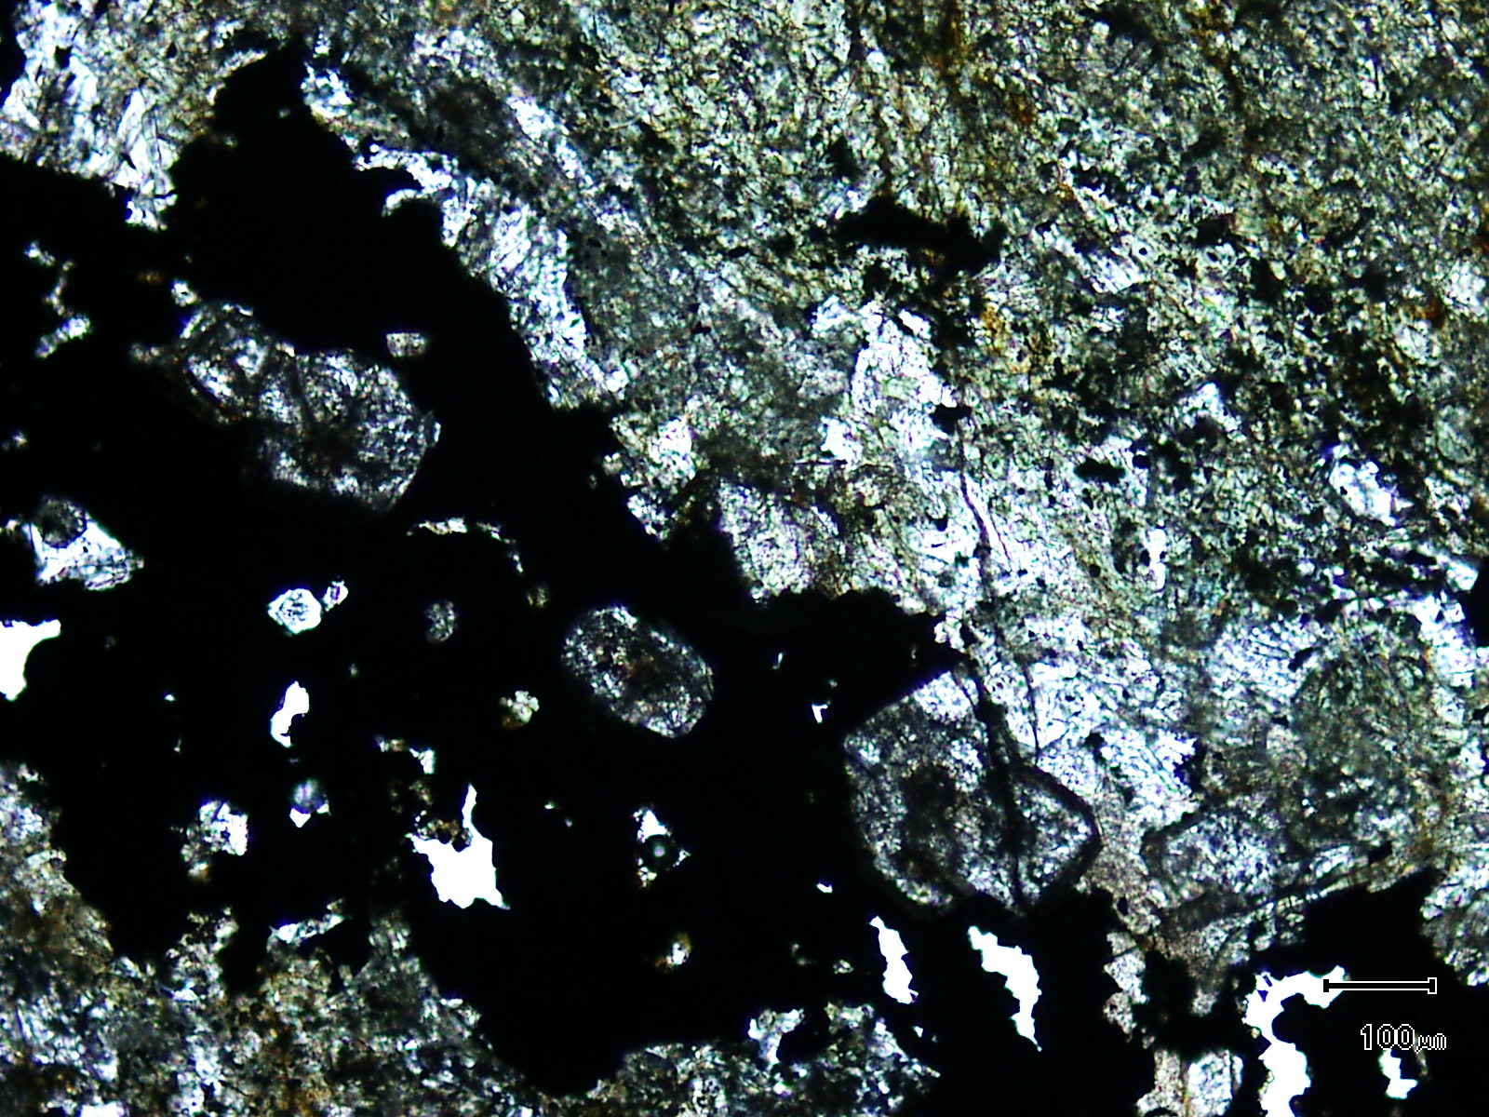
cassiterite
(Mag. x 100; scale bar = 100µ; PPL)

Sample ZS120 - 541.4m

The photomicrograph shows a general textural view of cassiterite associated with iron sulphides and flanked by tourmaline. Cassiterite can also develop within the tourmaline.

Plate 110

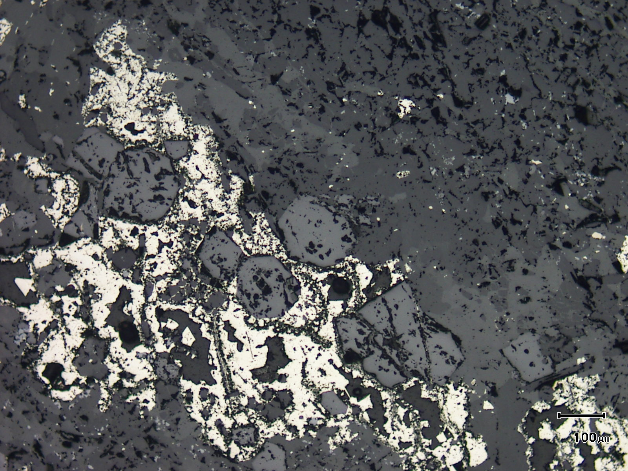
(Mag. x 100; scale bar = 100µ; reflected light)

Sample ZS120 - 541.4m

The photomicrograph shows a reflected light view of Plate 109. Note the coarse grained nature of the cassiterite grains.

Plate 111

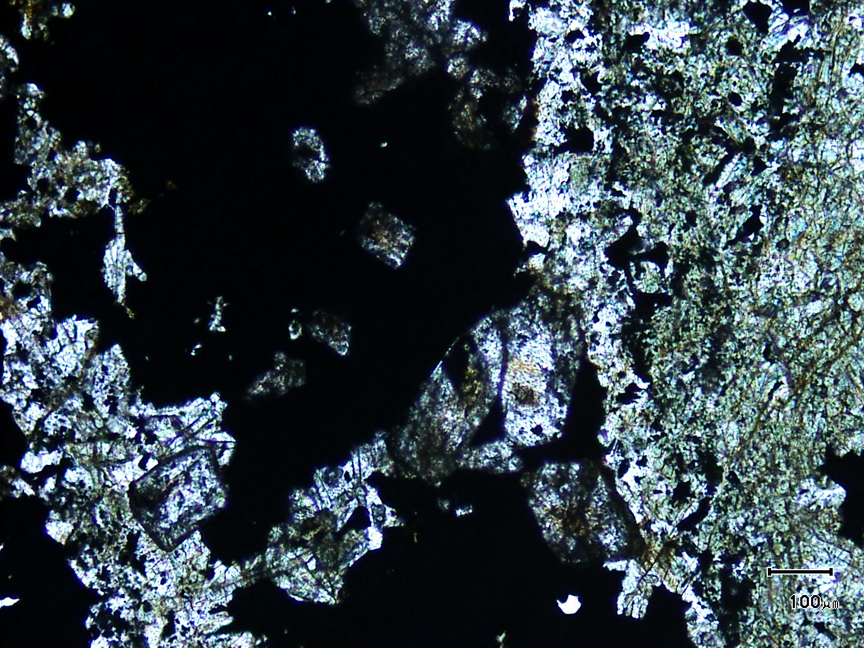
cassiterite
(Mag. x 100; scale bar = 100µ; PPL)

Sample ZS120 - 541.4m

Here is another textural view of cassiterite, tourmaline and sulphide.

Plate 112

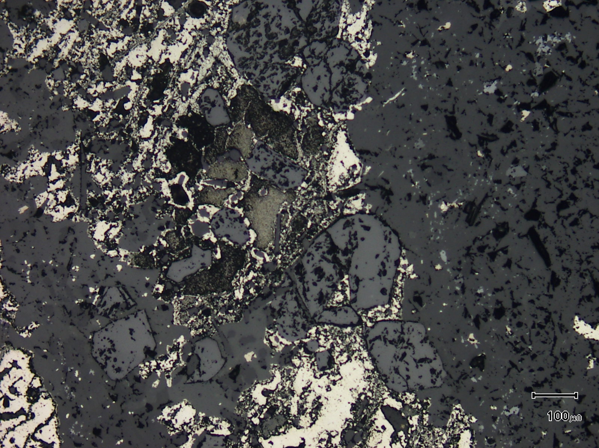
(Mag. x 100; scale bar = 100µ; reflected light)

Sample ZS120 - 541.4m

The photomicrograph shows a reflected light view of Plate 111. The cassiterite can now be seen very easily.

Sample Number: ZS120 - 552.5m

Sample Locality: Severn Ore body, Zeehan

Rock Type: Tourmaline veined and altered, mafic air-fall tuff

Sample Description:

The sample contains coarse grained tourmaline (up to 0.8mm) which has developed within alteration chlorite replacing the fine grained (<10µ) air-fall tuff. This “tuff” is exceptionally rich in anatase (~8%).

A visual estimate of the minerals present is:

Tuff groundmass ~42%
Vein quartz ~12%
Tourmaline ~12%
Pyrite ~10%
Cassiterite ~ 7%
Chlorite ~ 6%
Siderite ~ 5%
Anatase ~ 5%
Chalcopyrite trace

Cassiterite ranges from xenoblastic to idioblastic with most cassiterite developed within linear, carbonate-rich domains. These are often “sandwiched” between tourmaline-rich areas and/or iron-rich, fine grained chlorite. The latter exhibits a moderate cleavage suggesting that some early alteration minerals were deformed. Cassiterite grains range from 10µ to 100µ and some siderite-cassiterite domains can contain more than 50% cassiterite. Cassiterite also develops in adjacent tourmaline-rich “selvedges” but is still associated with siderite. Areas containing abundant pyrite can also host cassiterite (~50-100µ) which is still associated with siderite.

Pyrite develops within crude veins and some may be replacing pyrrhotite. Rare chalcopyrite is also present but is usually found as inclusions in siderite. Anatase tends to be only located within the unaltered, fine grained “tuff” host. The anatase grains average 5µ in diameter.

Vein quartz is brecciated and fractured and can sit within Fe-rich chlorite. Some vein quartz can be associated with cassiterite + tourmaline. The tourmaline is pleochroic from colourless to pale green and grains tend to be idioblastic. Many are choked with anatase inclusions.

The sample exhibits an earlier chloritic alteration which exhibits a moderate fabric. The chlorite can be associated with vein quartz and this quartz is often brecciated and boudinaged. The tin-rich domains are linear and most likely boudinaged. The cassiterite and tourmaline develop within siderite and chlorite.

Plate 113

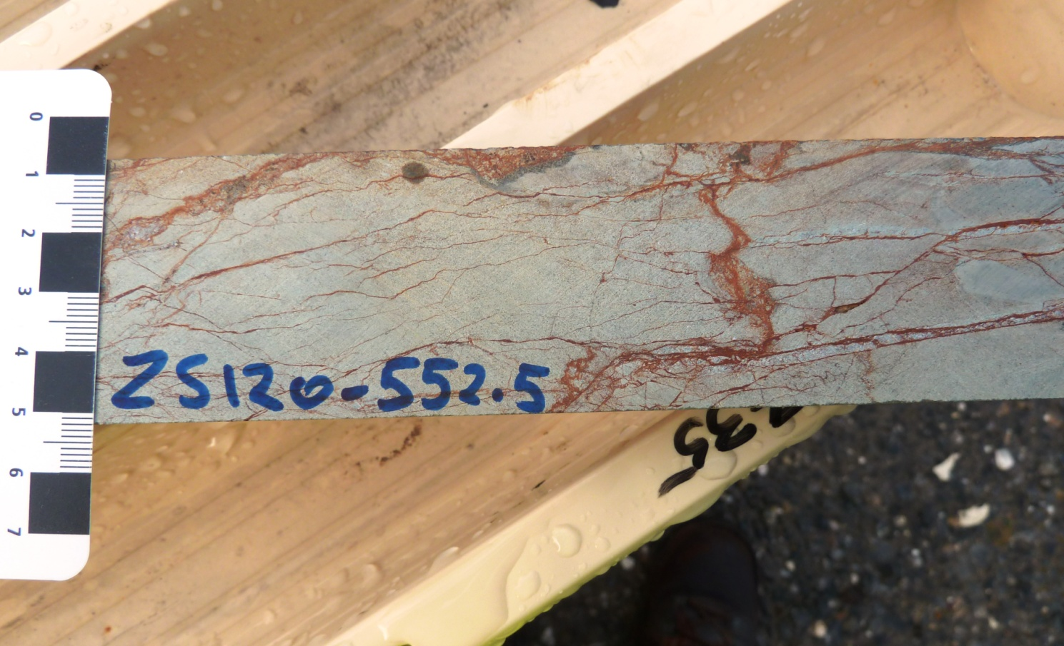

Sample ZS120 - 552.5m

The sample is a strongly veined and altered meta mafic air-fall tuff.

Plate 114

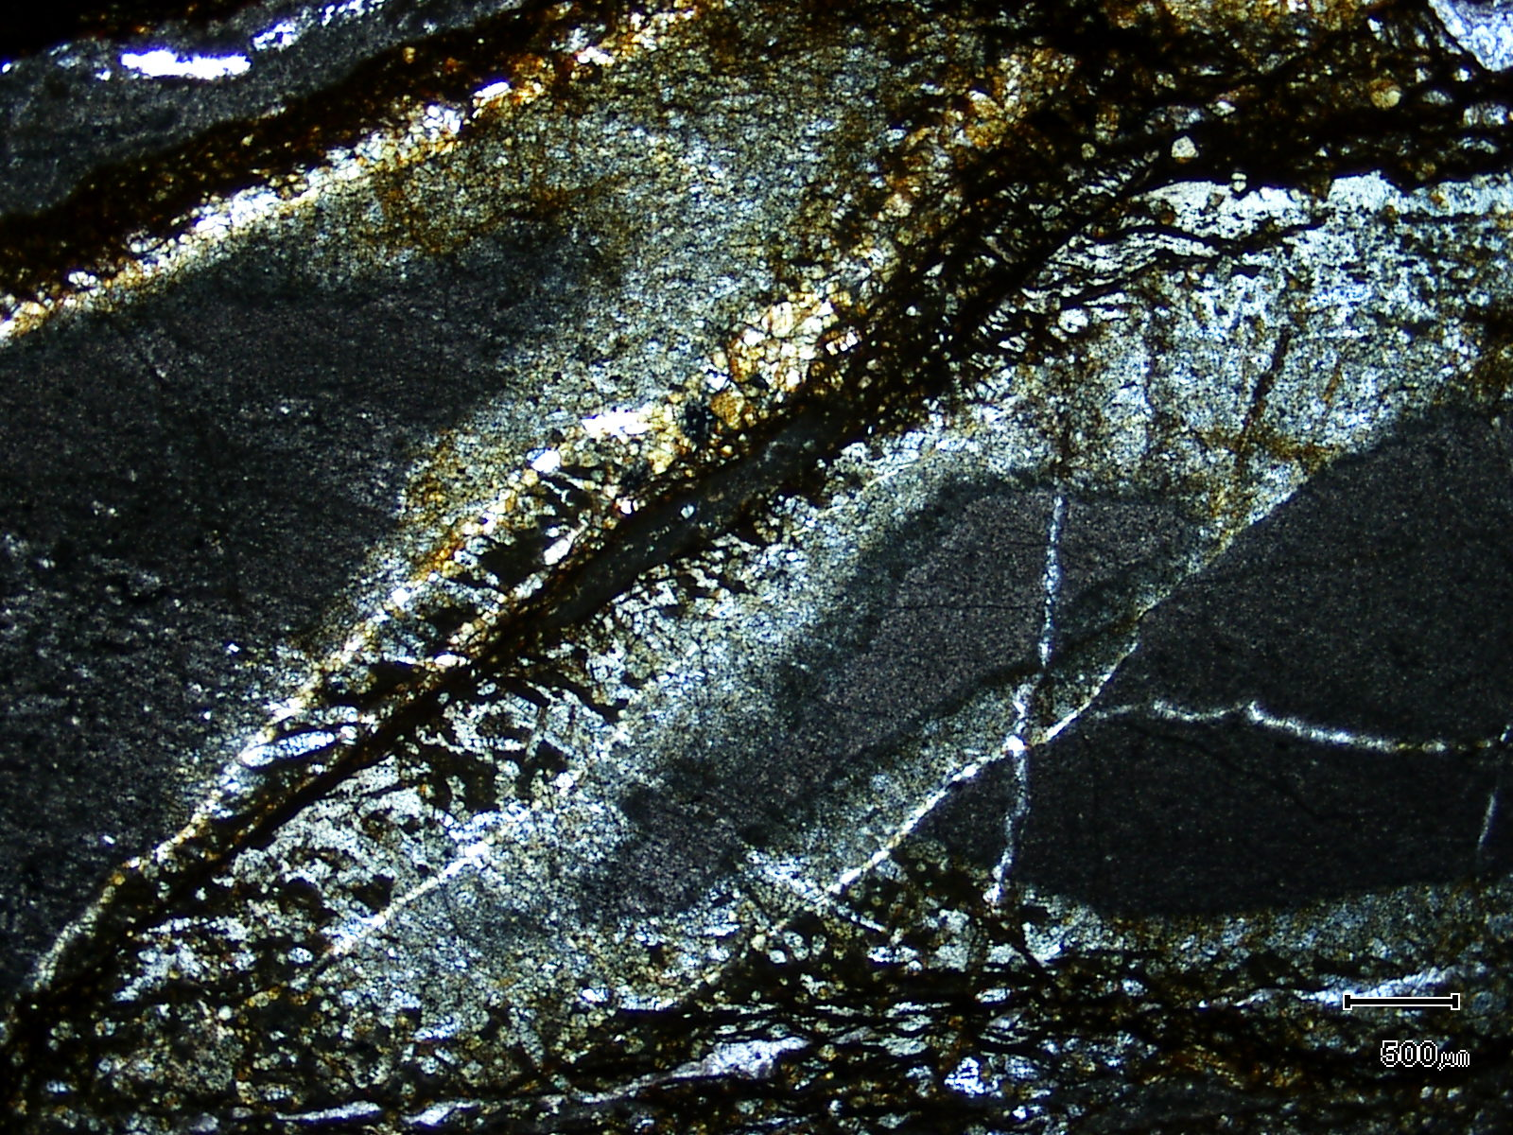
(Mag. x 20; scale bar = 500µ; PPL)

Sample ZS120 - 552.5m

The photomicrograph shows a general textural view of this sample with pyrite tourmaline veins cutting and bleaching the tuff.

Plate 115

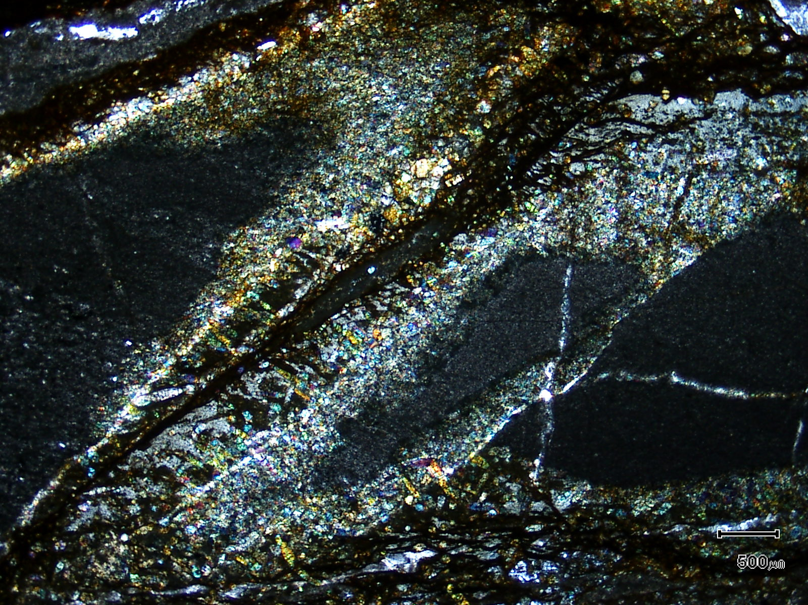
(Mag. x 20; scale bar = 500µ; crossed nicols)

Sample ZS120 - 552.5m

The photomicrograph shows a cross nicols view of Plate 114. Note the abundance of tourmaline in the alteration halo.

Sample Number: ZS120 - 554.55m

Sample Locality: Severn Ore body, Zeehan

Rock Type: Pyrite veined, in part silicified and tourmalinised,
meta-volcaniclastic

Sample Description:

The sample contains abundant “crude” pyritic veins which sit within silicified and carbonate altered volcaniclastic. The volcaniclastic is, like many other described volcaniclastics, extremely anatase-rich.

A visual estimate of the minerals present is:

Tourmaline ~27% Anatase ~ 4%
Pyrite ~23% Cassiterite ~ 2%
Quartz ~18% Rutile ~ 2%
Siderite ~ 8% Chalcopyrite trace
Chlorite ~ 8% Pyrrhotite trace
Unknown ~ 7%

Pyrite is xenoblastic, inclusion-choked and develops in crude bands and veins. It contains inclusions of chalcopyrite and pyrrhotite and much of the pyrite is secondary after pyrrhotite. Much of the pyrite is associated with siderite and there are abundant inclusions of idioblastic tourmaline grains. A colourless, highly birefringent mineral is also present throughout the pyrite and the groundmass (?sellaite). Rare cassiterite and abundant rutile are scattered through the pyrite and adjacent siderite.

Chalcopyrite occurs as coarse grains (0.4mm) or coarse grain aggregates (up to 1.2mm) associated with pyrite veins. Chalcopyrite is also located as fine grains (<10µ) within siderite and also as coarse grains (~100µ) within the siliceous groundmass.

The tourmaline is pleochroic from colourless to yellow-green. It is present as tabular, idioblastic grains which can be up to 0.5mm in length. It is also present as acicular, fine grains developed within quartz. Chlorite is fine grained and may replace fine phlogopite.

The groundmass contains angular fragments of altered plagioclase as well as angular clasts of probable devitrified volcanic glass. Although the sample is strongly veined and altered, relict textures can still be observed.

Plate 116

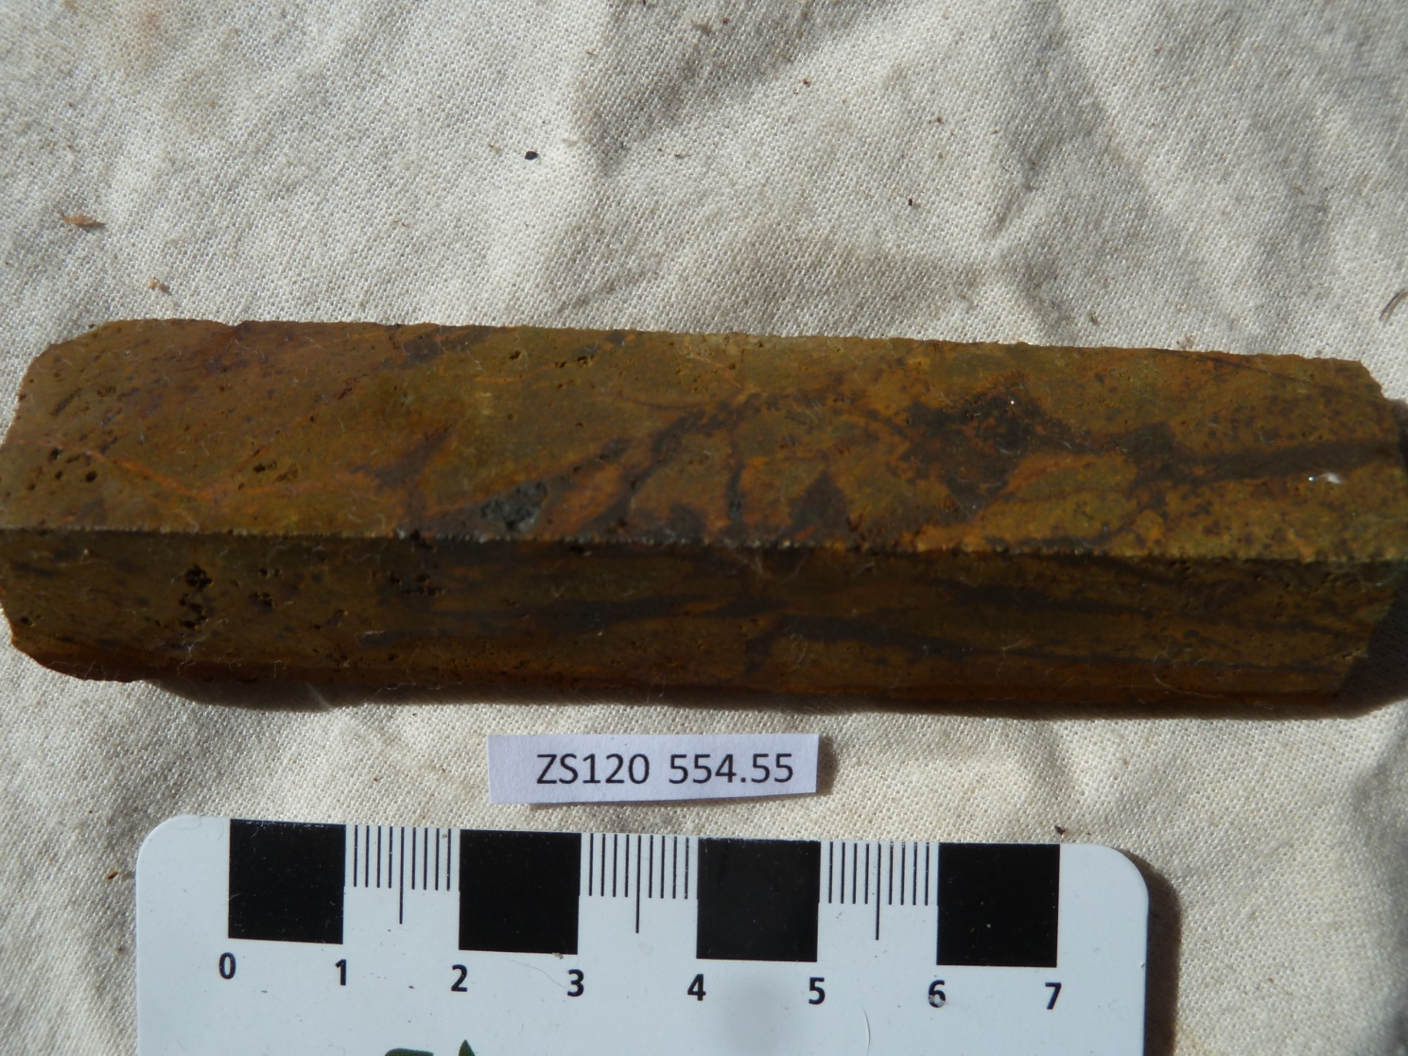

Sample ZS120 - 554.55m

The slab photograph shows an oxidised, pyrite-veined, silicified and tourmalinised meta-volcaniclastic.

Plate 117

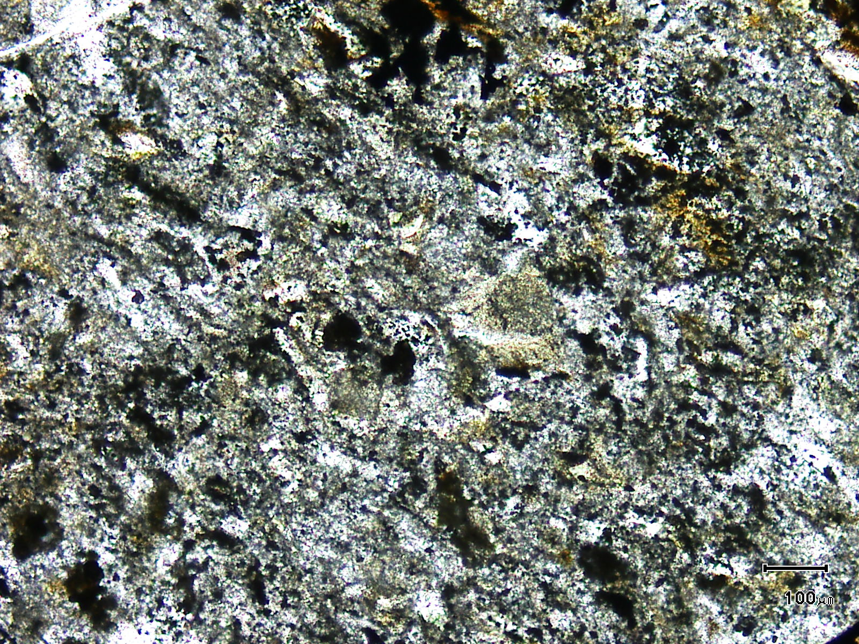
(Mag. x 100; scale bar = 100µ; PPL)

Sample ZS120 - 554.55m

The photomicrograph shows a general textural view of the volcaniclastic groundmass. Abundant tourmaline develops in the groundmass, however relict clasts are preserved.

Plate 118

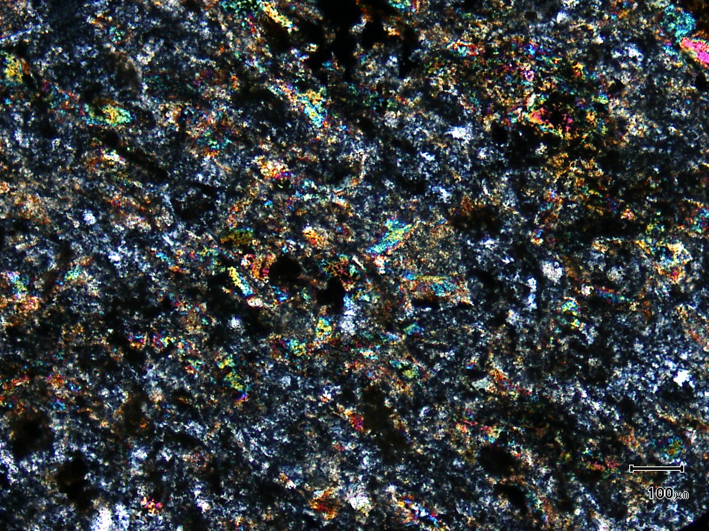
(Mag. x 100; scale bar = 100µ; crossed nicols)

Sample ZS120 - 554.55m

The photomicrograph shows a cross nicols view of Plate 117. The brightly coloured material is groundmass tourmaline.

