EL13/2019 Tribute Exploration Licence– Annual Report
  - 6 April 2020 – 7 April 2021

Joe Booth
Hydro Tasmania
4 Elizabeth St
Hobart TAS 7000
31 July 2021

Hydro Tasmania document control
Title |  |  | Version:V1.1
EL13/2019 Tribute Exploration Licence– Annual Report |  | Document owner: | Joe Booth
 |  | Date created: | July 2021
Reviewed: | Matt Ferguson | Date approved: | 06/08/2021
Approved: | Seth Langford | Signed: | Signed electronically

Contents
1.0 Executive Summary 4
2.0 Summary Activity Map 5
3.0 Introduction 7
4.0 Review of previous work 8
5.0 Exploration completed during the reporting period 15
6.0 Discussion of Results 17
7.0 Conclusions 20
8.0 Future exploration 21
9.0 Environmental Management 22
10.0 Expenditure 23
11.0 References 24
12.0 Appendices 25
12.1 Appendix 1 - Borehole logs 25
12.2 Appendix 2 - Borehole photographs 25
12.3 Appendix 3 - Environmental Impact Assessment 25
12.4 Appendix 4 - EL14/2019 Exploration Licence Annual Return 25

List of Figures
Figure 2.1: Location of EL13/2019, near Lake Murchison 5
Figure 2.2: Location of recent investigations conducted within EL13/2019. 6
Figure 4.1: Geological map of the area between Lake Plimsoll and Lake Murchison 9
Figure 4.2: Factual surface geological map of the Quinn Creek tunnel diversion area 12
Figure 4.3: Existing Tribute power tunnel (purple) and location of boreholes (green dot) in area of Quinn Creek diversion overlain on geological map 13
Figure 4.4: Tertiary valley model for the Quinn Creek tunnel deviation area 13
Figure 4.5: Interpretive cross section of the Quinn Creek tunnel diversion area showing the Tertiary valley model 14
Figure 4.6: Alternative structural interpretation for the Quinn Creek tunnel deviation area 14
Figure 5.1: Location of Tribute exploration sites 16
Figure 6.1: Draft Interpretive cross-section showing proposed drill hole traces (TR-BH02A and TR-BH02B) onto interpreted Quinn Creek Fault location 18
List of Tables
Table 4.1: Geological history of the Tribute area summarised from Corbett et al. (2014). 11
Table 5.1: Recent Hydro Tasmania Investigations 15
Table 6.1 Borehole TR-BH02A and TR-BH02B Summary rock logs 19

Executive Summary
Hydro Tasmania is currently investigating the development of a pumped hydro energy storage (PHES) in Tasmania as part of the Battery of the Nation initiative. Currently, feasibility studies are being undertaken at three sites to assess their suitability for the development of a PHES. Lake Cethana, Lake Rowallan and between Lake Murchison and Lake Plimsoll have all been identified as suitable sites. A critical component of the feasibility study is determining the geology and geotechnical properties at key locations across the project footprint and to identify adequate quantities of suitable construction materials including aggregate for concrete production, earth and rock fill for dam construction and sub-surface ground conditions for construction of shafts, tunnels and an underground power station. Category 3 (Construction Materials) Exploration Licenses were sought to cover the respective project footprints.
Geological mapping, drilling and test pitting investigations were planned to inform the development of a geological model to allow progression of engineering designs for the general arrangement of the scheme.
Investigations undertaken at the Tribute PHES site have provided sufficient information to inform an adequate understanding of the geology of the area between Lake Plimsoll and Lake Murchison, however Cethana PHES was selected as the preferred project to progress to final feasibility. Deep storage capacity, greater cost and technical certainty, environmental and social sustainability and flexibility in sizing and capacity make Cethana the preferred option to take to final feasibility.
Investigations and interpretation conducted at Tribute as part of the Battery of the Nation PHES Study were not exhaustive and this site still retains the potential to develop a PHES in the future, however limited further work will be undertaken whilst the Cethana PHES project is being prioritised.
This report aims to meet Hydro Tasmania’s reporting obligations in relation to the issuing of Exploration Licence EL13/2019, in the vicinity of Lake Murchison for the period 6 April 2020 to 7 April 2021.

Summary Activity Map
Figure 2.1: Location of EL13/2019, near Lake Murchison
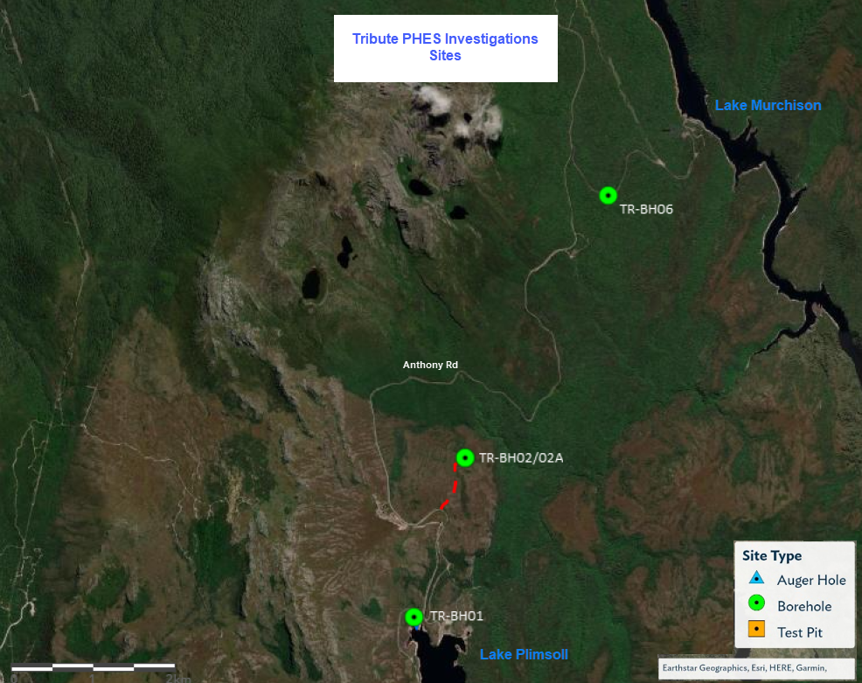
Figure 2.2: Location of recent investigations conducted within EL13/2019.

Introduction
Hydro Tasmania is currently investigating the development of a pumped hydro energy storage (PHES) in Tasmania as part of the Battery of the Nation initiative. Currently, feasibility studies are being undertaken at three sites to assess their suitability for the development of a PHES. Lake Cethana, Lake Rowallan, Lake Murchison and Lake Plimsoll have all been identified as suitable sites. A critical component of the feasibility study is the undertaking of investigations to determine geotechnical and geological conditions for construction of key components of the PHES. As well as identifying adequate quantities of suitable construction materials including aggregate for concrete production, earth and rock fill for dam construction and sub-surface ground conditions for construction of shafts, tunnels and an underground power station.
This report aims to meet Hydro Tasmania’s reporting obligations in relation to Licence number 13/2019, in the vicinity of Lake Murchison for the period 6 April 2020 to 7 April 2021.

Review of previous work
Work conducted in relation to the Tribute PHES began with a scoping study and shortlisting of 14 potential PHES sites around Tasmania. A Pre-Feasibility Study of the Tribute PHES was completed in early 2019 and followed into Feasibility Study in July 2019. Investigations as part of the Feasibility Study commenced in March 2020, prior to the granting of EL13/2019 and continued into the report period.
Previous work includes detailed desk-top analysis of existing geological data as well as geological mapping diamond drilling completed up until the granting of EL13/2019.
Geological mapping of the area between Lake Plimsoll and Lake Murchison comes from Mineral Resources Tasmania (MRT) 1:25,000 geological maps of Selina and Tullah. A geological map of the Tribute PHES area is shown in Figure 4.1.
The Lake Plimsoll reservoir and existing Tribute power tunnel and power station are sited on the eastern side of the far northern portion of the West Coast Range, with the majority of the scheme bound to the north and south by Mount Murchison and Mount Julia, respectively. The Tribute scheme utilises the tributaries to the northeast flowing Anthony River, and also captures runoff from large parts of the western side of the Mount Julia-Mount Murchison area via diversion of the upper reaches of the Henty and Langdon Rivers eastwards into the Anthony catchment. The proposed Tribute Pumped Hydro Energy Storage system follows the alignment of the existing Tribute power tunnel.
The Mount Julia-Mount Murchison area immediately above and to the west of the Tribute power tunnel are principally comprised of Cambrian Owen Group sandstones and conglomerates. The Anthony River valley cuts into Cambrian Mount Read Volcanics sedimentary, volcanic and intrusive rocks, and the low relief area to the east of Mount Murchison comprises the Cambrian Murchison Granite. Proterozoic metasedimentary rocks also occur in the lower reaches and to the east of the Anthony River, but the scheme’s alignment does not traverse these rocks.
Pleistocene glaciations modified the mountains and formed blankets of boulder-gravel-sand deposits throughout the area.
Thick forest is developed in the Anthony River valley where underlain by Cambrian Mount Read Volcanics, above the power station area on the Cambrian Murchison Granite, and in some glacial deposits on the eastern flank of the Mount Julia-Mount Murchison area. Elsewhere dense alpine grass and shrub growth results in a highly irregular and difficult to traverse surface; there is minimal area clear of vegetation in the scheme area.

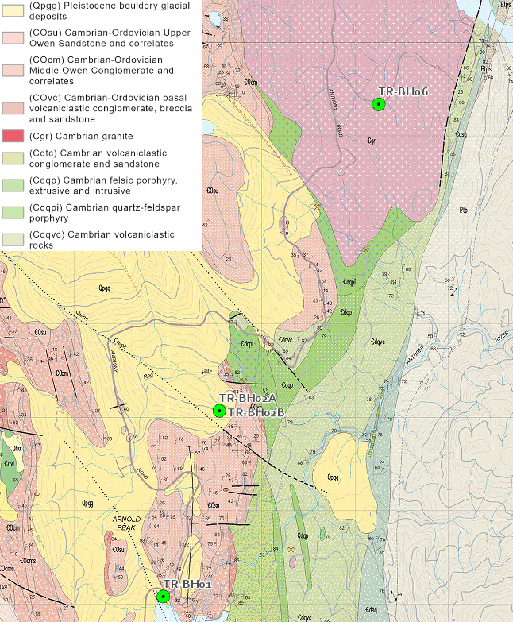
Figure 4.1: Geological map of the area between Lake Plimsoll and Lake Murchison (MRT 1:25,000)

Table 4.1 below summarises the geological history and general stratigraphy around the Lake Plimsoll to Lake Murchison area.
Period, age and regime details | Event | Resulting deposit or feature
Holocene  0 – 10 ka  Current and recent depositional regimes  Derived from all older material  Qha | Continued erosion of river banks and the toes of slopes during major flood events  Some climate variation | Sands, gravels, cobbles and boulders in river beds  Swampy and water saturated areas
Quaternary/Pleistocene  10 ka – 2.58 Ma  Ancient glacial-periglacial depositional and weathering regimes  Derived from all older material  Qpgg | Glacial and periglacial processes  Four glacial events since 60 ka  At least eight glacial events since 1 Ma | Variable thickness bouldery glacial deposits  Solifluction deposits formed by downslope movement during freezing and thaw  Out-wash gravels
Cenozoic/Tertiary  2.58 Ma – 66 Ma  Ancient weathering and erosion regimes and poorly understood sediment depositional regimes  Derived from all older material  Not differentiated at surface | Continuing weathering and erosion of the landscape, forming the slopes of the present valleys and deposits in restricted, small basins (Quinn Creek?)  Lake deposits –clays in poorly drained flats and valleys | Deposition of Tertiary sediments in valleys, possible reworking and/or lithification of some sediments
Silurian to Cretaceous  Generally quiescent | Prolonged weathering and erosion | Formation of an extensive erosion surface  Far-field tectonic events  Depositional periods missing from geological record in area
Cambrian-Ordovician  Late Cambrian mountain building event  COsu, COcm, COvc | Erosion of Proterozoic basement rocks and deposition of Owen Group in fault basins and half-grabens  Gordon Group limestone deposition above the Haulage Unconformity, over the Owen Group | Owen Group sandstones, conglomerates, and siltstones  Gordon Group limestones
Cambrian  506 Ma – 493 Ma  Mountain building event/arc-continent collision and extensional phase/volcanism and sedimentation  Cdqp, Cdqpi, Cdqvc | Post arc-continent collision volcanism and intervening sedimentation and reworking of volcanic deposits | Deposition of the eastern Mount Read Volcanics sequence comprising 2.5 km thick complex of porphyritic felsic lavas, intrusions and volcaniclastics
Table 4.1: Geological history of the Tribute area summarised from Corbett et al. (2014).

The existing headrace tunnel of the Tribute scheme encountered a section of very poor ground conditions in the area of Quinn Creek. A surface geological map of the area is shown in Figure 4.2
A tunnel diversion was constructed for this zone as it was not possible to excavate and support through this material. The lithologies in the vicinity of the diversion comprise tens of metres of formations of alternating conglomerate, conglomeratic sandstone, and minor sandstone.
Several potential geological models were explored in the evaluation of the Quinn Creek area subsurface feature in work during and following construction as shown in Figure 4.4, Figure 4.5 and Figure 4.6.
- As more data became available from drilling, interpretations favoured a model where two oblique faults crossed and then intersected within ~200 m of the initial tunnel design line, or alternatively, where a single fault zone crossed the tunnel alignment.
- Between these faults or to the north of the fault zone is a zone of silt, clay, sand and limestone which contained water under pressure at the tunnel level.
- Potential geological origins for this zone include a Cenozoic paleovalley concealed beneath glacial deposits, or weathered sedimentary rocks distinct from those recognised elsewhere.
- This zone included materials reported as ‘adversely orientated, relatively closely bedded, slightly to moderately weathered sandstone containing interbeds of weak to very weak, highly to completely weathered siltstone that required full support.
- In addition, groundwater inflows increased with an increased risk of flooding if the pumping system broke down’.

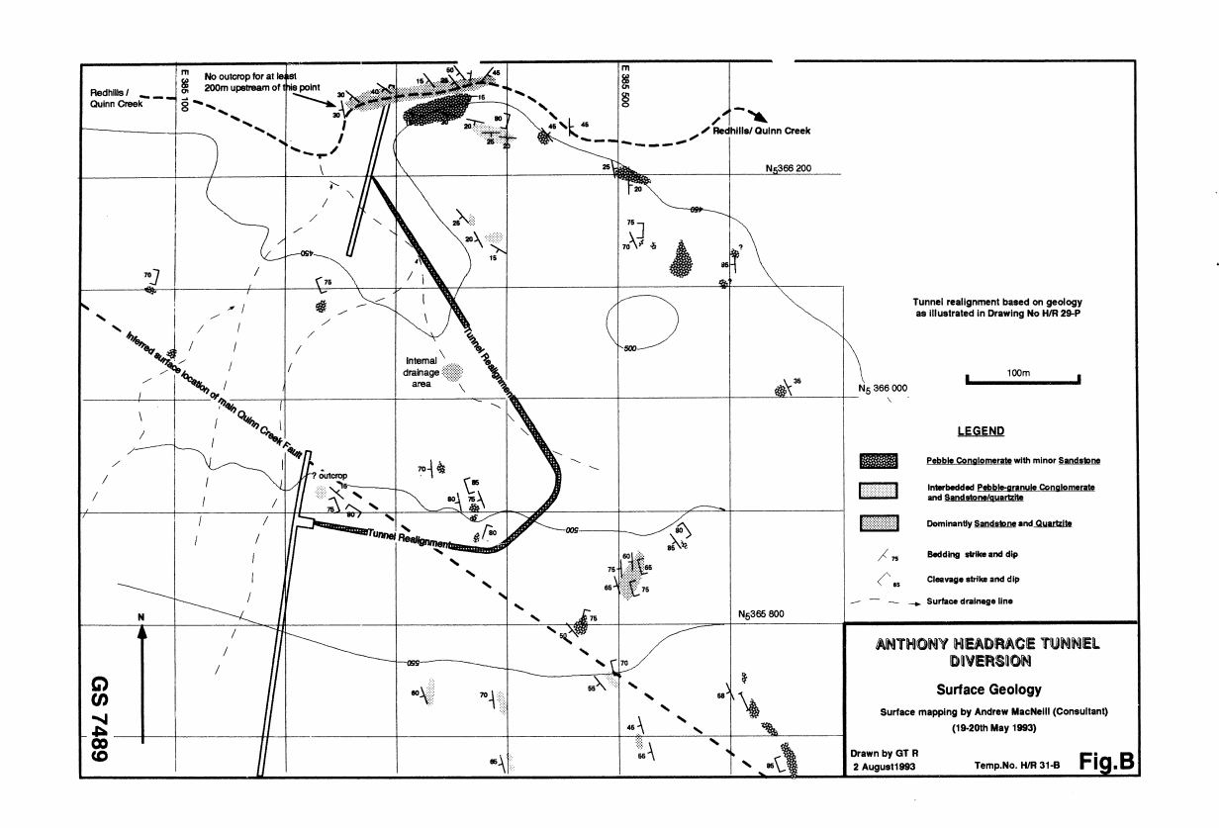
Figure 4.2: Factual surface geological map of the Quinn Creek tunnel diversion area
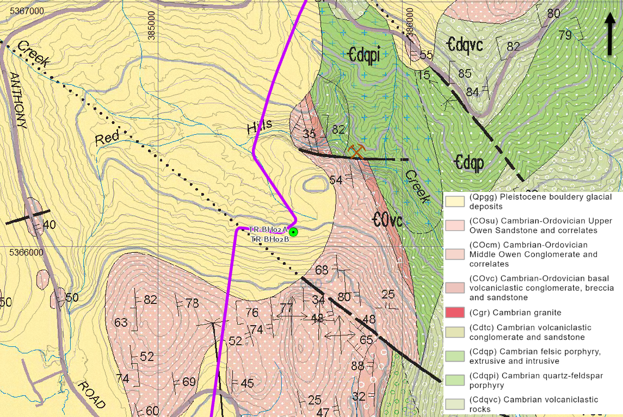
Figure 4.3: Existing Tribute power tunnel (purple) and location of boreholes (green dot) in area of Quinn Creek diversion overlain on geological map
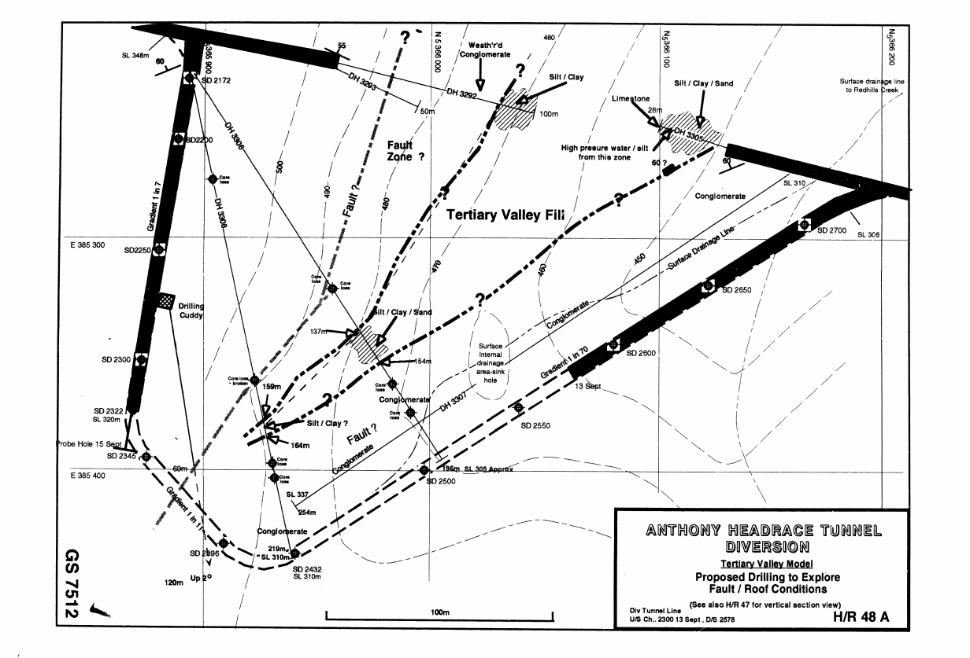
Figure 4.4: Tertiary valley model for the Quinn Creek tunnel deviation area
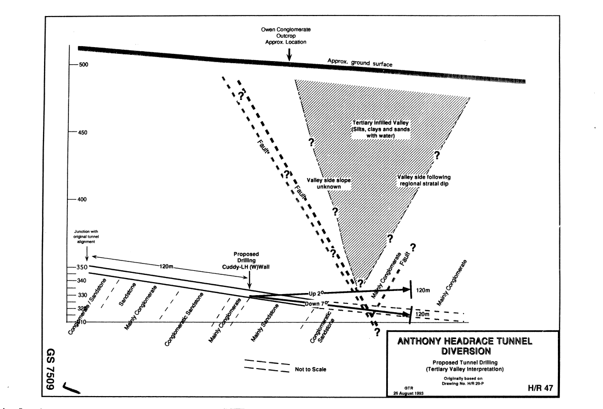
Figure 4.5: Interpretive cross section of the Quinn Creek tunnel diversion area showing the Tertiary valley model
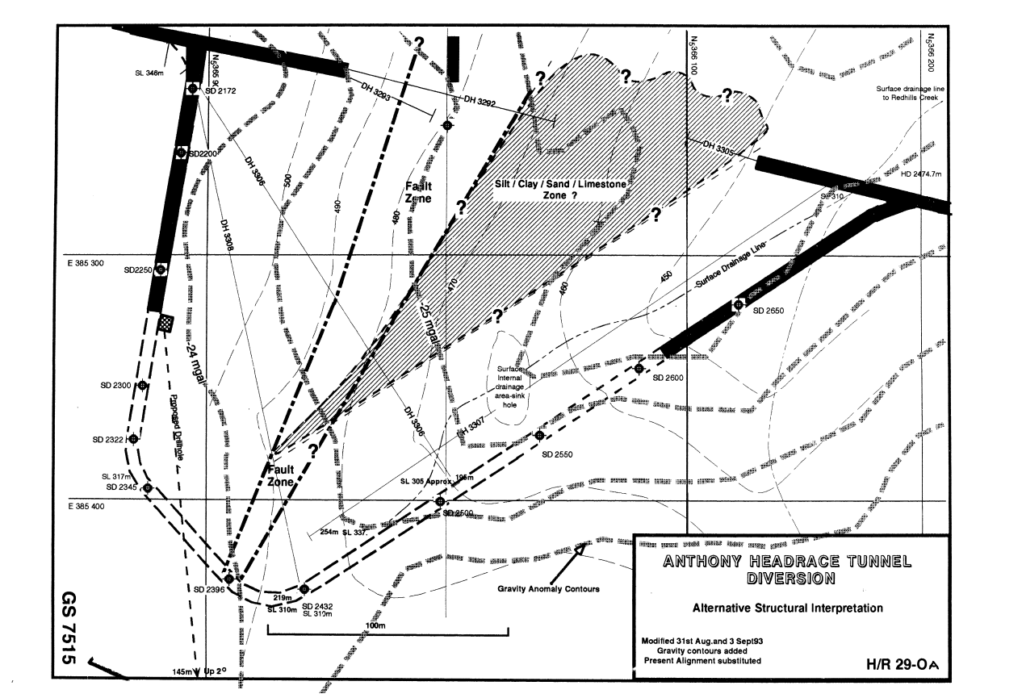
Figure 4.6: Alternative structural interpretation for the Quinn Creek tunnel deviation area

Exploration completed during the reporting period
Investigations including mapping and drilling at the Tribute PHES site commenced in March 2020 and were completed by August 2020.
Geological and geotechnical investigations conducted as part of the Tribute PHES Feasibility Study during the report period consisted of 2 diamond drill holes (TR-BH02A – 402.0m and TR-BH02B 371.5m) for a total of 773.5m.
- Borehole logs and core photographs are included in Error! Reference source not found. and Error! Reference source not found. respectively.
Drilling conducted during the reporting period was designed to intersect the interpreted Quinn Creek Fault Zone in order to determine ground conditions in the area for constructability assessment of the power tunnel for the Tribute PHES.
A summary of investigations including GDA94 coordinates is included in Table 5.1 below:
Hole ID | Objective | Comments | Elevation (m) | Easting (m) | Northing (m) | Orientation (true north) | Orientation (magnetic north) | Inclination (from horz.) | Expected depth (m) | Final depth (m)
TR-BH01 | Cored borehole to Investigate area around Lake Plimsoll intake | Casing expected to be required in surficial and highly weathered material | 527 | 384953 | 5364075 | - | - | -90 | 55 | 54.6
TR-BH02A | Cored borehole to Investigate area around Quinn Creek Fault (East of diversion) | Casing expected to be required in surficial and highly weathered material | 504 | 385553 | 5366060 | - | - | -90 | 344 | 402.0
TR-BH02B | Cored borehole to Investigate area around Quinn Creek Fault (East of diversion) | follow up angled hole to position Quinn Creek fault | 504 | 385552 | 5366058 | 180 | 166.3 | -70 | 390 | 371.5
TR-BH06 | Cored borehole to Investigate area around proposed power station cavern | Casing expected to be required in surficial and highly weathered material | 403 | 387198 | 5369334 | 130 | 116 | -80 | 265 | 200
Table 5.1: Recent Hydro Tasmania Investigations

Boreholes TR-BH01 and TR-BH06 were completed prior to EL13/2019 being granted. TR-BH01 was drilled at the northern end of Lake Plimsoll to inform constructability of the upper intake structure. TR-BH06 was targeting the proposed power station location and expected to be drilled to at least 265m. The hole was put on hold at 200m awaiting in situ stress testing by overcoring, which was to be conducted by a subcontractor. Unfortunately due to border closures associated with the Covid-19 pandemic this testing was unable to be completed. The hole has been capped and left open in order for in situ stress testing to be conducted in the future should investigations recommence at the Tribute PHES site.

Figure 5.1: Location of Tribute exploration sites
Hydro Tasmania was concurrently undertaking exploration activities at two other sites including the Rowallan PHES in the vicinity of Lakes Rowallan (EL14/2019) and the Cethana PHES near Lake Cethana (EL1/2020). These activities are reported in the respective Annual Reports for each licence.

Discussion of Results
The Tribute PHES water conveyance alignment was designed to run adjacent to the existing Tribute power tunnel. As discussed in the review of previous work (Section 4.0) a significant fault zone was interpreted to have been intersected by the existing tunnel.
An interpretive cross-section of the intersection of the fault zone and Tribute PHES power tunnel with planned drillholes plotted is shown in Figure 6.1.
Summary drill logs are shown in Table 6.1. Although several small fractured zones are present, the most significant fault zone was logged in TR-BH02B at 364.6m. It was logged as being ~1.2m wide, highly fractured, slickensided with quartz gravel and clay seams. No other structures with the characteristics expected of the Quinn Creek Fault Zone were intersected.
Although the Quinn Creek Fault Zone was not definitively intersected, there still remains a number of interpretations. It could be that the alignment and orientation of the interpreted fault was incorrect and that drilling was positioned such that it missed the fault zone altogether. Alternatively, given that the diversion of the original tunnel did not intersect large areas of clay, broad sheared or intensely fractured zones or significant groundwater, it may be that the fault zone pinches out to the south-east and no major structure is present.
Additional drilling or geophysical surveys in the future may be considered to increase confidence in the geological model and de-risk any potential construction.

Figure 6.1: Draft Interpretive cross-section showing proposed drill hole traces (TR-BH02A and TR-BH02B) onto interpreted Quinn Creek Fault location

BHID | Depth From | Depth To | Rock Type | Comments
TR-BH02A | 0 | 3 | Topsoil and colluvium | including small sections of core loss
TR-BH02A | 3 | 17.6 | Interbedded sandstone/conglomerate
TR-BH02A | 17.6 | 26.8 | Sandstone | minor siltstone and conglom interbeds
TR-BH02A | 26.8 | 45.8 | Interbedded sandstone/conglomerate
TR-BH02A | 45.8 | 72.3 | Sandstone | minor conglom interbeds typically <1m, minor siltstone interbeds
TR-BH02A | 72.3 | 104.23 | Interbedded sandstone/conglomerate
TR-BH02A | 104.23 | 206.6 | Sandstone | minor conglom interbeds typically <1m thick
TR-BH02A | 206.6 | 402 | Conglomerate | Pink-grey med grained rounded EOH

BHID | Depth From | Depth To | Rock Type | Comments
TR-BH02B | 0 | 3.4 | Topsoil and colluvium | including small sections of core loss
TR-BH02B | 3.4 | 289 | Sandstone (variably fg-mg-cg) | minor siltstone and conglom interbeds
TR-BH02B | 289 | 304.8 | Interbedded sandstone/conglomerate
TR-BH02B | 304.8 | 329.2 | Conglomerate | minor sandstone interbeds
TR-BH02B | 329.2 | 371.5 | Sandstone (variably fg-mg-cg) | minor conglom interbeds. 1.2m Flt zone at 364.5m. EOH

Table 6.1 Borehole TR-BH02A and TR-BH02B Summary rock logs

Conclusions
Although investigations at the Tribute PHES site provided sufficient information to inform an adequate understanding of the geology of the area between Lake Plimsoll and Lake Murchison, however Cethana PHES was selected as the preferred project to progress to final feasibility. Deep storage capacity, greater cost and technical certainty, environmental and social sustainability and flexibility in sizing and capacity make Cethana the preferred to finalise feasibility.
Investigations and interpretation conducted at Tribute as part of the Battery of the Nation PHES Study were not exhaustive and this site still retains the potential to develop a PHES, however limited further work will be undertaken whilst the Cethana PHES project is being prioritised.

Future exploration
Investigations across EL13/2019 have adequately informed a geological model of the Tribute PHES area to the level of detail required by the Feasibility Study. Future activity is expected to include further review and interpretation of the existing geological data at Tribute, particularly focusing on the Quinn Creek Fault Zone interpretation. Hydro Tasmania will also be progressing the Feasibility Study for the Cethana PHES site. There are no current plans for on-ground activities at EL13/2019 for the next reporting period.

Environmental Management
Hydro Tasmania maintains a detailed Health Safety and Environment Policy. Environmental Management at the Tribute PHES site included, ecological and cultural heritage surveys that formed the basis for a detailed Environmental Impact Assessment (EIA). The EIA, in conjunction with the MRT Exploration Code of Practice and the drilling contractors Environmental Management Plan (EMP), informed the general investigations philosophy, the main points are summarised below:
- Where possible existing access tracks were used to minimise surface disturbance.
- Helicopter portable drill rig and foot access track used in the Quinn Creek area of the Tyndall Reserve
- Drill pad size was limited to the minimum safe area for effective set up and operation of the drill rig and associated equipment.
- Only approved biodegradable drilling muds were used as additives to the drilling water, with the exception of minor amounts of rod grease to maintain effective operation of the drill rig.
- Drilling water was discharged to ground via in-ground excavated recirculation/settling sumps to minimise impact of drill cuttings and approved drilling muds/additives entering the environment.
- All excavations (test pits and drill sumps) were backfilled and drill holes capped.
More detail can be found in Appendix including:
- HT HSE Policy
- TDS EMP
- Hydro Tasmania EIA’s and associated supporting documents.
Drilling in the Quinn Creek area required low impact strategies to access the drill site within the Tyndall Reserve. An approximately 1.5km long foot access track was cut from Anthony Road to the drill pad, both of which were trimmed, covered with geo-fabric and overlain with hardwood woodchips to maintain the integrity of the track and provide improved protection of soil and vegetation.
The Quinn Creek drill site was audited by MRT (David Gatehouse) on 28/05/2020 and internally by a Hydro Tasmania Environmental Representative on 02/06/2020 . Feedback from the visits is also included in Appendix .
Upon completion of the drilling the geo-fabric and woodchips were collected into bulka-bags and helicoptered out of the site. Upon completion of rehabilitation representatives from Parks and Wildlife Service visited the site and were extremely satisfied with the final results.

Expenditure
A breakdown of exploration expenditure for the report period is included in EL13/2019 Murchison (Tribute) Exploration Licence Annual Return (Appendix 4 - EL14/2019 Exploration Licence Annual Return) and summarised below:
 | Tribute
Geology | $ 235,803
Geochemistry | $ -
Geophysics | $ 14,767
Remote Sensing | $ 3,131
Gridding | $ 6,251
Drilling | $ 412,475
Enviro/Land Access | $ 56,825
Rehabilitation | $ 20,003
Feasibility | $ 27,160
Other/Hire | $ 37,505
Admin (PM) | $ 27,175
Totals | $ 841,094

Drilling of two boreholes for a total of 773.5m were completed during the reporting period, a majority of the remaining expenditure falls under the Geology and Feasibility Study items and includes data compilation, processing and interpretation of results.

References
Corbett, K.D., Quilty, P., Calver, C.R., 2014. Geological Evolution of Tasmania: Geological Society of Australia Special Publication.

Walton, R. J. and Litterbach, N., 1990. Rock stress measurements by overcoring at the Anthony Power Station, Tasmania, CSIRO Division of Applied Geomechanics Internal Report - New Series No. 24.

Appendices

Appendix 1 - Borehole logs
(Attached Separately)

Appendix 2 - Borehole photographs
(Attached Separately)

Appendix 3 - Environmental Impact Assessment
(Attached Separately)

Appendix 4 - EL14/2019 Exploration Licence Annual Return
(Attached Separately)

