EL14/2019 Rowallan Exploration Licence– Annual Report
  - 6 April 2020 – 7 April 2021

Joe Booth
Hydro Tasmania
4 Elizabeth St
Hobart TAS 7000
31 July 2021

Hydro Tasmania document control
Title |  |  | Version:V1.1
EL14/2019 Rowallan Exploration Licence– Annual Report |  | Document owner: | Joe Booth
 |  | Date created: | July 2021
Reviewed: | Matt Ferguson | Date approved: | 06/08/2021
Approved: | Seth Langford | Signed: | Signed electronically

Contents
1.0 Executive Summary 4
2.0 Summary Activity Map 5
3.0 Introduction 7
4.0 Review of previous work 8
5.0 Exploration completed during the reporting period 12
6.0 Discussion of Results 13
7.0 Conclusions 17
8.0 Future exploration 18
9.0 Environmental Management 19
10.0 Expenditure 20
11.0 References 21
12.0 Appendices 22
12.1 Appendix 1 - Test pit logs 22
12.2 Appendix 2 - Test pit photographs 22
12.3 Appendix 3 - Borehole logs 22
12.4 Appendix 4 - Borehole photographs 22
12.5 Appendix 5 - Investigations Details 22
12.6 Appendix 6 - Environmental Impact Assessment 22
12.7 Appendix 7 - EL14/2019 Exploration Licence Annual Return 22

List of Figures
Figure 2.1: Location of EL14/2019, near Lake Rowallan 5
Figure 2.2: Location of recent investigations conducted within EL14/2019. 6
Figure 4.1: Geological map of the Rowallan area prior to dam construction 9
Figure 4.2: Location of Rowallan exploration sites 11
Figure 6.1: Preliminary interpreted cross section across Maggs Mountain prior to drilling RO-BH04 13
Figure 6.2 Geological Map of Maggs Mountain area adjacent to Lake Rowallan 15
Figure 6.3: Updated interpreted cross section across Maggs Mountain after drilling RO-BH04 16
List of Tables
Table 6.1 Borehole RO-BH04 and RO-BH100 Summary rock logs 14

Executive Summary
Hydro Tasmania is currently investigating the development of a pumped hydro energy storage (PHES) in Tasmania as part of the Battery of the Nation initiative. Currently, feasibility studies are being undertaken at three sites to assess their suitability for the development of a PHES. Lake Cethana, Lake Rowallan and between Lake Murchison and Lake Plimsoll have all been identified as suitable sites. A critical component of the feasibility study is determining the geology and geotechnical properties at key locations across the project footprint and to identify adequate quantities of suitable construction materials including aggregate for concrete production, earth and rock fill for dam construction and sub-surface ground conditions for construction of shafts, tunnels and an underground power station. Category 3 (Construction Materials) Exploration Licenses were sought to cover the respective project footprints.
Geological mapping, drilling and test pitting investigations were planned to inform the development of a geological model to allow progression of engineering deigns for the general arrangement of the scheme.
Investigations undertaken at the Rowallan PHES site have provided sufficient information to inform an adequate understanding of the geology of the Maggs Mountain area, however Cethana PHES was selected as the preferred project to progress to final feasibility. Deep storage capacity, greater cost and technical certainty, environmental and social sustainability and flexibility in sizing and capacity make Cethana the preferred option to take to final feasibility.
Investigations and interpretation conducted at Rowallan as part of the Battery of the Nation PHES Study were not exhaustive and this site still retains the potential to develop a PHES in the future, however limited further work will be undertaken whilst the Cethana PHES project is being prioritised.
This report aims to meet Hydro Tasmania’s reporting obligations in relation to the issuing of Exploration Licence EL14/2019, in the vicinity of Lake Rowallan for the period 6 April 2020 to 7 April 2021.

Summary Activity Map
Figure 2.1: Location of EL14/2019, near Lake Rowallan
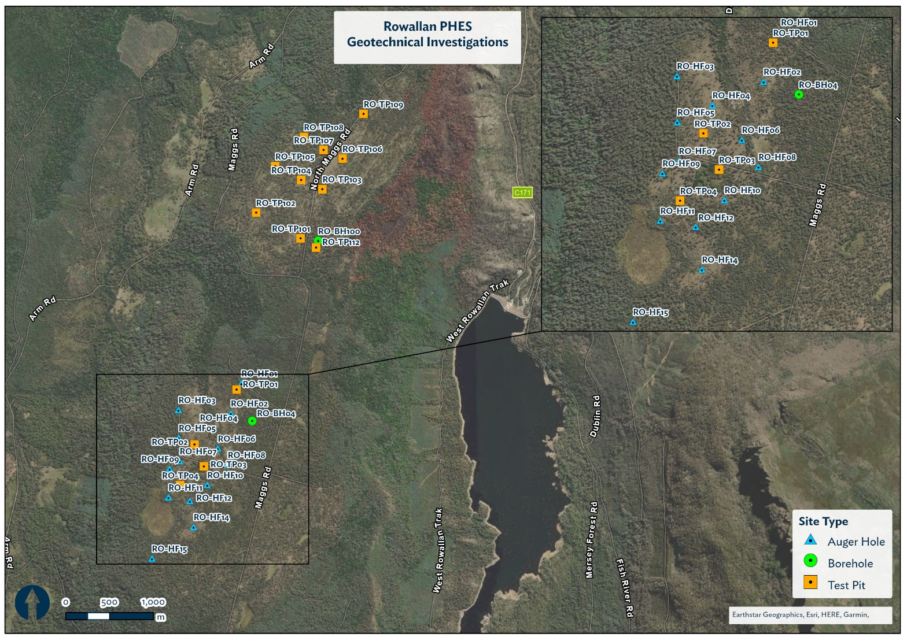
Figure 2.2: Location of recent investigations conducted within EL14/2019.

Introduction
Hydro Tasmania is currently investigating the development of a pumped hydro energy storage (PHES) in Tasmania as part of the Battery of the Nation initiative. Currently, feasibility studies are being undertaken at three sites to assess their suitability for the development of a PHES. Lake Cethana, Lake Rowallan, Lake Murchison and Lake Plimsoll have all been identified as suitable sites. A critical component of the feasibility study is the undertaking of investigations to determine geotechnical and geological conditions for construction of key components of the PHES. As well as identifying adequate quantities of suitable construction materials including aggregate for concrete production, earth and rock fill for dam construction and sub-surface ground conditions for construction of shafts, tunnels and an underground power station.
This report aims to meet Hydro Tasmania’s reporting obligations in relation to Licence number 14/2019, in the vicinity of Lake Rowallan for the period 6 April 2020 to 7 April 2021.

Review of previous work
Work conducted in relation to the Rowallan PHES began with a scoping study and shortlisting of 14 potential PHES sites around Tasmania. A Pre-Feasibility Study of the Rowallan PHES was completed in early 2019 and followed into Feasibility Study in July 2019. Investigations as part of the Feasibility Study commenced in September 2019, prior to the granting of EL14/2019.
Previous work includes detailed desk-top analysis of existing geological data as well as geological mapping, test pitting and diamond drilling completed up until the granting of EL14/2019.
Geological mapping of the Lake Rowallan area comes from Mineral Resources Tasmania (MRT) 1:63:360 geological maps of Middlesex as well as mapping associated with the Rowallan Dam site (Mitchell et al.1970 and URS 2010). Supplementary mapping was conducted by Hydro Tasmania during the Feasibility Study.
A geological map developed during the investigations of the Mersey-Forth scheme is shown in Figure 4.1
At the dam location, the Mersey River is superimposed on quartzite and schist of the Mersey River Metamorphic Complex and flows across the east–west structural trend. The valley floor and slopes are underlain by unweathered, very strong Precambrian quartzite and schist forming a ridge across the valley at the dam site (any previous weathering products have been interpreted to have been removed glacial period processes).
The Mersey River Metamorphic Complex is described as a package of Neoproterozoic to Early Cambrian-aged schists and quartzite sequences, with greenschist facies metamorphism. The rocks are jointed, predominantly along the foliation. Historic drilling indicated that some of the joints are open and filled in with clay or limonite. The beds are dipping steeply northwards.
Overlying the Precambrian rocks is a Cenozoic sequence, the base of which is at between 750 m and 800 m AHD. The Cenozoic sequence is estimated to be between 100 m and 160 m thick and is overlain by Pleistocene glacial, periglacial and fluvioglacial sediments including till and interglacial deposits. The glacial deposits are up to 50 m thick at the southern end of Maggs Mountain.
On the slopes of Maggs Mountain leading down to the reservoir, active talus is developed below the steeper parts of the basalt outcrops. Glacial till is present in some locations along the western edge of the reservoir overlying the quartzites; however, occasional rock outcrop within the glacial material, and the high degree of rock exposure at the reservoir margin, suggest that the glacial deposits on the slope may be relatively thin.

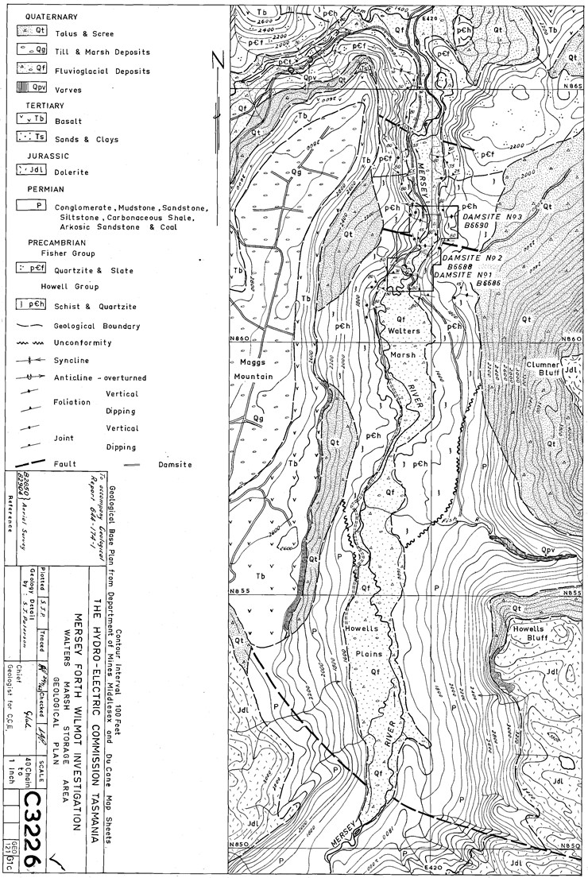
Figure 4.1: Geological map of the Rowallan area prior to dam construction
Descriptions of geological stages pertinent to the Rowallan area are summarised below from Corbett et al. (2014)
Pleistocene  ~1.8 Ma to 20,000 years before present | The Pleistocene Epoch saw Tasmania strongly affected by multiple periods of glacial activity, with glaciers and ice sheets sculpting much of our highland physiography (Colhoun et al., 2014). During cold phases there was extreme surface instability on slopes and a largely non-forested landscape, while during warm and wet phases a forested landscape with stable soil surfaces prevailed. Outside the ice limits, strong frost-induced processes, aeolian action and enhanced alluviation affected the landscape, causing much surface instability during the glacial stages. In contrast, during interglacial stages the land surface was largely stable and soil profiles developed.
Cenozoic  ~32 to 22 Ma | Cenozoic volcanic rocks, dominantly basaltic lavas, crop out over about 6% of Tasmania. A basalt sample from Wilmot Dam was dated at ~26.7 Ma (Macphail and Hill, 1994), however basalt ages in the central north show a spread of ages so the basalt sequences may have grown over several distinct eruptive stages.  Typically, the basalts are aphanitic or porphyritic, with olivine as the most common phenocryst, and some basalt samples containing pyroxenes and plagioclase. The basalts occur mostly as thick piles of lava that range from massive to highly amygdaloidal, vesicular or scoriaceous. Columnar jointing, caused by contraction during cooling, is widespread, particularly in thicker flows. In the Mersey-Forth area, the existing topography was largely buried by volcanics, radically altering the drainage patterns, and included damming of ancestral rivers to form lakes backing up to 15 km and possibly up to 120 m deep. These were filled by sediments and aquagene volcaniclastics, including flow-foot breccias which were eventually capped by subaerial lava (Burns, 1964; Jennings, 1979; Sutherland, 1980).  The volcanism largely post-dates major faulting, and the few described examples of displacement of basalt mostly represent only slight movements.
Paleogene-early Neogene  ~66 to 20 Ma | Paleogene-early Neogene onshore sediments occur in major Tasmanian basins and elsewhere as thin veneers or as thick terrigenous successions, in many places beneath or interbedded with basalt (Quilty et al., 2014). These deposits post-date deep topographic dissection and fill old river valleys.

Geological and geotechnical investigations conducted as part of the Rowallan PHES Feasibility Study prior to the current reporting period are shown in Figure 4.2 and included:
- 26 excavated test pits
Note: Solid flight auger holes were planned at a number of locations to minimise disturbance, however after excavation of the first test pit, a hard cemented duricrust layer was encountered. The cemented layer was not penetrable by the auger and the decision was made to excavate test pits at the auger sites instead.
Test pit logs and selected photographs are included in Appendix 1 and Appendix 2 respectively.
- 2 diamond drill holes (totalling 843.7m)
Note: RO-BH04 drilled to target depth EOH 504.2m. RO-BH100 was planned to ~500m however the drill string was snapped at 279m and unable to be retrieved. A casing wedge was installed at 250m and drilling continued (RO-BH100A) until 300.5m where drill string snapped again. Rods were unable to be recovered and the hole was abandoned.
Borehole logs and core photographs are included in Appendix 3 and Appendix 4 respectively.

A summary of investigations including GDA94 coordinates is included in Appendix 5
Figure 4.2: Location of Rowallan exploration sites

Exploration completed during the reporting period
Investigations including mapping, test pitting and drilling at the Rowallan PHES site commenced in September 2019 and were completed by March 2020, prior to the granting of EL14/2019. Activities relating to EL14/2019 conducted during the reporting period were restricted to the processing and interpretation of the previously acquired data.
Hydro Tasmania was concurrently undertaking exploration activities at two other sites including the Tribute PHES in the vicinity of Lakes Plimsoll and Murchison (EL13/2019) and the Cethana PHES near Lake Cethana (EL1/2020). These activities are reported in the respective Annual Reports for each licence.

Discussion of Results
The initial sub-surface geology of Maggs Mountain was interpreted to be a relatively simple stack of generally well understood rock units proceeding from Meso-Proterozoic quartzite and metasediments in the base overlain by a series of Cenozoic basaltic lavaswith minor interbedded, interflow sediments, all overlain by more recent fluvio-glacial and erosional landslide deposits. The preliminary interpretation is shown in Figure 6.1 below:
Figure 6.1: Preliminary interpreted cross section across Maggs Mountain prior to drilling RO-BH04.

Drilling of RO-BH04 identified what has been interpreted as a completely blind, buried paleo-valley with Cenozoic lavas and volcanic breccias sitting above and within lacustrine sediments and sedimentary rocks extending to approximately 480m below surface. A summary log of boreholes RO-BH04 and RO-BH100 are shown below in
BHID | Depth From | Depth To | Rock Type | Comments
RO-BH100 | 0 | 1.2 | No Core recovered
RO-BH100 | 1.2 | 15.6 | Fluvioglacial sediments | variably consolidated
RO-BH100 | 15.6 | 142.5 | Basalt | Multiple flows variably vesicular
RO-BH100 | 142.5 | 214.3 | Volcanic Breccia/Basalt | Inter-layered breccia and basalt with flows up to several metres
RO-BH100 | 214.3 | 250 | Sedimentary and associated breccia units | Rod string snapped at 279m re-drilled as RO-BH100A from 250m
RO-BH100A | 250 | 264.5 | Sedimentary and associated breccia units | mud/silt/sand-stones and conglomerate
RO-BH100A | 264.5 | 300.5 | Quartzite | Broken rod string unable to be retrieved. Hole abandoned

Table 6.1.

BHID | Depth From | Depth To | Rock Type | Comments
RO-BH04 | 0 | 13.0 | Fluvioglacial sediments | variably consolidated
RO-BH04 | 13.0 | 91.1 | Basalt | Multiple flows variably vesicular
RO-BH04 | 91.1 | 147.2 | Volcanic Breccia/Basalt | Inter-layerd breccia and basalt with flows up to several metres
RO-BH04 | 147.2 | 259.0 | Variably consolidated sediments | mud/silt/sand-stones with interbedded basalt flows
RO-BH04 | 259.0 | 304.15 | Basalt
RO-BH04 | 304.15 | 484.7 | Variably consolidated sediments | mud/silt/sand-stones with basal conglomerate
RO-BH04 | 484.7 | 504.2 | Quartzite | EOH Target depth achieved

BHID | Depth From | Depth To | Rock Type | Comments
RO-BH100 | 0 | 1.2 | No Core recovered
RO-BH100 | 1.2 | 15.6 | Fluvioglacial sediments | variably consolidated
RO-BH100 | 15.6 | 142.5 | Basalt | Multiple flows variably vesicular
RO-BH100 | 142.5 | 214.3 | Volcanic Breccia/Basalt | Inter-layered breccia and basalt with flows up to several metres
RO-BH100 | 214.3 | 250 | Sedimentary and associated breccia units | Rod string snapped at 279m re-drilled as RO-BH100A from 250m
RO-BH100A | 250 | 264.5 | Sedimentary and associated breccia units | mud/silt/sand-stones and conglomerate
RO-BH100A | 264.5 | 300.5 | Quartzite | Broken rod string unable to be retrieved. Hole abandoned

Table 6.1 Borehole RO-BH04 and RO-BH100 Summary rock logs
The drilling of borehole RO-BH100 established that the paleo-valley appears to be shallowing to the north/north-east of Maggs Mountain. Geological mapping of the northern and eastern slopes of Maggs Mountain suggest that the paleo-valley likely progresses through the north-western side of the plateau and into the Arm River Valley to the north as shown in Figure 6.2 which incorporates an interpretation of the surface geology from the MRT regional map data with mapping conducted as part of the Rowallan Feasibility Study.
A’/B’
A/B
Figure 6.2 Geological Map of Maggs Mountain adjacent to Lake Rowallan. Cross section line marked A/B – A’/B’
A schematic interpretive cross-section of the Paleo-valley beneath Maggs Mountain is presented in Figure 6.3
Figure 6.3: Updated interpreted cross section across Maggs Mountain after drilling RO-BH04

Conclusions
Although investigations at the Rowallan PHES site provided sufficient information to inform an adequate understanding of the geology of the Maggs Mountain area, however Cethana PHES was selected as the preferred project to progress to final feasibility. Deep storage capacity, greater cost and technical certainty, environmental and social sustainability and flexibility in sizing and capacity make Cethana the preferred to finalise feasibility.
Investigations and interpretation conducted at Rowallan as part of the Battery of the Nation PHES Study were not exhaustive and this site still retains the potential to develop a PHES, however limited further work will be undertaken whilst the Cethana PHES project is being prioritised.

Future exploration
Investigations across EL14/2019 have adequately informed a geological model to the level of detail required by the Feasibility Study. Future activity is expected to include further review and interpretation of the existing geological data at Rowallan and well as progressing the Feasibility Study for the Cethana PHES site. There are no current plans for on-ground activities at EL14/2019 for the next reporting period.

Environmental Management
Hydro Tasmania maintains a detailed Health Safety and Environment Policy. Environmental Management at the Rowallan PHES site included, ecological and cultural heritage surveys that formed the basis for a detailed Environmental Impact Assessment (EIA). The EIA, in conjunction with the MRT Exploration Code of Practice and the drilling contractors Environmental Management Plan (EMP), informed the general investigations philosophy, the main points are summarised below:
- Where possible existing access tracks were used to minimise surface disturbance.
- Drill pad size was limited to the minimum safe area for effective set up and operation of the drill rig and associated equipment.
- Only approved biodegradable drilling muds were used as additives to the drilling water, with the exception of minor amounts of rod grease to maintain effective operation of the drill rig.
- Drilling water was discharged to ground via in-ground excavated recirculation/settling sumps to minimise impact of drill cuttings and approved drilling muds/additives entering the environment.
- All excavations (test pits and drill sumps) were backfilled and drill holes capped.
More detail can be found in Appendix 6 including:
- HT HSE Policy
- TDS EMP
- Hydro Tasmania EIA’s and associated supporting documents.

Expenditure
A breakdown of exploration expenditure for the report period is included in EL14/2019 Rowallan Exploration Licence Annual Return (Appendix 7) and summarised below:
 | Rowallan
Geology | $ 101,058
Geochemistry | $ -
Geophysics | $ 1,265
Remote Sensing | $ 3,131
Gridding | $ -
Drilling | $ -
Enviro/Land Access | $ -
Rehabilitation | $ 10,001
Feasibility | $ 27,160
Other/Hire | $ 18,752
Admin (PM) | $ 16,305
Total | $ 177,674

Given that mapping, drilling and test pitting activities were completed prior to granting of EL14/2019, a majority of the expenditure falls under the Geology and Feasibility Study items and includes data compilation, processing and interpretation of results.

References

Burns, K.L., 1964. Devonport, Tasmania, Geological Atlas 1 Mile Series Explanatory Notes. Department of Mines Tasmania.
Colhoun, E., Harris, P., Heap, A., Bottrill, R., Bacon, C., DMcP, D., 2014. The Quaternary in Tasmania, in: Corbett, K.D., Quilty, P., Calver, C.R. (Eds.), Geological Evolution of Tasmania. Geological Society of Australia Special Publication, pp. 511-548.
Corbett, K.D., Quilty, P., Calver, C.R., 2014. Geological Evolution of Tasmania: Geological Society of Australia Special Publication.
Jennings, I., 1979. Sheffield, Tasmania. Tasmanian Department of Mines Geological Atlas 1 Mile Series.
Macphail, M., Hill, R., 1994. K-Ar dated palynofloras in Tasmania 1: early oligocene, Proteacidites tuberculatus zone sediments, Wilmot Dam, northwestern Tasmania, Papers and Proceedings of the Royal Society of Tasmania, pp. 1-15.
Mitchell, W.R. & Paterson, S.J. (1970), Introduction to the Engineering Geology of the Mersey-Forth Hydro-Electric Development, Tasmania, The Institution of Engineers Australia, Civil Engineering Transactions, October 1970 pp197–212
Quilty, P., Hill, P., Exon, N., Baillie, P., Everard, J., Forsyth, S., Calver, C., Bottrill, R., Taheri, J., Bayer, E., 2014. Cretaceous-Neogene evolution of Tasmania. Geological Evolution of Tasmania: Geological Society of Australia Special Publication 24, 409-509.
Sutherland, F., 1980. Aquagene volcanism in the Tasmanian Tertiary, in relation to coastal seas and river systems, Papers and Proceedings of the Royal Society of Tasmania, pp. 177-199.
URS (2010), Rowallan Dam – Engineering Geological Review, Ref: URS-REP-0001, June 2010

Appendices

Appendix 1 - Test pit logs
(Attached Separately)

Appendix 2 - Test pit photographs
(Attached Separately)

Appendix 3 - Borehole logs
(Attached Separately)

Appendix 4 - Borehole photographs
(Attached Separately)

Appendix 5 - Investigations Details
(Attached Separately)

Appendix 6 - Environmental Impact Assessment
(Attached Separately)

Appendix 7 - EL14/2019 Exploration Licence Annual Return
(Attached Separately)

