

EL48/2003 MT BLOCK, TASMANIA

ANNUAL REPORT
11th January 2021 to 10 January 2022

Prepared for: Pieman Resources Pty Ltd (ACN 631 444 089)

AN NQ MINERALS PLC COMPANY

Prepared by: Dr. Pierre Richard, Director

9 January 2022

Note: All figures and grids are according to the GDA94 datum and MGA94 grid system.

EXECUTIVE SUMMARY

Pieman Resources Pty Ltd (Pieman) is a fully owned subsidiary of NQ Minerals PLC (NQ Minerals). Pieman purchased EL48/2003 off Bass Metals Ltd (Bass) in January 2020. Before this the company in 2018 had an option over the tenement and provided the funding to Bass to undertake a drilling program on EL48/2003 which comprised a single diamond drill hole (DDH).

Diamond drill hole HED28 was completed to 309.3m testing the HBS. The drillhole confirmed the synclinal structure but did not intersect any significant alteration or mineralisation. While there is a commitment to undertake further drilling, it is anticipated that this year the company will initially apply further Geophysical approaches to the lease to determine drill targets. The Amoeba zone (general area) where the diamond hole was located shows substantial exploration potential based on a review of the area.

During 2021, given the implications of COVID 19 and its consequences for the business of Pieman’s parent that faced severe financial difficulties, the company only undertook desktop work. This was analysis of rerun Seismic and down the hole EM data (that was completed in 2020). The results from this work has provided the company with increased knowledge in relation to potential locations of volcanogenic massive sulphide (VMS) pods. Further to this the EM review has located. Pieman plans to follow these up with DTHEM in existing cased diamond holes to target several significant conductors that have been identified in the EM review to date.

Two drill holes are planned for 2022. These are the previously identified “HBS” and “Amoeba Zone” proposed DDH that have not been excluded by HED28 located nearby. These will be drilled to approximately 300m depth each.

TABLE OF CONTENTS

1 INTRODUCTION 1
2 Previous work and geological setting 2
3 EXPLORATION COMPLETED DURING THE REPORTING PERIOD 8
4 DISCUSSION OF RESULTS AND CONCLUSIONS 9
6 PROPOSED EXPLORATION 10
7 ENVIRONMENTAL MANAGEMENT 12
8 EXPENDITURE 12
9 KEY REFERENCES 13

Digital files submitted with this report:

Filename | File format
EL482003_202201_01_Report.doc | Doc

- INTRODUCTION

This report is a summary of exploration activities completed on the Mt Block exploration license EL48/2003 between 11th January 2020 and 10th January 2021.

EL48/2003 surrounds the Hellyer Mine Lease (103M/1987) and the Que River Mine Lease (68M/1984). The Hellyer and Que River Mines are examples of world class poly metallic VHMS deposits. The Que River and Hellyer deposits are particularly enriched in precious metals Au and Ag as well as base metal sulphides Cu, Pb, Zn. As such the tenement package is regarded as highly prospective for this style of mineralisation.

TENURE

EL48/2003 Mt Block is held by Pieman after acquisition from Bass in February 2020. During the tenure of the EL it has undergone several reductions in land area as well as a merger with the former adjacent EL24/2004, Bulgobac River. The current tenement comprises a total of 47km² after the last partial relinquishment in 2016.

EL48/2003 is a mature exploration license and as such requires ongoing term of extension applications to maintain tenure. This tenement has potential to provide future feed to the Hellyer Mill. The company is motivated to explore and develop the lease over the next few years

LOCATION AND ACCESS

The tenement is located approximately 15 km’s north-northeast of the township of Tullah, on the west coast of Tasmania (Figure 1). Access to the area is via the Murchison Highway and tracks which access via the 220kv power line which traverses the area. Access within the tenement is via a limited number of 4WD tracks and ATV- only tracks. The license area lies on the Sophia (#8014) 1:100,000 map sheet and Charter (#3839) and Block (#3838) 1:25,000 topographic map sheets.

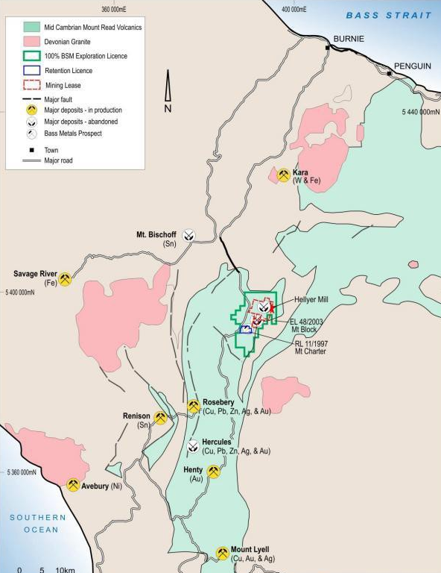
Figure 1 Location of EL48/2003

- REVIEW OF PREVIOUS WORK AND GEOLOGICAL SETTING

The Que River, Hellyer and Fossey polymetallic base metal sulphide and Mt Charter barite- precious metal deposits are hosted in the Que-Hellyer Volcanic (QHV) sequence within the Mt Charter Group of the Cambrian Mt Read Volcanics.

The QHV is a sequence of calc-alkaline mafic to felsic volcanics filling a northeast trending Cambrian submarine extensional basin. The basin depth varies dramatically from up to 1000m thickness near Que River and Hellyer but thins to 50m northwest of the Hellyer mine.

The QHV has been subdivided into several stratigraphic elements summarized below, with the arrangement and local faulting noted in Figure 2 below:

- Hellyer Basalt (Upper Basalt) - consisting of massive to pillowed amygdaloidal basalt lava and associated volcanoclastic rocks. An associated andesite is located in the Mt Charter region to the south.
- Mixed Sequence - host to the Que River, Hellyer and Mt Charter deposit is comprised of epiclastics, dacitic lavas and breccias.
- The Feldspar Phyric Andesite consisting of a porphyritic andesite lava in the footwall of the Hellyer and Que River deposits.
- The Lower Basalt, a sequence of basaltic pillow lavas and volcanoclastics, which form the immediate footwall at Que River and Hellyer.
- The QHV are overlain by the Que River Shale which is in turn overlain by the Southwell Subgroup consisting of felsic volcanoclastics, greywacke and shale. The Southwell subgroup is overlain by the Mt Cripps subgroup (a correlate of the Tyndall beds at the Henty mine) which is a sequence of volcanoclastics, siltstones and conglomerates only outcropping along the eastern boundary of the Hellyer area tenements

The Cambrian deposits have been subjected to the Mid Devonian regional deformation event resulting in folding, faulting, development of a regional foliation and prehnite- pumpellyite to lower greenschist metamorphism. Open, early NW trending folds and associated foliation has been overprinted by a later shallow NE-SW folding event. Cambrian syn-depositional faults have been reactivated and later brittle faulting is associated with rheology contrasts between earlier alteration facies. Cambrian basin architecture has been a control on volcanism, mineralisation and subsequent deformation.

In the south of the area covered by EL48/2003, the QHV are bound to the east by the northeast trending Henty Fault. The Geology east of the Henty Fault is dominated by Cambrian to Silurian siliciclastic and calcareous sediments of the Wurawina Supergroup.

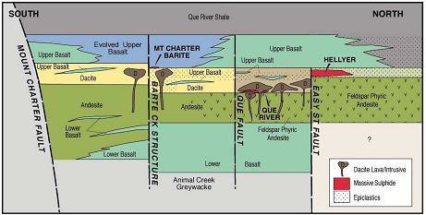
Figure 2 Schematic cross section of Que-Hellyer Stratigraphic sequence.

Much of the geology to the north of the EL is dominated by Tertiary basaltic lavas forming a thick plateau. These northern Tertiary basalts cover the underlying prospective volcanics making exploration expensive and difficult in the northern EL. Figure 3 below presents the regional geology.

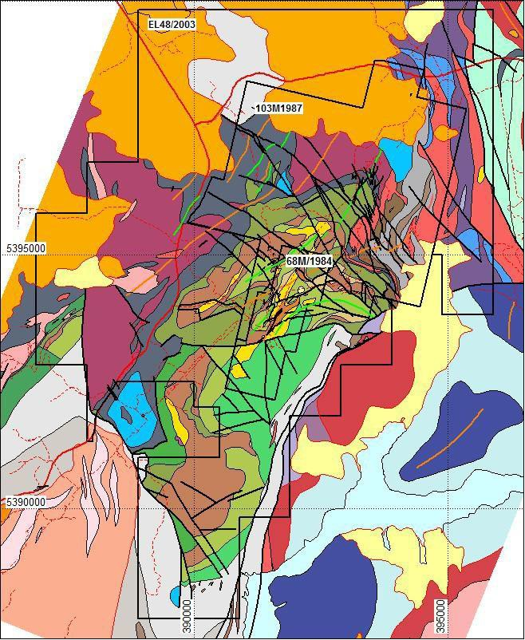
Figure 3 Regional Geology of the Que-Hellyer Volcanics

Work carried out in the Mt Block area prior to 2011 is summarised in the 2011 annual report (Denwer, 2011). The table below summarises more recent work:

2013-2014: Work completed since 2011 included a geochemical review of prospective alteration zones within the QHV. The review was completed by external consultants and Bass Geological staff. Two zones of interest were identified on EL48/2003, the Amoeba Zone and the Barite Creek Fault.
2015: Compilation and digitization of petrographic reports and photographs (Richardson, 2015).
2016: Exploration on EL48/2003 during 2016-17 involved a review of historic data and target generation in the Que River area (Callaghan, 2017).
2018: Drilling one diamond Drillhole HED28 for 309.3m. The drillhole intersected unmineralised and unaltered mixed volcanics below the hangingwall basalt.
2019: Exploration on EL48/2003 during 2019 involved a review of historic data and target generation in the Que River area by the Company and independent parties.
2020: Pieman reran a number of Historic DTH electromagnetic Data. The company also undertook a rerun of the 1995 Seismic Data.
2021 Pieman reran a number of Historic DTH electromagnetic Data. The company also undertook a rerun of the 1995 Seismic Data.

A summary discussion of work undertaken since acquisition of the project by Pieman is included below.

Seismic

In September 2020, Internode Seismic reprocessed the eastern half of 2D seismic line 95AGS-T2 because it intersected EL48/2003 tenement. For comparison, the original 1995 processed stack section was depth converted. The location map is shown in Figure 4 below.

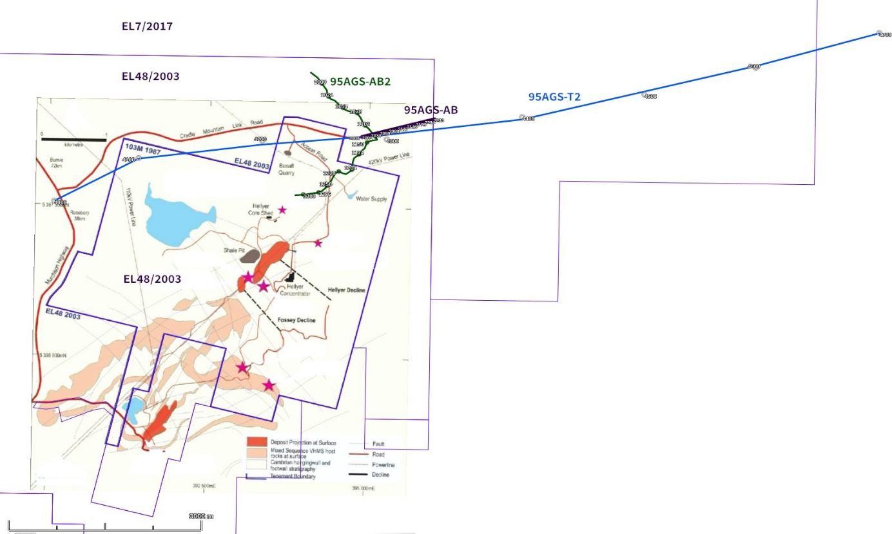
Figure 4 Seismic line 95AGS-T2 (blue) and high-resolution lines AB2 and AB (green/purple).

The reprocessing objectives were to:

- Generate a sub-surface image that could be linked to the mapped Hellyer geology
- Generate a deep structural image of the area beneath the Tertiary basalts
- Obtain stratigraphic understanding of the geological evolution of the area
- Delineate any potential areas for more detailed mineral exploration targeting

Acquiring new seismic lines would have been costly, whereas reprocessing the vintage seismic (at the existing resolution) offered better value because new techniques can improve old data so that structural and stratigraphic details become much more evident.

Commencing with field data, an advanced 2D land imaging sequence comprising 23 stages (listed below) was also applied in 2020. Seismic reprocessing involved pre-stack data enhancement and post- stack migration with optimised parameterisation designed to ensure that reflections observed on shot records were preserved in the final section. Pre-stack dip move-out (DMO) followed by post- stack migration is well known to be more useful in hard-rock reprocessing than pre-stack migration. Pre-stack algorithms were tested however pre-stack DMO and post-stack migration were applied during production.
The 2020 full reprocessing flow is summarised here:
  - Reformat field data
  - Geometry crooked line profile/binning
  - Spherical divergence compensation
  - Refraction statics
  - Shot domain noise attenuation, dip filter
  - Surface consistent amplitude compensation
  - Velocity analysis (1st pass)
  - Surface consistent static correction (1st pass)
  - Velocity analysis (2nd pass)
  - Surface consistent static correction (2nd pass)
  - Offset domain noise attenuation
  - Surface consistent deconvolution
  - Spectral balancing
  - Dip Move Out (DMO)
  - Offset noise attenuation
  - NMO/Mute/Stack
  - Coherency filter
  - Post-stack Finite-Difference migration
19. TVF 0-300ms 16-70Hz and 600-5000ms 7-50Hz
20. Velocity model building
    - DMO and PSTM velocity analysis
    - First arrivals used to generate refraction inversion velocity model (T2 only)
    - Interval model build using refraction velocities (shallow) and PSTM velocities (deeper). Interval velocities for depth (VintZ).
- Time to depth conversion using VintZ
- Datum from floating to fixed 1000m AHD
- SEG-Y format output

DHEM Reprocessing

Mineralisation on the Hellyer Mine Lease comprises massive base metal sulphide lenses within the core of a broadly folded volcanic-sedimentary sequence which plunges to the north-northeast. As the mineralisation generally does not outcrop, geophysics has played a vital part in mineral discoveries in the Hellyer region and down-hole electromagnetics (DHEM) is a core technique.

In 2020, NQ completed a first pass review of historical DHEM data for 8 surveyed drill holes in the priority-1 area. Remodelling work of the DHEM undertaken by Southern Geoscience, with input from former Hellyer geologists, highlighted the significant enhancement in modelling software, and has identified four revised high priority targets/zones (Target 1 to 3B), which warrant follow-up exploration work. These are presented in Figure 5, and represent significant potential for further base metals discoveries.

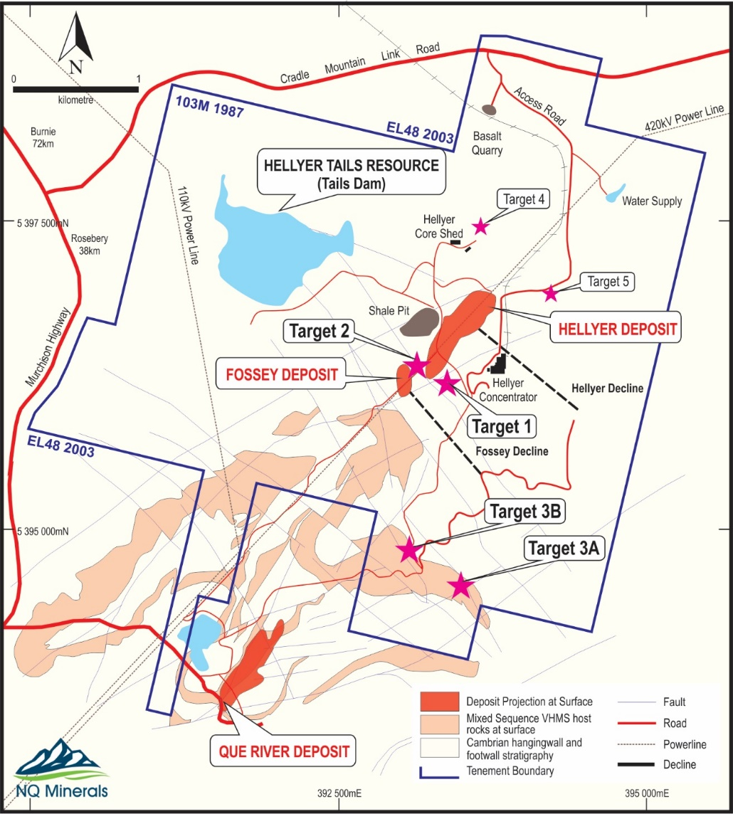
Figure 5 Modelled DHEM Target Locations and Schematic Geology

VMS DEPOSITS

The primary target of exploration is further VMS deposits, which may be pods related to already discovered and mined mineralisation. As noted previously, VMS deposits are genetically related to volcanic activity:

- Black smokers of the deep oceans are VMS deposits in the process of formation
- They can form on surface as per smokers or in the shallow subsurface
- They tend to occur broadly in groupings: more so within a stratigraphic sequence rather than a specific stratigraphic level. This presents an opportunity at the project, as early work focused on one stratigraphic position referred to as the Hellyer Ore Position (HOP), but the deposit model suggests they can be more broadly distributed
- The formation is dynamic, being associated with active volcanics systems where rock types may be highly varied, often with only short-range continuity.
- Archean deposits tend to be copper and zinc rich, lead-silver and gold tend to increase as deposits get younger
- Broadly there are 2 forms, proximal and distal; proximal formed at the source and distal that are displaced (e.g., downslope from the source at time of formation).
- A particular group known as “Kuroko” based on examples in Japan are very barite rich and Hellyer appear to bear strong analogies to these
- The volcanic activity provides the heat source to generate fluid flow along existing structures.

Stack (2009) provides a useful summary of the styles of VMS encountered in Australia (see Figure 4 below). These include the mound, stacked and stockwork types all encountered in the vicinity of the Mt Block (EL48/2003) tenement. A number of other styles are also encountered regionally within the Mt Read volcanics (e.g., at Mt Lyell and Rosebery)

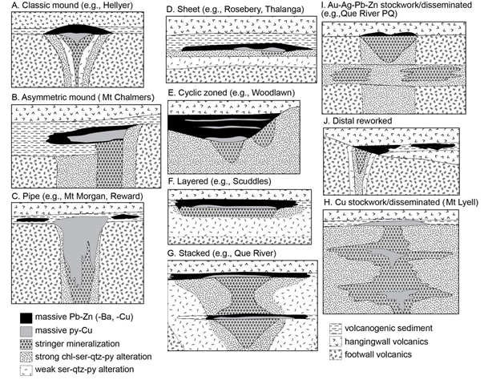
Figure 6 Schematic (not to scale) of VMS deposits in Australia (Stack 2009)

- EXPLORATION COMPLETED DURING THE REPORTING PERIOD

Work in 2021 continued with preparations for previously planned follow-up work. This included assessing the condition of each of the DHEM surveyed drill holes and neighbouring holes. Pieman has identified a number of holes that it is able to re-enter. These will be cased with PVC to the required depth in 2022 for DHEM to be performed.

The four high priority target zones identified in 2021 (of six original targets, two that were put aside after interpretation and assessment in 2020) were in areas of known mineralisation and or significant alteration. These were selected based on them also being near the prospective ‘ore-forming’ stratigraphic horizon adjacent to the Hellyer mine envelope.

The modelled targets comprise ‘plates’ representing conductive bodies, potentially massive base metal sulphide lenses. Due to constraints imposed by the data from historical surveys, the modelled plates are not well ‘constrained’ in terms of 3-D spatial co-ordinates, which is essential for efficient follow up drill testing. During 2021, these potential scenarios were assessed in an attempt to define sufficiently reliable drill targets. This expert assessment was judged the be a more cost effective alternative to further geophysical data collection. Modern, high powered DHEM surveying is seen as one alternative, but it would be preferable to identify new drilling if several low risk options can be identified.

The following notes provide a summary overview of the high priority targets after further geological interpretation during 2021, including reference to the applicable VMS deposit models relevant to the Mt Read volcanics environment. The work identified that two targets (1 and 2) were located on the sublease also held by Pieman, but targets 3A and 3B are close to the boundary of EL48/2003, and future exploration is planned to be undertaken on this tenement in pursuit of these:
- Target 1 – is associated with an extensive zone of alteration which hosts the McKay Prospect discovered in July 2011. HLD 1030 returned 7 metres at 22.3% Zn, 9.9% Pb, 0.7% Cu, 181 g/t Ag and 3.4 g/t Au. DHEM was applied to HLD 1030. The mineralisation intersected also formed an ‘in-hole’ conductor. Follow-up drilling at the time around this intercept failed to significantly extend this very high-grade massive base metal sulphide lens but did extend the zone of prospective alteration. On reassessment, the further drilling does not exclude a sufficient mineralised body, especially given the bonanza grades. Further drilling is recommended targeting a mineralised body associated with the McKay zone. This target is on sublease 103M 1987, and so is outside planned work on this tenement, but may lead to further work on EL48/2003 should there be an indication of more distal mineralisation.
- Target 2 is a high priority target located immediately southwest of the Hellyer deposit. The modelled plates based on DHEM survey of HLD975, occur within prospective stratigraphy with anomalous geochemistry and strong alteration. This is in close proximity to both the Fossey and Hellyer mine development.
- Targets 3A and 3B both occur within the historical Switchback Prospect where a large-scale alteration system and several mineralised intercepts have been returned in the area previously. This area has also yielded highly encouraging trace element and isotope data indicating the presence of VMS mineralisation. As noted previously, due to structural complexities, the original source for high-grade VMS clasts intersected previously such as in HED012 (4.85 metres at 1.6% Zn, 1.2% Pb, 18 g/t Ag and 0.9 g/t Au) has never been found. Drilling planned for 2022 will target this mineralisation, with an aim of generating additional data (both geochemical, and as location for further DHEM). The central source for mineralisation intersected in this area, which remains unrelated to source VMS known in the tenement area, is a priority target for upcoming work.

Targets 3A and 3B form the key exploration proposed for upcoming periods on EL48/2003.

- DISCUSSION OF RESULTS AND CONCLUSIONS

Additional geological interpretation, including deposit model assessment, was undertaken during 2021 against 2018 drilling performed in the “Amoeba Zone”. The Amoeba Zone was previously identified as holding a strong coincident IP and geochemical anomaly associated with strong silica-sericite-pyrite alteration (Figure 7). Historic drillhole HAT3 intersected the strongest zone of the anomaly with no significant mineralisation identified. Two previously identified drilling locations “HBS DDH” and “Amoeba Zone DDH” were reassessed in 2021 and are now proposed for 2022. The recently drilled HED28 does not exclude the potential of these holes. These will test the alteration to the south of HAT3.

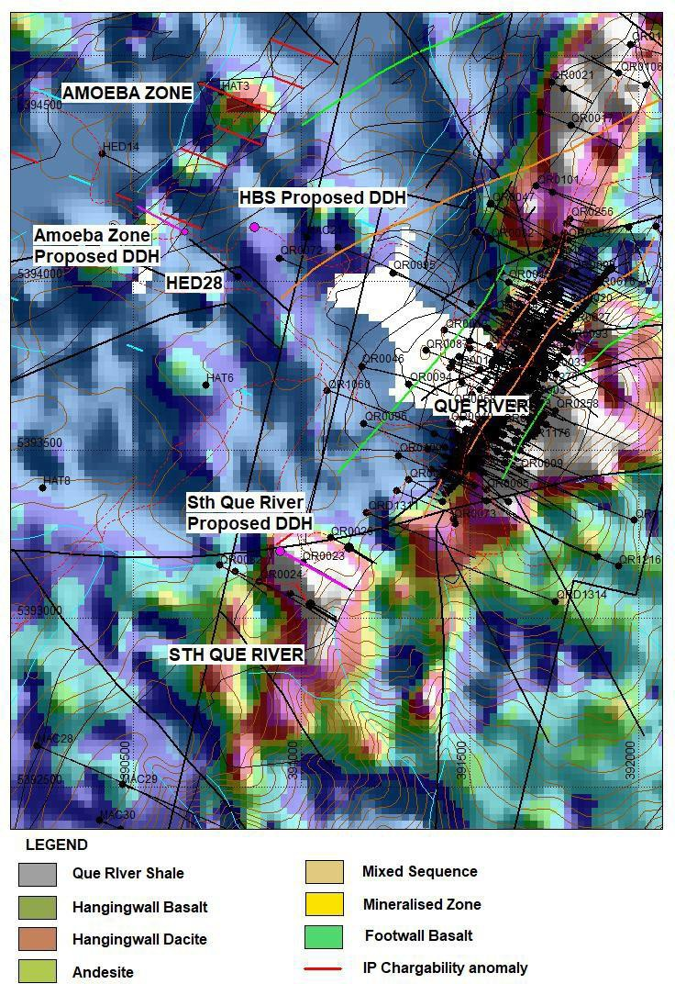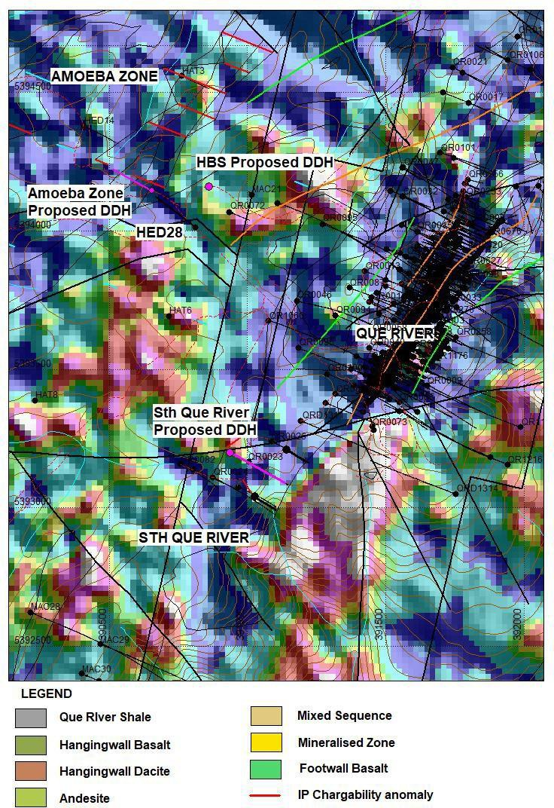

Figure 7 As Soils image (left) and Pb Soils Image (right)
The analysis and reassessment of the Sth Que River DDH was not positive. These hole, although prospective, is not currently proposed for 2022, but will be considered for future years.

Previous work has also noted other geophysical techniques that may be useful in the future. These were noted in the previous annual report and include Reduced to the Pole (RTP) aeromagnetics, precision mapping using LiDAR data, radar imaging and using hyperspectral indices to closely map (10m) iron mineralisation.

- PROPOSED EXPLORATION

Initial works planned for 2022 include completion of already planned studies that were not finished during 2021. These will be followed by core drilling of several targets.

DHEM

- Resurvey and clear lines at surface to enable wire loop arrays to be laid out on the ground as part of the new DHEM survey for each target zone.
- Mobilise geophysical contractor to Hellyer to undertake the DHEM surveys.

There have been significant enhancements to DHEM equipment since the last DHEM surveys were run at Hellyer approximately 10 years ago, including:

- Utilising much higher electrical power/current inputs to penetrate far deeper into the ground to detect any conductive bodies at greater distances;
- Optimised Electro-Magnetic (“EM”) loop arrays to get better 3-D resolution of conductive units; and
- Access to significantly enhanced modelling software to also resolve the position and dimensions of any modelled plates; and

These are particularly valuable, as work on EL48/2003 is now being undertaken with an expended target model. This extends deeper below the traditional ‘Hellyer ore-horizon’ which reflects the subsequent discovery of the new Fossey deposit and McKay mineralisation.

CORE DRILLING

Two drill holes are planned for 2022. These are the previously identified HBS and Amoeba Zone proposed DDH. These will be drilled to approximately 300m depth each. The location and orientation of the proposed holes is shown in Figure 8 below.
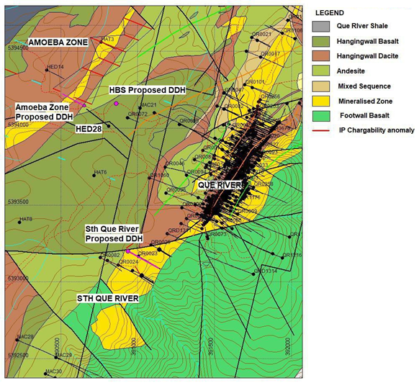
Figure 8 Que River geology map, Amoeba Zone Location

Exploration planned for 2022 has been preliminarily costed at $150,000.

- ENVIRONMENTAL MANAGEMENT

There was no physical undertaking on the lease in 2021 except for low impact, being field and environmental assessment from along existing roads and tracks. This examination did not involve earthworks and therefore no environmental remediation required.

- EXPENDITURE

Expenditure from 11th January 2021 to 10th January 2022 is summarised below for the Mt Block EL48/2003.

Table 1 Expenditure 11 JANUARY 2021 to 10 JANUARY 2022.

- Geoscience | $46,400.00
- Drilling and Gridding
- Land Access | $3,200.00
- Rehabilitation
- Feasibility Studies
- Other
- Administration | $2,130.75
TOTAL - ELIGIBLE | $51,730.75

REFERENCES

AGSO 1994 AGSO report 94/1085 Land Seismic Tasmania – Surveying

AGSO 1994 AGSO report 94/1086 Land Seismic Tasmania – Surveying

AGSO 1994 AGSO report 94/1087 Land Seismic Tasmania – Drilling

AGSO 1995 AGSO report 95/72 TASGO Seismic Survey Operation Report

Callaghan, T. 2017 Mt Block, Tasmania, EL48/2003, Annual Progress Report for period Ended 10th January 2017. Unpublished Report for Bass Metals Ltd.

Callaghan, T. 2018 Mt Block, Tasmania, EL48/2003, Annual Progress Report for period Ended 10th January 2018. Unpublished Report for Bass Metals Ltd.

Cantwell, N. and Cooper, M. 2008 Gravity processing, imaging and targeting for VMS style deposits for the Painter project, Tasmania. Report for Sinosteel Australia

Corbett, KD. and Komyshan, P. 1989. Geology of the Hellyer - Mt Charter area. Tasmanian Department of Mines Mt Read Volcanics Project, Geological Report 1, MRV1.

Cracknell MJ., Reading AM. and McNeill, AW. (2014) Mapping geology and volcanic-hosted massive sulfide alteration in the Hellyer–Mt Charter region, Tasmania, using Random Forests TM and Self- Organising Maps, Australian Journal of Earth Sciences v61:2, p 287-304, https://doi.org/10.1080/08120099.2014.858081

Denwer, K. 2011 Mt Block, Tasmania, EL48/2003, Annual Progress Report for period Ended 10th January 2011. Unpublished Report for Bass Metals Ltd.

Drummond B., Barton T., Johnstone D. and Browne A.V. 1995. Structure between the Arthur Lineament and Tyennan Block based on seismic data. (unpubl.; presentation at TASGO Achievements Workshop, Hobart, Nov. 1995)

Drummond, B., Korsch, R., Barton, T, and Yeates, A, 1996, Crustal Architecture in northwest Tasmania revealed by deep seismic reflection profiling: AGSO Research Newsletter, 25, 17-19.

Drummond, B, Barton, T, Korsch, R, Rawlinson N, Collins C, Brown A and Yeates, A 2000 Evidence for crustal extension and inversion in eastern Tasmania, Australia, during the Neoproterozoic and Early Palaeozoic. Tectonophysics v 329, p 1-21 https://doi.org/10.1016/S0040-1951(00)00185-2

Eshaghi E, Reading A, Roach M ,Duffett M, Bombardieri D, Cracknell MJ and Everard J 2020 Efficient regional scale 3D potential field geophysical modelling to redefine the geometry of granite bodies beneath prospective, geologically complex, northwest Tasmania in Ore Geology Reviews 25 September 2020, 103799 https://doi.org/10.1016/j.oregeorev.2020.103799

Goleby, B, Drummond, B, Owen, A, Yeates, A. Jackson, J. Swager, C and Upton, P., 1997, Structurally Controlled Mineralization in Australia - How Seismic Profiling Helps Find Minerals: Recent Case Histories in “Proceedings of Exploration 97: 4th Decennial Int Conf on Mineral Exploration” edited by A.G. Gubins,1997, p. 409–420

Jigsaw Geoscience Pty Ltd 2013 Review of the Hellyer-Que River Geological Data and Exploration Opportunities. Report to Bass Metals Ltd.

Leaman DE, 1994, Evaluation of AGSO Seismic Lines T4, T5 Tasmania. For Great Southland Minerals

McManus, T., 2020 Mt Block, Tasmania, EL48/2003, Annual Progress Report for period Ended 10th January 2020. Unpublished Report for Bass Metals Ltd.

Read, J., 1989 Seismic reflection investigations of the Hellyer orebody and Que-Hellyer Volcanics, North West Tasmania, Exploration Geophysics, 20, 159-162.

Richardson, S. 2015. Mt Block, Tasmania, EL48/2003, Annual Progress Report for period Ended 10th January 2015. Unpublished Report for Bass Metals Ltd.

Richardson, S. 2016. Mt Block, Tasmania, EL48/2003, Annual Progress Report for period Ended 10th January 2016. Unpublished Report for Bass Metals Ltd.

Yeates, A., McNeill, A, Richardson, S., Barton, T., Drummond, B and Richardson, R, 1997, High-resolution reflection seismic in the Hellyer Ore Environment: New Developments in Research for Ore Deposit Exploration, 3rd National Conference, January 1997, GSA Abstracts, 78.

