

EL48/2003 MT BLOCK, TASMANIA

ANNUAL REPORT
11th January 2022 to 10th January 2023

Prepared for: Pieman Resources Pty Ltd (ACN 631 444 089)

Prepared by: Dr. Pierre Richard, Director

9 January 2023

Note: All figures and grids are according to the GDA94 datum and MGA94 grid system.

EXECUTIVE SUMMARY

Pieman Resources Pty Ltd (Pieman) is a fully owned subsidiary of Ivy Resources Pty Ltd (Ivy Resources). Pieman purchased EL48/2003 from Bass Metals Ltd (Bass) in January 2020. Before this the company in 2018 had an option over the tenement.

In the reporting period, drilling commenced on a diamond drillhole (DDH) at location HER1 (Easting 390693, Northing 5394152 AGD) at the Amoeba Target. The hole targeted a strong IP and geochemical anomaly associated with strong silica-sericite-pyrite alteration. The drill hole had a target depth of 300m. The drilling at HER1 was commenced in December 2022 and had reached 100m depth by the end of the period, with drilling continuing.

The drilling at HER1 followed earlier drilling of HED28, which was completed to 309.3m testing the HBS. That drillhole did not intersect any significant alteration or mineralisation. The Amoeba Target (general area) where the diamond hole was located still shows substantial exploration potential based on a review of the area, and HER1 was planned to pursue that in the light of the results of HED28.

In the 2023 period, drilling to the target depth of 300m will be completed. This will be followed immediately by high-powered down hole electromagnetic (DHEM) survey. These are to be followed by further drilling based on the results of the DDH that is currently underway.

TABLE OF CONTENTS

1 INTRODUCTION 1
2 Previous work and geological setting 2
3 EXPLORATION COMPLETED DURING THE REPORTING PERIOD 5
4 DISCUSSION OF RESULTS AND CONCLUSIONS 6
5 PROPOSED EXPLORATION 6
6 ENVIRONMENTAL MANAGEMENT 7
7 EXPENDITURE 7
8 KEY REFERENCES 8

Digital files submitted with this report:

Filename | File format
EL482003_202301_01_Report.doc | Doc

- INTRODUCTION

This report is a summary of exploration activities completed on the Mt Block exploration license EL48/2003 between 11th January 2022 and 10th January 2023.

EL48/2003 surrounds the Hellyer Mine Lease (103M/1987) and the Que River Mine Lease (68M/1984). The Hellyer and Que River Mines are examples of world class poly metallic VHMS deposits. The Que River and Hellyer deposits are particularly enriched in precious metals Au and Ag as well as base metal sulphides Cu, Pb, Zn. As such the tenement package is regarded as highly prospective for this style of mineralisation.

TENURE

EL48/2003 Mt Block is held by Pieman after acquisition from Bass in February 2020. During the tenure of the EL it has undergone several reductions in land area as well as a merger with the former adjacent EL24/2004, Bulgobac River. The current tenement comprises a total of 47km² after the last partial relinquishment in 2016.

EL48/2003 is a mature exploration license and as such requires ongoing term of extension applications to maintain tenure. This tenement has potential to provide future feed to the Hellyer Mill, which is owned by Ivy Resources’ other subsidiary Hellyer Gold Mines Pty Ltd. The company is motivated to explore and develop the lease over the next few years

LOCATION AND ACCESS

The tenement is located approximately 15 km’s north-northeast of the township of Tullah, on the west coast of Tasmania (Figure 1). Access to the area is via the Murchison Highway and tracks which access via the 220kv power line which traverses the area. Access within the tenement is via a limited number of 4WD tracks and ATV- only tracks. The license area lies on the Sophia (#8014) 1:100,000 map sheet and Charter (#3839) and Block (#3838) 1:25,000 topographic map sheets.

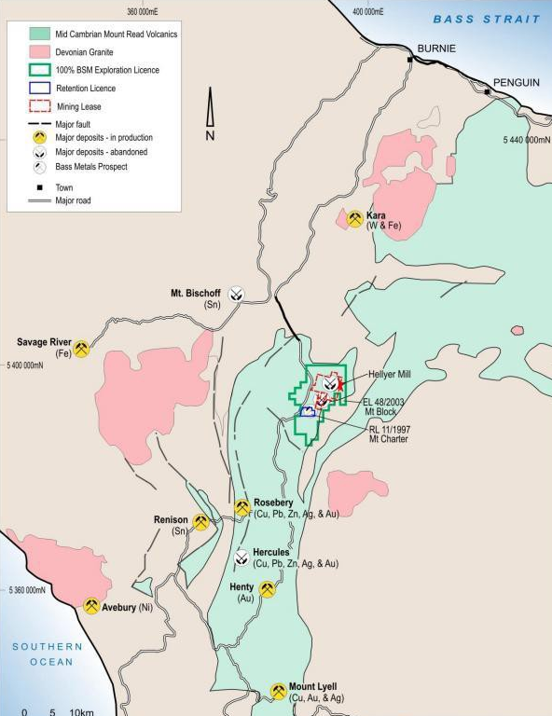
Figure 1 Location of EL48/2003

- REVIEW OF PREVIOUS WORK AND GEOLOGICAL SETTING

The Que River, Hellyer and Fossey polymetallic base metal sulphide and Mt Charter barite- precious metal deposits are hosted in the Que-Hellyer Volcanic (QHV) sequence within the Mt Charter Group of the Cambrian Mt Read Volcanics.

The QHV is a sequence of calc-alkaline mafic to felsic volcanics filling a northeast trending Cambrian submarine extensional basin. The basin depth varies dramatically from up to 1000m thickness near Que River and Hellyer but thins to 50m northwest of the Hellyer mine.

The QHV has been subdivided into several stratigraphic elements summarized below, with the arrangement and local faulting noted in Figure 2 below:

- Hellyer Basalt (Upper Basalt) - consisting of massive to pillowed amygdaloidal basalt lava and associated volcanoclastic rocks. An associated andesite is located in the Mt Charter region to the south.
- Mixed Sequence - host to the Que River, Hellyer and Mt Charter deposit is comprised of epiclastics, dacitic lavas and breccias.
- The Feldspar Phyric Andesite consisting of a porphyritic andesite lava in the footwall of the Hellyer and Que River deposits.
- The Lower Basalt, a sequence of basaltic pillow lavas and volcanoclastics, which form the immediate footwall at Que River and Hellyer.
- The QHV are overlain by the Que River Shale which is in turn overlain by the Southwell Subgroup consisting of felsic volcanoclastics, greywacke and shale. The Southwell subgroup is overlain by the Mt Cripps subgroup (a correlate of the Tyndall beds at the Henty mine) which is a sequence of volcanoclastics, siltstones and conglomerates only outcropping along the eastern boundary of the Hellyer area tenements

The Cambrian deposits have been subjected to the Mid Devonian regional deformation event resulting in folding, faulting, development of a regional foliation and prehnite- pumpellyite to lower greenschist metamorphism. Open, early NW trending folds and associated foliation has been overprinted by a later shallow NE-SW folding event. Cambrian syn-depositional faults have been reactivated and later brittle faulting is associated with rheology contrasts between earlier alteration facies. Cambrian basin architecture has been a control on volcanism, mineralisation and subsequent deformation.

In the south of the area covered by EL48/2003, the QHV are bound to the east by the northeast trending Henty Fault. The Geology east of the Henty Fault is dominated by Cambrian to Silurian siliciclastic and calcareous sediments of the Wurawina Supergroup.

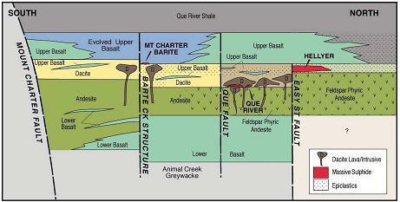
Figure 2 Schematic cross section of Que-Hellyer Stratigraphic sequence.

Work carried out in the Mt Block area prior to 2011 is summarised in the 2011 annual report (Denwer, 2011). The table below summarises more recent work:

2013-14: Work completed since 2011 included a geochemical review of prospective alteration zones within the QHV. The review was completed by external consultants and Bass Geological staff. Two zones of interest were identified on EL48/2003, the Amoeba Zone and the Barite Creek Fault.
2015: Compilation and digitization of petrographic reports and photographs (Richardson, 2015).
2016: Exploration on EL48/2003 during 2016-17 involved a review of historic data and target generation in the Que River area (Callaghan, 2017).
2018: Drilling one diamond Drillhole HED28 for 309.3m. The drillhole intersected unmineralised and unaltered mixed volcanics below the hangingwall basalt.
2019: Exploration on EL48/2003 during 2019 involved a review of historic data and target generation in the Que River area by the Company and independent parties.
2020: Pieman reran a number of Historic DTH electromagnetic Data. The company also undertook a rerun of the 1995 Seismic Data.
2021-22 Pieman reassessed DHEM due to constraints imposed by historical surveys, the modelled plates are not well constrained in 3-D spatial co-ordinates. New drilling targets were designed.

The reassessment during 2022 led to a renewed focus on the Amoeba Target, which is shown in relation to the regional geology in the figure below.

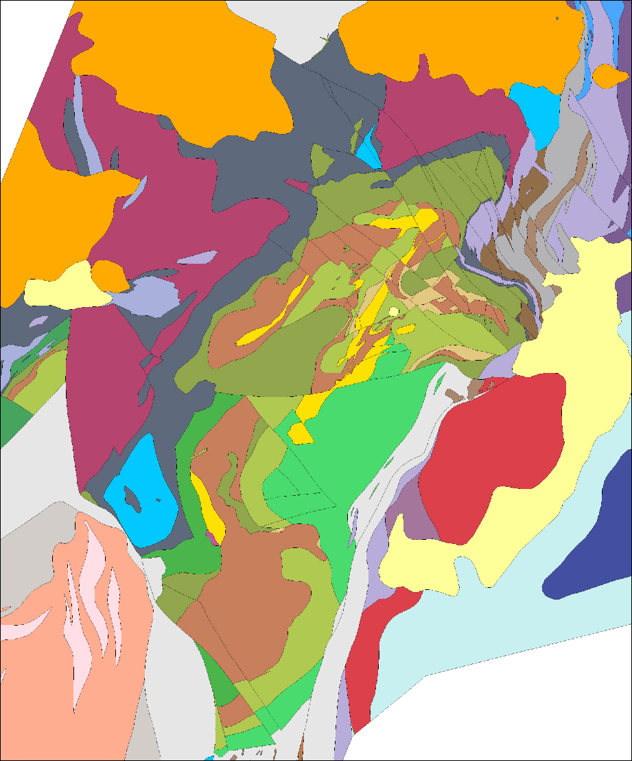
QUE RIVER
HELLYER
Amoeba
Target
Figure 3 Regional Geology of the Que-Hellyer Volcanics and Amoeba Target

- EXPLORATION COMPLETED DURING THE REPORTING PERIOD

GEOCHEMICAL TARGETING

Work in 2022 included preparation for drilling of new DDH at location HER1. Targeting of the drill hole was based on newly implemented pathfinder geochemistry, which was interpreted with existing geochemical and geophysical data.

Targeting work undertaken in 2022 included:

- Development multi-element geochemical dataset.
- Assessment of As, Sb, Tl as useful distal to proximal pathfinders.
- Recognition of pyrite pervasive throughout hydrothermal system, but that pyrite hosted trace element patterns can provide useful near-miss signals.

The geochemical data assessment is shown in Figure 4 below:

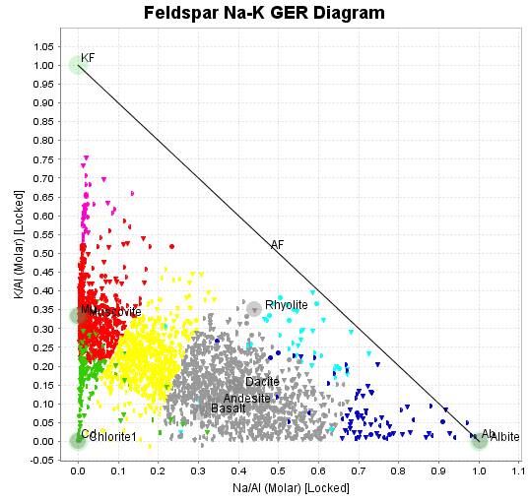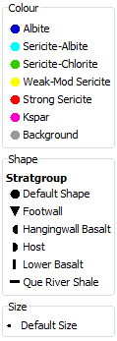
Figure 4 Geochemical data assessment and alteration identification

The preferred target was identified at the Amoeba Target (see location 5 in the figure below) which was identified as geochemical anomalism associated with strong silica-sericite-pyrite alteration within the Hellyer target horizon.

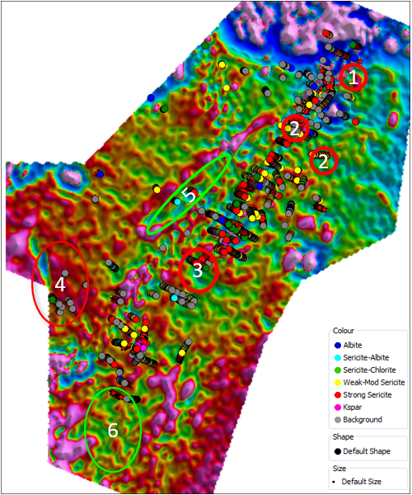
Figure 5 Geochemical alteration over electromagnetic with Amoeba Target (location 5) indicated.

CORE DRILLING

Prior to the end of the period diamond drilling commenced at the Amoeba Target at location HER1 (Easting 390693, Northing 5394152 AGD). Drilling was planned to test south of the historic drill hole HAT3. The selected location was characterised by a coincident zone of geophysical IP chargeability and geochemical anomalism associated with strong silica-sericite-pyrite alteration within the Hellyer target horizon.

An initial HQ diamond drillhole has commenced and reached 100m downhole depth prior to the end of the period. Initial logging suggested strongly developed pyritic stringer-style mineralisation within the target horizon sequence.

- DISCUSSION OF RESULTS AND CONCLUSIONS

The drill core will be logged and intersections submitted for geochemical assay. Results will inform further drilling planned for EL48/2003.

- PROPOSED EXPLORATION

Initial works planned for 2023 include completion of already commenced drilling, supporting geophysical surveys. The activities, and associated interpretation, will be followed by core drilling of further targets. The current drill hole is planned to continue to a target depth of 300m, this may be extended to up to 450m should results suggest that as required.

DHEM

Drilling activity is being supported by high-powered down hole electromagnetic (DHEM) geophysical surveying and pathfinder geochemical vectoring. DHEM on the current hole will be undertaken once the hole reaches the target depth.

The deployment of a high-powered DHEM system, for the first time in the Hellyer District, will provide enhanced signal-noise ratio and better define 3D conductive bodies within the target horizon.

CORE DRILLING

Once results for the hole located at HER1 are received, and follow-up DHEM results processed, an assessment will be made of the next location for core drilling. This will occur during 2023 and 2024.

Exploration planned for 2023 has been preliminarily costed at $250,000. This includes completion of the drill hole at HER1 (approx. $175,000 including rehabilitation) and DHEM (approx. $75,000 including processing and interpretation).

- ENVIRONMENTAL MANAGEMENT

The commencement of core drilling in 2022 saw the establishment of the drill at location HER1 with associated minor works including preparing the drill pad and clearing. Best-practice remediation will be completed once the drilling is completed. Holes will be securely capped pending DHEM and all rehabilitation procedures will be followed.

- EXPENDITURE

Expenditure from 11th January 2022 to 10th January 2023 is summarised below for the Mt Block EL48/2003.

Table 1 Expenditure 11 JANUARY 2022 to 10 JANUARY 2023.

- Geoscience | $68,308.00
- Drilling and Gridding | $18,963.39
- Land Access | $3,200.00
- Rehabilitation
- Feasibility Studies
- Other | $66,535.77
- Administration | $15,000.00
TOTAL - ELIGIBLE | $168,807.16

REFERENCES

Callaghan, T. 2017 Mt Block, Tasmania, EL48/2003, Annual Progress Report for period Ended 10th January 2017. Unpublished Report for Bass Metals Ltd.

Denwer, K. 2011 Mt Block, Tasmania, EL48/2003, Annual Progress Report for period Ended 10th January 2011. Unpublished Report for Bass Metals Ltd.

Richardson, S. 2015. Mt Block, Tasmania, EL48/2003, Annual Progress Report for period Ended 10th January 2015. Unpublished Report for Bass Metals Ltd.

